Srinivasan Kannan (alias) Ka.Shrinivaasan (alias) Shrinivas Kannan
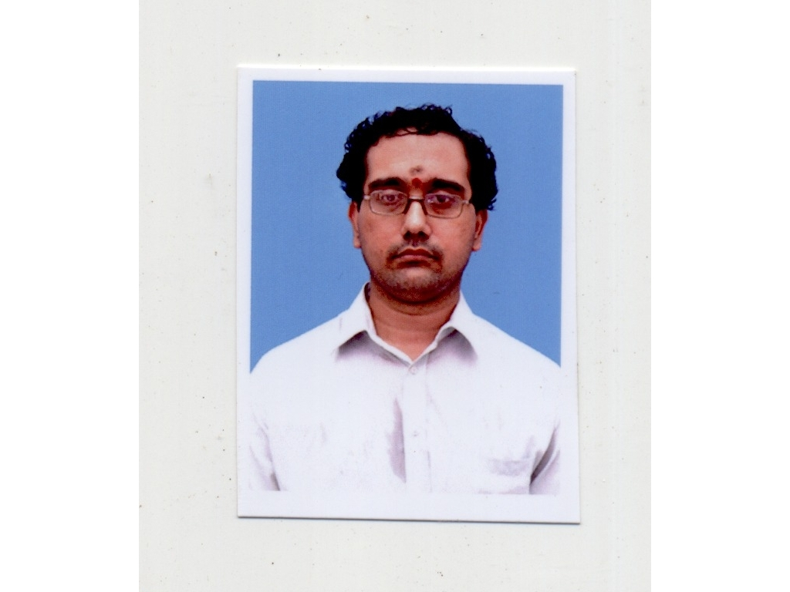
Permanent Address:
Srinivasan Kannan,
S/O. P.R.ES.Kannan,
172, Gandhi Adigal Salai,
Kumbakonam-612001, TamilNadu, India.
e-mail : ka.shrinivaasan@gmail.com
shrinivas.kannan@gmail.com
kashrinivaasan@live.com
Mobile : 9789346927, 9791165980, 9003082186
Name spellings in
consultancy/employer/academic
records : Srinivasan Kannan (academics, BaaN,Sun
Microsystems,Verizon, PiQube),
Shrinivas Kannan(webMethods/SoftwareAG and
CMI), Ka.Shrinivaasan (Global Analytics)
Personal website(research) :- https://sites.google.com/site/kuja27/ (has publications, drafts and related)
Krishna iResearch Open Source: https://sourceforge.net/users/ka_shrinivaasan, https://www.ohloh.net/accounts/ka_shrinivaasan
Date of Birth as per records: 19 May 1977
Marital Status: Unmarried, Single
Academics : BE(Computer Science – PSG Tech,Coimbatore – 1995-99), M.Sc(Theoretical Computer Science – CMI, Chennai – 2008-2010), [PhD - CMI, Chennai -2010-2011]

SUMMARY DETAILS OF WORK (1999 – Present)

C/C++/Java/Python on Windows and various Unix flavours

PRODUCTS
Netscape Application Server 4.0, iPlanet/SunONE Application Server 6.x, SunONE Web/Proxy Server 3.6/4.0, Apache web server 1.4.x/2.0.x, webMethods Broker Messaging Server 5.x/6.x/7.x, ASFER Classification and Inference Software for Large Data Sets (10.0,12.0+), USBmd (1.0,3.0+), VIRGO Linux Kernel Extensions for Cloud (5.0,6.0,7.0,8.0,10.0,12.0+), Global Decision Platform(GDP) 2.3.0/ 2.3.1/ 2.5.0/ 2.5.1/ 2.7 /2.7.1/3.0, KingCobra 1.0+, Automated Modelling Platform(AMP), Python 2.4.3 and 2.7 source code, Linux kernel [3.2.0, 3.7.8, 3.9.x,3.15.5], Maitreya's Dreams 7.0.3, STL, BOOST, wxWidgets library, Swiss Ephemeris API (based on NASA JPL DE406 Ephemeris).

LANGUAGES/PLATFORMS/TOOLS
C/C++, Java 1.5-1.7, J2EE, Python, R and rpy2, Haskell, Solaris 6-10, Windows 2000, HP-UX 11.23 (PA-RISC and IA64),AIX, Linux, Sun Studio, CORBA (Visibroker), VAX FORTRAN, VAX VMS, GNU collection, MS Visual Studio .NET C++, WinDbg, DDD, Visual Basic and ASP, OptimizIt, Eclipse, EclipseCDT, Code::Blocks, ActiveState Python, IDLE, Haskell FP, Insight, GreatCircle, Valgrind, Callgrind, Cloud Computing Mapreduce Tools (Dumbo Mapper-reducer on Hadoop), Python NLTK, Hadoop, PiCloud, ActiveMQ, RabbitMQ, Pyutilib workflow, PyF workflow, Linux kernel – [3.2.0, 3.7.8, 3.9.x, 3.15.5], Maitreya's Dreams 7.0.3, wxWidgets library, Swiss Ephemeris API (based on NASA JPL DE406 Ephemeris), BioInformatics Sequence Alignment Tools (BioPython, ClustalOmega), ROOT(CERN), Geolocation Python API, Beautiful Soup, CRF tools, GATE, SentiWordNet, Stanford CoreNLP, ENT, MongoDB, WEKA

January 2013 – present – Krishna iResearch (self-started, not-for-profit, open-source research initiative started in 2003) (https://sourceforge.net/users/ka_shrinivaasan)

Working on Research, Design and Development of open source projects started by self licensed under GPL v3:
http://asfer.sourceforge.net/
http://sourceforge.net/p/usb-md/
https://sourceforge.net/p/virgo-linux/
https://sourceforge.net/p/kcobra/
and
Publications and Drafts at:
https://sites.google.com/site/kuja27/ and
http://sourceforge.net/projects/acadpdrafts/

ZODIAC DATASOFT - In addition to the above, IT and other academic training for students and professionals is also done in freetime.

June 2014 – July 2014 – Clockwork Interviews Pvt Ltd, Chennai (Hiring product - http://piqube.com) – Consultancy on Design and a Java based minimal Implementation for computing the various statistical measures from a job experience sequence:

February 2014 – Clockwork Interviews Pvt Ltd, Chennai (Hiring product - http://piqube.com) – In-office non-profit Consultancy to PiQube for initial design of a Multivariate Linear Regression model for Stability and Gap scoring in Resume

October 2013 – January 2014 – continued work on my opensource products (Krishna iResearch - https://sourceforge.net/users/ka_shrinivaasan) and non-profit machine learning remote consultancy to Clockwork Interviews Pvt Ltd, Chennai (Hiring product - http://piqube.com)

September 2012 - February 2013 – Parttime Consultancy for Global Analytics(Chennai) and Work on my opensource products (Krishna iResearch)

January 2011 – March 2011 (Consultant) and July 2011 – August 2012 – Global Analytics(Chennai) – Senior Lead Software Architect (C/C++/Python)
Managed a team on Global Decision Platform(GDP) and Automated Modelling Platform and doing architectural design, development and releases of GDP versions 2.5, 2.5.1, 2.7, 2.7.1 and 3.0(GDP redesign)

January 2011 – March 2011 – Consultant for Global Analytics(Chennai) and Work on my opensource products (Krishna iResearch) – (C++/Python)
Worked on my Open Source Products Design & Development (Krishna iResearch) and Did consulting and development for Global Analytics,Chennai (optimization, a smart-pointer reference-counted memory manager backed-up by an Object Pool, and refactoring) in Global Decision Platform (GDP) 2.3 for GPD 2.3.1 and 2.5 which is written in C++ with boost::python embedding.

August 2008 – June 2011 – Work on my opensource products (Krishna iResearch)

Started working on open source project ASFER (http://asfer.sourceforge.net) as part of my non-profit open source initiative Krishna iResearch – ASFER is a rule miner and executer- presently uses Vector space retrieval and Support Vector Machines with added Support for Naive Bayesian Multinomial Classifier and Decision Tree Classifier

March 2006 – July 2008 - webMethods (now Software AG) (Bangalore) (C/C++/Java)

Worked on WebMethods Broker Server 5.x/6.x/7.x– a heavily multithreaded messaging productwritten in C/C++/Java based on publisher/subscriber model – Clients can publish and/or subscribe to certain predefined types of messages called “Events”. My responsibilities included development of new functionalities and fixing customer escalation issues in core areas of Broker (Connection Layer, Territories/Gateways,Broker Admin Tool etc.,) and writing knowledgebase documents.

November 2005 – February 2006 – Krishna iResearch (self-started, not-for-profit, open-source research initiative)
Initial design work for Krishna iResearch open source products focussing on algorithms for web and BigData

August 2005 – November 2005 – Verizon Data Services India, Chennai

May 2003 – Krishna iResearch (self-started, not-for-profit, open-source research initiative)
Registered on SourceForge.net and Initial design work started for open source products focussing on algorithms for web and BigData

February 2000 – July 2005 - Sun Microsystems (now Oracle) (Bangalore)

Implementation of a threaded ICP server and porting SOCKS server for Sun Java system web proxy server 4.0 (C/C++/Solaris/Windows/RHELinux) ,Load Balancer Module for Apache Web Server 1.3.27 / 2.0.47 (C/C++) ,Optimizations and Features for iPlanet/Sun ONE Application Server 6.x (Java) ,Debugging and Monitoring framework (MagicDraw),Designed a Debugging and Monitoring framework for Sun ONE Application Server 7.0 Enterprise Edition,
Store Adapter prototype for High Availability(Java) ,Added support for enabling/disabling TCP_NODELAY in SunOne Application Server 6.5 SP1,Survival Index based Transaction Timeout Manager for iPlanet Application Server (Java),Designed and implemented a new Transaction Timeout Manager for iPlanet Application Server. This resulted in an overall speed-up of 10% for the application server. (Invention Disclosure done),An automated SmokeTest suite for nightly build setup of iPlanet Application Server 6.0 ,Ported SunONE Application Server to Red Hat Enterprise Linux Advanced Server 2.1 ,Certified JWSDP 1.3 webservices pack on Sun One Application Server 7.1 ,Studied feasibility of supporting SunOne Web/Proxy Server on Solaris 10 zones

Team and Individual Patents/Disclosures:
1. Individual Invention Disclosure for Survival Index Based Transaction Timeout
Manager (Sun Microsystems)
2. US Pat. 7610305
3. US Pat. 7739252
4. US Pat. 7134008
5. US Pat. 7165061
6. US Pat. 7743083
7. US Pat. 7082432
8. US Pat. 7640545
9. US Pat. App 10655346
10.US Pat. App 10422453

July 1999 - January 2000 - BaaN Infosystems (now SSA Global) (Hyderabad)

Developed a storefront for an e-commerce application called
E-Enterprise using Microsoft Internet Information Server/Site Server, Visual Basic, Active Server Pages and Visual Interdev

