Evaluation Report – Employee Attrition Prediction

1. Objective
Build and compare four classifiers (Logistic Regression, Decision Tree, Random Forest, XGBoost) to predict employee attrition, evaluate them with Accuracy, Precision, Recall, F1 and ROC-AUC, and improve them with cross-validation, hyperparameter tuning and feature importance. An optional regression task predicts JobSatisfaction (1–4).

2. Dataset
IBM HR Analytics Employee Attrition dataset: 1470 employees, 35 original columns, no missing values. Only 16.1% of employees left, so the classes are imbalanced (about 1 leaver per 5 stayers). Because of this imbalance, accuracy alone is misleading, so recall, F1 and ROC-AUC are emphasised. Constant or ID columns (EmployeeCount, EmployeeNumber, StandardHours, Over18) were removed.

3. Method
- Stratified 80/20 train–test split (random_state=42) so both sets keep the 16% leaver rate.
- Pipeline: one-hot encoding for categorical columns and standard scaling for numeric columns (fitted on training data only, so no leakage).
- Imbalance handled with class_weight="balanced" (LR, Tree, RF) and scale_pos_weight (XGBoost).
- 5-fold stratified cross-validation, then GridSearchCV optimising ROC-AUC.
- Feature importance from Random Forest, XGBoost and Logistic Regression coefficients.

4. Baseline results (test set)
Model | Accuracy | Precision | Recall | F1 | ROC-AUC
Logistic Regression | 0.752 | 0.349 | 0.638 | 0.451 | 0.803
Decision Tree | 0.786 | 0.379 | 0.532 | 0.442 | 0.653
Random Forest | 0.847 | 0.625 | 0.106 | 0.182 | 0.791
XGBoost | 0.840 | 0.500 | 0.404 | 0.447 | 0.774

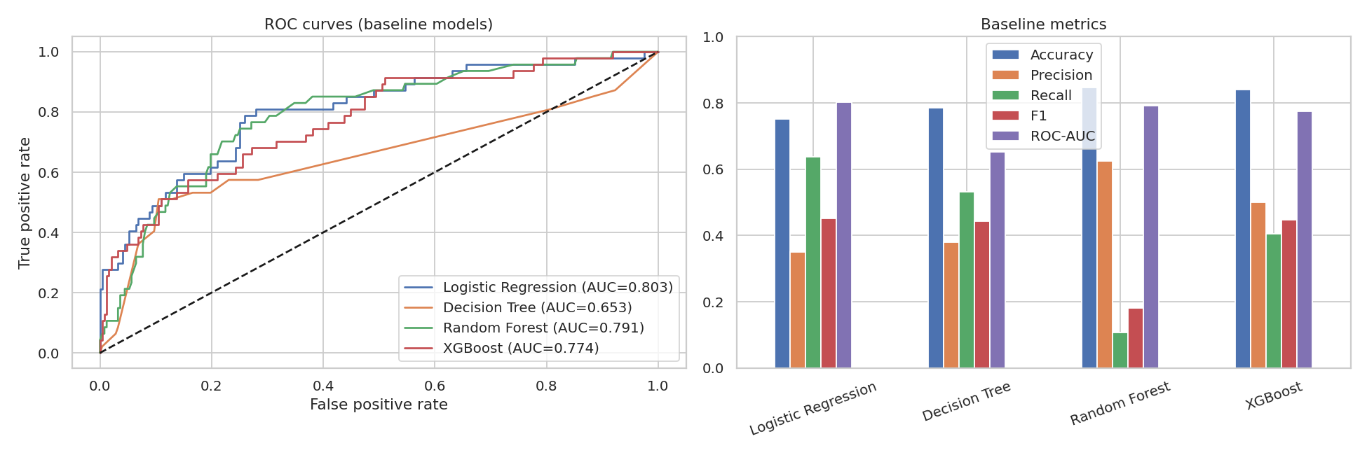

5. Cross-validation (training set, mean ± std)
Model | accuracy | precision | recall | f1 | roc_auc
Logistic Regression | 0.753 ± 0.031 | 0.372 ± 0.038 | 0.737 ± 0.062 | 0.492 ± 0.034 | 0.827 ± 0.028
Decision Tree | 0.697 ± 0.039 | 0.262 ± 0.030 | 0.468 ± 0.087 | 0.332 ± 0.036 | 0.627 ± 0.047
Random Forest | 0.861 ± 0.007 | 0.870 ± 0.108 | 0.174 ± 0.057 | 0.284 ± 0.078 | 0.800 ± 0.027
XGBoost | 0.871 ± 0.018 | 0.638 ± 0.074 | 0.458 ± 0.077 | 0.532 ± 0.076 | 0.796 ± 0.033

Logistic Regression and the tree ensembles reach cross-validated ROC-AUC of about 0.80–0.83, while the single Decision Tree is much weaker (≈0.63) and unstable. Random Forest shows high accuracy but very low recall at the default 0.5 cut-off because it mostly predicts "stays" for the minority class.

6. After hyperparameter tuning (test set)
Model | Accuracy | Precision | Recall | F1 | ROC-AUC
Logistic Regression | 0.772 | 0.381 | 0.681 | 0.489 | 0.812
Decision Tree | 0.728 | 0.301 | 0.532 | 0.385 | 0.704
Random Forest | 0.833 | 0.462 | 0.255 | 0.329 | 0.798
XGBoost | 0.816 | 0.429 | 0.447 | 0.438 | 0.756

Best parameters found: Logistic Regression: {'clf__C': 0.1}; Decision Tree: {'clf__max_depth': 4, 'clf__min_samples_leaf': 10}; Random Forest: {'clf__max_depth': None, 'clf__min_samples_leaf': 3, 'clf__n_estimators': 400}; XGBoost: {'clf__learning_rate': 0.03, 'clf__max_depth': 4, 'clf__n_estimators': 200}
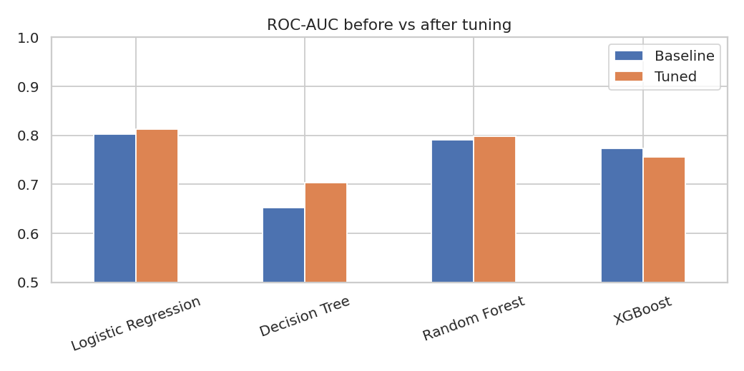
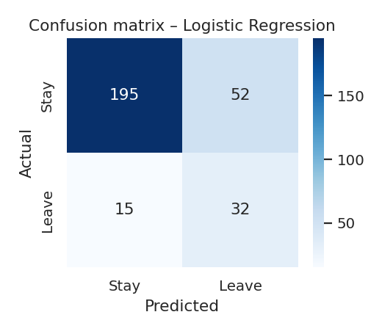

7. Feature importance
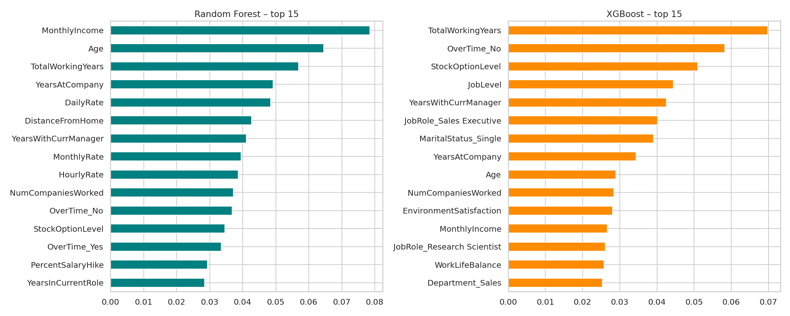
Across models, MonthlyIncome, Age, TotalWorkingYears, YearsAtCompany, OverTime and StockOptionLevel are the most important features. Logistic Regression coefficients show OverTime = Yes, frequent business travel, Laboratory Technician / Sales Representative roles, being single and long time since last promotion raise attrition risk, while higher total experience and good environment satisfaction lower it.

8. Optional regression: JobSatisfaction (1–4)
Model | MAE | RMSE | R2 (test) | R2 (5-fold CV)
Linear Regression | 0.975 | 1.155 | -0.054 | -0.056
Ridge | 0.973 | 1.151 | -0.049 | -0.049
Random Forest Reg. | 0.969 | 1.138 | -0.025 | -0.042
XGBoost Reg. | 0.987 | 1.158 | -0.061 | -0.106

All regression models have R² near zero or negative and MAE ≈ 0.97, no better than predicting the average satisfaction score. Job satisfaction is therefore not predictable from the other HR fields in this dataset, which is itself a finding: satisfaction must be measured directly through surveys.

9. Conclusion
Logistic Regression gave the best ROC-AUC (0.812) with recall 0.681, precision 0.381 and F1 0.489 on the held-out test set. Tuning helped Logistic Regression and the Decision Tree, barely changed Random Forest, and slightly lowered the test ROC-AUC of XGBoost (a sign of the noise from the small test set). Logistic Regression was both the most accurate at ranking and the most useful at catching leavers (highest recall), which suggests the signal in this dataset is largely linear and that more complex models are not automatically better.

10. Limitations
- Small dataset (1,470 rows, ~237 leavers) so metrics vary between splits; cross-validation standard deviations show this.
- The dataset is a fictional IBM sample; real-world results may differ.
- Models show association, not causation (e.g. overtime may be a symptom, not only a cause).

