Employee Workforce Segmentation
Employee Segmentation Report

1. Objective
The aim of this project is to divide the employees of a company into groups (segments) of similar employees, so that we can understand which groups are more likely to leave. We used two clustering methods, K-Means and Hierarchical clustering, and we used PCA to reduce the number of features and to plot the groups. After that we studied the high-risk clusters, the department-level segments, the performance groups and the retention risk groups.

2. Data
We used the IBM HR employee attrition dataset. It has 1,470 employees and 35 columns, and there are no missing values. Out of 1,470 employees, 237 have left the company, so the overall attrition rate is 16.1%.
For clustering we used 20 numeric features related to work, for example age, job level, monthly income, total working years, years at company, overtime and travel. Overtime and travel were converted to numbers first. We kept Attrition, Department and Performance out of the clustering. We wanted to use them later to check the segments, and using them in the clustering would make the result circular.

3. Method
- All 20 features were scaled with StandardScaler so that large-valued features like income do not dominate.
- PCA was applied and 12 components were kept. They explain 83.2% of the variance (details are in the PCA Summary).
- K-Means was run on the 12 components for different values of k, and the best k was chosen using silhouette score and Davies-Bouldin index.
- Hierarchical clustering with Ward linkage was run on the same data, with the same number of clusters.
- The two methods were compared, and the K-Means segments were used for the rest of the analysis.

3.1 Choosing the number of segments
We tried k from 2 to 10. Two groups gave the highest silhouette score (0.195), but two groups are too few to be useful for HR, so we looked at k from 3 to 6 and took the best one. This was k = 3 with a silhouette score of 0.126.
k | Silhouette | Davies-Bouldin
2 | 0.195 | 1.946
3 (chosen) | 0.126 | 2.285
4 | 0.118 | 2.210
5 | 0.102 | 2.370
6 | 0.099 | 2.302

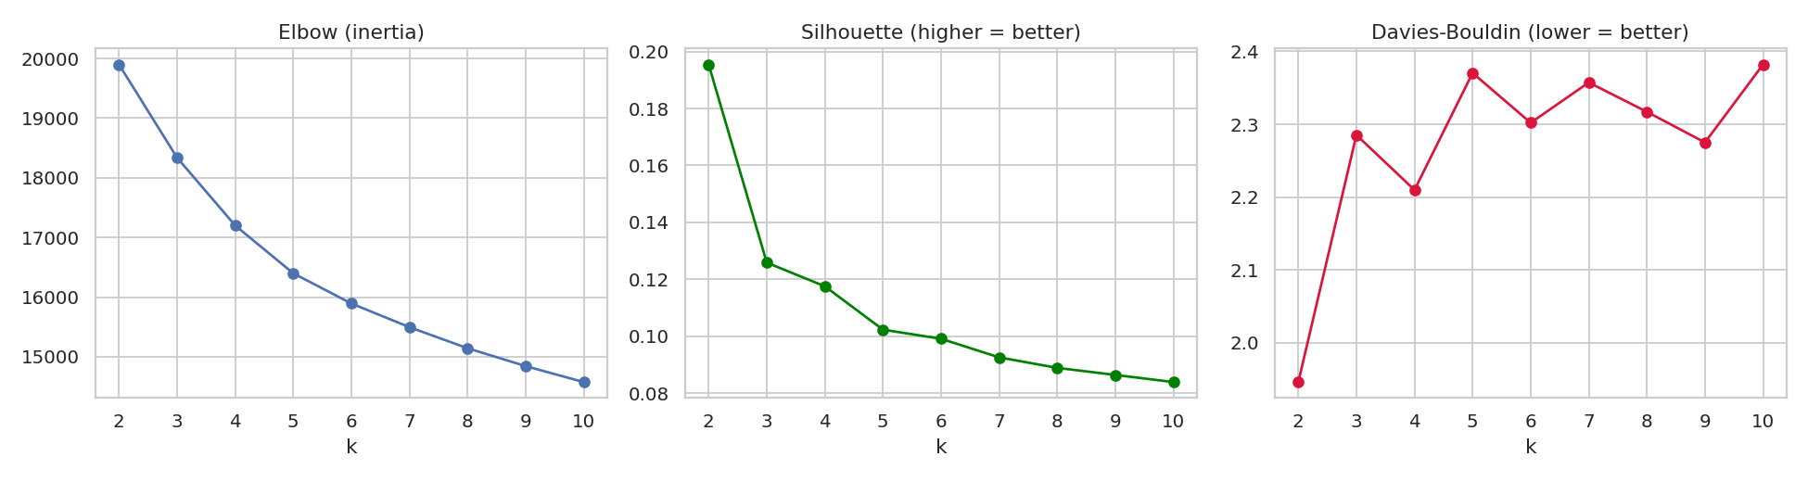
Figure 1: Model selection scores for different values of k

3.2 K-Means vs Hierarchical clustering
Measure | K-Means | Hierarchical (Ward)
Silhouette score | 0.126 | 0.105
Davies-Bouldin index | 2.284 | 2.484

The agreement between the two methods is high (Adjusted Rand Index = 0.753), so both found nearly the same groups. K-Means has a slightly better silhouette score and a lower Davies-Bouldin index, so we used the K-Means segments. The silhouette scores are low in both cases (around 0.1). This means the groups overlap and the borders between them are not sharp, which is normal for HR data because employees move slowly from junior to senior.
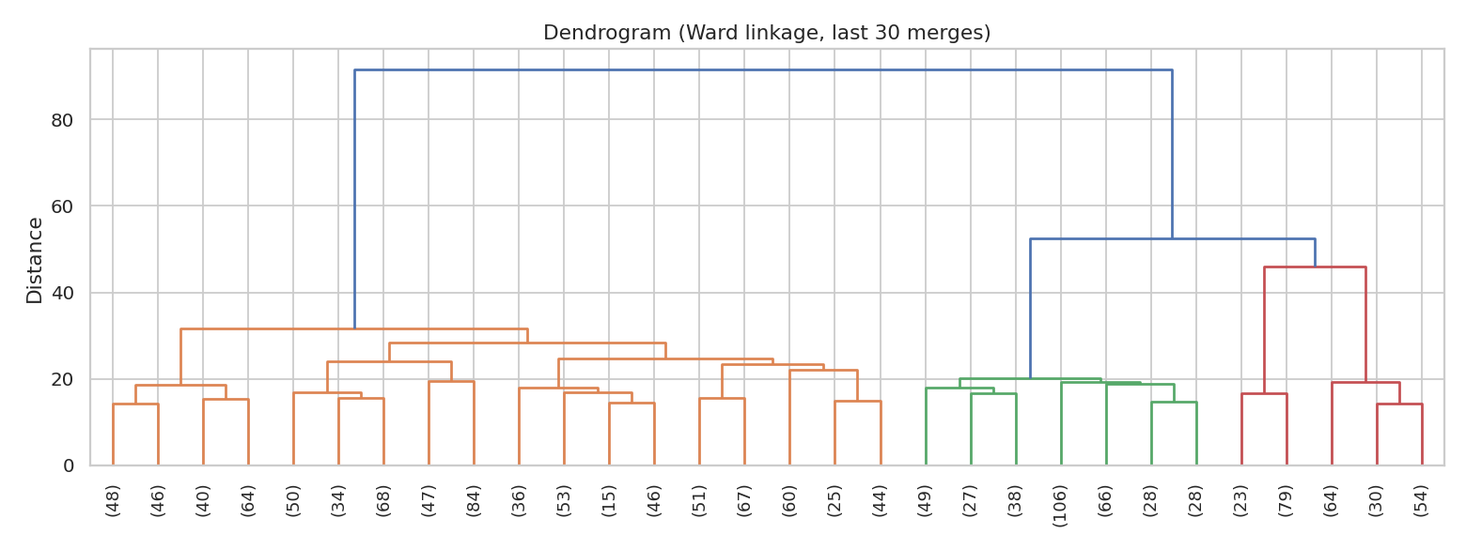
Figure 2: Dendrogram of the Ward hierarchical clustering

4. Segment profiles
The K-Means clustering gave three segments. We named them by looking at their average income, experience and tenure.
Segment | Staff | Age | Income | Job level | Total yrs | Yrs at co. | Overtime | Attrition
Early-Career Core | 835 | 34.3 | 4,270 | 1.51 | 7.2 | 3.4 | 30.2% | 21.3%
Established Mid-Career | 414 | 36.2 | 6,230 | 2.11 | 11.9 | 10.3 | 24.2% | 9.9%
Senior Experts | 221 | 48.2 | 15,452 | 4.07 | 25.6 | 14.5 | 29.0% | 8.1%

- Early-Career Core is the biggest group. These employees are young, have low income and low job level, and have been in the company for only about 3.4 years on average.
- Established Mid-Career employees have around 10 years in the company and a medium income. They have the lowest overtime of the three groups.
- Senior Experts are the oldest group with the highest income and job level and about 25 years of total work experience.
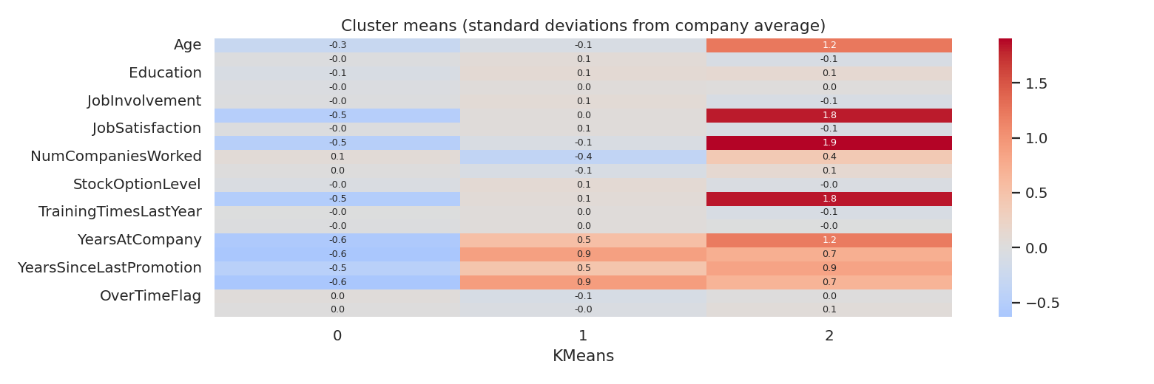
Figure 3: Segment averages compared with the company average (z-scores)
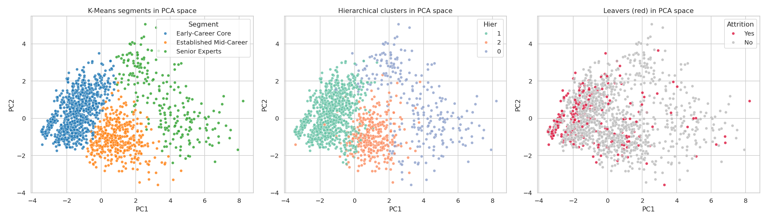
Figure 4: Segments, hierarchical clusters and leavers plotted on the first two principal components

5. High-risk employee clusters
We compared the attrition rate of every segment with the company average of 16.1%. A segment with a ratio of 1.25 or more was marked as high risk.
Segment | Employees | Leavers | Attrition | Ratio to average | Flag
Early-Career Core | 835 | 178 | 21.3% | 1.32 | High risk
Established Mid-Career | 414 | 41 | 9.9% | 0.61 | Low risk
Senior Experts | 221 | 18 | 8.1% | 0.50 | Low risk

Early-Career Core is the high-risk cluster. It has 56.8% of all employees but 178 of the 237 leavers (75.1%). The other two segments are both well below the company average.
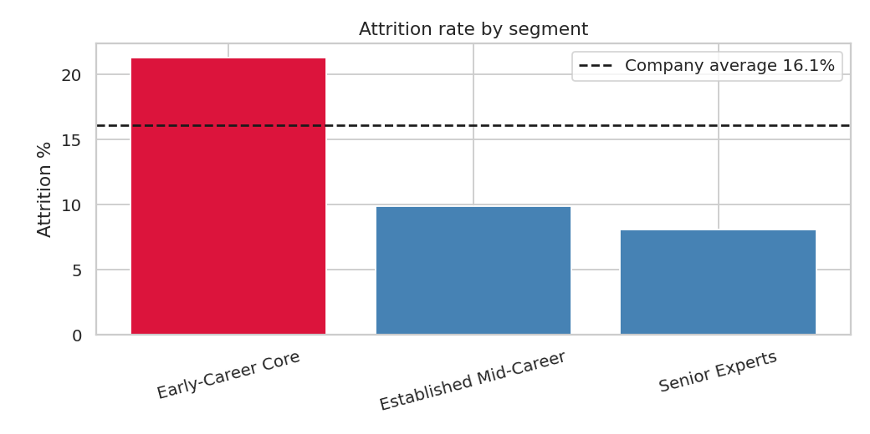
Figure 5: Attrition rate by segment

6. Department-level workforce segments
Department | Employees | Attrition | Early-Career Core | Established Mid-Career | Senior Experts
Human Resources | 63 | 19.0% | 65.1% | 14.3% | 20.6%
Research & Development | 961 | 13.8% | 57.8% | 27.0% | 15.3%
Sales | 446 | 20.6% | 53.6% | 32.7% | 13.7%

Sales (20.6%) and Human Resources (19.0%) have higher attrition than Research & Development (13.8%), and both are above the company average. In every department the Early-Career Core is the largest segment, and HR has the highest share of it (65.1%). Note that HR has only 63 employees, so its percentages can change a lot with a few people.
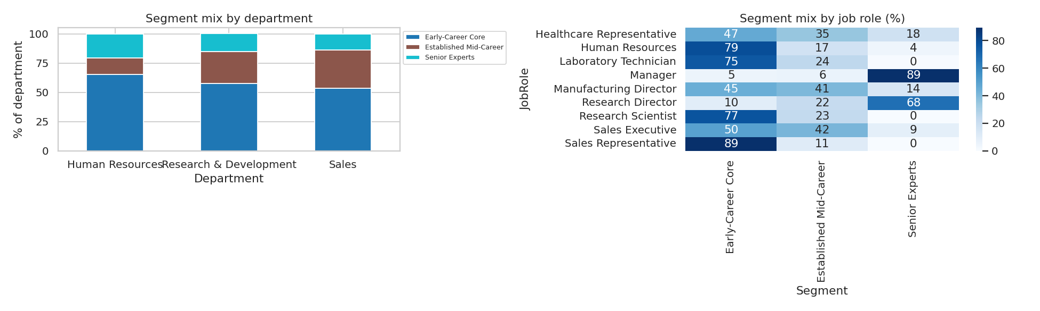
Figure 6: Segment mix by department and by job role

7. Performance groups
In this dataset PerformanceRating has only two values, 3 (Excellent) and 4 (Outstanding), so we made two performance groups.
Performance group | Employees | Attrition | Avg income | Avg salary hike
Excellent (3) | 1,244 | 16.1% | 6,537 | 14.0%
Outstanding (4) | 226 | 16.4% | 6,314 | 21.8%

The attrition rate is almost the same in both groups, so the performance rating alone does not tell us who will leave. The share of Outstanding employees is also similar in all segments (14.4% in Early-Career Core, 17.9% in Established Mid-Career and 14.5% in Senior Experts). The Outstanding group does get a much higher salary hike on average (21.8% against 14.0%).

8. Retention risk groups
Each segment was given a risk tier based on its attrition rate: High if it is at least 1.25 times the company average and Low if it is at most 0.75 times. Every employee gets the tier of his or her segment. No segment was in between, so there is no Medium tier.
Risk tier | Employees | Leavers | Attrition
High | 835 | 178 | 21.3%
Low | 635 | 59 | 9.3%

The High tier is 56.8% of the staff but holds 75.1% of all leavers.

9. Suggestions for HR
These are our own suggestions from the results. The data shows which groups leave more, but it does not prove the reasons.
- Give more attention to early-career employees (for example mentoring, career path discussions and a review of pay), because this group has the highest attrition.
- Look at Sales and Human Resources first, as their attrition is above the company average.
- Do not depend only on the performance rating to find employees at risk, because Outstanding and Excellent employees leave at nearly the same rate.
- Repeat the segmentation every year to see whether the groups and their attrition change.

10. Limitations
- The silhouette scores are low (about 0.1), so the segments overlap and should be seen as broad groups.
- The retention tiers come from the segments, so all employees in one segment get the same tier. This is a simple method and does not give a score for each person.
- The dataset is a sample HR dataset and the results may not be the same for another company.
- The analysis shows relations, not causes.

11. Conclusion
We divided 1,470 employees into three segments using PCA and K-Means, and Hierarchical clustering gave a similar result. The Early-Career Core segment is the high-risk group with 21.3% attrition and 75.1% of all leavers, while the other two segments have about 8 to 10% attrition. Sales and HR have higher attrition than R&D, and performance rating does not separate the leavers from the stayers.

