Employee Workforce Segmentation
PCA Summary

1. Why we used PCA
We used 20 numeric features to describe each employee, for example age, income, job level, years at company and overtime. Many of these features are related to each other. For example, employees with more total working years usually have a higher job level and a higher income. PCA (Principal Component Analysis) reduces such related features into fewer new features called components, and it keeps most of the information. We also used PCA to plot the employee groups in two dimensions.

2. What we did
- We selected 20 numeric features (Attrition, Department and Performance were not used).
- We scaled all features with StandardScaler, so that features with large values like income do not dominate.
- We applied PCA and checked the variance explained by each component with a scree plot and a cumulative variance plot.
- We kept the number of components needed to explain at least 80% of the variance.
- We used these components for K-Means and Hierarchical clustering and for the plots.

3. How many components we kept
Twelve components are needed to explain at least 80% of the variance, and 14 are needed for 90%. We kept 12 components, which explain 83.2% of the variance. So the 20 original features were reduced to 12, and less than 17% of the information was lost.
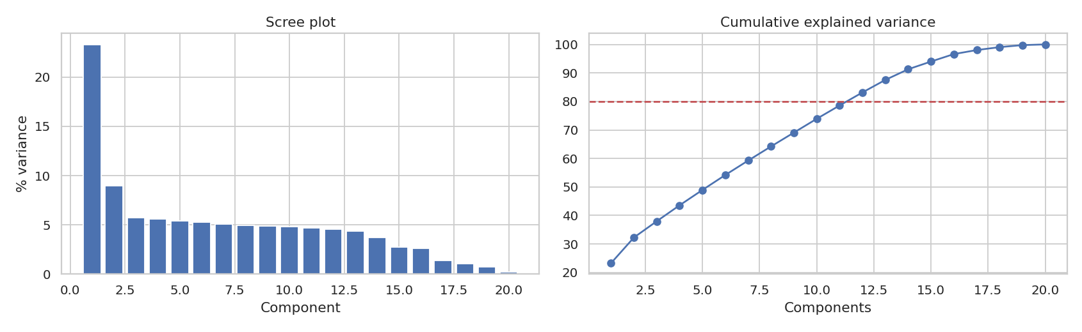
Figure 1: Scree plot and cumulative explained variance

4. What the first three components mean
Component | Variance | Features with the highest loadings
PC1 | 23.3% | TotalWorkingYears (0.40), YearsAtCompany (0.39), JobLevel (0.38), MonthlyIncome (0.38)
PC2 | 9.0% | NumCompaniesWorked (0.49), Age (0.38), YearsWithCurrManager (−0.36), YearsInCurrentRole (−0.35)
PC3 | 5.7% | OverTimeFlag (0.68), TrainingTimesLastYear (−0.43), EnvironmentSatisfaction (0.35), RelationshipSatisfaction (0.26)

- PC1 is mostly about experience and seniority. Employees with a high PC1 have many working years, a high job level and a high income.
- PC2 is about career history. It is high for older employees who worked in many companies, and low for employees who stayed long with the same manager and in the same role.
- PC3 is about the work environment. It is mostly overtime, together with training and satisfaction.
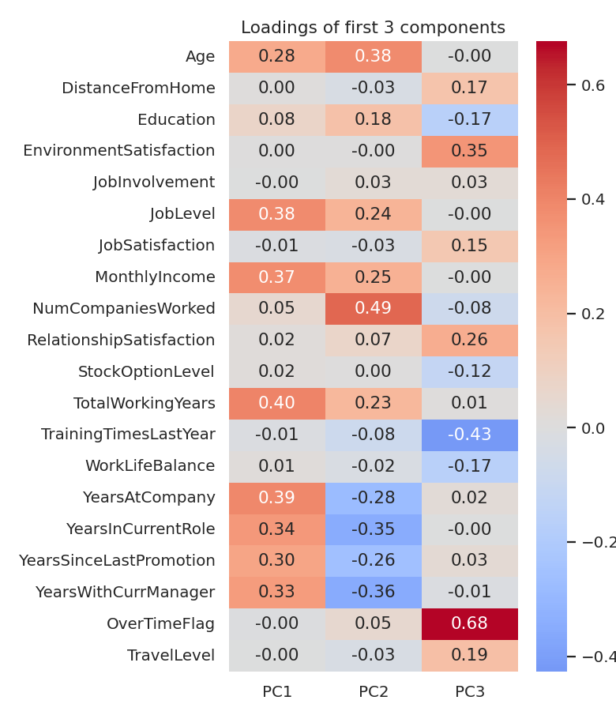
Figure 2: Loadings of the first three components

5. Using PCA to see the employee groups
We plotted the employees on PC1 and PC2 and coloured them by the K-Means segment. The Early-Career Core is on the left side (low PC1), the Senior Experts are on the right side (high PC1), and the Established Mid-Career is in the lower middle. This fits with PC1 being seniority. The groups touch and overlap at the edges, which matches the low silhouette score (0.126) of the clustering. The third panel shows the employees who left (red). Most of the red points are on the left side, which is the early-career area, and only a few are on the right side.
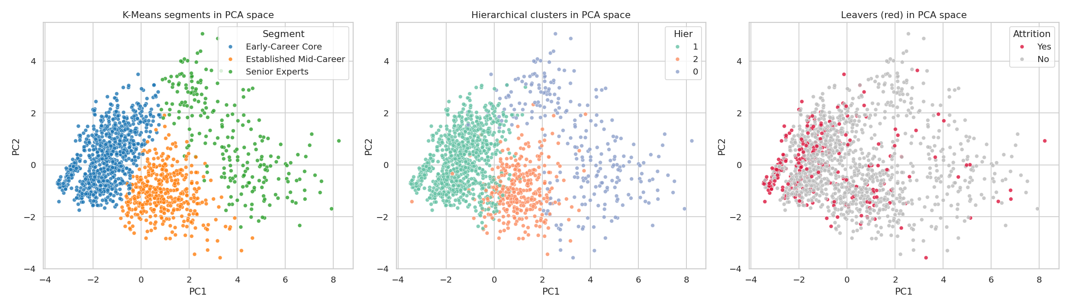
Figure 3: Employees on PC1 and PC2 coloured by K-Means segment, Ward cluster and attrition

6. Limitations
- The components are mixtures of features, so they are harder to explain than the original columns.
- The first three components explain only about 38% of the variance (23.3% + 9.0% + 5.7%), so a 2D plot cannot show everything.
- PCA works on linear relations only.

7. Conclusion
PCA reduced 20 features to 12 components and kept 83.2% of the variance. The first component shows seniority and it separates the segments the most. The 12 components were then used as input for K-Means and Hierarchical clustering.

