EMPLOYEE ATTRITION ANALYTICS PLATFORM
Prediction, deployment and dashboard for employee turnover
Shrinivas Wable
PRN No: 2124UDSM2065
Repository: https://github.com/shrinivas090605/employee-attrition-platform
Dashboard : https://employee-attrition-platform-i7ymnicw7iichr9je4kvbe.streamlit.app/

Abstract
This report describes a machine learning system that predicts whether an employee is likely to leave a company. The IBM HR Analytics dataset was used, which has 1470 employees, of whom 237 (16.1%) left. Seven models were compared: Logistic Regression, Random Forest, XGBoost, a neural network, Gaussian Naive Bayes, Linear Discriminant Analysis (LDA) and Quadratic Discriminant Analysis (QDA). Logistic Regression gave the best cross-validated ROC-AUC and was selected. After tuning the decision threshold to 0.67, it reached a recall of 0.661, precision of 0.557 and ROC-AUC of 0.855 on unseen data. Employees were grouped into Low, Medium and High risk bands, and the High band left about 10 times as often as the Low band. The model was deployed as a Streamlit dashboard and a FastAPI web service, and a GitHub Actions workflow retrains it every week.
Resource | Link
GitHub repository | https://github.com/shrinivas090605/employee-attrition-platform
Dashboard | https://employee-attrition-platform-i7ymnicw7iichr9je4kvbe.streamlit.app/
REST API documentation | https://employee-attrition-platform-yaou.onrender.com/docs
Retraining workflow run | https://github.com/shrinivas090605/employee-attrition-platform/actions/runs/39926780801

1. Introduction and Objectives
Losing an employee is costly. The company must advertise the post, interview candidates, train the new person and wait until the new person works at full speed. In most organisations HR learns that someone is unhappy only when the resignation arrives, which is too late to do anything about it.
The objectives of this project were:
- to build a model that estimates the probability that each employee will leave;
- to compare different families of models and choose one on evidence;
- to divide employees into risk groups that HR can act on;
- to deploy the model as a dashboard and a web API; and
- to keep the model up to date through automatic retraining.
Since only about one employee in six leaves, a model that always predicts "stays" would be 84% accurate and still useless. For this reason recall, precision, F1 and ROC-AUC were used to judge the models.

2. Dataset and Preparation
The dataset contains 1470 rows and 35 columns covering age, income, job role, satisfaction ratings, travel, overtime and years of service, with no missing values. The target column is Attrition. Four columns were dropped: EmployeeCount, StandardHours and Over18 have the same value for every employee, and EmployeeNumber is only an identifier.
Five new features were created to give the models more useful signals:
- IncomeToLevel: monthly income divided by job level, showing whether pay is high or low for the grade;
- TenureRatio: years at the company divided by total working years;
- PromotionGap: years since last promotion divided by years at the company;
- StabilityScore: years at the company divided by the number of companies worked for;
- SatisfactionIndex: average of the environment, job, relationship and work-life balance ratings.
Numeric columns were standardised and categorical columns were one-hot encoded inside a scikit-learn pipeline. The data was split with 75% for training and 25% for testing, keeping the same share of leavers in both parts (stratified split, random seed 7). The test set was used only for the final reporting. All feature creation is written in one file, hr_features.py, which the notebook, the dashboard and the API all import, so that new data is processed exactly as the training data was.

3. Methodology

3.1 Models compared
Model | Type | Notes
Logistic Regression | Linear classifier | Balanced class weights
Random Forest | Tree ensemble | 250 trees, balanced class weights
XGBoost | Boosted trees | Weight for the minority class
Neural Network (MLP) | Neural network | Two hidden layers (64, 32), L2 penalty 2.0
Gaussian Naive Bayes | Bayesian | Numeric features only
LDA and QDA | Discriminant analysis | Numeric features only

Every model was scored with five-fold stratified cross-validation on the training data. The best model was chosen using the cross-validated ROC-AUC, so the test set did not influence the choice. The chosen model was then tuned with a randomised search, and a decision threshold was selected by maximising F1 on out-of-fold predictions.

3.2 A note on the neural network
Early stopping was not used for the neural network. On this small and imbalanced dataset it ended training early and gave weaker scores in my first run. A strong L2 penalty was used instead to prevent overfitting, and the network trained to completion.

4. Results and Discussion

4.1 Comparison of all models
Model | Accuracy | Precision | Recall | F1 | Test AUC | CV AUC
Logistic Regression | 0.769 | 0.39 | 0.78 | 0.52 | 0.853 | 0.808
Random Forest | 0.861 | 0.654 | 0.288 | 0.4 | 0.837 | 0.783
XGBoost | 0.848 | 0.523 | 0.576 | 0.548 | 0.849 | 0.78
Neural Network (MLP) | 0.87 | 0.628 | 0.458 | 0.529 | 0.833 | 0.779
LDA | 0.861 | 0.786 | 0.186 | 0.301 | 0.785 | 0.728
Gaussian Naive Bayes | 0.785 | 0.386 | 0.576 | 0.463 | 0.75 | 0.715
QDA | 0.84 | 0.5 | 0.305 | 0.379 | 0.791 | 0.698
Table 1. Results at threshold 0.50. The selected model is shaded.
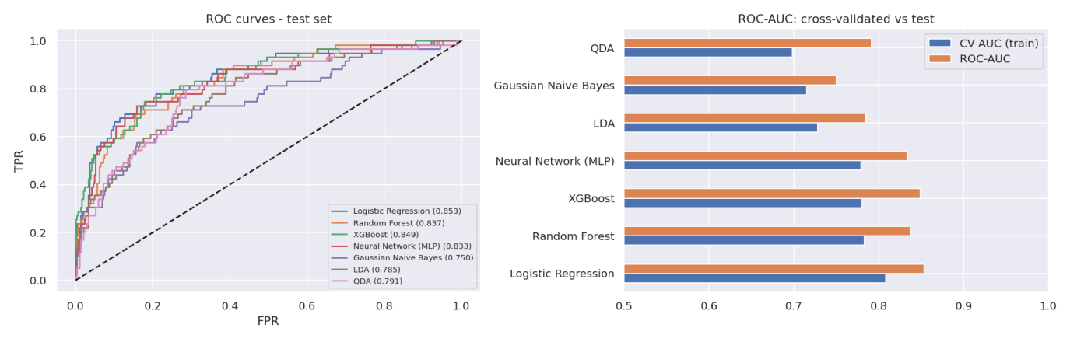
Figure 1. ROC curves and AUC of the seven models.
Logistic Regression achieved the highest cross-validated AUC (0.808), followed by Random Forest (0.783), XGBoost (0.78) and the neural network (0.779). The differences among the top four models are small. Because the simplest model matched the complex ones, it is the better choice: it is fast, stable and easy to explain to HR. A likely reason is that attrition here depends on features that act roughly additively, such as overtime, low pay and short tenure.
Accuracy alone would have been misleading. The neural network has the highest accuracy (0.87) but a recall of only 0.458, so it misses more than half of the leavers. Logistic Regression has a lower accuracy (0.769) but finds 78% of leavers at the default threshold.

4.2 Bayesian classification
Gaussian Naive Bayes applies Bayes theorem. The starting (prior) probability of leaving is 16.2%. For a given employee this is updated by multiplying the likelihood of each feature value under the "left" and "stayed" groups, under the assumption that the features are independent of one another.
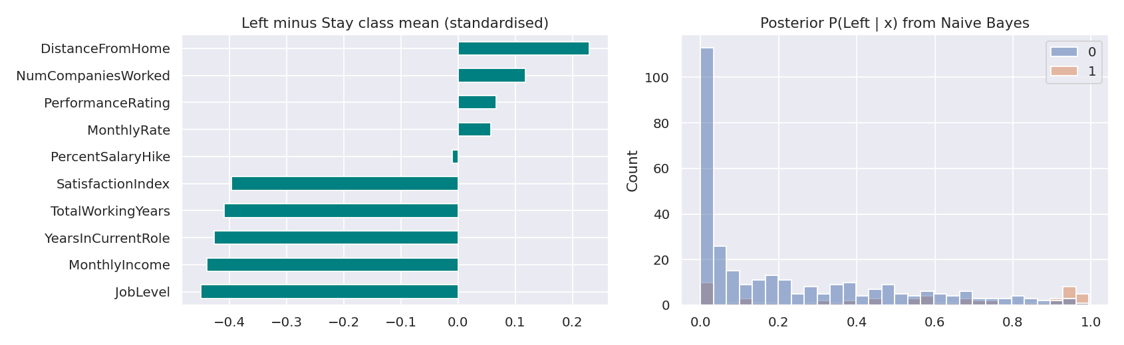
Figure 2. Difference between the class means (left) and posterior probabilities (right).
Employees who left had lower job level, monthly income, years in the current role, total working years and satisfaction index, and a longer distance from home. The model recalls 58% of leavers but its precision is only 0.386 and its AUC (0.75) is the lowest of all. Job level, income and experience are strongly related to each other, so the independence assumption does not hold, and the probabilities are therefore less reliable.

4.3 Discriminant analysis
LDA projects the data on the direction that best separates the two groups. It assumes normally distributed classes with equal covariance. QDA drops the equal covariance assumption. Both were run on numeric features.
The assumptions were tested first. Skewness of features such as StabilityScore and YearsSinceLastPromotion is above 1.5, so the normality assumption is not satisfied. The covariance matrices of the two classes are fairly similar (relative difference 0.18), which supports LDA over QDA on that point. Performance was below Logistic Regression: LDA test AUC 0.785 with recall 0.186, and QDA test AUC 0.791 with recall 0.305. Discriminant analysis is therefore only partly suitable for this data and was kept only for comparison.
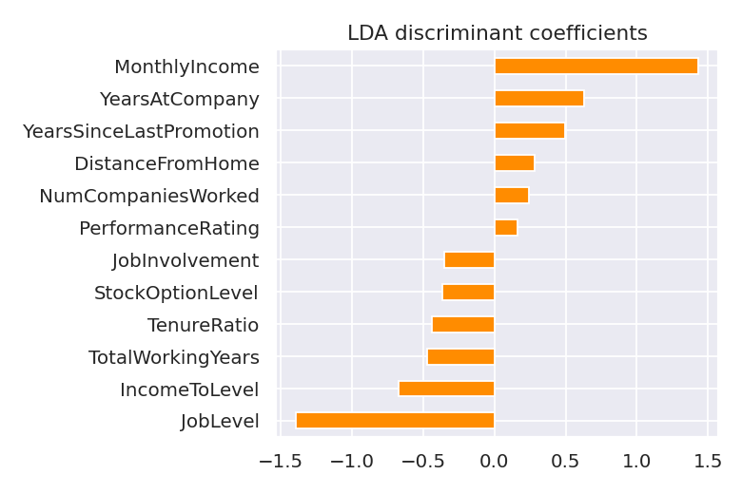
Figure 3. LDA discriminant coefficients.

4.4 Final model and threshold
Logistic Regression was tuned (regularisation strength C = 0.52) and its threshold was chosen to maximise F1, which gave 0.67. Compared with the default threshold of 0.50, precision rises from 0.387 to 0.557 and F1 from 0.517 to 0.605, while recall falls from 0.78 to 0.661. In other words, the tuned model raises fewer false alarms and still finds about two thirds of the leavers.
Setting | Accuracy | Precision | Recall | F1 | ROC-AUC
Default (0.50) | 0.766 | 0.387 | 0.78 | 0.517 | 0.855
Tuned (0.67) | 0.861 | 0.557 | 0.661 | 0.605 | 0.855
Table 2. Test-set performance before and after threshold tuning.
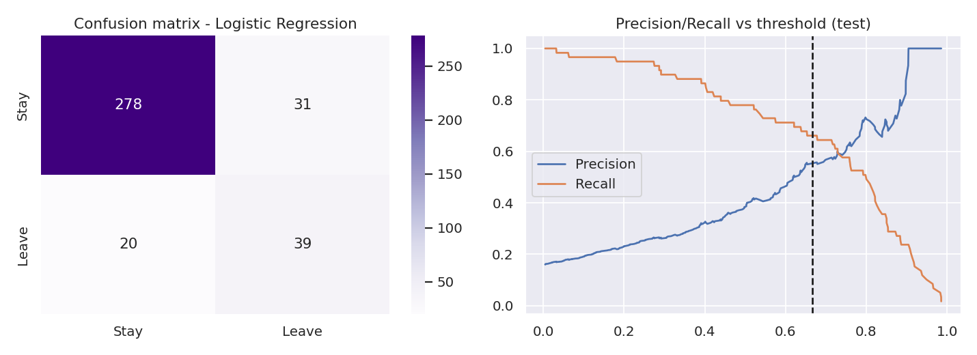
Figure 4. Confusion matrix and precision/recall against threshold.
Every employee was then given a risk band: High if the probability is at least 0.67, Medium if it is at least 0.34, and Low otherwise. The scores come from out-of-fold predictions so that no employee is scored by a model that was trained on that employee.
Risk band | Employees | Actual attrition rate
Low | 799 | 4.9%
Medium | 384 | 14.3%
High | 287 | 49.8%
Table 3. Actual attrition in each band. High-band employees left about 10 times as often as Low-band employees.

5. System Implementation
Function | Tool | Location
Dashboard and prediction page | Streamlit Community Cloud | https://employee-attrition-platform-i7ymnicw7iichr9je4kvbe.streamlit.app/
REST API with documentation | FastAPI hosted on Render | https://employee-attrition-platform-yaou.onrender.com/docs
Scheduled retraining | GitHub Actions | .github/workflows/retrain.yml
Code and version control | Git and GitHub | https://github.com/shrinivas090605/employee-attrition-platform

5.1 Model storage
The trained pipeline is stored with joblib. A model saved with one version of scikit-learn can fail on a machine with another version. To prevent this, model_utils.py tests the saved model when the application starts and, if the test fails, trains the model again from the dataset.

5.2 REST API
The API is written with FastAPI, which also generates the interactive documentation page at /docs. Fields that are not sent are replaced by typical values, so a client may send only the details it has.
The request below was tested on the deployed service. A 29-year-old first-level sales employee with overtime, low pay and frequent travel is given a 78.6% probability of leaving and a High risk rating.
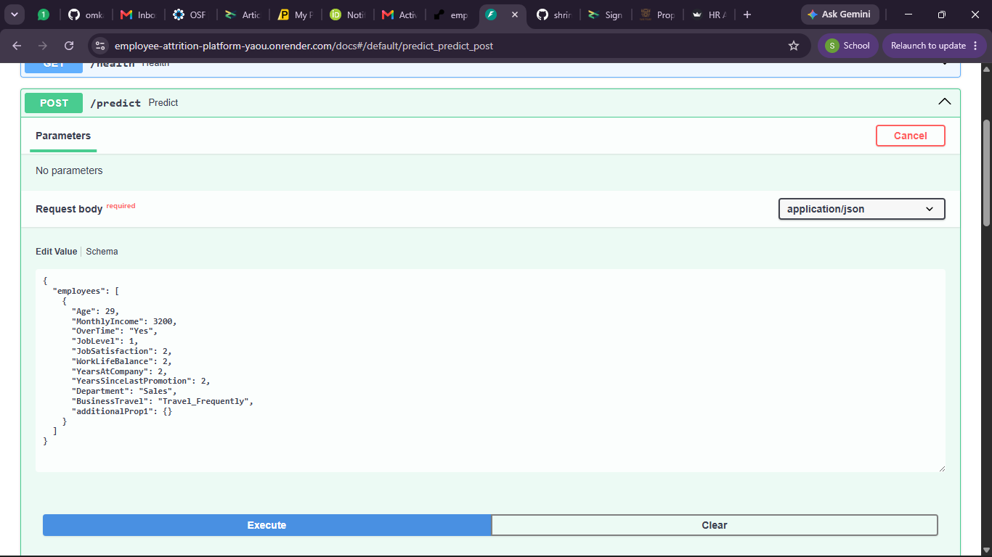
Figure 5. Request sent from the /docs page of the deployed API.
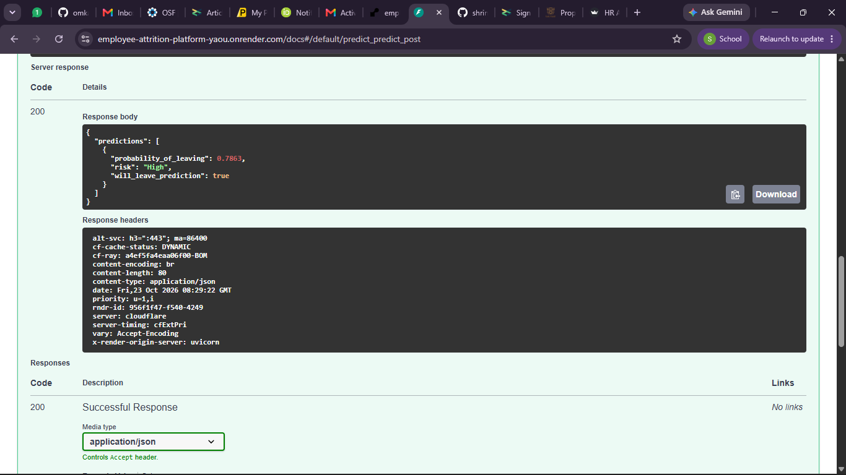
Figure 6. Server response (HTTP 200) with probability_of_leaving 0.7863 and risk "High".

5.3 Automated retraining
A GitHub Actions workflow retrains the model every Monday and can also be started manually. It rebuilds the model on the latest data and computes the cross-validated AUC. If this AUC is more than 0.01 below the stored value, the run is stopped on purpose so the existing model is kept. If not, the new model is committed back to the repository.
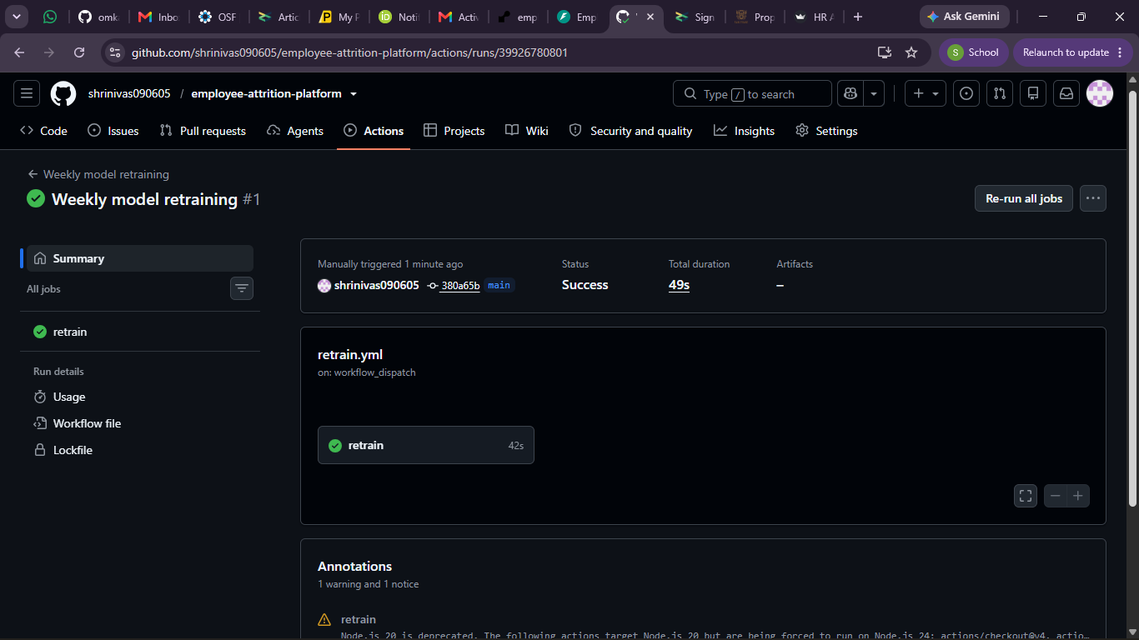
Figure 7. Weekly model retraining workflow, run #1, completed successfully in 49 seconds.

6. Dashboard
The dashboard is available at https://employee-attrition-platform-i7ymnicw7iichr9je4kvbe.streamlit.app/. It has filters for department and risk category and five tabs.
Tab | Content
HR KPIs | Headcount, employees who left, attrition rate, retention rate, number of high-risk employees, department table and attrition by years at the company.
Attrition and Risk | Attrition by department and job role, a donut chart of the risk bands and a list of the 25 highest-risk employees.
Workforce Demographics | Age, gender, marital status, tenure, overtime and income.
Model Performance | Selected model, metrics at both thresholds, AUC of all models, confusion matrix.
Predict Attrition | Form with ten inputs that returns the probability of leaving and the risk band.

Attrition rate = employees who left / total employees x 100. Retention rate = 100 - attrition rate.
Department | Headcount | Left | Attrition % | Average risk score
Human Resources | 63 | 12 | 19 | 0.422
Research & Development | 961 | 133 | 13.8 | 0.325
Sales | 446 | 92 | 20.6 | 0.434
Table 4. Department-wise KPIs.
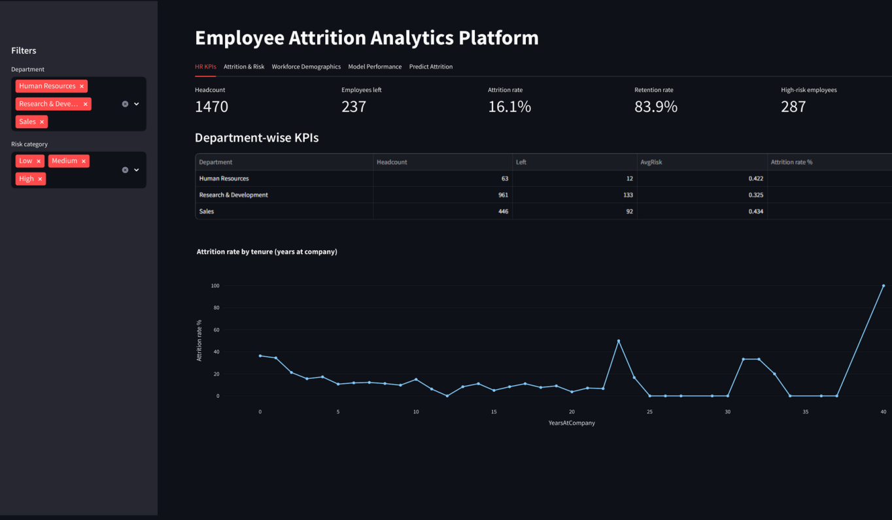
Figure 8. HR KPIs tab of the dashboard.
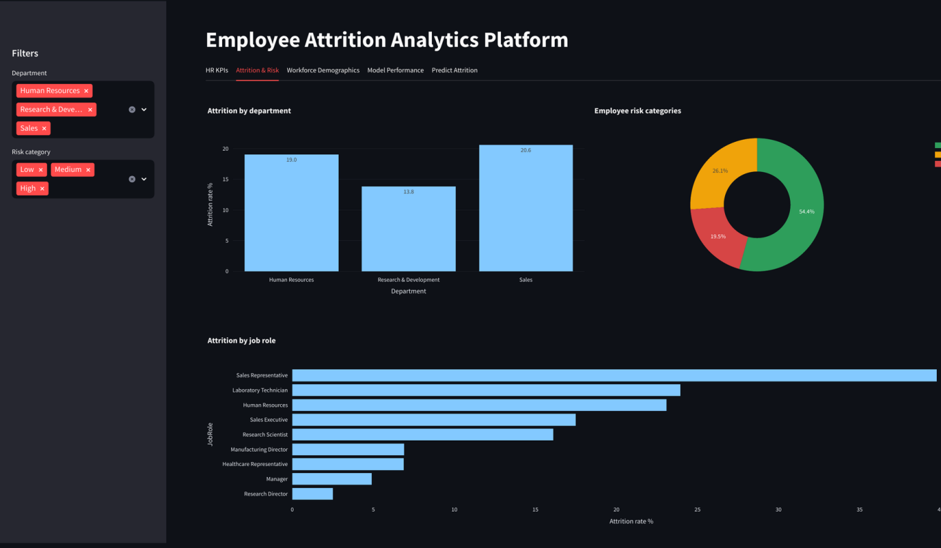
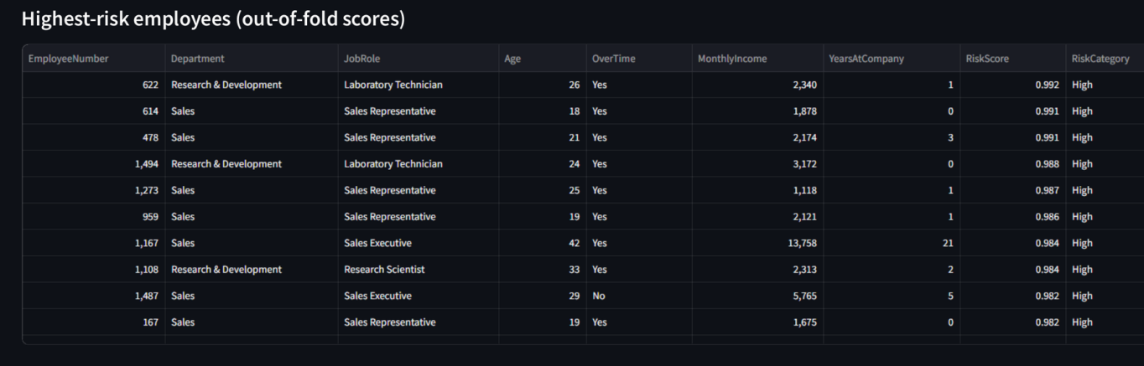
Figure 9. Attrition and Risk tab of the dashboard.
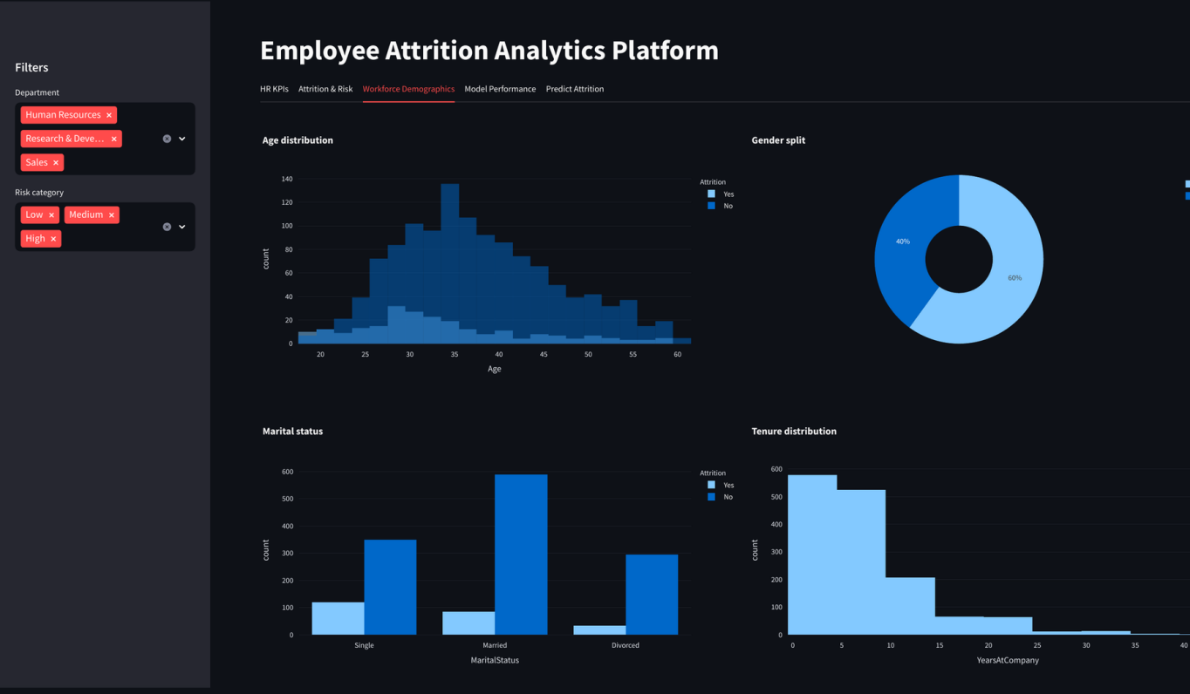
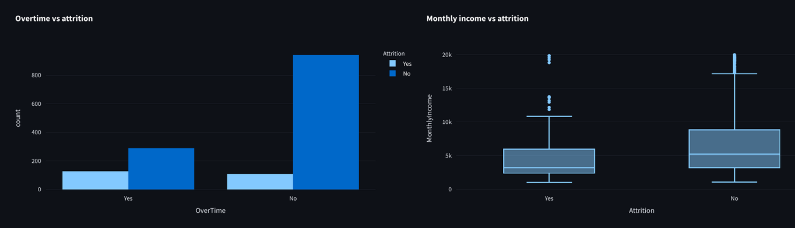
Figure 10. Workforce Demographics tab: age, gender, marital status, tenure, overtime and income.
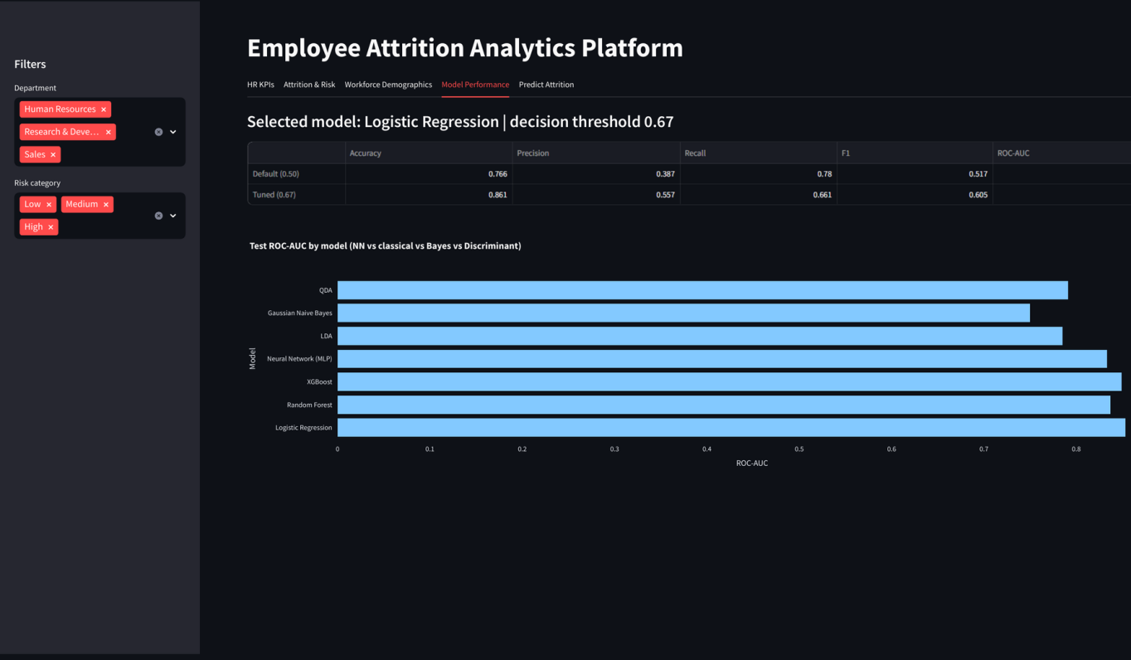
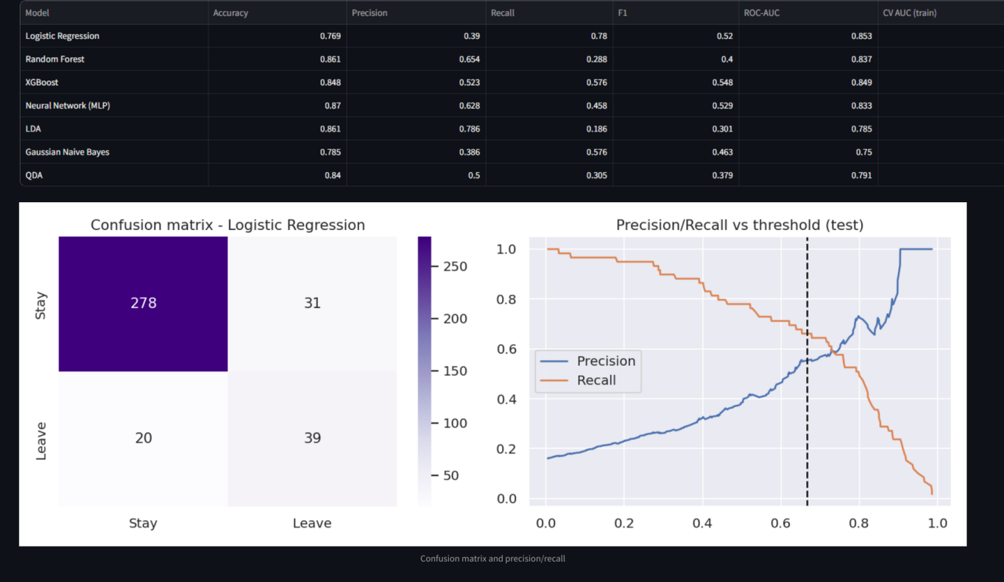
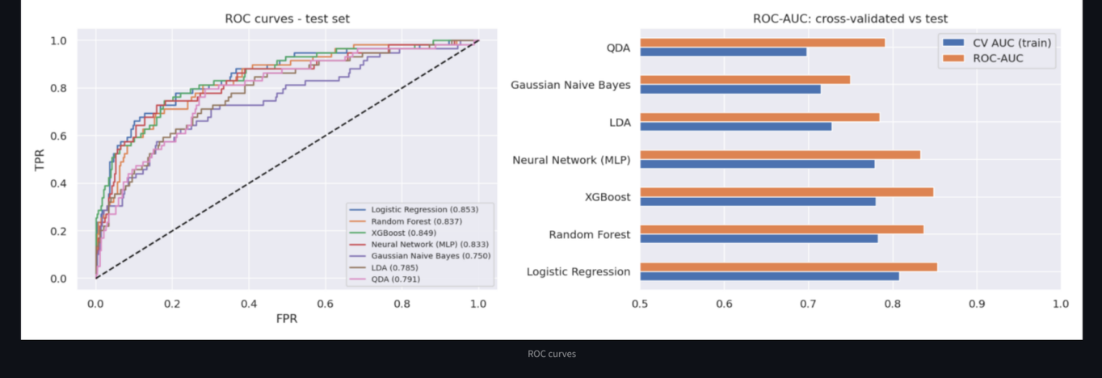
Figure 11. Model Performance tab: metrics at both thresholds, model comparison, confusion matrix and ROC curves.
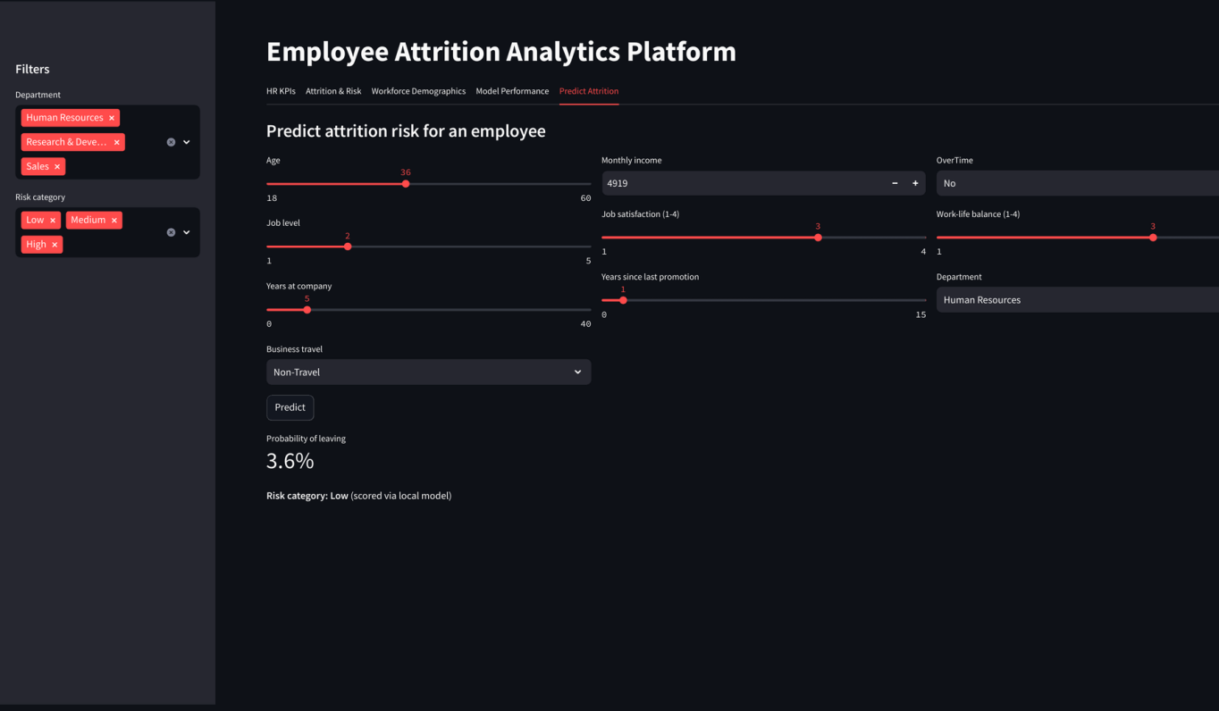
Figure 12. Predict Attrition tab: form inputs and the returned probability and risk category.

7. Findings from the Data
Overtime. 30.5% of employees who work overtime left, against 10.4% of those who do not, a ratio of 2.9 to 1.
Age and tenure. Attrition falls with age (18-25: 35.8%; 26-35: 19.1%; 36-45: 9.2%; 46-60: 12.5%) and with years at the company (0-2 yrs: 29.8%; 3-5 yrs: 13.8%; 6-10 yrs: 12.3%; 11+ yrs: 8.1%). The first two years are the riskiest.
Income. Attrition by income quarter, from lowest to highest, is Lowest 25%: 29.3%; 25-50%: 14.2%; 50-75%: 10.6%; Top 25%: 10.3%.
Personal and work factors. Single employees (25.5%) and frequent travellers (24.9%) leave more than married employees (12.5%) and non-travellers (8%). Employees with no stock options show 24.4% attrition, against 9.4% at option level 1.
Job role. Sales Representatives (39.8%) and Laboratory Technicians (23.9%) have the highest attrition, whereas Research Directors (2.5%) and Managers (4.9%) have the lowest. Attrition is 22.8% at the lowest job satisfaction rating and 11.3% at the highest.

8. Recommendations
- Reduce long-term overtime. Report overtime hours by team and move work around in teams with many High-risk employees.
- Support new joiners. Provide a mentor and a formal check-in after six months for employees in their first two years.
- Review the salaries of Sales Representatives and Laboratory Technicians against market rates.
- Offer stock options or retention bonuses to High-risk employees who have none.
- Limit frequent travel by rotating assignments or using online meetings.
- Hold a monthly meeting with employees on the High-risk list. The score should be used to offer support and not to penalise anyone.

9. Expected Benefits
The model places 287 employees in the High band, and about 143 of them did leave. As an illustration, if HR succeeds in keeping 25% of these employees, about 36 exits are avoided. Leavers earned about 4,787 per month on average (57,444 per year). If a replacement costs half a year of pay, the saving is about 1,033,992. The 25% retention and the 50% replacement cost are assumptions made only for this illustration and must be replaced by the company's real figures.

10. Limitations and Future Scope
The dataset is a public sample recorded at a single time. It does not show when employees left or why. Precision at the chosen threshold is about 0.56, so nearly half of the employees flagged as High risk would not have left, and the list must be used to start conversations and not to make decisions. The free hosting platforms also go to sleep when idle, so the first request can be slow.
In the future, SHAP values can explain each prediction, the model can be tested for fairness across gender and age groups, survival analysis can estimate when an employee might leave, and the dashboard can be connected to live HR data.

11. Conclusion
A simple Logistic Regression model, tuned for threshold, identified about 66% of leavers with an AUC of 0.855, performing as well as more complex models. It has been delivered as a working dashboard, a documented API and an automatically retrained pipeline. The analysis shows that overtime, short tenure, low pay and certain job roles are the main drivers of attrition, and the recommendations above target these directly.

