Selecting Neighbourhood for New Yoga Studio in Calgary

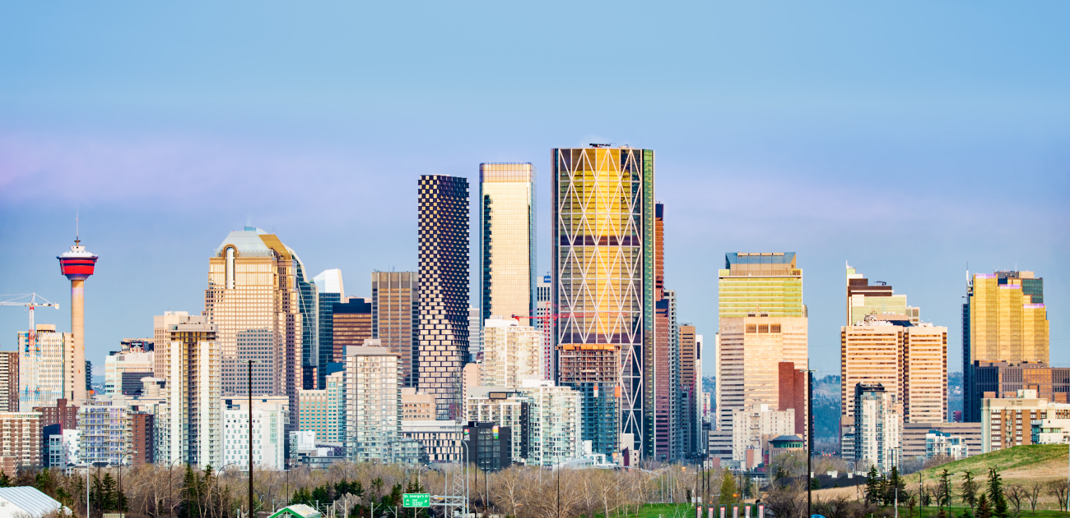

Data Sources and Methodologies

Data needed for this report:
- Neighbourhood names for city of Calgary along with latitude and longitude
- Neighbourhood venues data, specially, data related to yoga studios and related businesses

Data Sources:
- Data for Calgary neighbourhoods are captured from Wikipedia page (https://en.wikipedia.org/wiki/List_of_postal_codes_of_Canada:_T). Data will be captured using web scraping techniques and converted to pandas data frame.
- Neighbourhoods venue data will be derived from Four Square API. Foursquare API will provide many category related to venue data. Data will be captured using API calls and returned JSON data will be cleaned and converted to Pandas data frame. After required data cleaning, wrangling, machine-learning using K-Means Clustering, and map visualizations using Folium, final report will be generated recommending top 10 neighbourhoods/locations suitable for opening yoga studio in Calgary.

