Database I – CSE5330-Phase IV

***Nisa Management System***

Shripal Shah 1001238188

Lakshmi Meghana 1001417274

Nisa Management System is a web management system aimed for the business owner(s) to manage business by tracking orders, employees, and customers.

It will also allow the owner to monitor employee’s progress and add bonuses for every order placed. This app will motivate employee to stay on top of their game by being incentivized for every order placed by them or by the customers they introduce.

SYSTEM CONFIGURATION OF THE PROJECT

* Windows 10
* Software: Visual Studio 2010 - .Net 3.5
* Backend – SQL server 2008 Management studio(SQL server 2008 server r2)
* Browser Google Chrome

EVENT TABLE FOR ADMINISTRATOR

|  |  |  |  |  |  |
| --- | --- | --- | --- | --- | --- |
| **EVENT** | **TRIGGER** | **SOURCE** | **ACTIVITY** | **RESPONSE** | **DESTINATION** |
| **Admin Login** | **Logging In** | **Management** | **Sign In** | **Sign in confirmed** | **System** |
| **Add New**  **Employee** | **New Customer**  **Added** | **Management** | **Employee**  **Added** | **New Employee**  **Added** | **System** |
| **Add New**  **Customer** | **New Customer Added** | **Management** | **Customer Added** | **New Customer Added** | **System** |
| **Add New**  **Product** | **New Product Added** | **Management** | **Product Added** | **New Product Added** | **System** |
| **Add new Sales Order** | **Placing new Sales Order** | **Customer** | **Generated Sales Order** | **New Sales Order Added** | **Supplier** |
| **Sales Order Details** | **Request For Sales Order Details** | **Management** | **Showing details regarding to the Order** | **Display order details** | **System** |
| **Edit Sales Order** | **Request for edit information** | **Management** | **Edit Sales Order info** | **Sales Order edited confirmation** | **System** |
| **Product Details** | **Request For Products Details** | **Management** | **Showing**  **Details**  **Regarding to Product** | **Display Order Details** | **System** |
| **Edit Product info** | **Request for editing product details** | **Management** | **Edit Product info** | **Product edited confirmation** | **System** |
| **EVENT** | **TRIGGER** | **SOURCE** | **ACTIVITY** | **RESPONSE** | **DESTINATION** |
| **Customer**  **Details** | **Request For**  **Customer Details** | **Management** | **Showing Details Regarding to Customer** | **Display Customer Details** | **System** |
| **Edit Customer info** | **Request for editing customer details** | **Management** | **Edit Customer info** | **Customer edited confirmation** | **System** |
| **Report** | **Request for report** | **Management** | **Generation of report** | **Admin gets report** | **Management** |
| **Sales order cancellation** | **Request for cancellation** | **Customer** | **Canceling details of sales** | **Sales Order cancelled confirmation** | **Management** |
| **Order delivered to customer** | **Order delivered** | **Management** | **Order sent** | **Customer receives the order** | **Customer** |
| **Delete Customer** | **Customer deleted** | **Management** | **Customer deleted** | **Customer deleted confirmation** | **System** |
| **Delete Employee** | **Employee**  **Deleted** | **Management** | **Employee Deleted** | **Employee deleted Confirmation** | **System** |
| **Delete Product** | **Product deleted** | **Management** | **Product deleted** | **Product deleted confirmation** | **System** |
| **Delete Sales Order** | **Sales Order deleted** | **Management** | **Sales Order deleted** | **Sales order deleted confirmation** | **System** |
|  |  |  |  |  |  |
|  |  |  |  |  |  |
| **EVENT** | **TRIGGER** | **SOURCE** | **ACTIVITY** | **RESPONSE** | **DESTINATION** |
| **Employee Login** | **Logging In** | **Management** | **Sign In** | **Sign in confirmed** | **System** |
| **Add New**  **Customer** | **New Customer Added** | **Management** | **Customer Added** | **New Customer Added** | **System** |
| **Add New**  **Product** | **New Product Added** | **Management** | **Product Added** | **New Product Added** | **System** |
| **Add new Sales Order**  **With Employee Id given** | **Placing new Sales Order** | **Customer** | **Generated Sales Order** | **New Sales Order Added** | **Supplier** |
| **Sales Order Details**  **Pertaining to The Signed-In Employee** | **Request For Sales Order Details**  **Pertaining to The Signed-In Employee** | **Management** | **Showing details regarding to the Order** | **Display order details** | **System** |
| **Edit Sales Order**  **Pertaining to The Signed-In Employee** | **Request for edit information**  **Pertaining to The Signed-In Employee** | **Management** | **Edit Sales Order info** | **Sales Order edited confirmation** | **System** |
| **Product Details** | **Request For Products Details** | **Management** | **Showing**  **Details**  **Regarding to Product** | **Display Order Details** | **System** |
| **Edit Product info** | **Request for editing product details** | **Management** | **Edit Product info** | **Product edited confirmation** | **System** |
| **EVENT** | **TRIGGER** | **SOURCE** | **ACTIVITY** | **RESPONSE** | **DESTINATION** |
| **Customer**  **Details** | **Request For**  **Customer Details** | **Management** | **Showing Details Regarding to Customer** | **Display Customer Details** | **System** |
| **Edit Customer info** | **Request for editing customer details** | **Management** | **Edit Customer info** | **Customer edited confirmation** | **System** |
| **Report** | **Request for report** | **Management** | **Generation of report** | **Admin gets report** | **Management** |
| **Sales order cancellation** | **Request for cancellation** | **Customer** | **Canceling details of sales** | **Sales Order cancelled confirmation** | **Management** |
| **Order delivered to customer** | **Order delivered** | **Management** | **Order sent** | **Customer receives the order** | **Customer** |
| **Delete Customer** | **Customer deleted** | **Management** | **Customer deleted** | **Customer deleted confirmation** | **System** |
| **Delete Product** | **Product deleted** | **Management** | **Product deleted** | **Product deleted confirmation** | **System** |
| **Delete Sales Order Placed by signed emp** | **Sales Order deleted**  **Placed by signed employee** | **Management** | **Sales Order deleted** | **Sales order deleted confirmation** | **System** |

USE CASE DIAGRAMS

* + - 1. A use case diagram is a set of scenarios that describe the interaction between a user and a system.
      2. Its purpose is to present a graphical overview of the functionality provided by a system in terms of actors, their goals (represented as use cases), and any dependencies between those use cases.
      3. The main purpose of a use case diagram is to show what system functions are performed for which actors. Roles of the actors in the system can be depicted.
      4. A use case describes a sequence of actions that provide something of measurable value to an actor and is drawn as a horizontal ellipse.
* **Actors:**

An actor is a person, organization, or external system that plays a role in a more interactions with the system.

* **System boundary boxes (optional):**

A rectangle is drawn around the use cases, called the system boundary box, to indicate the scope of system.

Anything within the box represents functionality that is in the scope and anything outside the box is not.

Login

Admin Employee/Customer

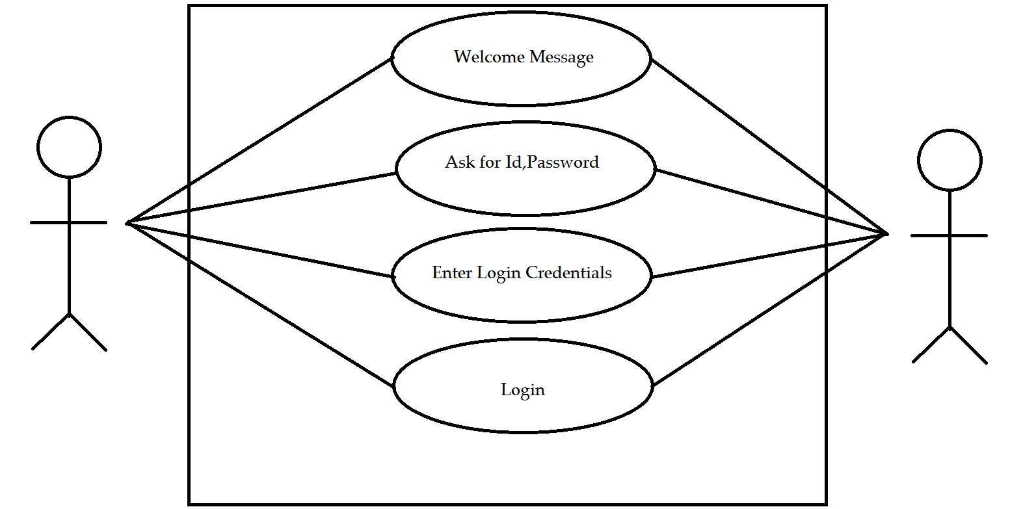

EMPLOYEE MAINTENANCE

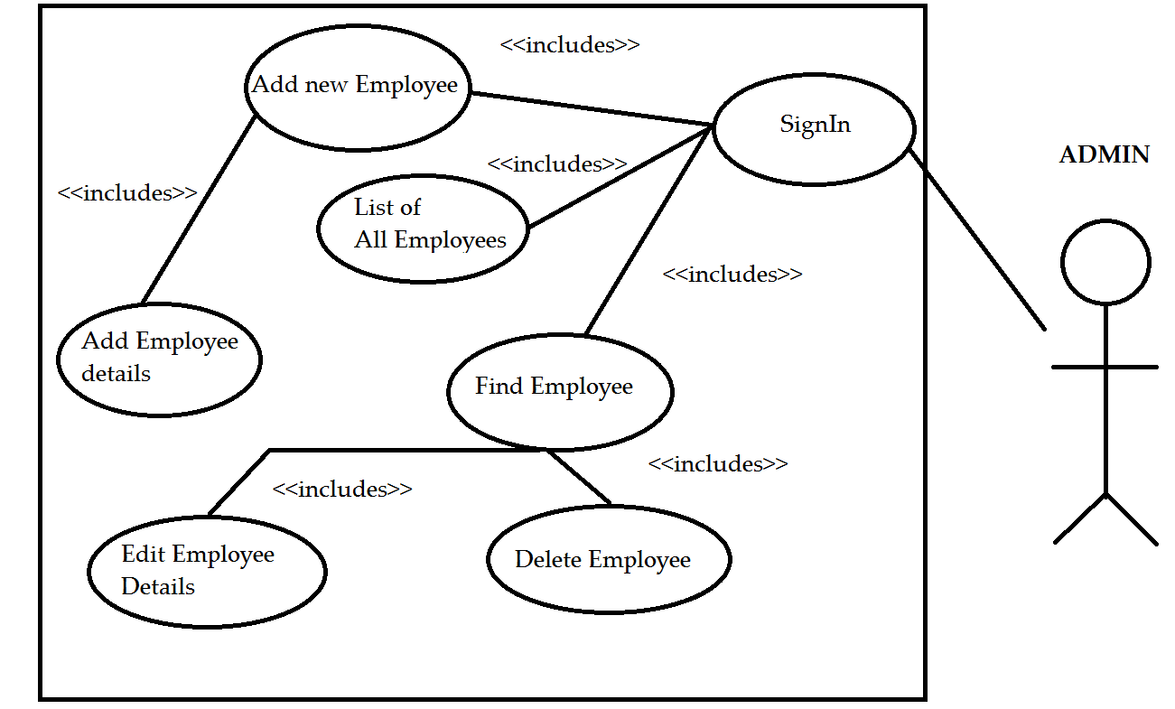

CUSTOMER MAINTENANCE

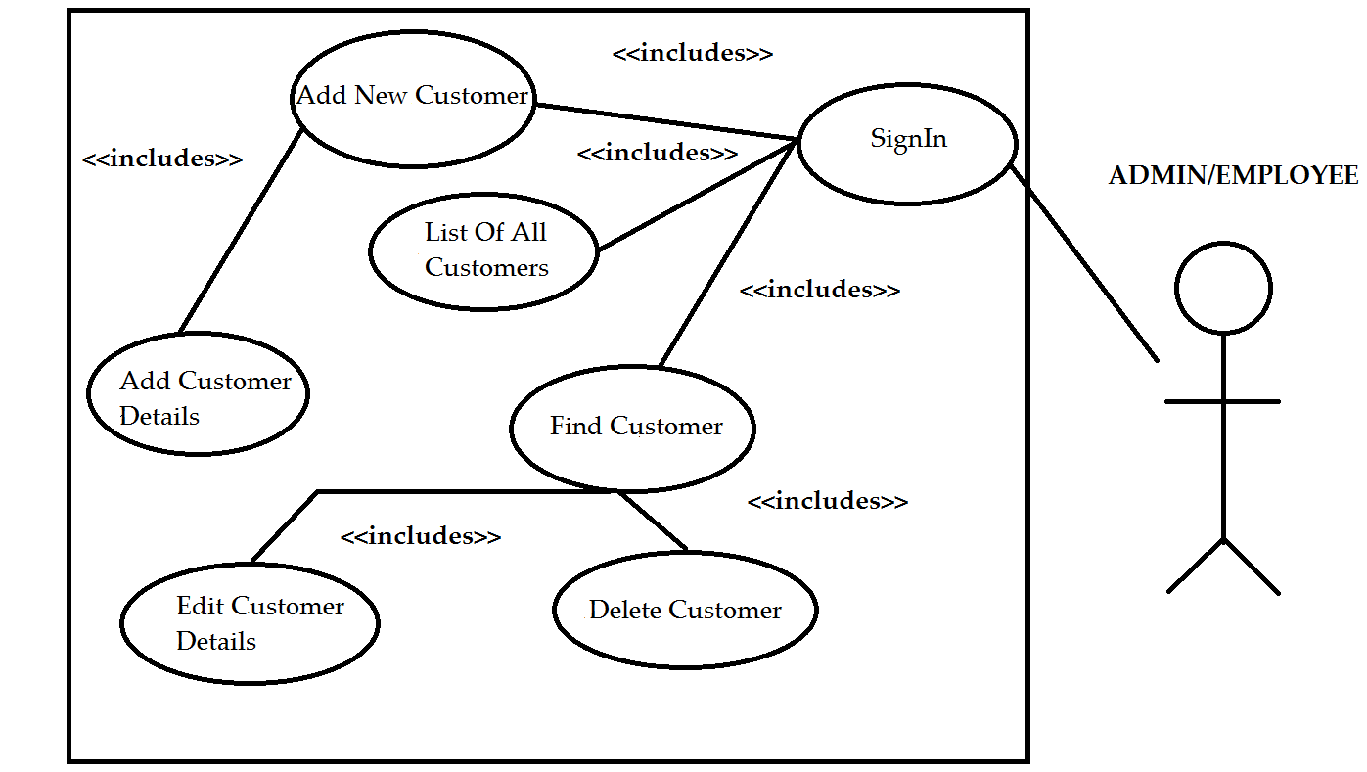

PRODUCT MANAGEMENT

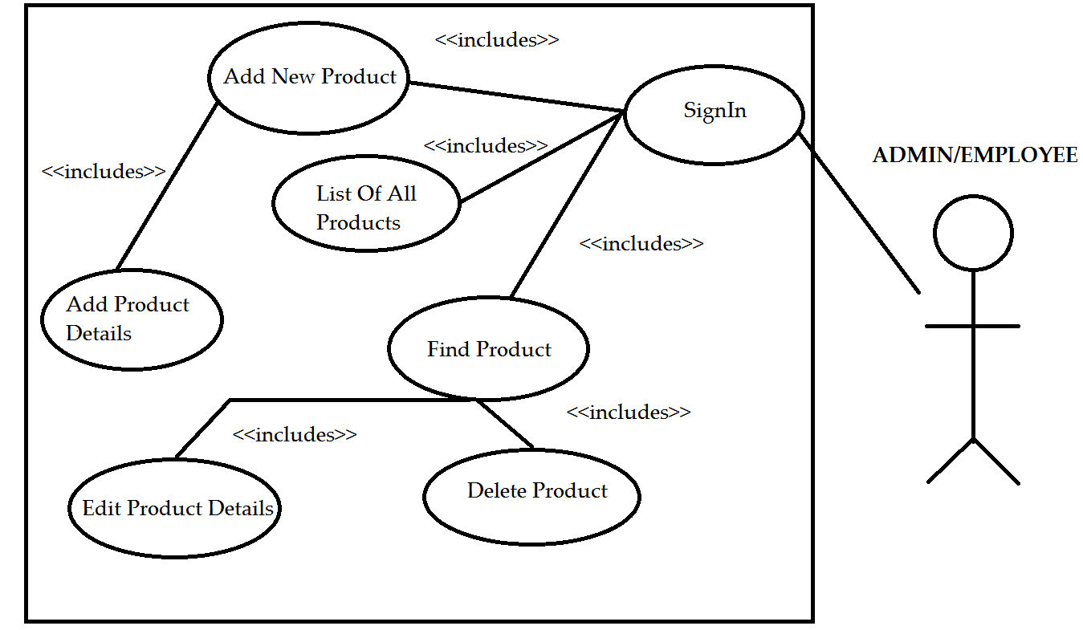

ORDER MANAGEMENT

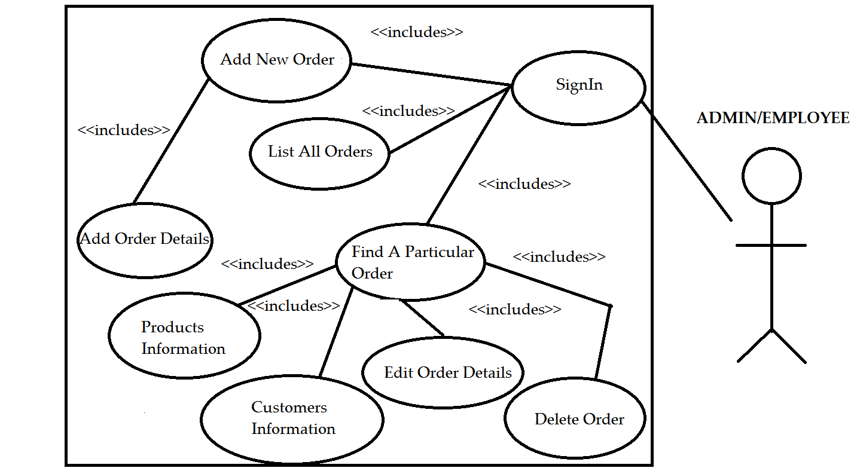

ACTIVITY DIAGRAMS

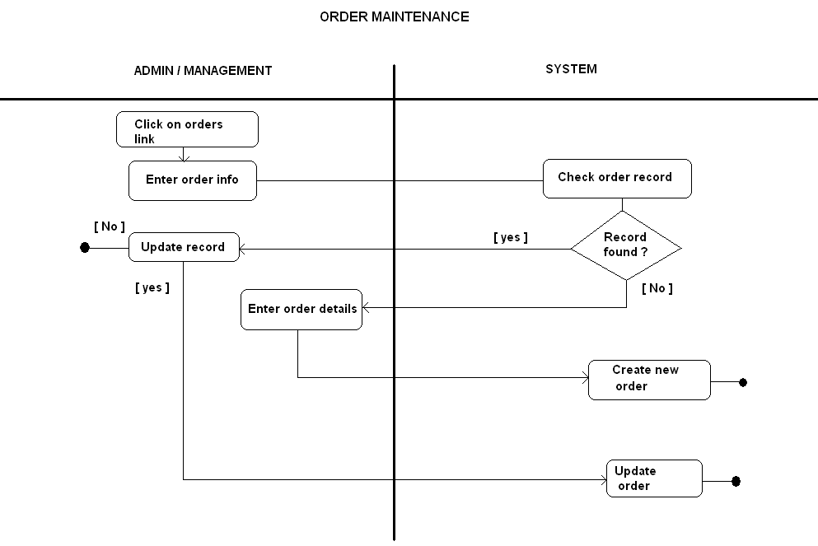

# 

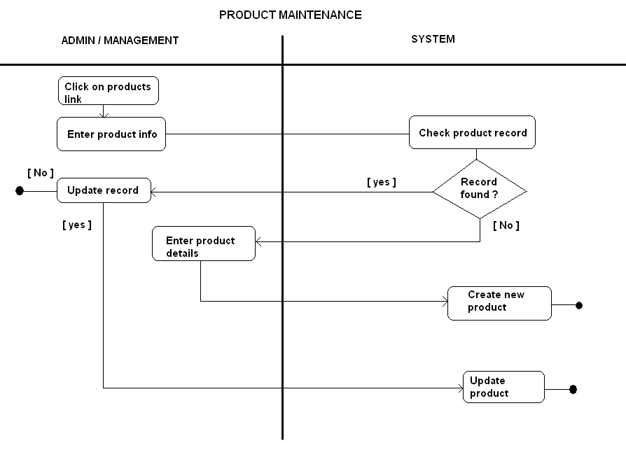

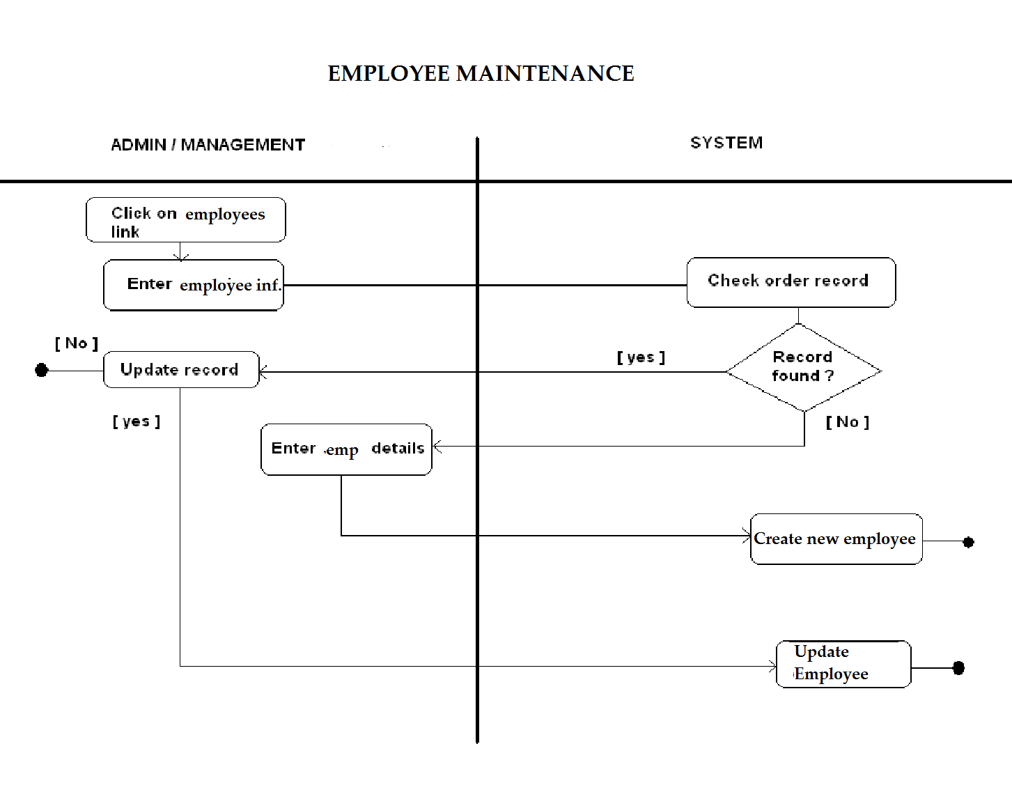

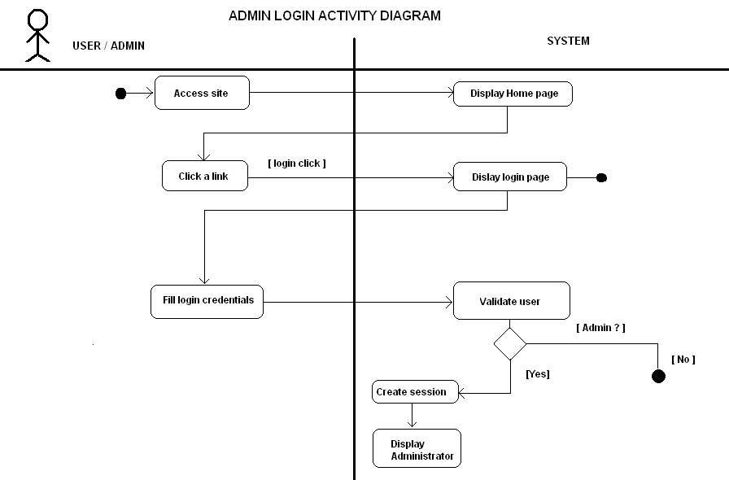

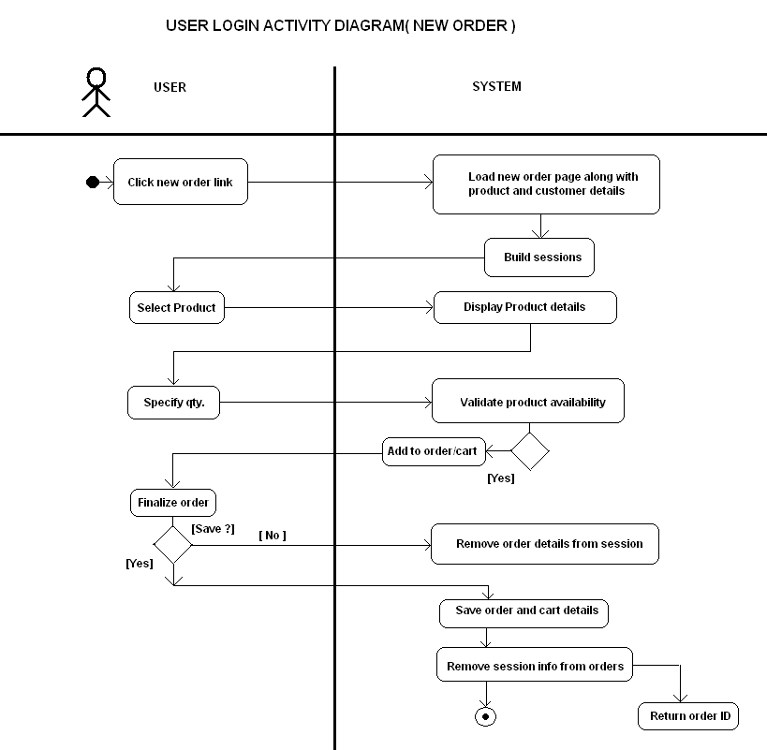

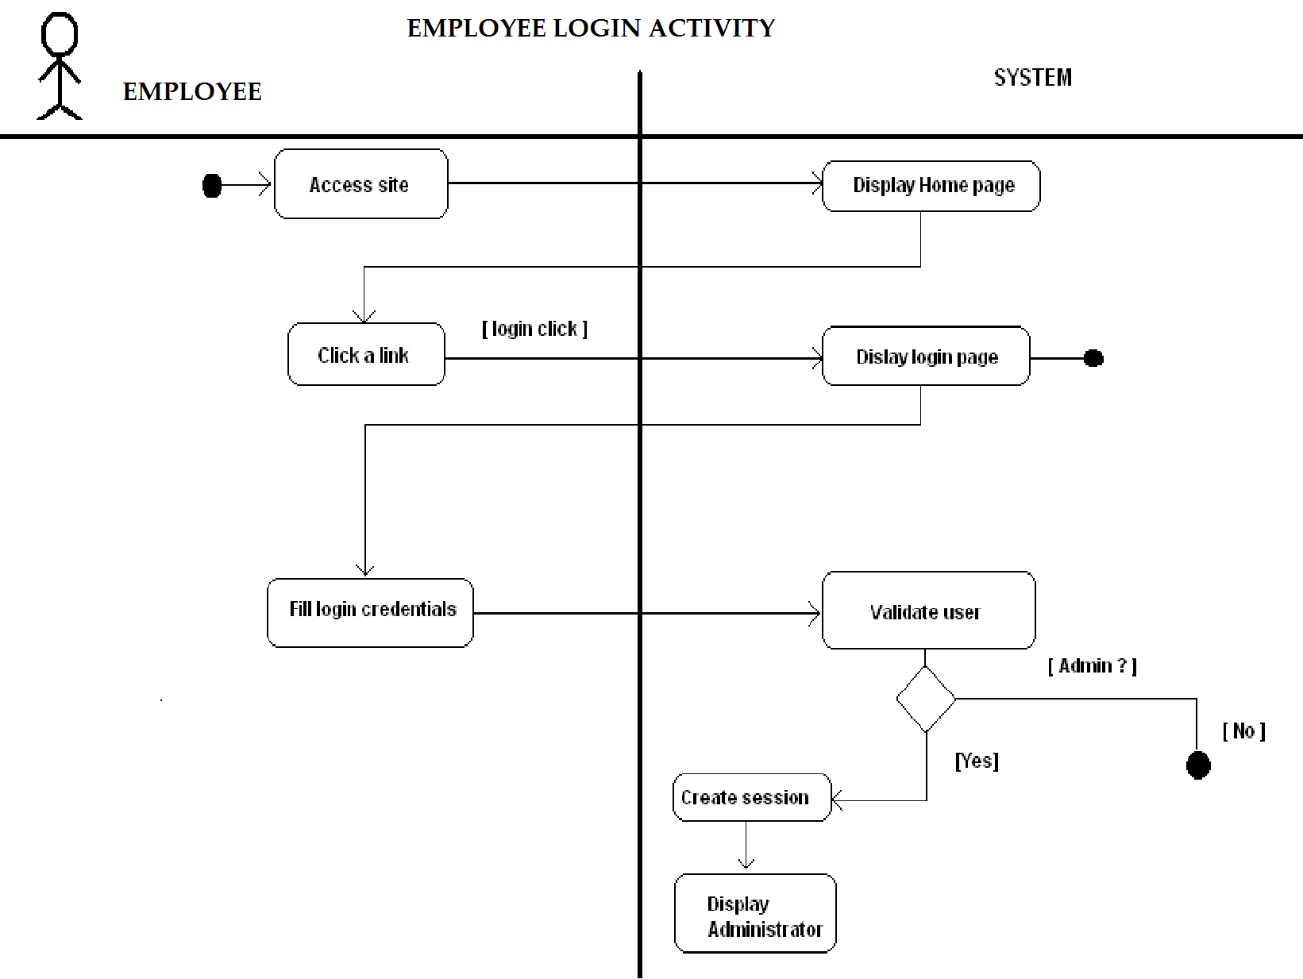

Conclusion

I have learned how to gather requirements from the user. Since the project is to be delivered to the client, we got practical exposure on how to interact with them.

For getting better output, we will be using Agile SCRUM methodology.

This system will automate the traditional methods of maintaining files for storing the documents.