Analysis of Death Risk Factors

Shripal Shah

*Data Visualization, Department of Applied Data Science  
San Jose State University  
San Jose, US*

shripal.shah@sjsu.edu

***Abstract— The life cycle includes the death cycle. Still, throughout the year, many man-made factors have been observed, causing millions of deaths. The statistics show that, on average, more than a thousand deaths are caused due to unhealthy lifestyles, health issues, and environmental factors. Even though the maximum number of deaths are due to high blood pressure, many other factors are responsible for perishability, such as lack of physical activity, diet, smoking, etc. Further correlation between these factors can also be analyzed as each affect’s others. The death rates dataset taken from Kaggle shows death rates by various factors like air pollution, child mortality, dietary and health issues, and lifestyle choices. To get useful insights from this dataset, I have joined the development indicators dataset and the population dataset to correlate these death factors with GDP per capita and the population of the respective countries. The analysis of this dataset is done through Tableau visualizations by creating various graphs and charts. It maps to find insight trends and correlations between different parameters responsible for the death. In addition, insightful results about the dataset have been provided for further prediction purposes.***

***Keywords*— pollution, child mortality, dietary and health issues, lifestyle choices, visualization, Number of deaths, Tableau**

# I. INTRODUCTION

In the wake of the pandemic, we have realized how important life is and what steps should be taken to improve our health and lifestyle. However, our experience with Covid-19 has taught us that other crucial factors may cause higher death rates. Therefore, to decrease mortality rates, we need to understand what causes increased death rates to take preventive measures such as improving lifestyle and dietary habits.

Four main categories of these factors are pollution, Dietary habits, Lifestyle choices, and Child Mortality. As a result of measuring death rates for each cause, the relevant authorities can plan resources accordingly. In sectors such as food & agriculture, the environment, and health, mortality data can help improve resources.

To analyze how a country's industrial and economic growth influences the overall death rate, it is important to analyze which continents and countries have the highest death rates.

# II. OBJECTIVE

1. Finding out which factors contribute most to deaths in each country.
2. Analyzing which parameter leads to most deaths across years based on different leading causes.
3. Examining the relationship between GDP, population, and economic development of countries and mortality rate.

To study the trend over time, forecasting the significant parameters of death.

# III. RELATED WORK

We referred to some research papers to understand the various countries' death rate statistics and the reasons for these factors.

## Pollution

Environmental problems are primarily caused by air pollution. Developing countries have become more industrialized over the years. A variety of diseases, particularly respiratory diseases, are caused by air pollution that adversely affects health. Life expectancy is directly affected by growing pollution. To understand the factors and how they can be improved, the Environmental Protection Agency closely monitors the trend and gathers data. A data visualization aimed at estimating air pollution-related deaths worldwide [1].

In this review, we will examine four important types of air pollution:

**Outdoor Pollution**: The leading cause of outdoor pollution is combustion from motor vehicles, solid fuel burning, and industry. Our society has witnessed a significant increase in the death rate over the years [4]. The increasing population and aging population are the primary causes of the increase in its population.

**Ozone Pollution**: Hydrocarbons and nitrogen oxides are responsible for ozone pollution. Lung function impairment and irritation of the eyes and nose are some of the adverse health effects.

**Matter Pollution**: All nongaseous particles in the air are classified as particulate matter. Sulfate, nitrates, ammonia, and other particles cause this pollution. Many sources contribute to particulate matter, including construction sites, unpaved roads, fires, and smokestacks. The droplets are microscopic and can be inhaled since they are solid or liquid. The virus can penetrate deep into the lungs or even the bloodstream.

**Household pollution**: Firewood, crop wastes, and dung are solid fuel sources responsible for household pollution. A common practice is cooking over open flames and using inefficient stoves, which caused 2.6 million deaths. Those who die from it are typically poor or live in low- or middle-income countries [3]. Those who spend most of their time at home tend to be women and young children who practice these inefficient cooking practices.

## Child Mortality

[5] The study examined how national income affects the child and under-five mortality in a few developing countries. Based on the study, child mortality will decrease from 50 per 1000 births to 45 per 1000 births as GDP increases by 10%. Therefore, income can be considered a critical factor in determining a child's survival.

[6] It was proposed that maternal, newborn, and child health interventions could reduce child mortality by addressing the country-wide estimates of the leading causes of child mortality.

Child mortality is caused by various factors, including

**Child Stunting**: Low height for the child's weight. It is caused due to poor nutrition, Lack of proper sanitation facilities, etc.

**Child wasting** refers to an underweight child for his or her height. A reduction in muscle and fat tissue is observed in children who have experienced short periods of undernutrition.

**Low birth weight:** A newborn baby who weighs less than 2500 grams is considered underweight. During pregnancy, the baby lacks oxygen and nutrients due to a lack of oxygen and nutrients. Low-weight babies are born to malnourished mothers, have chronic kidney disease and respiratory problems, and are addicted to drugs, alcohol, or smoking.

**Discontinued breastfeeding**: The practice of not breastfeeding a baby after six months of age.

**Non-exclusive breastfeeding:** Breastfeeding babies younger than 6 months is not exclusively breastfeeding.

**Discontinued and non-exclusive breastfeeding:** Typically occurs in mothers who are malnourished and under 17 years of age or over 35 years of age. There are health problems associated with infants not being exclusively breastfed, including acute respiratory diseases, diarrhea, etc.

## Dietary Habits & Health Issues

Under Dietary Habits

[7] This explored the causes of death caused by dietary habits.

Inadequate intake is responsible for the following factors:

* Diet-High in Sodium
* Diet Low in Fruits and Nut & Seeds
* Diet Low in Vegetables
* Diet Low in Wholegrain
* Vitamin- A Deficiency
* Iron Deficiency

For each factor, the optimal intake level is the one that minimizes the risk of death from all causes.

|  |  |
| --- | --- |
| Factors | Optimal Level of Intake |
| Diet-High in Sodium | 3 g (1–5) per day |
| Diet Low in Fruits and Nut & Seeds | 250 g (200–300) per day & 125 g (100–150) per day |
| Diet Low in Vegetables | 360 g (290–430) per day |
| Diet Low in Wholegrain | 125 g (100–150) per day |

Table 1. The optimal intake level

Under Health Issues

[8] This examined the causes of death associated with health.

The following are the factors responsible for death due to health issues:

* High Blood Pressure
* High Cholesterol
* High Plasma Glucose
* High BMI & Low Physical Activity
* Low Bone Mineral Density

|  |  |
| --- | --- |
| Factors | Leading Causes |
| High Blood Pressure & High Cholesterol | Due to a diet high in salt, fat, and/or cholesterol; chronic conditions, etc. |
| High Plasma Glucose | Due to stress, lack of exercise, eating junk food |
| High BMI & Low Physical Activity | Due to diet, lack of exercise, stress |
| Low Bone Mineral Density | Due to smoking, alcohol, age, poor diet, medications |

Table 2. Health Issues

## 

## Lifestyle Choices

We will primarily consider deaths due to two categories of lifestyle choices.

Unsafe Sanitation

Using unsanitary toilet facilities, drinking, bathing, cooking with and using contaminated water can have far-reaching and ill-fated effects for those who consume these items. The availability of clean water is taken for granted in first world countries. Having unlimited access to clean water is as simple as turning on the tap. The rest of the world, however, is not like that! contaminated water spreads pathogens and bacteria that cause diseases such as diarrhea, cholera, typhoid, etc. Several factors can contribute to water pollution, including industrial wastes, untreated sewage, mining & marine dumping, oil spills, and pesticides and fertilizers mixed with rainwater. There is a discussion of the causes of pollution and contamination of water in [1] In [3] the benefits of improving sanitation and challenges faced in the world are discussed along with key statistics and distributions of deaths in low-income countries, middle-income countries, and high-income countries. This section discusses the types of sanitation and water contamination, as well as preventative measures to be taken.

* There are three types of addictions alcoholism, drug abuse, and smoking.

An addiction, also known as substance, use disorder, occurs when a person cannot control drug or medication use. The use of substances such as alcohol, marijuana, and nicotine. Despite the harm caused by the drug, you may continue to use it if you are addicted. American deaths are primarily caused by alcohol and tobacco use. Furthermore, these substances often are used together: Smokers are more likely to drink, and drinkers are more likely to smoke. As discussed in [6], these addictions negatively affect our bodies. Almost no parts of the human body are unaffected by these addictions. A few of the major diseases include Cardiovascular disease, heart disease, stroke, cancer, HIV/AIDS, Lund, and Kidney disease, as well as brain damage. The World Health Organization (WHO) reports that nearly 6 million people die yearly from tobacco use. Detailed statistics are provided on the effects of alcohol, drugs, and smoking worldwide.

## Tableau Visualization

[11]This paper discusses using various visualizations to create simple views of datasets. Various visualizations can be drawn according to the requirements, including donut charts, geospatial, bar charts, heat maps, tree maps, bubble charts, line charts, etc. In addition, filters, pages, drop-down lists, calculated fields, sets, groups, etc., can also be used to build interactive visualizations.

Based on these research papers, we have used appropriate data visualization techniques and tools to analyze leading death parameters and identify correlations and patterns between these parameters. As part of our analysis, we also present the death trends based on geographical attributes such as continents, sub-regions, and countries.

# IV. DATASET & METHODOLOGY

In Visualization, datasets play a crucial role because they influence how the visualization appears in the dataset. The results may not be able to define all the variables. Choosing a dataset with many values is important to get meaningful results. Using three different data sources, we selected five data files from Kaggle for our dataset.

Files used:

1. Deaths by risk factors - describes the total number of deaths by various parameters

2. Population - discusses population about countries and continents

3. Development Indicators - Includes information about years, continents, sub-regions, countries, and GDP per capita.

4. Death rates from air pollution - discusses various categories of air pollution-related deaths

5. Death rate total air pollution- discusses overall pollution-related deaths

## Data Wrangling

The dataset can be found on Kaggle at https://www.kaggle.com/datasets/pavan9065/air-pollution and is called "Air Pollution." Data on air pollution and other risk factors are divided into four separate sheets. The data file of Development Indicators was obtained from tableau's official website, while the population data file was obtained from Kaggle. Upon joining, our data consists of about 4.5k records covering five continents from 1990 to 2014.

Below is an ER diagram of the parameters from each file:

Fig. 1. ER Diagram

Fig. 2. Column Names in Dataset

Tableau join was used to combine five datasets. The left join was used for two, whereas the inner join was used for the other three.

# V. VISUALIZATION DESIGN

In addition to being complicated, analyzing the number of deaths by risk factors is also sensitive. To address this issue from all angles, we divided the project into three parts: time, geography, and environment.

There is a particular time scale. We wanted to compare the number of deaths distributed across continents or countries with the GDP per capita of each country. We selected parameters that cause the highest deaths in all categories, such as child mortality, pollution, etc. From 1990 to 2014, we put a filter to select each parameter as needed. A better distribution of low-income, middle-income, and higher-income countries is obtained by grouping GDP per capita. The size of dots in countries represents the number of deaths. The bigger the dot, the greater the number of deaths in that country caused by selected parameters. A dual map showed varying colors for GDP per capita and varying sizes for death cases. Using the dual axis, both maps overlapped.

We Embedded some graphs in tooltips of other graphs for better visualization. As an example, the graph of child mortality rate by continent shows the distribution within each continent by subregion. As the years increased, we created a hierarchy of subregions and countries and their respective child mortality rates per 1000 births. Child mortality rate per country in selected continents and subregions under selected continents and subregions can be visualized by embedding this table into a graph of Child mortality for continents.

Fig. 3. Child Mortality Graph

# VI.TABLEAU OPERATION

With the help of interactive dashboards, this data visualization project aimed to show interesting insights from the death rate dataset. Each dashboard summarizes the statistics for each of the death parameters.

## Pollution

Based on death rates across continents over time, we created four graphs.

The first graph is a bar graph. Using continents in colors to separate the death rates by continent and year in pages to show the results by year, we measured values across rows and names in columns.  
A heat map was created to show the total number of deaths caused by air pollution. We measured the death rate, year-wise and across various continents.   
In a dual combination graph, we compared household pollution with outdoor pollution. Bars represent deaths caused by household pollution, while lines represent deaths caused by outdoor pollution. Our last graph compares the death rate caused by air pollution in three countries: China, India, and Finland. To separate only these 3 countries, we used Entity(countries) in the filter. Thousands of people have died.

## Death Analysis w.r.t to Nutritional Deficiency and Health Conditions

To analyze deaths related to diet and health, a geospatial map was created that shows death cases in two major parameters and GDP per capita for all countries. Using a parameter consisting of total death cases due to dietary habits and health issues, we presented the values in circles that the user could modify according to their preferences. The higher the value, the larger the diameter. The GDP was also shown in different colors and countries' GDPs.

Annotations were used to highlight areas with high GDP and death cases. The tooltip also included factors under two major categories. Using this map, we were able to gain insight into the death cases in developed and developing countries.

Fig. 3. Two Parameters of Death case

Fig. 4. Map showing higher GDP

Fig. 5. Insights of death case with particular reasons

Next, two parameters were created to visualize continents based on factors in two major categories: diet habit parameter consisting of sodium-rich diet, diet low in fruits and vegetables, etc. The same pattern was followed for the health condition parameter as well. In addition, two line graphs and a bar plot were plotted for better comparison and analysis. The bar chart shows the cumulative death cases under two major categories, which the user can modify. The line graphs show factors under two categories, which users can modify according to their needs. Additionally, a pie chart was embedded in the tooltip to drill down further into the sub-regions.

Fig. 6. Parameter of Diet Content

Fig. 7. Top factors under health issues,

The top factors under health issues, such as high blood pressure, high cholesterol, and high body mass index, were also compared using a bar plot. A mountain graph showing death cases and the population were also plotted concerning sub-regions. By analyzing this graph, we gained insights into death cases about the populations of continents/subregions.

Fig. 8. Different countries showing death rates

caused due to High B.P., Body-mass index glucose

Lastly, a pie chart shows the county's total deaths from sodium-rich diets. The tooltip shows a table showing the total number of deaths caused by diets high in sodium by country. Through this visualization, we identified the countries with the highest death rates due to sodium-rich diets.

Fig. 9. Deaths due to sodium deficiency in different regions

The year was embedded as a page in all the graphs so the user could change the year per their preference. You can also see the overall trend using the play button on the year mark card.

Fig. 10. Floating parameter for year

## Child mortality dashboard

We display categorical data using a bar chart to explain categorical data clearly. We filtered the null values in the continent by adding them to the filter mark card. For user interaction, we also displayed continents and countries using drop-down menus. To make the pages more interactive, we added years to the pages as the years increased.  
Using a calculated field, we calculated the total child mortality by adding deaths due to stunting, wasting, etc. To represent the Top N countries based on the total child mortality, we created a bubble chart that shows the size of the bubbles according to the level of total child mortality. It is easier to understand. The figure below shows the child mortality rates for Top N countries. To show the population of each country, we also embedded the heat map into the bubble chart in the tooltip.  
  
Fig. 11. Set for Child Mortality

To calculate the child mortality rate (per 1000 births) for each country, divide the total child mortality by the population and by 1000. We plotted child mortality rates across continents and subregions using a circle view. Circle views make it easier to summarize large amounts of data into one graph. A hierarchy chart is embedded in the tooltip of circle views to show countries by continent and sub-region. To allow users to select the continent and sub-region they are interested in, parameters were created.

Fig. 12. Code to map viewer with the continent, sub-region, and Country

Fig. 13. Parameter for viewer 1

The donut chart was used to visualize the distribution of child mortality rates across continents to show the proportions of categorical data. The tooltip of the donut chart includes a heat map showing GDP per capita across continents.

The trend for GDP per capita and the child mortality rate was shown using a line chart, best suited for time series data. GDP and child mortality rates were labeled with annotations and labels.

## Analysis of Deaths due to Lifestyle choices

There are new charts being used on the dashboard for Lifestyle choices, such as Butterfly charts, Word clouds, and Sunburst charts. For example, we calculated a field for all addictions (addition of alcohol, drugs, and smoking) in the butterfly chart. We compared it with deaths due to low physical activity to understand the correlation between the two. This graph shows the top 10 countries with the highest death rates in these parameters. Due to two parameters, we can observe that the pattern or ratio of the number of deaths in the top 10 countries is almost identical. In the same way, a word cloud is a type of visualization that assigns weights to words based on parameter values. Word clouds for total deaths due to sanitation issues, for example, include subregional names. As the number of deaths increases, so does the size of the subregion name. As we hover over any subregion in this word cloud, the respective countries are shown in the bubble chart, showing total deaths and countries with the highest deaths.  
  
Fig. 14. Word cloud charts for different countries

Sunburst charts are another new type of chart used here. A pie chart or donut chart shows the distribution of deaths by continent in the inner disc and by subregion in the outer disc. A calculated field dummy-zero has a value of 0 and is used to get empty circles or rings between discs. In this case, total addiction deaths are used in angle to create angles based on values per continent and subregion.

Fig. 15. Sunburst chart to depict the deaths due to all addictions

# VII. DATA ANALYSIS

## Air Pollution

i. Death by Pollution Parameters

The following graph compares deaths caused by household pollution, matter pollution, and ozone pollution across continents and over time. Based on the graph, we can see clearly that Deaths from Household Pollution are higher than Deaths from Matter Pollution and Ozone Pollution.

**Household pollution:** Between 1990 and 2014, the number of deaths caused by household pollution decreased in each continent, and the total number of deaths fell from 366 to 216. Deaths have decreased by 40% or 1.6% annually. There is a maximum decrease in deaths in Europe, 69%, and a minimum decrease in deaths in Oceania, 23%.

**Matter Pollution**: The number of deaths on the European continent has fallen by 33.3% from 1990 to 2014. The number of deaths on the African continent did not change.

**Ozone pollution**: As a result of ozone pollution, the number of deaths has decreased from 14 to 10, a 28% drop. It is difficult to obtain data on deaths caused by ozone pollution so that the data could be inaccurate. Ideally, since the pollution has increased, the deaths due to ozone pollution should also have increased.

Fig. 16. Deaths by Pollution parameters

ii. Heat map of Total Death by Air Pollution

Globally, deaths due to outdoor air pollution have continuously risen from 1990 to 2014.

The number of deaths caused by outdoor air pollution has steadily increased from 1990 to 2014.   
Outdoor air pollution caused the most deaths on the Asian continent.

From 1990 to 2014, the death rate in Asia increased by 71.75% or 2.8% annually.  
Deaths in the Oceania continent remained at 7K, which also shows the continent with the least increase in the number of deaths.

Fig. 17. Total deaths by Air pollution

In this graph, we compare household pollution with outdoor pollution. Primitive methods of household cooking and handling have changed significantly over the years due to innovations. The number of deaths caused by this pollution has decreased by 49%.

Due to industrialization and the transition from low to middle-income countries, outdoor pollution increased significantly (58.3%).

Fig. 19 shows a graph comparing the death rates in three countries, India, China, and Finland.

Populations and death rates are high in countries like China and India.

As a result of air pollution, China lost more than 1030K people between 1990 and 2017. The deaths have increased by 66% or 2.38% a year.

Between 1990 and 2017, the number of deaths due to air pollution in India increased from 368K to 819K, an increase of 4.47% annually or 122%. The reason for this increase is the excessive use of coal and vehicles.

As a result of air pollution, Finland's death rate from air pollution has dropped from 2K to 1K. Finland, a country that identified air pollution issues early on, took measures to reduce its effects.

Since air pollution has decreased, the country has greatly benefited from it. It's a 50% reduction in deaths due to air pollution or a 1.78% reduction in deaths annually as a successful result of the government. strong environmental regulations.

Fig. 20. Outdoor Pollution in countries

## Child Mortality

In 2014, child wasting was the leading cause of death, compared to other factors.

Fig. 21. Deaths due to various factors leading to child mortality

The figure below shows the Top N countries with the highest child mortality in 2014. With 699K child deaths, India had the highest child mortality rate. This high value may be attributed to India's large population of 1296 million.

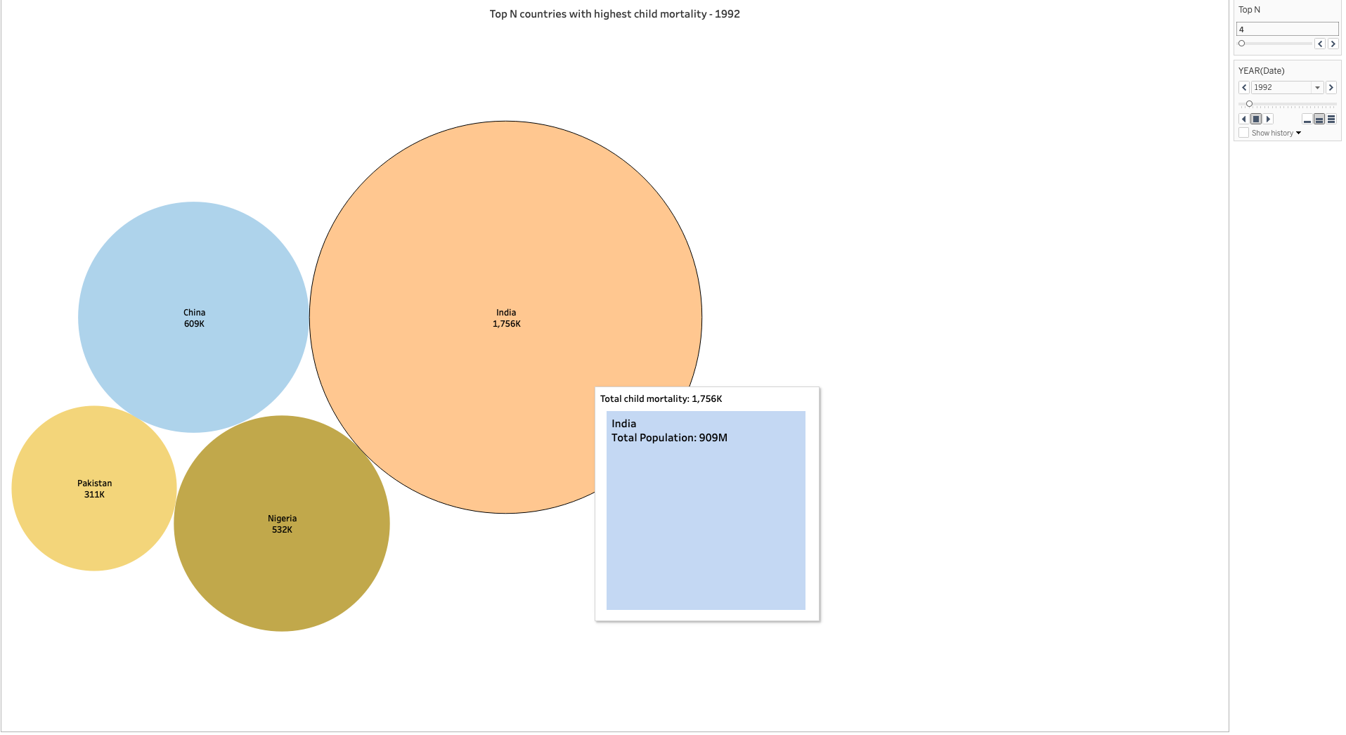

Fig. 22. Top N countries with highest child mortality

The figure below shows that the Western Africa sub-region of the African continent has the highest child mortality rate (per 1000 births), around 2.079. Furthermore, we can see that Niger, from the Western African sub-region, contributed to the highest child mortality rate, whereas Ghana contributed the least.

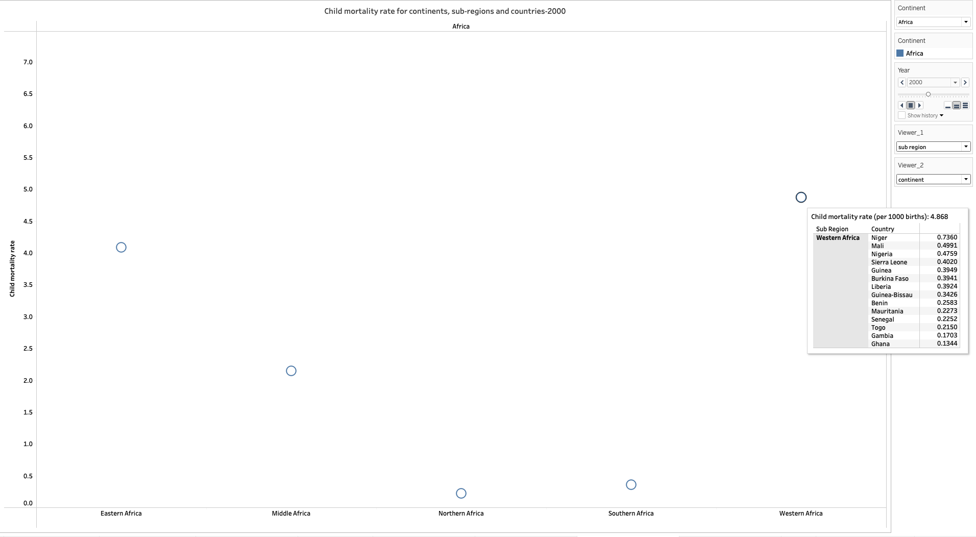

Fig. 23.

According to the donut chart below, the African continent has the highest child mortality rate (around 73%), while the European continent has the lowest child mortality rate.

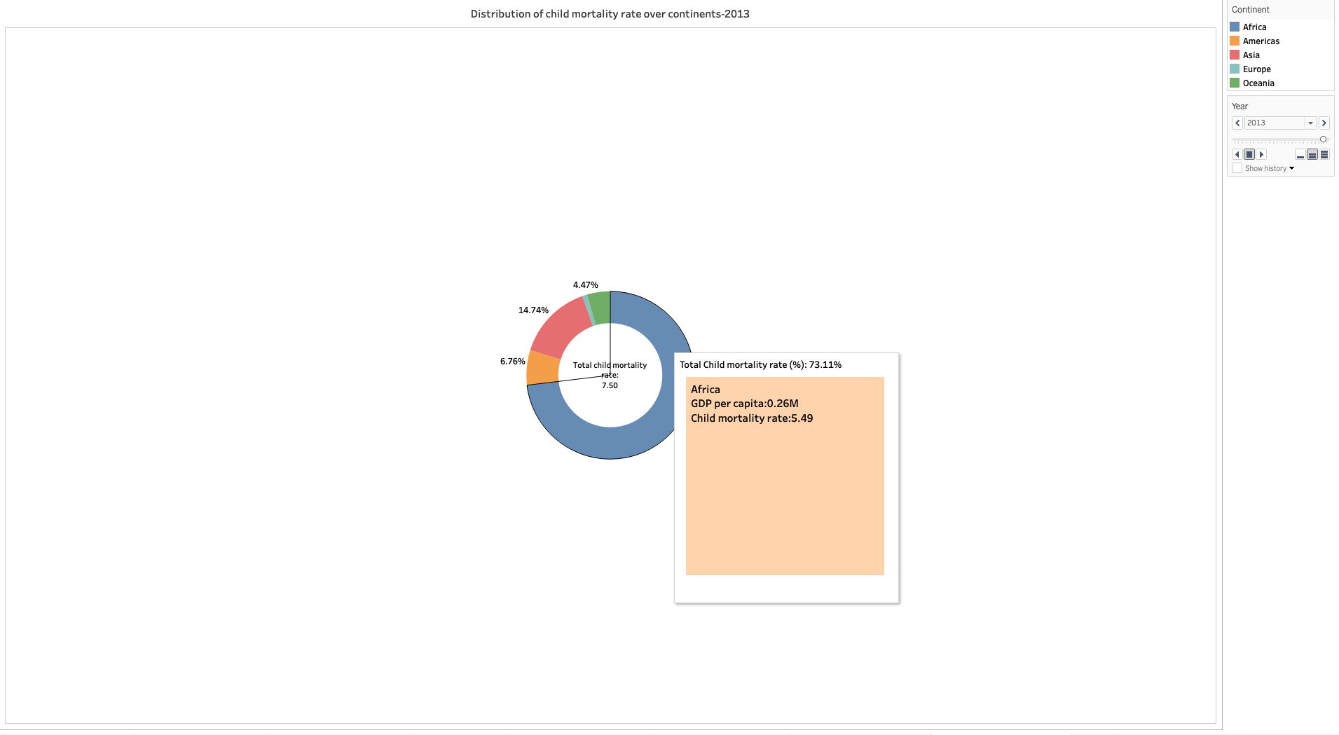

Fig. 24. Distribution of child mortality rate over continents

As GDP per capita increases (from around 2M in 1990 to around 3M in 2014), the child mortality rate decreases (from 24.452 in 1990 to 7.107 in 2014).

Fig. 25. Trend for GDP per capita and child mortality Rate

## Death Analysis wrt to Nutritional Deficiency and Health Conditions

## 

Fig. 26. comparison between GDP per capita and the number of deaths

According to the geospatial map above, the circle size for India and China is larger for 2014. In India and China, diet-related deaths were high. The highest number of deaths in India was also caused by high blood pressure. The same trend was observed for health issues.

Fig. 27. Overview of Deaths wrt Continents

The bar graph and line graph above show that Asia had the highest number of health-related deaths well as for low diet content. In Asia, death due to high blood pressure was more common than death due to a high sodium diet. According to the embedded pie chart, eastern Asia had the highest number of deaths (around 41%) in 2010.

Fig. 28. Chart of top N sub-region

According to the pie chart above, Eastern Asia had the highest number of death cases. Approximately the population consumes a high-sodium diet. As a result, China had the highest nuses, with approximately 945k cases in 1990. The trend was the same for all years.

Fig. 29. Deaths due to High BP, cholesterol, and BMI

According to the bar plot above, Europe and Asia had almost the same deaths due to high BMI in 1990 (i.e., around 16k). However, Asia had the highest number of death cases related to high blood pressure. Eastern Asia had the most cases due to its high population. All years showed the same behavior.

## Analysis of deaths due to Lifestyle Choices

All addiction parameters were compared, including smoking, alcohol, and drugs. By creating a filter, we can select the top N countries with the highest death rate in their respective parameters. As we can see, China has the highest death rate due to all three parameters, followed by India. The deaths for the next 10 years have also shown a clear upward trend.

Fig. 30. Deaths: Alcohol VS Drugs Vs. Smoking

Next, we compared deaths caused by smoking and deaths caused by secondhand smoke. While the number of deaths caused by secondhand smoke is not as high as the number of deaths caused by smoking, it is still a significant number, in fact, almost one-third of all deaths are caused by smoking. China, India & Russia are leading countries in deaths due to smoking and secondhand smoke.

Fig. 31. Deaths due to smoking Vs. Secondhand smoking

The butterfly chart below compares deaths from all addictions (alcohol, drugs, smoking) with deaths due to low physical activity. As we can see, addicted individuals are less likely to engage in physical activity, resulting in diseases due to inactivity resulting in death. Although numbers vary in scale, the number of deaths due to the left and right parameters is the same in the top 10 countries.

Fig. 32. Deaths due to addictions vs. low physical activity

The following graph illustrates the correlation between addictions and health issues. Comparing the deaths caused by high cholesterol, high blood pressure, and high BMI with the deaths caused by alcohol, drugs, and smoking. Addiction is one of the major factors causing the health issues listed above. As can be seen from the comparison graph, there is a strong positive correlation between the two.

Fig. 33. Deaths comparison between addictions and health issues.

According to research, a diet low in nutrients causes stunting and wasting in children. We plotted a correlation between stunting deaths and vitamin and nutrient deficiency deaths. Over the years, both graphs showed a similar decreasing trend.

Fig. 34. Graph showing people died due to health and physical conditions wrt year & GDP

# VIII. RESULTS

The following dashboards summarize the results for each death parameter

1. Death due to Child Mortality

Fig. 35. Dashboard of Death due to Child Mortality

1. Death due to Addictions

Fig. 36. Dashboard of Death due to Addictions

1. Death due to Pollution

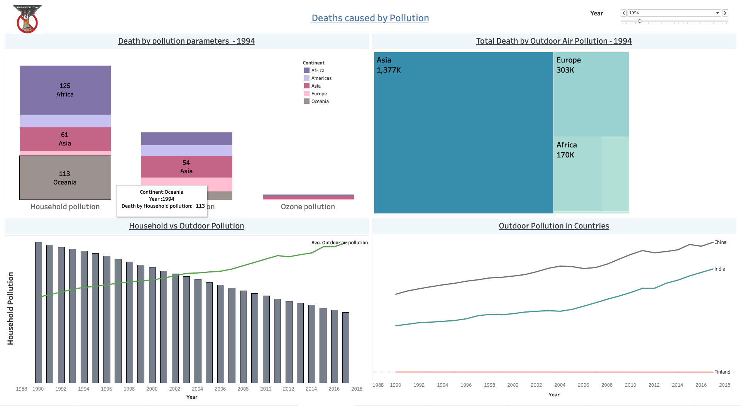

Fig. 37. Dashboard of deaths caused by Air pollution

1. Death due to Nutrition Deficiency and Health Conditions

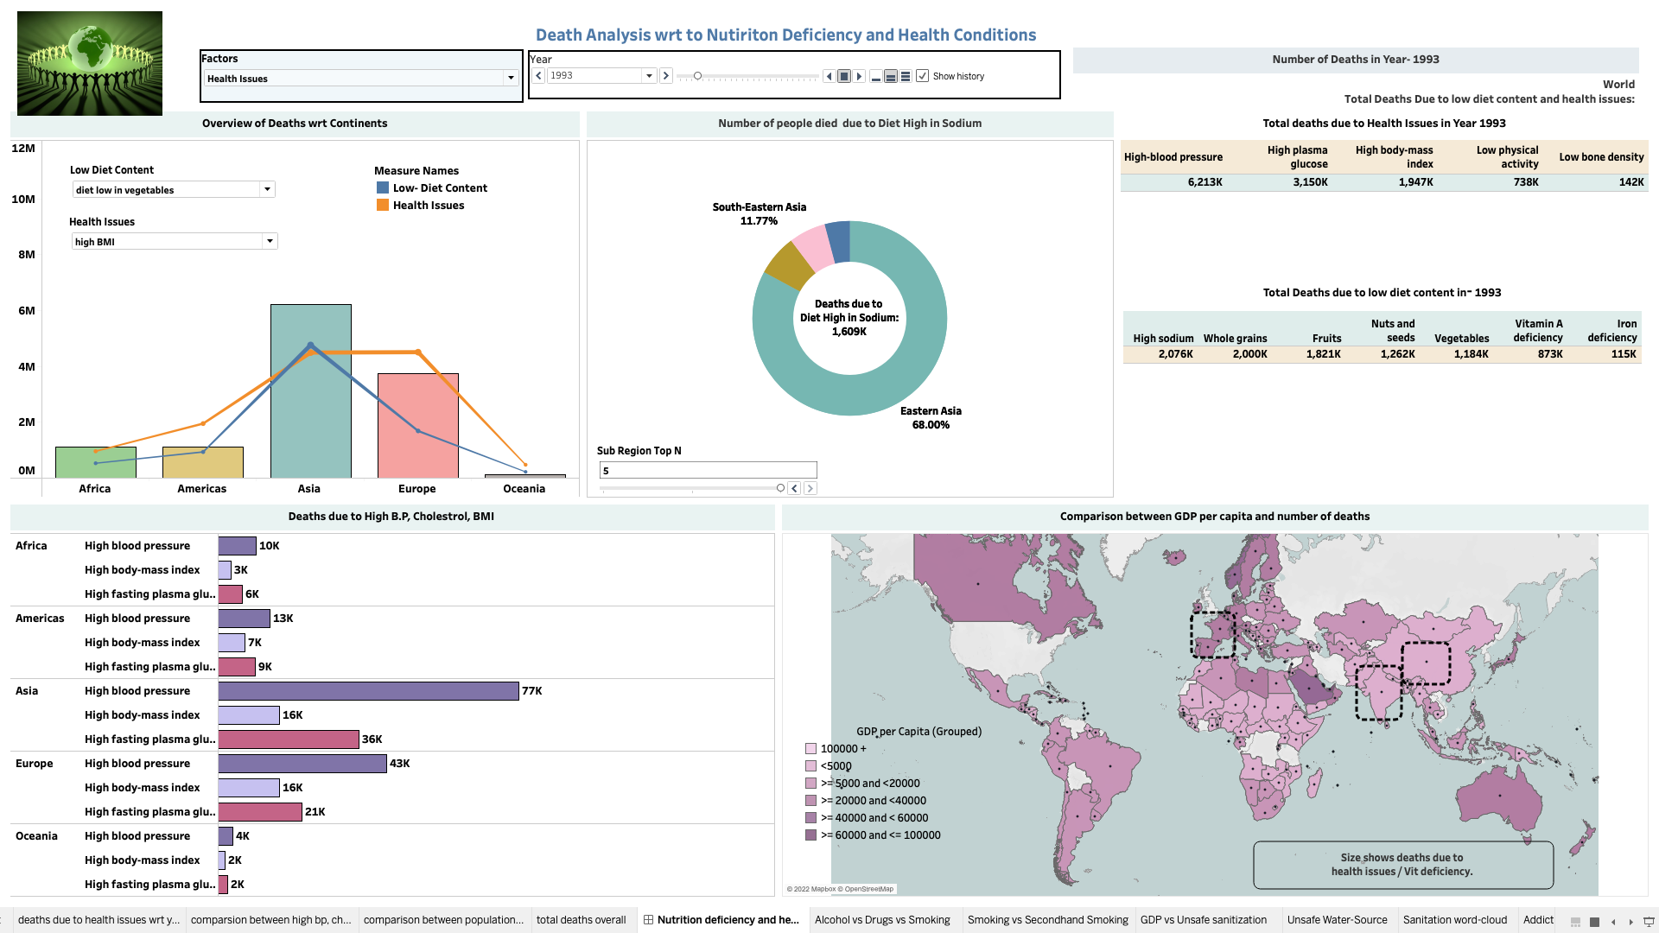

Fig. 38. Dashboard of Death due to Nutrition Deficiency and Health Conditions

1. Summary Dashboards with all the reasons for deaths according to the years

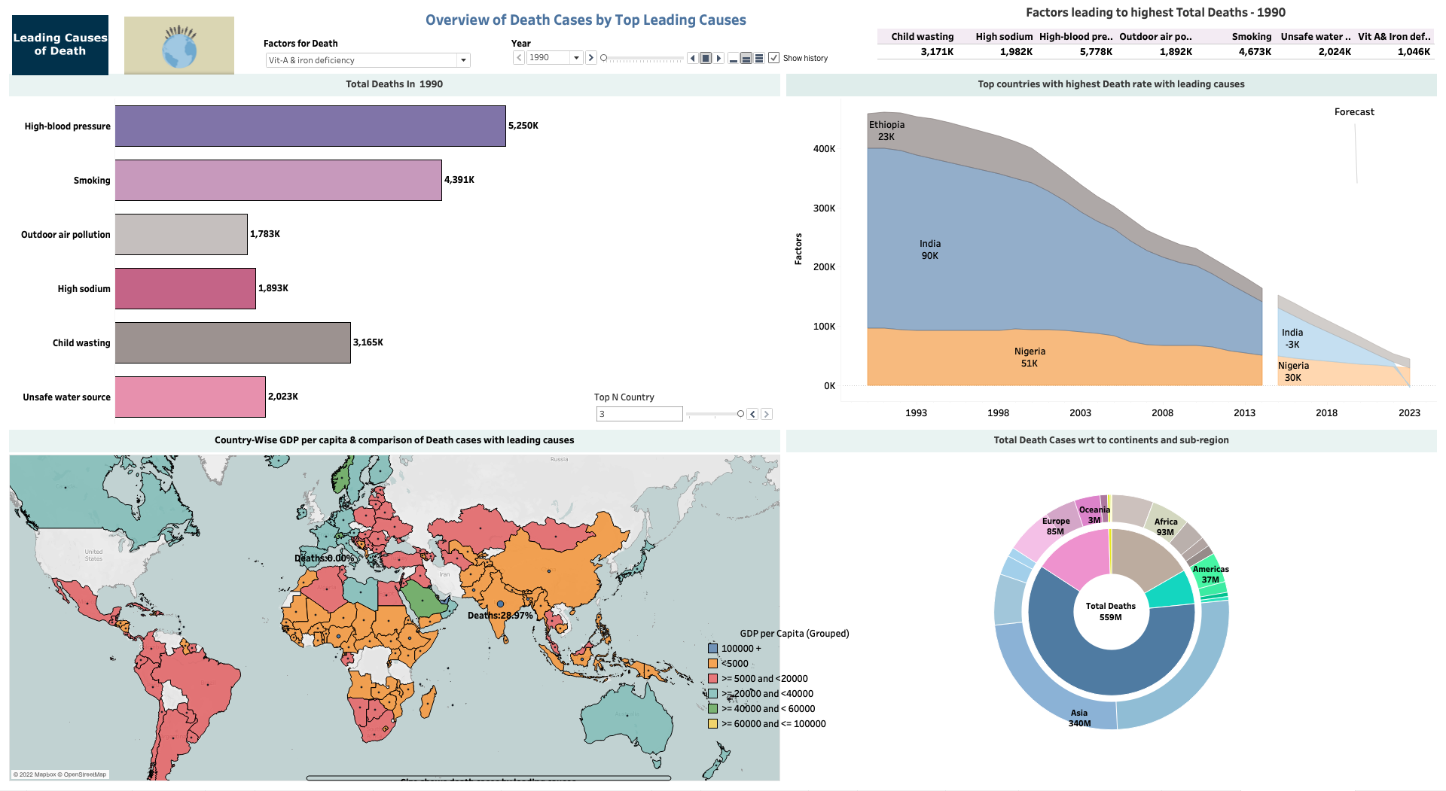

Fig. 39. Summary Dashboard of all the deaths caused

# IX. CONCLUSION

* **Air Pollution** - From 1990 to 2014, Deaths due to air pollution have continuously increased,i.e, 58.3%. Asia remained the leading continent with the maximum number of deaths due to outdoor air pollution. However, the death by household pollution is reduced by 49%.
* **Child Mortality** – Around 20% of global deaths account for child mortality. 70% decrease in child mortality rate from 1990 to 2014. Expected to decrease further by 67%till 2030.
* **Diet low in Nutrition**- Approximately 40% of global deaths accounted due to diet low nutrition
* **Health Conditions**- Around 62% of global deaths were due to health issues specifically, deaths due to high BMI was highest overall ie. around 19%
* **Unsafe Sanitation** – 1.4% of Global deaths are caused by poor sanitation and unsafe water source. In low-income countries, poor sanitary conditions account for 5% of deaths.
* **Alcohol, Drugs, Smoking, and Secondhand Smoking** – 74% of Global Deaths are due to all addiction-related issues. Drug overdose deaths have more than tripled since 1990.

# X. REFERENCES

[1]United States Environmental Protection Agency, Air Data: Air Quality Data Collected at Outdoor Monitors Across the US, URL: <https://www.epa.gov/outdoor-airquality-data>.  
  
[2]Visualization and Analysis of Air Pollution in US East Coast Cities,Diya Peng, Zhaopeng Xu, Jani Pallis, Xingguo Xiong, URL:[Visualization and Analysis of Air Pollution in US East Coast Cities](https://scholarworks.bridgeport.edu/xmlui/bitstream/handle/123456789/2230/Diyapeng-ASEENE-poster-final1.pdf?sequence=1&isAllowed=y)

[3]Household air pollution and health, URL: [Household air pollution and health](https://www.who.int/news-room/fact-sheets/detail/household-air-pollution-and-health)

[4]Outdoor Air Pollution, URL: [Outdoor Air Pollution - Our World in Data](https://ourworldindata.org/outdoor-air-pollution)

[5]O'Hare, B., Makuta, I., Chiwaula, L., & Bar-Zeev, N. (2013). Income and child mortality in developing countries: A systematic review and meta-analysis. *Journal of the Royal Society of Medicine*, *106*(10), 408–414. <https://doi.org/10.1177/0141076813489680>​​

[6]Black, Cousens, S., Johnson, H. L., Lawn, J. E., Rudan, I., Bassani, D. G., Jha, P., Campbell, H., Walker, C. F., Cibulskis, R., Eisele, T., Liu, L., & Mathers, C. (2010). Global, regional, and national causes of child mortality in 2008: a systematic analysis. The Lancet., 375(9730), 1969–1987. <https://doi.org/10.1016/S0140-6736(10)60549-1>

[7]Dietary Habits, “Health effects of dietary risks in 195 countries, 1990–2017: a systematic analysis for the Global Burden of Disease Study 2017”,

URL:<https://www.thelancet.com/article/S0140-6736(19)30041-8/fulltext>

[8]Deaths due to Health Conditions, “Combined Effect of Blood Pressure and Total Cholesterol Levels on Long-Term Risks of Subtypes of Cardiovascular Death”,

URL:<https://www.ahajournals.org/doi/10.1161/HYPERTENSIONAHA.114.04639>

[9]Sellis, Timos., ACM Digital Library., & Association for Computing Machinery. Special Interest Group on Management of Data. (2011). *Proceedings of the 2011 ACM SIGMOD International Conference on Management of data.* ACM.

[10]Kosara, R., & MacKinlay, J. (2013). Storytelling: The next step for visualization. *Computer*, *46*(5), 44–50. <https://doi.org/10.1109/MC.2013.36>

[11]Vasundhara,S.(n.d.). DATA VISUALIZATION VIEW WITH TABLEAU. <https://www.researchgate.net/publication/35384705>