Game Design Document

Fill up the Following document

1. Write the title of your project.

Ice Cream Paradise Run

1. What is the goal of the game?

To reach the end cake house without losing.

1. Write a brief story of your game?

Doraemon has stuck on a ice cream paradise and he needs to get

Out. He has only one way which is the door of the cake house. He

Needs to reach the cake house as soon as possible.

1. Which are the playing characters of this game?

* Playing characters are the ones which respond to the user based on the input from the user
* Cars, monkeys, dinos, wizards etc, are the playing characters in the game.

|  |  |  |
| --- | --- | --- |
| Number | Character Name | What can this character do? |
| 1 | doraemon | This character runs on the ground and it will help you complete the goal. |
| 2 |  |  |
| 3 |  |  |
| 4 |  |  |
| 5 |  |  |
| 6 |  |  |
| 7 |  |  |
| 8 |  |  |

1. Which are the Non Playing Characters of this game?

* Non Playing characters are the ones which don't have an action or a behaviour when the user interacts with the game.
* Hurdles, stones, bananas, coins, etc are non playing characters in the game.

|  |  |  |
| --- | --- | --- |
| Number | Character Name | What can this character do? |
| 1 | Hard turtles | Bring ­­­­­­­­­the doraemon to the starting point. |
| 2 | Bomb | Cuts one life of doraemon |
| 3 | fire | Cuts half life of doraemon |
| 4 | thorn | Brings doraemon to the starting point |
| 5 |  |  |
| 6 |  |  |
| 7 |  |  |
| 8 |  |  |

Draw your imagination of this game. What does this game look like?

* Draw the game either on your computer or on paper,
* Add images of scenes of the game to show each of the playing and non-playing characters at least once.

Pic of doraemon running in the starting is given below. The player can play this game both on PC and mobile.

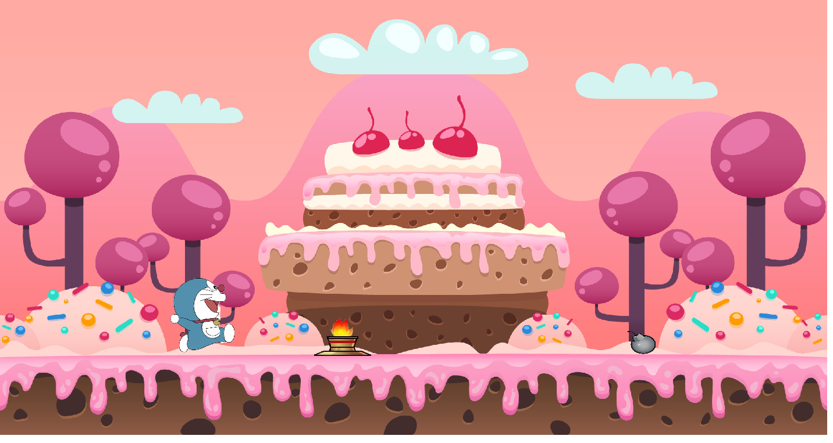

How do you plan to make your game engaging?

By putting obstacles and giving 3 life chances to doraemon to balance the

Game. Even adding many fun elements in the game by changing the

obstacles and difficulty of the game.