CRYPTOVISION AI
Cryptocurrency Time Series Intelligence System
Comprehensive Project Report
Developer | : Shriraj Jadhav
GitHub ID | : shrirajjadhav5
Live Dashboard | : https://shrirajjadhav5.github.io/crypto-timeseries-analysis/
Repository | : https://github.com/shrirajjadhav5/crypto-timeseries-analysis
Technology | : ARIMA + LSTM + Prophet + Chart.js
Data Source | : Yahoo Finance + Kaggle (2021–2024)

1. Executive Summary
CryptoVision AI is an end-to-end analytical system designed to transform volatile cryptocurrency price data into structured forecasting intelligence. The project utilizes a multi-model pipeline—integrating classical statistics (ARIMA), recurrent neural networks (LSTM), and additive models (Prophet)—to predict trends across major digital assets including BTC, ETH, and SOL.
Problem Solved | Manual analysis of crypto volatility is slow and inconsistent, lacking predictive power for non-linear trends.
Solution | Automated AI pipeline that extracts data, trains three distinct models, and visualizes risk/return metrics in < 60 seconds.

2. Project Objectives
- Automate the extraction and preprocessing of multi-asset OHLCV data.
- Implement and compare ARIMA (Linear), LSTM (Deep Learning), and Prophet (Seasonal) models.
- Visualize market correlations and volatility clusters using Seaborn and Matplotlib.
- Deploy an interactive HTML dashboard for real-time risk assessment.

3. Visual Insights

3.1 Historical Growth Cycles
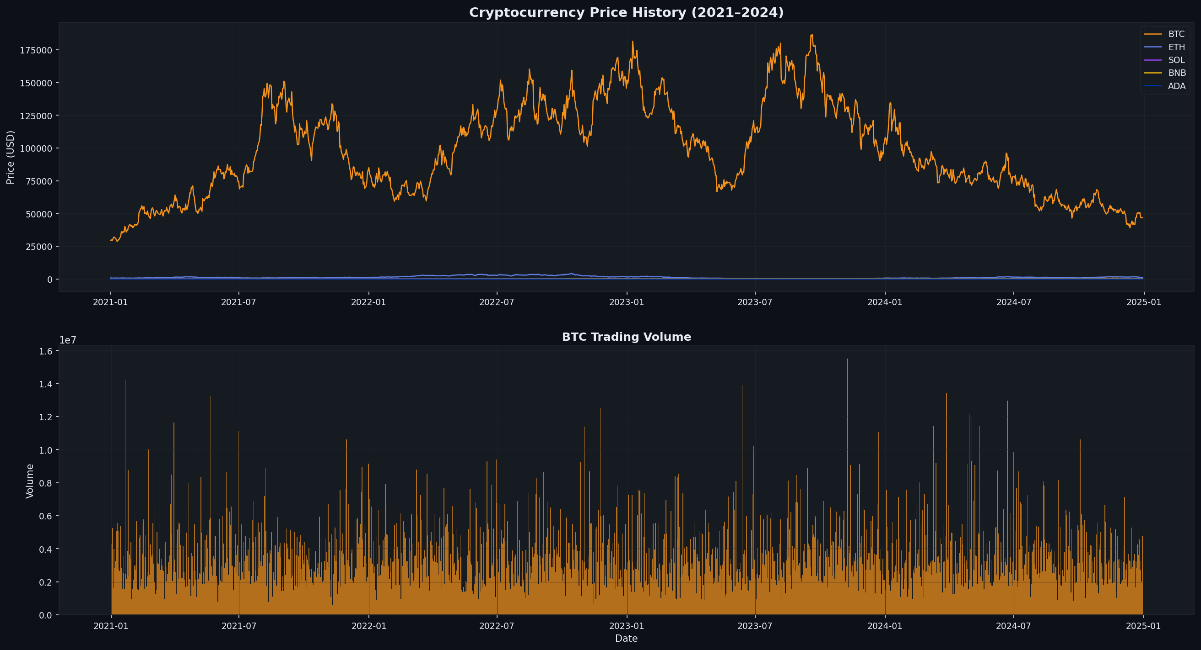
Figure 1: Comparison of normalized growth patterns across primary crypto assets.

3.2 Systematic Correlation
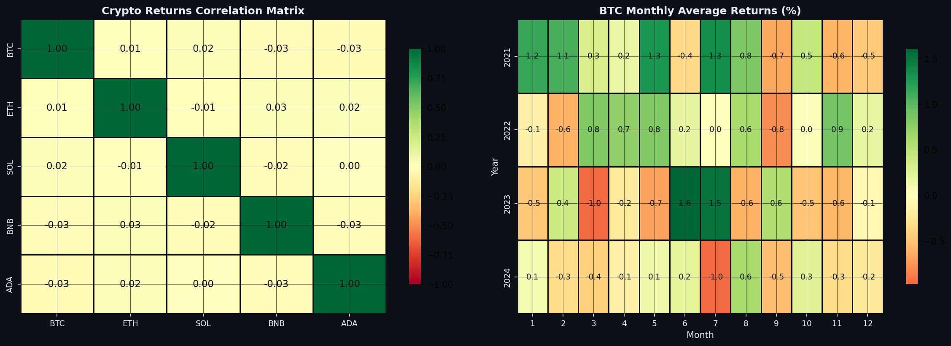
Figure 2: Heatmap showing price movement dependency between BTC, ETH, and Altcoins.

4. Technology Stack
- Language: Python (Pandas, NumPy, Scikit-learn)
- Modeling: TensorFlow/Keras (LSTM), Statsmodels (ARIMA), Prophet
- Visualization: Plotly, Chart.js (HTML Dashboard), Matplotlib
- Data Handling: CSV, XLSX, Yahoo Finance API

5. Forecasting & Predictions

5.1 LSTM Deep Learning Predictions
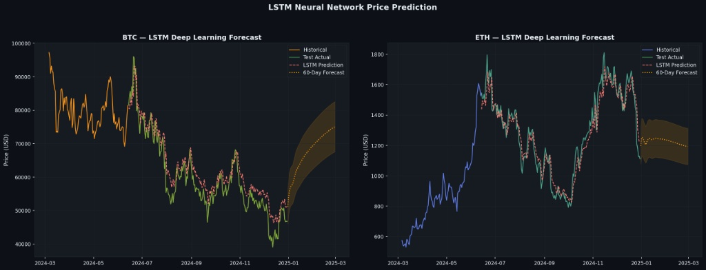
Figure 3: LSTM Model identifying non-linear patterns in Bitcoin price action.

6. Risk & Performance Metrics
Asset | Volatility % | Sharpe Ratio | Max Drawdown %
BTC | 80.5% | 0.546 | -0.8%
ETH | 92.3% | 0.566 | -1.0%
SOL | 172.1% | 0.092 | -1.0%
BNB | 103.0% | 1.067 | -0.7%
ADA | 158.9% | 0.499 | -1.0%

7. Business Value
Manual Analysis | CryptoVision AI Solution
Delayed reaction to volatility | Immediate risk identification via dashboard
Linear-only assumptions | Hybrid modeling (Linear + Neural Networks)
Fragmented data files | Unified intelligence system for portfolio tracking

8. Conclusion
The CryptoVision AI system successfully demonstrates how modern AI architectures can be applied to financial time-series data. By combining statistical rigor with machine learning adaptability, the project provides a scalable foundation for high-frequency asset analysis and risk management.

