**Migrate Firewall-Rules, Resource Tags and PG Roles/Users from Single to Flexible Server**

We will be using a python script to migrate Firewall Rules and Resource Tags from single server to Flexible server. The script will be run in the Microsoft Azure portal [Cloud shell](https://docs.microsoft.com/en-us/azure/cloud-shell/overview#:~:text=%20Overview%20of%20Azure%20Cloud%20Shell%20%201,Regular%20storage...%205%20Next%20steps.%20%20More%20).

Link To Migration Script: [migrate_firewall_tags.py](https://microsoftapc-my.sharepoint.com/:u:/g/personal/chajain_microsoft_com/EYIrN1bNOvJHt9ORyWARgnABWUWZAYGqPWFGK6ZtiTER7Q?e=ZNv6bz)

**Steps to migrate the Firewall Rules and Resource Tags:**

1. Gather the following as prerequisites:

* Azure Subscriptions containing the Source and Target Servers.
* Resource Group Names containing the Source and Target servers.
* Source and Target server names.
* Azure user with contributor privileges on both source and target servers.

2. Open the Cloud Shell in Microsoft Azure portal after signing in using the user that has contributor privileges as mentioned in the step above. Click on the highlighted area in the image below to start the cloud shell.

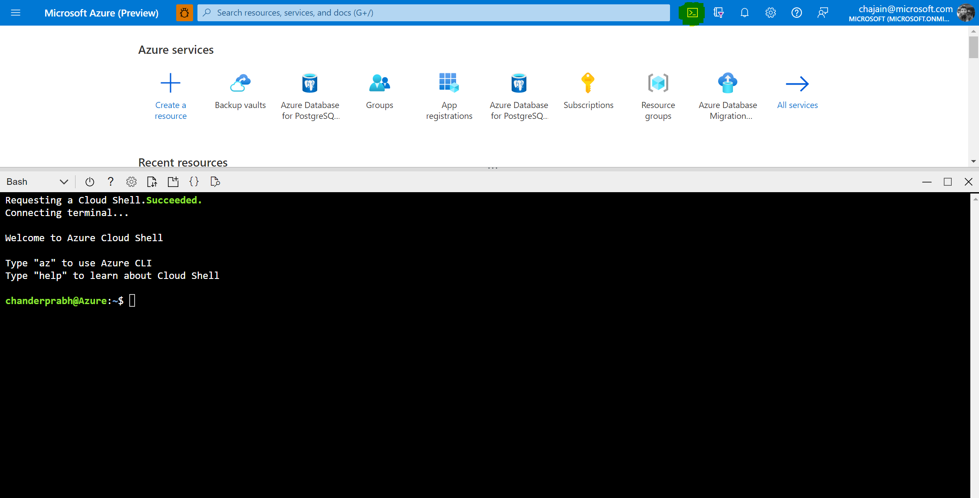

3. Download the python script file from here to your local system.  
We will now upload this python script to the file share of the Cloud shell so that it can used to migrate the Firewall rules and resource tags.   
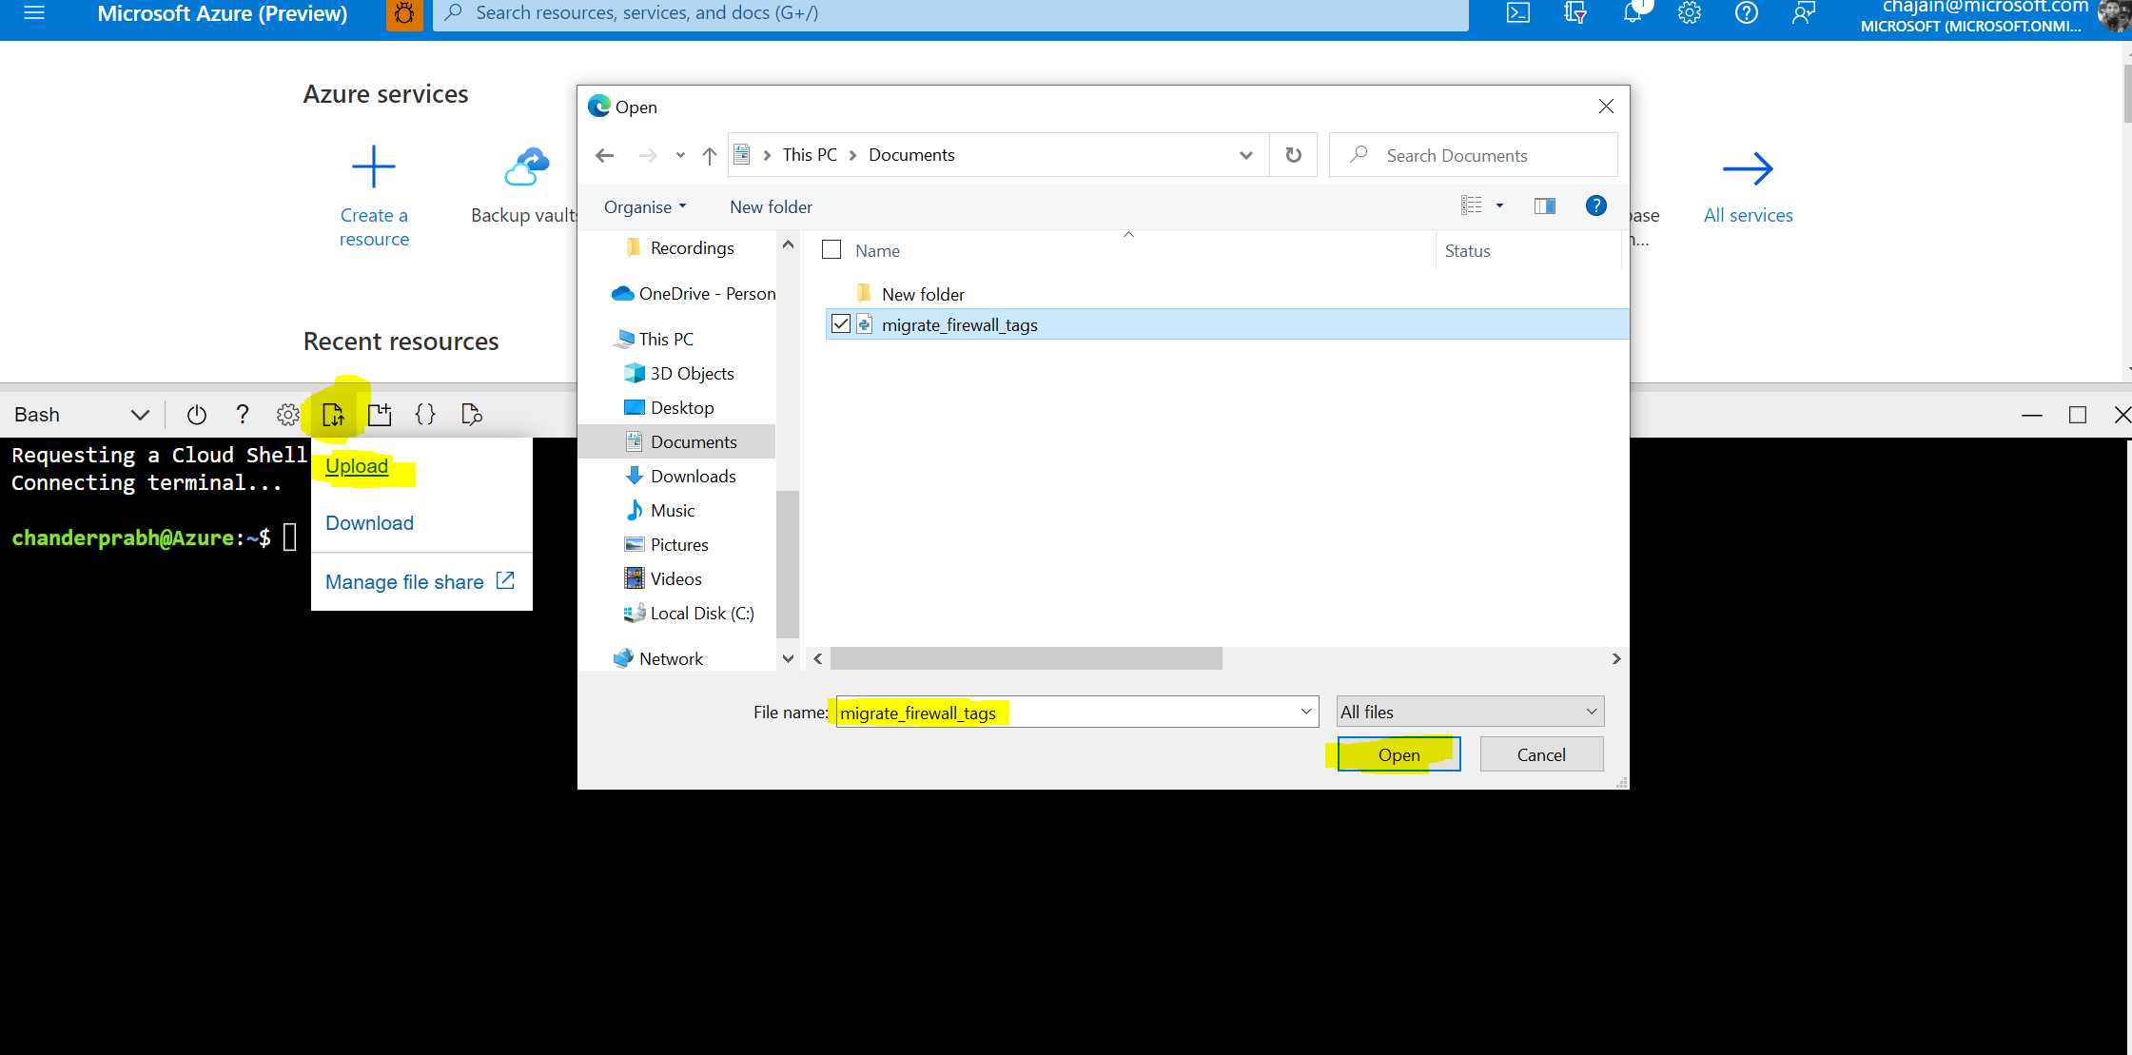

4. On Successful upload, the file should be visible in the directory when you run the list directory(ls) command.  
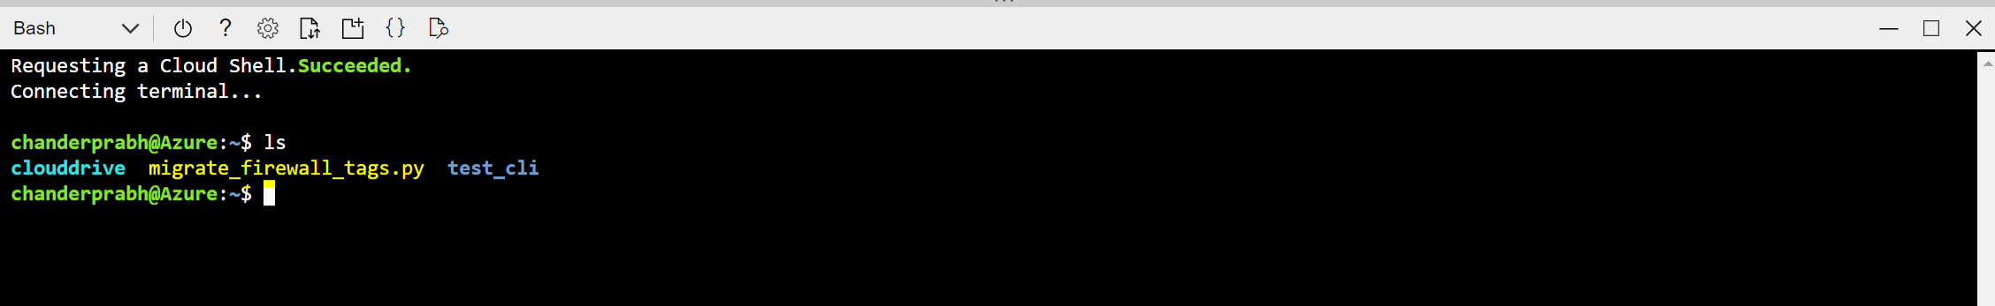

5. Let us first see what all parameters are needed by the script to migrate firewall rules and resource tags successfully. All these parameters are part of the prerequisite's steps mentioned at the start.

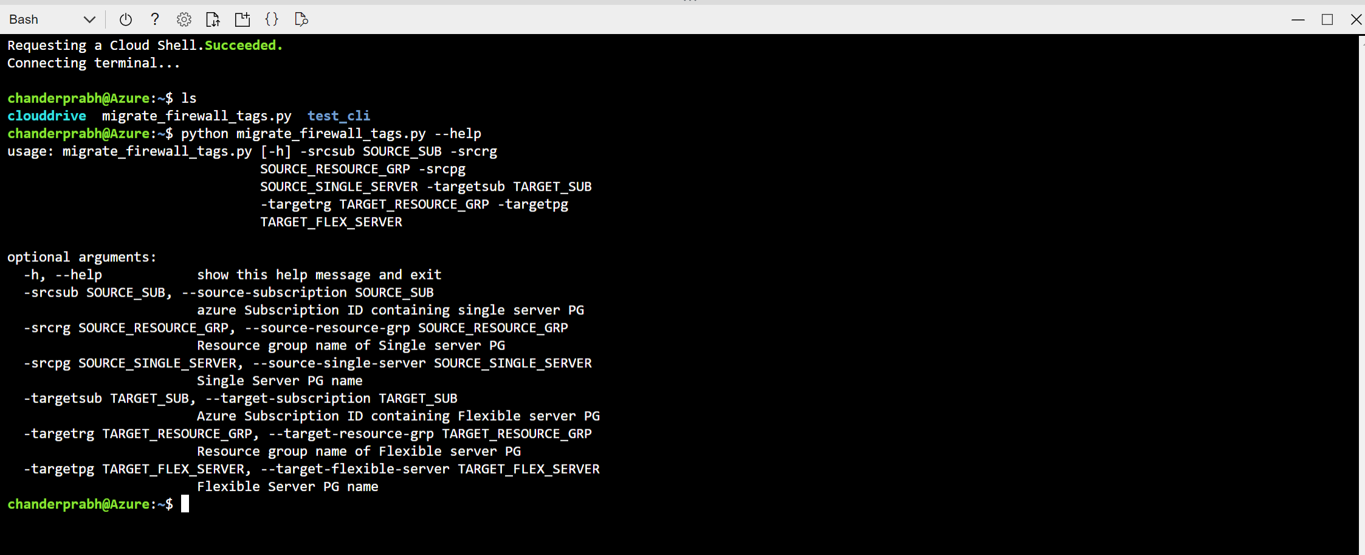

6. Run the command below to migrate the firewall rules and resource tags:  
**Note: The Full FQDN is not needed for the single and flex servers but only server-names as highlighted in the image below.**

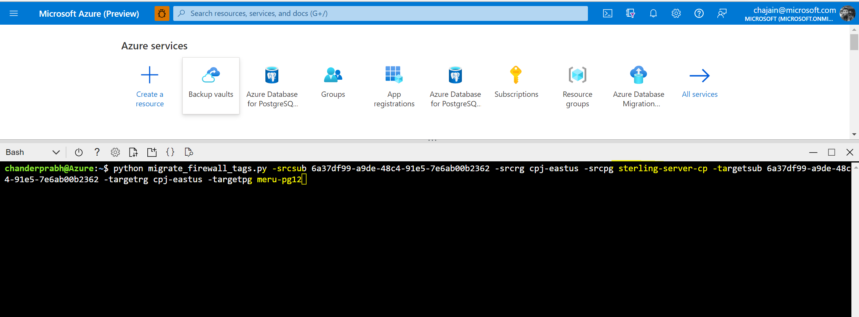

7. On Successful migration you will see Success Message as below:  
