Docker
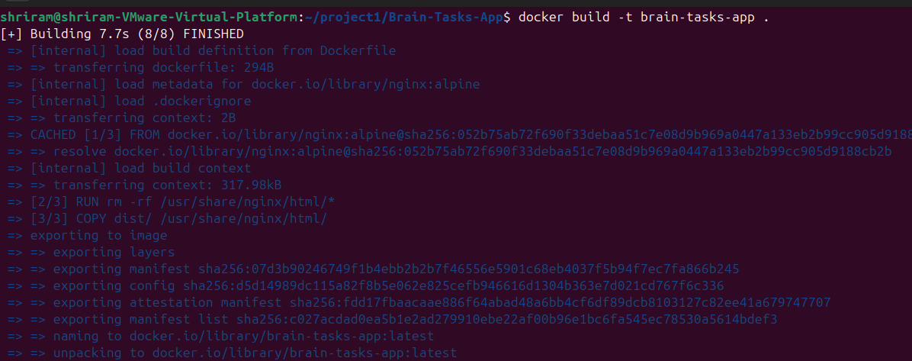

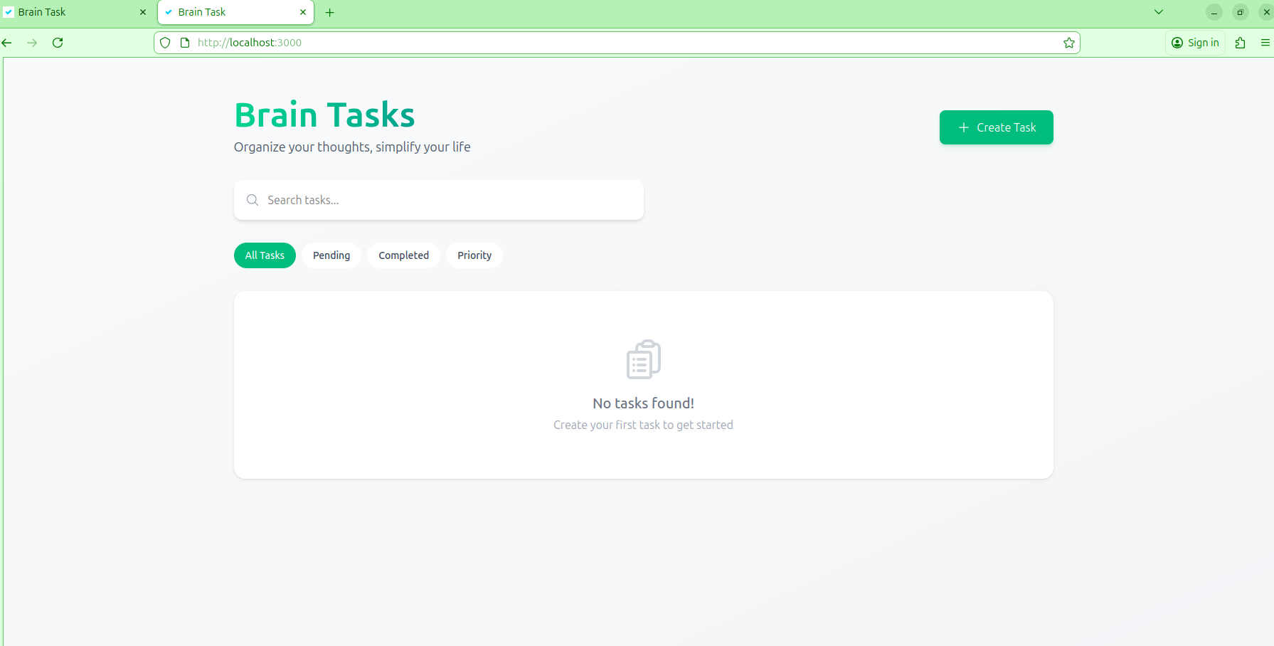

ECR
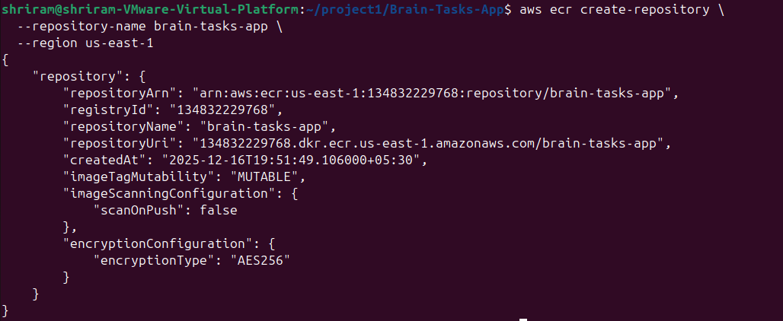
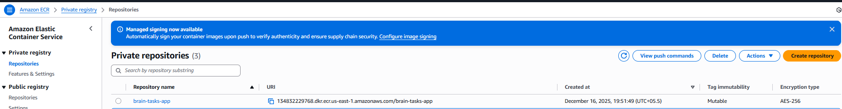
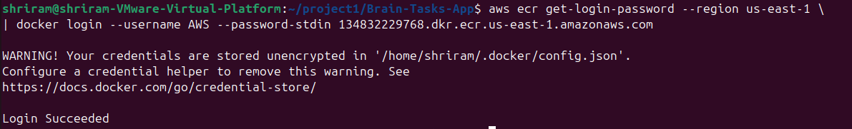
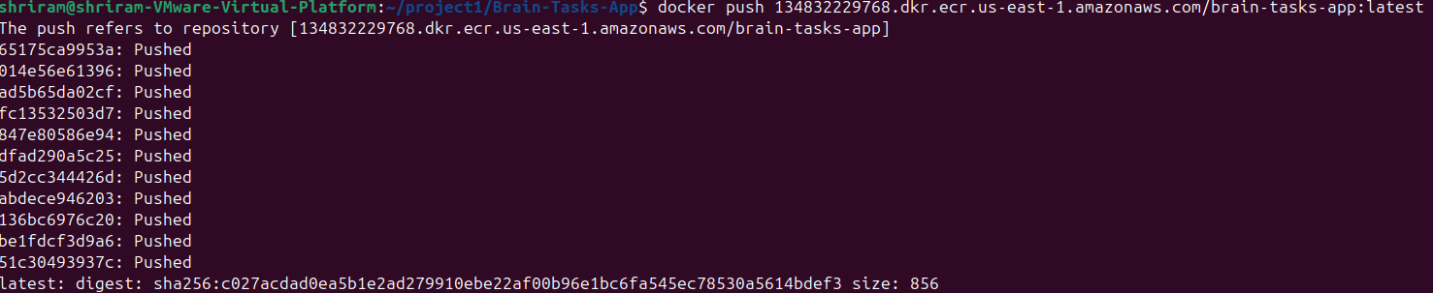

URI
134832229768.dkr.ecr.us-east-1.amazonaws.com/brain-tasks-app

Github

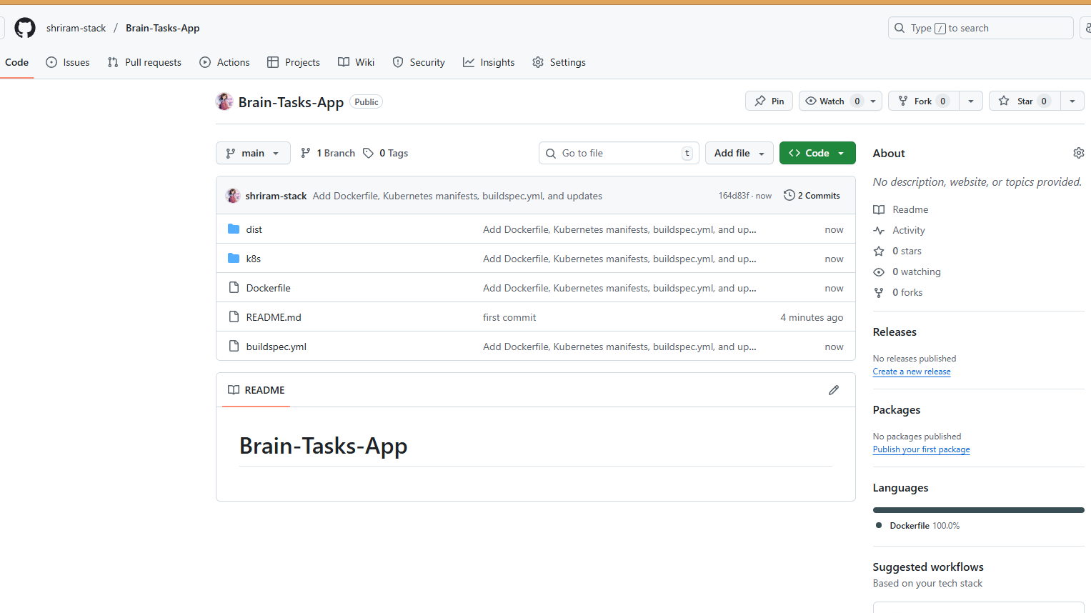
Kubernetes:
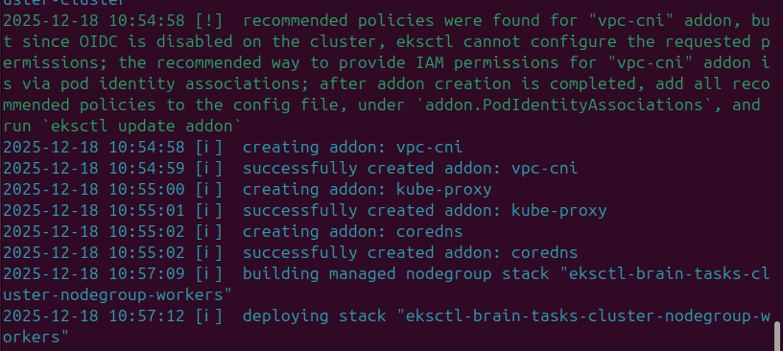
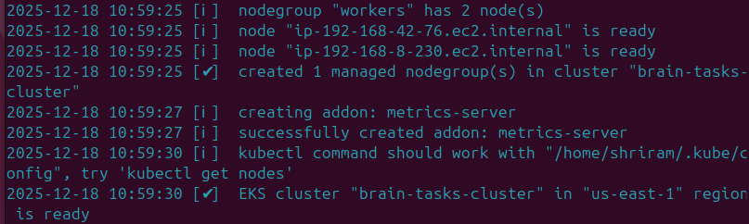

aa0bfac867b254deba5c99c2427ca8ad-377438211.us-east-1.elb.amazonaws.com
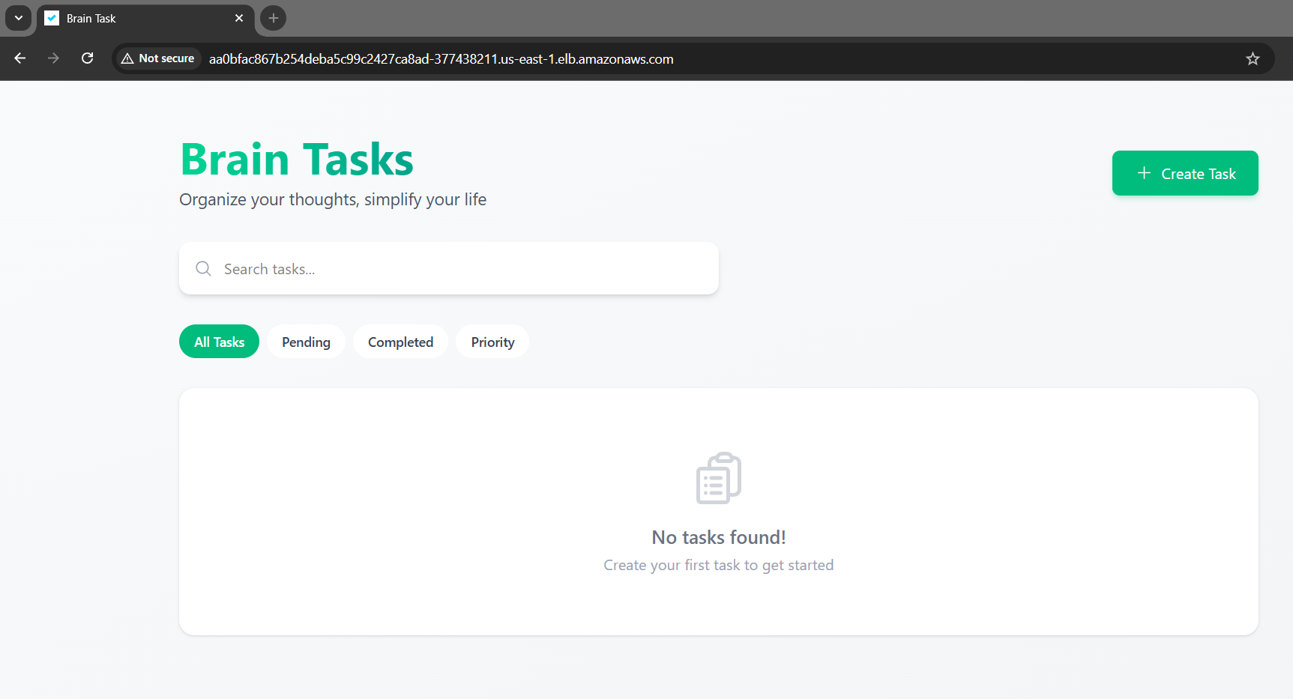

Code build
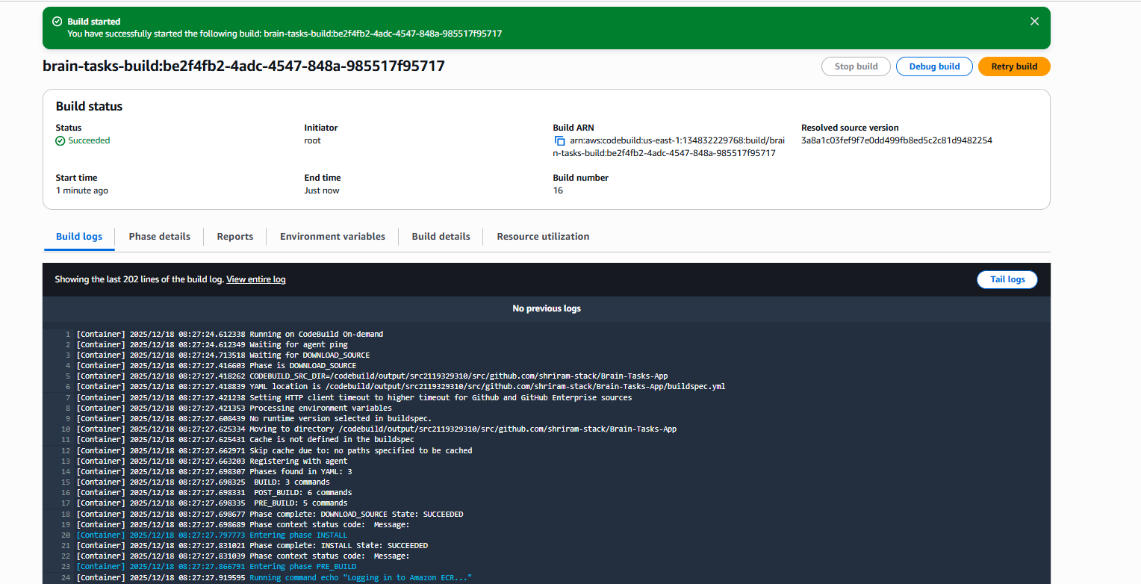

Code deploy
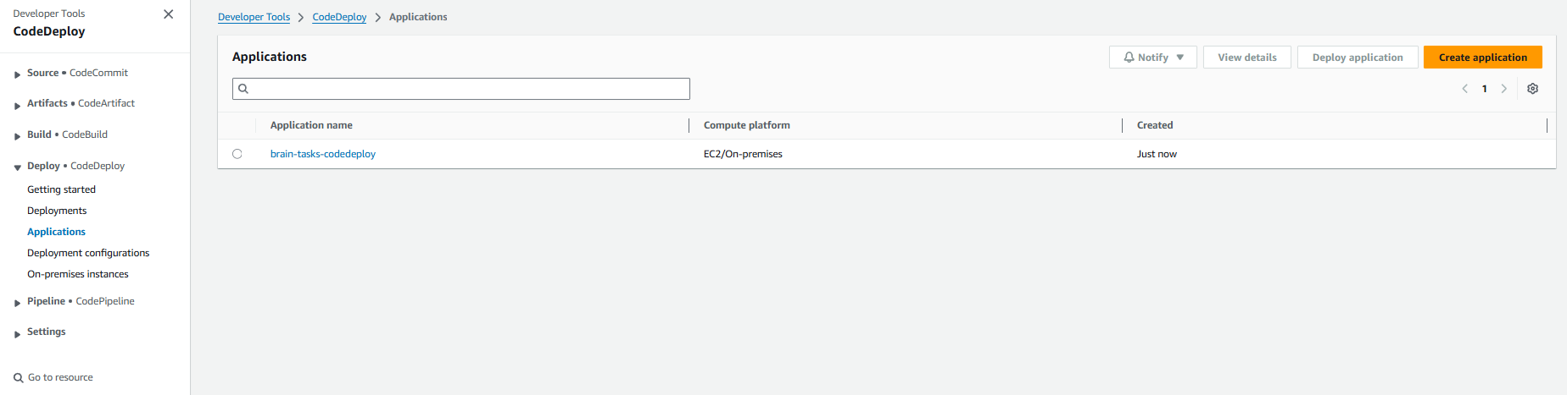

Code pipeline

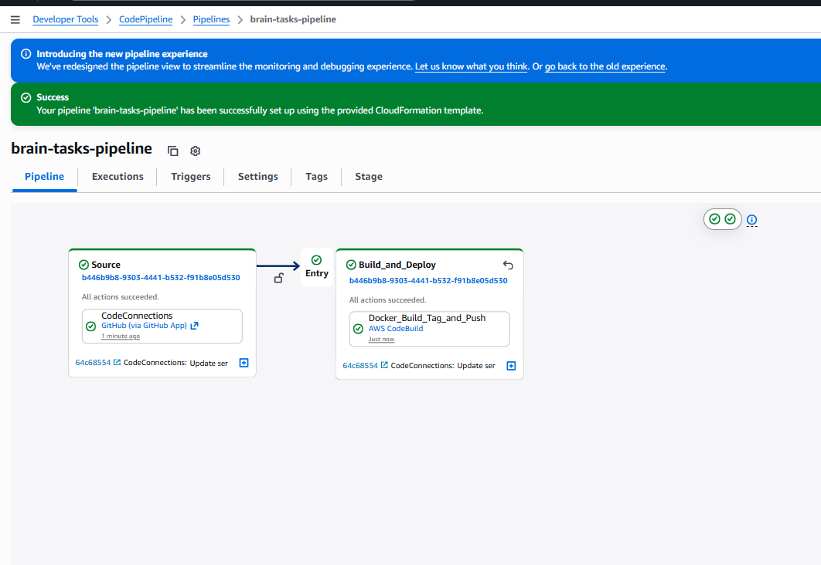
Cloud watch
