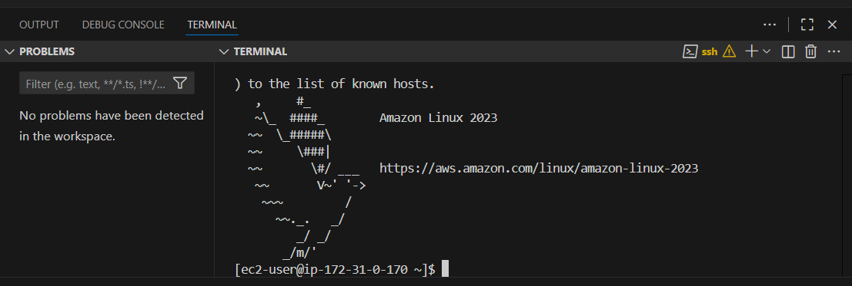

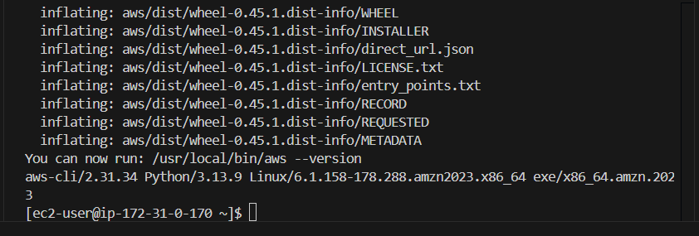

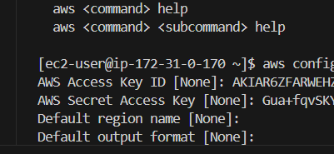

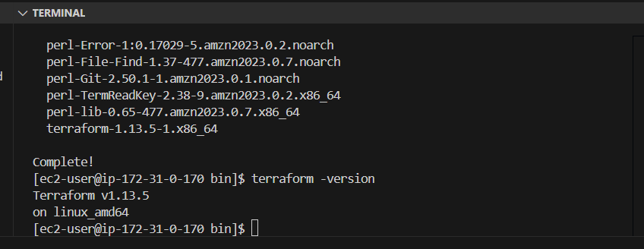

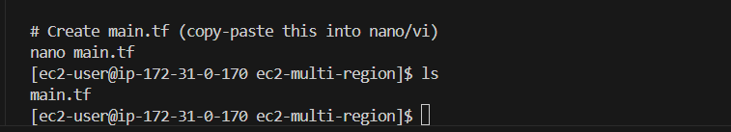

Main.tf
# main.tf
terraform {
required_version = ">= 1.13"
required_providers {
aws = {
source = "hashicorp/aws"
version = "~> 5.0"
}
}
}

provider "aws" {
alias = "east"
region = "us-east-1"
}

provider "aws" {
alias = "west"
region = "us-west-2"
}
data "aws_ami" "amzn_east" {
provider = aws.east
most_recent = true
owners = ["amazon"]

filter {
name = "name"
values = ["amzn2-ami-hvm-*-x86_64-gp2"]
}
filter {
name = "virtualization-type"
values = ["hvm"]
}
}

data "aws_ami" "amzn_west" {
provider = aws.west
most_recent = true
owners = ["amazon"]

filter {
name = "name"
values = ["amzn2-ami-hvm-*-x86_64-gp2"]
}
filter {
name = "virtualization-type"
values = ["hvm"]
}
}

resource "aws_instance" "east" {
provider = aws.east
ami = data.aws_ami.amzn_east.id
instance_type = "t2.micro"

tags = {
Name = "Terraform-East-Child"
Environment = "test"
}
}

resource "aws_instance" "west" {
provider = aws.west
ami = data.aws_ami.amzn_west.id
instance_type = "t2.micro"

tags = {
Name = "Terraform-West-Child"
Environment = "test"
}
}

output "east_instance_id" {
value = aws_instance.east.id
}
output "west_instance_id" {
value = aws_instance.west.id
}

