docker-version.png

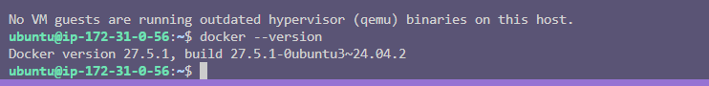

docker-images-before.png

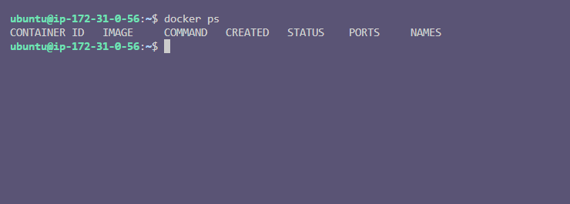

docker-pull.png

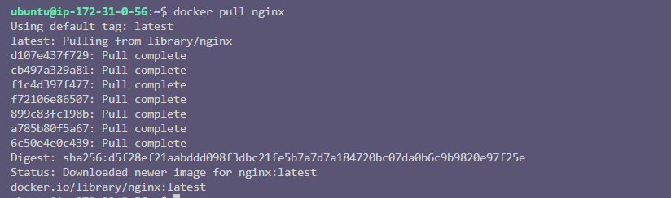

docker-ps.png

volume-create.png

network-create.png

