**Exp.No: 1**

**Downloading and installing Hadoop, Understanding different Hadoop modes, Startup scripts, Configuration files.**

**AIM:**

To Download and install Hadoop, Understanding different Hadoop modes, Startup scripts, Configuration files.

**PROCEDURE:**

**Step 1:** Install java jdk 8 First of all you must install Java JDK 8 on your system. You can just type this command to install java jdk on your system.

**sudo apt install openjdk-8-jdk**

To check it’s there cd /usr/lib/jvm

**Step 2:** Add this configuration on you bash file Now just open .bashrc file and paste these commands.

**export JAVA_HOME=/usr/lib/jvm/java-8-openjdk-amd64**

**export PATH=$PATH:/usr/lib/jvm/java-8-openjdk-amd64/bin**

**export HADOOP_HOME=~/hadoop-3.2.3/**

**export PATH=$PATH:$HADOOP_HOME/bin**

**export PATH=$PATH:$HADOOP_HOME/sbin**

**export HADOOP_MAPRED_HOME=$HADOOP_HOME**

**export YARN_HOME=$HADOOP_HOME**

**export HADOOP_CONF_DIR=$HADOOP_HOME/etc/hadoop**

**export HADOOP_COMMON_LIB_NATIVE_DIR=$HADOOP_HOME/lib/native**

**export HADOOP_OPTS="-Djava.library.path=$HADOOP_HOME/lib/native"**

**exportHADOOP_STREAMING=$HADOOP_HOME/share/hadoop/tools/lib/hadoopstreaming-3.2.3.jar**

**export HADOOP_LOG_DIR=$HADOOP_HOME/logs**

**export PDSH_RCMD_TYPE=ssh**

(ssh — secure shell — protocol used to securely connect to remote server/system — transfers data in encrypted form)

**sudo apt-get install ssh**

Now go to hadoop.apache.org website download the tar file (hadoop.apache.org — download tar file of hadoop.)

**tar -zxvf ~/Downloads/hadoop-3.2.3.tar.gz (Extract the tar file)**

**cd hadoop-3.2.3/etc/hadoop**

Now open hadoop-env.h

**sudo nano hadoop-env.h**

**JAVA_HOME=/usr/lib/jvm/java-8- openjdk-amd64** (set the path for JAVA_HOME).

**Step 3:** **Add this file in core-site.xml** :

Now add this configuration in core-site.xml file.

**core-site.xml**

**<configuration> <property>**

**<name>fs.defaultFS</name>**

**<value>hdfs://localhost:9000</value> </property>**

**<property>**

**<name>hadoop.proxyuser.dataflair.groups</name> <value>*</value>**

**</property>**

**<property>**

**<name>hadoop.proxyuser.dataflair.hosts</name> <value>*</value>**

**</property>**

**<property>**

**<name>hadoop.proxyuser.server.hosts</name> <value>*</value>**

**</property>**

**<property>**

**<name>hadoop.proxyuser.server.groups</name> <value>*</value>**

**</property>**

**</configuration>**

**Step 4: Add this file in hdfs-site.xml**

Now add this configuration in hdfs-site.xml file.

**hdfs-site.xml**

**<configuration>**

**<property>**

**<name>dfs.replication</name>**

**<value>1</value>**

**</property>**

**</configuration>**

**Step 5: Add this file in mapred-site.xml**

Now add this configuration in mapred-site.xml file.

**mapred-site.xml**

**<configuration>**

**<property>**

**<name>mapreduce.framework.name</name> <value>yarn</value>**

**</property>**

**<property>**

**<name>mapreduce.application.classpath</name>**

**<value>$HADOOP_MAPRED_HOME/share/hadoop/mapreduce/*:$HADOOP_MAPRED_HOME/share/hadoop/mapreduce/lib/*</value>**

**</property>**

**</configuration>**

**Step 6: Add this file in yarn-site.xml**

Now add this configuration in yarn-site.xml file.

**yarn-site.xml**

**<configuration>**

**<property>**

**<name>yarn.nodemanager.aux-services</name>**

**<value>mapreduce_shuffle</value>**

**</property>**

**<property>**

**<name>yarn.nodemanager.env-whitelist</name>**

**<value>JAVA_HOME,HADOOP_COMMON_HOME,HADOOP_HDFS_HOME,HADOOP_CONF_DIR,CLASSPATH_PREPEND_DISTCACHE,HADOOP_YARN_HOME,HADOOP_MAPRED_HOME</value>**

**</property>**

**</configuration>**

**ssh**

**ssh localhost**

**ssh-keygen -t rsa -P '' -f ~/.ssh/id_rsa**

**cat ~/.ssh/id_rsa.pub >> ~/.ssh/authorized_keys**

**chmod 0600 ~/.ssh/authorized_keys**

**hadoop-3.2.3/bin/hdfs namenode -format**

Format the file system

**export PDSH_RCMD_TYPE=ssh**

**Step 7: Start hadoop**

To start, type the command below:

**start-all.sh** (Start NameNode daemon and DataNode daemon)

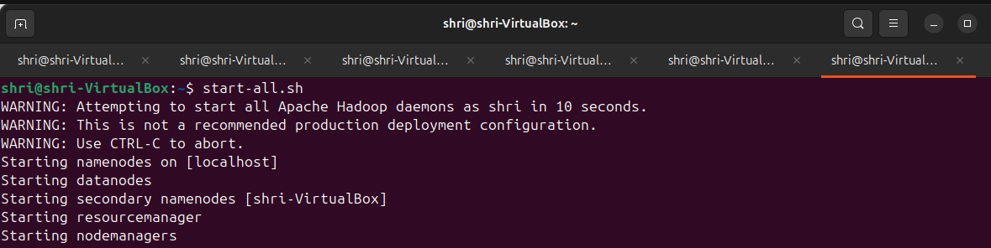

This is how you can install hadoop on your ubuntu operating system and start using on your system.

**Step 8: Check the status using jps**

**jps**

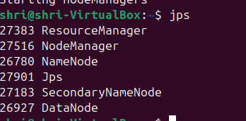

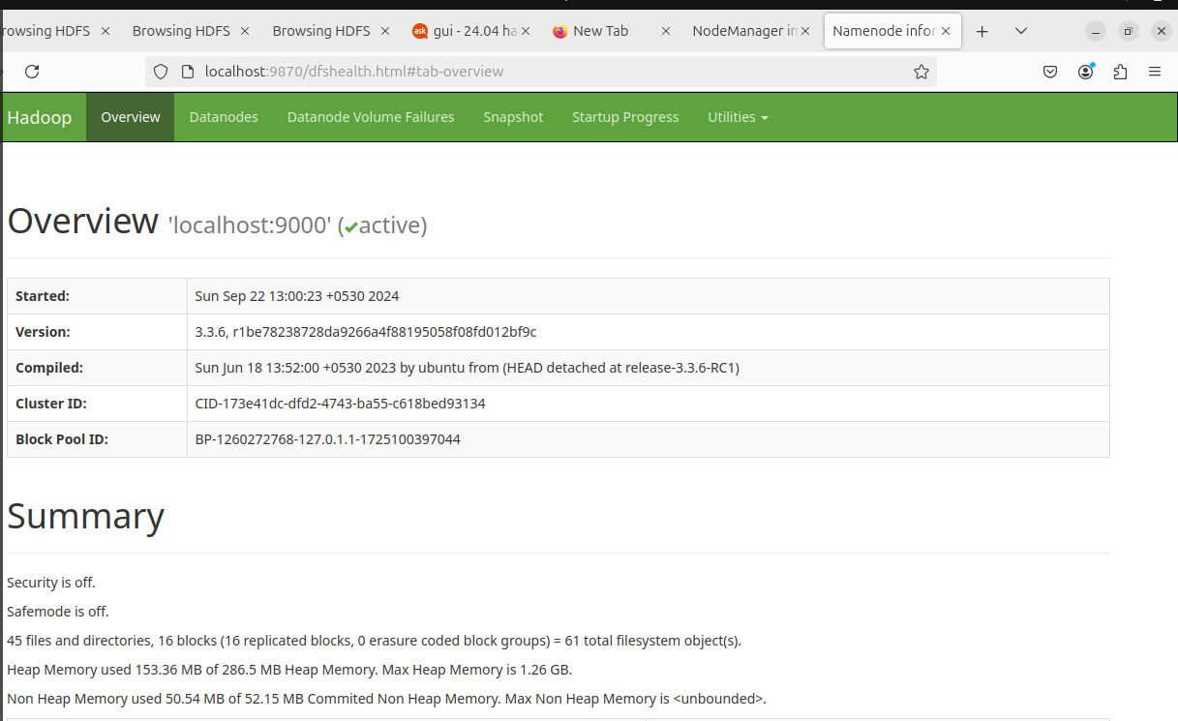

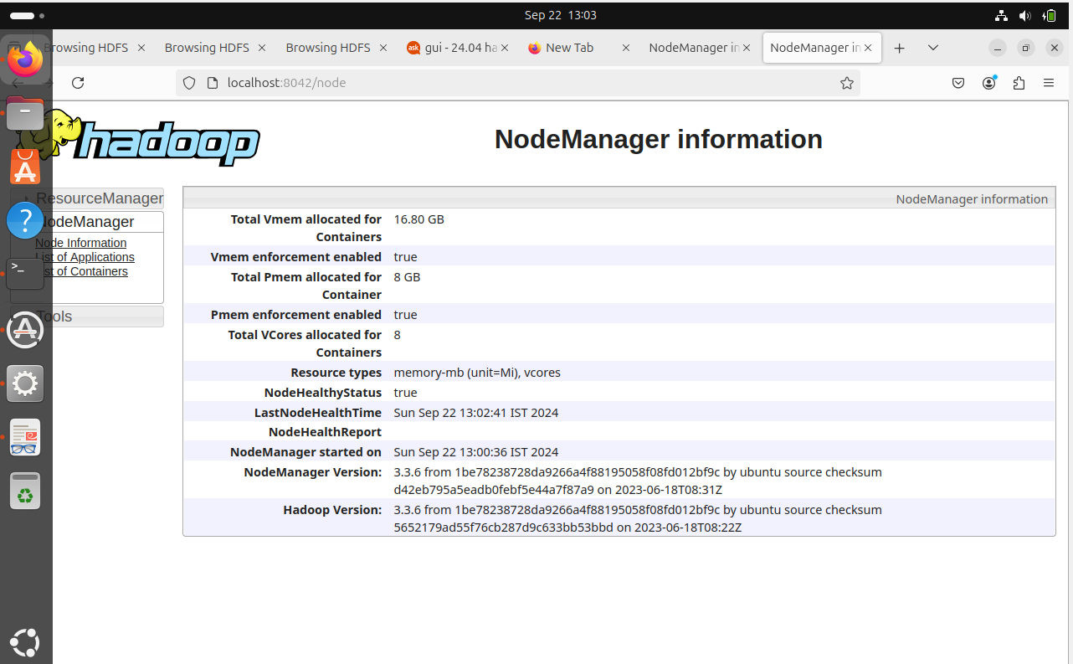

**Step 9: Stop Hadoop Cluster**

To stop the Hadoop all services, run the following command:

**stop-all.sh**



**RESULT:**

The step-by-step installation and configuration of Hadoop on Ubuntu system have been successfully completed.