**Exp.No: 9**

**Implement clustering techniques – Hierarchical and K-Means**

**AIM:**

To Implement clustering techniques – Hierarchical and K-Means using R.

**PROCEDURE:**

* Load the dataset from sources such as CSV files or databases using appropriate libraries.
* Perform data cleaning and preprocessing, including handling missing values and scaling features for consistency.
* Decide on the number of clusters (K) for K-Means or establish the stopping criterion for Hierarchical Clustering.
* Select the suitable clustering algorithm: utilize K-Means for partitioning or Hierarchical Clustering for creating nested groups.
* Implement the K-Means algorithm using fit_predict to categorize data points into clusters.
* Use Agglomerative Clustering for Hierarchical Clustering to create a hierarchy of clusters.
* Visualize the resulting clusters using scatter plots for K-Means and dendrograms for Hierarchical Clustering.
* Assess clustering performance through metrics such as silhouette score or inertia for K-Means.
* Tune the clustering process by modifying the number of clusters or adjusting linkage criteria.
* Analyze the results to gain insights into the data structure and the relationships among clusters.

**PROGRAM:**

**Hierarchical Clustering.R:**

# Load the iris dataset

data(iris)

# Use only the numeric columns for clustering (exclude the Species column)

iris_data <- iris[, -5]

# Standardize the data

iris_scaled <- scale(iris_data)

# Compute the distance matrix

distance_matrix <- dist(iris_scaled, method = "euclidean")

# Perform hierarchical clustering using the "complete" linkage method

hc_complete <- hclust(distance_matrix, method = "complete")

# Plot the dendrogram

plot(hc_complete, main = "Hierarchical Clustering Dendrogram", xlab = "", sub = "", cex = 0.6)

# Cut the tree to form 3 clusters

clusters <- cutree(hc_complete, k = 3)

# Print the cluster memberships

print(clusters)

# Add the clusters to the original dataset

iris$Cluster <- as.factor(clusters)

# Display the first few rows of the updated dataset

head(iris)

**K-Means Clustering.R:**

# Load the iris dataset

data(iris)

# Use only the numeric columns for clustering (exclude the Species column)

iris_data <- iris[, -5]

# Standardize the data

iris_scaled <- scale(iris_data)

# Set the number of clusters

set.seed(123) # For reproducibility

k <- 3 # Number of clusters

# Perform K-Means clustering

kmeans_result <- kmeans(iris_scaled, centers = k, nstart = 25)

# Print the K-Means result

print(kmeans_result)

# Print the cluster centers

print(kmeans_result$centers)

# Add the cluster assignments to the original dataset

iris$Cluster <- as.factor(kmeans_result$cluster)

# Display the first few rows of the updated dataset

head(iris)

# Plot the clusters

library(ggplot2)

ggplot(iris, aes(x = Sepal.Length, y = Sepal.Width, color = Cluster)) +

geom_point(size = 3) +

labs(title = "K-Means Clustering of Iris Dataset", x = "Sepal Length", y = "Sepal Width")

**OUTPUT:**

**Hierarchical Clustering:**

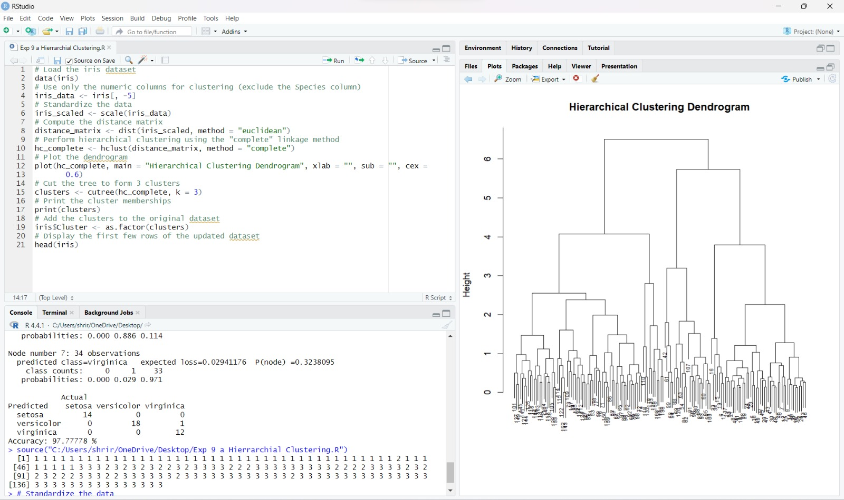

**K-Means Clustering:**

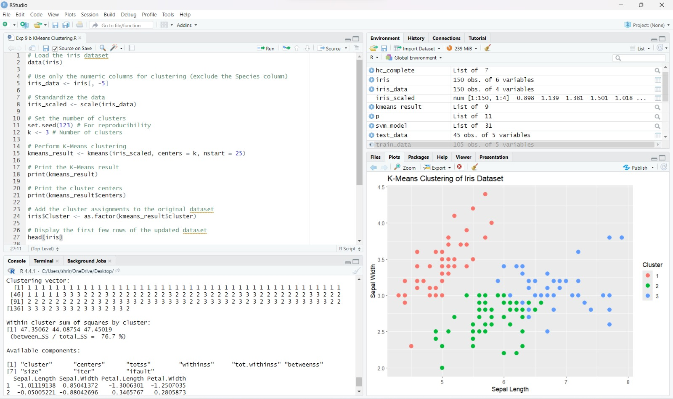

**RESULT:**

Thus the clustering techniques – Hierarchical and K-Means using R has been successfully executed.