**Exp.No: 10**

**Visualize Data using Any plotting Framework**

**AIM:**

To Visualize Data using Any plotting Frame work using R programming.

**PROCEDURE:**

* Install Plotly if it’s not already present by running pip install plotly.
* Import the required libraries: import plotly.express as px and import pandas as pd.
* Load your dataset into a DataFrame using pd.read_csv() or other suitable methods for data loading.
* Examine the dataset to grasp its structure, variables, and potential visualizations.
* Select the appropriate Plotly function (e.g., px.scatter, px.bar, px.line) based on the data type and the visualization you wish to create.
* Specify the x and y axes by selecting the corresponding columns from the DataFrame.
* Enhance the plot by adding titles, axis labels, color coding, and other relevant attributes.
* A Introduce interactive features such as hover data, tooltips, or facet plots for enriched insights.
* Render the plot using fig.show() to display it in a web browser or inline within a notebook.
* Save the visualization to an HTML file or as a static image using fig.write_html() or fig.write_image().

**PROGRAM:**

**Scatter Plot.R:**

# Install ggplot2 (if not already installed)

install.packages("ggplot2")

# Load the ggplot2 package

library(ggplot2)

# Scatter plot of Sepal.Length vs Sepal.Width, colored by Species

ggplot(data = iris, aes(x = Sepal.Length, y = Sepal.Width, color = Species)) +

geom_point(size = 3) + # Adds points

labs(title = "Scatter Plot of Sepal Dimensions",

x = "Sepal Length (cm)",

y = "Sepal Width (cm)") + # Adds axis labels and title

theme_minimal() # Applies a minimal theme

**Bar Chart.R:**

# Install ggplot2 (if not already installed)

install.packages("ggplot2")

# Load the ggplot2 package

library(ggplot2)

# Bar plot of Species counts

ggplot(data = iris, aes(x = Species)) +

geom_bar(fill = "steelblue") + # Adds bars filled with steel blue color

labs(title = "Count of Different Species in Iris Dataset",

x = "Species",

y = "Count") +

theme_minimal()

**Histogram.R:**

# Install ggplot2 (if not already installed)

install.packages("ggplot2")

# Load the ggplot2 package

library(ggplot2)

# Histogram of Sepal Length

ggplot(data = iris, aes(x = Sepal.Length)) +

geom_histogram(binwidth = 0.3, fill = "orange", color = "black") + # Adds histogram bars

labs(title = "Histogram of Sepal Length",

x = "Sepal Length (cm)",

y = "Frequency") +

theme_minimal()

**Box Plot.R:**

# Install ggplot2 (if not already installed)

install.packages("ggplot2")

library(ggplot2)

# Box plot of Sepal Length for each Species

ggplot(data = iris, aes(x = Species, y = Sepal.Length, fill = Species)) +

geom_boxplot() + # Adds box plot

labs(title = "Box Plot of Sepal Length by Species",

x = "Species",

y = "Sepal Length (cm)") +

theme_minimal()

**OUTPUT:**

**Scatter Plot:**

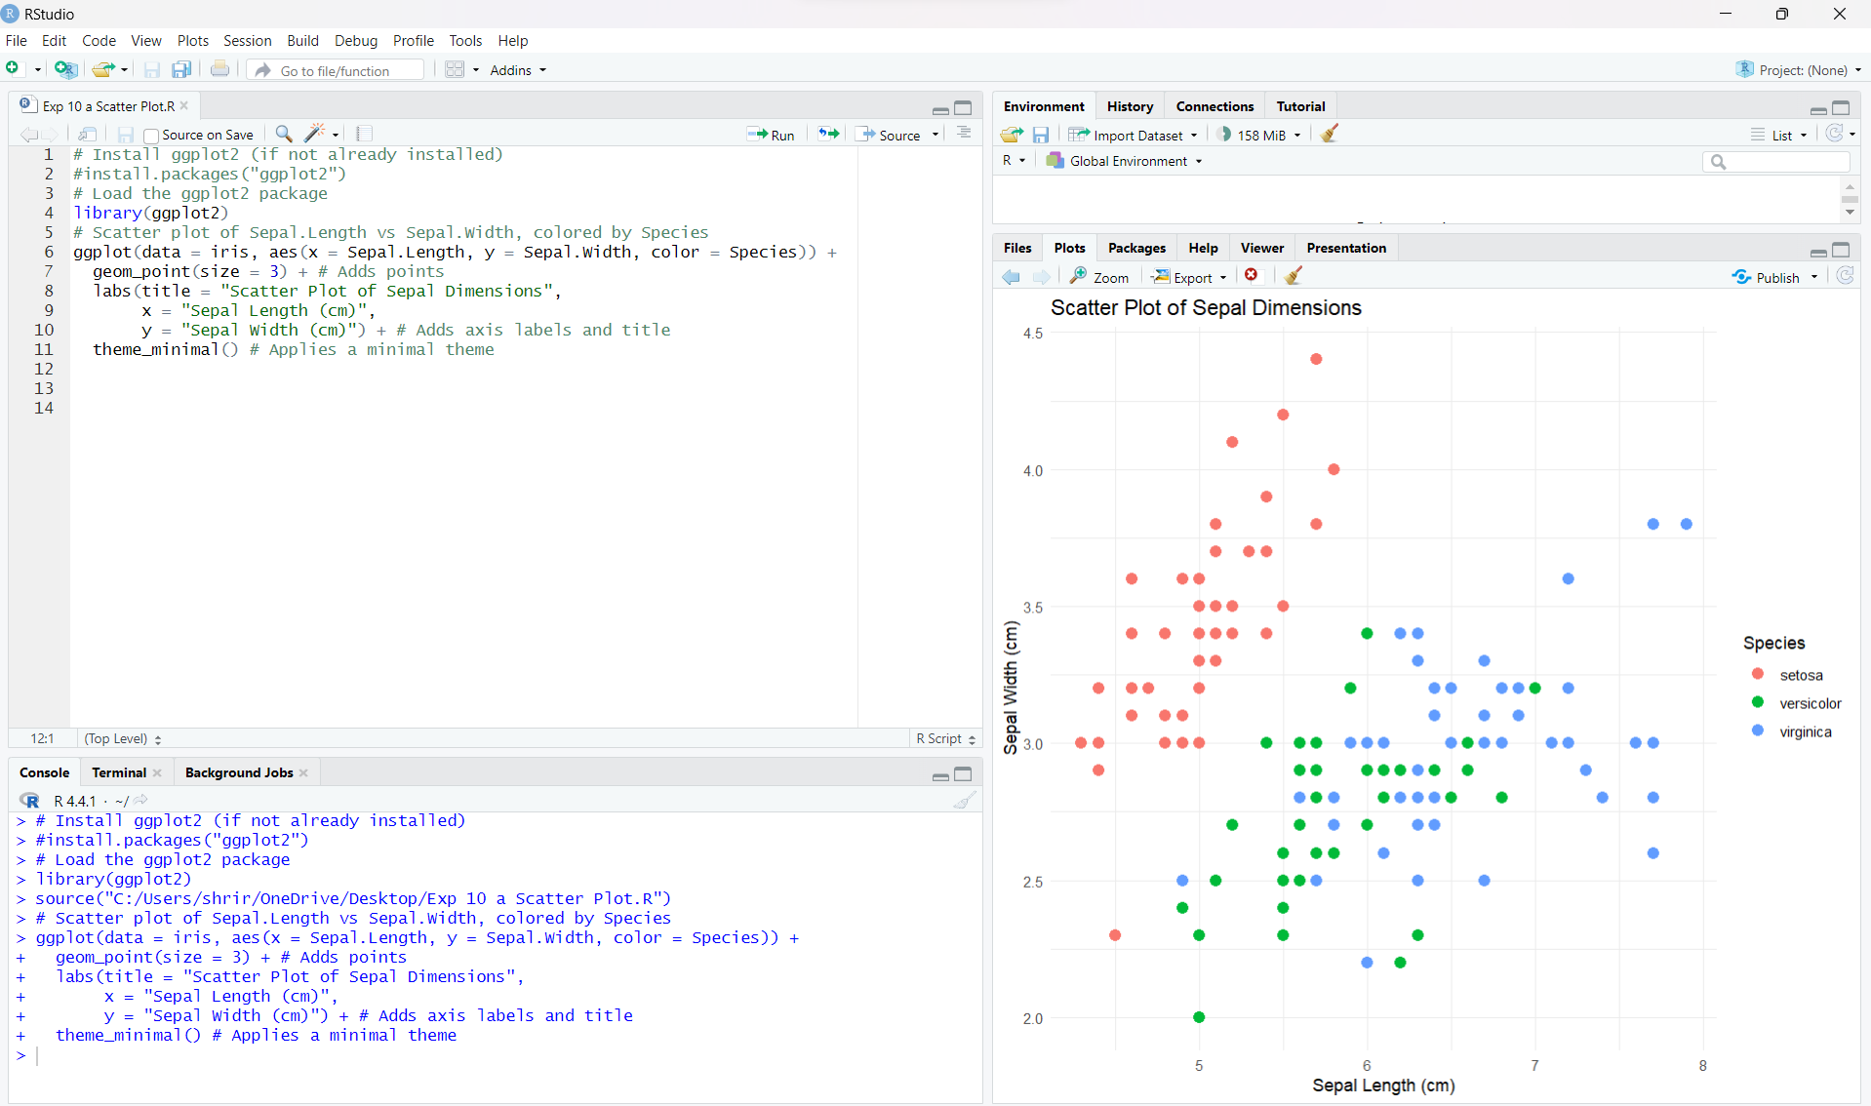

**Bar Chart:**

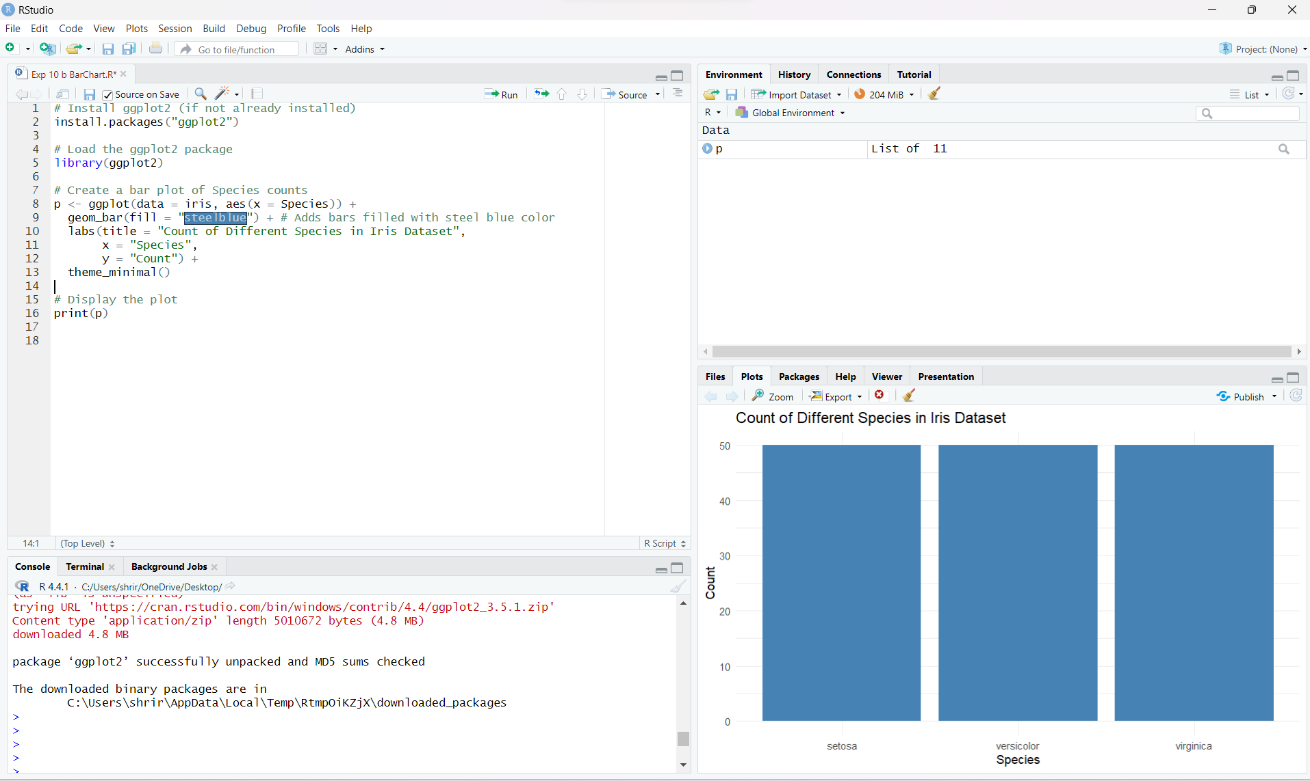

**Histogram:**

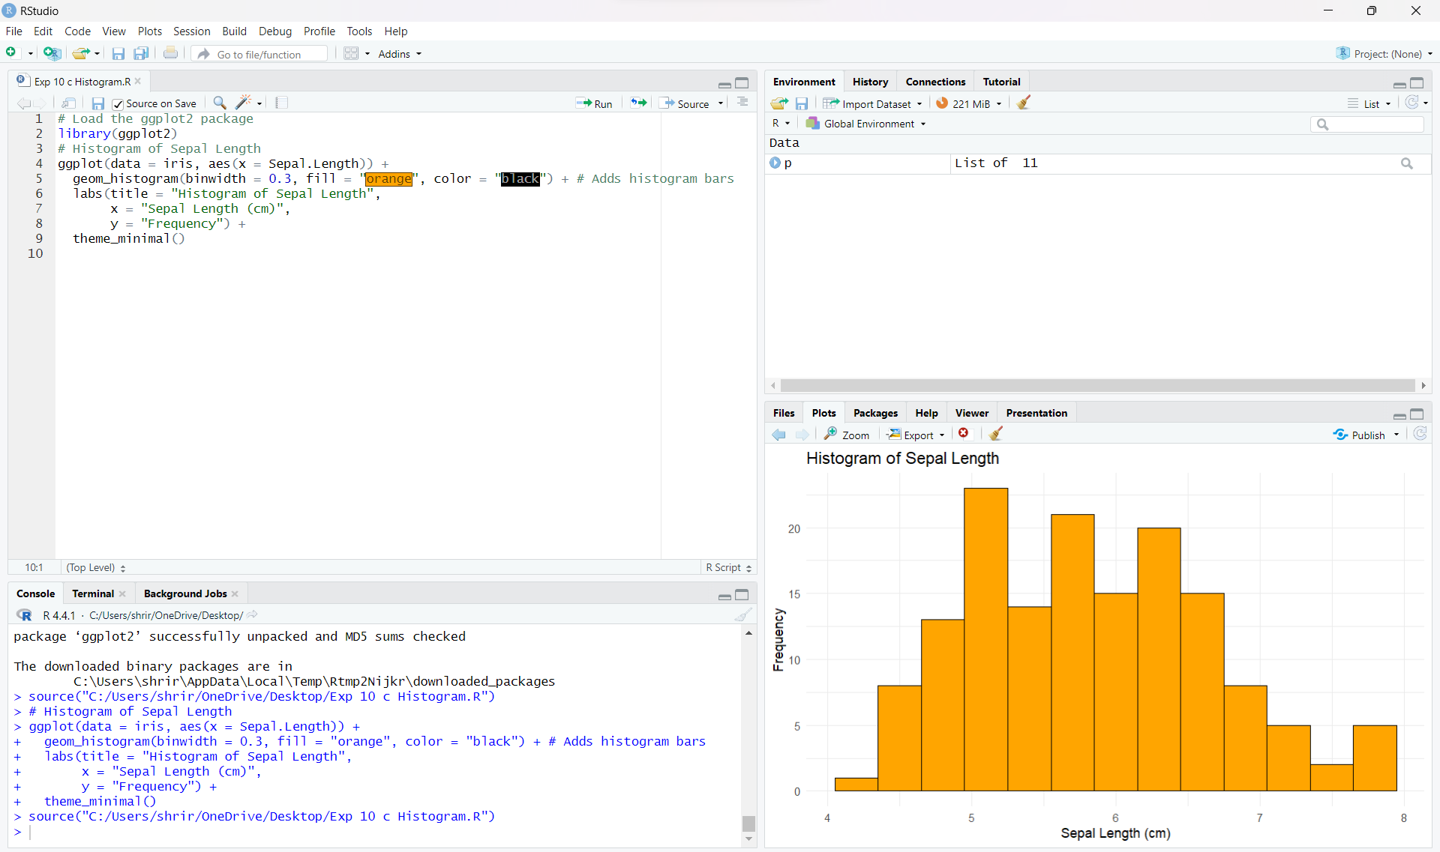

**Box Plot:**

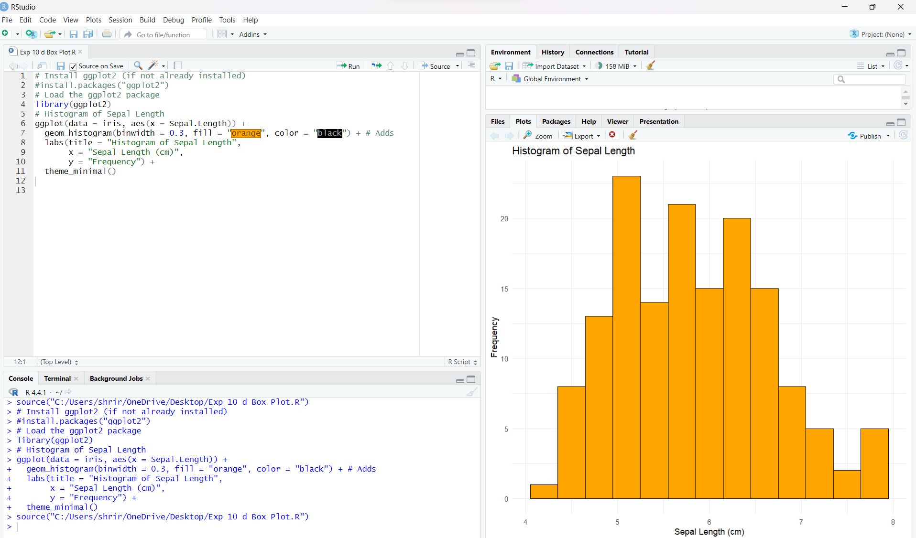

**RESULT:**

Thus, Visualizing Data using any plotting framework using R programming has been successfully executed.