TCI SAP S/4 HANA Implementation

Technical Specification

Booking Program – UI – XSA Document

Version : 2.0
Date Created : 23-04-2020

Author : Harish Surwase

Document Information

GAP/CR ID

FS Definition Form ID

Type of development | UI5, HDB, XSODATA
SAP R/3 Version | S/4HANA ON PREMISE 1709

Approval

Approved by | Name | Role | Signature | Date
Process Team Lead
Development Team Lead
TCI System Analyst

Document History

Version | Author | Reason for change | Date
1.0 | Harish Surwase | Initial draft | 16.04.2020
2.0 | Harish Surwase | New CR | 22.04.2020

Related Documents
<Reference document name and location link>
Table of Contents

1. General Information 4
2. Description and Purpose 4
3. Assumptions 5
4. Issues 5
5. Dependencies 5
6. Technical Details 5
7. Models Details 9
8. Views Details 10
9. View Controllers Details 13
10. Fragments Details 15
11. Component JS Details 15
12. Formatters Details 15
13. Patterns Details 15
14. ODATA-Gateway (Back-end) 16
15. Data Source consideration 16
16. Data Validation 16
17. Error Handling 16
18. Security Requirements/ Authorization Details 17
19. Additional Information and attachments 17
20. HANA Artifacts 17
21. Node JS/XSJS 17
22. Unit Test Plan 19

General Information

WRICEF ID
Description | Booking Program
Implementation Phase | Wave 2
Transaction(s) (if applicable) | N/A
Package | ZFIORI
Message Class (if applicable)
Develop. Class
Module | XSA, UI, HANA 2.0
Enhancement User/User Group
Run Frequency |  | Language | English & French

GIT Information

Sr.No # | Branch Name | User id | Description
1 |  | harish_surwase@toyota.ca | https://toyotacanada.visualstudio.com/SAP/_git/bookingprogram  Booking Program

Description and Purpose

Toyota Canada runs Booking Programs to allow Dealers to pre-plan their inventory needs, both from an overall quantity and from a delivery timeline perspective. Often these programs have incentivized pricing that is only offered during the Booking Program.

To date programs have been primarily orchestrated by Service Retention (for Tires, Wheels and Wheel Packages), with heavy reliance on Information Services. Going forward the aim is to make Business much more self-sufficient in setting up and running these Programs
According to type of user logged in differ OData services will be called up,

1.Program Admin:

- Program Admin can initiate the Setup of new program and administer booking program for their own department.
- Search for or update existing active booking programs.
- Can define different parameters like booking window, delivery window, part categories, parts offered, include vendors, delivery methods, available delivery locations for booking program.
- Can initiate the generation of Dealer orders to SAP and complete the program for their department once it is ‘Closed’.
- Can view dealer bookings.
- Update summary information for the program
- Upload / Update Vendors (offering Parts or acting as Distributors), Delivery Methods, Delivery locations and parts.
- Upload / Update Prior purchase information for dealers.

2.Booking parts:

- Dealers can book the parts they want to order within booking Window of program.
- Dealer can save partially completed orders and can confirm or unconfirm the same within booking window of program.
- Dealers can view the orders/parts they have booked and can export list of parts orders and booking quantities to spreadsheet.
- Dealer can generate Sales Plan report for their dealership.
- Cannot modify parts on confirmed order.

3.Schedule delivery

- Dealer can schedule delivery for booked quantities within Delivery Window.
- They can schedule the deliveries for the quantities they would like to delivery each month.
- Delivery quantities can be re-scheduled during delivery window if order is not confirmed.

CR 1063 Requirement

Dealer Booking View:
- Add additional filters: 1. Series, 2. Model year, 3. Vendor & 4. Tire Size, dealer User must be forced to do a primary selection on Series or tire size first to have the data load and then see additional filter for year, manufacturer(vendor) once they get the frst set of data

- Allow dealer user to sort on the columns part number, price, tire size, speed rating and load rating

- Add Tire Size, speed rating and load rating to the search results

- Extract Tire Size , load rating, speed rating and Dealer Net from local HANA instead of S4. Also don’t store Dealer Net In the dealer order table – identify any downstream impact caused by this

- Part Upload:
  - Extract Tire Size, speed rating, load rating & Dealer Net from S4 during the part upload and save it to local HANA database . Add 4 columns to the Program Part Table for Tire Size , speed rating, load rating and Dealer Net
  - Update the UI to display the new fields to the admin user for validation

- Extract Model Descriptions (English and French), Series Descriptions(English and French) and Brand during the Fitment upload and store in LOCAL HANA Tables. Optimize the local HANA tables for better performance.

- For Fitment information please investigate if we can automate the tire fitment information to get the data for the Program parts from the ZVMS_FITMENT Table in S4 and store it in the local hana database based on Adhoc request from User ( there would be a need to add a user driven event to trigger this ) , this would be an alternative to the excel upload functionality
Lower Priority issues to be resolved:
- All excel uploads need to provide error details if the load fails , success message to be displayed only once data is successfully loaded to the database tables
- Export orders button to be displayed on Program info page , to reduce the number of key clicks and make process more efficient for user when exporting the orders to spreadsheet
- Allow delta load based on key fields , if key exists overwrite if it does not exist add the record

CR-1079 Requirement
Create sales order with one delivery line per part number instead of multiple delivery lines.

Current Functionality: -

For Booking Program sales order get created with multiple schedule lines having each schedule line has its own date,
as Jason file is creating multiple schedule dates for one part per dealer.

Expected Functionality: -

Need to restructure Jason file per dealer per material in single schedule line.
Means even though dealer booked the same part in multiple delivery dates file needs to consolidate all the quantity in one delivery date which is earliest.
Eg. If Dealer Booked Part# C0PTI2362900 with Qty
10 on schedule date 2020-08-30,
Next Qty.
10 on schedule date 2020-27-09,
Next Qty.
10 on schedule date 2020-11-01,
Next Qty.
10 on schedule date 2020-11-29,

Then UI side pay load should club all 40 Qty with one schedule date 2020-08-30.

Sample Payload for existing scenario is,

[{"ORDER_TYPE":"ZBO","SALES_ORG":"7000","DIST_CHANNEL":"10","PARTNER_TYPE":"AG","DIVISON":"10","DEALER_BP":"2400042120","PROGRAM_ID":"81D41FB0D3C62C00F000000253860400","ITEMS":[{"VENDOR_ID":"2400100001","PART_NUMBER":"C0PTI2362900","schedule_lines":[{"Order_Qty":"10","Schedule_date":"2020-08-30"},{"Order_Qty":"10","Schedule_date":"2020-09-27"},{"Order_Qty":"10","Schedule_date":"2020-11-01"},{"Order_Qty":"10","Schedule_date":"2020-11-29"}]}

Expected Payload for existing scenario as part of this CR is

[{"ORDER_TYPE":"ZBO","SALES_ORG":"7000","DIST_CHANNEL":"10","PARTNER_TYPE":"AG","DIVISON":"10","DEALER_BP":"2400042120","PROGRAM_ID":"81D41FB0D3C62C00F000000253860400","ITEMS":[{"VENDOR_ID":"2400100001","PART_NUMBER":"C0PTI2362900","schedule_lines":[{"Order_Qty":"40","Schedule_date":"2020-08-30"}]}

After clubbing all the qty in one schedule line Idoc will get created with only one E1EDP20 segment per material

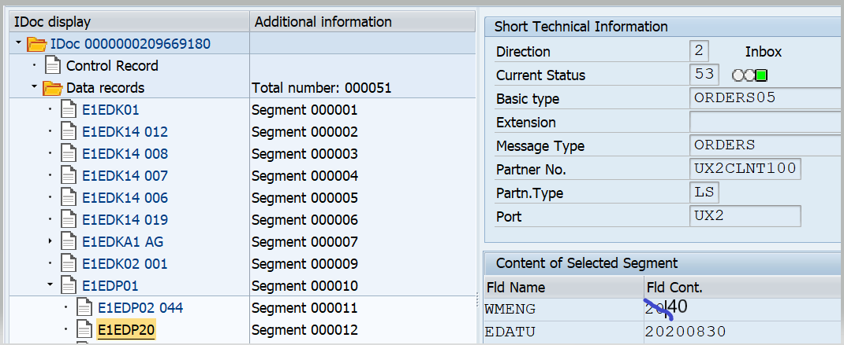

End Of Change for CR1079

Assumptions
Dealer will use Dealer Booking View to book quantity of the respective parts. National Users/ Booking Admins will use Admin Page to add Part and Part Fitment entries for dealers so that they will book quantity of respective parts.

Issues
Module | Defect
Dealer - Manage Booking - Book Orders | Booking program list should not show programs in future status - currently dealer can see ALL programs
 | Scroll buttons not working
Dealer- Schedule Delivery screen | This screen should not be affected by the search criteria - it should show all the dealers orders for all the vendors where quantity is greater than 0 . The confirm booking button should only allow confirm once all the scheduling information is populated
Dealer- Search Order Screen | When showing series dropdown – lexus dealers should see Lexus series only and Toyota should see only Toyota series
Admin- Vendor | Export Vendor Orders - column Dealer Order Status should show the dealer order status(confirmed or not confirmed) NOT the program status
Dealer - Manage Booking - Schedule delivery | Export All the dealers orders where order quantity greater than 0 & vendor description
 | "Export Vendor orders" button to be displayed on Program info page , to reduce the number of key clicks and make process more efficient for user when exporting the orders to spreadsheet (no change to functionality only button move)
Dealer Screen | Expand the visible area when showing the dealer booking to use more are on the page
Admin – Parts | Expand the number of records on the screen - use full screen , currently lots of empty space at the bottom
Admin-Fitment | Only 100 records are displayed at anytime on the screen and there is no ability to page to the next set .. lots of empty space at bottom of screen can whole screen be used
 | Edit mode - cannot filter data
Admin-  Delivery Location | Export not working for Delivery Location
Admin-Export Vendor Orders | Export Vendor Orders not working

Dependencies

Technical Details
  - Application Name: Booking Program
  - Type: XSA Multi Target Application
  - Latest Version: 1.0.0
  - UI5 Libraries: sap.ui.layout, sap.ui.core, sap.ushell, sap.m
  - Components: Device, Model, Dialog, Text, Filter, History, MessageBox
  - Screens: Home Screen for Admin:
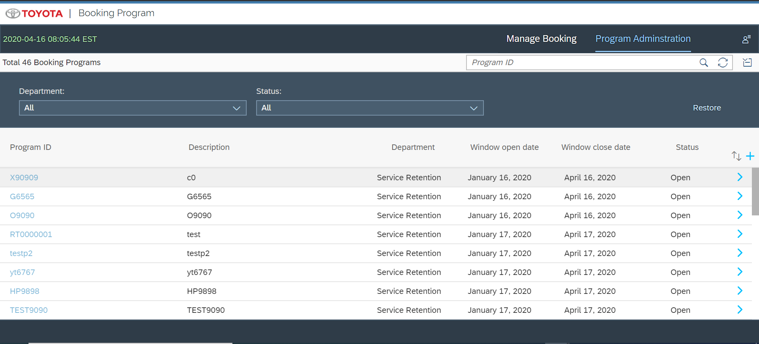

After clicking on Add(+) button Admin can add new program
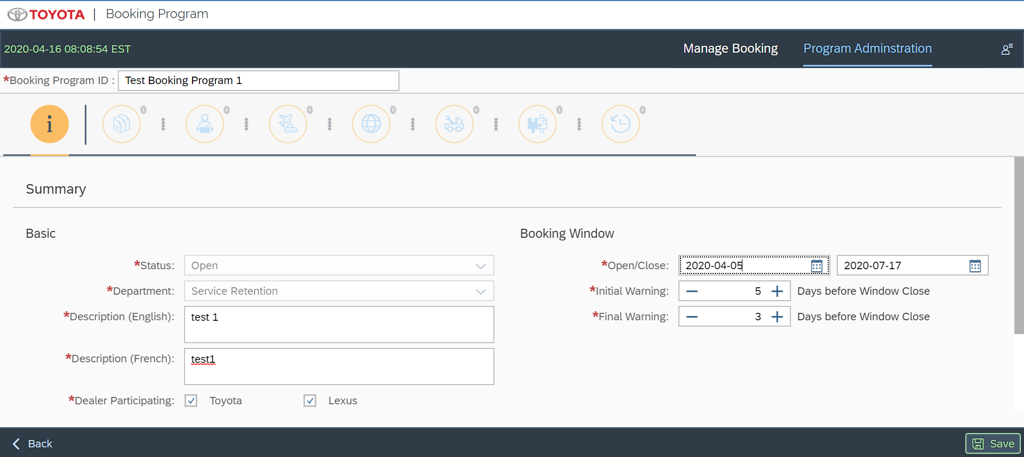

After clicking on Save button Admin can add remaining details of Category either manually or importing file.
- Manual Adding of Category
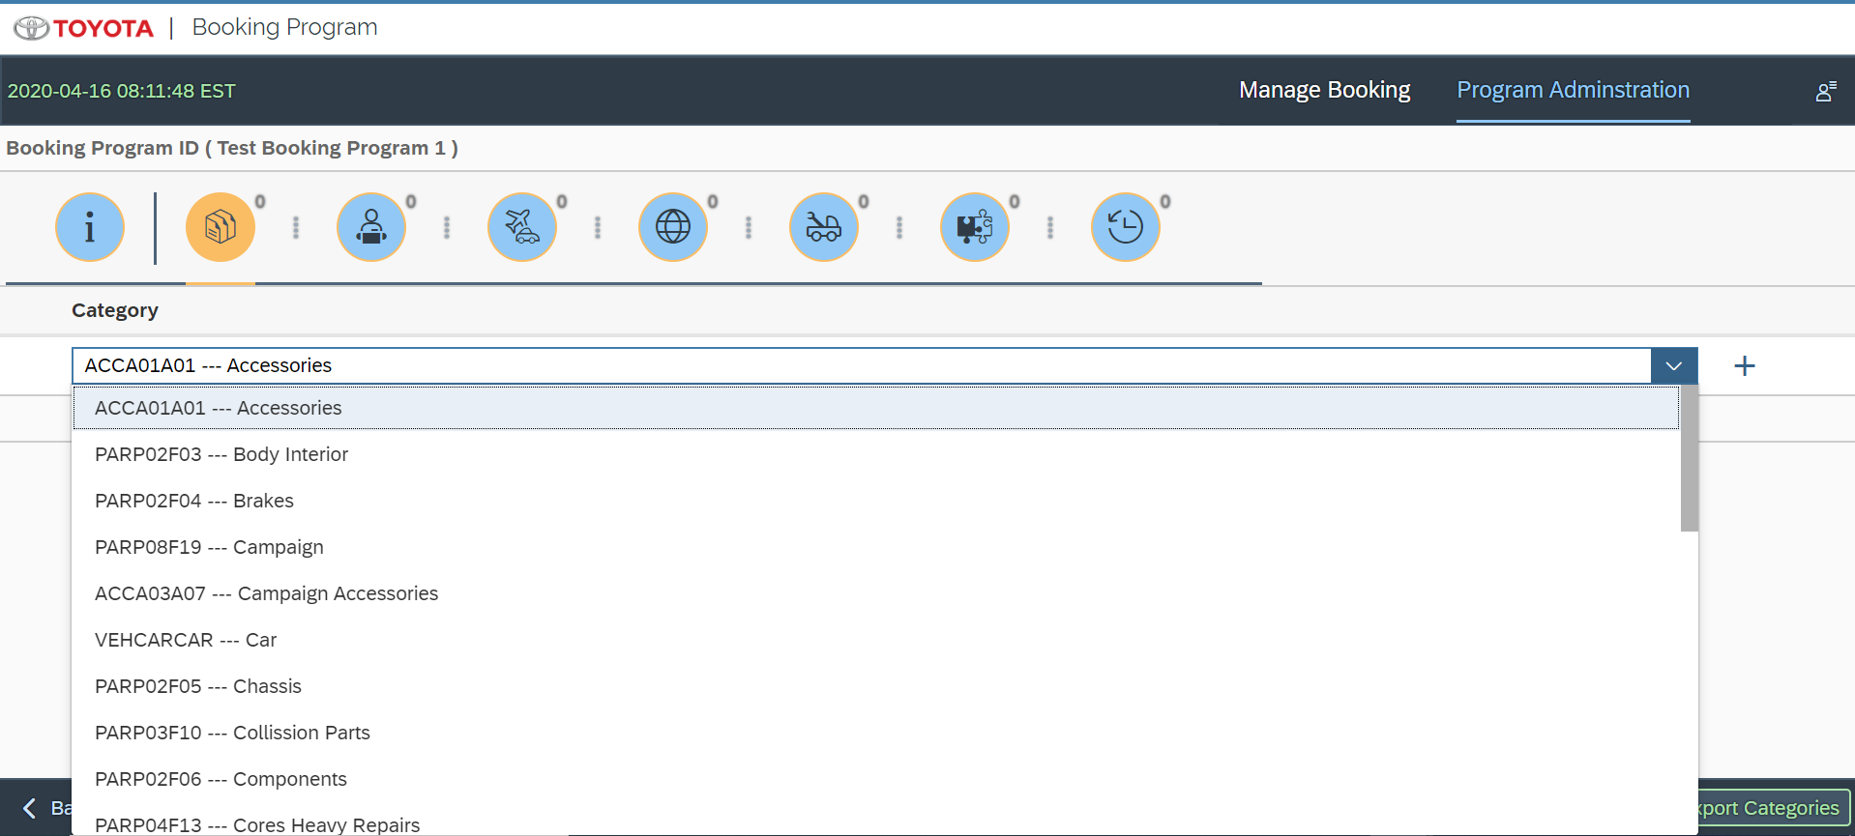

- Importing File of Categories

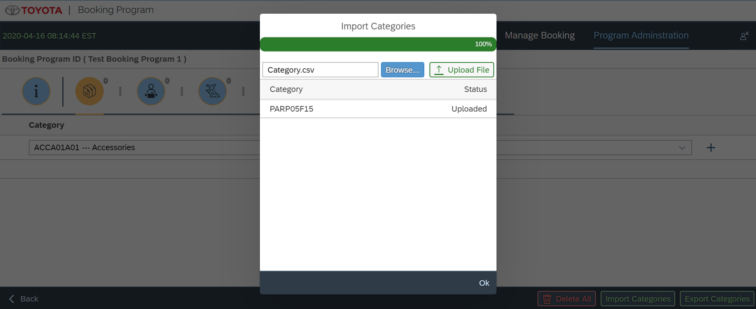

Same list of Categories can be exported into excel using “Export Categories” button

Same way they can add Vendor
- Manually
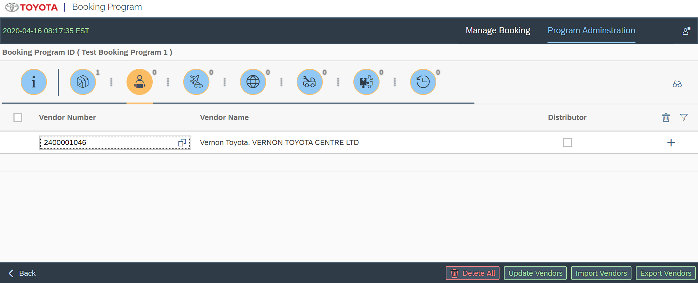

- Importing File
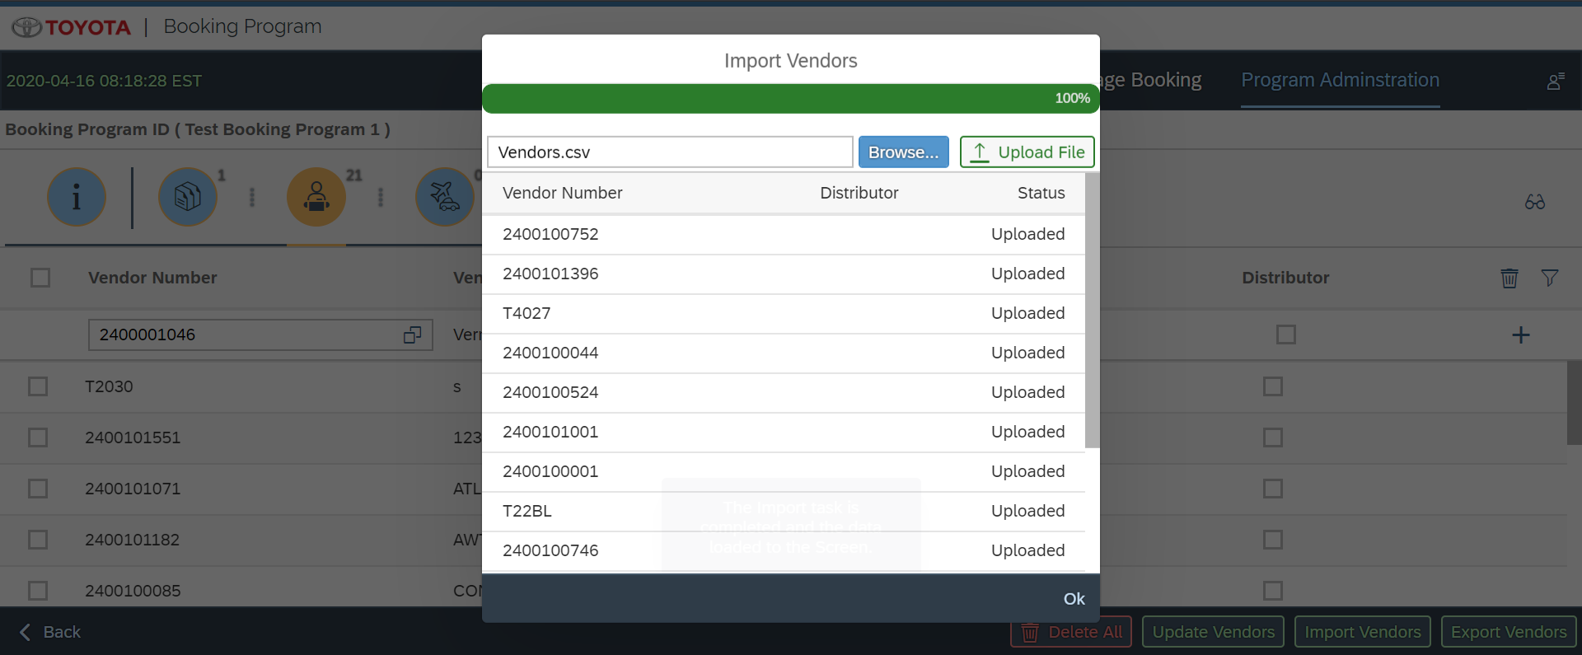

Same list of Vendors can be exported into excel using “Export Vendors” button

Add Delivery method
1.Manually

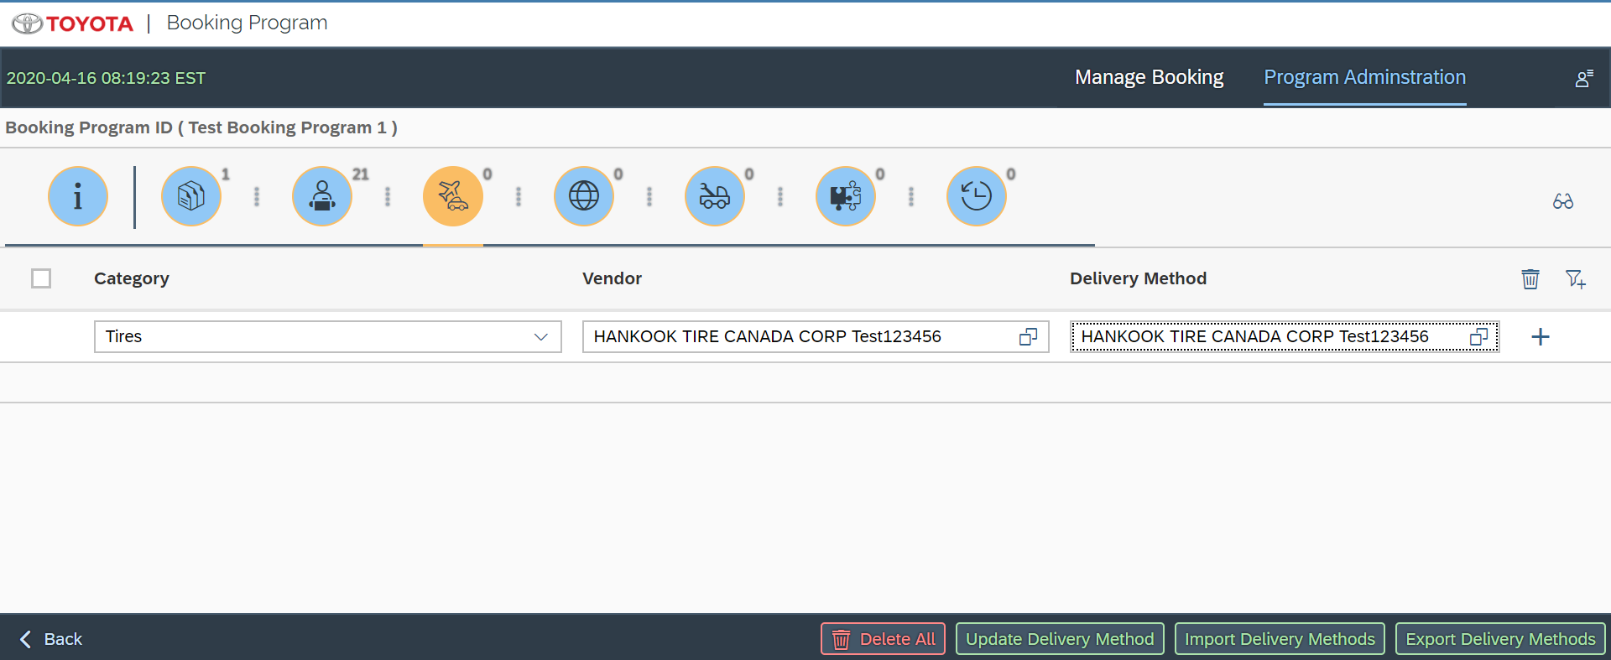

2.Importing File
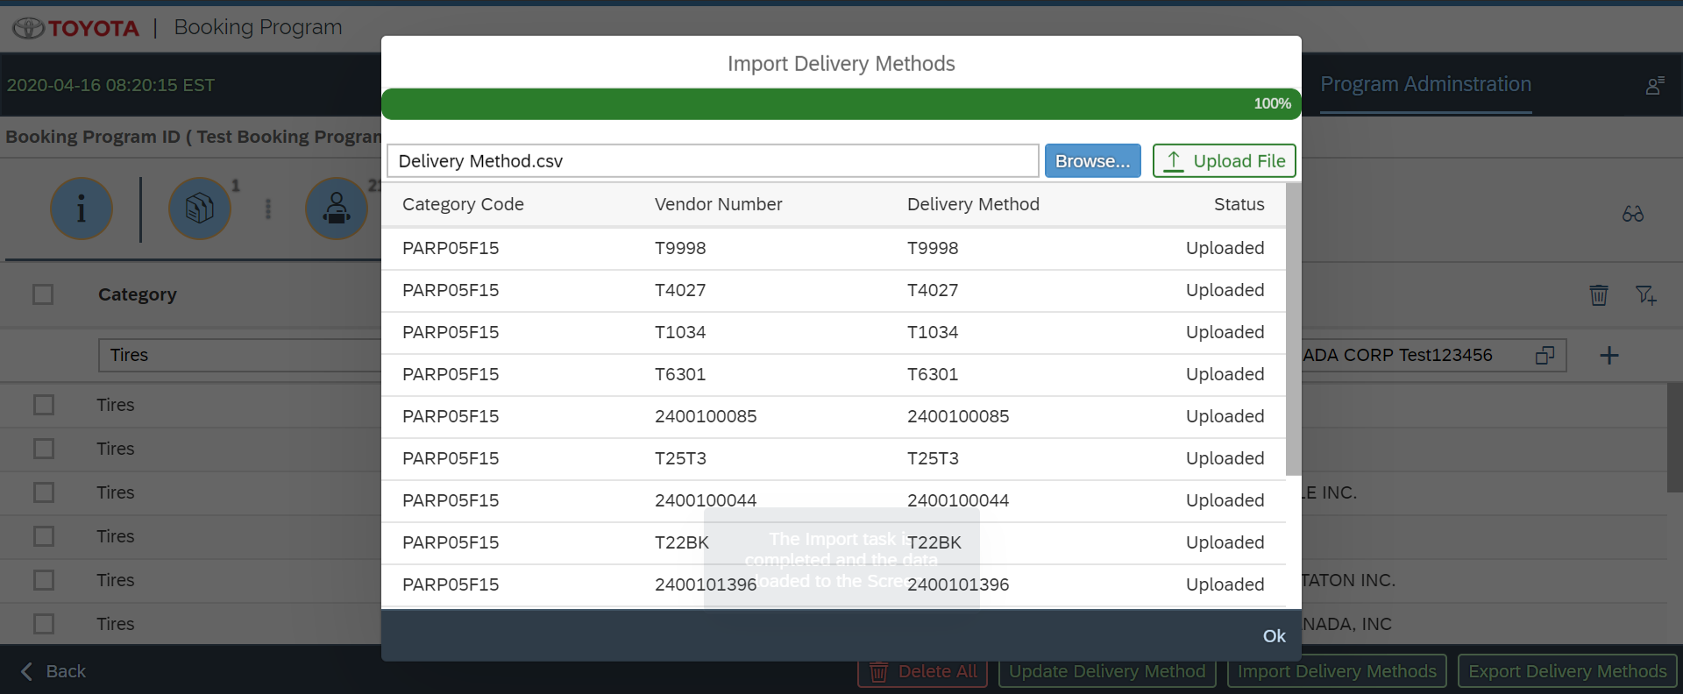
Same list of delivery methods can be exported into excel using “Export Delivery Methods” button

Adding Delivery Location
1.Manually

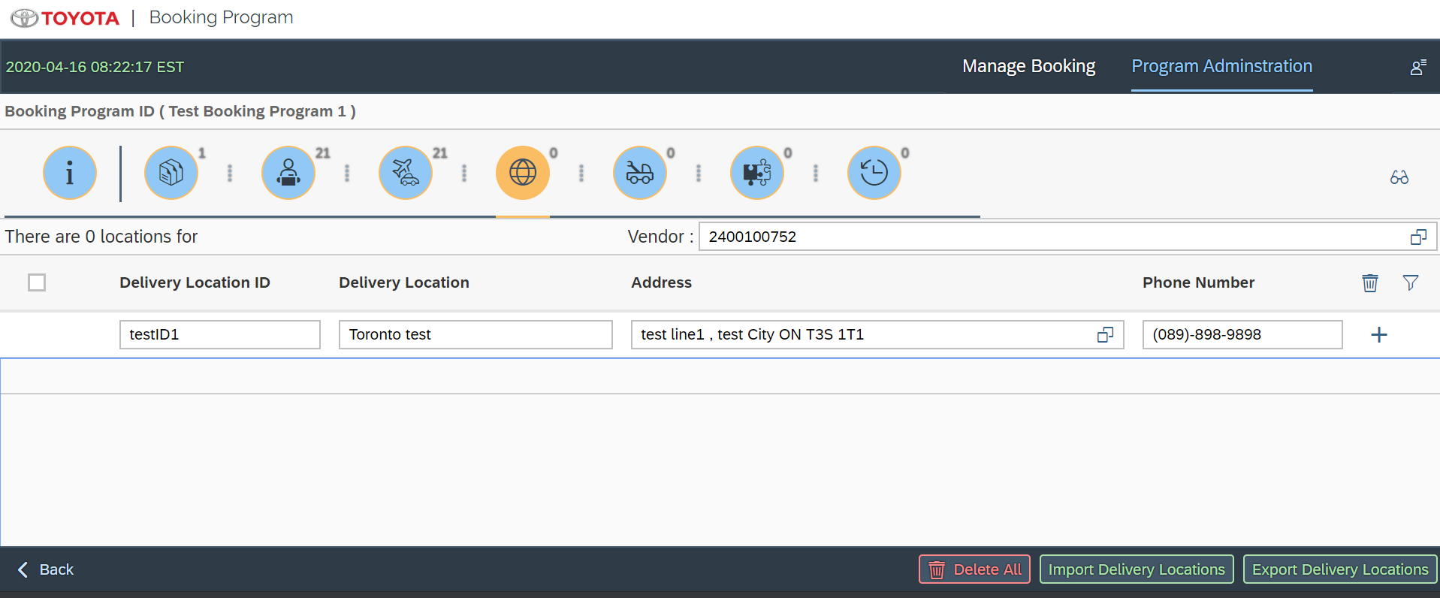

2.Importing File

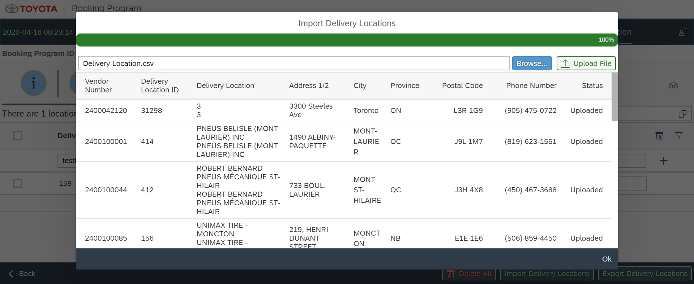

Same list of Delivery Locations can be exported into excel using “Export Delivery Locations” button
Adding Parts
1.Manually
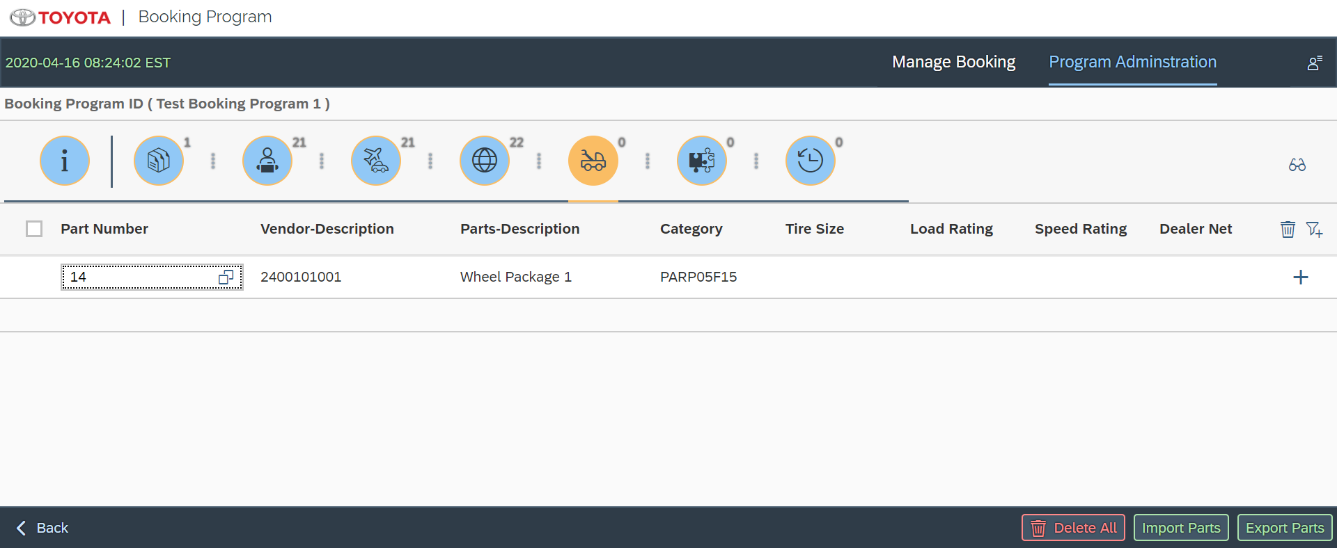

2.Importing File for Parts

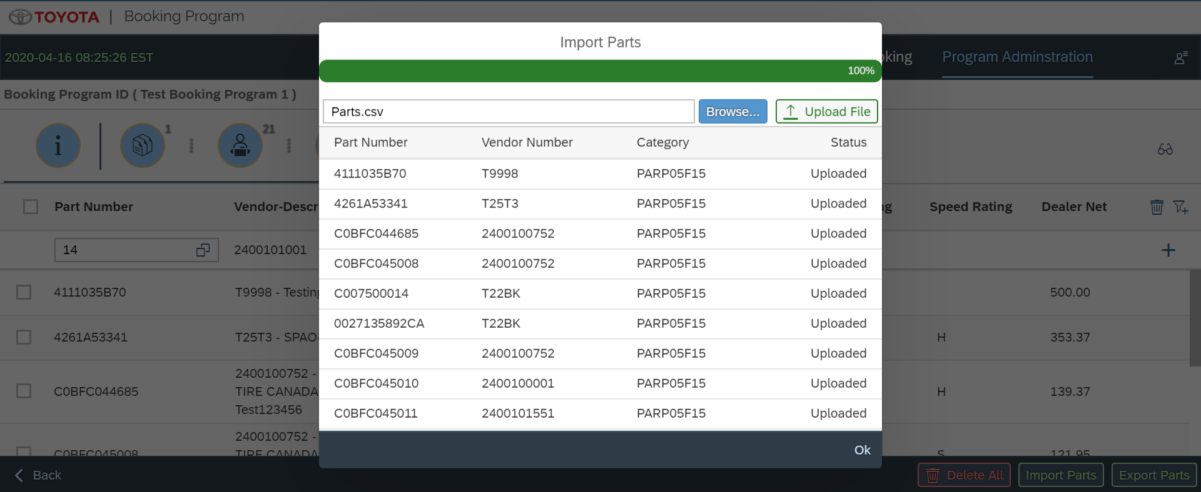
Same list of Parts can be exported into excel using “Export Parts” button
Adding Part Fitments
1.Manually
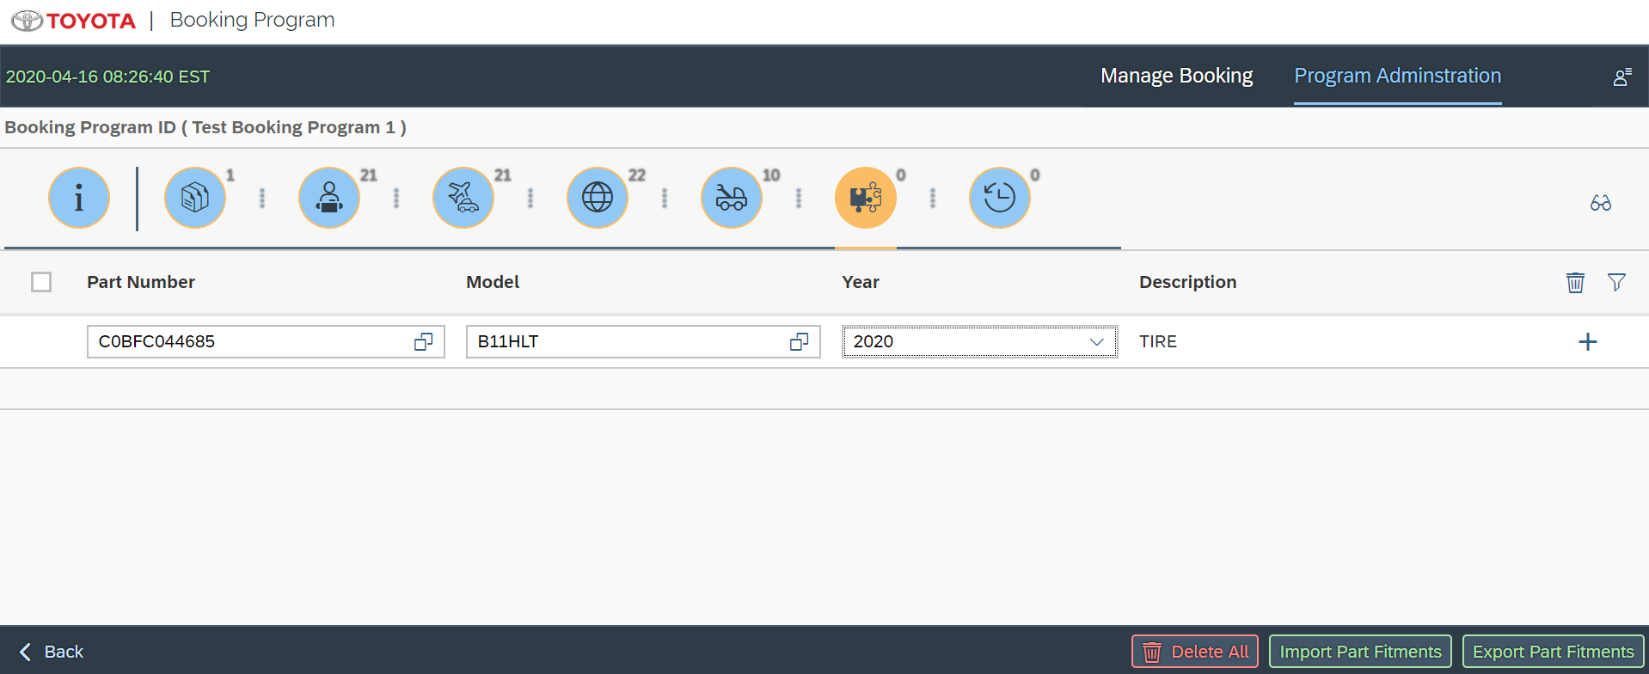

2.Importing File of Part Fitments

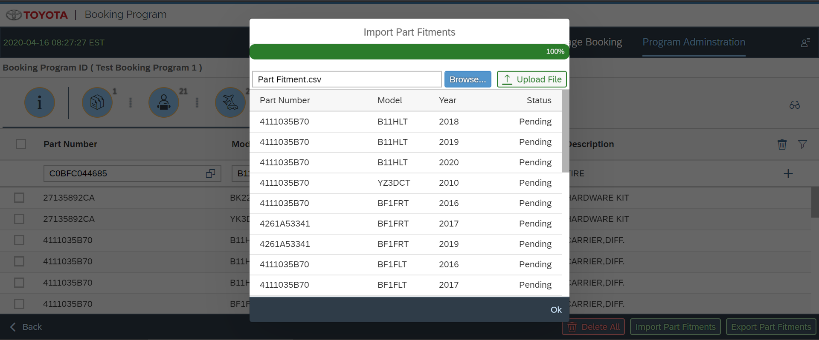
Same list of Part Fitments can be exported into excel using “Export Part Fitments” button

(Same way Admin can add Prior Purchases)

For Dealer Login Home Page
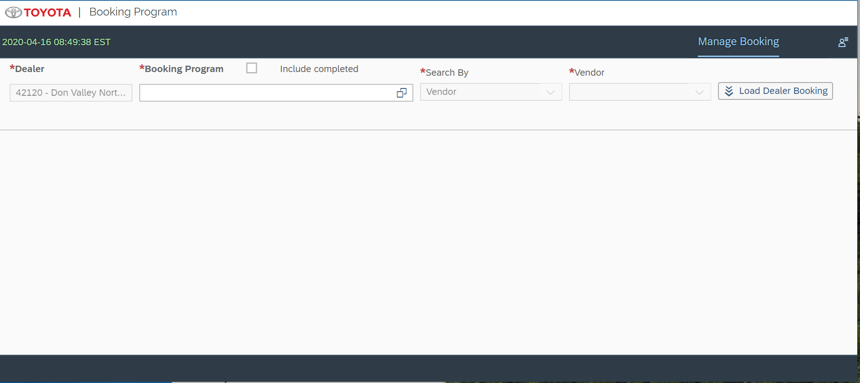

Here Dealer can select program created by admin
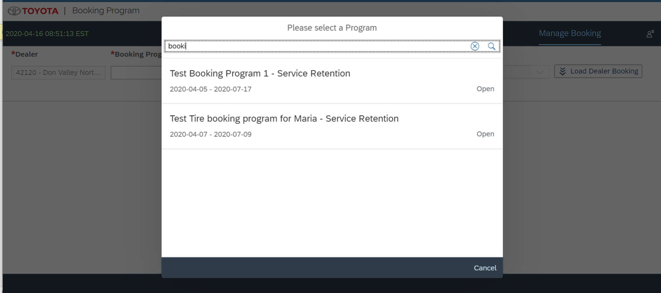

Then based on Vendor, Tire Size, Series they can select parts for booking their quantity

1.Vendor
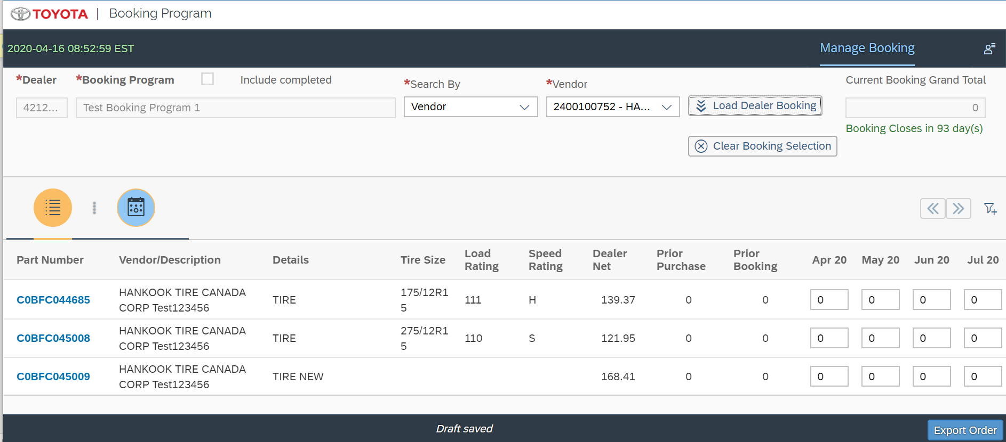

Here Export Order button will export the list of Parts with total quantity.
2.Tire Size

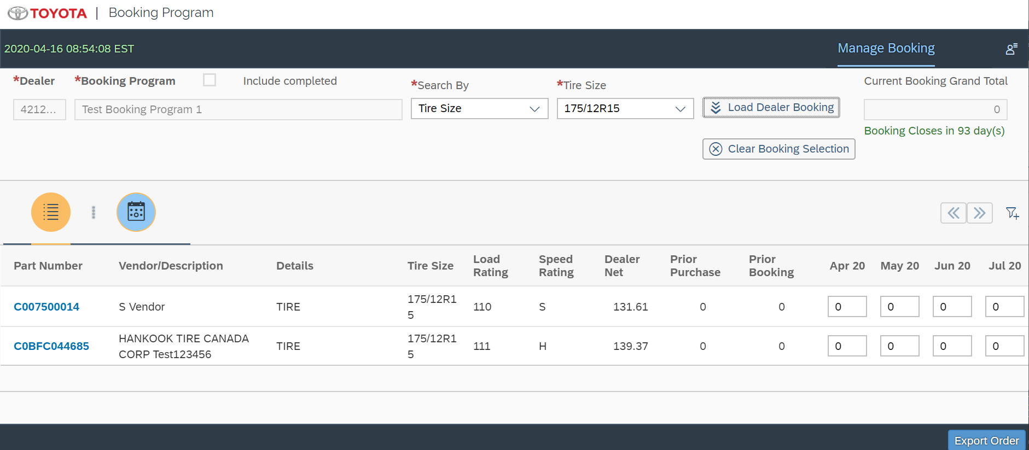
3.Series with specific year
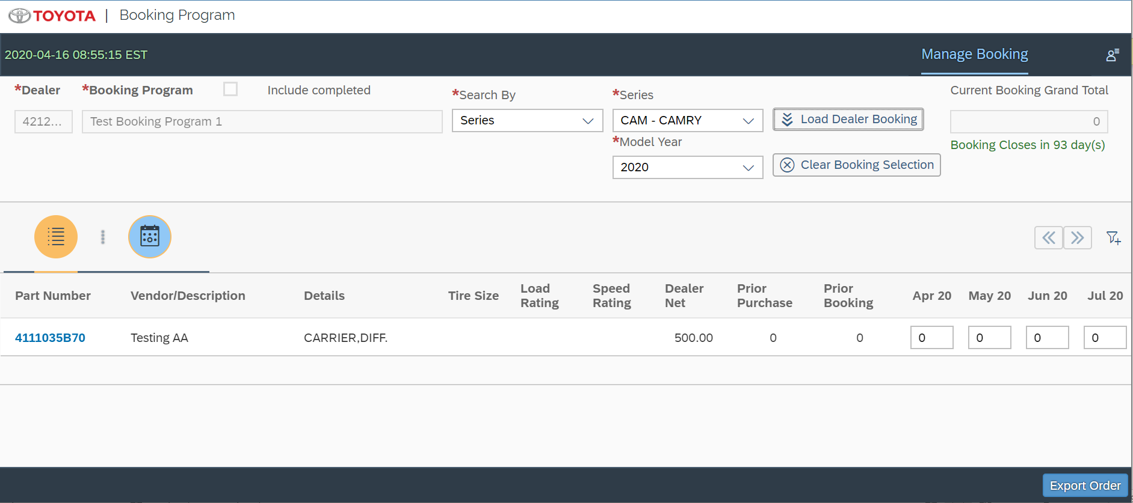

After adding quantity for parts Dealer can go to Schedule Delivery TAB and enter delivery method, delivery location and Delivery week for those cycle. And confirm their booking.

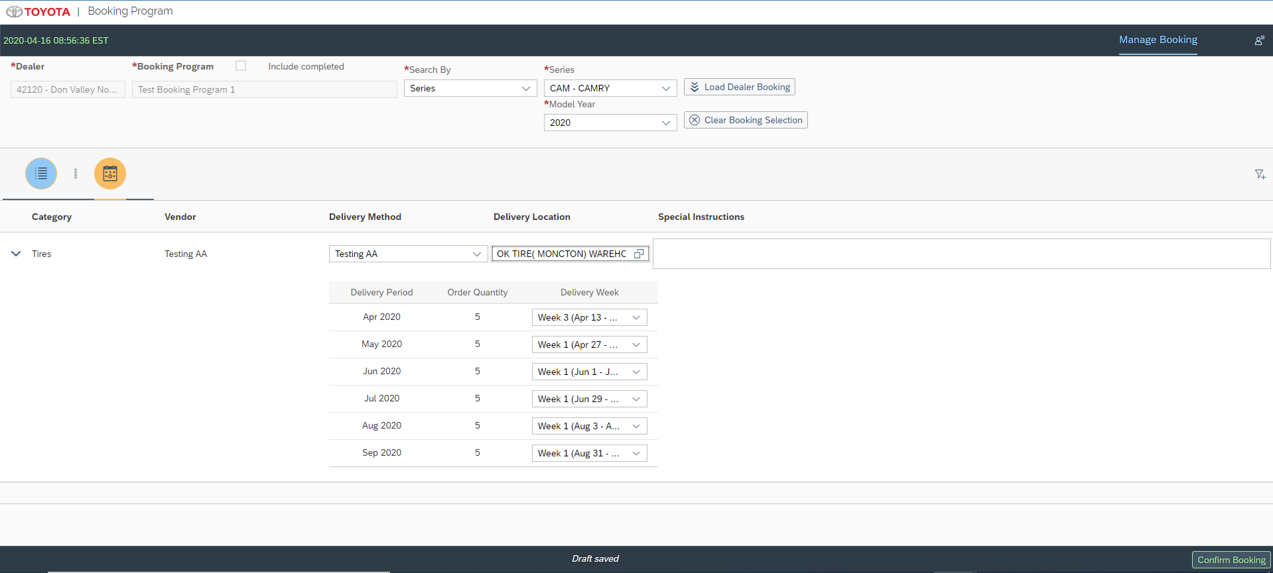

Once Program Close Date is crossed the status of that Program changes to Closed and Admin can see Submit Orders Button in Booking Summary Page

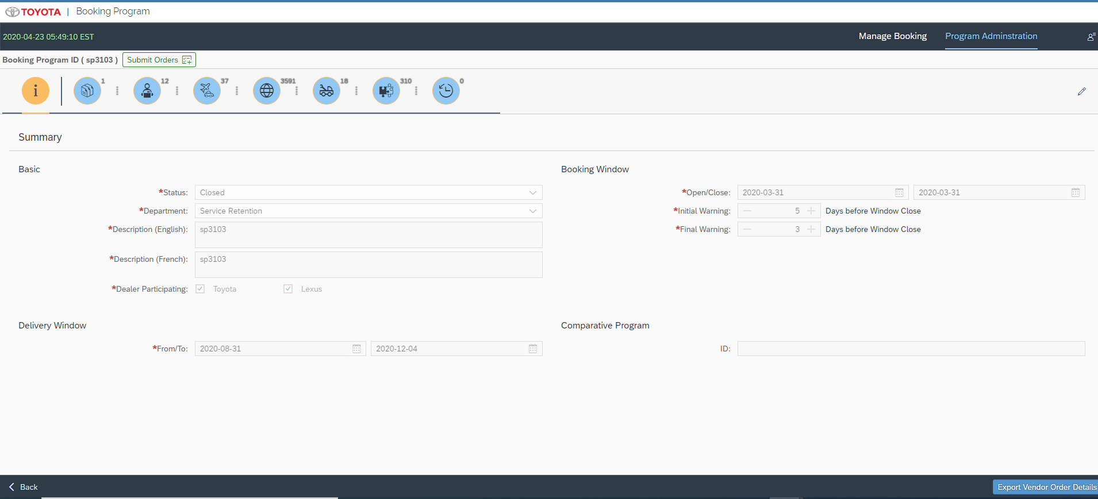
Here if you click on Export Vendor Order Details button will give you all orders of respective dealers with parts along with quantity and Delivery information
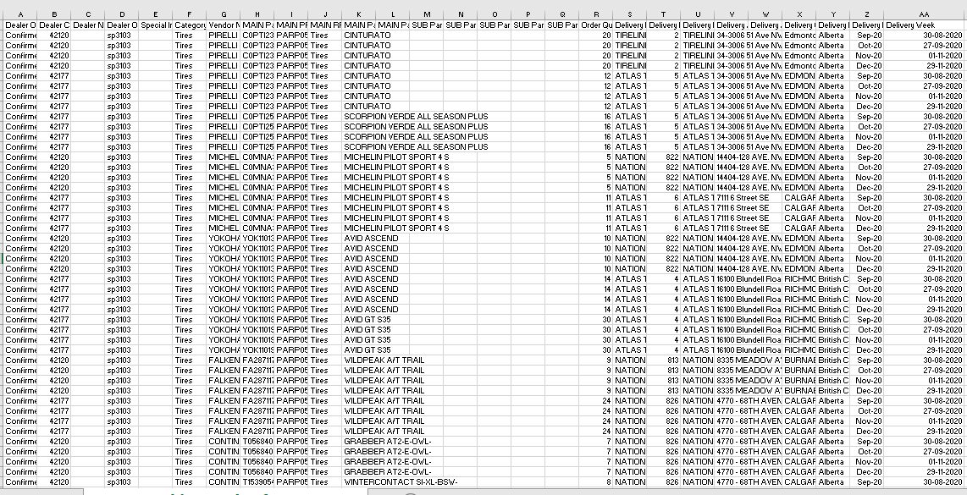
When user clicks on Submit Order, user now can see the payload with total quantity and first delivery week as delivery date.

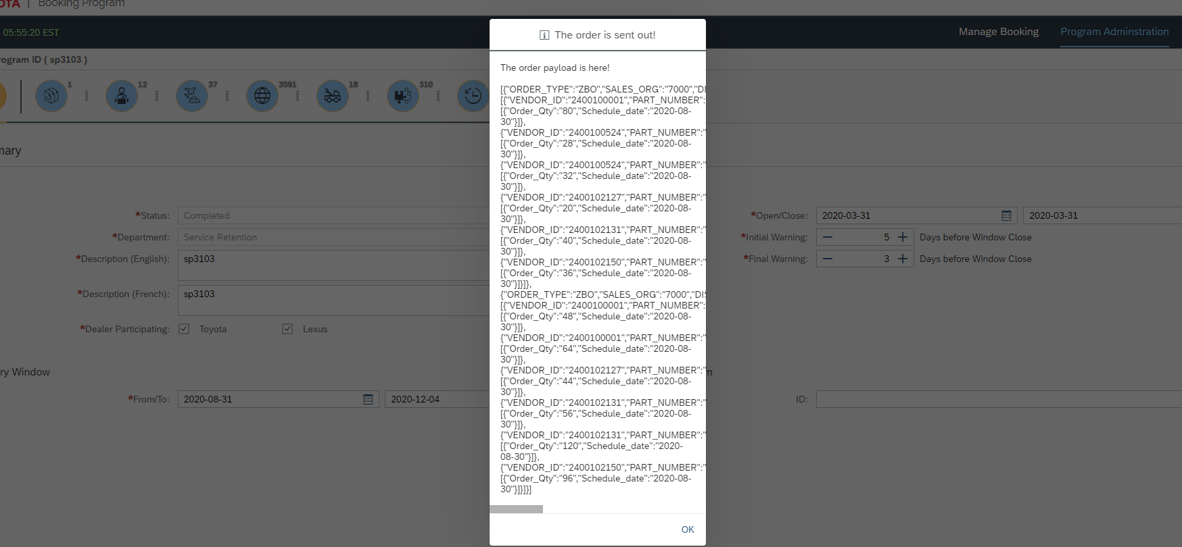

Now the payload is:
[{"ORDER_TYPE":"ZBO","SALES_ORG":"7000","DIST_CHANNEL":"10","PARTNER_TYPE":"AG","DIVISON":"10","DEALER_BP":"2400042120","PROGRAM_ID":"4F2F046E3FA32C00F000000205815400","ITEMS":[{"VENDOR_ID":"2400100001","PART_NUMBER":"C0PTI2362900","schedule_lines":[{"Order_Qty":"80","Schedule_date":"2020-08-30"}]},{"VENDOR_ID":"2400100524","PART_NUMBER":"T05684090000","schedule_lines":[{"Order_Qty":"28","Schedule_date":"2020-08-30"}]},{"VENDOR_ID":"2400100524","PART_NUMBER":"T15390540000","schedule_lines":[{"Order_Qty":"32","Schedule_date":"2020-08-30"}]},{"VENDOR_ID":"2400102127","PART_NUMBER":"C0MNA31139","schedule_lines":[{"Order_Qty":"20","Schedule_date":"2020-08-30"}]},{"VENDOR_ID":"2400102131","PART_NUMBER":"YOK110132361","schedule_lines":[{"Order_Qty":"40","Schedule_date":"2020-08-30"}]},{"VENDOR_ID":"2400102150","PART_NUMBER":"FA28711775","schedule_lines":[{"Order_Qty":"36","Schedule_date":"2020-08-30"}]}]},{"ORDER_TYPE":"ZBO","SALES_ORG":"7000","DIST_CHANNEL":"10","PARTNER_TYPE":"AG","DIVISON":"10","DEALER_BP":"2400042177","PROGRAM_ID":"4F2F046E3FA32C00F000000205815400","ITEMS":[{"VENDOR_ID":"2400100001","PART_NUMBER":"C0PTI2362900","schedule_lines":[{"Order_Qty":"48","Schedule_date":"2020-08-30"}]},{"VENDOR_ID":"2400100001","PART_NUMBER":"C0PTI2570200","schedule_lines":[{"Order_Qty":"64","Schedule_date":"2020-08-30"}]},{"VENDOR_ID":"2400102127","PART_NUMBER":"C0MNA31139","schedule_lines":[{"Order_Qty":"44","Schedule_date":"2020-08-30"}]},{"VENDOR_ID":"2400102131","PART_NUMBER":"YOK110132361","schedule_lines":[{"Order_Qty":"56","Schedule_date":"2020-08-30"}]},{"VENDOR_ID":"2400102131","PART_NUMBER":"YOK110193348","schedule_lines":[{"Order_Qty":"120","Schedule_date":"2020-08-30"}]},{"VENDOR_ID":"2400102150","PART_NUMBER":"FA28711775","schedule_lines":[{"Order_Qty":"96","Schedule_date":"2020-08-30"}]}]}]

Models Details

  - Odata Model
- API_BUSINESS_PARTNER
- bookingOdataV2
- MD_PRODUCT_FS_SRV
- ZC_VENDOR_MATERIAL_CDS
- Z_VEHICLE_CATALOGUE_SRV
- ZC_MATERIAL_BOM_CDS
- Z_VENDORMAT_VAL_SRV

  - i18n
→Type: sap.ui.model.resource.ResourceModel
→BundleName: “i18n.i18n”

  - JSONModel
→Type: sap.ui.model.json.JSONModel

Views Details
- SearchProgram.view
Home Page for Admin user to search Programs created

var key = "/ProgramSearchInput(IN_LANG='" + that.getCurrentLanguageKey() + "')/Programs";

- ProgramDetail.view
Here Admin user can Add Program details like Delivery Window , Open and Close Date for Dealers.

Also Admin can add Categories, Vendors, Delivery method, Delivery location, Parts, Part Fitments, Prior Purchases.

- DealerBooking.view
This is for Home Page for Dealers login. Here dealers can enter quantity of parts they want to book for specific Delivery Window
<VBox class="customMargin">
<Label text=""/>
<Label text="{i18n>SearchBy}" required="true"/>
<ComboBox placeholder="{i18n>Search}" id="searchOptionList" selectionChange="changeOptionPress" value="" selectedKey=""
items="{ path: 'SelectJSONModel>/SearchOptionsList'}" enabled="false">
<core:ListItem key="{SelectJSONModel>SearchText}" text="{SelectJSONModel>SearchText}"/>
</ComboBox>
</VBox>
<VBox id="forTiresizeSearchOnly" visible="{MasterModel>/enableTiresize}" class="customMargin">
<Label text=""/>
<Label text="{i18n>Label.TireSize}" required="true"/>
<ComboBox id="TiresizeSearchCombo" selectionChange="onTiresizeChange" change="onComboInputChange" value="" selectedKey=""
items="{ path: 'GlobalJSONModel>/tireData', sorter: { path: 'TIRESIZE' } }">
<core:ListItem key="{GlobalJSONModel>TIRESIZE}" text="{GlobalJSONModel>TIRESIZE}"/>
</ComboBox>
</VBox>
<VBox id="forVendorSearchOnly" visible="{MasterModel>/enableVendor}" class="customMargin">
<Label text=""/>
<Label text="{i18n>Label.Vendor}" required="true"/>
<ComboBox id="VendorSearchCombo" selectionChange="onVendorChange" change="onComboInputChange" value="" selectedKey=""
items="{ path: 'GlobalJSONModel>/vendorData', sorter: { path: 'VENDOR_ID' } }" enabled="false">
<core:ListItem key="{GlobalJSONModel>VENDOR_ID}" text="{GlobalJSONModel>VENDOR_ID} - {GlobalJSONModel>VENDOR_DESC}"/>
</ComboBox>
</VBox>
<VBox id="forSeriesSearchOnly" visible="{MasterModel>/enableSeries}" class="customMargin">
<Label text=""/>
<Label text="{i18n>Label.Vechicle.Series}" id="SeriesLabel" required="true"/>
<ComboBox id="SeriesCombo" selectionChange="onSeriesChange" change="onComboInputChange" value="" selectedKey=""
items="{ path: 'GlobalJSONModel>/seriesData', sorter: { path: 'SERIES_CODE', descending: false } }">
<core:ListItem key="{GlobalJSONModel>SERIES_CODE}" text="{GlobalJSONModel>SERIES_CODE} - {GlobalJSONModel>SERIES_DESC}"/>
</ComboBox>
<Label text="{i18n>Label.ModelYear}" id="ModelLabel" required="true"/>
<ComboBox id="YearCombo" selectionChange="onYearChange" change="onComboInputChange" value="" selectedKey=""
items="{ path: 'GlobalJSONModel>/yearData', sorter: { path: 'YEAR', descending: false } }">
<core:ListItem key="{GlobalJSONModel>YEAR}" text="{GlobalJSONModel>YEAR}"/>
</ComboBox>
</VBox>

View Controllers Details
- SearchProgram.controller
Home Page for Admin user to search Programs is loaded

- ProgramDetail.controller
Program details like Delivery Window , Open and Close Date for Dealers are saved to HANA Cloud Databases

Added Categories, Vendors, Delivery method, Delivery location, Parts, Part Fitments, Prior Purchases are saved in HANA Cloud Database and loaded on UI screen using functions in this controller.
For Parts:
Load added parts:
loadListParts: function () {
// console.log("calling load list part 1");
var that = this;
var viewModel = this.getModel(CONST_VIEW_MODEL);
var currentProgram = viewModel.getProperty("/currentProgram");
var theObj = currentProgram.parts;
var bModel = this.getBookingOdataV2Model();
this.nextPartsBtn.setEnabled(true);
this.prevPartsBtn.setEnabled(false);
this.getListCategory(currentProgram.programUUId, true, function (rItems) {
if (!!rItems && rItems.length > 0) {
theObj.categoryList = rItems;
} else {
theObj.categoryList = [];
}
theObj.categoryList.unshift({
key: "",
enDesc: "",
frDesc: "",
isDistributor: false,
desc: ""
});

viewModel.setProperty("/currentProgram", currentProgram);
});

var key = "/MiniProgramPartsInput(ProgramUid='" + currentProgram.programUUId + "',Language='" + this.getCurrentLanguageKey() +
"')/Results";

this.numParts = 0;
this.clickParts = 0;
bModel.read(key, {
urlParameters: {
"$skip": this.numParts,
"$top": 200
},
success: function (oData, oResponse) {
if (!!oData && !!oData.results) {
var JSONModel = new sap.ui.model.json.JSONModel();
JSONModel.setSizeLimit(1000);
JSONModel.setData(oData.results);
thisView._partsTable.bindItems({
path: "/",
template: thisView._partsRowT
});
thisView._partsTable.setModel(JSONModel);

thisView.refreshCounts();
if (currentProgram.parts.count <= 200) {
thisView.nextPartsBtn.setEnabled(false);
}

}

},
error: function (err) {

}
});

},

Pagination for Parts:
onNextParts: function () {
var viewModel = this.getModel(CONST_VIEW_MODEL);
var currentProgram = viewModel.getProperty("/currentProgram");

if (this.clickParts < 0) {
this.clickParts = 0;
this.clickParts += 1;
} else {
this.clickParts += 1;
}
this.numParts = this.clickParts * 200;
this.count1 = currentProgram.parts.count;

if (this.numParts <= this.count1 && parseInt(this.count1 / this.numParts) == 1) {
this.nextPartsBtn.setEnabled(false);
}
if (this.numParts >= 200) {
this.prevPartsBtn.setEnabled(true);

}
this.nextDataParts();
},

onPreviousParts: function () {

this.clickParts -= 1;
if (this.clickParts <= 0) {
this.numParts = 0;
} else {
this.numParts = this.clickParts * 200;
}
if (this.numParts < this.count1) {

this.nextPartsBtn.setEnabled(true);

}
if (this.numParts === 0) {

this.prevPartsBtn.setEnabled(false);

}

this.nextDataParts();
},

nextDataParts: function () {
var viewModel = this.getModel(CONST_VIEW_MODEL);
var currentProgram = viewModel.getProperty("/currentProgram");
var theObj = currentProgram.partfitments;

var bModel = this.getBookingOdataV2Model();
this.clicks = 0;
var key = bModel.createKey("/MiniProgramPartsInput", {
"ProgramUid": currentProgram.programUUId,
"Language": this.getCurrentLanguageKey()
});

bModel.read(key + "/Results", {
urlParameters: {
"$skip": this.numParts,
"$top": 200
},
success: function (oData, oResponse) {
if (!!oData && !!oData.results) {
var JSONModel = new sap.ui.model.json.JSONModel();
JSONModel.setSizeLimit(1000);
JSONModel.setData(oData.results);
thisView._partsTable.bindItems({
path: "/",
template: thisView._partsRowT
});
thisView._partsTable.setModel(JSONModel);
thisView.refreshCounts();

}

},
error: function (err) {

}
});

},

Add Parts manually

handleAddParts: function (oEvent) {
var that = this;
var viewModel = this.getModel(CONST_VIEW_MODEL);
var currentProgram = viewModel.getProperty("/currentProgram");
var newlineObj = currentProgram.parts.newline[0];
var resourceBundle = this.getResourceBundle();

if (!!!newlineObj.partId) {
MessageBox.error(resourceBundle.getText("Message.error.parts.nokey"));
return;
}
// the xsa
var bModel = this.getBookingOdataV2Model();
var entry = bModel.createEntry("/ProgramPartSet", {});
var obj = entry.getObject();

/**************CR Booking Program*********/

var newObj = {},
vaList = [];
if (!!newlineObj.vendorId) {
newObj.Vendor = newlineObj.vendorId.toString();
} else {
newObj.Vendor = "";
}

if (!!newlineObj.partId) {
newObj.Material = newlineObj.partId.toString();
} else {
newObj.Material = "";
}

if (!!newlineObj.categoryId) {
newObj.Category = newlineObj.categoryId.toString();
} else {
newObj.Category = "";
}

vaList.push(newObj);

// prepare the data set
that.validatePartsList(vaList, function (rList) {
if (!!rList && rList.length > 0) {

if (!!rList[0].Tire_Size) {
obj.TIRESIZE = rList[0].Tire_Size;

} else {
obj.TIRESIZE = "";

}
if (!!rList[0].LoadRating) {
obj.LOADRATING = rList[0].LoadRating;

} else {
obj.LOADRATING = "";

}
if (!!rList[0].SpeedRating) {
obj.SPEEDRATING = rList[0].SpeedRating;

} else {
obj.SPEEDRATING = "";

}
if (!!rList[0].DealerNet) {
obj.DEALERNET = rList[0].DealerNet;

} else {
obj.DEALERNET = "";

}
/**************CR Booking Program*********/

obj.PROGRAM_UUID = currentProgram.programUUId;
obj.VALID = "X";
obj.VENDOR_ID = newlineObj.vendorId;
obj.CATEGORY_ID = newlineObj.categoryId;
obj.PART_NUM = newlineObj.partId;
obj.DETAIL = newlineObj.details;
obj.EN_DESC = newlineObj.partDesc;
obj.FR_DESC = newlineObj.partDesc;
obj.CHANGED_BY = that.getUserId();
obj.EN_VENDOR_DESC = "NA";
obj.FR_VENDOR_DESC = "NA";
obj.EN_CATEGORY_DESC = "NA";
obj.FR_CATEGORY_DESC = "NA";

sap.ui.core.BusyIndicator.show(0);

bModel.create("/ProgramPartSet", obj, {
success: function (oData, oResponse) {
// get the details from the reload
that.getProgramParts(oData.OBJECT_KEY,
function (reObj) {
if (!!reObj) {
// reObj.isNew = true;
// reObj.hasError = false;
// currentProgram.parts.items.unshift(reObj);
// currentProgram.parts.count = currentProgram.parts.items.length;

// clear the new line.
currentProgram.parts.newline[0].selected = false;
currentProgram.parts.newline[0].isNew = true;

currentProgram.parts.newline[0] = {
partId: "",
partDesc: "",
vendorId: "",
details: "",
vendorName: "",
categoryId: "",
categoryName: ""
};

viewModel.setProperty("/currentProgram", currentProgram);
}
that.refreshListParts();
sap.ui.core.BusyIndicator.hide();

}
);
},
error: function (oError) {
sap.ui.core.BusyIndicator.hide();

if (oError.statusCode === "551" || oError.statusCode === 551) {
MessageBox.error(resourceBundle.getText("Message.error.part.exist"));
} else if (oError.statusCode === "552" || oError.statusCode === 552) {
MessageBox.error(resourceBundle.getText("Message.error.programid.empty"));
} else if (oError.statusCode === "553" || oError.statusCode === 553) {
MessageBox.error(resourceBundle.getText("Message.xsdata.error.BP01026"));
} else if (oError.statusCode === "554" || oError.statusCode === 554) {
MessageBox.error(resourceBundle.getText("Message.xsdata.error.BP01035"));
}
that.refreshListParts();
}
});
}
});
},

Importing Parts:

handleUploadPress: function (oEvent) {
var that = this;
var resourceBundle = this.getResourceBundle();

var oFileUploader = this.getView().byId("fileUploader");
if (!oFileUploader.getValue()) {
MessageToast.show(resourceBundle.getText("Message.error.import.nofile"));
return;
}

var oDialog = this._get_oItemImportDialog();
var theModel = oDialog.getModel();
var currentImportitems = theModel.getProperty("/currentImportitems");
var currentTab = theModel.getProperty("/currentTab");

var domRef = oFileUploader.getFocusDomRef();
var file = domRef.files[0];
var oUploadB = that.getView().byId("startUpload");
// Create a File Reader object
var reader = new FileReader();

reader.onload = function (e) {
var binary = "";
var bytes = new Uint8Array(e.target.result);
var length = bytes.byteLength;
for (var i = 0; i < length; i++) {
binary += String.fromCharCode(bytes[i]);
}
var workbook = XLSX.read(binary, {
type: "binary"
});

if (!!workbook && !!workbook.SheetNames && workbook.SheetNames.length > 0) {
var aSheet = workbook.Sheets[workbook.SheetNames[0]];
currentImportitems = that.getImportitems(currentTab, aSheet);
oUploadB.setEnabled(true);

} else {
MessageToast.show(resourceBundle.getText("Message.error.import.errorfile"));
oUploadB.setEnabled(false);
currentImportitems = [];
}
theModel.setProperty("/currentImportitems", currentImportitems);
};
reader.onerror = function (ex) {
oUploadB.setEnabled(false);
MessageToast.show(resourceBundle.getText("Message.error.import.errorfile"));
theModel.setProperty("/currentImportitems", []);
};
reader.readAsArrayBuffer(file);
},

getPartImportitems: function (sheet) {
var exLines = [];
var exLine = {};
var lines = XLSX.utils.sheet_to_json(sheet, {
// header: ["A", "B", "C", "D"],
header: ["A", "B", "C"],
skipHeader: false
});
// first line is title
if (!!lines && lines.length > 1) {
for (var i = 1; i < lines.length; i++) {
exLine = {};
exLine.part = lines[i].A;
exLine.vendorid = lines[i].B;
//exLine.desc = lines[i].C;
exLine.category = lines[i].C;
exLine.status = "PD";
exLines.push(exLine);
}
}
return exLines;
},

updatePart: function () {
var that = this;
var viewModel = this.getModel(CONST_VIEW_MODEL);
var currentProgram = viewModel.getProperty("/currentProgram");
var resourceBundle = this.getResourceBundle();
var oDialog = this._get_oItemImportDialog();
var theModel = oDialog.getModel();
var currentImportitems = theModel.getProperty("/currentImportitems");
theModel.setProperty("/isProgressing", true);
theModel.setProperty("/showBar", true);

var perT = 0;
var todoCountF = 0;
var doneCountF = 0;

var obj = null;
var vaList = [];
var aKey = null;
var addedKeys = [];
var objectList = [];
var errorCode = [];

// sap.ui.core.BusyIndicator.show(0);
this.onOpenDialog();
if (!!currentImportitems && currentImportitems.length > 0) {
todoCountF = currentImportitems.length * 2; // the send and receive all count
// prepare for the validation
for (var x1 = 0; x1 < currentImportitems.length; x1++) {
obj = {};
if (!!currentImportitems[x1].vendorid) {
obj.Vendor = currentImportitems[x1].vendorid.toString();
} else {
obj.Vendor = "";
}

if (!!currentImportitems[x1].part) {
obj.Material = currentImportitems[x1].part.toString();
} else {
obj.Material = "";
}

if (!!currentImportitems[x1].category) {
obj.Category = currentImportitems[x1].category.toString();
} else {
obj.Category = "";
}

vaList.push(obj);
currentImportitems[x1].status = "UP";
doneCountF += 1;
}
perT = 30;
theModel.setProperty("/progressValue", perT);
theModel.setProperty("/progressValueP", "" + perT + "%");
theModel.setProperty("/currentImportitems", currentImportitems);

var index = 0;
var arrayLength = vaList.length;
var tempArray = [],
chunk_size = 150;

for (index = 0; index < arrayLength; index += chunk_size) {
var myChunk = vaList.slice(index, index + chunk_size);
tempArray.push(myChunk);
}

for (var m = 0; m < tempArray.length; m++) {
var aList = tempArray[m];
var incr = 70 / tempArray.length;
var limit = tempArray.length;
var count = 0;

that.validatePartsList(aList, function (rList) {
if (!rList) {
MessageBox.alert(resourceBundle.getText("Data.Not.Upload"), {
icon: MessageBox.Icon.INFORMATION,
title: "",
actions: ['OK'],
onClose: function (oAction) {
that._dialog.close();
}

});
}
if (!!rList && rList.length > 0) {
objectList = [];
for (var x2 = 0; x2 < rList.length; x2++) {
errorCode = [];
obj = {};

if (!!rList[x2].Material) {
obj.partId = rList[x2].Material;
} else {
obj.partId = "";
}

if (!!rList[x2].Category) {
obj.categoryId = rList[x2].Category.toString().replace("%", "");
} else {
obj.categoryId = "";
}

if (!!rList[x2].Vendor) {
obj.vendorId = rList[x2].Vendor;
} else {
obj.vendorId = "";
}

/**************CR Booking Program*********/
if (!!rList[x2].Tire_Size) {
obj.tiresize = rList[x2].Tire_Size;

} else {
obj.tiresize = "";

}
if (!!rList[x2].LoadRating) {
obj.loadrating = rList[x2].LoadRating;

} else {
obj.loadrating = "";

}
if (!!rList[x2].SpeedRating) {
obj.speedrating = rList[x2].SpeedRating;

} else {
obj.speedrating = "";

}
if (!!rList[x2].DealerNet) {
obj.dealernet = rList[x2].DealerNet;

} else {
obj.dealernet = "";

}
/**************CR Booking Program*********/

aKey = obj.partId + ':' + obj.categoryId + ':' + obj.vendorId;
if (addedKeys.indexOf(aKey) < 0) {
addedKeys.push(aKey);
} else {
errorCode.push('BP01046');
}

if (rList[x2].Message === 'X') {
errorCode.push('BP01045');
obj.enDesc = "";
obj.frDesc = "";
} else {
obj.enDesc = rList[x2].Mat_descEN;
obj.frDesc = rList[x2].Mat_descFR;
}
obj.detail = '';

if (errorCode.length > 0) {
obj.hasError = true;
obj.errorCodes = errorCode.join();
} else {
obj.hasError = false;
obj.errorCodes = "";
}
objectList.push(obj);
doneCountF += 1;
}

var finalData = {};
finalData.updateList = objectList;
finalData.updatedBy = that.getUserId();
finalData.programUuid = currentProgram.programUUId;

that.saveUploadedPartsList(finalData, function (ok) {
count++;
if (ok) {

perT += incr;
theModel.setProperty("/progressValue", perT);
theModel.setProperty("/progressValueP", "" + perT + "%");
theModel.setProperty("/isOk", true);
if (perT > 99) {
theModel.setProperty("/isProgressing", false);
that.refreshListParts();
// sap.ui.core.BusyIndicator.hide();
that._dialog.close();
}
} else {

if (count === limit) {
MessageBox.alert(resourceBundle.getText("Data.Not.Upload"), {
icon: MessageBox.Icon.INFORMATION,
title: "",
actions: ['OK'],
onClose: function (oAction) {
that._dialog.close();
}

});
}
}
});

} else {
// sap.ui.core.BusyIndicator.hide();
that._dialog.close();
}
});
}
}
},

In the Payload, made sum of all quantities and delivery week made first week of selected weeks

formatSubmitJsonfunction: function (header, oData) {
var dataArray = [];
var iDate = null;
var dtFormat = sap.ui.core.format.DateFormat.getDateInstance({
pattern: "YYYY-MM-dd"
});
var currentHeader = null;
var currentItem = null;
var currentLine = null;
var currentItemCount = 0;
var currentLineCount = 0;
var iStartScheduleLineDate = null;
var iQty = 0;

// if (!!oData && !!oData.results && oData.results.length > 0) {
if (!!oData && oData.length > 0) {
for (var i = 0; i < oData.length; i++) {
iDate = oData[i];
//iStartScheduleLine = oData[0];
// header level
if (i == 0) {
currentHeader = {};
Object.assign(currentHeader, header);
currentHeader.DEALER_BP = iDate.DEALER_CODE;
currentHeader.PROGRAM_ID = iDate.PROGRAM_UUID;
currentHeader.ITEMS = [];
} else {
if (currentHeader.DEALER_BP !== iDate.DEALER_CODE || currentHeader.PROGRAM_ID !== iDate.PROGRAM_UUID) {
// add the header to array
if (currentHeader.ITEMS.length > 0 || currentItemCount > 0) {
currentHeader.ITEMS.push(currentItem); //GSR
////////////////////////////******************CR1079************************************//////////////////////////////////
iQty = 0;
for (var j = 0; j < currentHeader.ITEMS.length; j++) {

var scheduleLine = null;
for (var k = 0; k < currentHeader.ITEMS[j].current_lines.length; k++) {
iStartScheduleLineDate = currentHeader.ITEMS[j].current_lines[0].Schedule_date;
iQty += parseInt(currentHeader.ITEMS[j].current_lines[k].Order_Qty);
var l = k;
if (l + 1 == currentHeader.ITEMS[j].current_lines.length) {
scheduleLine = {};
scheduleLine.Order_Qty = iQty.toString();
scheduleLine.Schedule_date = iStartScheduleLineDate;

iQty = 0;
currentHeader.ITEMS[j].schedule_lines.push(scheduleLine);
}
}
delete currentHeader.ITEMS[j].current_lines;

}
////////////////////////////******************CR1079************************************//////////////////////////////////
dataArray.push(currentHeader);
currentItem = null; //GSR
}
currentItemCount = 0;
// get new header
currentHeader = {};
Object.assign(currentHeader, header);
currentHeader.DEALER_BP = iDate.DEALER_CODE;
currentHeader.PROGRAM_ID = iDate.PROGRAM_UUID; //GSR
currentHeader.ITEMS = [];
}
}

//item level
if (currentItem === null) {
currentItem = {};
currentItem.VENDOR_ID = iDate.VENDOR_ID;
currentItem.PART_NUMBER = iDate.PART_NUM;
currentItem.schedule_lines = [];
currentItem.current_lines = [];

} else {
if (currentItem.VENDOR_ID !== iDate.VENDOR_ID || currentItem.PART_NUMBER !== iDate.PART_NUM) {
currentHeader.ITEMS.push(currentItem);
currentItem = {};
currentItem.VENDOR_ID = iDate.VENDOR_ID;
currentItem.PART_NUMBER = iDate.PART_NUM;
currentItem.schedule_lines = [];
currentItem.current_lines = [];

}
}

// line level - always
currentLine = {};
currentLine.Order_Qty = iDate.ORDER_QTY;
currentLine.Schedule_date = dtFormat.format(iDate.SCHEDULE_DATE);

currentItem.current_lines.push(currentLine); // CR1079 changes
if (currentLine.Order_Qty > 0) { // consider only items where quantity greater than zero.
currentItemCount = currentItemCount + 1;
}

}

if (!!currentHeader) {
if (!!currentItem) {
currentHeader.ITEMS.push(currentItem); //GSR
}
if (currentHeader.ITEMS.length > 0) {
////////////////////////////******************CR1079************************************//////////////////////////////////
iQty = 0;
for (var j = 0; j < currentHeader.ITEMS.length; j++) {

var scheduleLine = null;
for (var k = 0; k < currentHeader.ITEMS[j].current_lines.length; k++) {
iStartScheduleLineDate = currentHeader.ITEMS[j].current_lines[0].Schedule_date;
iQty += parseInt(currentHeader.ITEMS[j].current_lines[k].Order_Qty);
var l = k;
if (l + 1 == currentHeader.ITEMS[j].current_lines.length) {
scheduleLine = {};
scheduleLine.Order_Qty = iQty.toString();
scheduleLine.Schedule_date = iStartScheduleLineDate;

iQty = 0;
currentHeader.ITEMS[j].schedule_lines.push(scheduleLine);
}
}
delete currentHeader.ITEMS[j].current_lines;

}
////////////////////////////******************CR1079************************************//////////////////////////////////
dataArray.push(currentHeader);
}
}
}
return dataArray;
},

- DealerBooking.controller
This loads Home Page for Dealers login. Here dealers can enter quantity of parts they want to book for specific Delivery Window
loadVendorList: function (programUUID) {
var bModel = this.getBookingOdataV2Model();
var langKey = this.getCurrentLanguageKey();
var that = this;

var oGlobalJSONModel = new sap.ui.model.json.JSONModel();
that.getAllProgramVendorMini(programUUID, function (data) {
var vendorArray = [],
finalData = [];
for (var i = 0; i < data.length; i++) {
if (!vendorArray.includes(data[i].VENDOR_ID) && data[i].VENDOR_ID) {
vendorArray.push(data[i].VENDOR_ID);
var vendorData = {};
vendorData.VENDOR_ID = data[i].VENDOR_ID;
vendorData.VENDOR_DESC = data[i].VENDOR_DESC;
/*
if (langKey == "EN") {
vendorData.VENDOR_DESC = data[i].EN_VENDOR_DESC;
} else {
vendorData.VENDOR_DESC = data[i].FR_VENDOR_DESC;

}*/
finalData.push(vendorData);
}
}
var lastFinalData = {
vendorData: finalData
};
oGlobalJSONModel.setSizeLimit(20000);
oGlobalJSONModel.setData(lastFinalData);
that.getView().setModel(oGlobalJSONModel, "GlobalJSONModel");

});

},

Loading list of Tire Size
loadTireSizeList: function (programUUID) {
//var bModel = this.getBookingOdataV2Model();
var langKey = this.getCurrentLanguageKey();
var that = this;
var finalData = {};
finalData.programUuid = programUUID;
var oGlobalJSONModel = new sap.ui.model.json.JSONModel();
that.getDistinctTiresizeList(finalData, function (data, ok) {

var finalData = [];
for (var i = 0; i < data.length; i++) {
if (data[i].TIRESIZE) {
var tireSize = {};
tireSize.TIRESIZE = data[i].TIRESIZE;
finalData.push(tireSize);
}
}
var lastFinalData = {
tireData: finalData
};
oGlobalJSONModel.setSizeLimit(20000);

oGlobalJSONModel.setData(lastFinalData);
that.getView().setModel(oGlobalJSONModel, "GlobalJSONModel");

});
},

Loading list of Series and Year
loadModelYearList: function (programUUID) {
var bModel = this.getBookingOdataV2Model();
var langKey = this.getCurrentLanguageKey();
var appStateModel = this.getAppStateModel();
var division = appStateModel.getProperty("/division");
var that = this;
var userType = that._profileDate.userData.userType;
if (userType === "National") {
division = "";
}
var oGlobalJSONModel = new sap.ui.model.json.JSONModel();
this.UUID = programUUID;
var finalData = {};
finalData.programUuid = programUUID;

finalData.division = division;
that.getDistinctSeriesYearListOfBrand(finalData, function (data, ok) {

var finalData = [],
seriesArray = [];

for (var i = 0; i < data.length; i++) {
if (!seriesArray.includes(data[i].SERIES_CODE) && data[i].SERIES_CODE) {
seriesArray.push(data[i].SERIES_CODE);
var seriesData = {};
seriesData.SERIES_CODE = data[i].SERIES_CODE;
if (langKey == "EN") {
seriesData.SERIES_DESC = data[i].EN_SERIES_DESC;
} else {
seriesData.SERIES_DESC = data[i].FR_SERIES_DESC;

}
finalData.push(seriesData);

}
}
var lastFinalData = {
seriesData: finalData
};
oGlobalJSONModel.setSizeLimit(20000);

oGlobalJSONModel.setData(lastFinalData);
that.getView().setModel(oGlobalJSONModel, "GlobalJSONModel");

});

}

- Base.controller
This initiates all odata models and used for all odata, XSJS calls for GET,POST, PUT, DELETE entries

getPageOfProgramVendorMini: function (programUid, skip, callback) {
var bModel = this.getBookingOdataV2Model();

/*var key = bModel.createKey("/MiniProgramVendorInput", {
"ProgramUid": programUid,
"Language": this.getCurrentLanguageKey()
});*/
var key = bModel.createKey("/MiniProgramVendorInput", {
"ProgramUid": programUid,
"Language": 'EN'
});

bModel.read(key + "/Results", {
urlParameters: {
"$expand": "to_messages",
"$skip": skip,
"$top": 1000
},
success: function (oData, oResponse) {
if (!!oData && !!oData.results) {
callback(oData.results);
} else {
callback([]);
}
},
error: function (err) {
callback([]);
}
});
},
getDistinctTiresizeList: function (data, callbackFunc) {
$.ajax({
type: "GET",
url: "/xsjs/tiresizeInput.xsjs?programUUID='" + data.programUuid + "'",
dataType: "json",
contentType: "application/json",

success: function (rdata, textStatus, jqXHR) {
callbackFunc(rdata, true);
},
error: function (jqXHR, textStatus, errorThrown) {
callbackFunc(null, false);
}
});
},
getDistinctSeriesYearListOfBrand: function (data, callbackFunc) {
$.ajax({
type: "GET",
url: "/xsjs/SeriesYearBrand.xsjs?programUUID=" + data.programUuid + "&division="+data.division,
dataType: "json",
contentType: "application/json",
success: function (rdata, textStatus, jqXHR) {
callbackFunc(rdata, true);
},
error: function (jqXHR, textStatus, errorThrown) {
callbackFunc(null, false);
}
});

},

- Base.controller
This initiates all odata models and used for all odata, XSJS calls for GET,POST, PUT, DELETE entries

Fragments Details
- TopHeader
- - Logo with Application Name
- ToolHeader
Menu Options for dealer and admin login
- ProgramSummary
-loads selected program details
- ProgramCategory
-loads categories to be added
- ProgramVendor
- VendorSelectDialog
Shows list of Vendors available
- VendorSorterDialog
- sorts current list of Vendors
- ProgramDeliveryMethod
- ProgramDmVenSelectDialog
Loads list of Vendors selected
- ProgramDmSelectDialog
Shows list of valid Delivery Methods
- DelMethodsFilterDialog

- ProgramDeliveryLocation
- AddressInputDialog
- ProgramParts
- ProgramPartsSelectDialog
Loads list of Parts available
- ProgramPartsFilterDialog
- ProgramPartFitments
- PartFitmentDialog
-Loads list of Part Fitments from Parts
- PartFitmentFilterDialog
- ProgramPriorPurchases
- PriorPurchaseFilterDialog
- ItemImportDialog

Component JS Details
- Loads manifest
- Initializes UI Components for application
- Initializes app router
- Initializes i18n resource bundle
- Handles session expiry dialog for the application

Formatters Details
- Model -> formatter.js has the code to support the quantity and price details.

Patterns Details

Data Source consideration
N/A
Field name / Description | Table Field Name | Comments / Calculations / Field Manipulations

ODATA-Gateway (Back-end)

Data Validation
N/A

Table Field Name | Validation Rule

Error Handling

  - Error Conditions and Logging

Form and few controls validation using validator -3rd party library

  - Notification

N/A
Error | How error message should be reported | Error Messages | Corrective action

  - Restart / Recovery

N/A

Security Requirements/ Authorization Details

UserDetails →attributes: Fetches Logged in user authorization details -language, zone and usertype also Business partner data and sales data as per provided filters in security layer

UserDetails →currentScopesForUser: Fetched scopes for logged in user as per the mapped groups and roles

Additional Information and attachments
  - Reconciliation Reporting

If a specific report or additional information is required is required for reconciliation
  - Attachments

HANA Artifacts
  - Object List : List out all the HANA artifacts which is required to be created/changed

Object Name | Object Type | Ref. ABAP Object | Object Description | Action | Package | Delivery Units | Comments
MiniProgramCategoryCalView | Calculation View |  | Read all categories in current program | Read
MiniProgramVendorCalView | Calculation View |  | Read all vendors in current program | Read
MiniProgramDeliveryMethodCalView | Calculation View |  | Read all delivery methods in current program | Read
MiniProgramDeliveryLocationCalView | Calculation View |  | Read all delivery locations in current program | Read
MiniProgramPartsCalView | Calculation View |  | Read all Parts in current program | Read
MiniProgramPartFitmentCalView | Calculation View |  | Read all Part Fitments in current program | Read
ProgramStatusCalculation | Calculation View |  | Read status in current program | Read
ProgramSearch | Calculation View |  | Read all Programs for current dealer | Read
DealerBookingPartPeriodView | Calculation View |  | Read all Part Fitment Data of specific Series and Year in current program | Read
DealerBookingPartVendorPeriodView | Calculation View |  | Read all Part Data specific to Vendor/Tire Size in current program | Read
DealerBookingCategoryDeliveryScheduleView | Calculation View |  | Read all Delivery Schedule Data in current program | Read

  - DB Procedure Details: Specify the details of DB procedure

- bookingProgramCreate: Creates Program
- bookingProgramUpdate: Updates Program
- bookingProgramDelete: Deletes Program
- bookingProgramStatusCreate: Updates Status of Program
- programCategoryCreate: Create Categories for current program
- programCategoryDelete: Deletes specific Categories for current program
- programCategoryDeleteAll: Deletes all Categories for current program
- programCategoryDeleteBatch: Deletes Categories in batch for current program
- programVendorAdd: Imports from file Categories for current program
- programVendorCreate: Create Vendors for current program
- programVendorDelete: Delete specific Vendors for current program
- programVendorDeleteAll: Delete All Vendors for current program
- programVendorDeleteBatch: Delete Vendors in batch for current program
- programVendorAdd: Imports from file Vendors for current program
- programDeliveryMethodCreate: Create Delivery Methods for current program
- programDeliveryMethodDelete: Delete specific Delivery Methods for current program
- programDeliveryMethodDeleteAll: Delete All Delivery Methods for current program
- programDeliveryMethodDeleteBatch: Delete in Batch Delivery Methods for current program
- programDeliveryMethodAdd: Imports from file Delivery Methods for current program
- programDeliveryLocationCreate: Create Delivery Locations for current program
- programDeliveryLocationDelete: Delete Delivery Locations for current program
- programDeliveryLocationDeleteAll: Delete All Delivery Locations for current program
- programDeliveryLocationDeleteBatch: Delete in Batch Delivery Locations for current program
- programDeliveryLocationAdd: Imports from file Delivery Locations for current program
- programPartCreate: Create Parts for current program
- programPartDelete: Delete Parts for current program
- programPartDeleteAll: Delete All Parts for current program
- programPartDeleteBatch: Delete in Batch Parts for current program
- programPartAdd: Imports from file Parts for current program
- programPartFitmentCreate: Create Part Fitments for current program
- programPartFitmentDelete: Delete Part Fitments for current program
- programPartFitmentDeleteAll: Delete All Part Fitments for current program
- programPartFitmentDeleteBatch: Delete in Batch Part Fitments for current program
- programPartFitmentAdd: Imports from file Part Fitments for current program
- programPriorPurchaseMiniCreate: Create Prior Purchases for current program
- programPriorPurchaseMiniDelete: Delete Prior Purchases for current program
- programPriorPurchaseMiniDeleteAll: Delete All Prior Purchases for current program
- programPriorPurchaseMiniDeleteBatch: Delete in Batch Prior Purchases for current program
- programPriorPurchaseMiniAdd: Imports from file Prior Purchases for current program
- dealerBookingPeriodCreate: Create Booking Periods with quantity for parts
- dealerBookingDeliveryCreate: Create Delivery Methods with location for vendors in current program
- dealerBookingDeliveryPeriodCreate: Create Delivery weeks for vendors

  - DB Objects (View/Table) : Specify the details of DB object structure

View Column | Table Column | SQL Data Type | Dimension | Not Null | Default
Sample View Screenshot:

Node JS/XSJS
Object List : List out all XSJS

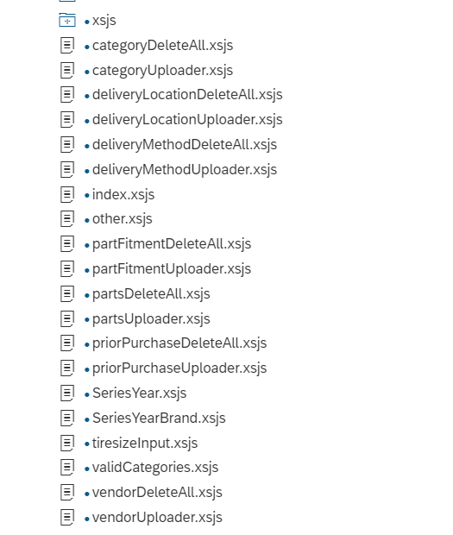

21. Unit Test Plan
Normal Functionality - test cases that ensure the workflow functions as it should. (e.g. updates fields correctly, processes all records)

Test Condition | Step | Step Description | Test Data | Expected Result | Actual Result | Executed By/Date | Remarks

Exception - special logic or exceptions (e.g. do not process Government Markets customers, only process pre-packs)

Test Condition | Step | Step Description | Test Data | Expected Result | Actual Result | Executed By/Date | Remarks

Error Handling - functionality in case of errors (e.g. Customer not found, Record already exists)

Test Condition | Step | Step Description | Test Data | Expected Result | Actual Result | Executed By/Date | Remarks

