TCI SAP S/4 HANA Implementation

Technical Specification – EDD 244

Parts Ordering

Version : 1.0
Date Created : 18-06-2019

Author : Parts Ordering

Document Information

GAP/CR ID

FS Definition Form ID

Type of development | UI5
SAP R/3 Version | S/4HANA ON PREMISE 1709

Approval

Approved by | Name | Role | Signature | Date
Process Team Lead
Development Team Lead
TCI System Analyst

Document History

Version | Author | Reason for change | Date
1.0 | Ravi Harlalka | Initial draft | 18.06.2019
1.1
1.2
1.3

Related Documents
<Reference document name and location link>
Table of Contents

1. General Information 4
2. Description and Purpose 4
3. Assumptions 4
4. Issues 4
5. Dependencies 5
6. Technical Details 5
7. Models Details 11
8. Views Details 11
9. View Controllers Details 12
10. Fragments Details 14
11. Component JS Details 14
12. Formatters Details 14
13. Patterns Details 14
14. ODATA-Gateway (Back-end) 15
15. Data Source consideration 15
16. Data Validation 16
17. Error Handling 16
18. Security Requirements/ Authorization Details 17
19. Additional Information and attachments 17
20. HANA Artifacts 17
21. Unit Test Plan 19

General Information

WRICEF ID | EDD
Description | Parts Ordering & Order Status
Implementation Phase | Wave 2
Transaction(s) (if applicable) | N/A
Package | ZFIORI
Message Class (if applicable)
Develop. Class
Module | ODATA
Enhancement User/User Group
Run Frequency |  | Language | English

GIT Information

Sr.No # | Branch Name | User id | Description
1 | PartsOrdering |  | https://git.ca1.hana.ondemand.com/d36z7bqhz1/partsordering

Description and Purpose
Parts Ordering application is used by the dealers/TCI users to Order Parts & Check order status. Dealers use this functionality to place different types of orders based on their eligibility.

Assumptions
User must be authorized to access the consolidated Parts Ordering application. This application will perform validation to show create order types & accessibility as per logged in used roles and data access.

Issues
N/A

Issue # | Date Raised |  | Issue Description | Issue Resolution

Dependencies

Technical Details
  - Application Name: Parts Ordering
  - Type: XSA Multi Target Application
  - Latest Version: 1.0.0
  - UI5 Libraries: sap.ui.layout, sap.ui.core, sap.ushell, sap.m
  - Components: Device, Model, Dialog, Text, Filter, History, MessageBox
  - Program Flow:
Check Order Status

Create Order
Find Draft

  - Screens: Check Order Screen
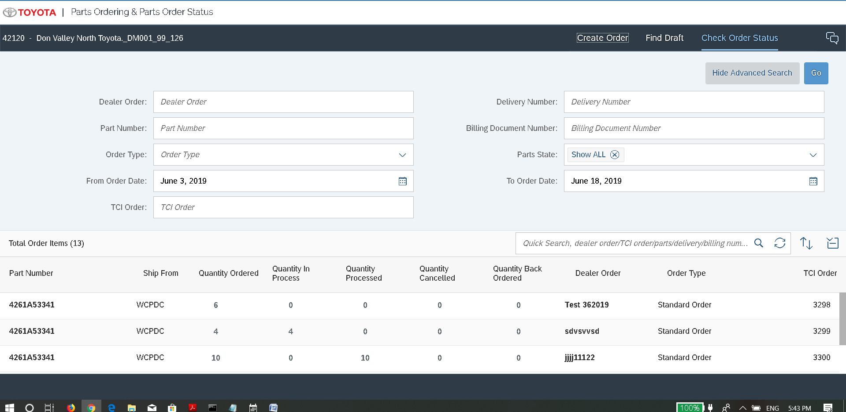

Create Order
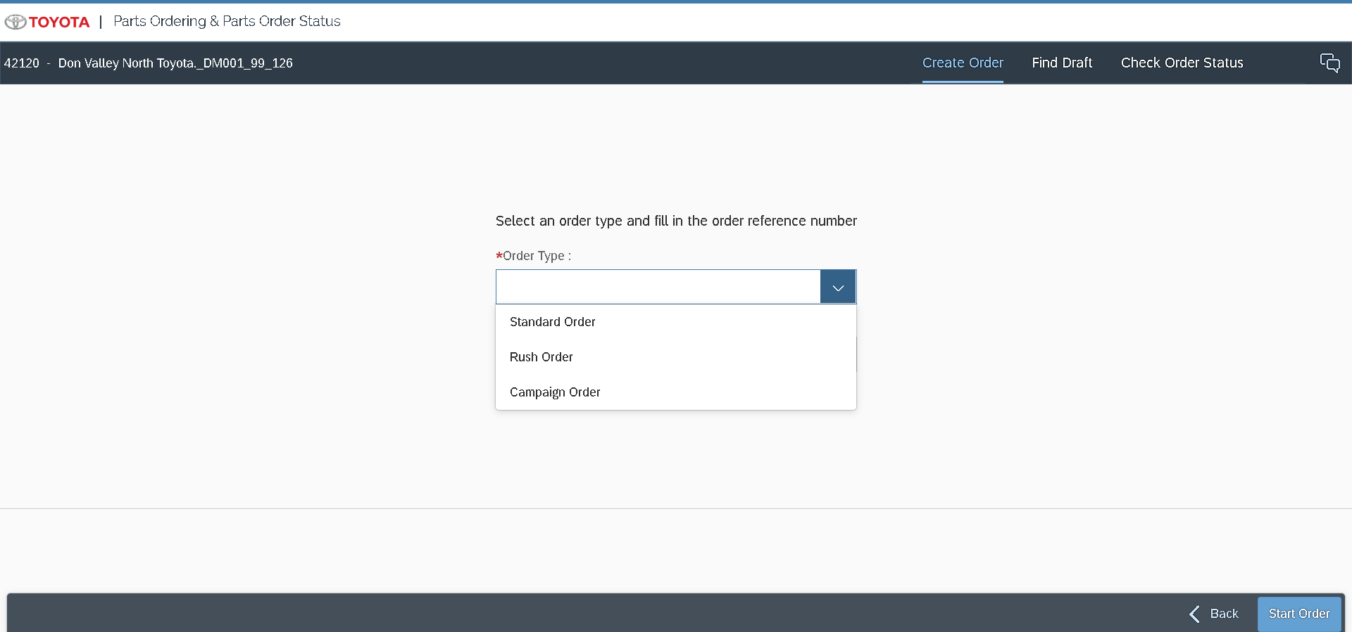
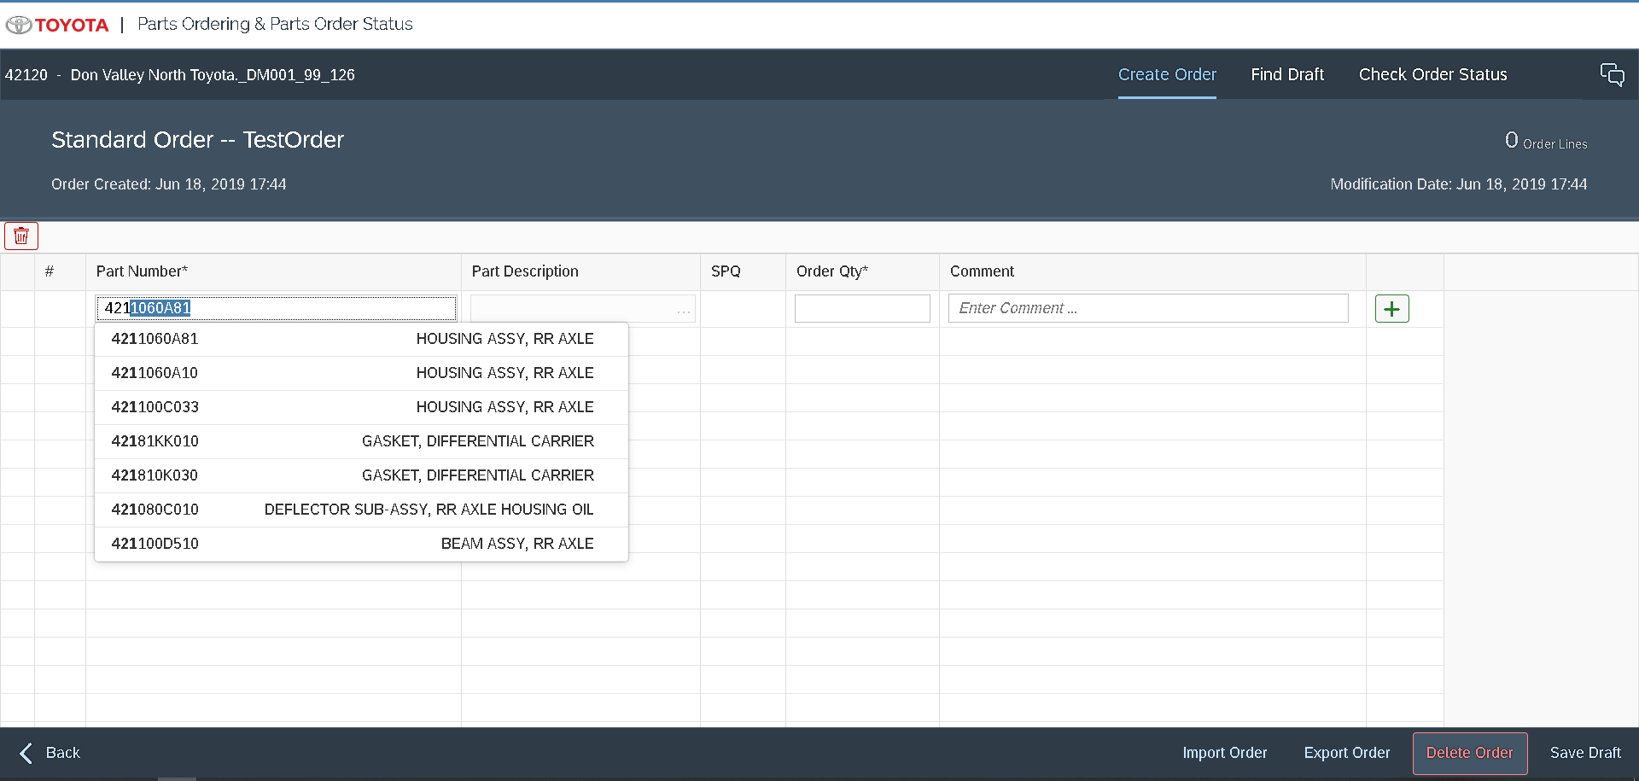

Find Draft Screen

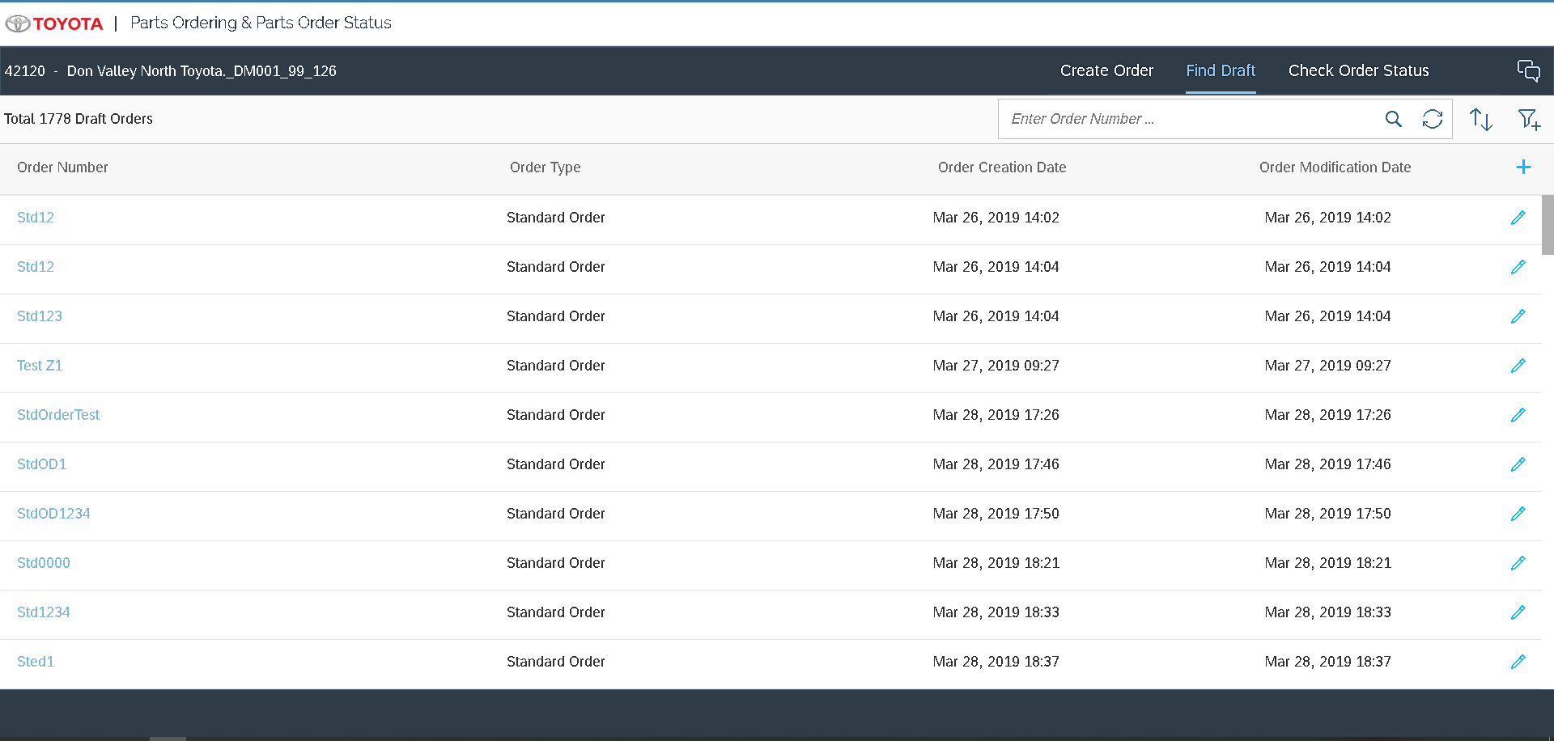

Models Details
- PriceServiceModel
  - Type: sap.ui.model.odata.v2.ODataModel
  - DataSource: MD_PRODUCT_FS_SRV
- ProductModel
  - Type: sap.ui.model.odata.v2.ODataModel
  - DataSource: API_PRODUCT_SRV
- ProductModel
  - Type: sap.ui.model.odata.v2.ODataModel
- DataSource: API_PURCHASEORDER_PROCESS_SRV
- Create Sales Order
  - Type: sap.ui.model.odata.v2.ODataModel
- DataSource: ZC_CREATE_SO_SRV

- Purchase Order Service
  - Type: sap.ui.model.odata.v2.ODataModel
- DataSource: MM_PUR_INFO_RECORDS_MANAGE_SRV
- Purchase Order Maintain Service
  - Type: sap.ui.model.odata.v2.ODataModel
- DataSource: MM_PUR_PO_MAINT_V2_SRV
- Store Location CDS
  - Type: sap.ui.model.odata.v2.ODataModel
- DataSource: ZC_STOR_LOCN_CDS
- Part Description & SPQ
  - Type: sap.ui.model.odata.v2.ODataModel
- DataSource: Z_SEARCH_HELPS_SRV
- BusinessPartnerModel
  - Type: sap.ui.model.odata.v2.ODataModel
  - DataSource: API_BUSINESS_PARTNER
- i18n
  - Type: sap.ui.model.resource.ResourceModel
  - BundleName: “tireSelector. tireSelector.i18n.i18n”
- JSONModel
  - Type: sap.ui.model.json.JSONModel

Views Details
  - Check Order Status View: This view serves as landing view for the App and is common for all users, contains Search Criteria section for Search by date, TCI order No, Order Type Status, ..etc The search results can be further filtered in Quick search. Sorting is also provided for results.
  - Start Order : This view displays the order types for which user is eligible to create order.
  - Create View: This view shows a table where user can part no or part of it – displays the part description. The selected part can then be added to the order. The added parts first needs to be saved and then the complete order will be submitted. All UI validations & checks are done before submission. Any error is in activation are displayed.
  - Find Draft : The view shows the orders which are saved as draft. User can select the draft to edit (Create View) .

View Controllers Details
  - Component : Component loads the userprofile:

this.loadUserProfile(function(userData){
var userProfile ={};
userProfile.loaded = true;

if (!!userData && !!userData.userContext && !!userData.userContext.userAttributes){
//var appMode = that.getModel('ApplicationMode');
if (!!userData.userContext.userAttributes.DealerCode && userData.userContext.userAttributes.DealerCode.length > 0){
userProfile.dealerCode = userData.userContext.userAttributes.DealerCode[0];
}

// only two lang
if (!!lang ){
lang = lang.trim().toLowerCase();
if ('fr' === lang){
userProfile.language ="fr";
} else {
userProfile.language ="en";
}
} else {
if (!!userData.userContext.userAttributes.Language && userData.userContext.userAttributes.Language.length > 0){
lang = userData.userContext.userAttributes.Language[0];
if (!!lang){
lang = lang.trim().toLowerCase();
if ('french' === lang){
userProfile.language ="fr";
} else {
userProfile.language ="en";
}
}
}
}

if(!!userProfile.language){
// only set the locale is the lang is set,
sap.ui.getCore().getConfiguration().setLanguage(userProfile.language);
}

if (!!userData.userContext.userAttributes.UserType && userData.userContext.userAttributes.UserType.length > 0){
userProfile.userType = userData.userContext.userAttributes.UserType[0];
}

if(!!userData.userContext.userInfo){
userProfile.email = userData.userContext.userInfo.email;
userProfile.familyName = userData.userContext.userInfo.familyName;
userProfile.givenName = userData.userContext.userInfo.givenName;
userProfile.logonName = userData.userContext.userInfo.logonName;
}

if (!!division){
userProfile.division = division;
if (division === "20") {
userProfile.logoImage = 'images/Lexus_EN.png';
} else {
userProfile.logoImage = 'images/toyota.png';
}
} else {
userProfile.division = '';
//Default
userProfile.logoImage = 'images/toyota.png';
}

appMode.setProperty("/userProfile", userProfile);
}

if (that.isAppModelLoaded() ){
sap.ui.core.BusyIndicator.hide();
}
});

  - Check Order Status Controller:
- Fetching all dealers data for National & Zone users === getDealersForTCIUsers()
- Setting the dealercode, bpName, bpGroup, bpNumber === onBusinessPartnerSelected ()
- Open of the pop up window on select of the line Item=== onMasterSelected()
- Quick Search – search within the search results === onLiveChange ()
- Called on the click of the go button ===refresh()
- Toggle for Filters to show===onExpandFilter()
- Called on the route of the page===_onObjectMatched()

  - Create Order Controller:
- Sets the data for the page – initializes the data models === _oObjectMatched()
- Called when the part link is clicked- takes you to the parts availability page === showPartsAvailabilityInfo()
- Shows parts suggested items, drop down on enter of part no === handleSuggest()
- Part No selected selected from drop down or Imported into the page – fetches the part description & SPQ === handleProductChange()
- Called on the click of the Add Button === handleAddPart()
- Saving of the draft items = onSaveDraft()
- Called on the click of the ActivateButton == onActivate()
- Shows & set error at the lineItemLevel === _setLineError()
- Reset error for the line item level === _resetLineError()

  - Base Controller:
- Gets the InternalUserType for the logged In user based on the logged In user=== getInternalUserType()
- Gets the supplier for the part === getSupplierForPart()
- To get the bussinespartner by Id === getBussinessParterByID()
- Gers the bussinerPartner based on the dealerCode === getBussinessParterByDealerCode()
- Back Navigation === onNavBack()

Fragments Details
  - CosDetails : Fragment to show the details on the click of the item on search results
  - LineErrorPopover : Fragment to show the error on click of the error icon
  - TopHeader : Fragment to show the Top of the each page (logo)
  - ToolHeader : Fragment to show the page links on the top page.
  - PartsOrderImport : Import popover dialog to import Items on click of the Import button.

Component JS Details
- Loads manifest
- Loads userprofile
- Initializes UI Components for application
- Initializes app router
- Initializes i18n resource bundle
- Handles session expiry dialog for the application

Formatters Details
- formatter.js: Handles currencyValue, removing leading zeros to show data, etc

Patterns Details

ODATA-Gateway (Back-end)
Please check OData documentation for PartsOrdering..

Data Source consideration
N/A
Field name / Description | Table Field Name | Comments / Calculations / Field Manipulations

Data Validation
N/A

Table Field Name | Validation Rule

Error Handling

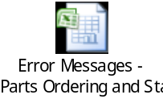

  - Error Conditions and Logging

  - Notification

N/A
Error | How error message should be reported | Error Messages | Corrective action

  - Restart / Recovery

N/A

Security Requirements/ Authorization Details
- Dealer User
- Will interact with Parts Ordering to order Parts
- Internal TCI User
  - Can check Order Status for a selected Dealer.

Additional Information and attachments

  - Reconciliation Reporting

If a specific report or additional information is required is required for reconciliation

  - Attachments

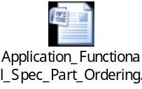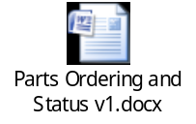

HANA Artifacts
  - Object List : List out all the HANA artifacts which is required to be created/changed

Object Name | Object Type | Ref. ABAP Object | Object Description | Action | Package | Delivery Units | Comments
 | Calculation View/ Attribute view/ Analytic view/ Table/  DB Procedure |  |  | Create/  Modify

  - DB Procedure Details: Specify the details of DB procedure

Procedure Name:

Parameter Name | Parameter Type | Parameter Data Type | Data Type | Length | Scale
 | IN/OUT

Procedure Logic:

  - DB Objects (View/Table) : Specify the details of DB object structure

View Column | Table Column | SQL Data Type | Dimension | Not Null | Default

Sample View Screenshot:

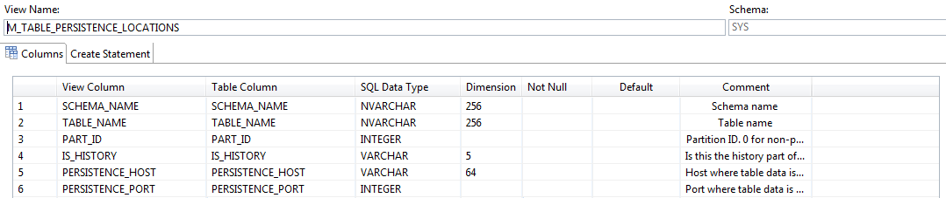

21. Unit Test Plan
Normal Functionality - test cases that ensure the workflow functions as it should. (e.g. updates fields correctly, processes all records)

Test Condition | Step | Step Description | Test Data | Expected Result | Actual Result | Executed By/Date | Remarks

Exception - special logic or exceptions (e.g. do not process Government Markets customers, only process pre-packs)

Test Condition | Step | Step Description | Test Data | Expected Result | Actual Result | Executed By/Date | Remarks

Error Handling - functionality in case of errors (e.g. Customer not found, Record already exists)

Test Condition | Step | Step Description | Test Data | Expected Result | Actual Result | Executed By/Date | Remarks

