TCI SAP S/4 HANA Implementation

Technical Specification

Stock Allocation – UI – XSA Document

Version : 1.0
Date Created : 07-08-2019

Author : Gunasekhar Reddy

Document Information

GAP/CR ID

FS Definition Form ID

Type of development | UI5
SAP R/3 Version | S/4HANA ON PREMISE 1709

Approval

Approved by | Name | Role | Signature | Date
Process Team Lead
Development Team Lead
TCI System Analyst

Document History

Version | Author | Reason for change | Date
1.0 | Gunasekhar Reddy | Initial draft | 07.08.2019
1.1 | Aarti Dhamat | Second Draft | 04.02.2020
1.2 | Aarti Dhamat | Third Draft | 05.05.2020
1.3

Related Documents
<Reference document name and location link>
Table of Contents

1. General Information 4
2. Description and Purpose 4
3. Assumptions 5
4. Issues 5
5. Dependencies 5
6. Technical Details 5
7. Models Details 9
8. Views Details 9
9. View Controllers Details 9
10. Fragments Details 12
11. Component JS Details 12
12. Formatters Details 12
13. Patterns Details 12
14. ODATA-Gateway (Back-end) 12
15. Data Source consideration 13
16. Data Validation 14
17. Error Handling 14
18. Security Requirements/ Authorization Details 14
19. Additional Information and attachments 15
20. HANA Artifacts 16
21. Unit Test Plan 18

General Information

WRICEF ID
Description | Stock Allocation
Implementation Phase | Wave 2
Transaction(s) (if applicable) | N/A
Package | ZFIORI
Message Class (if applicable)
Develop. Class
Module | XSA, UI, HANA 2.0
Enhancement User/User Group
Run Frequency |  | Language | English & French

GIT Information

Sr.No # | Branch Name | User id | Description
1 | Master | Gunasekhar_reddy2@toyota.ca | https://git.ca1.hana.ondemand.com/plugins/gitiles/d36z7bqhz1%2Fstockallocation  Repo URL for Checkouts:  https://git.ca1.hana.ondemand.com/d36z7bqhz1/stockallocation

Description and Purpose
Toyota Canada Inc. (TCI) has embarked upon a project to refresh its existing mainframe vehicle system using SAP. Multiple existing functionality present in different applications are consolidated into one application. The following functionalities are included in the Stock Allocation application.

Stock Allocation : The Suggested Stock Allocation tool allows the Dealer to understand, plan and request vehicle allocation in a specified allocation window.
The system, based on the capital allocation bandwidth determined by the TCI business team, would be able to ‘suggest an allocation’ of vehicles to a particular Dealer, down to the level of Series, Model Year, Model, Suffix, Colour and Trim.

CR2.0 –
- Dealers will be able to add new series which is not in configuration list along with model, suffix and color options using “Add Series” Popup
- If configuration for newly selected series exists, user will be navigated with filtered data on second screen with reset option. Reset option will remove all filters.
- Show All button will provide flexibility to show/hide model data
- Model level total and subtotal for all the column values except restricted ones

CR60 – Displaying past 6 months sales data on allocation summary screen
CR3.0 – Two new functionalities to be added to details screen:
- Dealer configuration Option Flag: This flag will allow dealer to flag suggested configuration quantity as optional and if they do not get what is actually requested by them then allocation will be done for optional flagged configuration.
- Variance Check (Threshold flag): This check will restrict user from requesting more quantity than what is allowed quantity tolerance based on actual suggested quantity to dealer.

Assumptions
Dual Dealers will login to their respective portal to request and allocate stock for Toyota vehicles and Lexus Vehicles.

Issues
N/A

Issue # | Date Raised | Issue Description | Issue Resolution

Dependencies

Technical Details
  - Application Name: Stock Allocation
  - Type: XSA Multi Target Application
  - Latest Version: 1.0.0
  - UI5 Libraries: sap.ui.layout, sap.ui.core, sap.ushell, sap.m
  - Components: Device, Model, Dialog, Text, Filter, History, MessageBox

  - Screens: Home Screen
When logged in as internal user, the screen will show a dealer drop down to select the dealer from the screen only for viewing.
When the dealer logs in, the dealer will not have an option to change the dealer ID.

The Order prefix is editable for a Dealer login

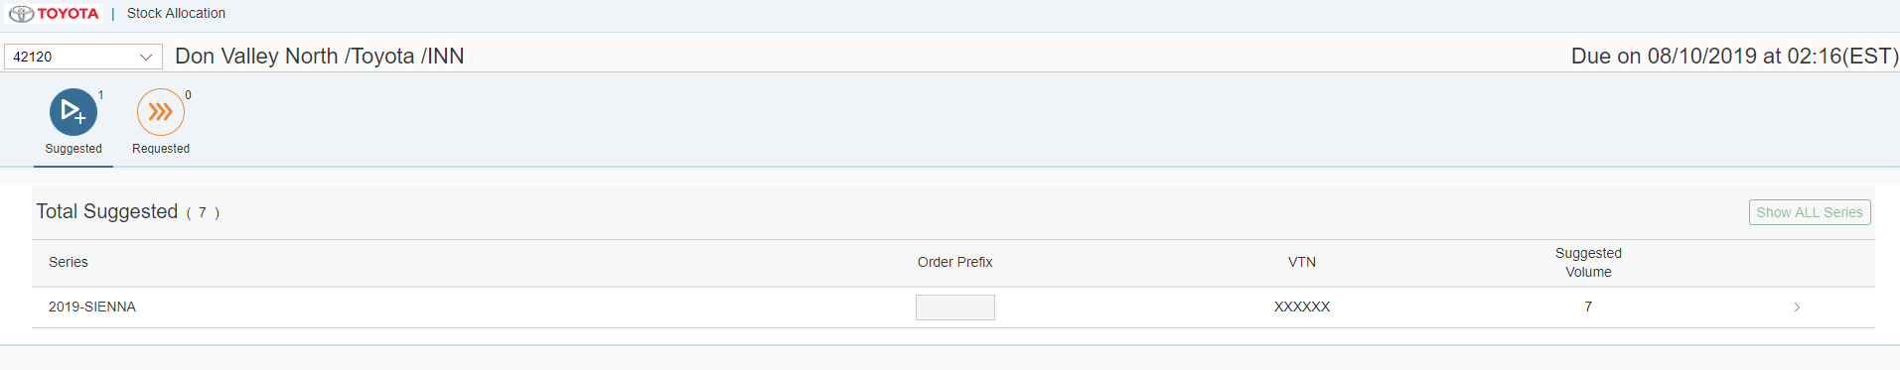

As per CR2.0 -dealer login screen
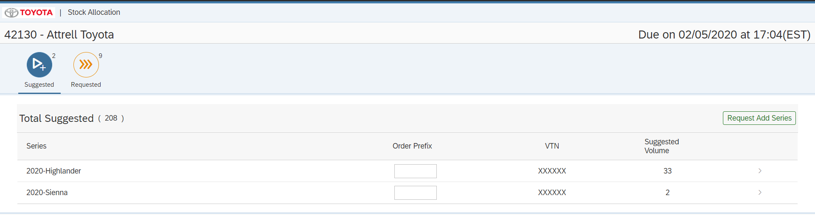

The above screen is showing all the series that has been allocated to the dealer. First screen shows list of series which are suggested, requested and allocated.

On clicking on series, the details screen will show the list of models for this series that has been suggested. At this time, the user will have an option to decrease or increase the quantitites that are allocated.

CR2.0: Added “Request add series” which will allow dealer to add series which is not in configuration list. Dealer can add all details including, model, color, suffix using this option.

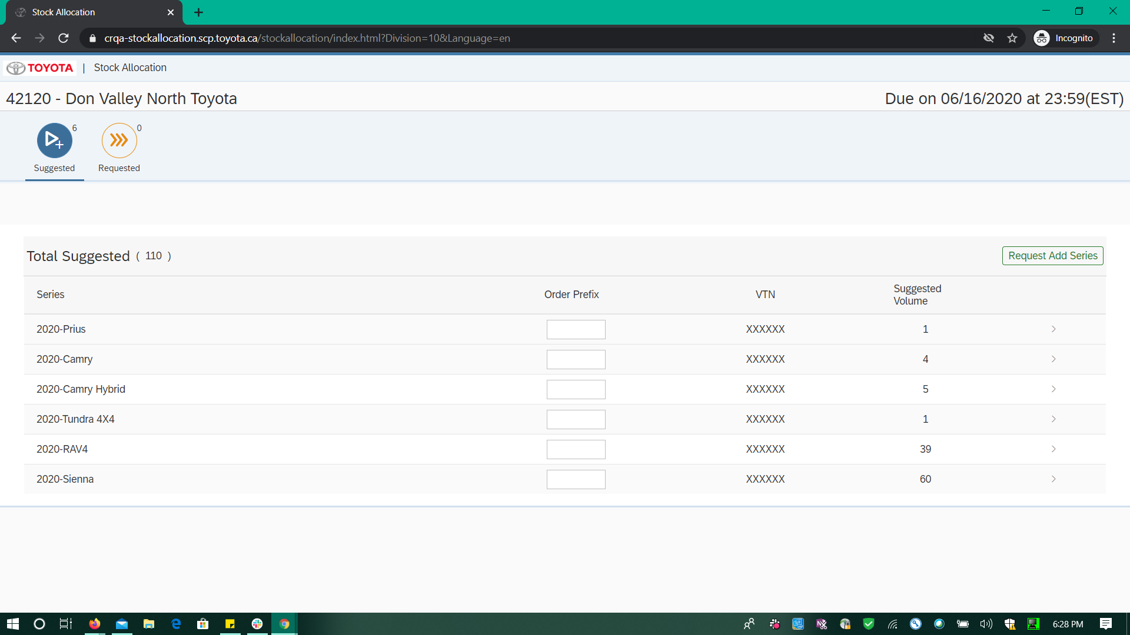

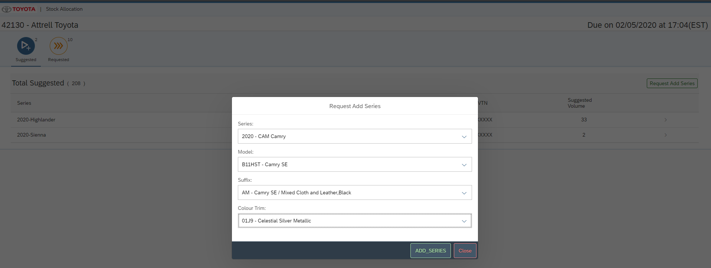

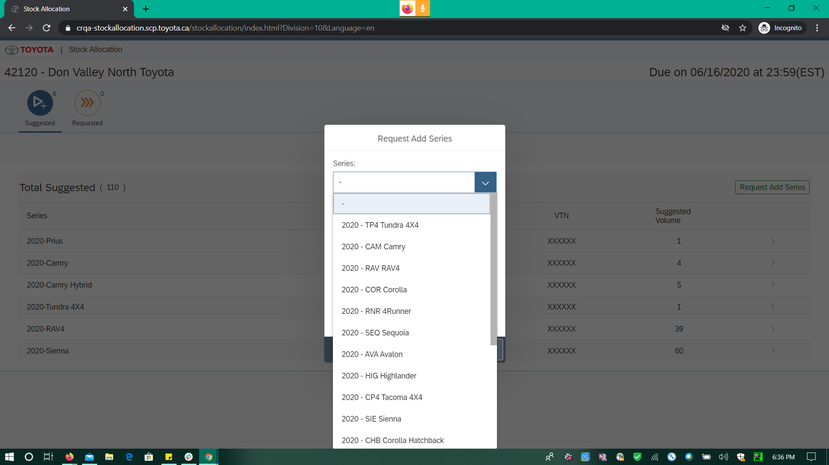

Clicking on “Add Series” button, dealer will be redirected to next screen where dealers can add quantities against the selected new series.

The Requessted Volume is editable for a Dealer login id

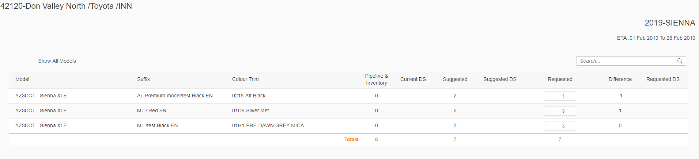

CR 2.0: Second screen:

When dealer is redirected to second screen based on series selection, they see all the details against selected series including model level subtotal and complete total for all columns.

Reset to suggested will reset all columns to the initial details.

Request Add Model will allow dealers to add more configurations against the series in the screen along with color, suffix and quantity.

Save request will save all the changes against dealer for selected series.

Show All button is to collapse/expand model details.

Back button will navigates dealers back to first screen, i.e login screen.

Reset Search: If newly added series configuration already exists, then dealer will be navigated to second screen with filtered data. Dealer can then reset back to all the data using Reset search button.

Search input: It will allow dealers to search through screen/table data to find exact data without scrolling througn page.

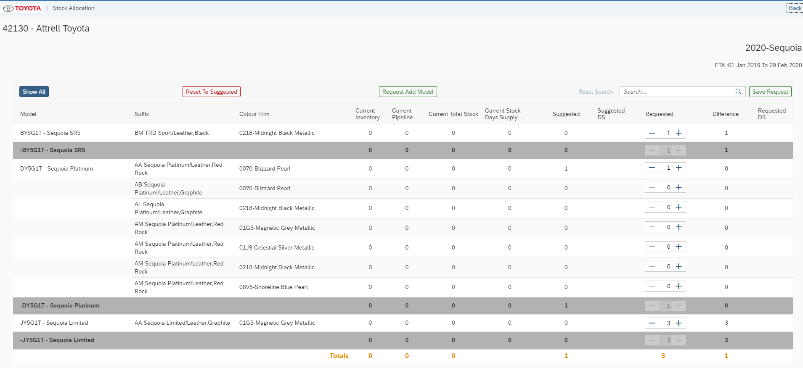

CR60 - Past 6 months sales data

In this change, we are fetching Past 6 months retails sales data for user against selected series configuration. Column added for displaying this data on UI is “P6M Retails”.
Screeshot:

CR3.0 Changes:

Below two new columns are added on Sumary screen:
Dealer Config and Variance.

Dealer config will act as flag for optional configuration

Variance will act as threshold/upper limit for requested quantity. Dealer will not be able to request qunatity more than variance value.

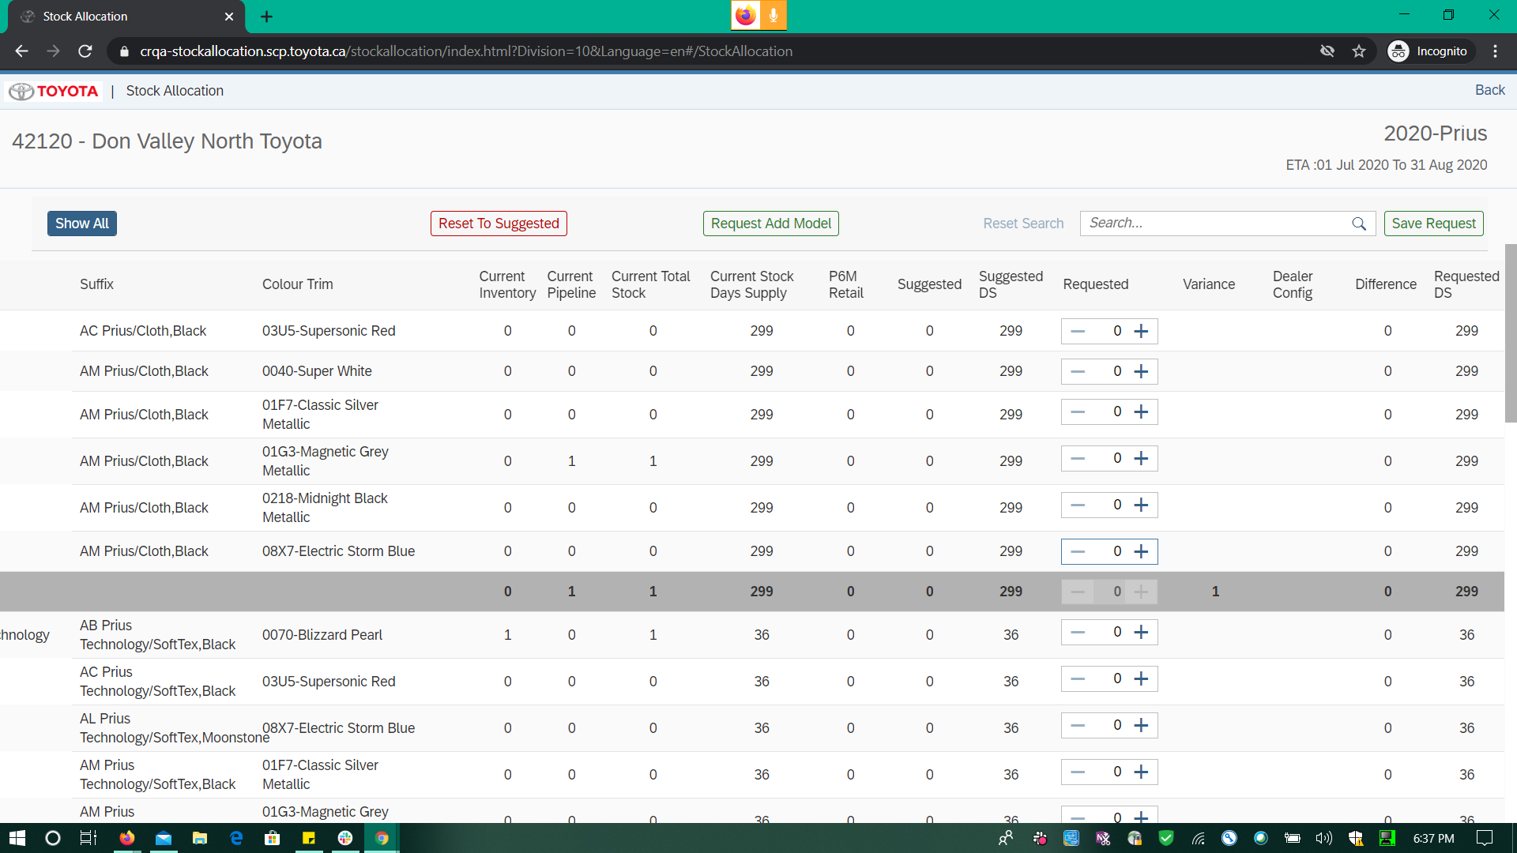

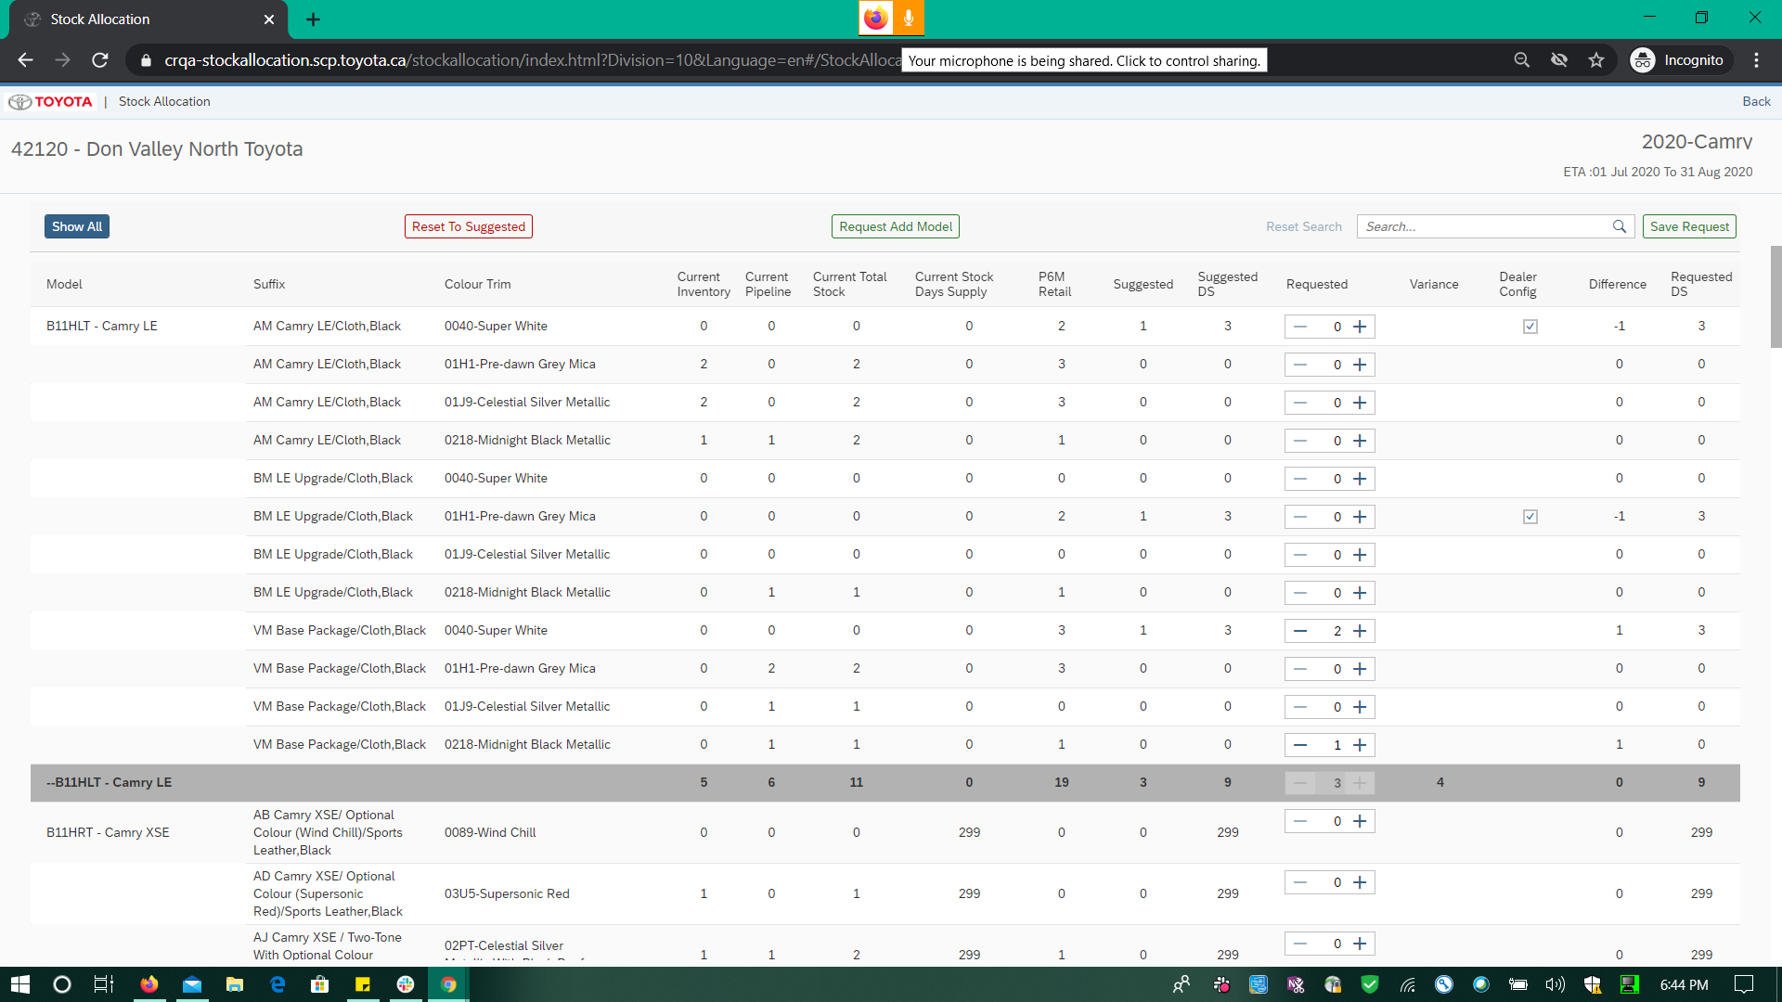

Models Details
  - Default Model
→Type: sap.ui.model.odata.v2.ODataModel
→DataSource: ZCDS_SUGGEST_ORD_CDS, ZCDS_SUGGEST_ORD_SUM_CDS, ZCDS_SUGGEST_ORD_COUNT_CDS, ZSD_SUGGEST_ORDER_UPDATE_SRV

  - i18n
→Type: sap.ui.model.resource.ResourceModel
→BundleName: “i18n.i18n”

  - JSONModel
→Type: sap.ui.model.json.JSONModel

Views Details
The View is of type XML using Master Detail template and has the below structure and controllers.

ProductionRequestSummary.view.xml is the name of the parent view. In here we can see page controls table controls and button controls.

There are three Icon tabs to this view.

Suggested,
Requested and
Allocated

The page control shows the title and class of the page. This is followed by a customHeader which displays the Image and custom page headings.

When the app is launched for a new allocation cycle, there are several validations after fetching the data from the S/4 System. Based on the Data the visibility and adjustability of the properties are adjusted. (Please refer the functional Specification document for any additioinal details that are of interest on Requirement).

The production Request Summary view for the Dealer is as below.

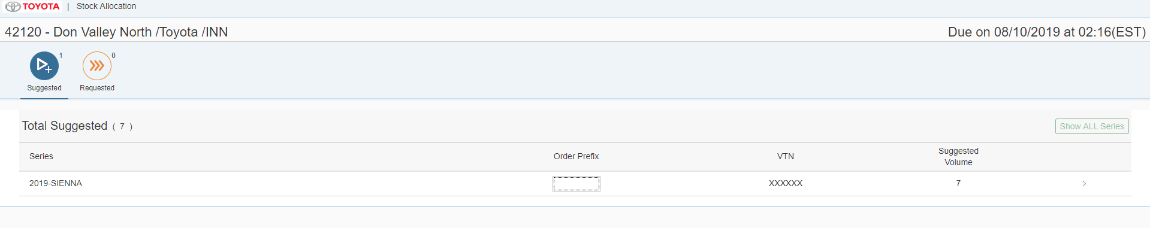

On the click of the series, the routing navigates to Stock Allocation View. This screen is a place holder for the quantities requested. The show all models will show all the quantities with quantity greater than zero. And clicking it on again will show the quantities with zero assuming the suggested quantities will be greater than zero for suggested models. The click on Save Request will make an AJAX API call to push the data to S/4. The click on Reset to Suggested will reset the quantities to the initial suggested quantity by IBP.

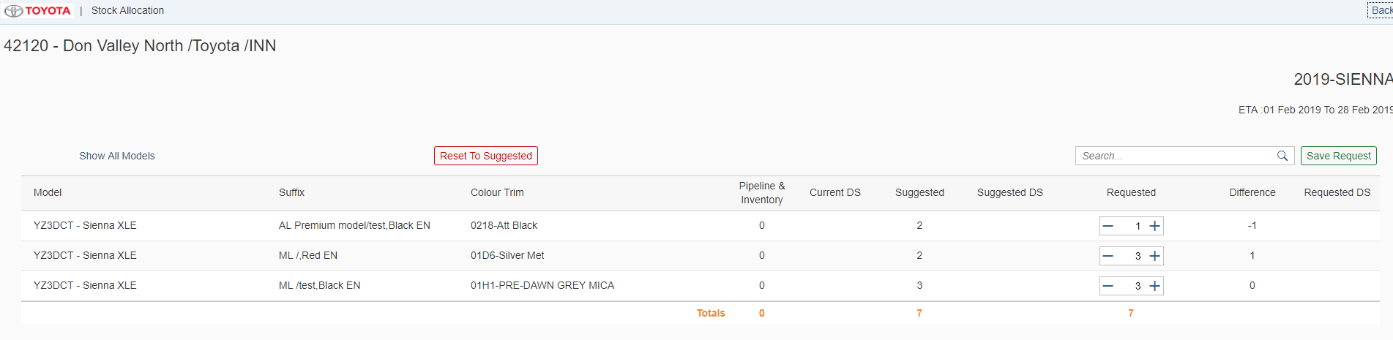

View Controllers Details
ProductionRequestSummary.controller.js, the onit on this controller, detailview model is instantiated with variables needed to control the ui display and editable properties.

currentScopesForUser is the node module API that returns the details to the UI on type of user, DealerUser/InternalUSer/Zone user.
On Success of the AJAX call, the properties of the display and editable are set to DetailView model and then another AJAX call is made to fetch the Dealer Details from the node module. The name for this API is Attributes. ("/userDetails/attributes")

On the async completion of above api call, attachrequestcompleted event, the s/4 API Call to get the series data is requested.

ZCDS_SUGGEST_ORD_SUM_CDS/ ZCDS_SUGGEST_ORD_SUM
Filtering on the Logged in Dealer and Division from the URL

The success of the AJAX call the oData models are built, There is no much of technical difference between the navigation for suggested, requested and allocated tabs so all the three models are built using the data received from S/4.
Based on the allocation indicator if S, the suggested tab is shown,
If R the allocated indicator is shown.
If A the requested and Allocated tabs are shown

The next step another call is made to fetch the count off the records from the CDS. ZCDS_SUGGEST_ORD_COUNT_CDS/ ZCDS_SUGGEST_ORD_COUNT using the filter for
Selected Dealer and Division.

The count model is set to reflect the data on how many records exists at the series level which are not yet suggested/requested.

On the click of the table Item for Series, the below variables will get the data into the controller to determine from which tab the model details view is requested.

var checkForSuggestedString = selectedKey.search("iconTabFilterSuggested");
var checkForRequested = selectedKey.search("iconTabFilterRequested");
var checkForAllocated = selectedKey.search("iconTabFilterAllocated");

Based on the selected tab, the corresponding model context is read to the variable.

var oBindingContext = oEvent.getParameter("listItem").getBindingContext('suggestedDataModel');

the core model is set with the series details.
sap.ui.getCore().setModel(new sap.ui.model.json.JSONModel(selectedData), 'selectedSeries');

StockAllocation Controller:

onInit function, the router is initialized and the request is forwarded to handleRouteMatched function.

this.oRouter = sap.ui.core.UIComponent.getRouterFor(this);
this.oRouter.getTarget("StockAllocation").attachDisplay(jQuery.proxy(this.handleRouteMatched, this));

The data from the core model is read into a variable.

var selectedSeries = sap.ui.getCore().getModel('selectedSeries').getData();

A local model is instantiated to store the details on the visible and editable properties.

The model data call is made using the oData ZCDS_SUGGEST_ORD_CDS/ zcds_suggest_ord with the below filter.

"$filter": "zzdealer_code eq'" + this.dealerCode + "'and zzseries eq '" + this.series + "'" + "and zzmoyr eq '" + this.yearModel +
"'"
The success of this oData call will give the suggested model details and this is bound to the View as appropriate with standard controls.

Fragments Details
Busy Dialog Fragment was created to provide the dealer to wait for the activity completion.
NewCarModelDialog is created to provide dealer with option to add more model configurations to the selected series
NewCarSeriesDialog is created to provide dealer with option to add more series configurations which are not listed already to the logged in screen

Component JS Details
- Loads manifest
- Initializes UI Components for application
- Initializes app router
- Initializes i18n resource bundle
- Handles session expiry dialog for the application

Formatters Details
- Model -> formatter.js has the code to support the quantity and price details.

Patterns Details

ODATA-Gateway (Back-end)
- Main oData Service: ZCDS_SUGGEST_ORD_SUM_CDS/
- List of Entity Sets:

Entity set | Filters/key/order | Response | OP
ZCDS_SUGGEST_ORD_SUM | $filter:  zzdealer_code eq '2400042120'and zdivision eq 'TOY' | - allocated_ds: "0"  - allocated_volum: "0"  - dealer_review_count: ""  - pending_allocation: "0"  - perc_request_volum_allocated: "7"  - requested_ds: "0"  - suggest_count: 1  - suggested_ds: "7"  - tot_suggest_mix_requested: "7"  - tot_suggest_perc: "7"  - total_allocated_qty: "0"  - total_curr_ds: "0"  - total_curr_stock: "0"  - total_request_qty: "7"  - total_request_rec: 3  - total_suggest_qty: "7"  - total_suggest_rec: 3  - unfilled_allocation: "7"  - zdivision: "TOY"  - zzallocation_ind: "S"  - zzdealer_code: "2400042120"  - zzdel_review: ""  - zzmoyr: "2019"  - zzprefix: ""  - zzseries: "SIE"  - zzseries_desc_en: "SIENNA"  - zzseries_desc_fr: "SIENNA"  - zzseries_tag: "U"  - zzzadddata4: "200" | R
ZCDS_SUGGEST_ORD_COUNT | $filter:  zzdealer_code eq '2400042120'and zdivision eq 'TOY' | - allocat_count: "0"  - totalAllocatedCount: "0"  - totalPendingCount: "0"  - totalRequestedCount: "7"  - totalUnfilledcount: "7"  - totalsuggestedCount: "7"  - zdivision: "TOY"  - zzdealer_code: "2400042120"  - zzend_date: "20190810021617"  - zzstart_date: "20190801021617"  - zzstatus: "A"  - zzwin_id: "000013" | R
ZCDS_SUGGEST_ORD_CDS/  zcds_suggest_ord? | $filter:  zzdealer_code eq'2400042120'and zzseries eq 'SIE'and zzmoyr eq '2019' | - allocated_ds: "0.00"  - diff_sugg_req: "1"  - int_trim_desc_en: ",Red EN"  - int_trim_desc_fr: ",Red FR"  - mktg_desc_en: "Silver Met"  - mktg_desc_fr: "Silver Met FR"  - model_desc_en: "Sienna XLE"  - model_desc_fr: "SIENNA SE V6 7"  - pending_allocation: "0"  - requested_ds: "0.00"  - suffix_desc_en: ""  - suffix_desc_fr: ""  - suggested_ds: "0.00"  - unfilled__allocation: "0"  - zsrc_werks: "X"  - zzalc_qty_2ndcut: "0"  - zzalc_qty_3rdcut: "0"  - zzallocated_qty: "0"  - zzallocation_ind: "S"  - zzcur_ds: "0"  - zzcur_stock: "0"  - zzdealer_code: "2400042120"  - zzdel_review: ""  - zzend_date: "20190810021617"  - zzextcol: "01D6"  - zzint_alc_qty: "2"  - zzintcol: "LB15"  - zzmodel: "YZ3DCT"  - zzmoyr: "2019"  - zzprefix: ""  - zzprocess_dt: "/Date  - zzrequest_qty: "3"  - zzseries: "SIE"  - zzseries_desc_en: "SIENNA"  - zzseries_tag: "U"  - zzstart_date: "20190801021617"  - zzsuffix: "ML"  - zzsug_seq_no: "00000002"  - zzsuggest_qty: "2"  - zzwin_id: "000013"  zzzadddata1: "500 | R
ZSD_SUGGEST_  ORDER_UPDATE_SRV/  SuggestOrdSet |  | - ZsrcWerks: "X"  - ZzdealerCode: "2400042120"  - ZzdelReview: "Y"  - Zzextcol: "0218"  - ZzintAlcQty: "2"  - Zzintcol: "LC14"  - Zzmodel: "YZ3DCT"  - Zzmoyr: "2019"  - Zzprefix: "12345"  - ZzprocessDt: "/Date(1565395200000)/"  - ZzrequestQty: "2"  - Zzsuffix: "AL"  - ZzsugSeqNo: "00000010" | PO
/Z_VEHICLE_MASTER_SRV/zc_myear | $filter: ModelYear eq '2019' and Model eq 'B11HLT'" | Gives Source Plant for the newly requested/added Model configuration | R
/ZSD_SUGGEST_ORDER_UPDATE_SRV/SuggestOrderSet | NA | Gives sequence number for the selected/added model | P

Data Source consideration
N/A
Field name / Description | Table Field Name | Comments / Calculations / Field Manipulations

Data Validation
N/A

Table Field Name | Validation Rule

Error Handling

  - Error Conditions and Logging

Form and few controls validation using validator -3rd party library

  - Notification

N/A
Error | How error message should be reported | Error Messages | Corrective action

  - Restart / Recovery

N/A

Security Requirements/ Authorization Details

UserDetails →attributes: Fetches Logged in user authorization details -language, zone and usertype also Business partner data and sales data as per provided filters in security layer

UserDetails →currentScopesForUser: Fetched scopes for logged in user as per the mapped groups and roles

Additional Information and attachments

  - Reconciliation Reporting

If a specific report or additional information is required is required for reconciliation

  - Attachments

HANA Artifacts
  - Object List : List out all the HANA artifacts which is required to be created/changed

Object Name | Object Type | Ref. ABAP Object | Object Description | Action | Package | Delivery Units | Comments

  - DB Procedure Details: Specify the details of DB procedure

Procedure Name:

Parameter Name | Parameter Type | Parameter Data Type | Data Type | Length | Scale
 | IN/OUT

Procedure Logic:

  - DB Objects (View/Table) : Specify the details of DB object structure

View Column | Table Column | SQL Data Type | Dimension | Not Null | Default

Sample View Screenshot:

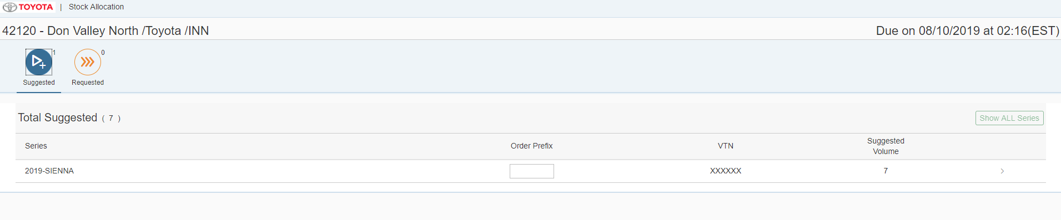

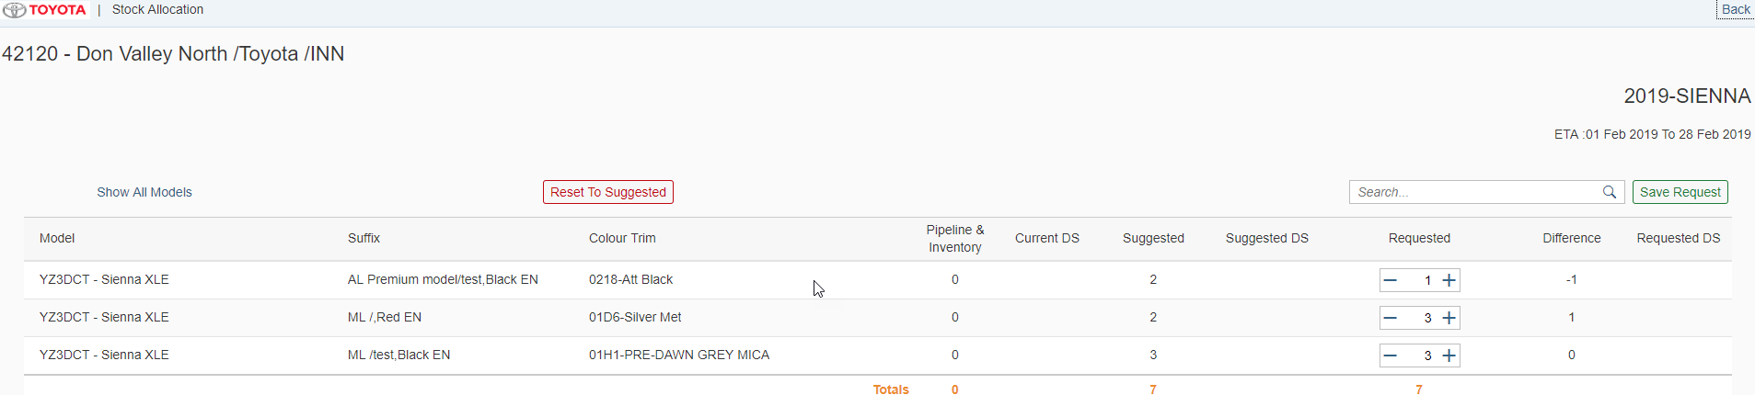

CR2.0 updated screens:

Login with suggested series:

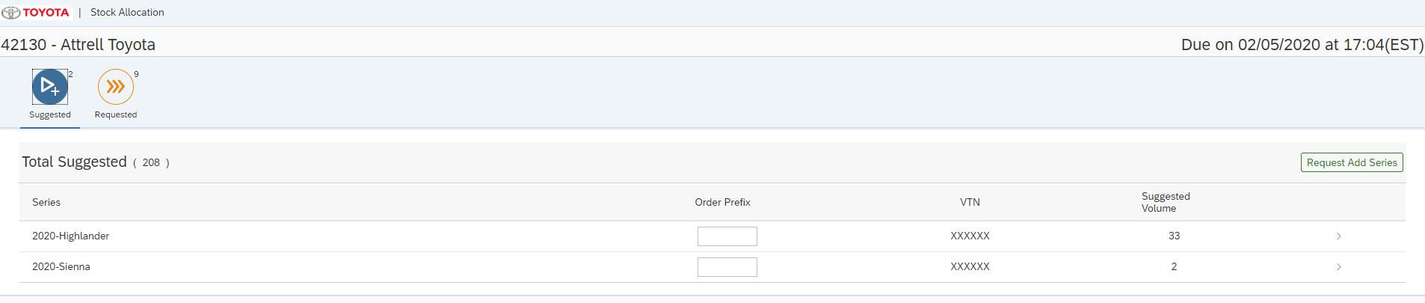

Login with requested series:

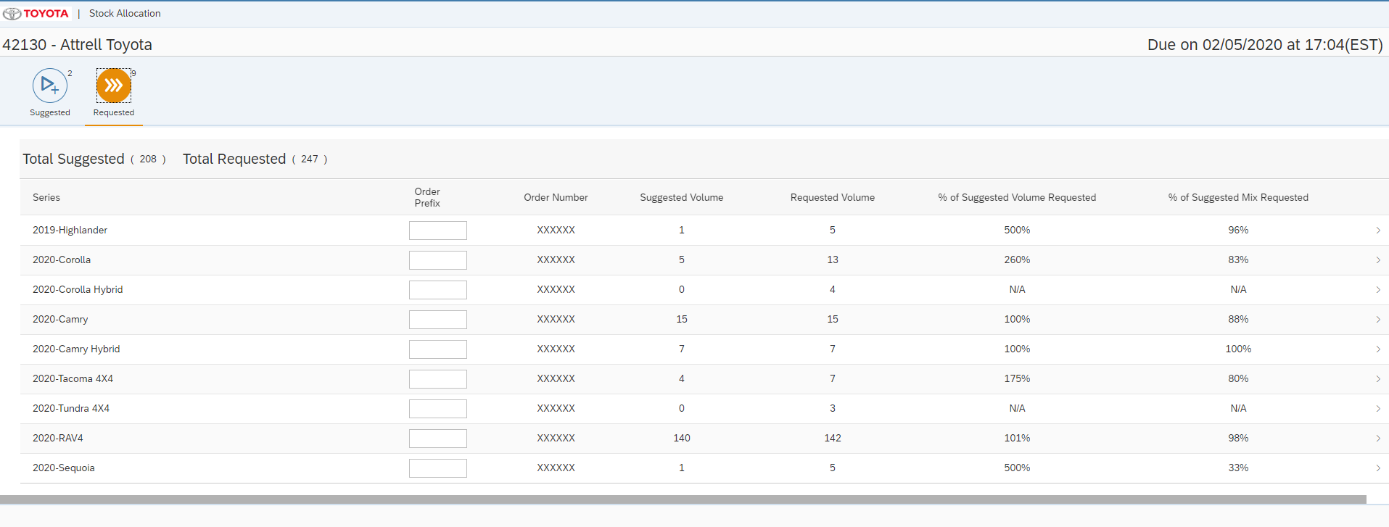

Add New series popup:

Series details screen: (Expanded view)

Series details screen: Collapsed View:

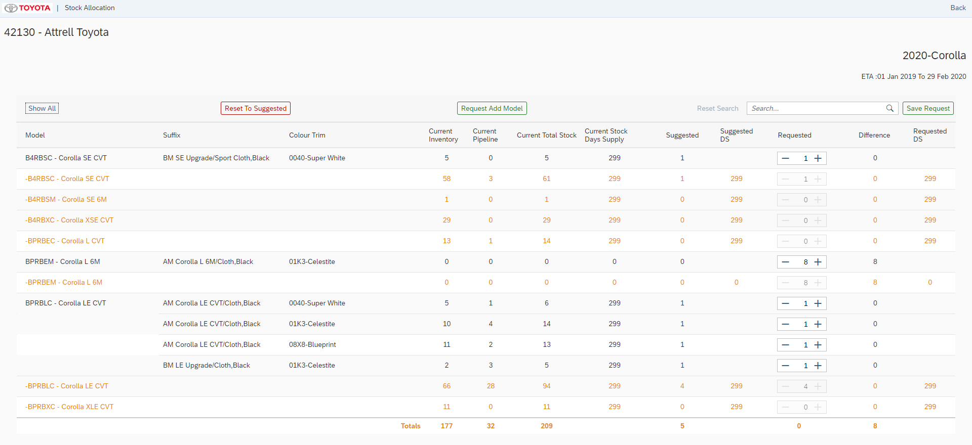

Request model popup:

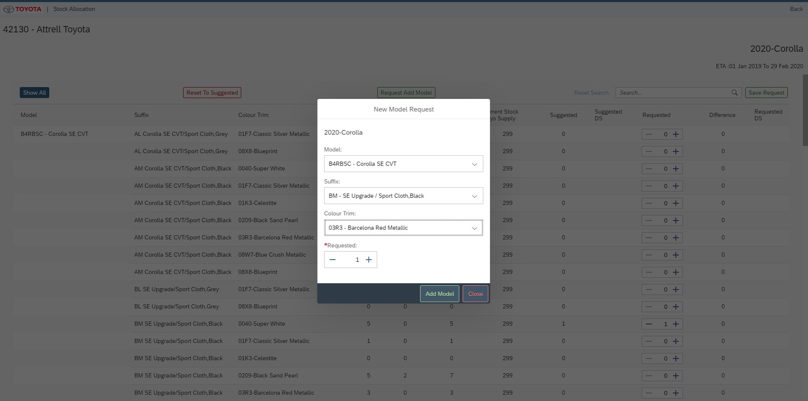

21. Unit Test Plan
Normal Functionality - test cases that ensure the workflow functions as it should. (e.g. updates fields correctly, processes all records)

Test Condition | Step | Step Description | Test Data | Expected Result | Actual Result | Executed By/Date | Remarks

Exception - special logic or exceptions (e.g. do not process Government Markets customers, only process pre-packs)

Test Condition | Step | Step Description | Test Data | Expected Result | Actual Result | Executed By/Date | Remarks

Error Handling - functionality in case of errors (e.g. Customer not found, Record already exists)

Test Condition | Step | Step Description | Test Data | Expected Result | Actual Result | Executed By/Date | Remarks

