TCI SAP S/4 HANA Implementation

Technical Specification

Vehicle Locator – UI – XSA Document

Version : 1.1
Date Created : 07-08-2019

Author : Gunasekhar Reddy

Document Information

GAP/CR ID

FS Definition Form ID

Type of development | UI5
SAP R/3 Version | S/4HANA ON PREMISE 1709

Approval

Approved by | Name | Role | Signature | Date
Process Team Lead
Development Team Lead
TCI System Analyst

Document History

Version | Author | Reason for change | Date
1.0 | Gunasekhar Reddy | Initial draft | 07.08.2019
1.1 | Vivek Saraogi | Changes for Change Requests | 13.11.2019
1.2 | Vivek Saraogi | Changes for CR2.0 | 28.01.2020
1.3 | Vivek Saraogi | Changes for CR 81 | 04.05.2020
1.4 | Vivek Saraogi | Changes for CR152 | 15.07.2020

Related Documents
<Reference document name and location link>
Table of Contents

1. General Information 4
2. Description and Purpose 4
3. Assumptions 5
4. Issues 5
5. Dependencies 5
6. Technical Details 5
7. Models Details 9
8. Views Details 10
9. View Controllers Details 13
9. Fragments Details 15
10. Component JS Details 15
11. Formatters Details 15
12. Patterns Details 15
13. ODATA-Gateway (Back-end) 16
14. Data Source consideration 16
15. Data Validation 16
16. Error Handling 16
17. Security Requirements/ Authorization Details 17
18. Additional Information and attachments 17
19. HANA Artifacts 17
21. Unit Test Plan 19

General Information

WRICEF ID
Description | Vehicle Locator
Implementation Phase | Wave 2
Transaction(s) (if applicable) | N/A
Package | ZFIORI
Message Class (if applicable)
Develop. Class
Module | XSA, UI, HANA 2.0
Enhancement User/User Group
Run Frequency |  | Language | English & French

GIT Information

Sr.No # | Branch Name | User id | Description
1 | Master | Gunasekhar_reddy2@toyota.ca | https://git.ca1.hana.ondemand.com/plugins/gitiles/d36z7bqhz1%2Fvehiclelocator  Repo URL for Checkouts:  https://git.ca1.hana.ondemand.com/d36z7bqhz1/vehiclelocator

Description and Purpose
Toyota Canada Inc. (TCI) has embarked upon a project to refresh its existing mainframe vehicle system using SAP. Multiple existing functionality present in different applications are consolidated into one application. The following functionalities are included in the vehicle locator application.

Vehicle Locator: There are multiple functions that are done by this application.
- Tradable vehicle inventory: when a dealer logs in to this application, the first thing the app does is to provide the dealer the details of the tradable vehicles.
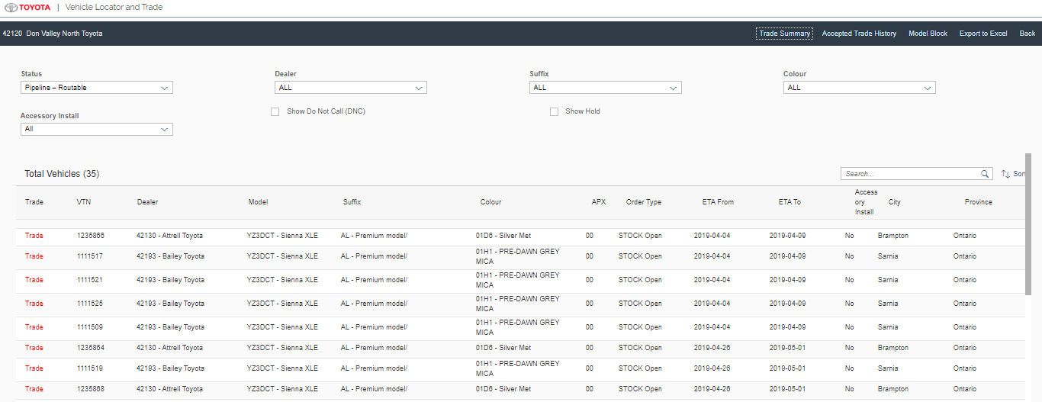

- Vehicle Trade: if the dealer wanted a vehicle from the inventory from the other dealers, the system provides an option to request the vehicle using the trade button and the trade request is sent to the other dealer either to accept/counter/reject the trade request.
- After the dealer accepts the trade requests, the vehicle changes the ownership in S/4 system and then starts the further actions for the same.
- For a zone user, the application provides an option to pull the vehicle to the zone inventory.
- If for any reason if the dealer decides to put a block on model of a particular vehicle for the dealers the application can be used to provide the Model block.
- The trade history will be available for the Dealer for one month from the date of Acceptance.

Assumptions
Dual Dealers will login to their respective portal to request and allocate stock for Toyota vehicles and Lexus Vehicles.

Issues
N/A

Issue # | Date Raised |  | Issue Description | Issue Resolution

Dependencies

Technical Details
  - Application Name: Vehicle Locator
  - Type: XSA Multi Target Application
  - Latest Version: 1.0.0
  - UI5 Libraries: sap.ui.layout, sap.ui.core, sap.ushell, sap.m
  - Components: Device, Model, Dialog, Text, Filter, History, MessageBox

  - Screens: Home Screen

Updated Version CR152 : Wild Search functionality is added for Suffix field( for ex: A* for all suffix starting with A) in VehicleLocSearch screen so that user can only see the vehicle related to the wild search(starting with A for ex) in the Search result screen.

Updated Version Cr81: Push Trade button is added.
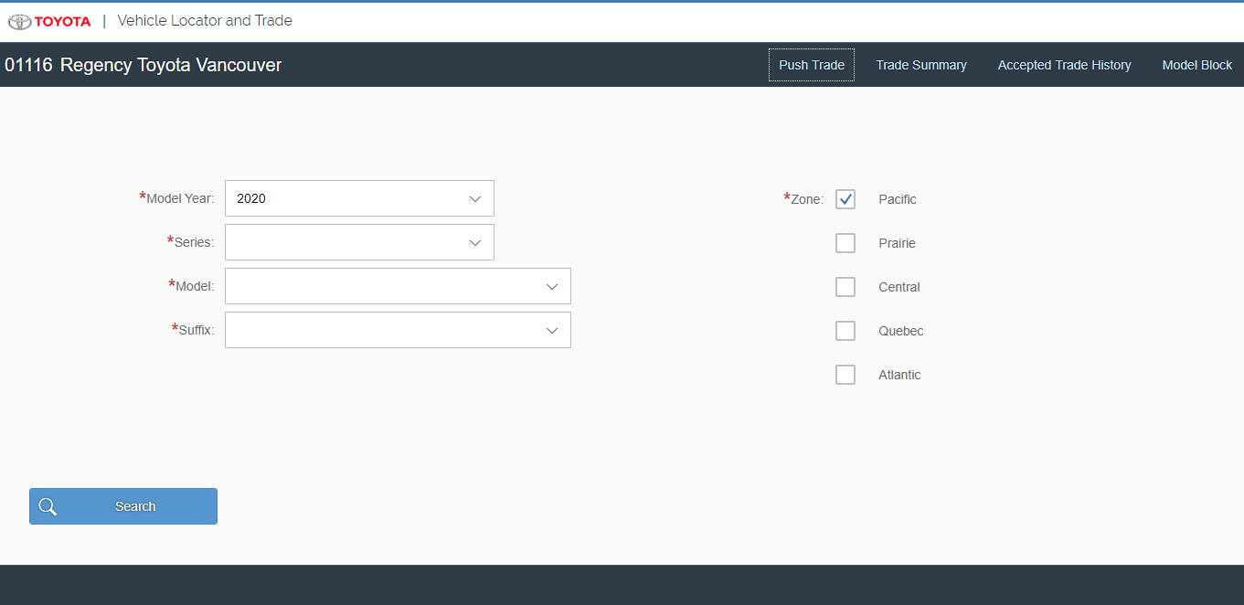

Vehicle Inventory Screen

Updated Version CR152: Wild Search functionality is also added on this screen so user can filter the table based on first letter of suffix.

Updated Version CR2.0: VTN column and Super Search is added.

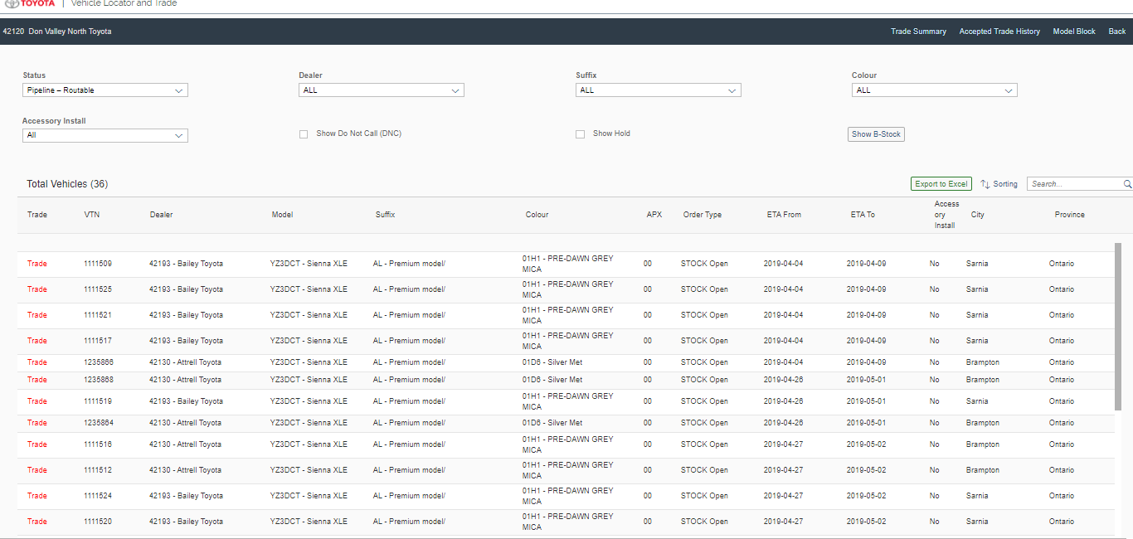

Update Version : Changes for CR 2.0 : New screen for Demo Vehicles

Demo Vehicle Screen
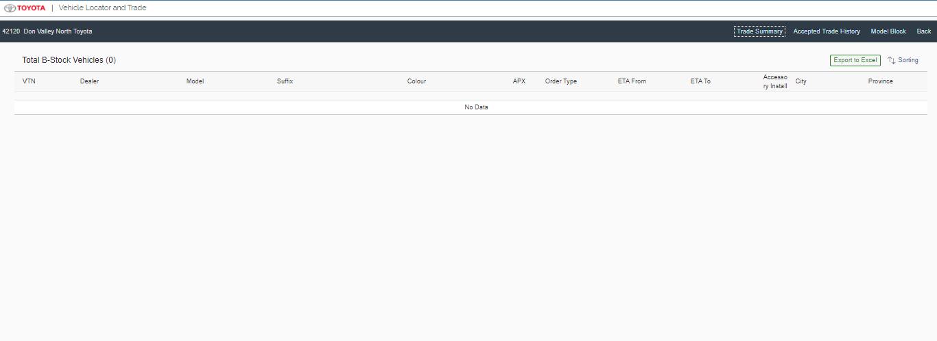
Vehicle Trade Screen

Updated Version CR2.0 : VTN and VIN field is added.

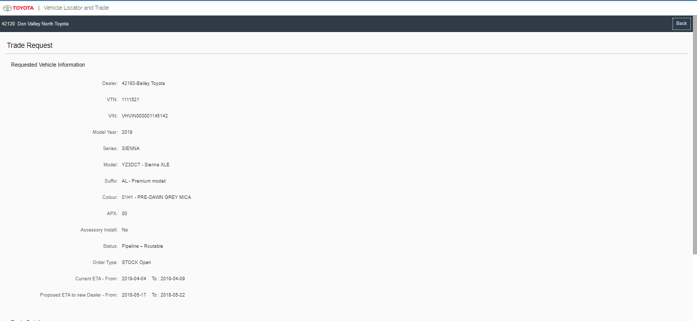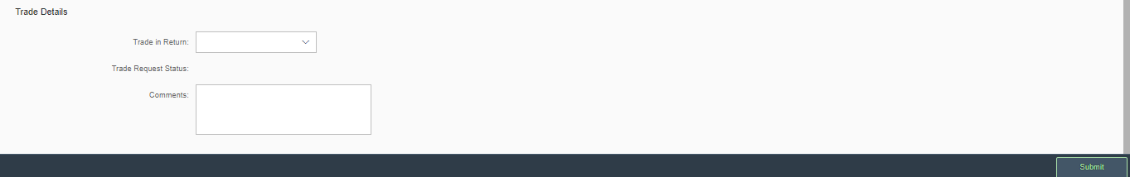
Update Version: Changes for CR2.0. New Filters were added to Vehicle Trade Vehicle Selection Screen

Vehicle selection Own Vehicle Offered Vehicle Screen. New Column VIN and Super Search is also added to the screen.
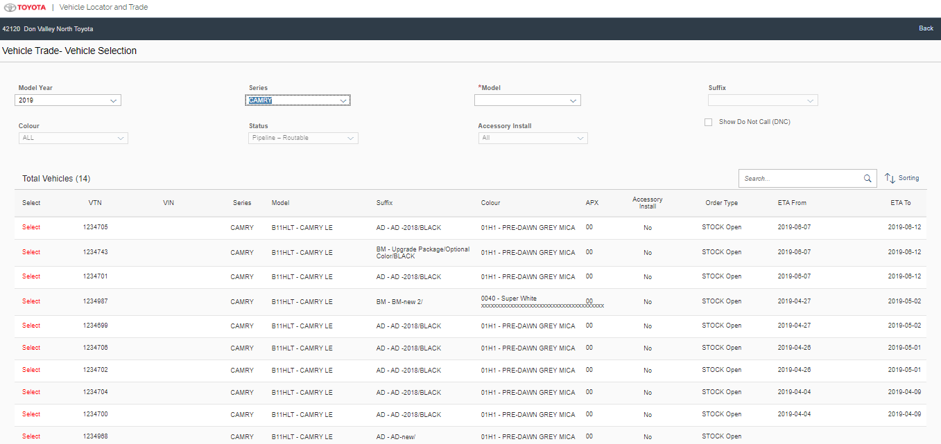

Updated Version: Changes for CR 2.0. New field VIN is added to the Trade Request screen. Label is also changed to Requested Vehicle Information and Offered Vehicle Information.

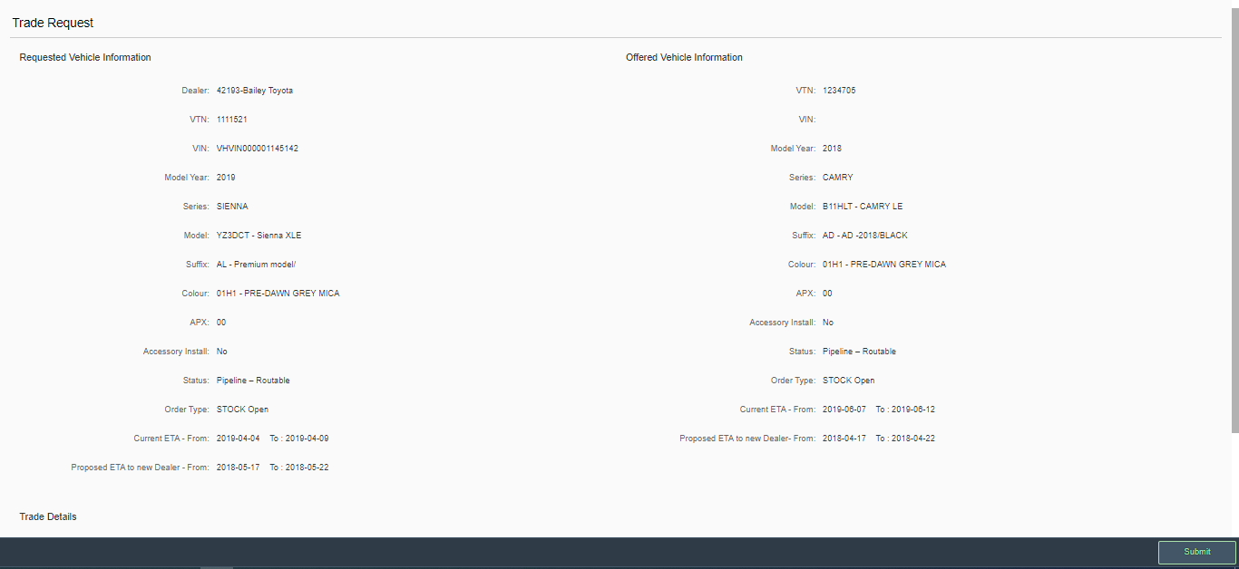
Trade Summary Screen.

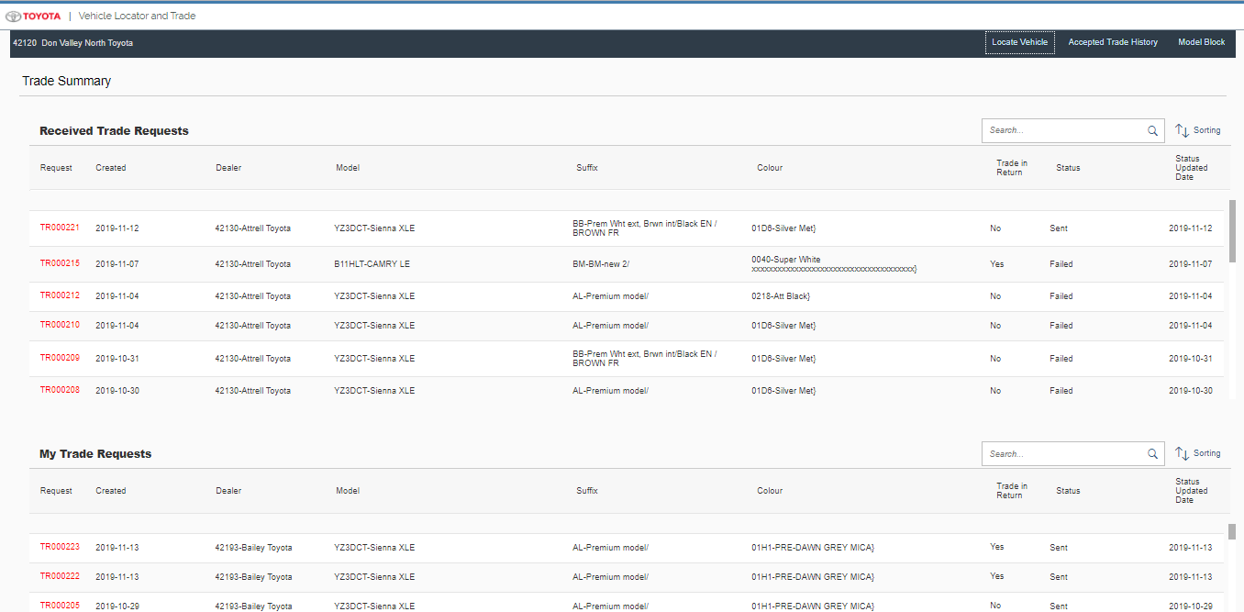

Updated Version : Changes for CR2.0. Trade History Screen splits in two tables: Trade Out and Trade In. VIN column is also added to both the tables.

Trade History Screen

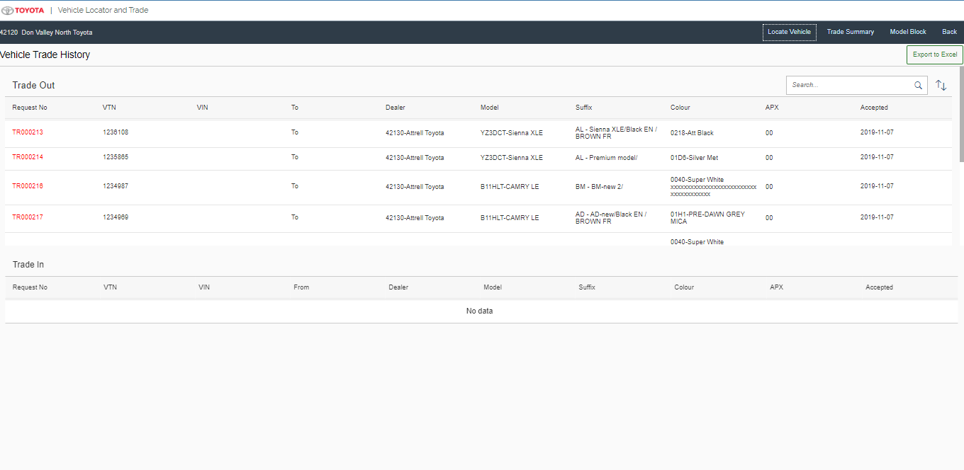

Model block Screen

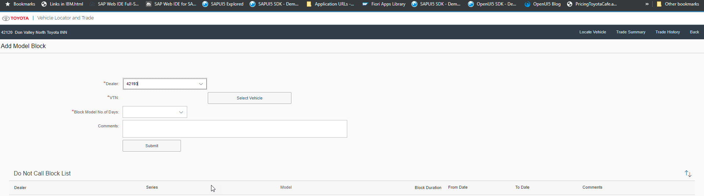

New Version: Changes for CR 81. New screen Push Trade – Vehicle Selection Screen is created for Push Trade to other Dealers.

Push Trade Screen
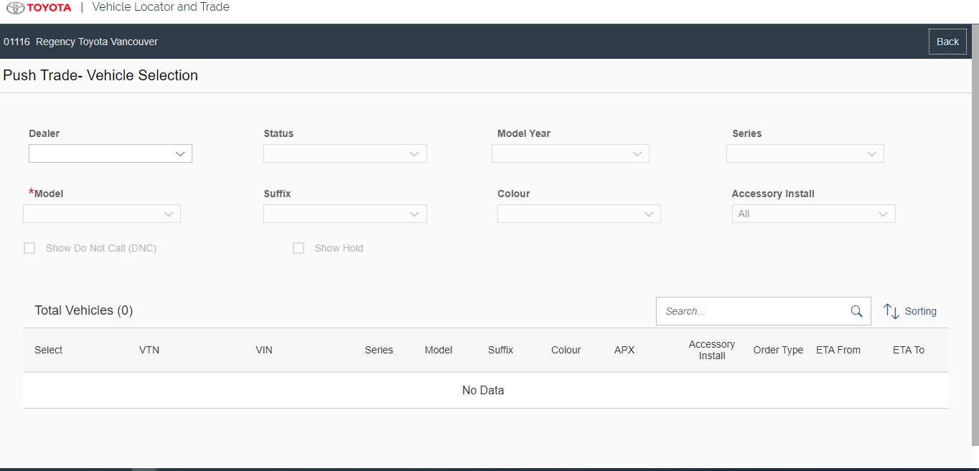

Models Details
  - Default Model
→Type: sap.ui.model.odata.v2.ODataModel
→DataSource: ZCDS_SUGGEST_ORD_CDS, ZCDS_SUGGEST_ORD_SUM_CDS, ZCDS_SUGGEST_ORD_COUNT_CDS, ZSD_SUGGEST_ORDER_UPDATE_SRV

  - i18n
→Type: sap.ui.model.resource.ResourceModel
→BundleName: “i18n.i18n”

  - JSONModel
→Type: sap.ui.model.json.JSONModel

Views Details
We have 10 views for this application built using the XML view as below.
.
Updated Version for CR2.0 : New controller DemoVehicleSearchResults.view.xml is added.
Updated Version for CR 81: New controller PushTrade_VehicleScreen.view.xml is added.

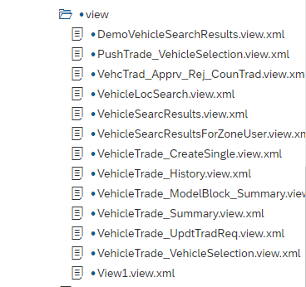

The First view that gets loaded is the VehicleLocSearch.view.xml.
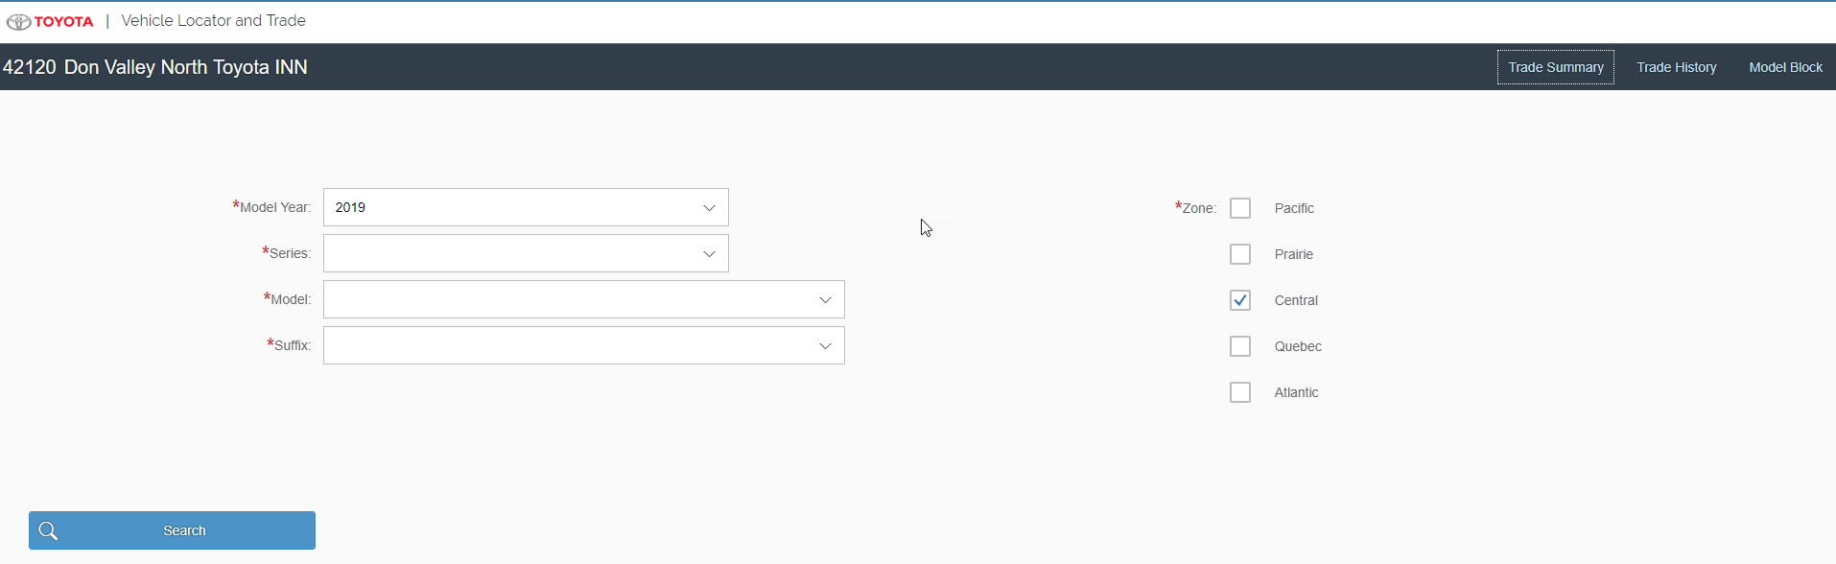
This view has comboxbox controls and standard page controls to receive the user input and a search button that navigates to vehicle search results.

2. The vehicle search results : For the logged in Dealer the next screen would be the vehicle search results screen with a list of available vehicles for the dealer to trade. A search filter is built into the table with count of vehicles with a pagination for 200 vehicles and a combo box for filter values for the screen. The click of Trade text is a link that routes to the selection of offered vehicle.

3. Vehicle Trade details page.

The view has a form and standard control to display the data from the previous navigation (vehicle search results).

4. clicking on the Submit will land the user on the trade summary page.

5. on accepting the trade the trade gets moved to Trade history page.

- If the dealer decides to place a model block then the dealer is provided with an option to block the vehicle for trade for a particular dealer.
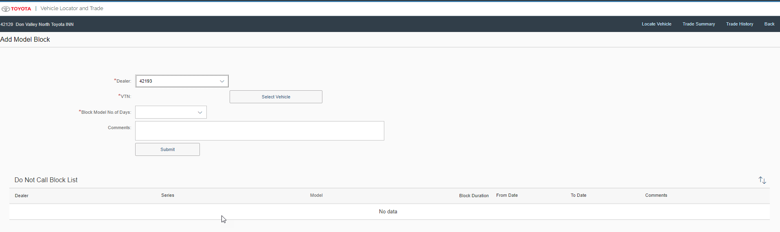
- On the click of Show B-stock button in Vehicle Search Result screen, it will navigate to Demo Vehicle Screen

View Controllers Details
The Summary of Controllers supporting this View are as below.
Updated Version for CR2.0 : New controller DemoVehicleSearchResults.controller is added.
Updated Version for CR 81: New controller PushTrade_VehicleScreen.controller is added.

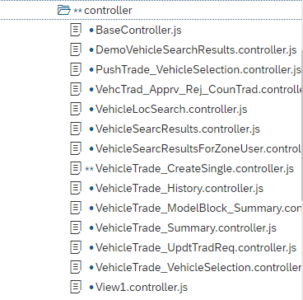

VehicleLocSearch.controller.js
On init even checks for local api from node js module the dealer type and scope of the user.
Based on the dealer type and scope and the url division the form is enabled to accept the dealer input. The system defaults to zone based on the S/4 returned data. On the click of the search button the screen navigates to vehicle search results.
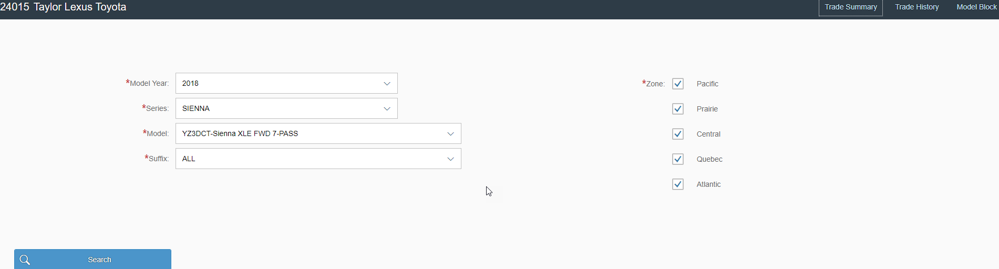

vehicleSearchResults: the onit event takes care of reading the Division and Locale. The vehicle search results are displayed in the table and filters are applied for the table data.

Name of the controller : vehicleSearchResults

On the click of Trade request the control is a link and the routing is mapped in manifest.json for the view traderequest create.

Vehicle_Trade_create Single.

Routing info

"pattern": "VehicleTrade_CreateSingle/:SelectedTrade:",
"name": "VehicleTrade_CreateSingle",
"target": "VehicleTrade_CreateSingle"
Target:
"VehicleTrade_CreateSingle": {
"viewName": "VehicleTrade_CreateSingle",
"async": true,
"clearControlAggregation": false
},

The above routing details are provided as an example and the same thing can be referred to manifest.json.

The user has an option to offer the vehicle by choosing yes/no from the trade in return option, with a selection of yes, the routing is navigated to vehicle list for the own inventory.

The url call to fetch the vehicle own inventory is as below.

/Z_VEHICLE_CATALOGUE_SRV/ZC_MODEL_DETAILS?$filter=Modelyear eq current year / past two years/ future year.

Once the vehicle is selected then the routing takes back to vehicle create single screen, where the user is provided with an option to Submit the Trade request.

The Vehicle trade Summary displays the list of Trade that were sent and received for the particular dealer id. Two controls with fixed headers using the scrolling container were used to build this screen.

Clicking on the Trade ID navigates to the VehcTrad_Apprv_Rej_CounTrad.

Fragments Details
The Fragment created as below to allow the Sort on the Table.

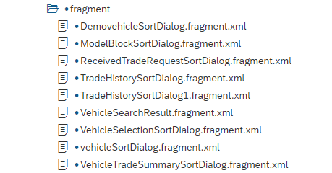

The Fragment has the standard controls with an addDependent to open the fragment

if (!this._sortDialog1) {

this._sortDialog1 = sap.ui.xmlfragment("VehicleTradeSummarySortDialog", "vehicleLocator.fragment.VehicleTradeSummarySortDialog",
this);
}
this.getView().addDependent(this._sortDialog1);

this._sortDialog1.open();

Component JS Details
- Loads manifest
- Initializes UI Components for application
- Initializes app router
- Initializes i18n resource bundle
- Handles session expiry dialog for the application

Formatters Details
The location of the formatter can be found in webapp - > formatter -> formatter.js
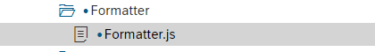

Patterns Details

ODATA-Gateway (Back-end)
- Main oData Service: vehicleTrade_SRV.xsodata, Z_DEALER_TRADE_REQUEST_SRV, Z_VEHICLE_CATALOGUE_SRV

- List of Entity Sets: just to name a few, this is not practical to list the every detail of the entity set to document here and so it is requested to refer the controller code/manifest for the entity sets.

Entity set | Filters/key/order | Response | OP
TradeComment | filter=Trade_Id eq '" + this.Tradeid + "'"
TradeRequest
TradeVehicles
TradeVehicleDesc

Data Source consideration
N/A
Field name / Description | Table Field Name | Comments / Calculations / Field Manipulations

Data Validation
N/A

Table Field Name | Validation Rule

Error Handling

  - Error Conditions and Logging

Form and few controls validation using validator -3rd party library

  - Notification

N/A
Error | How error message should be reported | Error Messages | Corrective action

  - Restart / Recovery

N/A

Security Requirements/ Authorization Details

UserDetails →attributes: Fetches Logged in user authorization details -language, zone and usertype also Business partner data and sales data as per provided filters in security layer

UserDetails →currentScopesForUser: Fetched scopes for logged in user as per the mapped groups and roles

Additional Information and attachments

  - Reconciliation Reporting

If a specific report or additional information is required is required for reconciliation

  - Attachments

HANA Artifacts
  - Object List : List out all the HANA artifacts which is required to be created/changed

Object Name | Object Type | Ref. ABAP Object | Object Description | Action | Package | Delivery Units | Comments

  - DB Procedure Details: Specify the details of DB procedure

Procedure Name:

Parameter Name | Parameter Type | Parameter Data Type | Data Type | Length | Scale
 | IN/OUT

Procedure Logic:

  - DB Objects (View/Table) : Specify the details of DB object structure

View Column | Table Column | SQL Data Type | Dimension | Not Null | Default

Sample View Screenshot: This is already provided above.

21. Unit Test Plan
Normal Functionality - test cases that ensure the workflow functions as it should. (e.g. updates fields correctly, processes all records)

Test Condition | Step | Step Description | Test Data | Expected Result | Actual Result | Executed By/Date | Remarks

Exception - special logic or exceptions (e.g. do not process Government Markets customers, only process pre-packs)

Test Condition | Step | Step Description | Test Data | Expected Result | Actual Result | Executed By/Date | Remarks

Error Handling - functionality in case of errors (e.g. Customer not found, Record already exists)

Test Condition | Step | Step Description | Test Data | Expected Result | Actual Result | Executed By/Date | Remarks

