Create an instance, install apache server(using start-up script) and add an index.html file. Create a robust web server with the use of auto scaling and load balancing.

Deliverable :- start-up script, security group rules, Listener configuration, steps
1. PART 1 – Create an instance and install apache server and add an index.html file
START UP SCRIPT :-

#!/bin/bash
yum update -y
yum install -y httpd
systemctl start httpd
systemctl enable httpd
usermod -a -G apache ec2-user
chown -R ec2-user:apache /var/www
chmod 2775 /var/www
find /var/www -type d -exec chmod 2775 {} \;
find /var/www -type f -exec chmod 0664 {} \;
echo "<h1>Hello SHRIRAM</h1>" > /var/www/html/index.html
service httpd start

Security group rules : Allow all HTTP AND HTTPS traffic (from the internet 0.0.0.0/0). Restrict SSH access only to my IP

INBOUND RULES

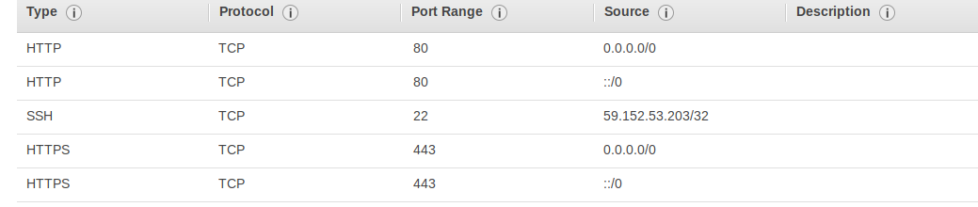

OUTBOUND RULES

Allow all traffic

2. ROBUST WEBSERVER USING AUTO SCALING AND LOAD BALANCER

1. We begin by creating a launch configuration for our Auto-Scaling group
2. Click on the Launch Configuration tab under the EC2 services
3. Click on create new launch configuration and select the required AMI ( Amazon LInux AMI ami-035b3c7efe6d061d5)
4. Choose the instance type and then give a name for the launch config. Also in the additional details part, enter the script for the webserver in the user data section
5. Finish the launch configuration process by selecting the storage, the security grps and review them
6. NOw, we get an option asking us whether we want to create an Auto Scaling group, click yes
7. Alternatively, you can create an auto scaling group from the tab with the same name and choose the required launch configuration
8. Set the name of the group and choose the VPC and the subsequent subnet to launch the group
9. Next in configure the scaling policies, set the min and the max amount of instances.
10. Add tags for the groups as required
11. Review and complete the process
12. Now you can also add instances from the instances tab if they are in the same VPC by updating the value of MAX
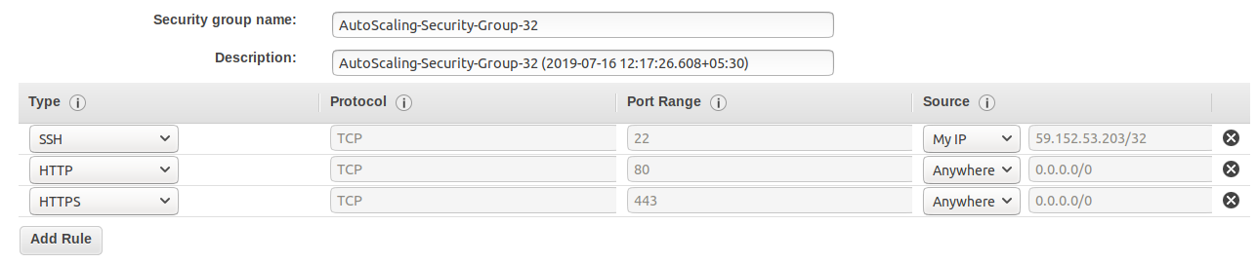
Security group settings:

LOAD BALANCER LISTENER CONFIGURATION
STEPS :

1. Go to EC2 services and then navigate to the Load Balanacer tab.
2. Click on create LOad balanacer and select Application LOad Balancer
3. GIve a name for the LOad balancer and select the AZ from the available AZ in the selected VPC. Under the Listener tab, we can configure the listeners that we want the load balancer to have. (Here we couldnt add HTTPS as it required us to upload a certificate, which we didnt have). Click on NEXT
4. Select the required security groups from the Configure security groups tab
5. In the configure Routing tab, click on create new ROuting group and select target type as INSTANCE Give a name for the target group and then click on next
6. In the register targets tab, specify the IP targets (Private IPs of the instances in the VPC) and click on next
7. REview and create the load balancer

ATTACHING LOAD BALANCER TO AUTO SCALING GROUP:

1. Go to the Auto-Scaling tab and click on the name of the auto scaling group
2. From the options tab, click on edit
3. In the target group option, select the same target group that you created for the load balancer.

Now load balancer is attached to the auto scaling group and all the instances will have robust webserver and load balancer will route requests acc to the need.

Security grp for load balancer
