Launch 3 different instances in each of the above private subnets. Launch a bastion server in one of the public subnets. Restrict the security groups of the private instances to allow SSH only from the bastion host and restrict the access to the Bastion host to Quantiphi IP Range.
Deliverable :- security group rules of all instances

1. CREATE BASTIAN HOST AND LAUNCH IT INTO THE PUBLIC SUBNET

INBOUND RULES:

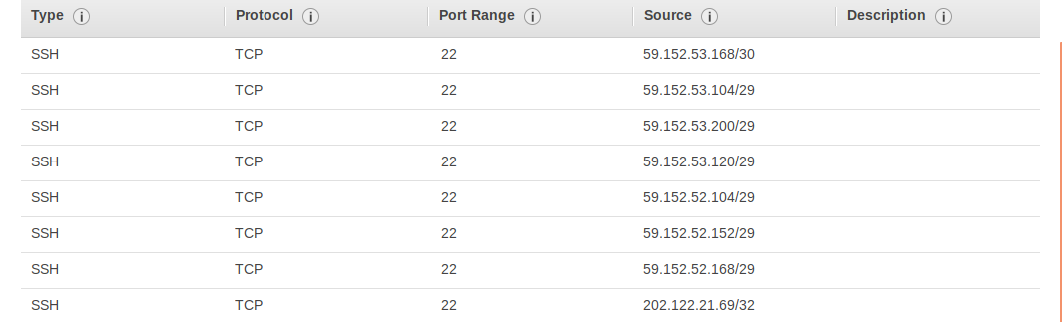
Outbound all allowed
2. SECURITY GRP OF PRIVATE INSTANCE

Inbound only from the bastian host sg
outbound -all

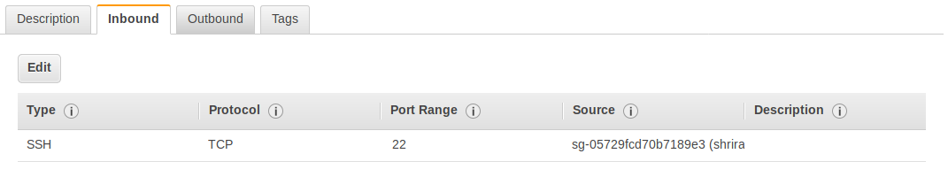
NOW WE USE SSH TUNNELING TO MAKE SURE WE DONOT STORE THE PRIVATE KEYS IN THE BASTIAN HOST

IN THE LOCAL MACHINE, WE ADD

ssh-add -k /home/shriram/Downloads/shriram.pem
Identity added: /home/shriram/Downloads/shriram.pem (/home/shriram/Downloads/shriram.pem)

NOW WE CAN ACCESS THE BASTIAN HOST USING

$ ssh -A ec2-user@<bastion-host-elastic-ip>

AND THE PRIVATE EC2 INSTANCE USING

$ ssh ec2-user@<private-instance-ip>

