Q) Create an auto scaling instance group that hosts the apache server that displays the name of the instance that has served the current request to the user. Stress the Autoscaling group artificially using the stress tool (sudo apt-get install stress) and demonstrate the group being autoscaled. Use cli/client library

1. Create an instance template:

The startup script is:
#! #! /bin/bash
apt-get update
apt-get install -y apache2
/etc/init.d/apache2 start
cat <<EOF > /var/www/html/index.html
<html>
<body>
<p>hostname is: $(hostname)</p>
</body>
</html>
EOF

root@Quantiphi-928:/home/shriram# gcloud compute --project=pe-training instance-templates create shri-inst-temp --machine-type=f1-micro --network=projects/pe-training/global/networks/default --network-tier=PREMIUM --metadata=startup-script=\#\!\ /bin/bash$'\n'apt-get\ update$'\n'apt-get\ install\ -y\ apache2$'\n'/etc/init.d/apache2\ start$'\n'cat\ \<\<EOF\ \>\ /var/www/html/index.html$'\n'\<html\>$'\n'\<body\>$'\n'\<p\>hostname\ is:\ \$\(hostname\)\</p\>$'\n'\</body\>$'\n'\</html\>$'\n'EOF --maintenance-policy=MIGRATE --service-account=912623308461-compute@developer.gserviceaccount.com --scopes=https://www.googleapis.com/auth/devstorage.read_only,https://www.googleapis.com/auth/logging.write,https://www.googleapis.com/auth/monitoring.write,https://www.googleapis.com/auth/servicecontrol,https://www.googleapis.com/auth/service.management.readonly,https://www.googleapis.com/auth/trace.append --tags=http-server,https-server --image=debian-9-stretch-v20190618 --image-project=debian-cloud --boot-disk-size=10GB --boot-disk-type=pd-standard --boot-disk-device-name=shri-inst-temp
WARNING: You have selected a disk size of under [200GB]. This may result in poor I/O performance. For more information, see: https://developers.google.com/compute/docs/disks#performance.
Created [https://www.googleapis.com/compute/v1/projects/pe-training/global/instanceTemplates/shri-inst-temp].
NAME MACHINE_TYPE PREEMPTIBLE CREATION_TIMESTAMP
shri-inst-temp f1-micro 2019-07-19T03:14:38.106-07:00

2. Create a managed instance group
root@Quantiphi-928:/home/shriram# gcloud beta compute --project=pe-training instance-groups managed create shri-inst-grp --base-instance-name=shri-inst-grp --template=shri-inst-temp --size=1 --description="A cluster of Apache servers" --zones=us-central1-b,us-central1-c,us-central1-f --instance-redistribution-type=PROACTIVE --health-check=akash-hc --initial-delay=300
Created [https://www.googleapis.com/compute/beta/projects/pe-training/regions/us-central1/instanceGroupManagers/shri-inst-grp].
NAME LOCATION SCOPE BASE_INSTANCE_NAME SIZE TARGET_SIZE INSTANCE_TEMPLATE AUTOSCALED
shri-inst-grp us-central1 region shri-inst-grp 0 1 shri-inst-temp no
root@Quantiphi-928:/home/shriram# gcloud beta compute --project "pe-training" instance-groups managed set-autoscaling "shri-inst-grp" --region "us-central1" --cool-down-period "60" --max-num-replicas "10" --min-num-replicas "1" --target-cpu-utilization "0.6"
Created [https://www.googleapis.com/compute/beta/projects/pe-training/regions/us-central1/autoscalers/shri-inst-grp-4s87].
---
autoscalingPolicy:
coolDownPeriodSec: 60
cpuUtilization:
utilizationTarget: 0.6
maxNumReplicas: 10
minNumReplicas: 1
creationTimestamp: '2019-07-19T03:16:57.853-07:00'
id: '1045818435635521142'
kind: compute#autoscaler
name: shri-inst-grp-4s87
region: https://www.googleapis.com/compute/beta/projects/pe-training/regions/us-central1
selfLink: https://www.googleapis.com/compute/beta/projects/pe-training/regions/us-central1/autoscalers/shri-inst-grp-4s87
status: PENDING
target: https://www.googleapis.com/compute/beta/projects/pe-training/regions/us-central1/instanceGroupManagers/shri-inst-grp

3. Install stress tool on the instance

Go to the instance initialized and SSH into it

Install the stress tool using the command apt-get install stress

Run the command stress --cpu 1 --timeout 300

Then instances get initialized automatically to handle the load. The image is as follows

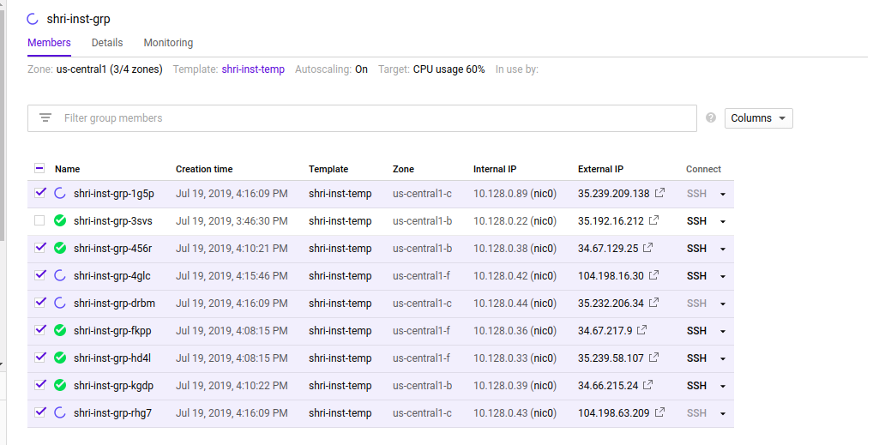
Once the stress request is served, it returns to the original state with 1 instance.

