- Launch instance with only private ip and configure NAT so instance can access Internet. (Need to use network tags)

STEPS :

A. CREATE A VPC NETWORK

1. Go to Networking tab and click on the VPC Networking tab.
2. Click on the create new VPC network option.
3. Give the VPC a name, and under Subnets , set the mode to Custom
4. Enter a name for the subnet , select a region and assign it a CIDR block.
5. Click on CREATE.

B. CREATE A BASTIAN HOST (WITH EXTERNAL IP)

1. GO to VM instances tab and click on Create Instance option.
2. Specify a name for the host, set the region and zone.
3. Click on the Management, security, disks, networking, sole tenacy link.
4. Click on the Networking tab.
5. Under the network interfaces, set the network name to the name of the VPC created, select the subnet and click on done
6. Under the network tags option, give the VM instance a name/network tag.
7. Click on CREATE.

C. CREATE A VM INSTANCE WITH NO EXTERNAL IP

1. GO to VM instances tab and click on Create Instance option.
2. Specify a name for the host, set the region and zone.
3. Click on the Management, security, disks, networking, sole tenacy link.
4. Click on the Networking tab.
5. Under the network interfaces, set the network name to the name of the VPC created, select the subnet
6. Set the External IP to None and click on done.
7. Click on CREATE.

D. CREATE A FIREWALL RULE TO ALLOW SSH ACCESS

1. GO to the Firewall rules page and click on Create Firewall rule.
2. Enter a name for the rule.
3. Specify the name of the created VPC network
4. Set the direction of traffic to ingress.
5. Set the action on match to allow.
6. Set the target to all Instances in the network.
7. Set the source filter to IP ranges.
8. Set Source IP ranges to 0.0.0.0/0
9. Under the second source filter, select the source tags, and then specify the name of the network tag given to the bastian host, this allows ssh traffic from the bastian host.
10. Under the protocols and ports, click on specified ports and give 22 beside the tcp tab
11. Click on Create.

E. SSH into the instance with private ip

1. Click on the SSH button along the line of the name of the bastian host that we created.
2. After the Google Chrome terminal for Ssh is open after the keys are transferred and managed by Google, enter the following command
ssh -A [name of the private VM instance]
3. Approve the SSH connection, and now you will be connected to the private instance.
4. Try to ping any website, there would be a 100 percent packet loss as the instance isnt connected to the internet.
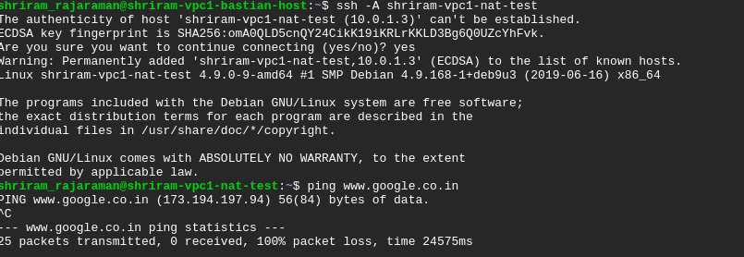
F. Create a NAT gateway

1. Go to the Cloud NAT page under Networking services.
2. Click on create new NAT gateway.
3. Select the VPC network that you created.
4. Set the region
5. Under Cloud router, select Create new router and enter a name , click on create.
6. Click on Create.
7. You can further customize other relevant options by configuring NAT Mapping.

G. TEST THE INTERNET CONNECTIVITY.

Now again ssh into the private instance and ping any internet website, you will be able to ping it.
Thus NAT gateway has been set up.

