Git Solutions

1) Create a Distributed version control system, and put files into it.

root@Quantiphi-928:/home/shriram/Desktop# mkdir GitAssessment
root@Quantiphi-928:/home/shriram/Desktop# cd GitAssessment
root@Quantiphi-928:/home/shriram/Desktop/GitAssessment# chmod 777 -R ./
root@Quantiphi-928:/home/shriram/Desktop/GitAssessment# git init
Initialized empty Git repository in /home/shriram/Desktop/GitAssessment/.git/
root@Quantiphi-928:/home/shriram/Desktop/GitAssessment# echo hello >hw.txt
root@Quantiphi-928:/home/shriram/Desktop/GitAssessment# git add hw.txt
root@Quantiphi-928:/home/shriram/Desktop/GitAssessment# git commit -m 'initial commit'
[master (root-commit) f6980a6] initial commit
1 file changed, 1 insertion(+)
create mode 100644 hw.txt
root@Quantiphi-928:/home/shriram/Desktop/GitAssessment# echo "Sample Git" >README
root@Quantiphi-928:/home/shriram/Desktop/GitAssessment# git add README
root@Quantiphi-928:/home/shriram/Desktop/GitAssessment# git commit -m "Added Readme"
[master 4d94144] Added Readme
1 file changed, 1 insertion(+)
create mode 100644 README
root@Quantiphi-928:/home/shriram/Desktop/GitAssessment# git remote add origin /home/shriram/Desktop/GitAssessment
root@Quantiphi-928:/home/shriram/Desktop/GitAssessment# git push origin master
Everything up-to-date

2) Replicate a DVCS on your local machine, make changes to its files, and then put them back into it.

root@Quantiphi-928:/home/shriram/Desktop/GitAssessment# git clone https://github.com/shriram2712/sample.git
Cloning into 'sample'...
remote: Enumerating objects: 3, done.
remote: Counting objects: 100% (3/3), done.
remote: Compressing objects: 100% (2/2), done.
remote: Total 13 (delta 0), reused 2 (delta 0), pack-reused 10
Unpacking objects: 100% (13/13), done.
root@Quantiphi-928:/home/shriram/Desktop/GitAssessment# cd sample
root@Quantiphi-928:/home/shriram/Desktop/GitAssessment/sample# ls
branch2test.txt hw.txt README.md Sample1
root@Quantiphi-928:/home/shriram/Desktop/GitAssessment/sample# cat hw.txt
hello
root@Quantiphi-928:/home/shriram/Desktop/GitAssessment/sample# cat >>hw.txt
world
^C
root@Quantiphi-928:/home/shriram/Desktop/GitAssessment/sample# cat hw.txt
hello
world
root@Quantiphi-928:/home/shriram/Desktop/GitAssessment/sample# git add hw.txt
root@Quantiphi-928:/home/shriram/Desktop/GitAssessment/sample# git commit -m "CHanged contents of hw.txt"
[master 897c714] CHanged contents of hw.txt
1 file changed, 1 insertion(+)
root@Quantiphi-928:/home/shriram/Desktop/GitAssessment/sample# git push origin master
Username for 'https://github.com': 2015shriram.rajaraman@ves.ac.in
Password for 'https://2015shriram.rajaraman@ves.ac.in@github.com':
Counting objects: 3, done.
Delta compression using up to 8 threads.
Compressing objects: 100% (2/2), done.
Writing objects: 100% (3/3), 290 bytes | 290.00 KiB/s, done.
Total 3 (delta 1), reused 0 (delta 0)
remote: Resolving deltas: 100% (1/1), completed with 1 local object.
To https://github.com/shriram2712/sample.git
74fae72..897c714 master -> master

3) List down all the files which have changed in the last commit. List only the file names.

root@Quantiphi-928:/home/shriram/Desktop/GitAssessment/sample# git diff --name-only HEAD~1
hw.txt

4) You’ve accidentally added some files on a DVCS. Remove those files from the DVCS without deleting them from your local system.

root@Quantiphi-928:/home/shriram/Desktop/GitAssessment/sample# git rm --cached branch2test.txt
rm 'branch2test.txt'
root@Quantiphi-928:/home/shriram/Desktop/GitAssessment/sample# git commit -m "branch2test.txt removed"
[master 978c199] branch2test.txt removed
1 file changed, 0 insertions(+), 0 deletions(-)
delete mode 100644 branch2test.txt
root@Quantiphi-928:/home/shriram/Desktop/GitAssessment/sample# git push master origin
fatal: 'master' does not appear to be a git repository
fatal: Could not read from remote repository.

Please make sure you have the correct access rights
and the repository exists.
root@Quantiphi-928:/home/shriram/Desktop/GitAssessment/sample# git push origin master
Username for 'https://github.com': 2015shriram.rajaraman@ves.ac.in
Password for 'https://2015shriram.rajaraman@ves.ac.in@github.com':
Counting objects: 2, done.
Delta compression using up to 8 threads.
Compressing objects: 100% (2/2), done.
Writing objects: 100% (2/2), 240 bytes | 240.00 KiB/s, done.
Total 2 (delta 1), reused 0 (delta 0)
remote: Resolving deltas: 100% (1/1), completed with 1 local object.
To https://github.com/shriram2712/sample.git
897c714..978c199 master -> master
root@Quantiphi-928:/home/shriram/Desktop/GitAssessment/sample#

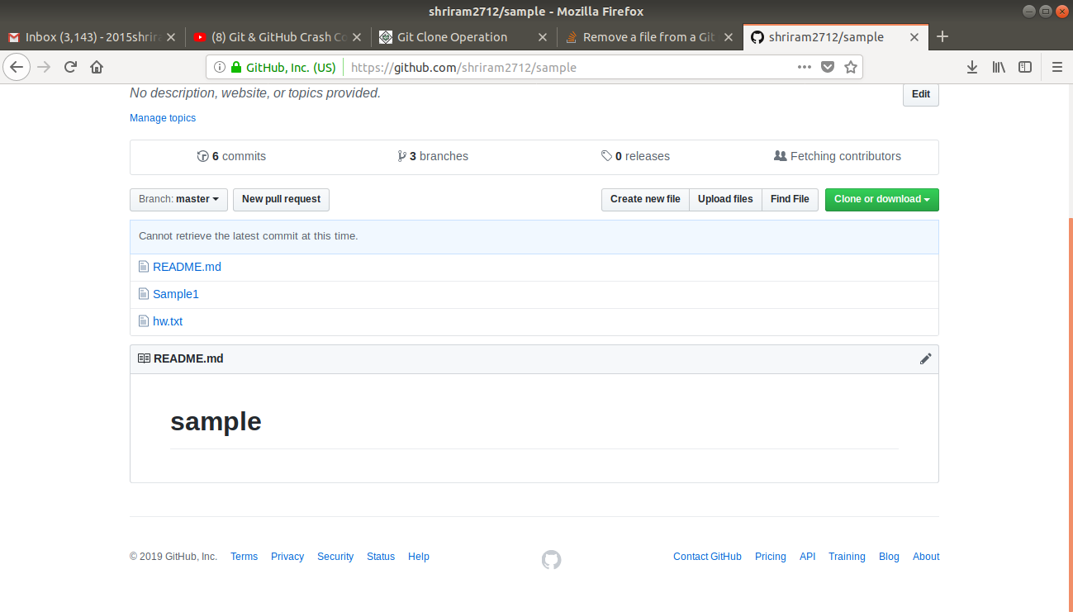
5) You’ve accidentally committed some files on a DVCS. Revert the DVCS to a previous stable state.

root@Quantiphi-928:/home/shriram/Desktop/GitAssessment/sample# git log
commit 978c199e311da14b6453c911cd1ce3b11803cf47 (HEAD -> master, origin/master, origin/HEAD)
Author: Shriram Rajaraman <2015shriram.rajaraman@ves.ac.in>
Date: Thu Jul 4 16:36:51 2019 +0530

branch2test.txt removed

commit 897c714993e509b10d17c9a08fbaaa3f90d8d930
Author: Shriram Rajaraman <2015shriram.rajaraman@ves.ac.in>
Date: Thu Jul 4 16:28:39 2019 +0530

CHanged contents of hw.txt

commit 74fae7233f191a2f7622e882c28784f9b16c7b24
Author: Shriram Rajaraman <2015shriram.rajaraman@ves.ac.in>
Date: Thu Jul 4 16:19:16 2019 +0530

Added Hello world

commit 8ed36e3b97c85326448b87263304f316836bead5
Author: Shriram Rajaraman <32219070+shriram2712@users.noreply.github.com>
Date: Sat Apr 7 01:18:03 2018 -0700

Initial commit

root@Quantiphi-928:/home/shriram/Desktop/GitAssessment/sample# git checkout 897c714993e509b10d17c9a08fbaaa3f90d8d930
Note: checking out '897c714993e509b10d17c9a08fbaaa3f90d8d930'.

You are in 'detached HEAD' state. You can look around, make experimental
changes and commit them, and you can discard any commits you make in this
state without impacting any branches by performing another checkout.

If you want to create a new branch to retain commits you create, you may
do so (now or later) by using -b with the checkout command again. Example:

git checkout -b <new-branch-name>

HEAD is now at 897c714 CHanged contents of hw.txt
root@Quantiphi-928:/home/shriram/Desktop/GitAssessment/sample# git revert 978c199e311da14b6453c911cd1ce3b11803cf47
HEAD detached at 897c714
nothing to commit, working tree clean
root@Quantiphi-928:/home/shriram/Desktop/GitAssessment/sample# git push origin master
Username for 'https://github.com': 2015shriram.rajaraman@ves.ac.in
Password for 'https://2015shriram.rajaraman@ves.ac.in@github.com':
Everything up-to-date

6) Create a DVCS capable of supporting 2 similar dev environments. Make changes in the files which are present on both of them and then merge the environments into one.

root@Quantiphi-928:/home/shriram/Desktop# mkdir qsix
root@Quantiphi-928:/home/shriram/Desktop# cd qsix
root@Quantiphi-928:/home/shriram/Desktop/qsix# git init
Initialized empty Git repository in /home/shriram/Desktop/qsix/.git/
root@Quantiphi-928:/home/shriram/Desktop/qsix# echo "hello" >h1.txt
root@Quantiphi-928:/home/shriram/Desktop/qsix# git add h1.txt
root@Quantiphi-928:/home/shriram/Desktop/qsix# git commit -m "h1 to master"
[master (root-commit) bf3a1ee] h1 to master
1 file changed, 1 insertion(+)
create mode 100644 h1.txt
root@Quantiphi-928:/home/shriram/Desktop/qsix# git remote add origin /home/shriram/Desktop/qsix
root@Quantiphi-928:/home/shriram/Desktop/qsix# echo "hello" >h2.txt
root@Quantiphi-928:/home/shriram/Desktop/qsix# echo "hello" >h3.txt
root@Quantiphi-928:/home/shriram/Desktop/qsix# git add h2.txt
root@Quantiphi-928:/home/shriram/Desktop/qsix# git add h3.txt
root@Quantiphi-928:/home/shriram/Desktop/qsix# git commit -m "h2 and h3 added"
[master 55daea4] h2 and h3 added
2 files changed, 2 insertions(+)
root@Quantiphi-928:/home/shriram/Desktop/qsix# git branch dev2
root@Quantiphi-928:/home/shriram/Desktop/qsix# git checkout dev2
Switched to branch 'dev2'
root@Quantiphi-928:/home/shriram/Desktop/qsix# echo "world" >>h3.txt
root@Quantiphi-928:/home/shriram/Desktop/qsix# git add h3.txt
root@Quantiphi-928:/home/shriram/Desktop/qsix# git commit -m "H3 change from dev2"
[dev2 ddb3b2e] H3 change from dev2
1 file changed, 1 insertion(+)
root@Quantiphi-928:/home/shriram/Desktop/qsix# git checkout dev1
Switched to branch 'dev1'
root@Quantiphi-928:/home/shriram/Desktop/qsix# git merge dev2
Updating 55daea4..ddb3b2e
Fast-forward
h2.txt | 1 +
h3.txt | 1 +
2 files changed, 2 insertions(+)
root@Quantiphi-928:/home/shriram/Desktop/qsix# git checkout dev1
Switched to branch 'dev1'
root@Quantiphi-928:/home/shriram/Desktop/qsix# cat h3.txt
hello
world
root@Quantiphi-928:/home/shriram/Desktop/qsix# git checkout master
Switched to branch 'master'
root@Quantiphi-928:/home/shriram/Desktop/qsix# cat h3.txt
hello
root@Quantiphi-928:/home/shriram/Desktop/qsix# git merge dev1
Updating 9f19bca..ddb3b2e
Fast-forward
h3.txt | 1 +
1 file changed, 1 insertion(+)
root@Quantiphi-928:/home/shriram/Desktop/qsix# cat h3.txt
hello
world

7) You have a DVCS supporting your prod, test and dev environments, you need to make sure that only a particular set of commits from the test environment are added in the prod environment. What & how would you do it?

The idea here is to create 2 branches - the test branch and the prod branch which will exist along with the master (dev) branch. Using the cherry-pick command we commited only commit e into prod branch using the commit id

root@Quantiphi-928:/home/shriram/Desktop# cd ques7
root@Quantiphi-928:/home/shriram/Desktop/ques7# git init
Initialized empty Git repository in /home/shriram/Desktop/ques7/.git/
root@Quantiphi-928:/home/shriram/Desktop/ques7# echo "Hello world" >>a.txt
root@Quantiphi-928:/home/shriram/Desktop/ques7# git add .
root@Quantiphi-928:/home/shriram/Desktop/ques7# git commit -m "First Commit"
[master (root-commit) f0b2e83] First Commit
1 file changed, 1 insertion(+)
create mode 100644 a.txt
root@Quantiphi-928:/home/shriram/Desktop/ques7# git remote add origin /home/shriram/Desktop/ques7
root@Quantiphi-928:/home/shriram/Desktop/ques7# git branch prod
root@Quantiphi-928:/home/shriram/Desktop/ques7# git branch test
root@Quantiphi-928:/home/shriram/Desktop/ques7# git branch
* master
prod
test
root@Quantiphi-928:/home/shriram/Desktop/ques7# git checkout test
Switched to branch 'test'
root@Quantiphi-928:/home/shriram/Desktop/ques7# echo "hello" >b.txt
root@Quantiphi-928:/home/shriram/Desktop/ques7# git add .
root@Quantiphi-928:/home/shriram/Desktop/ques7# git commit -m "b commit on test"
[test 6d82ec1] b commit on test
1 file changed, 1 insertion(+)
create mode 100644 b.txt
root@Quantiphi-928:/home/shriram/Desktop/ques7# echo "hello" >c.txt
root@Quantiphi-928:/home/shriram/Desktop/ques7# git add .
root@Quantiphi-928:/home/shriram/Desktop/ques7# git commit -m "c commit on test"
[test 76c137d] c commit on test
1 file changed, 1 insertion(+)
create mode 100644 c.txt
root@Quantiphi-928:/home/shriram/Desktop/ques7# echo "hello" >e.txt
root@Quantiphi-928:/home/shriram/Desktop/ques7# git add .
root@Quantiphi-928:/home/shriram/Desktop/ques7# git commit -m "e commit on test"
[test fcb370d] e commit on test
1 file changed, 1 insertion(+)
create mode 100644 e.txt
root@Quantiphi-928:/home/shriram/Desktop/ques7# echo "hello" >f.txt
root@Quantiphi-928:/home/shriram/Desktop/ques7# git add .
root@Quantiphi-928:/home/shriram/Desktop/ques7# git commit -m "f commit on test"
[test 13b9dd8] f commit on test
1 file changed, 1 insertion(+)
create mode 100644 f.txt
root@Quantiphi-928:/home/shriram/Desktop/ques7# git checkout prod
Switched to branch 'prod'
root@Quantiphi-928:/home/shriram/Desktop/ques7# echo "hello" >g.txt
root@Quantiphi-928:/home/shriram/Desktop/ques7# git add .
root@Quantiphi-928:/home/shriram/Desktop/ques7# git commit --amend -m "g commit on test"
[prod 97a3a14] g commit on test
Date: Fri Jul 5 18:11:36 2019 +0530
1 file changed, 1 insertion(+)
create mode 100644 g.txt
root@Quantiphi-928:/home/shriram/Desktop/ques7# git checkout test
Switched to branch 'test'
root@Quantiphi-928:/home/shriram/Desktop/ques7# git log --pretty=oneline
13b9dd8cfbbd22b7fc2aa84577bec5df07fd1ffe (HEAD -> test) f commit on test
fcb370db8bde919aca8513143959709f2113575d e commit on test
76c137d58d069beab58d501f86f6903ff566fec1 c commit on test
6d82ec19b6f3f493e6c23051c5654653ea8a33d9 b commit on test
f0b2e83e2787e185b715402775742bde2775309e (master) First Commit
root@Quantiphi-928:/home/shriram/Desktop/ques7# git checkout prod
Switched to branch 'prod'
root@Quantiphi-928:/home/shriram/Desktop/ques7# git log --pretty=oneline
d4a01e4601f1ea2fe637d7f35d54059b2f272b09 (HEAD -> prod) h commit on test
97a3a14476a4f0cabcc0448aecfb6555a9511bc0 g commit on test
f0b2e83e2787e185b715402775742bde2775309e (master) First Commit
root@Quantiphi-928:/home/shriram/Desktop/ques7# git cherry-pick fcb370db8bde919aca8513143959709f2113575d
[prod 3edb190] e commit on test
Date: Fri Jul 5 18:10:47 2019 +0530
1 file changed, 1 insertion(+)
create mode 100644 e.txt
root@Quantiphi-928:/home/shriram/Desktop/ques7# git log --pretty=oneline
3edb190e9b37f77c5a33bb292591134bca94804c (HEAD -> prod) e commit on test
d4a01e4601f1ea2fe637d7f35d54059b2f272b09 h commit on test
97a3a14476a4f0cabcc0448aecfb6555a9511bc0 g commit on test
f0b2e83e2787e185b715402775742bde2775309e (master) First Commit

