# Spring Boot Customer Application using Microservices architecture

## Run without IDE(Assumptions – maven is installed in your PC, java 8 is installed as well)

1. Clone this project from root folder.( https://github.com/shriramdevanathan/spring-customer-crm/tree/feature/development)
2. Unzip the file. You should see the below folder structure.

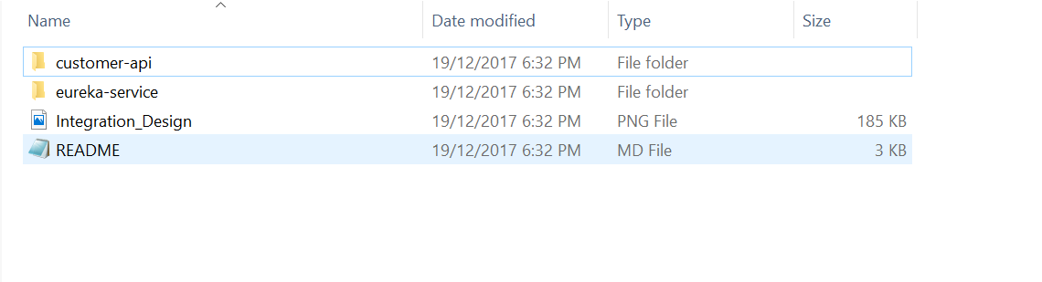

1. Navigate to ‘eureka-service’ root and run

* **mvn clean install**
* *mvn package*

1. This should create the ‘target’ folder and also contain eureka-service-0.0.1-SNAPSHOT.jar
2. Run the following command.

* cd target
* java -jar eureka-service-0.0.1-SNAPSHOT.jar

1. This should startup the embedded tomcat and the entity manager stuff. The port should be **8302** as per settings.
2. Navigate to ‘customer-api’ root and run

* **mvn clean install**
* *mvn package*

1. This should create the target folder and also contain customer-api-0.0.1-SNAPSHOT.jar
2. Run the following command then.

* cd target
* java -jar customer-api-0.0.1-SNAPSHOT.jar

1. This should startup the embedded tomcat in port **8300**.

If the above steps were successful, it means that we have a Eureka server running, with the customer-api eureka client registered to the Eureka server.

Now from browser, access the following url to access the Eureka Dashboard

* **http://localhost:8302**

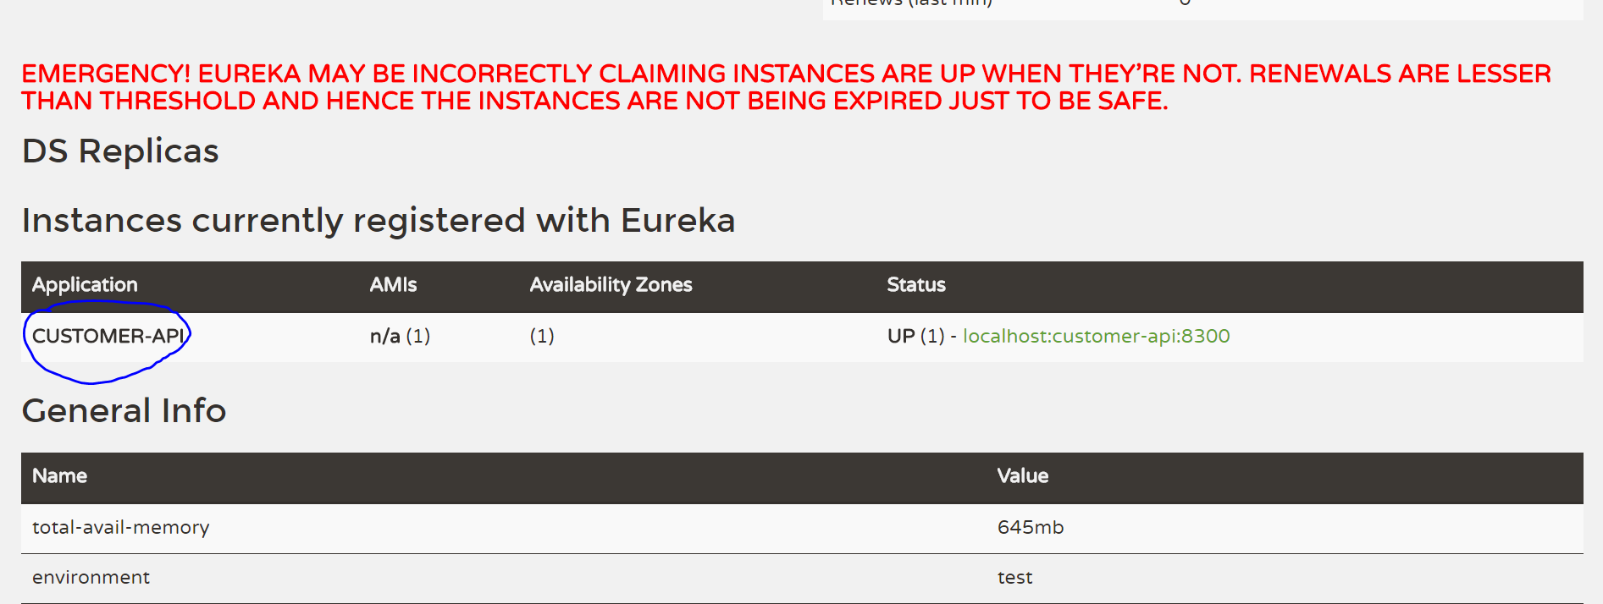

You should see the above screenshot with the customer-api registered(as circled)

1. In another browser tab, access the following url which will hit the gateway and reroute to customer-api using the Eureka registry.

**🡪localhost:8082/api/customer-api/swagger-ui.html**

This will bring up the swagger ui which will show up all of the rest end points along with relevant documentation about each REST.

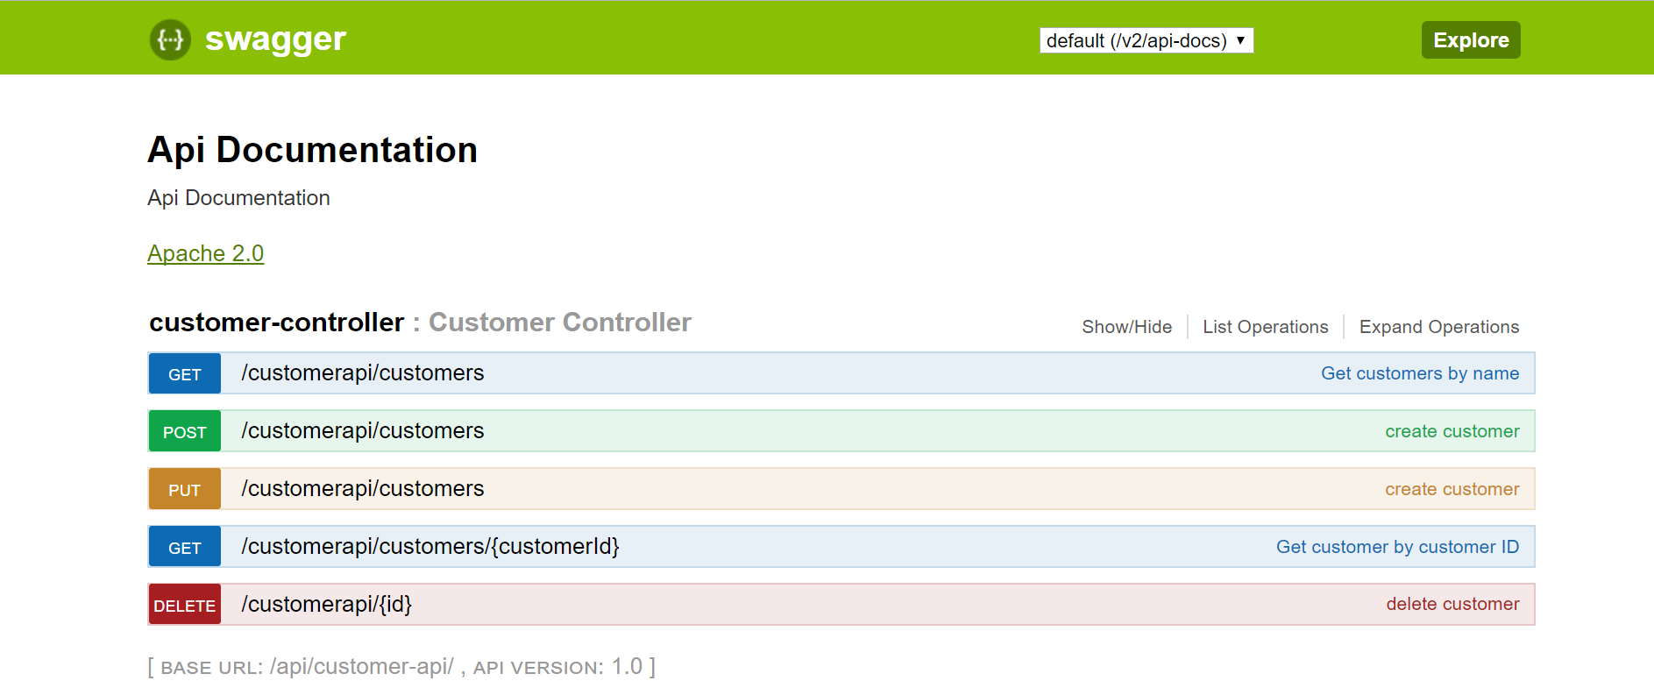

Sample POST request customer:

{

"addresses": [

{

"address_type": "Office",

"city": "North Sydney",

"country": "Australia",

"postalCode": "1000",

"street": "Miller Street",

"complexName" : "Chifley Square"

},

{

"address_type": "Home",

"city": "Parramatta",

"country": "Australia",

"postalCode": "2150",

"street": "Great Western Highway",

"unitNumber" : "20",

"apartmentNumber" : "62"

}

],

"dob": "2017-12-20T03:01:39.317Z",

"firstName": "Shriram",

"lastName": "Devanathan"

}

1. Access the following url to access the H2 database console :

* **localhost:8082**

Use the following credentials:

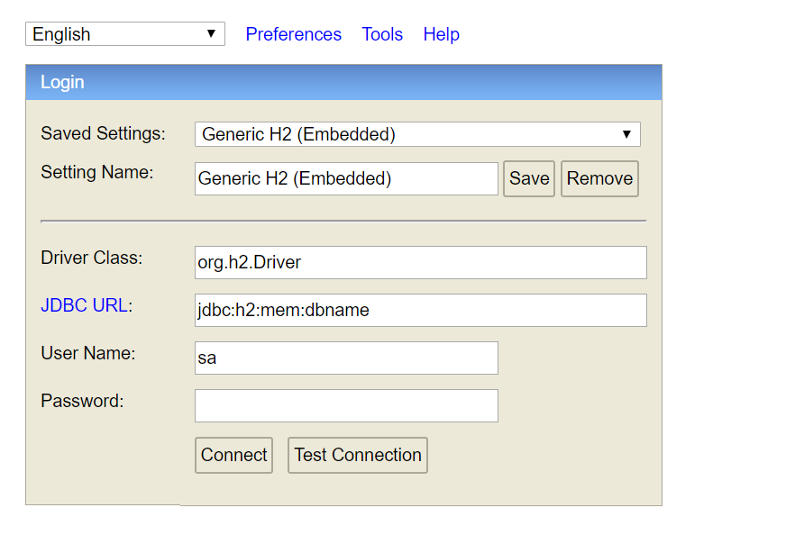

You should be able to see the next screen as follows,

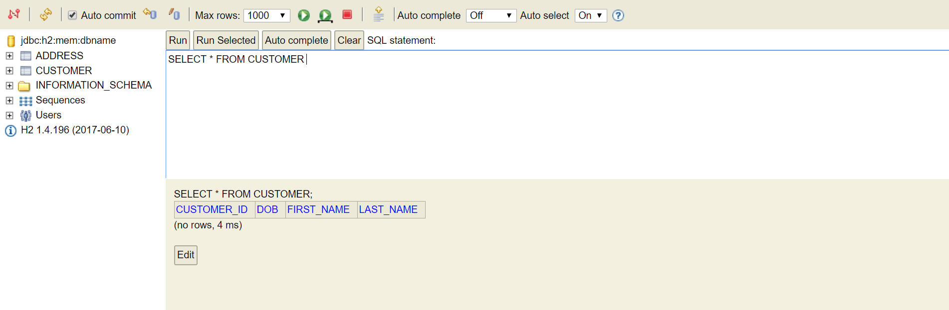

# Run with IDE(preferably Intellij)

1. Import both projects in Intellij and let the maven imports run.
2. Run the Eureka-service first and then the customer-api.
3. Now repeat step 11 from above.

We have now established an API design via a API gateway, that can be extended to Mobile as well.