Enterprise Ephemeral
Test Platform
Architecture & Step-by-Step Implementation Guide

Version: 1.0 — POC Edition
Provider: AWS (Spring Boot + PostgreSQL reference implementation)
Scope: Short-lived ephemeral environments for integration testing
Audience: Platform engineers and application team leads

What this document covers
Part 1: Architecture — system context, functional layers, lifecycle flow, and AWS stack detail with embedded diagrams. Part 2: Implementation — 10 numbered steps from repo setup through to first successful PR run, with all code files, Terraform, GitHub Actions workflow, and a verification checklist.

Part 1 — Architecture
System design, functional layers, and infrastructure diagrams

1. Overview
The ephemeral test platform creates a complete, isolated infrastructure stack when a pull request is opened, runs the application's integration test suite against real cloud services, and tears everything down when the PR closes or a TTL expires. No infrastructure survives past the test run.

Three core principles:
- Any team, any stack — a single env.yaml file is the only contract teams write.
- Any cloud — the same ProviderAdapter interface works on AWS, GCP, and on-prem Kubernetes.
- Zero residual cost — destroy always runs, even when tests fail.

POC scope
This document covers the core ephemeral lifecycle. The policy engine, self-service portal, and chargeback dashboard are post-POC extensions that plug into the same architecture without changes to the core.

1.1 Key design decisions
Component | Description
ProviderAdapter SPI | Platform core has zero cloud SDK imports. All cloud operations go through one Java interface: provision, seedData, runTests, destroy.
env.yaml contract | Teams write one file. The platform reads, validates, and acts on it. No Terraform, no cloud SDK, no IAM knowledge required from application teams.
Workspace isolation | Every PR gets its own Terraform workspace (pr-{number}). All resource names are prefixed — zero collisions between concurrent PRs.
Destroy guarantee | CI uses if: always() on the destroy job. A TTL watchdog destroys stale stacks independently, catching anything the CI runner left behind.
Idempotent seed | Test data uses INSERT ... ON CONFLICT DO NOTHING. Safe to re-run on a retried job without duplicating rows.

2. Ephemeral lifecycle
The platform executes a four-stage linear lifecycle for every PR. Stages run in strict sequence. If any stage fails, destroy still runs unconditionally.

Stage | Name | What happens
1 | Trigger | PR opened/updated. GitHub Actions fires. CI reads env.yaml, runs mvn package, builds a Docker image, pushes to ECR tagged pr-{number}.
2 | Provision | Terraform creates an isolated VPC with the application container, database, and object storage — all named with the pr-{number} prefix. Terraform outputs (endpoints, secret ARNs) are captured.
3 | Test execution | Flyway migrations run first. The data loader pulls CSV files from S3 and bulk-inserts them. The test runner executes the JUnit suite with live endpoints injected as env vars. Results post to the PR check.
4 | Destroy | terraform destroy removes every resource. Secrets Manager secret uses recovery_window=0 for instant deletion. TTL watchdog fires independently after the configured timeout.

2.1 Architecture diagram — ephemeral lifecycle
The diagram below shows the complete lifecycle from PR trigger through provisioning, test execution, and teardown. All AWS resources live inside an isolated VPC per PR.

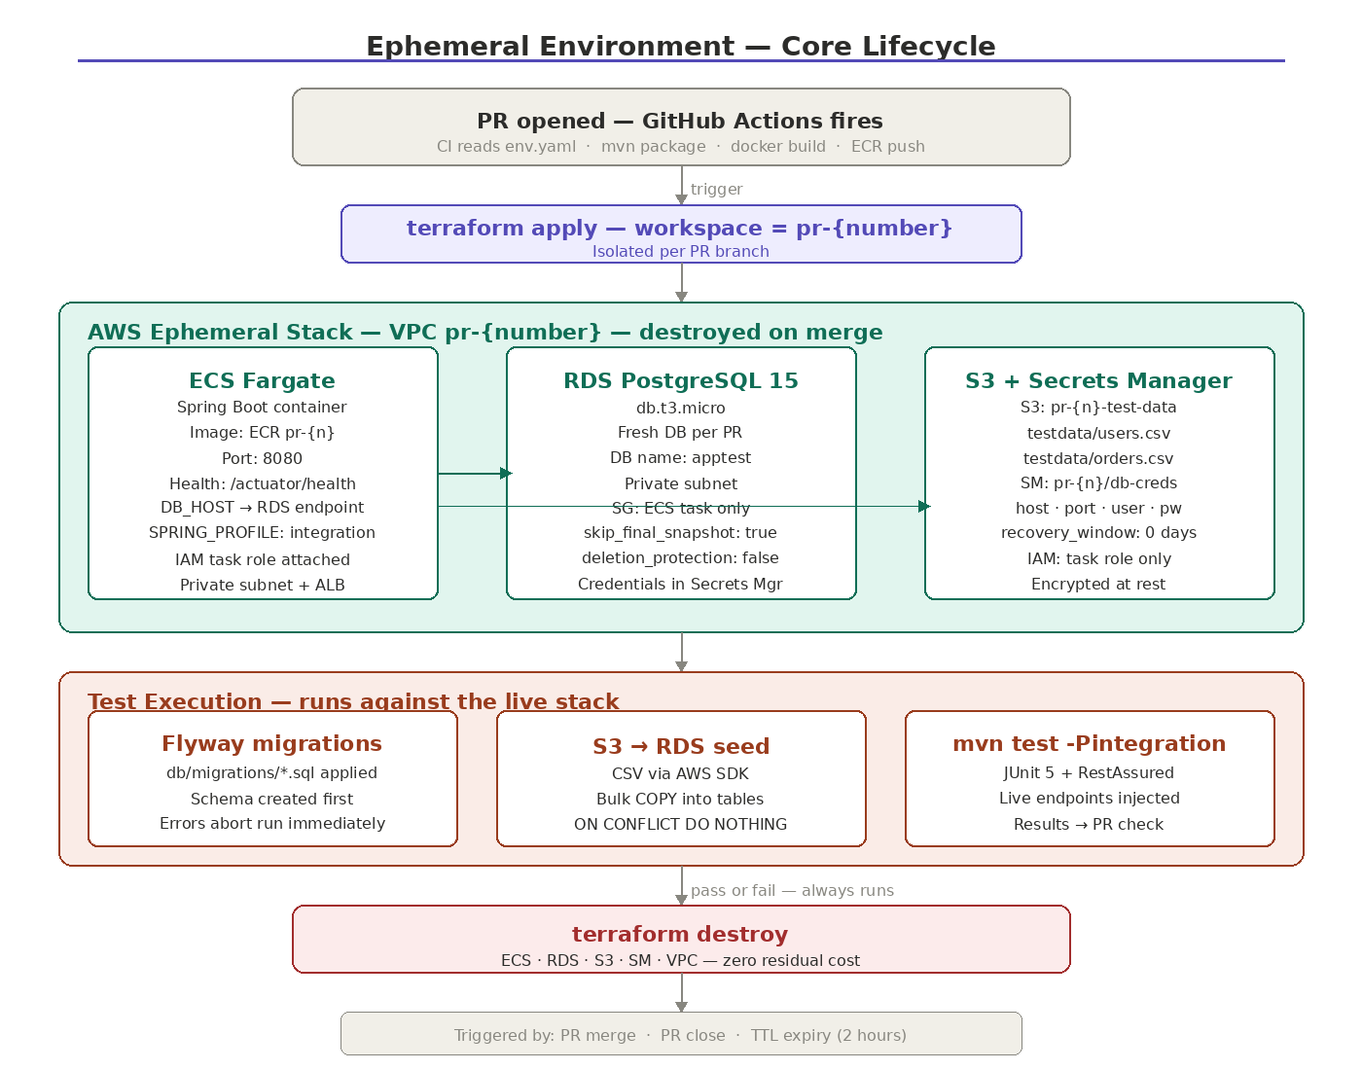
Figure 1 — Ephemeral lifecycle: trigger → provision → test execution → destroy

3. Functional architecture
The platform is structured in five layers. Each layer has a single responsibility and communicates downward only.

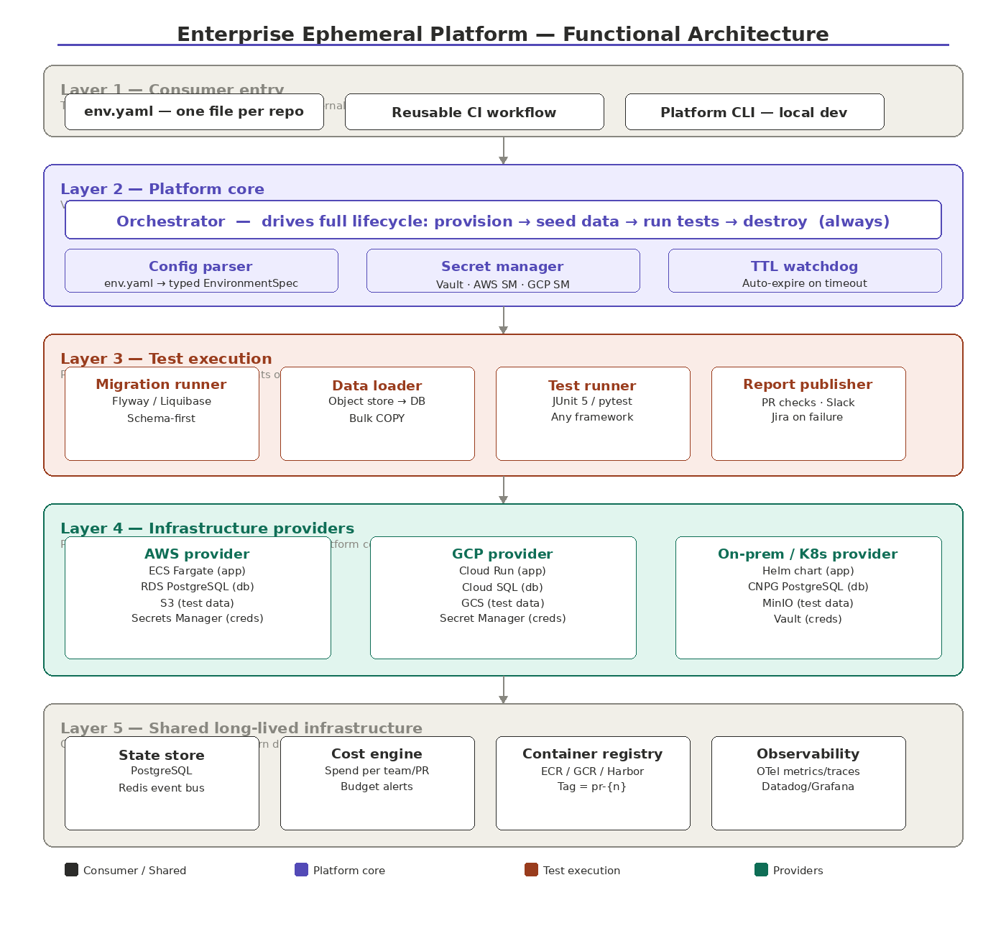
Figure 2 — Functional architecture: five-layer platform structure

3.1 Layer summary
Component | Description
L1 — Consumer entry | Teams interact with one env.yaml, a two-line CI workflow call, and an optional CLI. No platform internals are exposed.
L2 — Platform core | Orchestrator, Config parser, Secret manager, TTL watchdog. Distributed as a versioned Docker image. Zero cloud SDK imports.
L3 — Test execution | Migration runner, Data loader, Test runner, Report publisher. Provider-agnostic — identical on AWS, GCP, and on-prem.
L4 — Infrastructure providers | Pluggable ProviderAdapter implementations for AWS, GCP, and Kubernetes. Adding a provider means implementing one interface.
L5 — Shared infra | State store (PostgreSQL + Redis), Cost engine, Container registry, Observability stack. Never torn down.

3.2 Platform core components
Component | Description
Orchestrator | Drives provision → seedData → runTests → destroy in sequence. Wraps destroy() in finally so it cannot be skipped. Registers TTL before provisioning starts.
Config parser | Parses env.yaml into a typed EnvironmentSpec. Validates schema version, TTL limits, and required fields. Errors are reported before any cloud resource is touched.
Secret manager | Abstraction over Vault, AWS SM, and GCP SM. Returns DbCredentials — the orchestrator never touches raw passwords.
TTL watchdog | Scheduled every 5 minutes. Destroys any environment whose startedAt + ttl is in the past. Catches stacks orphaned by runner timeouts or OOM kills.

4. Spring Boot + PostgreSQL on AWS — stack detail
The diagram below shows every AWS resource provisioned per PR, how they connect, and the complete test and teardown sequence. This is the reference implementation for the POC.

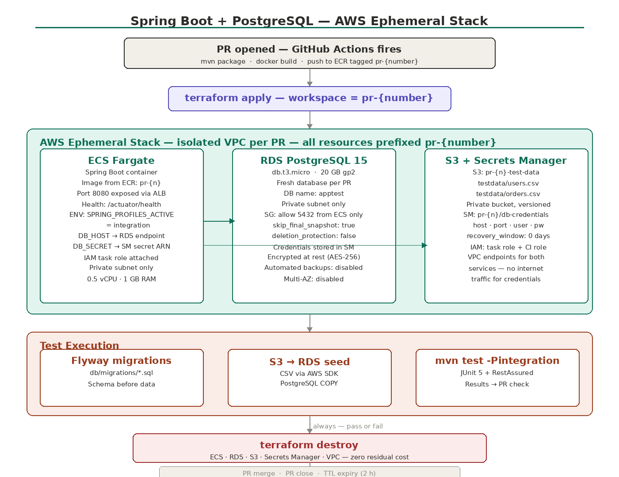
Figure 3 — Spring Boot + PostgreSQL on AWS: complete ephemeral stack

4.1 AWS resources per PR
Resource | Configuration | Purpose
ECS Fargate | 0.5 vCPU · 1 GB · private subnet | Runs the Spring Boot container. Health check at /actuator/health. IAM task role grants S3 and Secrets Manager access.
ALB (internal) | Private subnets only | Routes HTTP to ECS port 8080. ALB DNS name becomes APP_ENDPOINT injected into the test runner.
RDS PostgreSQL 15 | db.t3.micro · 20 GB · private subnet | Fresh DB per PR. SG allows 5432 from ECS only. skip_final_snapshot=true, deletion_protection=false for fast teardown.
S3 bucket | pr-{n}-test-data · private | Holds CSV seed files. Emptied then deleted on destroy. VPC endpoint avoids public internet traffic.
Secrets Manager | pr-{n}/db-creds · recovery=0 days | Stores host/port/username/password as JSON. Instantly deleted on destroy.
VPC + subnets | Private subnets · no public IP | Isolated per PR. VPC endpoints for S3 and SM. ECS and RDS in separate private subnets.

Part 2 — Implementation
10 steps from empty repo to first successful PR run
Before you begin
Prerequisites: Java 21, Maven 3.9+, Docker Desktop, Terraform 1.7+, AWS CLI v2 (admin credentials), Git. AWS account needs: S3 bucket for TF state, DynamoDB table for TF locks, ECR repository, and a GitHub OIDC IAM role.

1 | Bootstrap the repository  Create the Maven multi-module project and folder structure

Create the platform repository and initialise the Maven multi-module structure:

mkdir ephemeral-platform && cd ephemeral-platform
git init

# Create Maven multi-module skeleton
mvn archetype:generate -DgroupId=com.company.ephemeral \
-DartifactId=ephemeral-platform \
-DarchetypeArtifactId=maven-archetype-quickstart \
-DinteractiveMode=false

# Create submodules
mkdir -p platform-core aws-provider infra/aws infra/k8s
mkdir -p platform-cli .github/workflows

Root pom.xml — declares all modules and shared dependency versions:

<project>
<modelVersion>4.0.0</modelVersion>
<groupId>com.company.ephemeral</groupId>
<artifactId>ephemeral-platform</artifactId>
<version>1.0.0</version>
<packaging>pom</packaging>

<modules>
<module>platform-core</module>
<module>aws-provider</module>
</modules>

<properties>
<java.version>21</java.version>
<spring.boot.version>3.2.0</spring.boot.version>
<aws.sdk.version>2.21.0</aws.sdk.version>
<flyway.version>10.4.1</flyway.version>
</properties>
</project>

Module layout
platform-core/ holds the ProviderAdapter SPI and Orchestrator — zero cloud SDK imports. aws-provider/ holds the AWS implementation and imports the AWS SDK. infra/aws/ holds all Terraform HCL. This separation means the platform core can be tested without any cloud credentials.

2 | Build platform-core  Define the ProviderAdapter interface and Orchestrator

2a. ProviderAdapter interface
This is the single most important file in the platform. Every cloud provider must implement it. The orchestrator only ever calls this interface — it has no cloud SDK imports.

// platform-core/src/main/java/com/company/ephemeral/spi/ProviderAdapter.java
package com.company.ephemeral.spi;

import java.nio.file.Path;

public interface ProviderAdapter {

/** Provider name used in env.yaml and state store */
String name();

/**
* Provision all infrastructure for one ephemeral environment.
* Returns a fully-resolved spec with live endpoints injected.
* Must be idempotent — safe to call on retry.
*/
EnvironmentSpec provision(EnvironmentSpec spec);

/**
* Upload test data to object storage then seed into the DB.
*/
void seedData(EnvironmentSpec spec, Path testDataDir);

/**
* Execute the test suite against the live environment.
* Returns structured results (pass/fail counts, duration).
*/
TestResult runTests(EnvironmentSpec spec);

/**
* Tear down every resource created during provision().
* Must succeed even if provision() or runTests() partially failed.
* Must be idempotent — safe to call multiple times.
*/
void destroy(EnvironmentSpec spec);
}

2b. EnvironmentSpec model
The typed object produced by parsing env.yaml. Empty before provisioning; fully populated with live endpoints and secret ARNs after:

// platform-core/src/main/java/.../model/EnvironmentSpec.java
@Data @Builder @With
public class EnvironmentSpec {
// Identity
private String envId; // "pr-42-payment-service"
private String team;
private String app;
private String provider; // "aws" | "gcp" | "onprem"
private Duration ttl;

// Database (from env.yaml)
private String dbEngine;
private String dbVersion;
private String dbSize;
private String migrationsPath;

// Resolved at provision-time (empty before, filled after)
private String dbHost;
private int dbPort;
private String dbName;
private String dbSecretRef; // pointer — never a raw password

// Object storage
private String testDataBucket;
private String testDataPrefix;

// App
private String imageRef; // fully-qualified after build
private String appEndpoint; // filled post-deploy
private Map<String, String> appEnv;

// Notifications
private List<String> notifyOnSuccess;
private List<String> notifyOnFailure;
}

2c. Orchestrator
Drives the full lifecycle. Saves state before provisioning starts so the TTL watchdog can destroy the environment even if the CI runner crashes:

// platform-core/src/main/java/.../orchestrator/Orchestrator.java
@Component @Slf4j @RequiredArgsConstructor
public class Orchestrator {

private final ProviderRegistry registry;
private final StateStore stateStore;
private final ReportPublisher reporter;
private final TTLWatchdog watchdog;

public OrchestratorResult run(EnvironmentSpec spec) {
ProviderAdapter provider = registry.resolve(spec.getProvider());

// Persist state BEFORE provision so watchdog can destroy on crash
stateStore.save(spec.getEnvId(), LifecycleState.PROVISIONING, spec);
watchdog.register(spec.getEnvId(), spec.getTtl());

EnvironmentSpec live = null;
TestResult result = null;

try {
live = provider.provision(spec);
stateStore.transition(spec.getEnvId(), LifecycleState.SEEDING, live);

Path testDataDir = resolveTestData(spec);
provider.seedData(live, testDataDir);
stateStore.transition(spec.getEnvId(), LifecycleState.TESTING, live);

result = provider.runTests(live);
stateStore.transition(spec.getEnvId(), LifecycleState.COMPLETE, live);

} catch (Exception e) {
log.error("Lifecycle failure: {}", e.getMessage(), e);
stateStore.transition(spec.getEnvId(), LifecycleState.FAILED, live);
result = TestResult.failed(e);

} finally {
destroySafely(provider, live != null ? live : spec);
watchdog.deregister(spec.getEnvId());
}

reporter.publish(spec, result);
return OrchestratorResult.of(spec, result);
}

private void destroySafely(ProviderAdapter provider, EnvironmentSpec spec) {
try {
stateStore.transition(spec.getEnvId(), LifecycleState.DESTROYING, spec);
provider.destroy(spec);
stateStore.transition(spec.getEnvId(), LifecycleState.DESTROYED, spec);
} catch (Exception e) {
log.error("DESTROY FAILED for {} — manual cleanup required!",
spec.getEnvId(), e);
stateStore.transition(spec.getEnvId(), LifecycleState.DESTROY_FAILED, spec);
}
}
}

destroy() in finally
The finally block is the guarantee. It runs whether provision succeeded, tests failed, or an unhandled exception occurred anywhere in the lifecycle. destroySafely() catches and logs destroy failures separately so they never mask the original error.

3 | Build aws-provider  Implement ProviderAdapter using Terraform + AWS SDK

3a. Maven dependencies
Add AWS SDK modules to aws-provider/pom.xml:

<!-- aws-provider/pom.xml -->
<dependency>
<groupId>software.amazon.awssdk</groupId>
<artifactId>ecs</artifactId>
</dependency>
<dependency>
<groupId>software.amazon.awssdk</groupId>
<artifactId>rds</artifactId>
</dependency>
<dependency>
<groupId>software.amazon.awssdk</groupId>
<artifactId>s3</artifactId>
</dependency>
<dependency>
<groupId>software.amazon.awssdk</groupId>
<artifactId>secretsmanager</artifactId>
</dependency>
<dependency>
<groupId>com.company.ephemeral</groupId>
<artifactId>platform-core</artifactId>
<version>${project.version}</version>
</dependency>

3b. AwsProviderAdapter
The AWS implementation of ProviderAdapter. Shells out to the Terraform CLI for provisioning and teardown. Uses the AWS SDK only for S3 uploads and Secrets Manager reads:

// aws-provider/src/main/java/.../AwsProviderAdapter.java
@Component @Slf4j @RequiredArgsConstructor
public class AwsProviderAdapter implements ProviderAdapter {

private final TerraformRunner tf;
private final AwsSecretsClient secrets;
private final S3DataUploader s3;
private final EcrImageBuilder ecr;

@Override public String name() { return "aws"; }

@Override
public EnvironmentSpec provision(EnvironmentSpec spec) {
String workspace = spec.getEnvId();

Map<String, String> vars = Map.of(
"env_name", workspace,
"db_engine", spec.getDbEngine(),
"db_version", spec.getDbVersion(),
"db_instance", dbSizeToInstanceType(spec.getDbSize()),
"app_image", ecr.buildAndPush(spec),
"app_port", String.valueOf(spec.getAppPort()),
"ttl_hours", String.valueOf(spec.getTtl().toHours())
);

tf.init("infra/aws/");
tf.apply("infra/aws/", workspace, vars);

Map<String, String> out = tf.outputs("infra/aws/", workspace);
return spec.withDbHost(out.get("db_host"))
.withDbPort(Integer.parseInt(out.get("db_port")))
.withDbSecretRef(out.get("db_secret_arn"))
.withTestDataBucket(out.get("test_data_bucket"))
.withAppEndpoint(out.get("app_endpoint"));
}

@Override
public void seedData(EnvironmentSpec spec, Path testDataDir) {
s3.upload(spec.getTestDataBucket(), spec.getTestDataPrefix(), testDataDir);
DbCredentials creds = secrets.resolve(spec.getDbSecretRef());

Flyway.configure()
.dataSource(jdbcUrl(spec), creds.username(), creds.password())
.locations("filesystem:" + spec.getMigrationsPath())
.load().migrate();

CsvSeeder.seed(creds, spec.getTestDataBucket(),
spec.getTestDataPrefix(), spec.getDbName());
}

@Override
public TestResult runTests(EnvironmentSpec spec) {
return TestRunner.run(spec.getAppEnv(), Map.of(
"APP_ENDPOINT", spec.getAppEndpoint(),
"DB_HOST", spec.getDbHost(),
"DB_SECRET_REF", spec.getDbSecretRef(),
"TEST_DATA_BUCKET", spec.getTestDataBucket()
));
}

@Override
public void destroy(EnvironmentSpec spec) {
tf.destroy("infra/aws/", spec.getEnvId());
}
}

TerraformRunner
TerraformRunner is a thin ProcessBuilder wrapper that: (1) sets TF_WORKSPACE env var, (2) passes -var flags from the vars map, (3) captures stdout for output parsing, (4) throws on non-zero exit code. Keep it under 100 lines — complexity belongs in the HCL, not the Java wrapper.

4 | Write Terraform — AWS stack  ECS Fargate + RDS + S3 + Secrets Manager

4a. main.tf — backend and locals
Workspace name becomes the resource prefix. Remote state in S3 with DynamoDB locking prevents concurrent apply collisions:

# infra/aws/main.tf
terraform {
required_version = ">= 1.7"
backend "s3" {
bucket = "myapp-tfstate"
key = "ephemeral/terraform.tfstate"
region = "us-east-1"
dynamodb_table = "myapp-tf-locks"
encrypt = true
}
required_providers {
aws = { source = "hashicorp/aws", version = "~> 5.0" }
}
}

provider "aws" { region = var.region }

locals { env = terraform.workspace } # e.g. "pr-42"

data "aws_vpc" "default" { default = true }
data "aws_subnets" "private" {
filter {
name = "vpc-id"
values = [data.aws_vpc.default.id]
}
}

4b. rds.tf — PostgreSQL instance
The two critical teardown settings are skip_final_snapshot = true and recovery_window_in_days = 0. Without them, destroy blocks:

# infra/aws/rds.tf
resource "random_password" "db" {
length = 24
special = false
}

resource "aws_db_instance" "main" {
identifier = "${local.env}-db"
engine = var.db_engine
engine_version = var.db_version
instance_class = var.db_instance
allocated_storage = 20
db_name = "apptest"
username = "app"
password = random_password.db.result

# Critical for fast teardown
skip_final_snapshot = true
deletion_protection = false
publicly_accessible = false

vpc_security_group_ids = [aws_security_group.rds.id]
db_subnet_group_name = aws_db_subnet_group.main.name

tags = { env = local.env, ttl = "${var.ttl_hours}h" }
}

resource "aws_secretsmanager_secret" "db" {
name = "${local.env}/db-credentials"
recovery_window_in_days = 0 # instant delete on destroy
}

resource "aws_secretsmanager_secret_version" "db" {
secret_id = aws_secretsmanager_secret.db.id
secret_string = jsonencode({
host = aws_db_instance.main.address
port = 5432
username = aws_db_instance.main.username
password = random_password.db.result
dbname = "apptest"
})
}

4c. ecs.tf — Fargate task and service
Task definition injects DB_HOST and DB_SECRET_ARN as environment variables. Health check polls /actuator/health every 30 seconds:

# infra/aws/ecs.tf
resource "aws_ecs_cluster" "main" {
name = "${local.env}-cluster"
}

resource "aws_ecs_task_definition" "app" {
family = "${local.env}-app"
requires_compatibilities = ["FARGATE"]
network_mode = "awsvpc"
cpu = 512
memory = 1024
execution_role_arn = aws_iam_role.task_exec.arn
task_role_arn = aws_iam_role.task.arn

container_definitions = jsonencode([{
name = "app"
image = var.app_image
portMappings = [{ containerPort = var.app_port }]
environment = [
{ name = "SPRING_PROFILES_ACTIVE", value = "integration" },
{ name = "DB_HOST", value = aws_db_instance.main.address },
{ name = "DB_SECRET_ARN", value = aws_secretsmanager_secret.db.arn }
]
healthCheck = {
command = ["CMD-SHELL",
"curl -f http://localhost:${var.app_port}/actuator/health || exit 1"]
interval = 30
timeout = 5
retries = 3
startPeriod = 60
}
logConfiguration = {
logDriver = "awslogs"
options = {
awslogs-group = "/ecs/${local.env}"
awslogs-region = var.region
}
}
}])
}

resource "aws_ecs_service" "app" {
name = "${local.env}-svc"
cluster = aws_ecs_cluster.main.id
task_definition = aws_ecs_task_definition.app.arn
desired_count = 1
launch_type = "FARGATE"

network_configuration {
subnets = data.aws_subnets.private.ids
security_groups = [aws_security_group.ecs.id]
assign_public_ip = false
}
}

4d. outputs.tf — surface endpoints to Java
The AWS provider reads these outputs after apply and injects them into EnvironmentSpec:

# infra/aws/outputs.tf
output "db_host" {
value = aws_db_instance.main.address
}

output "db_port" {
value = 5432
}

output "db_secret_arn" {
value = aws_secretsmanager_secret.db.arn
}

output "test_data_bucket" {
value = aws_s3_bucket.test_data.bucket
}

output "app_endpoint" {
value = "http://${aws_lb.main.dns_name}"
}

Variables file
Create infra/aws/variables.tf declaring: env_name (string), db_engine (string, default postgres), db_version (string, default 15), db_instance (string, default db.t3.micro), app_image (string), app_port (number, default 8080), ttl_hours (number, default 2), region (string, default us-east-1).

5 | Create env.yaml and test data  The only files the application team writes

5a. env.yaml — platform contract
Place this in the root of the application repository. Every field maps directly to a field in EnvironmentSpec:

# env.yaml — place in root of application repo
apiVersion: ephemeral-platform/v1
metadata:
team: payments-squad
app: payment-service
contact: payments@company.com

environment:
ttl: 2h
provider: aws

database:
engine: postgres
version: "15"
size: small # db.t3.micro
migrations: db/migrations/

testData:
source: object-storage
path: testdata/
# Files: testdata/users.csv, testdata/orders.csv

app:
image: auto # built from Dockerfile in this repo
port: 8080
healthCheck: /actuator/health
env:
SPRING_PROFILES_ACTIVE: integration
LOG_LEVEL: INFO

notifications:
onSuccess: slack:#payments-ci
onFailure: slack:#payments-alerts

5b. testdata/users.csv — seed data
Stable IDs (usr-001, usr-002) allow tests to make hard assertions. ON CONFLICT DO NOTHING makes repeated loads safe:

# testdata/users.csv
id,email,name,created_at
usr-001,alice@example.com,Alice,2024-01-01 00:00:00
usr-002,bob@example.com,Bob,2024-01-01 00:00:00
usr-003,carol@example.com,Carol,2024-01-01 00:00:00

5c. testdata/orders.csv

# testdata/orders.csv
id,user_id,amount,status,created_at
ord-001,usr-001,49.99,PENDING,2024-01-01 10:00:00
ord-002,usr-001,120.00,COMPLETED,2024-01-01 11:00:00
ord-003,usr-002,75.50,PENDING,2024-01-01 12:00:00

5d. db/migrations/V1__initial_schema.sql
Flyway applies this before the data loader runs. Schema-first guarantees the COPY command has valid target tables:

-- db/migrations/V1__initial_schema.sql
CREATE TABLE users (
id TEXT PRIMARY KEY,
email TEXT UNIQUE NOT NULL,
name TEXT NOT NULL,
created_at TIMESTAMP DEFAULT NOW()
);

CREATE TABLE orders (
id TEXT PRIMARY KEY,
user_id TEXT REFERENCES users(id),
amount NUMERIC(10,2) NOT NULL,
status TEXT NOT NULL DEFAULT 'PENDING',
created_at TIMESTAMP DEFAULT NOW()
);

Seed data naming convention
Prefix all seed IDs with a recognisable prefix (usr-, ord-, prd-) and keep them short. Tests can assert on exact IDs (assertThat(response.getUserId()).isEqualTo("usr-001")) rather than relying on order of insertion or generated UUIDs. This makes failures specific and reproducible.

6 | Write integration tests  JUnit 5 tests that run identically locally and in CI

6a. Integration test class
Tests read APP_ENDPOINT from an environment variable. The same test class runs locally (pointing at localhost or Testcontainers) and in CI (pointing at the live ALB):

// src/test/java/com/company/payment/PaymentIntegrationTest.java
@SpringBootTest(webEnvironment = RANDOM_PORT)
@TestPropertySource(properties = {
"spring.datasource.url=jdbc:postgresql://${DB_HOST:localhost}:5432/apptest"
})
class PaymentIntegrationTest {

// Platform injects these — same names locally and in CI
static final String APP =
System.getenv().getOrDefault("APP_ENDPOINT", "http://localhost:8080");

@Test
void createPayment_returnsCreated() {
var req = new PaymentRequest("usr-001", new BigDecimal("49.99"), "USD");
var res = given()
.contentType(ContentType.JSON)
.body(req)
.post(APP + "/payments")
.then()
.statusCode(201)
.extract().as(PaymentResponse.class);

assertThat(res.getId()).isNotNull();
assertThat(res.getStatus()).isEqualTo("PENDING");
}

@Test
void getPayments_returnsSeedData() {
// usr-001 has 2 orders from testdata/orders.csv
given()
.get(APP + "/payments?userId=usr-001")
.then()
.statusCode(200)
.body("content.size()", greaterThanOrEqualTo(2));
}

@Test
void createPayment_idempotency() {
String key = UUID.randomUUID().toString();
var req = new PaymentRequest("usr-002", new BigDecimal("10.00"), "USD");

String id1 = given().header("Idempotency-Key", key).body(req)
.post(APP + "/payments").then().statusCode(201)
.extract().path("id");
String id2 = given().header("Idempotency-Key", key).body(req)
.post(APP + "/payments").then().statusCode(201)
.extract().path("id");

assertThat(id1).isEqualTo(id2);
}
}

6b. Maven integration profile
The -Pintegration profile scopes which test classes run and passes environment variables through from the CI process:

<!-- pom.xml — integration test profile -->
<profiles>
<profile>
<id>integration</id>
<build>
<plugins>
<plugin>
<groupId>org.apache.maven.plugins</groupId>
<artifactId>maven-surefire-plugin</artifactId>
<configuration>
<includes>
<include>**/*IntegrationTest.java</include>
</includes>
<environmentVariables>
<!-- Picked up from process env when running in CI -->
<APP_ENDPOINT>${env.APP_ENDPOINT}</APP_ENDPOINT>
<DB_HOST>${env.DB_HOST}</DB_HOST>
<DB_SECRET_REF>${env.DB_SECRET_REF}</DB_SECRET_REF>
</environmentVariables>
</configuration>
</plugin>
</plugins>
</build>
</profile>
</profiles>

Local development
To run integration tests locally: (1) Start Testcontainers by adding a @BeforeAll that starts a PostgreSQL container and sets DB_HOST. (2) Run the Spring Boot app locally. (3) Set APP_ENDPOINT=http://localhost:8080 in your IDE run config. (4) Run mvn test -Pintegration. No AWS credentials or real infrastructure needed.

7 | Configure Docker  Dockerfile and Spring Boot profile for the container

7a. Dockerfile
Multi-stage not needed for Spring Boot fat jar. Use eclipse-temurin:21-jre-alpine for the smallest footprint:

# Dockerfile — in application repo root
FROM eclipse-temurin:21-jre-alpine AS runtime

RUN addgroup -S appgroup && adduser -S appuser -G appgroup

WORKDIR /app
COPY target/*.jar app.jar

USER appuser

EXPOSE 8080

HEALTHCHECK --interval=30s --timeout=5s --retries=3 \
CMD wget -qO- http://localhost:8080/actuator/health || exit 1

ENTRYPOINT ["java",
"-XX:+UseContainerSupport",
"-XX:MaxRAMPercentage=75.0",
"-jar", "app.jar"]

7b. application-integration.yml
Spring Boot profile active when SPRING_PROFILES_ACTIVE=integration. Flyway is disabled here because the platform runs it externally before tests start:

# src/main/resources/application-integration.yml
spring:
datasource:
url: jdbc:postgresql://${DB_HOST:localhost}:5432/${DB_NAME:apptest}
username: ${DB_USERNAME:app}
password: ${DB_PASSWORD:}
hikari:
connection-timeout: 30000
maximum-pool-size: 5
jpa:
hibernate:
ddl-auto: validate # migrations handle schema — never auto-create
show-sql: false
flyway:
enabled: false # platform runs Flyway externally before tests

logging:
level:
root: INFO
com.company: DEBUG

Container startup time
Spring Boot apps on Fargate typically take 45–90 seconds to pass their health check for the first time. Set startPeriod = 60 in the ECS health check (done in ecs.tf above) to prevent ECS from killing the task before Spring Boot finishes starting. If startup regularly exceeds 90 seconds, add -XX:TieredStopAtLevel=1 to the JVM flags to disable tiered compilation.

8 | Configure IAM  Least-privilege roles for CI runner and ECS task

Two IAM roles are needed: one for the ECS task (reading secrets and S3 at runtime) and one for the CI runner (provisioning and tearing down infrastructure via GitHub Actions OIDC):

# infra/aws/iam.tf
data "aws_iam_policy_document" "task" {
statement {
sid = "SecretsRead"
effect = "Allow"
actions = ["secretsmanager:GetSecretValue"]
resources = ["arn:aws:secretsmanager:*:*:secret:pr-*"]
}
statement {
sid = "S3TestData"
effect = "Allow"
actions = ["s3:GetObject", "s3:ListBucket"]
resources = [
"arn:aws:s3:::*-test-data",
"arn:aws:s3:::*-test-data/*"
]
}
}

# CI runner role — used by GitHub Actions OIDC
data "aws_iam_policy_document" "ci_runner" {
statement {
sid = "TerraformState"
actions = ["s3:GetObject", "s3:PutObject", "s3:DeleteObject",
"s3:ListBucket"]
resources = [
"arn:aws:s3:::myapp-tfstate",
"arn:aws:s3:::myapp-tfstate/*"
]
}
statement {
sid = "TerraformLock"
actions = ["dynamodb:GetItem", "dynamodb:PutItem",
"dynamodb:DeleteItem"]
resources = ["arn:aws:dynamodb:*:*:table/myapp-tf-locks"]
}
statement {
sid = "EphemeralProvision"
actions = ["ecs:*", "rds:*", "s3:*",
"secretsmanager:*", "ec2:*",
"elasticloadbalancing:*", "logs:*",
"iam:PassRole"]
resources = ["*"]
condition {
test = "StringLike"
variable = "aws:ResourceTag/env"
values = ["pr-*"]
}
}
}

GitHub Actions OIDC (no long-lived credentials)
Create an IAM OIDC provider for token.actions.githubusercontent.com with thumbprint list. Create the CI runner role with a trust policy that allows sts:AssumeRoleWithWebIdentity where token.actions.githubusercontent.com:sub StringLike repo:YOUR_ORG/*:pull_request. Store the role ARN as PLATFORM_ROLE_ARN in GitHub repository secrets. No AWS access keys are stored anywhere.

9 | Write GitHub Actions workflows  Platform reusable workflow + application caller

9a. Platform reusable workflow (platform repo)
Published once by the platform team. Three jobs: provision → test → destroy. Destroy uses if: always() so it cannot be skipped:

# .github/workflows/ephemeral-platform.yml (PLATFORM REPO)
name: Ephemeral platform
on:
workflow_call:
inputs:
env-yaml-path:
type: string
default: env.yaml
secrets:
PLATFORM_ROLE_ARN: { required: true }

jobs:
provision:
runs-on: ubuntu-latest
outputs:
rds_host: ${{ steps.out.outputs.rds_host }}
s3_bucket: ${{ steps.out.outputs.s3_bucket }}
app_endpoint: ${{ steps.out.outputs.app_endpoint }}
steps:
- uses: actions/checkout@v4
- uses: aws-actions/configure-aws-credentials@v4
with:
role-to-assume: ${{ secrets.PLATFORM_ROLE_ARN }}
aws-region: us-east-1
- uses: hashicorp/setup-terraform@v3
- run: terraform init
working-directory: infra/aws/
- run: terraform apply -auto-approve
working-directory: infra/aws/
env:
TF_WORKSPACE: pr-${{ github.event.pull_request.number }}
- id: out
working-directory: infra/aws/
run: |
echo "rds_host=$(terraform output -raw db_host)" >> $GITHUB_OUTPUT
echo "s3_bucket=$(terraform output -raw test_data_bucket)" >> $GITHUB_OUTPUT
echo "app_endpoint=$(terraform output -raw app_endpoint)" >> $GITHUB_OUTPUT

test:
runs-on: ubuntu-latest
needs: provision
steps:
- uses: actions/checkout@v4
- uses: actions/setup-java@v4
with: { java-version: '21', distribution: temurin }
- uses: aws-actions/configure-aws-credentials@v4
with:
role-to-assume: ${{ secrets.PLATFORM_ROLE_ARN }}
aws-region: us-east-1
- name: Upload seed data to S3
run: |
aws s3 sync testdata/ s3://${{ needs.provision.outputs.s3_bucket }}/testdata/
- name: Run integration tests
run: mvn test -Pintegration
env:
APP_ENDPOINT: ${{ needs.provision.outputs.app_endpoint }}
DB_HOST: ${{ needs.provision.outputs.rds_host }}
DB_SECRET_REF: pr-${{ github.event.pull_request.number }}/db-credentials
- uses: actions/upload-artifact@v4
if: always()
with:
name: test-results
path: target/surefire-reports/

destroy:
runs-on: ubuntu-latest
needs: test
if: always() # critical — runs even on test failure
steps:
- uses: actions/checkout@v4
- uses: aws-actions/configure-aws-credentials@v4
with:
role-to-assume: ${{ secrets.PLATFORM_ROLE_ARN }}
aws-region: us-east-1
- uses: hashicorp/setup-terraform@v3
- run: terraform init
working-directory: infra/aws/
- run: terraform destroy -auto-approve
working-directory: infra/aws/
env:
TF_WORKSPACE: pr-${{ github.event.pull_request.number }}

9b. Application caller workflow (application repo)
The only workflow file the application team writes. Two lines of job configuration:

# .github/workflows/ci.yml (APPLICATION REPO)
# This is the only file the application team writes.
name: CI
on:
pull_request:
types: [opened, synchronize, reopened]

jobs:
ephemeral:
uses: company/ephemeral-platform/.github/workflows/ephemeral-platform.yml@v1
secrets:
PLATFORM_ROLE_ARN: ${{ secrets.PLATFORM_ROLE_ARN }}

Reusable workflow versioning
Pin to a released tag (e.g. @v1) not @main. The platform team publishes a GitHub release when shipping breaking changes and maintains a changelog. Teams bump their pin at their own pace — they do not need to change anything else in their repository.

10 | Bootstrap shared infrastructure  One-time setup before the first PR run

The following resources must exist before any PR runs. Create them once using the AWS console or a separate Terraform root module:

Resource | Command / action | Notes
S3 state bucket | aws s3 mb s3://myapp-tfstate --region us-east-1 | Enable versioning and server-side encryption (AES-256).
DynamoDB lock table | aws dynamodb create-table --table-name myapp-tf-locks ... | Partition key: LockID (String). PAY_PER_REQUEST billing.
ECR repository | aws ecr create-repository --repository-name myapp | Lifecycle policy: keep last 20 images, expire untagged after 1 day.
GitHub OIDC provider | IAM console → Identity providers → Add provider | URL: https://token.actions.githubusercontent.com. Audience: sts.amazonaws.com.
CI runner IAM role | IAM console → Roles → Create role | Trust: GitHub OIDC. Attach the ci_runner policy from Step 8.
GitHub repo secret | Settings → Secrets → PLATFORM_ROLE_ARN | Set to the ARN of the CI runner role created above.

10.1 Verification checklist
Run through these checks before opening your first test PR:

 | Check | How to verify
☐ | Terraform state backend | S3 bucket and DynamoDB table created. Run: terraform init in infra/aws/
☐ | ECR repository | Image repository exists. Run: aws ecr describe-repositories
☐ | GitHub OIDC provider | OIDC provider configured for token.actions.githubusercontent.com
☐ | GitHub secret | PLATFORM_ROLE_ARN set in repo settings > Secrets and variables > Actions
☐ | env.yaml valid | No validation errors. Run: platform-cli validate --file env.yaml
☐ | First PR test | Open a test PR. Confirm three jobs appear: provision, test, destroy
☐ | Provision succeeds | All Terraform resources created. Check AWS Console for pr-{n} prefix
☐ | Tests execute | JUnit report visible in Actions > test job > Artifacts
☐ | Destroy completes | All pr-{n} resources removed. Confirm in AWS Console
☐ | Cost check | No lingering resources billed. Check AWS Cost Explorer next day

First run tip
Open a PR with a trivial change (e.g. add a comment to README.md). Watch the three GitHub Actions jobs: provision (5–8 min), test, destroy (4–6 min). The first run is always the slowest — subsequent runs reuse the Terraform provider cache in CI.

11. Troubleshooting

Symptom | Likely cause | Fix
Terraform destroy hangs | RDS has deletion_protection = true or final snapshot pending | Set deletion_protection = false and skip_final_snapshot = true in rds.tf
ECS task keeps restarting | Spring Boot fails health check before startPeriod expires | Increase startPeriod to 90s in the ECS task health check block in ecs.tf
Tests get connection refused | ALB not yet healthy — ECS task still starting | Add a wait-for-health step in the test job using aws elbv2 describe-target-health
S3 destroy fails | Bucket not empty — test run uploaded files but destroy didn't empty | Add aws s3 rm s3://${bucket} --recursive before terraform destroy in the workflow
Secrets Manager destroy fails | recovery_window_in_days not set to 0 | Add recovery_window_in_days = 0 to aws_secretsmanager_secret resource
Workspace collision | Two PRs with the same number (branch rename edge case) | Use PR number + repo slug: pr-{number}-{repo-name} as workspace name
GitHub OIDC fails | Trust policy sub condition does not match the workflow trigger | Change StringEquals to StringLike and use wildcard: repo:ORG/*:pull_request

12. Glossary

Term | Definition
Ephemeral environment | A complete infrastructure stack created for one PR and destroyed when it closes. Nothing survives past the test run.
ProviderAdapter | The Java interface all cloud providers implement. Four methods: provision, seedData, runTests, destroy.
EnvironmentSpec | Typed Java object produced from env.yaml. Starts empty; provider fills in live endpoints and secret ARNs after provisioning.
TF workspace | Terraform workspace named pr-{number}. All resource names carry the prefix — prevents collisions between concurrent PRs.
TTL watchdog | Scheduled job that destroys any environment whose startedAt + ttl is past, regardless of CI status.
env.yaml | The only file application teams write. Declares app, database, test data, TTL, and notifications.
Seed data | Test records loaded before the test suite. Stored as CSVs in object storage, loaded via PostgreSQL COPY.
skip_final_snapshot | RDS setting. Must be true for terraform destroy to succeed immediately without waiting for a backup.
recovery_window_in_days | Secrets Manager setting. Must be 0 for the secret to be permanently deleted on terraform destroy.
IRSA / OIDC | IAM Roles for Service Accounts / OpenID Connect. Lets GitHub Actions assume an AWS IAM role without storing long-lived credentials.

End of document | Enterprise Ephemeral Test Platform v1.0 | Architecture & Implementation Guide

