LINEAR ALGEBRA FOR MACHINE LEARNING
  - A connected, beginner-friendly guide from first principles to real AI applications
Explained with simple stories, worked examples, Python/NumPy, and one continuous house-price project.

How to use this guide | What to do
Read for intuition | Start with the story before looking at the formula.
Work the example | Calculate each step by hand at least once.
Run the code | Use Python and NumPy to verify the arithmetic.
Connect it to ML | Ask: what data goes in, what calculation happens, and what comes out?
Check understanding | Try the practice questions before reading the answers.

Audience: a complete beginner. You do not need calculus or advanced mathematics. Basic addition, multiplication, and square roots are enough to begin.
Primary reference: GeeksforGeeks, “Linear Algebra for Machine Learning” — https://www.geeksforgeeks.org/machine-learning/linear-algebra-for-ml/

The big picture: why this math exists
Imagine teaching a computer to estimate the price of a house. The computer sees examples of houses and their prices. It needs a way to store the facts, combine the facts, find patterns, and improve its guesses. Linear algebra is the language for doing much of that work.
Everyday idea | Linear algebra idea | How ML uses it
One fact, such as a house size | Scalar | A single measurement or model parameter
A list of facts about one house | Vector | One row/example represented by features
A spreadsheet of many houses | Matrix | A dataset represented as numbers
A weighted score | Dot product | Combines features and learned weights
Changing a list of numbers systematically | Matrix transformation | Maps inputs to new representations
Solving for unknown values | Linear system | Finds parameters that satisfy equations
Finding the strongest directions in data | Eigenvectors/eigenvalues or SVD | PCA and dimensionality reduction

Our running example: predict a house price from size and number of bedrooms. We will use small made-up numbers to make the arithmetic easy. Real-world systems need larger datasets, careful units, validation, and more features.

A tiny glossary
Word | Plain-language meaning
Feature | A piece of information used by a model, such as size or bedrooms.
Example / observation | One item in the dataset, such as one house.
Parameter / weight | A number the model learns to decide how strongly a feature affects its prediction.
Bias / intercept | A starting value added to a model score.
Shape | The number of rows and columns in a matrix.
Training | The process of adjusting model parameters using examples.
Prediction | The model’s output for an input it has not necessarily seen before.
Dimension | A coordinate or feature in a vector; in a dataset, often the number of features.

PART 1 — Mathematical foundations

1. Scalars: one number at a time
A scalar is a single number. Think of one sticky note that says “size = 1,500”. Other examples are the number of bedrooms (3), a model weight (2.5), or a learning rate (0.01).
3 × 4 = 12
In ML, scalar operations are used constantly: multiply a feature by its weight, add a bias, or adjust a parameter during training.

2. Vectors: a bundle of numbers
A vector is an ordered list of numbers. One house might be represented by x = [2, 3], where 2 means “two thousand square feet” and 3 means “three bedrooms”. The order matters: [2, 3] is not the same as [3, 2]. Always document what each position means.
x = [2, 3]
This vector has two entries, so it has two features. A vector with 100 features has 100 entries, even though we cannot draw it in ordinary 2D or 3D space.

3. Vector addition, subtraction, and scaling
Let a = [2, 3] and b = [4, 1]. Add matching positions: a + b = [2+4, 3+1] = [6, 4]. Subtract: a − b = [−2, 2]. Multiply every entry of a by 2: 2a = [4, 6].
These operations require compatible vector lengths. In ML, vectors can represent a user, a product, a document, or one row of features.

4. Matrices: number tables
A matrix is a rectangular table of numbers. Suppose each row is one house and the columns are size (in thousands of square feet) and bedrooms:
X = [[1.0, 2], [1.5, 3], [2.0, 4]]
X has 3 rows and 2 columns, so its shape is 3 × 2. Rows are examples; columns are features. A dataset with a million houses and 50 features can be represented as a matrix with shape 1,000,000 × 50.

5. Dot product: combine features with weights
The dot product multiplies matching entries and adds the results. It turns two same-length vectors into one number.
[2, 3] · [4, 5] = (2×4) + (3×5) = 23
Imagine [2, 3] are feature values and [4, 5] are weights. The weighted score is 23. For a simple linear model, prediction = dot product of features and weights + bias. The numbers and units in this toy example are arbitrary; a real model learns useful weights from data.
ŷ = w · x + b
Here x is the input feature vector, w is the learned weight vector, b is the bias, and ŷ (“y-hat”) is the predicted value.

6. Vector length, distance, and similarity
Vector length (also called the norm) tells us how large a vector is. For a 2D vector [a, b], its Euclidean length is √(a² + b²). For [3, 4], the length is √(9+16) = 5.
Euclidean distance measures straight-line distance between two points. Between [1, 2] and [4, 6], it is √((4−1)²+(6−2)²) = √25 = 5.
Manhattan distance adds the absolute coordinate differences: |4−1| + |6−2| = 7. It is like walking along city blocks instead of cutting diagonally.
Cosine similarity compares direction rather than raw size. It is often used to compare text embeddings. Its value is commonly between −1 and 1 for nonzero vectors: 1 means same direction, 0 means perpendicular, and −1 means opposite direction. Many embedding systems use nonnegative or differently distributed values, so interpret scores in context.
cosine similarity = (a · b) / (||a|| × ||b||)

7. Orthogonality and the cross product
Two vectors are orthogonal when their dot product is zero. For [1, 0] and [0, 1], the dot product is 0. They point in perpendicular directions. Orthogonality matters in projections, PCA, and matrix decompositions.
The cross product is a different operation for 3D vectors. It produces a vector perpendicular to both inputs. It is important in 3D geometry, graphics, and physics, but is less central to everyday ML than the dot product.

Part 1: Python check
Run this in Python after installing NumPy (python -m pip install numpy):
import numpy as np
a = np.array([2, 3])
b = np.array([4, 5])
print("a + b =", a + b) # [6 8]
print("2a =", 2 * a) # [4 6]
print("dot product =", np.dot(a, b)) # 23
print("length of [3, 4] =", np.linalg.norm([3, 4])) # 5.0
print("distance =", np.linalg.norm(np.array([4, 6]) - np.array([1, 2]))) # 5.0

PART 2 — Matrix operations and transformations

8. Matrix addition and subtraction
Matrices can be added or subtracted entry by entry when they have the same shape.
A = [[1, 2], [3, 4]]; B = [[5, 6], [7, 8]]
A + B = [[6, 8], [10, 12]]
In ML, element-wise operations can combine compatible batches of values or update arrays. Matrix addition is not the same as matrix multiplication.

9. Matrix multiplication: row meets column
To calculate an output cell, take one row from the first matrix and one column from the second, multiply matching values, then add them.
A = [[2, 1], [1, 2]]; B = [[3, 0], [1, 2]]
AB = [[7, 2], [5, 4]]
For the top-left cell: (2×3)+(1×1)=7. For the top-right: (2×0)+(1×2)=2. Continue the same way for the second row.
Shape rule: (m × n) multiplied by (n × p) produces (m × p). The two inner dimensions must match. Matrix multiplication is generally not commutative: AB is usually not equal to BA.
ML connection: if X contains many examples and W contains model weights, matrix multiplication can calculate predictions for a whole batch at once. This is much faster than treating every example as a separate job.

10. Transpose
Transpose flips rows into columns and columns into rows. If A has shape 2 × 3, its transpose has shape 3 × 2.
A = [[1, 2, 3], [4, 5, 6]]
Aᵀ = [[1, 4], [2, 5], [3, 6]]
The transpose appears in dot products written with column vectors, covariance calculations, least-squares methods, and neural-network math.

11. Identity matrix
The identity matrix is like the number 1 for matrix multiplication: multiplying a compatible matrix by it leaves the matrix unchanged.
I = [[1, 0], [0, 1]]; AI = IA = A

12. Determinant and inverse
For a 2 × 2 matrix [[a, b], [c, d]], the determinant is ad − bc. It is one clue about whether the matrix squashes dimensions in a way that prevents reversing the transformation.
det([[2, 1], [1, 2]]) = (2×2) − (1×1) = 3
A square matrix with nonzero determinant has an inverse. The inverse undoes the transformation, similar to how division undoes multiplication when division is allowed.
A⁻¹ = (1 / (ad−bc)) × [[d, −b], [−c, a]]
For the example matrix, A⁻¹ = (1/3) [[2, −1], [−1, 2]]. A matrix with determinant zero has no ordinary inverse. In practical ML, directly computing an inverse is often less stable and less efficient than solving the system with a numerical method.

13. Linear transformations
A matrix can scale, reflect, rotate, or otherwise transform vectors. A transformation is linear if it respects vector addition and scalar multiplication: T(u+v)=T(u)+T(v), and T(ku)=kT(u).
In ML, a dense layer in a neural network performs a matrix multiplication and adds a bias. An activation function such as ReLU then adds nonlinearity, allowing the network to learn more complicated patterns.

Part 2: Python check
import numpy as np
A = np.array([[2, 1], [1, 2]])
B = np.array([[3, 0], [1, 2]])
print(A + B)
print(A @ B) # @ means matrix multiplication
print(A.T) # transpose
print(np.linalg.det(A))
print(np.linalg.inv(A)) # useful for learning; often not the best way to solve ML systems

PART 3 — Solving equations

14. A system of linear equations
A linear equation describes a relationship where variables appear to the first power. Two equations can be used together to find two unknowns.
x + y = 5
x − y = 1
Add the equations: 2x=6, so x=3. Substitute into the first equation: 3+y=5, so y=2. The solution is x=3 and y=2.
Many equations can be written compactly as Ax=b. A contains the known coefficients, x contains the unknowns, and b contains the known results.
[[1, 1], [1, −1]] [x, y]ᵀ = [5, 1]ᵀ

15. Gaussian elimination
Gaussian elimination uses legal row operations to simplify a system until the unknowns can be read off or solved by back-substitution. It is the spreadsheet-like method of simplifying several equations together.
- Write the equations as an augmented matrix: [[1, 1 | 5], [1, −1 | 1]].
- Subtract row 1 from row 2 to eliminate x in row 2: [[1, 1 | 5], [0, −2 | −4]].
- The second row says −2y=−4, so y=2.
- Use x+y=5 to find x=3.

16. LU and QR decomposition
LU decomposition breaks a suitable square matrix into L (lower triangular) and U (upper triangular) matrices. It can make repeated linear-system solves more efficient.
QR decomposition writes a matrix as Q times R, where Q has orthonormal columns and R is upper triangular. It is especially useful for least-squares problems, including fitting linear regression models.

17. Least squares: when no exact answer fits every example
Real data is noisy. A straight line may not pass exactly through every observed house price. Least squares chooses parameters that minimize the sum of squared prediction errors.
Error for one example = actual price − predicted price
Squared error = (actual price − predicted price)²
Squaring makes positive and negative errors both count as positive and gives large errors a larger penalty. Linear regression often finds its weights using least squares or an optimization method.

A small regression example
Suppose we use the simple rule predicted price (in thousands of dollars) = 100 × size (in thousands of square feet) + 50. A 1.5-thousand-square-foot house gets a prediction of 100×1.5+50 = 200, or $200,000. The values 100 and 50 are illustrative; training is the process of choosing weights and bias from examples.

Part 3: Python check
import numpy as np
A = np.array([[1, 1], [1, -1]], dtype=float)
b = np.array([5, 1], dtype=float)
solution = np.linalg.solve(A, b)
print(solution) # [3. 2.]
# A least-squares example: estimate y ≈ slope*x + intercept
x = np.array([1, 2, 3, 4], dtype=float)
y = np.array([3, 5, 7, 8], dtype=float)
X = np.column_stack([x, np.ones_like(x)])
slope, intercept = np.linalg.lstsq(X, y, rcond=None)[0]
print(slope, intercept)

PART 4 — Eigenvalues and matrix decompositions

18. Eigenvectors and eigenvalues
Most vectors change both length and direction when a matrix transforms them. An eigenvector is a special nonzero vector whose direction stays the same (or reverses) after the transformation. Its eigenvalue is the scaling factor.
Av = λv
For A = [[2,1],[1,2]], choose v=[1,1]ᵀ. Then Av=[3,3]ᵀ=3v, so v is an eigenvector and λ=3 is its eigenvalue. Another eigenvector is [1,−1]ᵀ, with eigenvalue 1.
ML connection: eigenvectors can reveal important directions in data. Eigenvalues tell us how much variance or scaling is associated with those directions in the appropriate matrix.

19. Eigen decomposition
For a diagonalizable square matrix, eigen decomposition writes A = QΛQ⁻¹. Q contains eigenvectors and Λ contains the corresponding eigenvalues on its diagonal. This rewrites a transformation in terms of its special directions and their scale factors.
Not every matrix can be diagonalized. For real symmetric matrices, a particularly useful form uses orthonormal eigenvectors and Q⁻¹=Qᵀ.

20. Singular Value Decomposition (SVD)
A = UΣVᵀ
SVD works for any real matrix, including rectangular datasets. U and V contain orthonormal directions, while Σ contains nonnegative singular values. Large singular values often represent the strongest patterns in the data.
ML connection: keeping only the largest singular values creates a lower-rank approximation. This can compress data, remove some noise, or reduce the number of dimensions.

21. PCA: Principal Component Analysis
PCA finds new axes that capture as much variation in a dataset as possible. Instead of describing a person with many correlated measurements, PCA can summarize the data using fewer combined features called principal components.
- Collect numerical features and handle missing values and scaling appropriately.
- Center the features by subtracting each feature’s mean. Scaling may also be needed when units differ.
- Find principal directions using a covariance-matrix eigen decomposition or SVD.
- Rank the directions by how much variance they explain.
- Keep the top directions and project the original examples into the smaller space.
Example: a dataset contains height in centimeters and height in inches. These features carry nearly the same information. PCA may summarize their shared variation with one principal component. PCA does not automatically know which information is useful for predicting a target; it preserves variance, not necessarily predictive value.

22. Matrix factorization and NMF
Matrix factorization represents a large matrix as a product of smaller matrices. A recommendation system might approximate a user-by-movie rating table using hidden user preferences and hidden movie characteristics.
Non-negative Matrix Factorization (NMF) restricts the factors to nonnegative values. This can be useful when parts add together naturally, such as topic weights in documents or components in some signal and image data.

Part 4: Python check
import numpy as np
A = np.array([[2.0, 1.0], [1.0, 2.0]])
eigenvalues, eigenvectors = np.linalg.eigh(A) # for symmetric matrices
print("eigenvalues:", eigenvalues)
print("eigenvectors (columns):\n", eigenvectors)
# SVD also works for rectangular matrices
X = np.array([[1.0, 2.0], [2.0, 4.0], [3.0, 6.0]])
U, singular_values, Vt = np.linalg.svd(X, full_matrices=False)
print(singular_values)

PART 5 — How the dots connect in machine learning

23. One complete story: predict house prices
We now connect all five parts in one workflow. Imagine we have past house sales and want to estimate the price of a new house.
Step | What we do | Linear algebra involved | Why it matters
1. Collect examples | Store size and bedrooms for many houses. | Matrix X and target vector y. | Makes data organized and computable.
2. Prepare data | Check units, missing values, and feature scales. | Vector operations and scaling. | Prevents inconsistent inputs from confusing the model.
3. Calculate a score | Combine each feature with a weight. | Dot product. | Produces a prediction from inputs.
4. Predict a batch | Calculate predictions for many houses together. | Matrix multiplication. | Efficient computation on large datasets.
5. Measure mistakes | Compare predicted prices with actual prices. | Vector subtraction and squared lengths. | Quantifies model error.
6. Learn weights | Adjust weights to reduce errors. | Least squares or iterative optimization using vectors and matrices. | Improves future predictions.
7. Simplify features | Find redundant or dominant directions. | PCA, eigenvectors, eigenvalues, SVD. | May reduce dimension or noise.
8. Deploy prediction | Apply the learned rule to a new house. | Same vector and dot-product operations. | Produces a usable estimate.

24. A fully worked tiny example
To keep the arithmetic easy, suppose we have already trained a simple model. Its rule is:
predicted price (in $1,000s) = 80 × size (in 1,000 sq. ft.) + 30 × bedrooms + 20
For a house with size 1.5 (meaning 1,500 sq. ft.) and 3 bedrooms:
prediction = 80×1.5 + 30×3 + 20 = 120 + 90 + 20 = 230
The model predicts $230,000. The feature vector is x=[1.5,3], the weights are w=[80,30], and the bias is b=20. The dot product is 210, and adding the bias gives 230. These coefficients are invented for learning, not a market estimate.

25. The same calculation for many houses
Put the houses in a matrix X and the weights in a vector w. The predictions for every row can be calculated together using matrix multiplication. If there are N houses and two features, X has shape N × 2, w has shape 2, and the result contains N predictions.
predictions = Xw + b
In actual code, broadcasting lets a single bias be added to every prediction.

26. How a neural network uses the same ideas
A neural network is a sequence of layers. A typical dense layer calculates a weighted combination of inputs, adds a bias, and applies an activation function.
z = Wx + b; a = ReLU(z)
W is a matrix of learned weights, x is an input vector, b is a bias vector, z is the linear result, and ReLU replaces negative values with zero. The next layer uses a again as its input. Repeating this pattern lets the network learn complex relationships.
Training changes the weights to reduce a loss function. The learning algorithm calculates how the loss changes with the parameters and updates the weights. Linear algebra organizes these large groups of numbers and makes the operations efficient; calculus supplies the gradients used by common training methods.

27. How embeddings and semantic search use vectors
A text model can turn a sentence into a list of numbers called an embedding. Sentences with related meaning may have vectors that point in similar directions. A search system can compare a query embedding with document embeddings using cosine similarity or another similarity measure.
For example, a user searches “affordable family car”. A semantic search system can find a document about “budget-friendly vehicles for families” even when the wording differs, because the representations may encode related meaning. Similarity is a ranking signal, not a guarantee that a result is correct.

28. How recommendation systems use matrices
Imagine a table where rows are users, columns are movies, and cells are ratings. Most people have rated only a few movies, so many cells are empty. Matrix factorization tries to discover a small number of hidden preference factors that help predict missing ratings. These hidden factors are mathematical patterns; they are not necessarily human-readable labels.

29. Common mistakes to avoid
- Confusing rows and columns. Write down the matrix shape before multiplying.
- Assuming matrix multiplication is the same as element-wise multiplication. They are different operations.
- Mixing units, such as square feet and square meters, without converting or documenting them.
- Thinking correlation or similarity proves causation or truth. It does not.
- Using PCA before thinking about scaling. Features with large numeric ranges can dominate variance.
- Assuming a model’s output is automatically accurate. Evaluate it on data not used to train it.
- Computing a matrix inverse just because a formula shows one. Numerical solvers are often safer.
- Thinking eigenvectors and SVD are only theory. They provide practical ways to summarize, compress, and analyze data.

30. Practice problems
- Let a=[2,4] and b=[1,3]. Calculate a+b and a·b.
- A dataset has 200 rows and 6 features. What is its matrix shape?
- Can a 3 × 2 matrix be multiplied by a 2 × 4 matrix? What is the output shape?
- Calculate the Euclidean distance between [0,0] and [3,4].
- Solve x+y=9 and x−y=3.
- If Av=4v for a nonzero vector v, what is the eigenvalue associated with v?
- Why might PCA help when a dataset has hundreds of correlated features?
- In a neural network layer, what do W, x, and b represent in z=Wx+b?
- Why should a house-price model be evaluated on held-out examples?

Answer key
- a+b=[3,7]; a·b=(2×1)+(4×3)=14.
- 200 × 6.
- Yes. The inner dimensions 2 match; the result is 3 × 4.
- √(3²+4²)=5.
- Add the equations: 2x=12, so x=6 and y=3.
- 4.
- PCA may summarize repeated information using fewer combined dimensions, though it preserves variance rather than guaranteeing better predictions.
- W is the weight matrix, x the input vector, and b the bias vector.
- Held-out examples estimate how well the model works on data it did not memorize during training.

31. A practical learning sequence
Session | Study | Hands-on task | You are ready to move on when…
1 | Scalars, vectors, shapes | Represent 3 houses as vectors and a matrix. | You can explain each row and column.
2 | Dot product and distances | Calculate a weighted score and compare two vectors. | You can calculate a dot product by hand.
3 | Matrix operations | Try addition, multiplication, and transpose in NumPy. | You can predict output shapes before running code.
4 | Linear systems and regression | Solve Ax=b and fit a tiny line. | You can explain weights, bias, and prediction error.
5 | Eigenvalues, SVD, PCA | Run NumPy eigen and SVD examples; try PCA on sample data. | You can explain what dimension reduction keeps and loses.
6 | Connect the concepts | Build a small house-price regression model and evaluate it. | You can trace data from input to prediction and error.

32. A small end-to-end Python project
This example trains a simple linear regression model using NumPy least squares. It is intentionally tiny so you can inspect every number. The price data is made up.
import numpy as np
# Each row is a house: [size in 1,000 sq. ft., bedrooms]
X = np.array([
[1.0, 2.0],
[1.5, 3.0],
[2.0, 3.0],
[2.2, 4.0],
[2.8, 4.0],
])
# Target price in thousands of dollars (made-up teaching data)
y = np.array([180.0, 230.0, 260.0, 290.0, 340.0])
# Add a column of ones so the model can learn an intercept/bias.
X_with_bias = np.column_stack([X, np.ones(len(X))])
# Find coefficients that minimize squared error.
weights_and_bias = np.linalg.lstsq(X_with_bias, y, rcond=None)[0]
print("size weight, bedroom weight, bias:", weights_and_bias)
# Predict a new house: 1.8 thousand sq. ft., 3 bedrooms
new_house = np.array([1.8, 3.0, 1.0])
prediction = new_house @ weights_and_bias
print("predicted price ($1,000s):", prediction)
# Evaluate on training examples (not a substitute for a proper test set)
train_predictions = X_with_bias @ weights_and_bias
mae = np.mean(np.abs(y - train_predictions))
print("training mean absolute error ($1,000s):", mae)
What this project demonstrates: rows and columns organize the examples; dot products combine features and weights; matrix multiplication predicts many examples; least squares learns parameters; error measures how far predictions are from targets. A real project must split data into training and test sets, compare against a baseline, check data quality, and avoid using future or target information as input.

Final mental model: connect all the dots
Concept | Think of it as… | ML job
Scalar | One number | One value or weight
Vector | A list of features | Describe one example or embedding
Matrix | A table of examples | Store a dataset or layer weights
Dot product | Multiply matching values, then add | Calculate a weighted score
Matrix multiplication | Many dot products together | Compute a batch or neural-network layer
Distance / cosine similarity | Nearness or direction | Find similar items or embeddings
Transpose / inverse | Rearrange / reverse when possible | Support equations and numerical methods
Linear system / least squares | Find unknown coefficients | Fit regression parameters
Eigenvectors / eigenvalues | Special directions / their scales | Understand covariance and PCA
SVD / factorization | Break a big table into simpler pieces | Compress data or discover latent patterns
PCA | Keep the strongest directions | Reduce feature dimensions

The central idea: machine learning turns real-world examples into numbers. Linear algebra gives us a consistent way to organize those numbers, combine them, find patterns, and calculate predictions. The mathematics is not separate from ML—it is part of the machinery that makes ML work.
Reference for further reading: GeeksforGeeks — Linear Algebra for Machine Learning: https://www.geeksforgeeks.org/machine-learning/linear-algebra-for-ml/
Learning tip: do not try to memorize every formula in one sitting. For each concept, explain it in your own words, solve one small example by hand, then verify it in NumPy.

VISUAL MEMORY ATLAS — SEE THE IDEAS
Use these pictures as memory anchors. Read the short explanation, cover it, and try to explain the picture in your own words. The visuals reinforce the five parts already taught in this guide.

Picture 1 — Scalar, vector, matrix (Part 1)
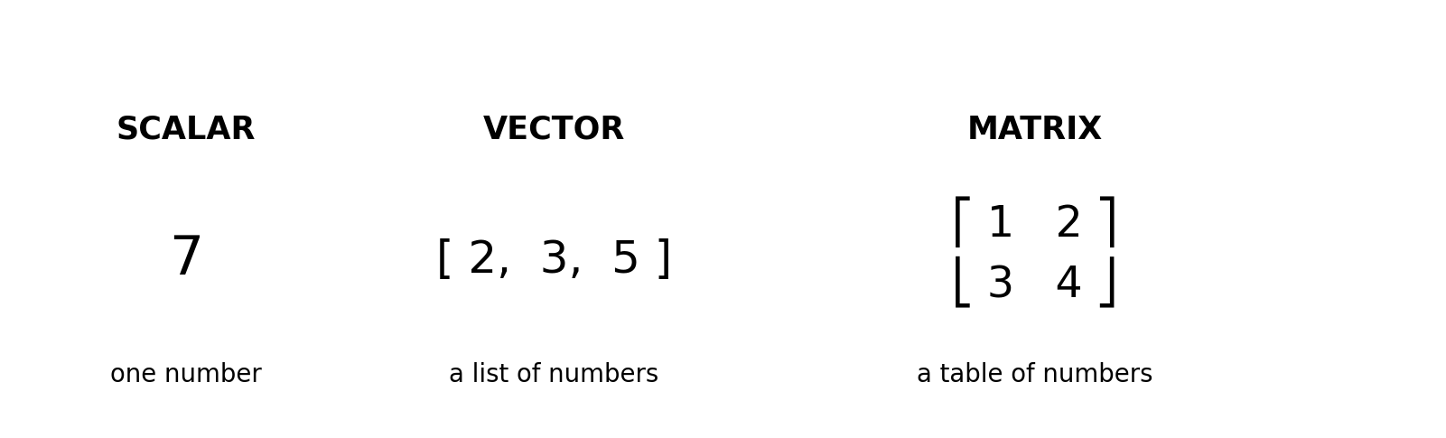
Remember: one number → a list of numbers → a table of numbers. In ML, these grow from one value to one example to many examples.

Picture 2 — A vector is an arrow (Part 1)
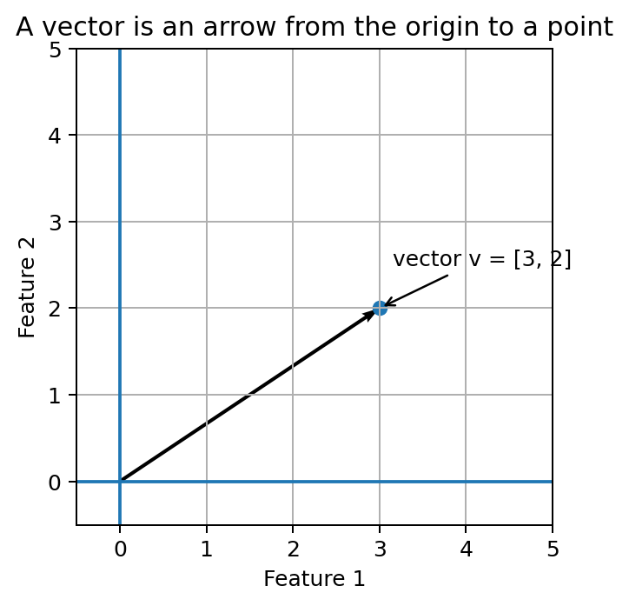
The arrow ends at coordinates [3, 2]. Features act like coordinates; a real dataset may have many more than two.

Picture 3 — Rows are examples, columns are features (Part 1)
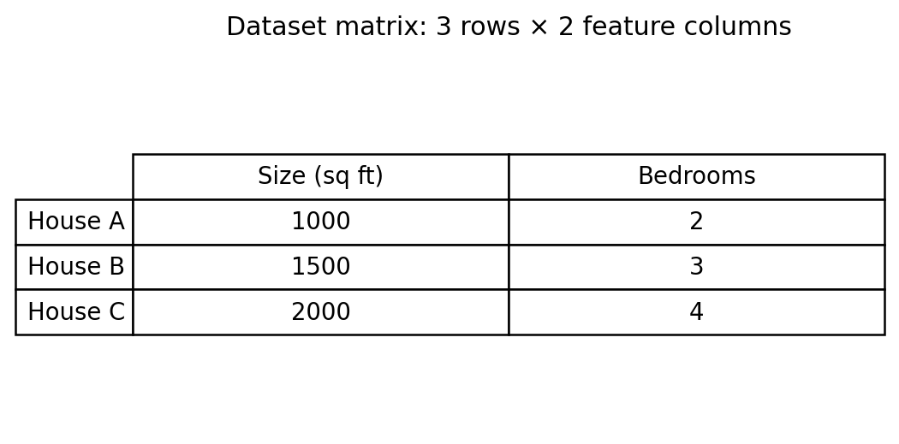
This 3 × 2 matrix stores three houses and two features. Say the shape out loud: rows first, columns second.

Picture 4 — Dot product makes one score (Part 1)
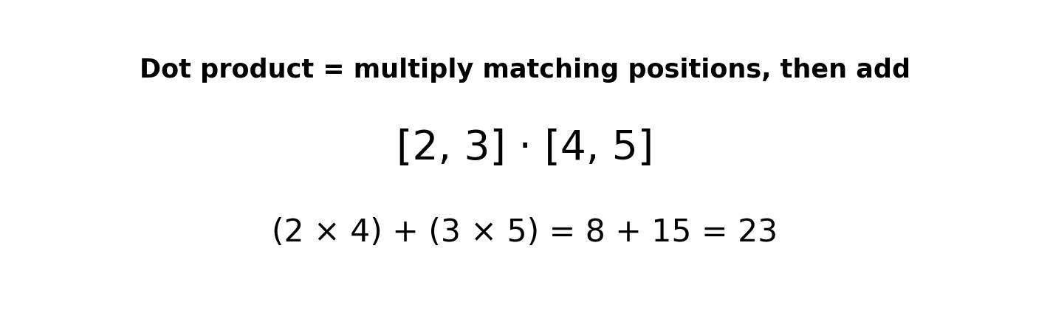
Multiply matching positions, then add. ML uses this to combine feature values with learned weights.

Picture 5 — Distance can mean different things (Part 1)
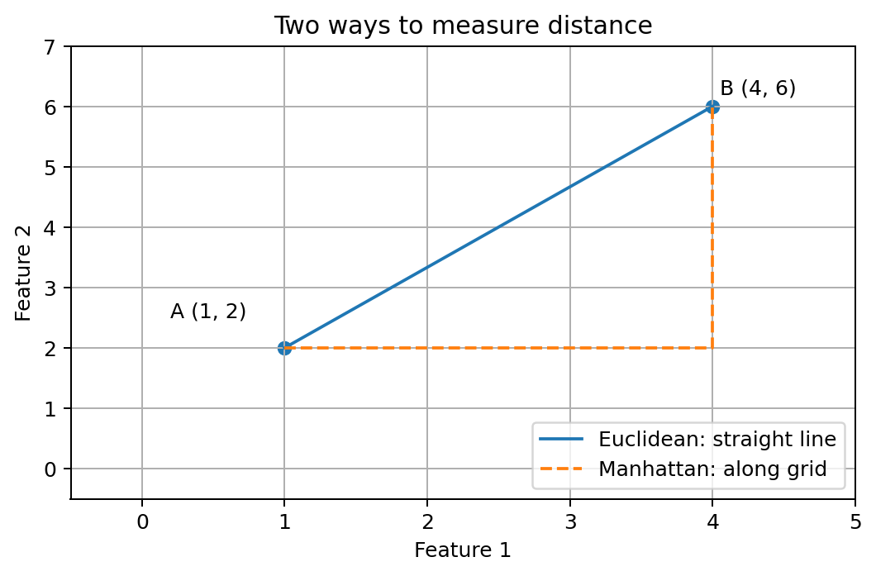
Euclidean distance is the diagonal; Manhattan distance follows horizontal and vertical steps. Both can compare data points.

Picture 6 — Matrix multiplication shape rule (Part 2)
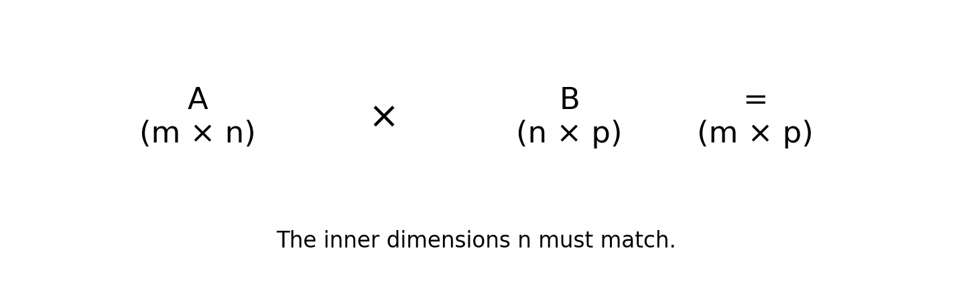
The inside numbers must match: (m × n)(n × p) gives (m × p).

Picture 7 — Regression learns a line (Parts 3 and 5)
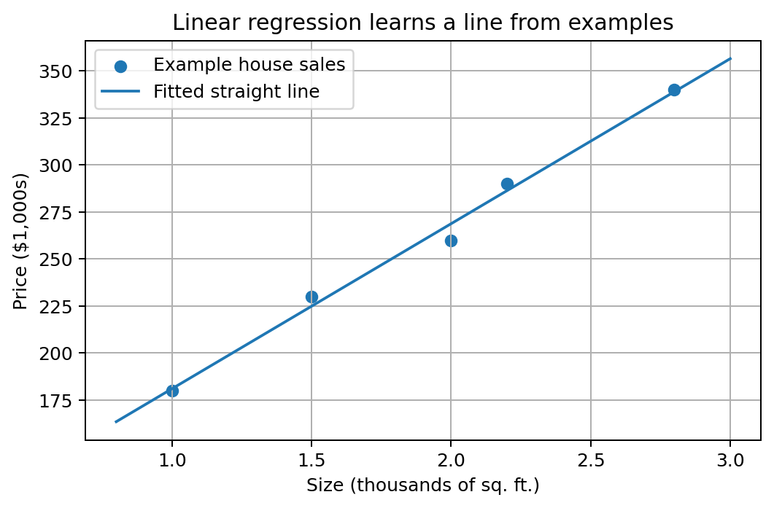
The dots are example sales; the line is a simple fitted pattern. The model learns parameters that make predictions closer to examples.

Picture 8 — PCA intuition (Part 4 and 5)
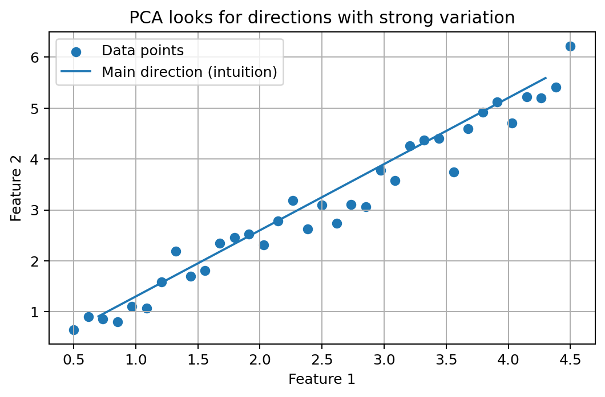
PCA searches for directions where the data varies strongly. This picture is intuition, not a full PCA calculation.

Picture 9 — Neural-network layer (Part 5)
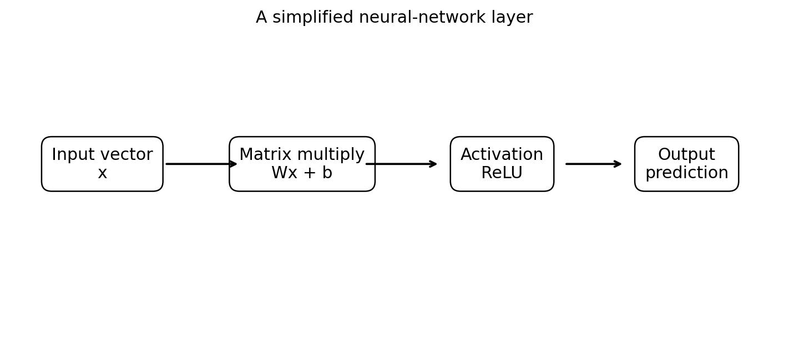
Input numbers are combined by Wx+b, then an activation function transforms the result before the next stage.

Picture 10 — The complete ML connection (Parts 1–5)
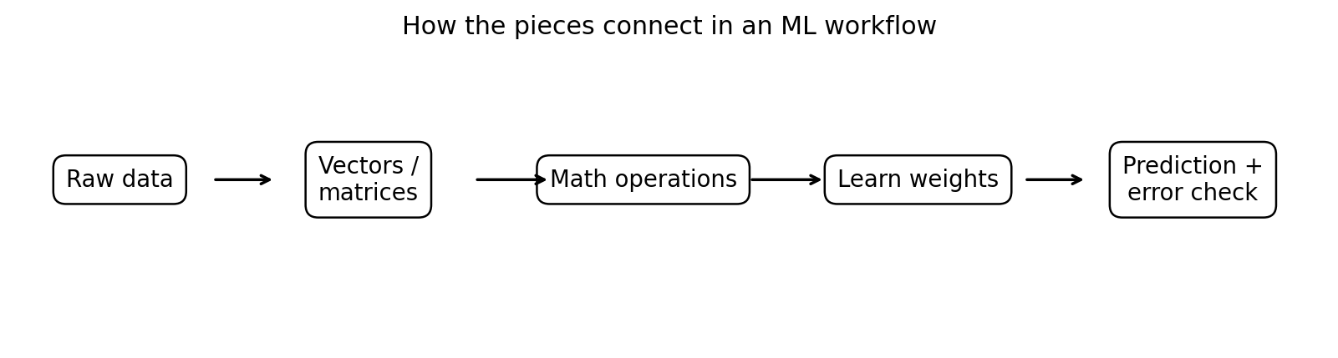
Raw data is organized into arrays, transformed with linear algebra, used to learn weights, and evaluated through predictions and errors.

Fast visual memory rules
Concept | Picture to remember | ML connection
Scalar | one number | one measurement or parameter
Vector | a list / arrow | features for one example; an embedding
Matrix | a number table | many examples or a layer's weights
Dot product | pair, multiply, add | weighted score / one neuron's linear calculation
Matrix multiply | row meets column | many scores at once
Transpose | flip rows and columns | rearrange dimensions for math
Distance | how far apart | nearest neighbors / clustering
Cosine similarity | compare direction | text or image embedding similarity
Linear system | unknowns that satisfy equations | solve for coefficients
Eigenvector | special direction | directions preserved by a transformation
Eigenvalue | scale on that direction | strength associated with an eigenvector
SVD | break a matrix into structured pieces | compression / low-rank approximation
PCA | keep strongest variation directions | reduce dimensions

How to use the visuals for active recall
- Look at one picture for 20 seconds.
- Look away and explain what each shape, arrow, row, or box means.
- Give one ML example for the concept.
- Do one small calculation by hand.
- Run the matching NumPy code from the main guide to verify your result.

