Guidelines for running:
- Use myMainScript.m
- Run the first section which defines the custom colormap
- Then, each section can be run individually. On running each section, the resulting images are displayed in figures; result of each original image is displayed in separate figure
- Parts d, e take significant time(around 20, 10 minutes for 3 images, respectively) and progress bar has been displayed. In these two parts, as soon as each image processing completes, result is displayed but enlarging them takes some time as Matlab seems to be prioritizing execution over displaying images
- Images are saved in .mat format in images/ folder for parts d,e. Each original image has a .mat result file. part d) has N=optimal, N=optimal*4, N=optimal/4 – 3 images in it. Part e has N = same as used for d(which we found as optimal) and clip factor as 0.0075 and 0.0075/2 in .mat file
- Code was run on matlab r2018a

Q2:
a.
Linear Contrast Stretching:
Required to extend the range of intensities from the current range to 0-255 linearly.
Formula for Linear Contrast Stretching:
For a given image, find the minimum intensity – min_intensity, maximum intensity – max_intensity
The pixel value of the contrast stretched image(NewImage) is given by,
NewImage(i, j) = (OriginalImage(i, j) – min_intensity) / (max_intensity – min_intensity) * 255
for all pixel position (i, j)
For RGB image, this has to be done individually for each channel.

If min_intensity is close to zero and and max_intensity is close to 255, then NewImage(i, j) will be close to OriginalImage(i, j) as 255 / (max_intensity – min_intensity) ~ 1. So, there won’t be much difference between the newImage and OriginalImage. Even a presence of one close to zero and one close to maximum intensity pixel is enough to do this irrespective of histogram. This is what happens in church.png.
min_intensity for 3 channels:
(0, 0, 0)
max_intensity for 3 channels:
(255, 255, 255)
Even though the whole image is dark, there are very few pixels which are bright and this contributes to max_intensity of 255 and consequently no effect of linear contrast stretching. There is no change at all.

Original
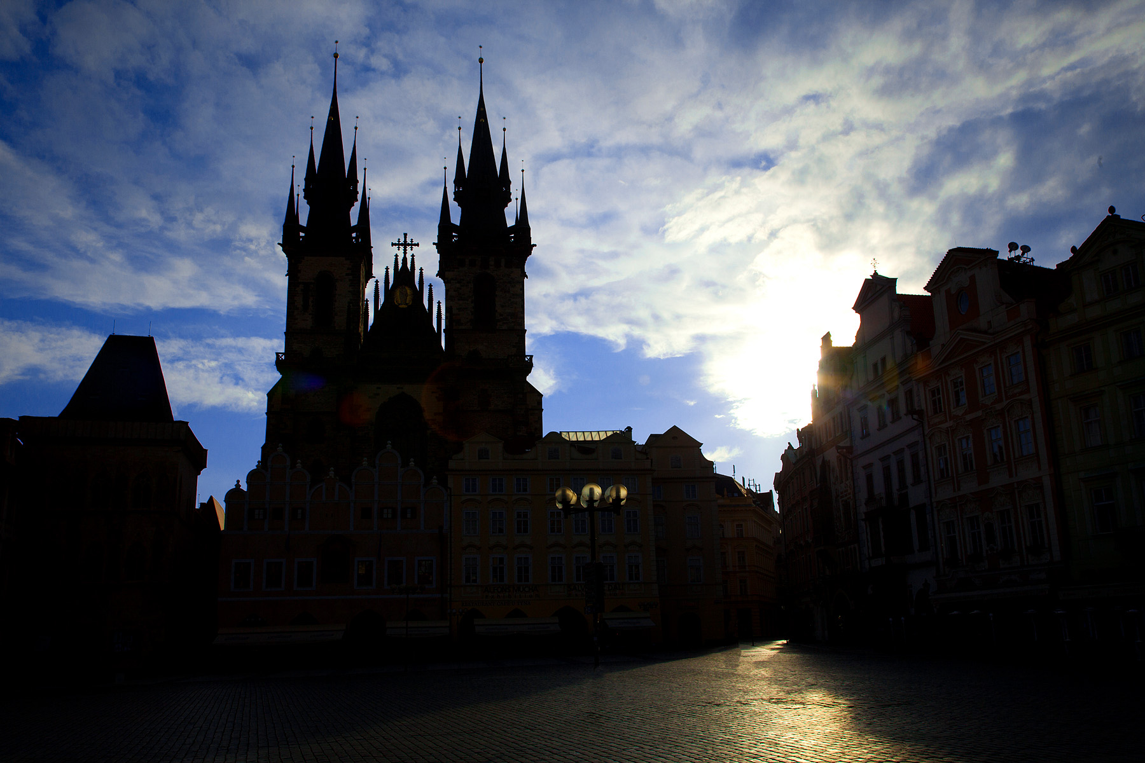

Stretched
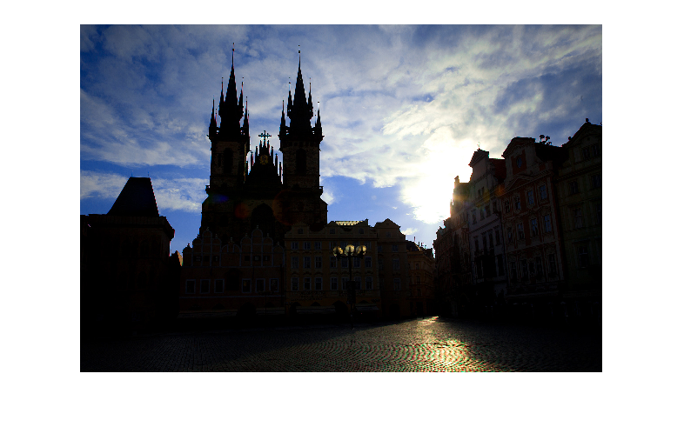

b.
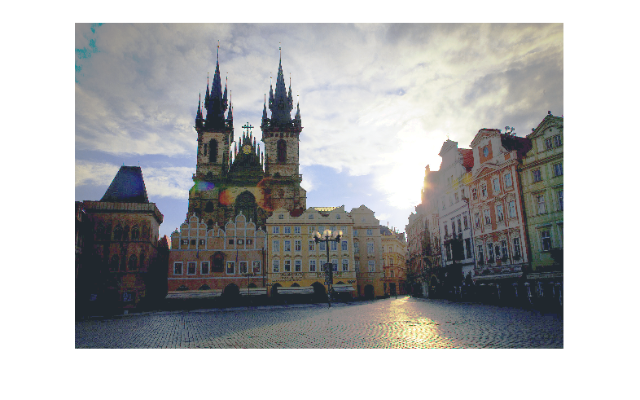
Equalized

Most of the pixels in original image were dark. Histogram equalization tried to spread the histogram equally to dark and bright pixel values and hence we get an overall bright image. In the original image, the gap between buildings is the darkest and church is a little brighter than that, but still low in intensity. There are very little bright pixels. This is spread across intensity 0-255 and church becomes much brighter now.
This is preferred over contrast stretched image as the church is more brighter.

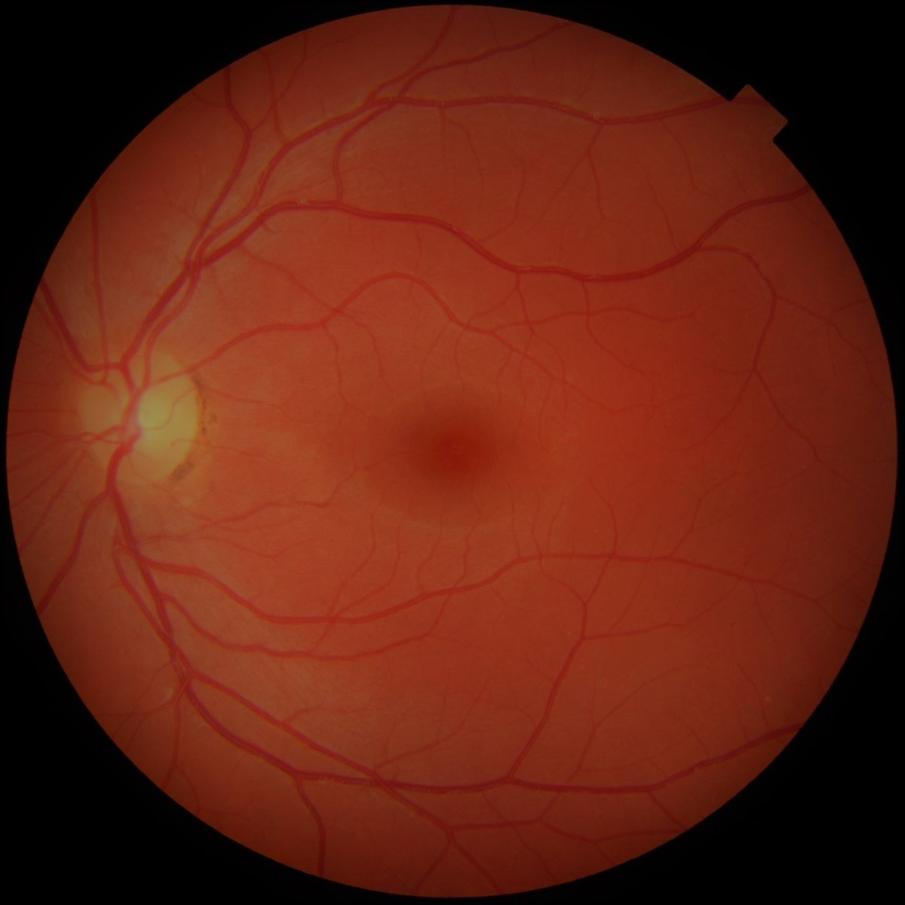
c.
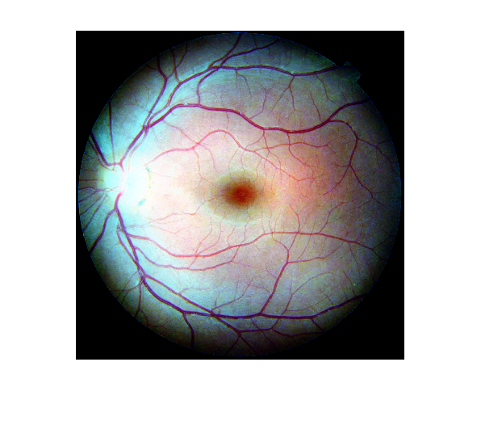
retina.png

retina retina equalized

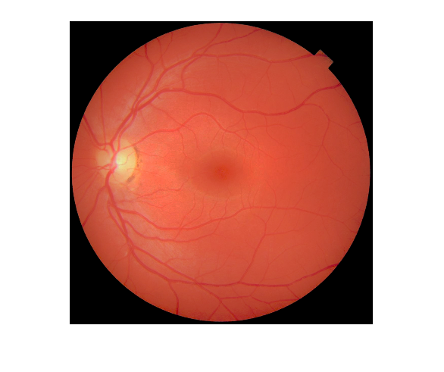
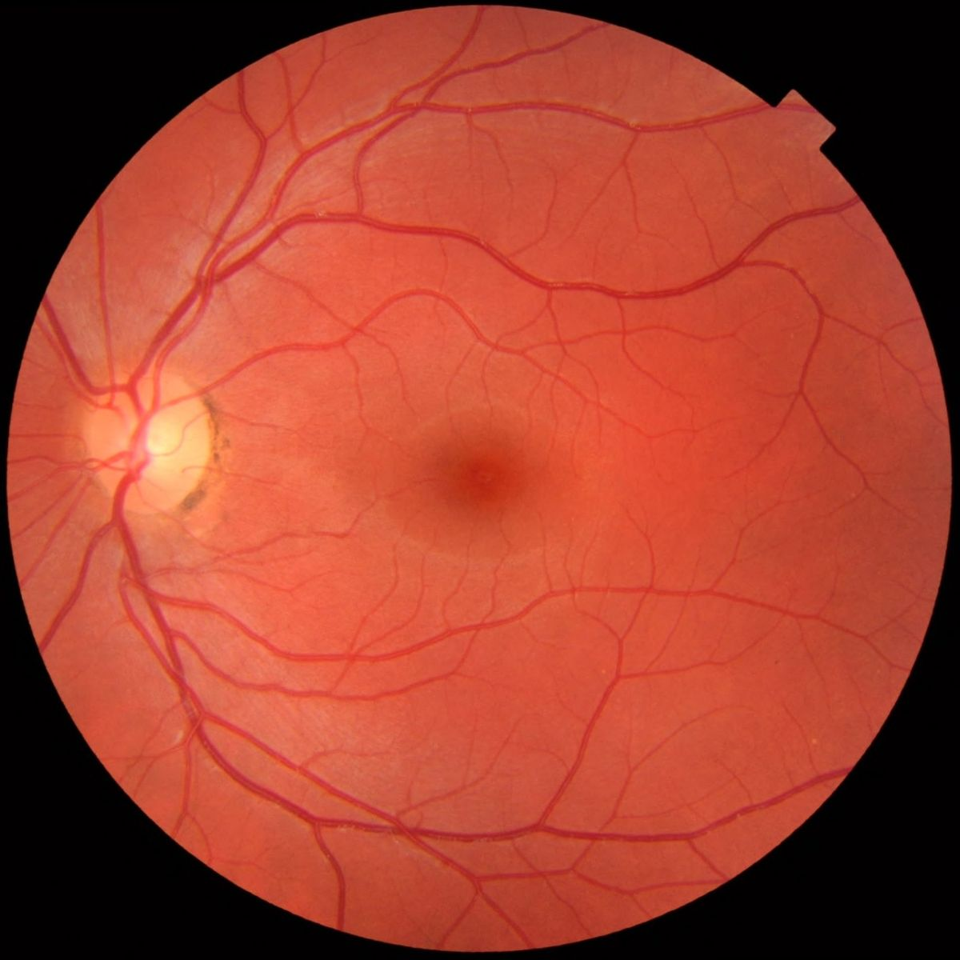

retinaRef retinaMatched

Equalization helps to increase contrast as seen in retina equalized image where nerves are visible very brightly. But for medical analysis, this is not desirable. Medical experts who analyze want to know the state of nerve. The original image is a little darker and needs to be made as bright as the reference image for examination, but not changing the RGB values drastically so that color of the retina itself changes.
Histogram matching achieves this. Original image is adjusted to make its histogram almost same as that of reference image. This maintains the RGB values and also makes it brighter.
After matching, the nerves can be examined. In this case, in the matched image, nerves look faded compared to reference image. This shows some problem with the patient’s eye. Histogram matching made their histograms almost equal which brought intensity of most of original image up and background pixels have almost same intensity as that of reference image and it is useful for examination. The state of the nerves is not clear from equalized image and the equalization has drastically modified the intensity, causing to lose information about nerves.

d. In Adaptive Histogram Equalization (AHE), after tuning the window size we can clearly see increased contrast in patches of images which had large number of low intensity pixels. This is precisely what AHE adds on to HE. In images with window size = Tuned N * 4 , the images are almost equal to what was produced by HE. In some images it might not be so apparent that image with windowsize N is “better looking” than with windowsize N *4 but if we look for overall image constrast improvement and less noise amplification, former one is slightly better. Images with window size N/4 are very noisy and color images go haywire.

For instance in barbara.png for window size 920, we see that whole image is too bright and details of shadow part on table are lost. Compared to this with size 230, we can see the shadows and overall intensity is lower than other image. Also we can clearly see the discontinuous patchy appearace of almost all parts of image for window size 58.
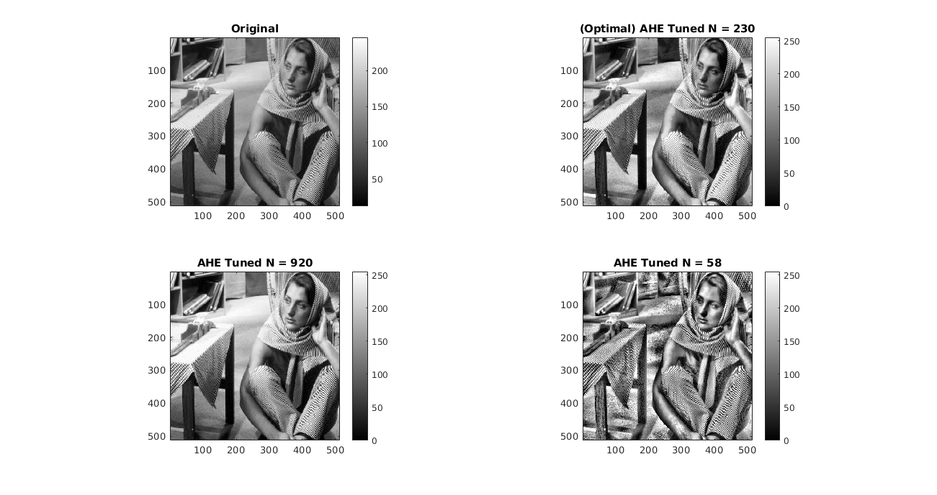
A patch can be in optimal image(top right) and N=58 is noisy at some places(sudden black pixels), N=920 doesn’t provide much contrast, ground is almost bright and shadow is not visible clearly.

e. IN CLAHE, compared to AHE, noise amplified is less and the images are less patchy. Decreasing gamma reduces noise and makes the image look almost similar to orignal image but with a little better contrast, for example face in barbara.png. Also, in all images we can see that CLAHE has smoothened out most parts of image noise issues thaat were present in AHE. The below middle image has better contrast to face and is smoother. Less gamma value give result similar to original image.
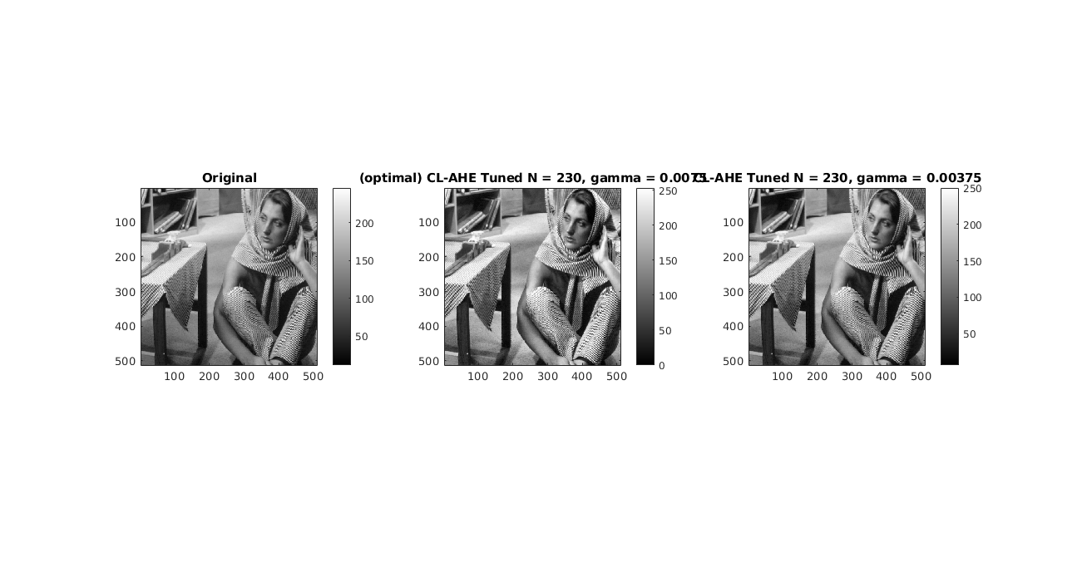

N=230 and clip parameter=0.0075 (optimal) looks best. It avoids patches as seen in AHE and also has better contrast(face) compared to original image.

