CS 663 Assignment 4
Q1 Report
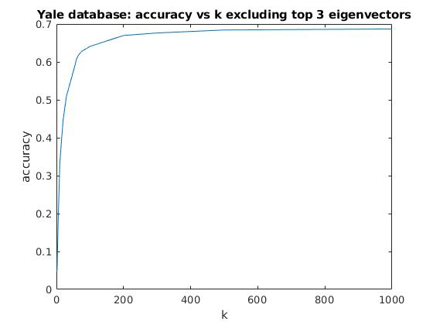
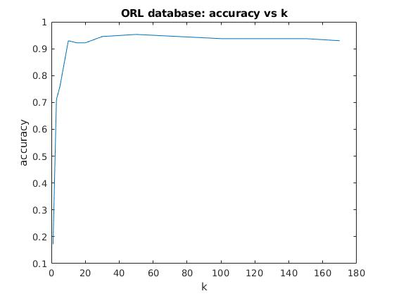
image: images/orl.jpg

image: images/yale_exc_top3.jpg

image: images/yale_inc_top3.jpg

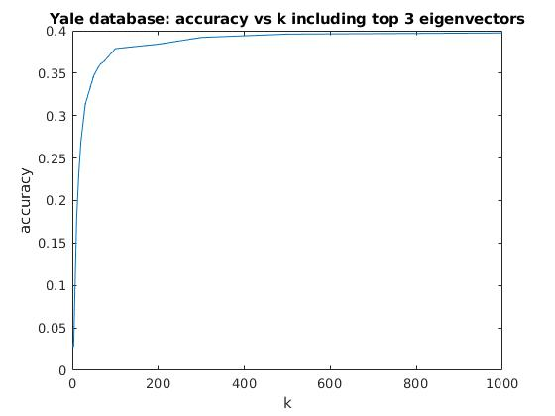
While executing the code, make sure that both the databases (ORL and Yale) are extracted just outside code/ directory.

