CS 663 Assignment 4
Q2 Report

Image Reconstruction:
PCA was trained for 38 individuals, with 40 images from each individual. A test image not present in training image is reconstructed with varying ‘k’ - number of eigenvectors corresponding to top eigenvalues chosen

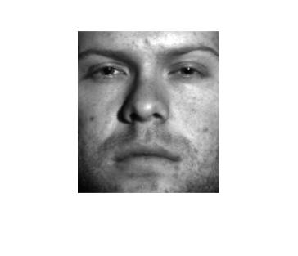
Original Image

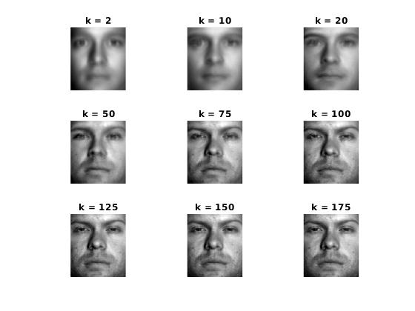
Reconstructed Images
Eigenfaces:
Eigenvectors corresponding to top 25 eigenvalues
Each eigenvector has been contrast stretched to 0-255 for convenience
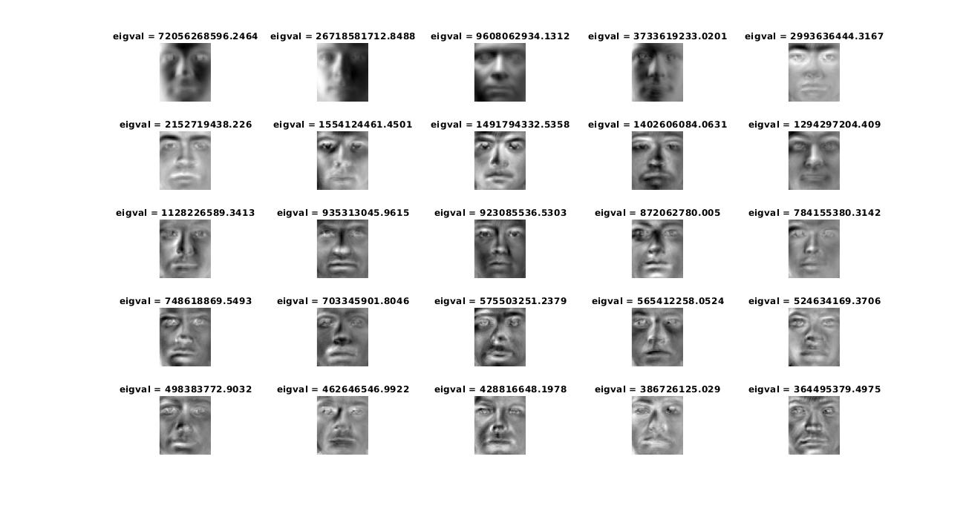
Please refer to images/eigenfaces.jpg for better clarity

While executing the code, make sure that Yale database is extracted just outside code/ directory.

