Question 1. What is Garbage Collection process in java?

Ans. GC (Garbage collection) is the process by which JVM cleans objects (unused objects) from heap to reclaim heap space in java

Question 2. What is Automatic Garbage Collection in JVM heap memory in java?

Answer. Very important thing you must know in garbage collection interview.

Automatic garbage collection is the process of

* Identifying objects which are in use in java heap memory and Which objects are not in use in java heap memory and
* deleting the unused objects in java heap memory.

Question 3. Explain JVM Heap memory (Hotspot heap structure) with diagram in java?

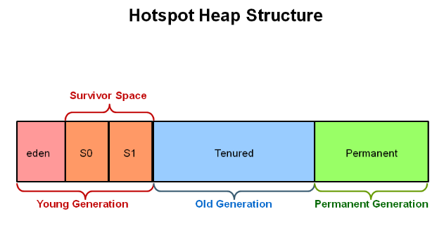

Question 4. What is Minor garbage collection in JVM Heap memory in java?

* When the young generation fills up, this causes a minor garbage collection.
* All the unreferenced (dead) objects are cleaned up from young generation.
* All the non-daemon threads running in application are stopped during minor garbage collections

Question 5. What are Minor, Major and Full garbage collection in JVM Heap memory in java >

* Young Generation (Minor garbage collection occurs in Young Generation)
* Old Generation (tenured generation) - (Major garbage collection occurs in Old Generation)
* Permanent Generation or (Permgen) - (full garbage collection occurs in permanent generation in java

Question 6. What are different Garbage collectors available in JVM?

* Serial collector / Serial GC (Garbage collector) in java
* Throughput GC (Garbage collector) or Parallel collector in java
* Concurrent Mark Sweep (CMS) collector / concurrent low pause garbage collector
* G1 garbage collector / Garbage first collector
* PS Scavenge
* PS Mark Sweep
* Par New collector

Question 7. Explain Serial GC?

* Serial GC is designed for the single threaded environments in java.
* In Serial GC (Garbage collector) , both minor and major garbage collections are done serially by one thread in java.
* Serial GC uses a mark-compact collection method. The serial garbage collector is the default for client style machines in Java SE 5 and 6.
* Vm (JVM) option for enabling serial GC (garbage Collector) in java >
* -XX:+UseSerialGC

Question 8. Explain Parallel GC?

* -XX: +UseParallelGC
* Throughput garbage collector is the default garbage collector for JVM in java.
* Throughput garbage collector uses multiple threads to execute a minor collection and so reduces the serial execution time of the application in java.
* The throughput garbage collector is similar to the serial garbage collector but uses multiple threads to do the minor collection in java.
* This garbage collector uses a parallel version of the young generation garbage collector in java.
* The tenured generation collector is the same as the serial garbage collector in java.
* java -Xms256m -Xms512m  -XX:+UseParallelGC -XX:ParallelGCThreads=5 -jar d:\MyJar.jar

<https://www.javamadesoeasy.com/2016/10/throughput-gc-garbage-collector-or.html>

Question: Explain G1 GC?

* Introduce in java 7.
* It is parallel, concurrent,
* targeted for multi-processor machines with large memories.
* https://www.javamadesoeasy.com/2016/10/g1-garbage-collector-garbage-first.html