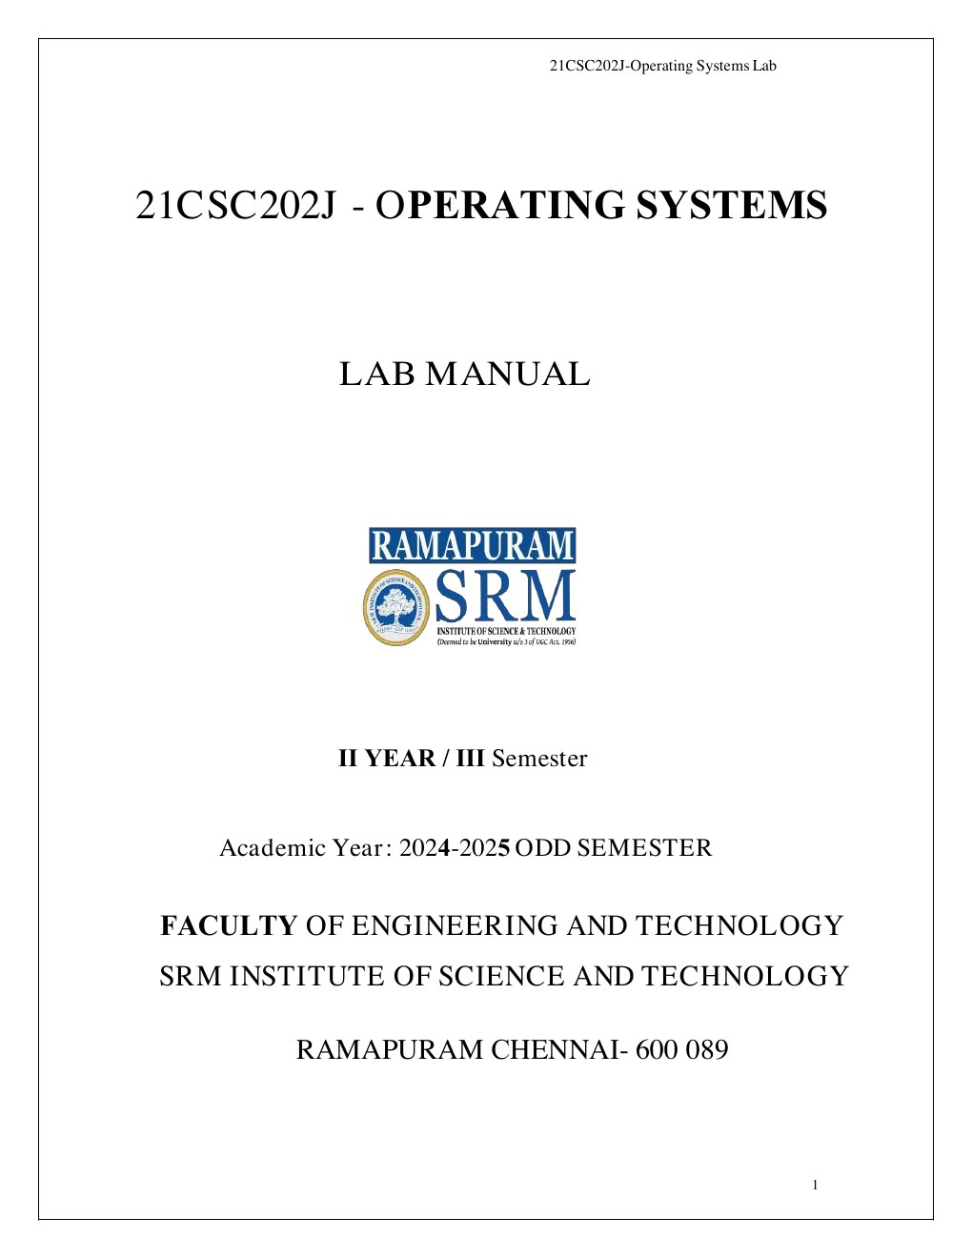
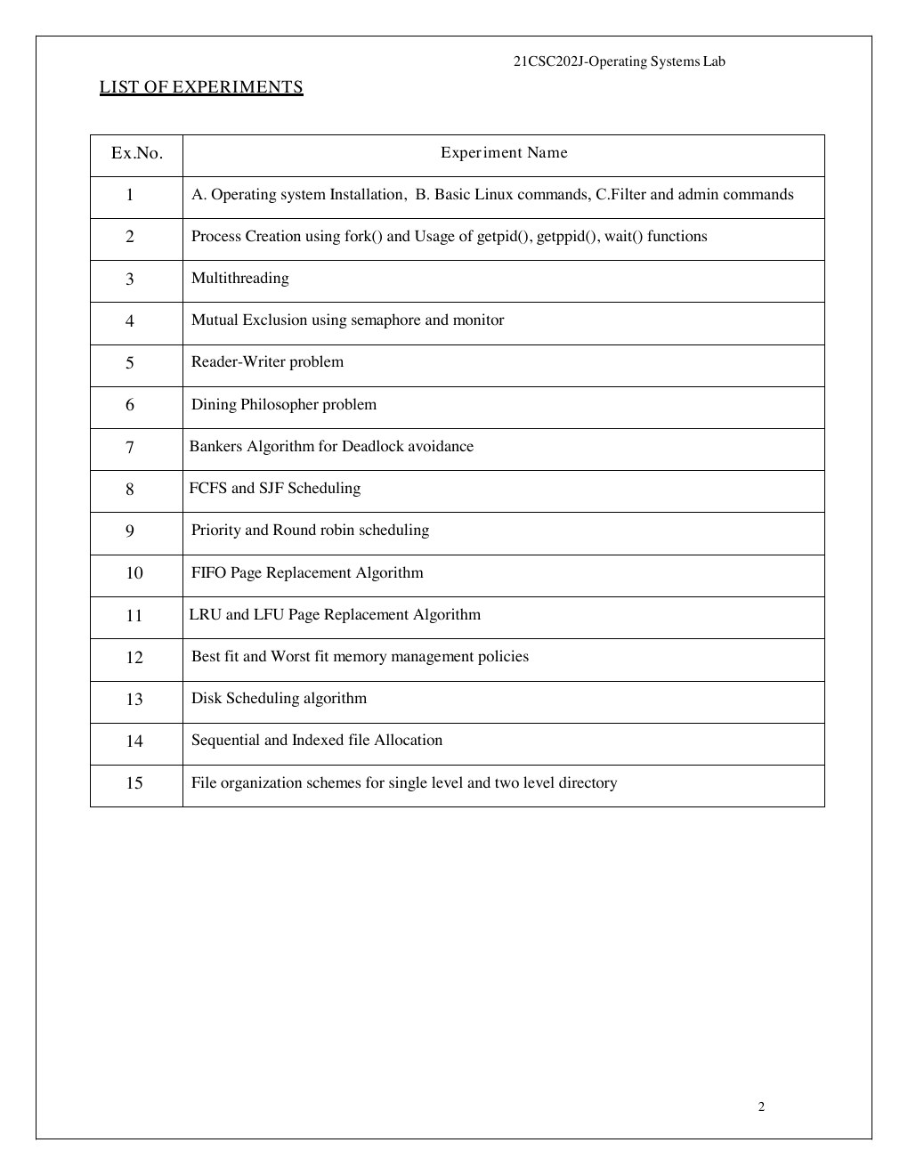
TABLE OF CONTENTS
Experiment 1A Operating System Installation | 4
Experiment 1B Basic Linux Commands | 12
Experiment 1C Filters and Admin Commands | 15
Experiment 2 Process Creation using fork and wait | 17
Experiment 3 Multithreading | 20
Experiment 4 Mutual Exclusion using Semaphore and Monitor | 22
Experiment 5 Reader-Writer Problem | 25
Experiment 6 Dining Philosophers Problem | 27
Experiment 7 Banker's Algorithm | 29
Experiment 8 FCFS and SJF Scheduling | 32
Experiment 9 Priority and Round Robin Scheduling | 35
Experiment 10 FIFO Page Replacement | 38
Experiment 11 LRU and LFU Page Replacement | 40
Experiment 12 Best Fit and Worst Fit | 42
Experiment 13 Disk Scheduling Algorithm | 44
Experiment 14 Sequential and Indexed File Allocation | 48
Experiment 15 Single and Two-Level Directory | 50
Submitted by: RA2511026020156
21CSC202J Operating Systems Lab
SRM Institute of Science and Technology, Ramapuram
Source code and run guide: https://github.com/shriramzx/OS-LAB
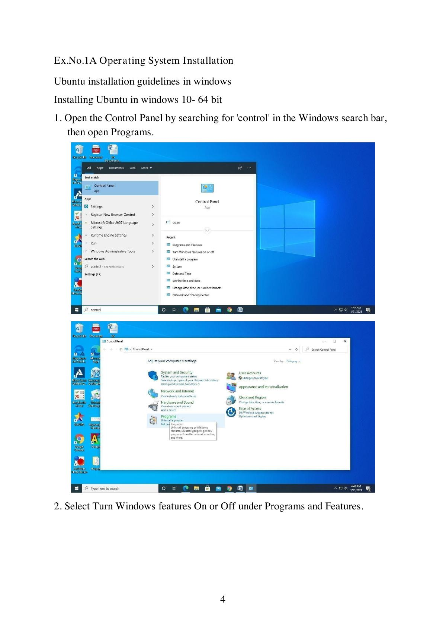
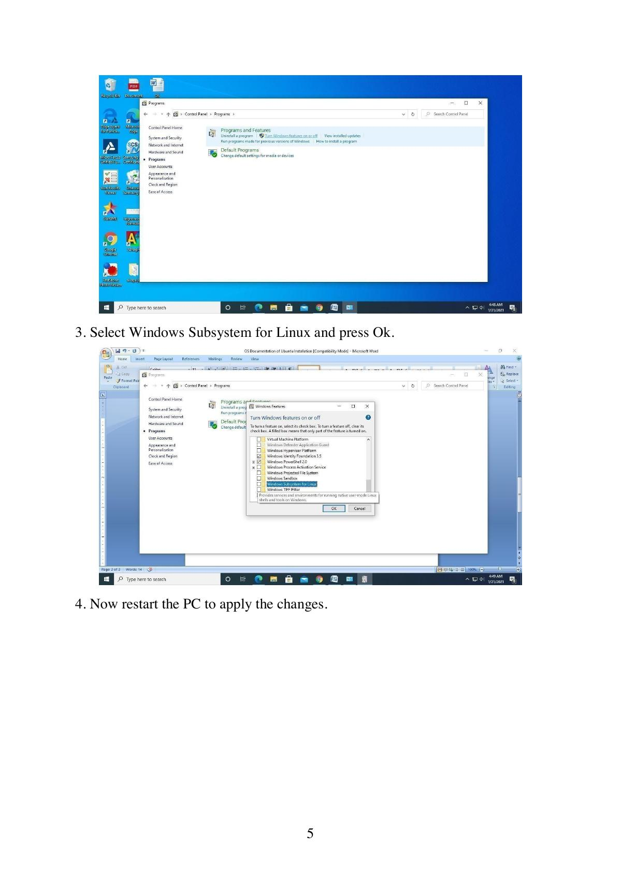
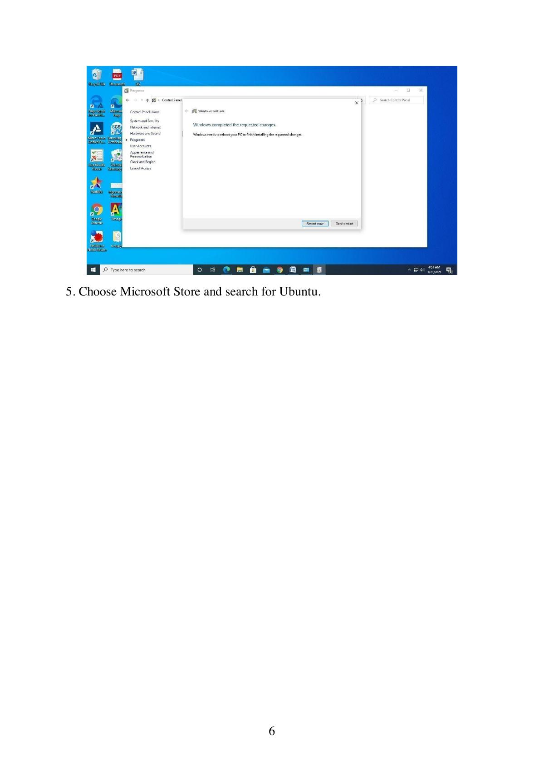

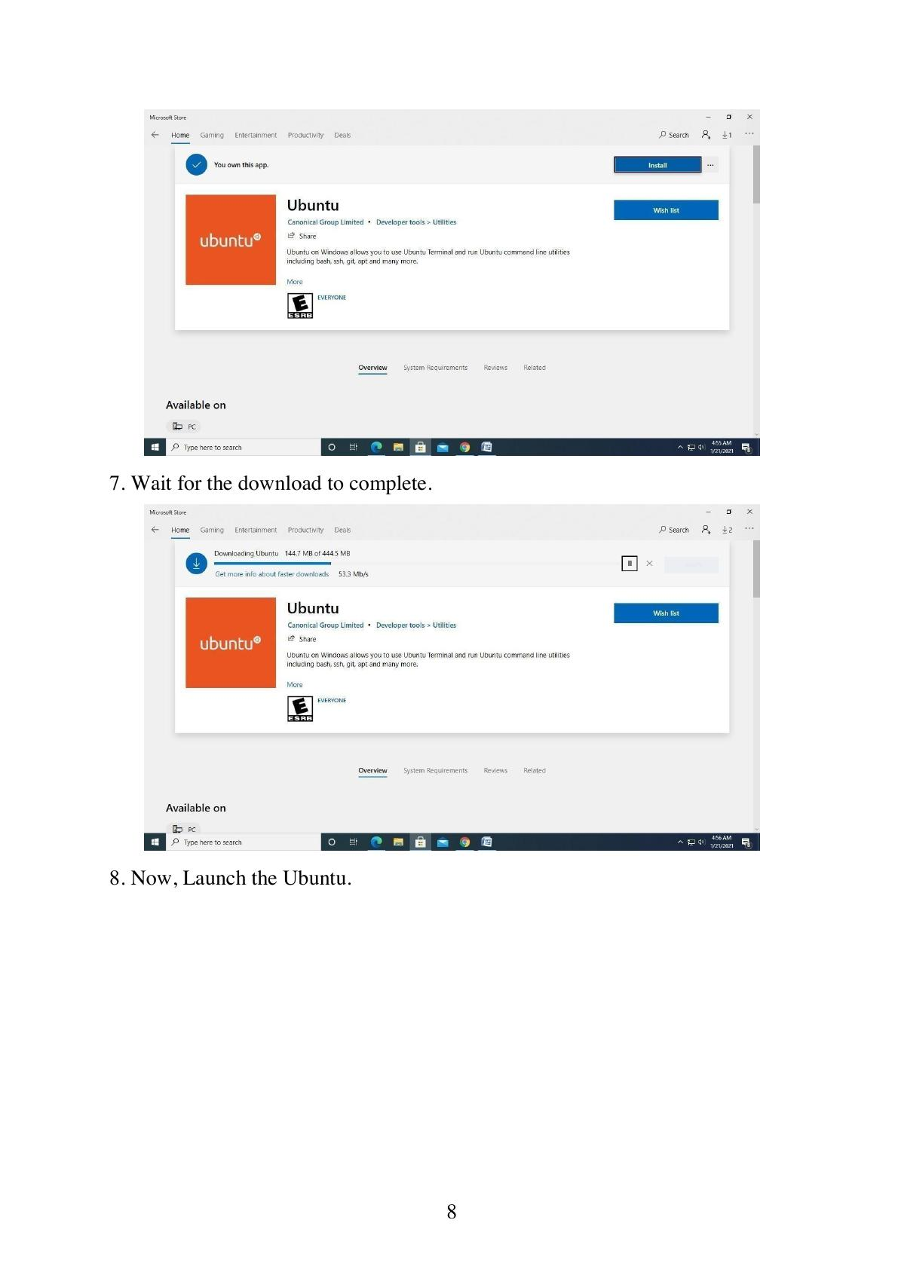
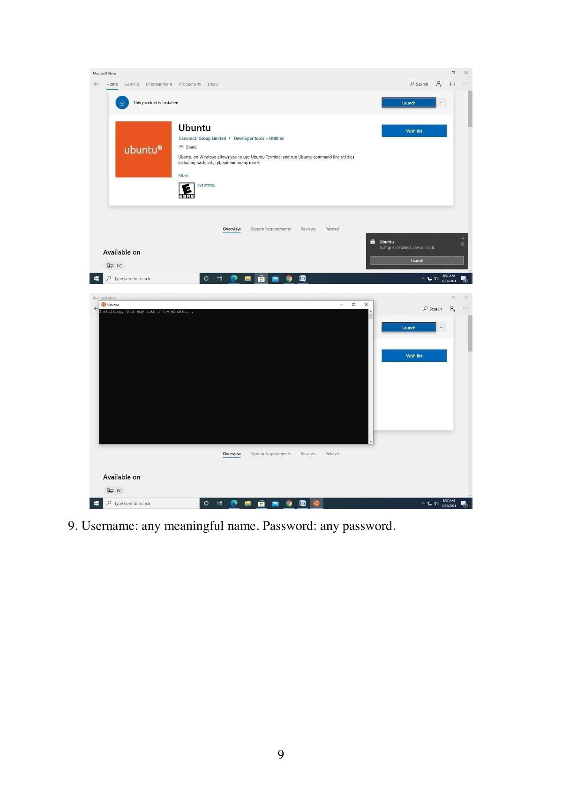
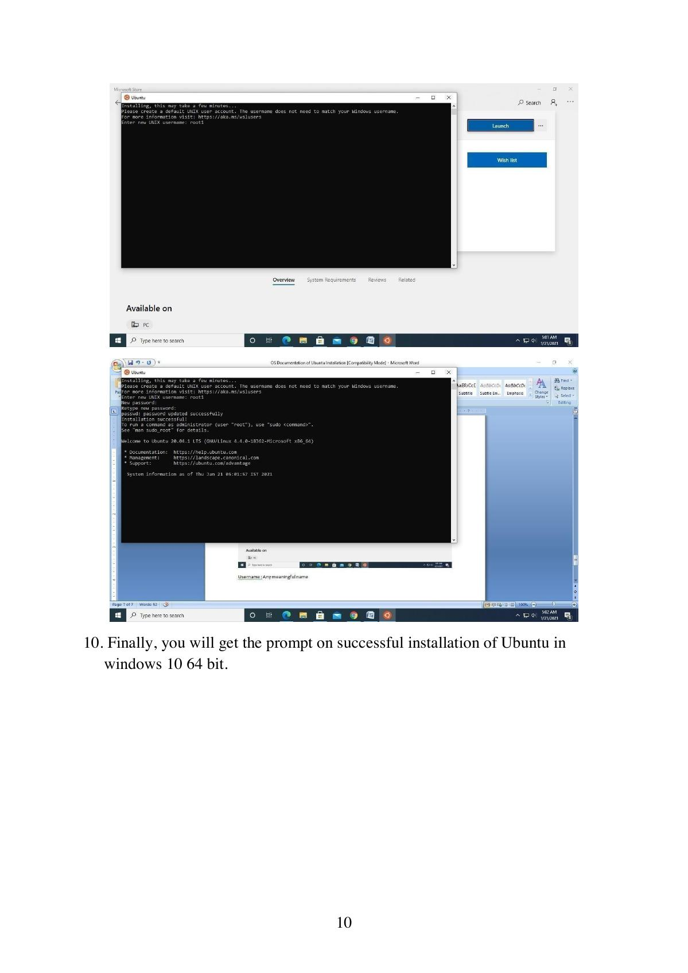
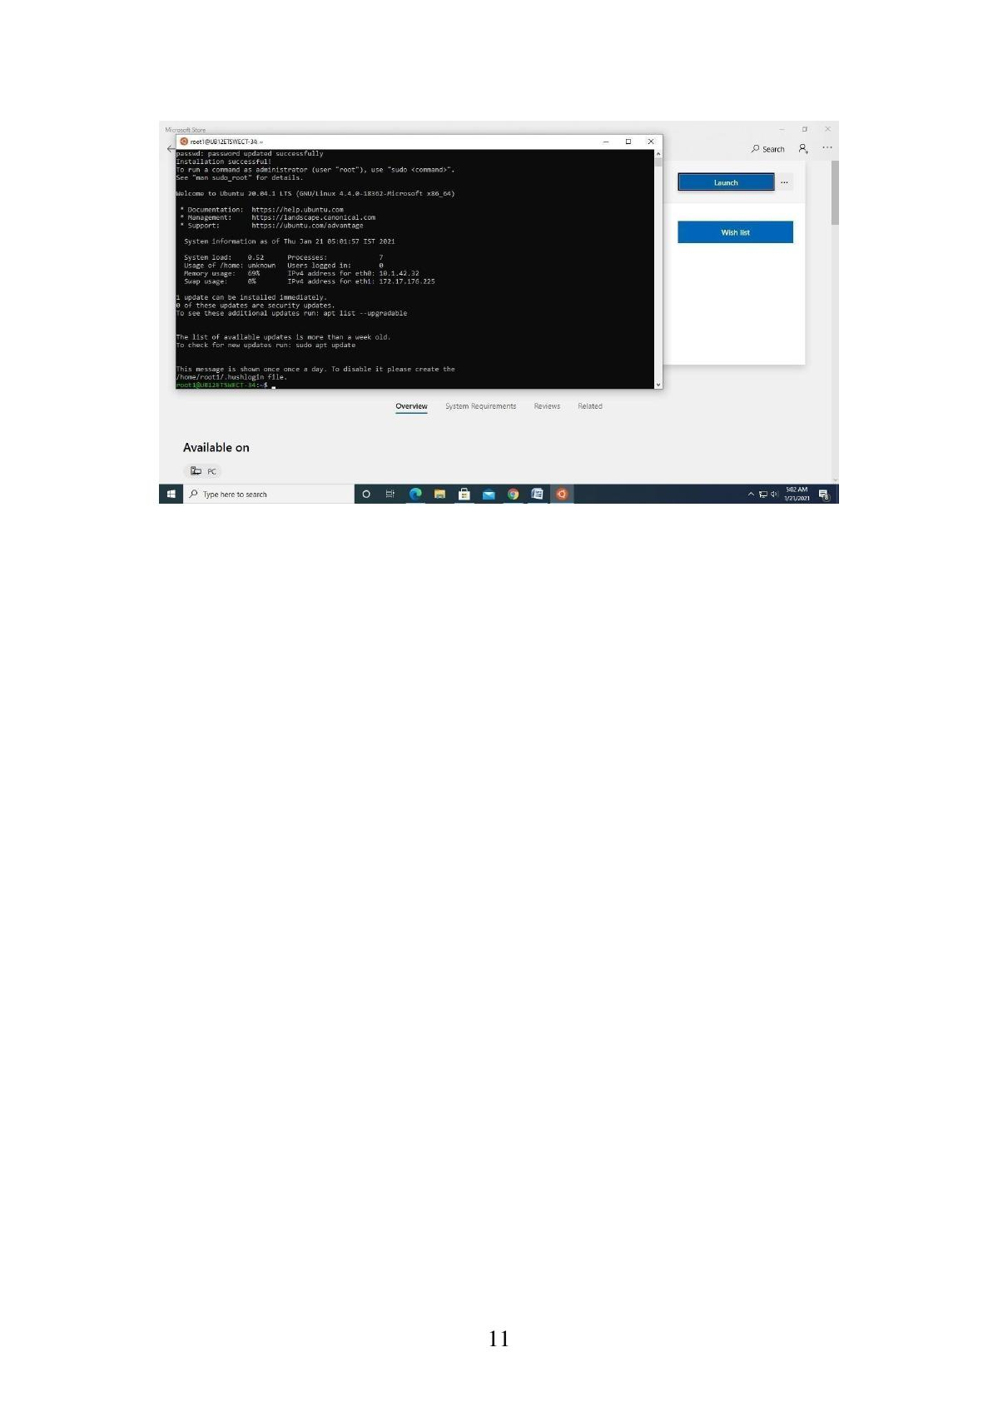

Experiment.No-1B BASIC LINUX COMMANDS
a) Basics
1. echo SRM - To display the string SRM
2. clear - To clear the screen
3. date - To display the current date and time
4. cal 2003 - To display the calendar for the year 2003
cal 6 2003 - To display the calendar for June 2003
5. passwd - To change the password
b) Working with Files
1. ls - List files in the present working directory
ls -l - List files with detailed information (long list)
ls -a - List all files including the hidden files
2. cat > f1 - To create a file (Press Ctrl+D to finish typing)
3. cat f1 - Display the content of the file f1
4. wc f1 - List no. of characters, words & lines of a file f1
wc -c f1 - List only no. of characters of file f1
wc -w f1 - List only no. of words of file f1
wc -l f1 - List only no. of lines of file f1
5. cp f1 f2 - Copy file f1 into f2
6. mv f1 f2 - Rename file f1 as f2
7. rm f1 - Remove the file f1
8. head -5 f1 - List first 5 lines of the file f1
tail -5 f1 - List last 5 lines of the file f1
c) Working with Directories
1. mkdir elias - To create the directory elias
2. cd elias - To change the directory to elias
3. rmdir elias - To remove the directory elias
4. pwd - To display the path of the present working directory
5. cd - To go to the home directory
cd .. - To go to the parent directory
cd - - To go to the previous working directory
cd / - To go to the root directory
d) File name substitution
1. ls f? - List files that start with 'f' & are followed by any one character
2. ls *.c - List files with extension 'c'
3. ls [gpy]et - List files whose first letter is any one of the characters g, p or y and followed by the word et
4. ls [a-d,l-m]ring - List files whose first letter is any one of the characters from a to d and l to m and followed by the word ring
e) I/O Redirection
1. Input redirection
wc -l < ex1 - To find the number of lines of the file 'ex1'
2. Output redirection
who > f2 - The output of 'who' will be redirected to file f2
3. cat >> f1 - To append more into the file f1
f) Piping
Syntax: Command1 | Command2
Output of command 1 is transferred to command 2 as input. Finally the output of command 2 is displayed on the monitor.
ex. cat f1 | more - Lists the contents of file f1 screen by screen
head -6 f1 | tail -2 - Prints the 5th & 6th lines of the file f1
g) Environment variables
1. echo $HOME - Display the path of the home directory
2. echo $PS1 - Display the prompt string $
3. echo $PS2 - Display the second prompt string (>)
4. echo $LOGNAME - Login name
5. echo $PATH - List of path names where the OS searches for an executable file
h) File permission
The chmod command is used to change the access permission of a file.
Method-1
Syntax: chmod [ugo] [+/-] [rwxa] filename
u: user, g: group, o: others
+: Add permission, -: Remove the permission
r: read, w: write, x: execute, a: all permissions
ex. chmod ug+rw f1 - adding read & write permissions of file f1 to both user and group members.
Method-2
Syntax: chmod octnum file1
The 3-digit octal number represents as follows:
- First digit - file permissions for the user
- Second digit - file permissions for the group
- Third digit - file permissions for others
Each digit is specified as the sum of the following: 4 - read permission, 2 - write permission, 1 - execute permission.
ex. chmod 754 f1 - it changes the file permission for the file as follows:
- Read, write & execute permissions for the user, i.e., 4+2+1 = 7
- Read & execute permissions for the group members, i.e., 4+0+1 = 5
- Only read permission for others, i.e., 4+0+0 = 4
Output:

Experiment.No-1C FILTERS and ADMIN COMMANDS
FILTERS
1. cut
Used to cut characters or fields from a file/input.
Syntax: cut -c chars filename
cut -f fieldnos filename
By default, tab is the field separator (delimiter). If the fields of the files are separated by any other character, we need to specify it explicitly by the -d option.
cut -d delimitchar -f fields filename
2. grep
Used to search one or more files for a particular pattern.
Syntax: grep pattern filename(s)
> Lines that contain the pattern in the file(s) get displayed.
> Pattern can be any regular expression.
> More than one file can be searched for a pattern.
3. sort
Used to sort the file in order.
Syntax: sort filename
> Sorts the data as text by default.
> Sorts by the first field by default.
-r option sorts the file in descending order
-u eliminates duplicate lines
-o filename writes sorted data into the file filename
-t dchar sorts the file in which fields are separated by dchar
-n sorts the data as numbers
+1n skip the first field & sort the file by the second field numerically
4. uniq
Displays unique lines of a sorted file.
Syntax: uniq filename
-d option displays only the duplicate lines
-c displays unique lines with no. of occurrences
5. diff
Used to differentiate two files.
Syntax: diff f1 f2
Compares two files f1 & f2 and prints all the lines that are different between f1 & f2.
Questions:
Q1. Write a command to cut characters 5 to 8 of the file F1.
Ans: $ cut -c 5-8 F1
Q2. Display the user ID (UID) of all users in your system.
Ans: $ cut -d: -f3 /etc/passwd
Q3. Check whether the user judith is available in your system using grep.
Ans: $ grep "^judith:" /etc/passwd
Q4. Display the lines of the file F1 that start with SRM.
Ans: $ grep "^SRM" F1
Q5. Sort the file /etc/passwd in descending order.
Ans: $ sort -r /etc/passwd
Q6. Display the unique lines of the sorted file f21. Also display the number of occurrences of each line.
Ans: $ uniq -c f21
Q7. Write a command to display the lines that are common to the files f1 & f2.
Ans: $ grep -xFf f1 f2
Output:

Experiment.No-2 Process Creation using fork() and usage of getpid(), getppid(), wait() functions.
Aim: To write a program for process creation using fork() and usage of getpid(), getppid() and wait() functions.
Definitions:
1. What is fork()?
fork() is a system call used to create a new child process.
2. What does getpid() do?
getpid() returns the PID of the current process.
3. What does getppid() do?
getppid() returns the PID of the parent process.
4. What is the use of wait()?
wait() makes the parent process wait until a child process terminates.
5. What does fork() return?
0 → Child process
Positive value → Parent process (child's PID)
-1 → fork() failed
Program 1: Process creation using fork()
#include <stdio.h>
#include <sys/types.h>
#include <unistd.h>
int main()
{
fork();
fork();
printf("Hello World\n");
}
Sample Output:
Hello World
Hello World
Hello World
Hello World
Output:

Program 2: Usage of getpid() & getppid()
#include <stdio.h>
#include <sys/types.h>
#include <unistd.h>
void main()
{
// variable to store calling function's process id
int process_id, p_process_id;
// getpid() - will return process id of calling function
process_id = getpid();
// getppid() - will return process id of parent function
p_process_id = getppid();
// printing the process ids
printf("The process id: %d\n", process_id);
printf("The process id of parent function: %d\n", p_process_id);
}
Sample Output:
The process id: 3258
The process id of parent function: 1914
Output:

Program 3: Usage of wait()
#include <stdio.h>
#include <stdlib.h>
#include <sys/wait.h>
#include <unistd.h>
int main()
{
pid_t cpid;
if (fork() == 0)
exit(0); /* terminate child */
else
cpid = wait(NULL); /* reaping parent */
printf("Parent pid = %d\n", getpid());
printf("Child pid = %d\n", cpid);
return 0;
}
Sample Output:
Parent pid = 3310
Child pid = 3311
Output:

Result:
Thus successfully completed process creation using fork() and usage of getpid(), getppid() and wait() functions.

Program (4) | Output (3) | Viva (3) | Result (10)

Experiment No. 3 Multithreading
Aim: To divide a computation among multiple POSIX threads and combine the partial results.
Theory: A thread is a lightweight execution path within a process. This program assigns each worker a non-overlapping range of integers, joins all worker threads, and sums their results.
Algorithm:
1. Divide the integers from 1 through 1000 into four equal ranges.
2. Create one POSIX thread for each range and compute its partial sum.
3. Join each thread and add its partial sum to the total.
4. Display the four partial sums and the final total.
Program: pthread sum of 1 to 1000
#include <pthread.h>
#include <stdio.h>
typedef struct {
int first;
int last;
long long sum;
} ThreadData;
static void *sum_range(void *argument)
{
ThreadData *data = argument;
data->sum = 0;
for (int value = data->first; value <= data->last; ++value)
data->sum += value;
return NULL;
}
int main(void)
{
enum { THREADS = 4, MAX_VALUE = 1000 };
pthread_t threads[THREADS];
ThreadData data[THREADS];
const int chunk = MAX_VALUE / THREADS;
long long total = 0;
for (int i = 0; i < THREADS; ++i) {
data[i].first = i * chunk + 1;
data[i].last = (i + 1) * chunk;
if (pthread_create(&threads[i], NULL, sum_range, &data[i]) != 0) {
perror("pthread_create");
return 1;
}
}
for (int i = 0; i < THREADS; ++i) {
if (pthread_join(threads[i], NULL) != 0) {
perror("pthread_join");
return 1;
}
printf("Thread %d sum = %lld\n", i + 1, data[i].sum);
total += data[i].sum;
}
printf("Total sum = %lld\n", total);
return 0;
}
MARK ALLOCATION | Allocated: ______ | Awarded: ______
Compile and run: clang Experiment-03/experiment3.c -Wall -Wextra -pthread -o Experiment-03/experiment3 && ./Experiment-03/experiment3
Expected check: partial sums 31375, 93875, 156375, and 218875; total 500500.
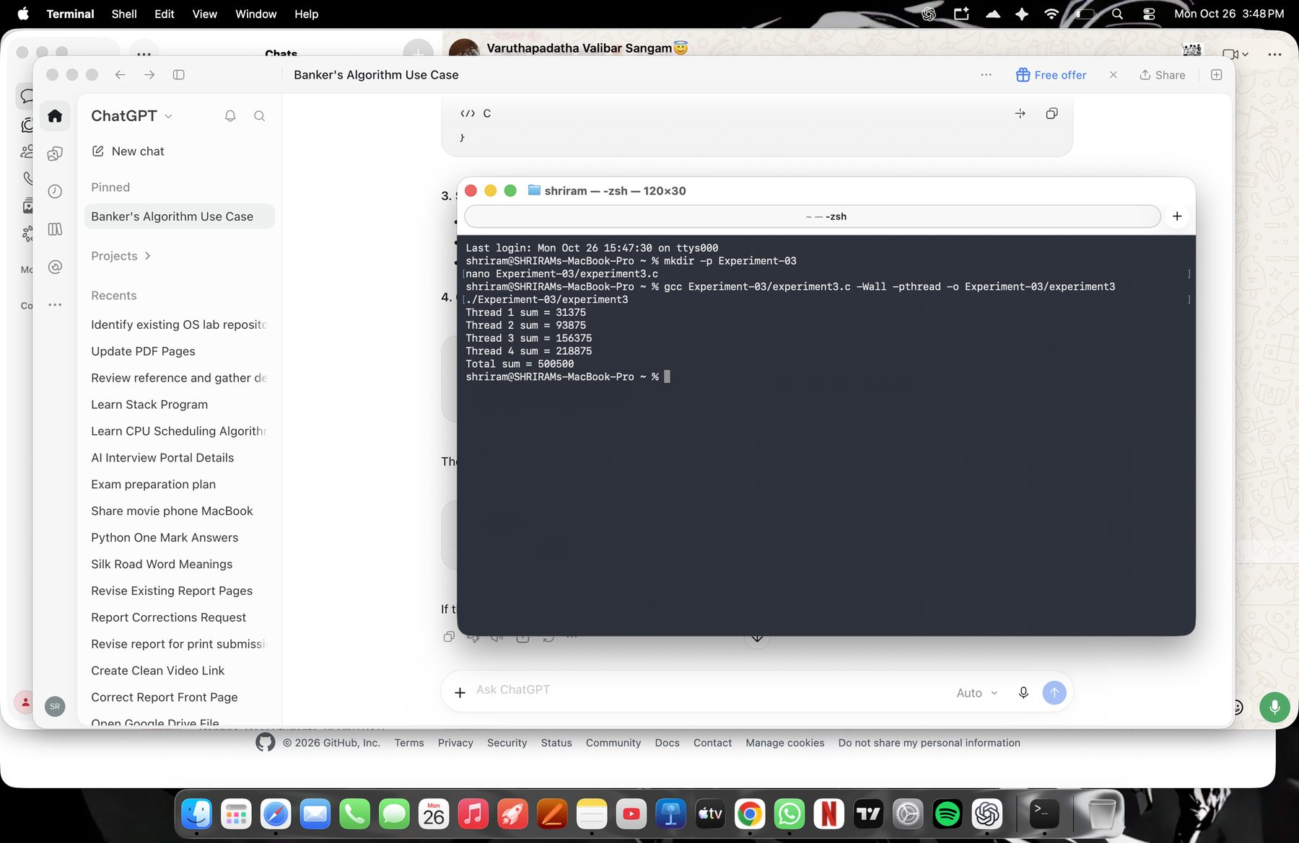
User-supplied Mac Terminal output for Experiment 3.
Result: The four worker threads calculate partial sums whose total is 500500.

Experiment No. 4 Mutual Exclusion Using Semaphore and Monitor
Aim: To protect a shared account balance from conflicting concurrent updates.
Theory: A semaphore or mutex can protect a critical section so that only one thread updates shared data at a time. The programs below model ATM withdrawals.
Algorithm:
1. Create two withdrawal threads and initialize the shared balance.
2. Acquire the synchronization primitive before checking or changing the balance.
3. Perform the withdrawal only when sufficient funds remain.
4. Release the primitive and join both threads.
Program A: named semaphore ATM withdrawal
#include <stdio.h>
#include <pthread.h>
#include <semaphore.h>
#include <fcntl.h>
sem_t *mutex;
int balance = 1000;
void *withdraw_money(void *arg)
{
int amount = *(int *)arg;
sem_wait(mutex);
if (balance >= amount) {
int before = balance;
balance -= amount;
printf("Withdrawal: %d\n", amount);
printf("Balance: %d -> %d\n", before, balance);
} else {
printf("Withdrawal of %d declined. Balance = %d\n",
amount, balance);
}
sem_post(mutex);
return NULL;
}
int main(void)
{
pthread_t t1, t2;
int amount1 = 700, amount2 = 500;
mutex = sem_open("/atm_mutex_oslab", O_CREAT, 0600, 1);
if (mutex == SEM_FAILED) {
perror("sem_open");
return 1;
}
pthread_create(&t1, NULL, withdraw_money, &amount1);
pthread_create(&t2, NULL, withdraw_money, &amount2);
pthread_join(t1, NULL);
pthread_join(t2, NULL);
printf("Final balance = %d\n", balance);
sem_close(mutex);
sem_unlink("/atm_mutex_oslab");
return 0;
}
MARK ALLOCATION | Allocated: ______ | Awarded: ______
Compile and run: clang Experiment-04/atm_semaphore.c -Wall -Wextra -pthread -o Experiment-04/atm_semaphore && ./Experiment-04/atm_semaphore
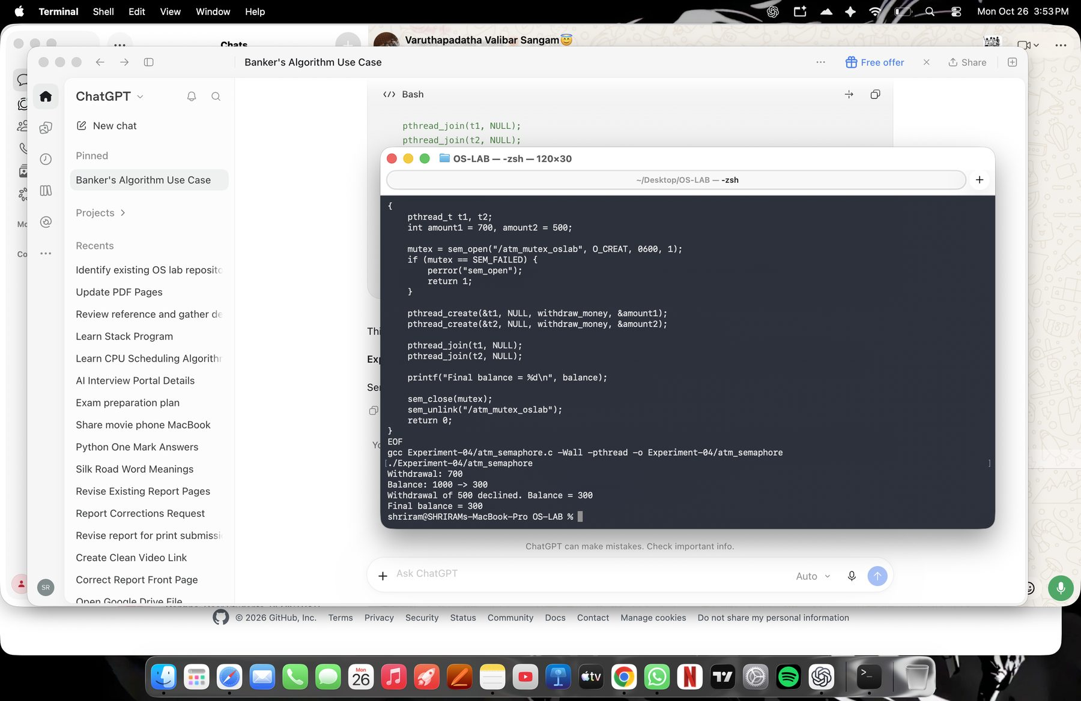
User-supplied Mac Terminal output for the named semaphore run.
Program B: mutex-protected ATM critical section (monitor-style mutual exclusion)
#include <stdio.h>
#include <pthread.h>
#include <unistd.h>
int balance = 10000;
pthread_mutex_t atm_lock;
void *atm_transaction(void *arg)
{
int id = *(int *)arg;
int withdraw = 2000;
pthread_mutex_lock(&atm_lock);
printf("ATM %d accessing account...\n", id);
printf("Current Balance: Rs.%d\n", balance);
if (balance >= withdraw)
{
balance -= withdraw;
printf("ATM %d withdrew Rs.%d\n", id, withdraw);
printf("Remaining Balance: Rs.%d\n\n", balance);
}
else
{
printf("ATM %d: Insufficient Balance\n\n", id);
}
pthread_mutex_unlock(&atm_lock);
return NULL;
}
int main()
{
pthread_t atm1, atm2;
int id1 = 1;
int id2 = 2;
pthread_mutex_init(&atm_lock, NULL);
printf("ATM Machine - Mutual Exclusion\n\n");
pthread_create(&atm1, NULL, atm_transaction, &id1);
pthread_create(&atm2, NULL, atm_transaction, &id2);
pthread_join(atm1, NULL);
pthread_join(atm2, NULL);
printf("Final Account Balance: Rs.%d\n", balance);
pthread_mutex_destroy(&atm_lock);
return 0;
}
MARK ALLOCATION | Allocated: ______ | Awarded: ______
Compile and run: clang Experiment-04/experiment4.c -Wall -Wextra -pthread -o Experiment-04/experiment4 && ./Experiment-04/experiment4
Actual Mac screenshot for the mutex/monitor-style program pending.
Result: The semaphore run allows the 700 withdrawal and declines the 500 withdrawal after the balance falls to 300. The second program protects the balance update with a mutex.

Experiment No. 5 Reader-Writer Problem
Aim: To model readers accessing a shared hospital record and a doctor updating that record.
Theory: The reader-writer problem concerns safe access to shared data when reader operations and writer updates can overlap. A synchronization primitive is needed to prevent data races.
Algorithm:
1. Initialize the shared patient record.
2. Create reader threads that display the current record.
3. Create a writer thread that updates the record.
4. Join every thread and display the observed values.
Program: hospital record reader and writer
#include <stdio.h>
#include <pthread.h>
int record = 0;
void *reader(void *arg)
{
printf("Patient record = %d\n", record);
return NULL;
}
void *writer(void *arg)
{
record++;
printf("Doctor updated record = %d\n", record);
return NULL;
}
int main()
{
pthread_t r1, r2, r3, w;
pthread_create(&r1, NULL, reader, NULL);
pthread_create(&r2, NULL, reader, NULL);
pthread_create(&r3, NULL, reader, NULL);
pthread_create(&w, NULL, writer, NULL);
pthread_join(r1, NULL);
pthread_join(r2, NULL);
pthread_join(r3, NULL);
pthread_join(w, NULL);
return 0;
}
MARK ALLOCATION | Allocated: ______ | Awarded: ______
Compile and run: clang Experiment-05/hospital.c -Wall -Wextra -pthread -o Experiment-05/hospital && ./Experiment-05/hospital
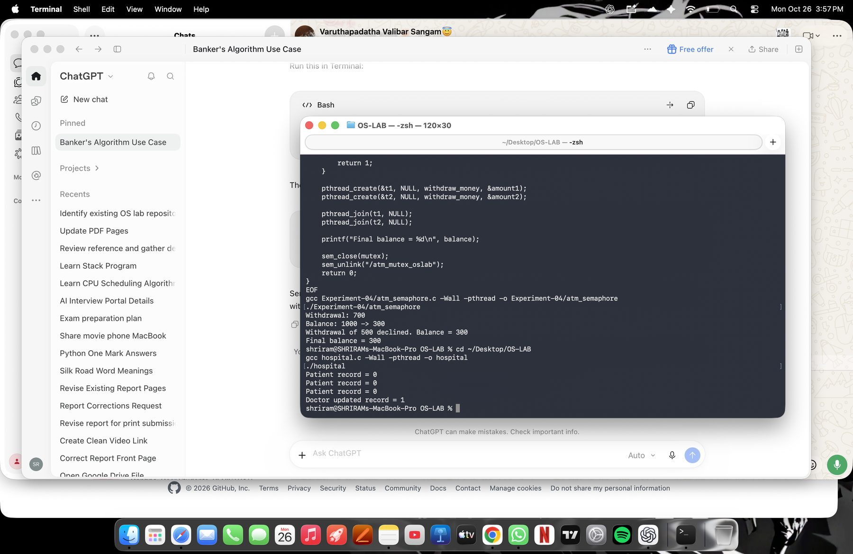
User-supplied Mac Terminal output for the hospital record program.
Implementation note: the supplied hospital.c does not lock the shared record. This screenshot documents the supplied run, but the source does not guarantee race-free reader-writer behavior.
Result: The run displays three reads of record 0 followed by an update to 1. The implementation needs a read-write lock or equivalent before it can be described as race-free.

Experiment No. 6 Dining Philosopher Problem
Aim: To demonstrate concurrent threads representing electric vehicles requesting access to a shared charging resource.
Theory: The dining philosopher problem illustrates contention for shared resources. In this simplified EV example, each thread reports waiting, charging, and releasing the resource.
Algorithm:
1. Create one thread for each of five electric vehicles.
2. Each thread prints its waiting, charging, and release messages.
3. Join all five threads before exiting.
Program: EV charging station thread demonstration
#include <stdio.h>
#include <pthread.h>
void *charging(void *arg)
{
int ev = *(int *)arg;
printf("EV %d waiting for charging connectors\n", ev);
printf("EV %d is charging\n", ev);
printf("EV %d finished charging and released connectors\n", ev);
return NULL;
}
int main()
{
pthread_t t[5];
int ev[5];
printf("EV Charging Station Started\n");
for (int i = 0; i < 5; i++)
{
ev[i] = i + 1;
pthread_create(&t[i], NULL, charging, &ev[i]);
}
for (int i = 0; i < 5; i++)
{
pthread_join(t[i], NULL);
}
return 0;
}
MARK ALLOCATION | Allocated: ______ | Awarded: ______
Compile and run: clang Experiment-06/ev.c -Wall -Wextra -pthread -o Experiment-06/ev && ./Experiment-06/ev
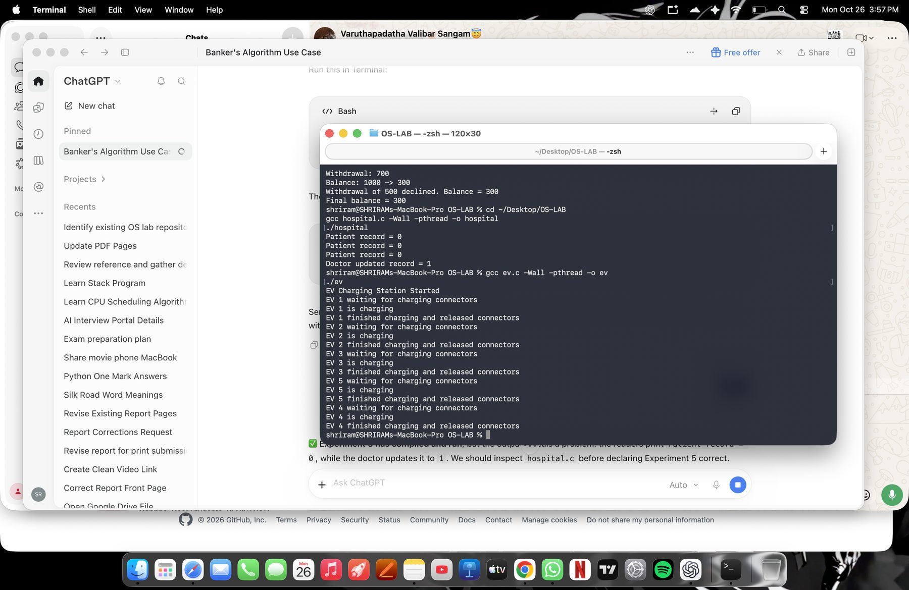
User-supplied Mac Terminal output for the EV thread demonstration.
Implementation note: the supplied ev.c does not use a semaphore or mutex to limit access to charging connectors; it demonstrates thread output but not exclusive resource allocation.
Result: The run shows each EV thread printing a waiting, charging, and release sequence. Connector-capacity synchronization would be needed for a complete resource-contention simulation.

Experiment No. 7 Banker’s Algorithm for Deadlock Avoidance
Aim: To determine whether the configured resource state is safe and print a safe sequence.
Theory: Banker’s Algorithm compares each process’s remaining need with currently available resources. A process that can finish releases its allocated resources for the next process.
Algorithm:
1. Calculate Need = Maximum - Allocation for each process and resource.
2. Copy Available into the Work vector and mark all processes unfinished.
3. Find an unfinished process whose Need is no greater than Work.
4. Assume that process finishes, add its Allocation to Work, and record it in the safe sequence.
5. Repeat until all processes finish or no eligible process remains.
Program: Banker’s safety check
#include <stdio.h>
#include <stdbool.h>
#define P 5
#define R 3
int main(void)
{
int allocation[P][R] = {
{0, 1, 0},
{2, 0, 0},
{3, 0, 2},
{2, 1, 1},
{0, 0, 2}
};
int maximum[P][R] = {
{7, 5, 3},
{3, 2, 2},
{9, 0, 2},
{2, 2, 2},
{4, 3, 3}
};
int available[R] = {3, 3, 2};
int need[P][R];
int work[R];
bool finished[P] = {false};
int safe_sequence[P];
int count = 0;
for (int i = 0; i < P; i++) {
for (int j = 0; j < R; j++) {
need[i][j] = maximum[i][j] - allocation[i][j];
}
}
printf("BANKER'S ALGORITHM\n");
printf("Need Matrix:\n");
printf("Process\tA\tB\tC\n");
for (int i = 0; i < P; i++) {
printf("P%d\t", i);
for (int j = 0; j < R; j++) {
printf("%d\t", need[i][j]);
}
printf("\n");
}
for (int j = 0; j < R; j++) {
work[j] = available[j];
}
while (count < P) {
bool found = false;
for (int i = 0; i < P; i++) {
if (finished[i]) {
continue;
}
bool can_finish = true;
for (int j = 0; j < R; j++) {
if (need[i][j] > work[j]) {
can_finish = false;
break;
}
}
if (can_finish) {
for (int j = 0; j < R; j++) {
work[j] += allocation[i][j];
}
safe_sequence[count++] = i;
finished[i] = true;
found = true;
}
}
if (!found) {
break;
}
}
if (count == P) {
printf("\nSystem is in a SAFE state.\n");
printf("Safe sequence: ");
for (int i = 0; i < P; i++) {
printf("P%d", safe_sequence[i]);
if (i < P - 1) {
printf(" -> ");
}
}
printf("\n");
} else {
printf("\nSystem is in an UNSAFE state.\n");
printf("No safe sequence exists for the given state.\n");
}
return 0;
}
MARK ALLOCATION | Allocated: ______ | Awarded: ______
Compile and run: clang Experiment-07/bankers.c -Wall -Wextra -o Experiment-07/bankers && ./Experiment-07/bankers
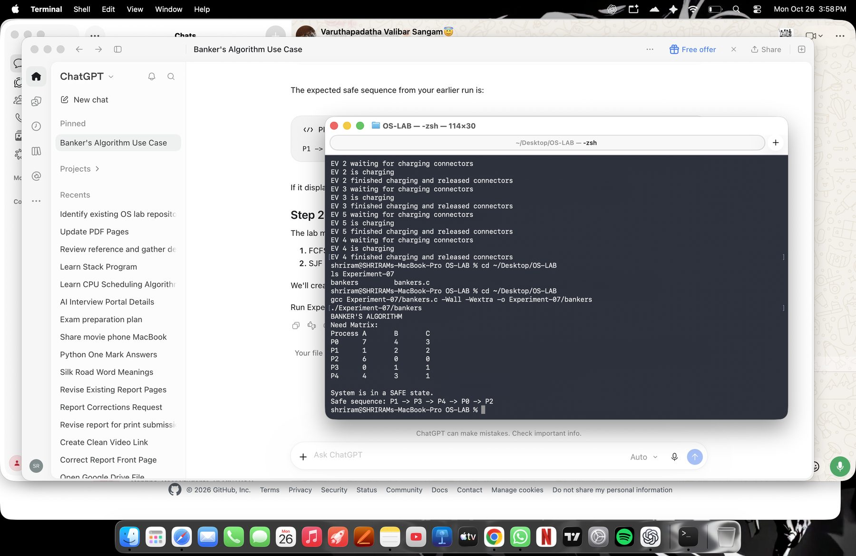
User-supplied Mac Terminal output for Experiment 7.
Result: The displayed state is safe and the program prints a safe execution sequence.

Experiment No. 8 FCFS and SJF Scheduling
Aim: To compare First-Come, First-Served and non-preemptive Shortest Job First scheduling.
Theory: FCFS schedules ready processes by arrival order. Non-preemptive SJF selects the shortest available burst and lets it complete before selecting another process.
Algorithm:
1. Read each process arrival time and burst time.
2. For FCFS, select the earliest arrived ready process.
3. For SJF, select the available process with the shortest burst time.
4. Calculate CT, TAT = CT - AT, and WT = TAT - BT.
5. Display a Gantt chart and average waiting and turnaround times.
Program: combined FCFS and non-preemptive SJF scheduler
#include <stdio.h>
#include <stdbool.h>
#define MAX 20
typedef struct {
int id, at, bt, ct, tat, wt;
} Process;
typedef struct {
int id;
int start, end;
} Segment;
void simulate(Process input[], int n, bool use_sjf)
{
Process p[MAX];
Segment gantt[2 * MAX];
bool done[MAX] = {false};
int count = 0, time = 0, completed = 0;
for (int i = 0; i < n; i++) {
p[i] = input[i];
p[i].ct = p[i].tat = p[i].wt = 0;
}
while (completed < n) {
int chosen = -1;
for (int i = 0; i < n; i++) {
if (done[i] || p[i].at > time)
continue;
if (chosen == -1) {
chosen = i;
} else if (use_sjf) {
if (p[i].bt < p[chosen].bt ||
(p[i].bt == p[chosen].bt &&
p[i].at < p[chosen].at) ||
(p[i].bt == p[chosen].bt &&
p[i].at == p[chosen].at &&
p[i].id < p[chosen].id)) {
chosen = i;
}
} else {
if (p[i].at < p[chosen].at ||
(p[i].at == p[chosen].at &&
p[i].id < p[chosen].id)) {
chosen = i;
}
}
}
if (chosen == -1) {
int next = -1;
for (int i = 0; i < n; i++) {
if (!done[i] &&
(next == -1 || p[i].at < p[next].at))
next = i;
}
if (next == -1)
break;
gantt[count++] = (Segment){0, time, p[next].at};
time = p[next].at;
continue;
}
int start = time;
time += p[chosen].bt;
p[chosen].ct = time;
p[chosen].tat = p[chosen].ct - p[chosen].at;
p[chosen].wt = p[chosen].tat - p[chosen].bt;
gantt[count++] =
(Segment){p[chosen].id, start, time};
done[chosen] = true;
completed++;
}
printf("\n========================================\n");
printf("%s\n", use_sjf
? "SJF (NON-PREEMPTIVE) SCHEDULING"
: "FCFS SCHEDULING");
printf("========================================\n");
printf("\nGantt Chart:\n");
for (int i = 0; i < count; i++) {
if (gantt[i].id == 0)
printf("| IDLE ");
else
printf("| P%d ", gantt[i].id);
}
printf("|\n");
if (count > 0) {
printf("%d", gantt[0].start);
for (int i = 0; i < count; i++)
printf("\t%d", gantt[i].end);
printf("\n");
}
printf("\nPID\tAT\tBT\tCT\tTAT\tWT\n");
double total_tat = 0, total_wt = 0;
for (int i = 0; i < n; i++) {
printf("P%d\t%d\t%d\t%d\t%d\t%d\n",
p[i].id, p[i].at, p[i].bt,
p[i].ct, p[i].tat, p[i].wt);
total_tat += p[i].tat;
total_wt += p[i].wt;
}
printf("\nAverage Turnaround Time = %.2f\n",
total_tat / n);
printf("Average Waiting Time = %.2f\n",
total_wt / n);
}
int main(void)
{
Process p[MAX];
int n;
printf("CPU SCHEDULING: FCFS AND SJF\n");
printf("Enter number of processes (1-%d): ", MAX);
if (scanf("%d", &n) != 1 || n < 1 || n > MAX) {
printf("Invalid number of processes.\n");
return 1;
}
for (int i = 0; i < n; i++) {
p[i].id = i + 1;
printf("Enter arrival time and burst time for P%d: ",
i + 1);
if (scanf("%d %d", &p[i].at, &p[i].bt) != 2 ||
p[i].at < 0 || p[i].bt <= 0) {
printf("Invalid input. AT must be >= 0 and BT > 0.\n");
return 1;
}
}
simulate(p, n, false);
simulate(p, n, true);
return 0;
}
MARK ALLOCATION | Allocated: ______ | Awarded: ______
Compile and run: clang Experiment-08/scheduling.c -Wall -Wextra -o Experiment-08/scheduling && ./Experiment-08/scheduling
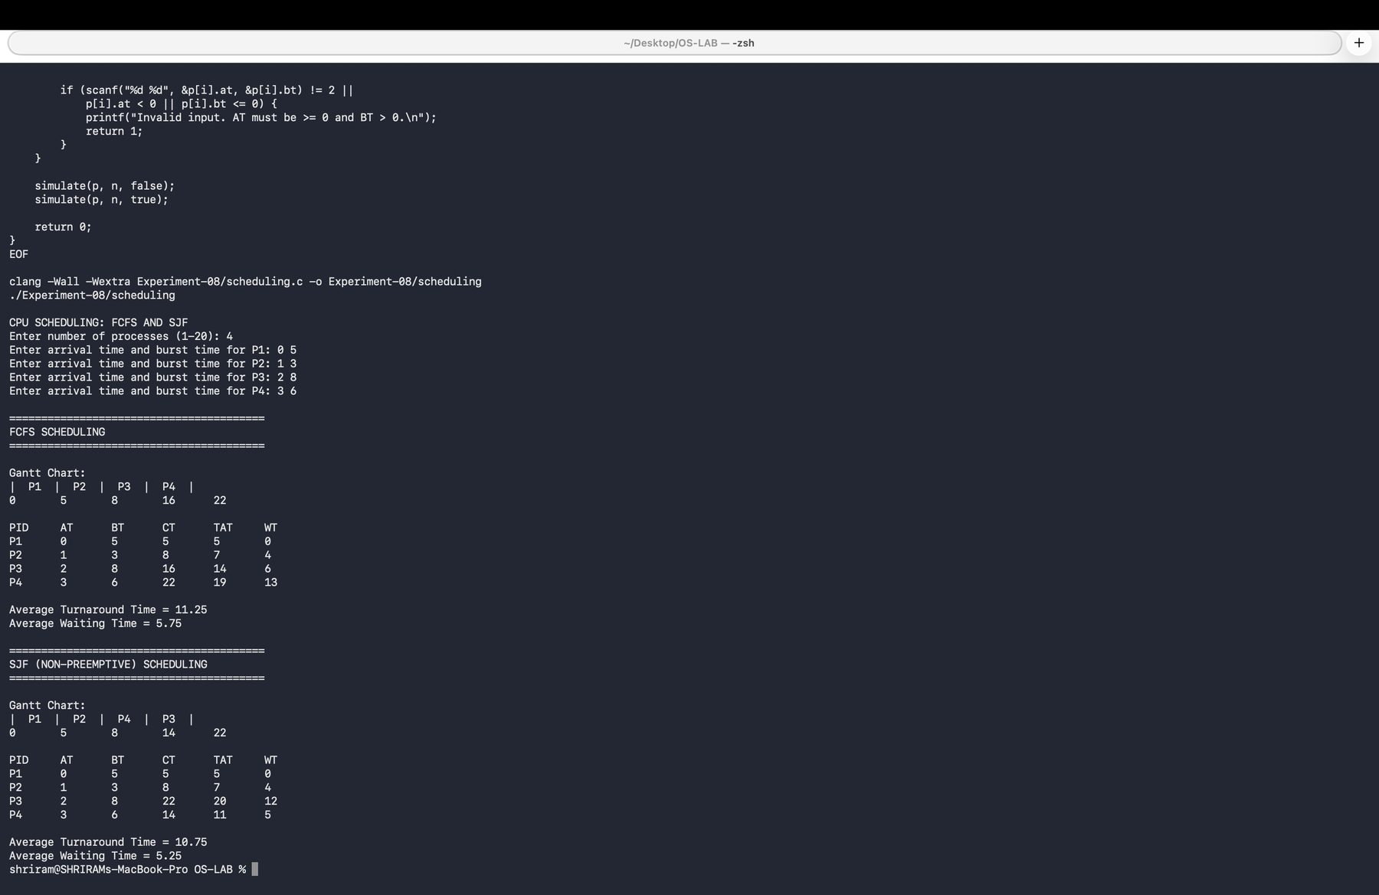
User-supplied Mac Terminal output showing FCFS and SJF results.
Result: The program prints Gantt charts and CT, TAT, and WT values for both scheduling algorithms.

Experiment No. 9 Priority and Round Robin Scheduling
Aim: To implement non-preemptive priority scheduling and preemptive Round Robin scheduling.
Theory: Priority scheduling chooses the ready task with the highest priority (the smaller priority number is higher). Round Robin gives each ready process a fixed time quantum in turn.
Algorithm:
1. For Priority, order tasks by priority and compute completion, turnaround, and waiting times.
2. For Round Robin, place arrived processes in a ready queue.
3. Run each process for at most one quantum and re-queue unfinished work.
4. Calculate and display CT, TAT, WT, execution order, and averages.
Program A: Priority scheduling for the disaster-response control center
#include <stdio.h>
#include <stdlib.h>
#define MAX_PROCESSES 100
typedef struct {
int id, burst, priority, completion, turnaround, waiting;
} Process;
int main(void) {
Process p[MAX_PROCESSES], tmp;
int n, time = 0;
double total_wait = 0, total_turnaround = 0;
puts("Smart Disaster-Response Control Center - Priority Scheduling");
puts("Non-preemptive priority scheduling; smaller number means higher priority.");
printf("Number of emergency tasks (1-%d): ", MAX_PROCESSES);
if (scanf("%d", &n) != 1 || n < 1 || n > MAX_PROCESSES) {
fputs("Invalid task count.\n", stderr); return 1;
}
for (int i = 0; i < n; ++i) {
p[i].id = i + 1;
printf("Task %d burst time and priority: ", i + 1);
if (scanf("%d %d", &p[i].burst, &p[i].priority) != 2 ||
p[i].burst <= 0 || p[i].priority < 0) {
fputs("Burst time must be positive and priority non-negative.\n", stderr); return 1;
}
}
/* Stable ordering: lower priority value first, then input order. */
for (int i = 1; i < n; ++i) {
tmp = p[i]; int j = i;
while (j > 0 && p[j - 1].priority > tmp.priority) { p[j] = p[j - 1]; --j; }
p[j] = tmp;
}
printf("\nExecution order: ");
for (int i = 0; i < n; ++i) {
p[i].completion = (time += p[i].burst);
p[i].turnaround = p[i].completion;
p[i].waiting = p[i].turnaround - p[i].burst;
total_wait += p[i].waiting; total_turnaround += p[i].turnaround;
printf("P%d%s", p[i].id, i == n - 1 ? "\n" : " -> ");
}
puts("\nProcess\tPriority\tBT\tCT\tTAT\tWT");
for (int i = 0; i < n; ++i)
printf("P%d\t%d\t\t%d\t%d\t%d\t%d\n", p[i].id, p[i].priority,
p[i].burst, p[i].completion, p[i].turnaround, p[i].waiting);
printf("Average turnaround time = %.2f\nAverage waiting time = %.2f\n",
total_turnaround / n, total_wait / n);
return 0;
}
MARK ALLOCATION | Allocated: ______ | Awarded: ______
Compile and run: clang Experiment-09/priority.c -Wall -Wextra -Wpedantic -o Experiment-09/priority && ./Experiment-09/priority
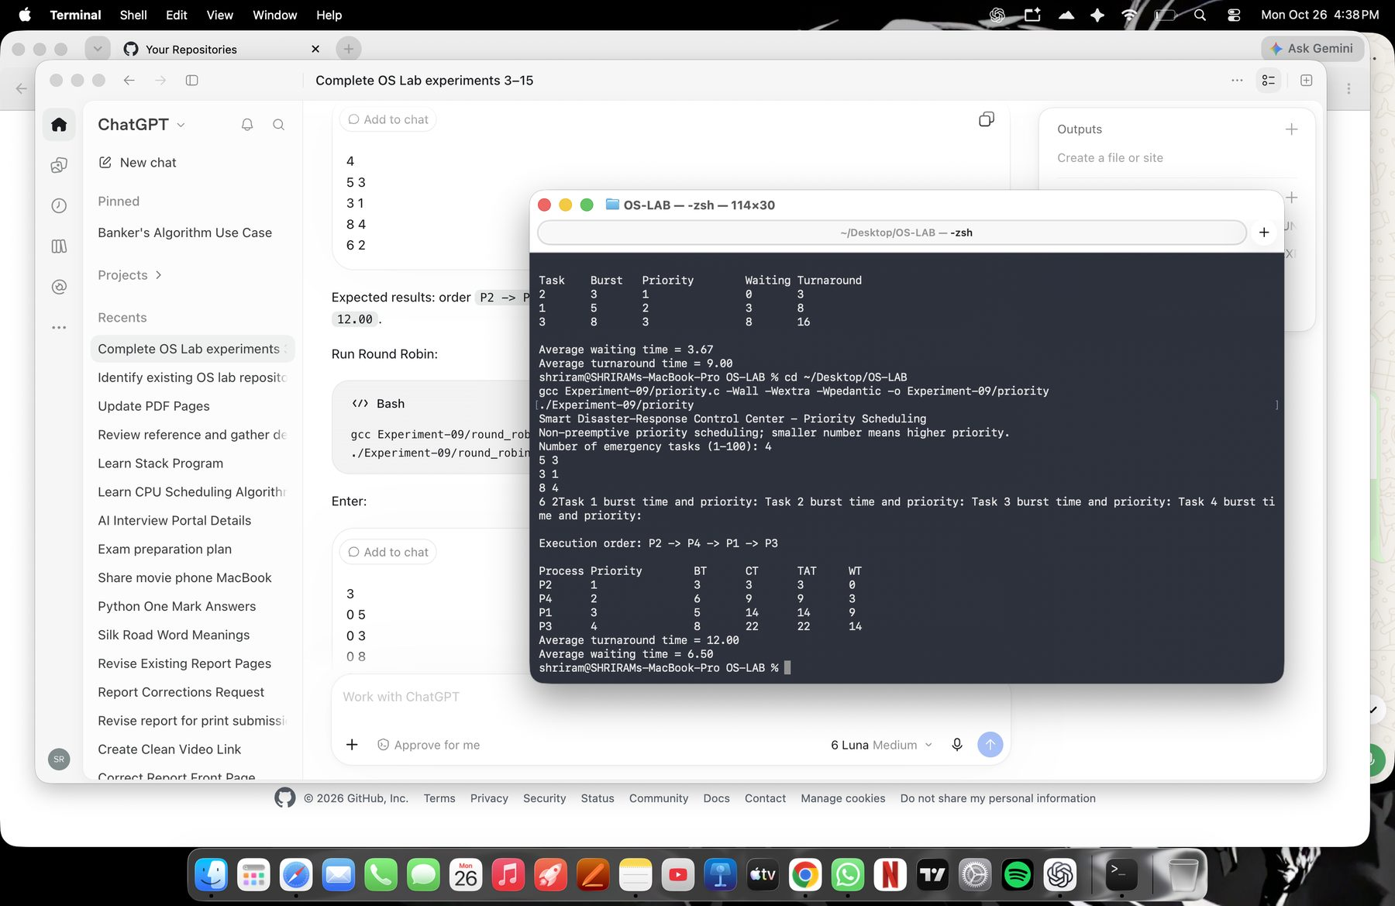
User-supplied Mac Terminal output for Priority Scheduling.
Program B: Round Robin for a virtual production render scheduler
#include <stdio.h>
#include <stdlib.h>
#define MAX_PROCESSES 100
typedef struct { int id, arrival, burst, remaining, completion; } Process;
int main(void) {
Process p[MAX_PROCESSES];
int n, quantum, done = 0, time = 0, queue[MAX_PROCESSES + 1];
int front = 0, back = 0, size = 0, queued[MAX_PROCESSES] = {0};
double total_wait = 0, total_turnaround = 0;
puts("Virtual Production Render Scheduler - Round Robin");
printf("Number of rendering jobs (1-%d): ", MAX_PROCESSES);
if (scanf("%d", &n) != 1 || n < 1 || n > MAX_PROCESSES) {
fputs("Invalid job count.\n", stderr); return 1;
}
for (int i = 0; i < n; ++i) {
p[i].id = i + 1;
printf("Job %d arrival time and burst time: ", i + 1);
if (scanf("%d %d", &p[i].arrival, &p[i].burst) != 2 ||
p[i].arrival < 0 || p[i].burst <= 0) {
fputs("Arrival must be non-negative and burst time positive.\n", stderr); return 1;
}
p[i].remaining = p[i].burst;
}
printf("Time quantum: ");
if (scanf("%d", &quantum) != 1 || quantum <= 0) {
fputs("Time quantum must be positive.\n", stderr); return 1;
}
/* Advance time across idle gaps; newly arrived jobs join the FIFO ready queue. */
printf("\nExecution order (time slices):\n");
while (done < n) {
for (int i = 0; i < n; ++i)
if (!queued[i] && p[i].remaining > 0 && p[i].arrival <= time) {
queue[back] = i; back = (back + 1) % (MAX_PROCESSES + 1);
++size; queued[i] = 1;
}
if (size == 0) {
int next = -1;
for (int i = 0; i < n; ++i)
if (p[i].remaining > 0 && (next < 0 || p[i].arrival < p[next].arrival)) next = i;
if (next < 0) break;
time = p[next].arrival;
continue;
}
int i = queue[front]; front = (front + 1) % (MAX_PROCESSES + 1);
--size; queued[i] = 0;
int run = p[i].remaining < quantum ? p[i].remaining : quantum;
int start = time; time += run; p[i].remaining -= run;
printf("P%d: %d-%d\n", p[i].id, start, time);
for (int j = 0; j < n; ++j)
if (j != i && !queued[j] && p[j].remaining > 0 && p[j].arrival <= time) {
queue[back] = j; back = (back + 1) % (MAX_PROCESSES + 1);
++size; queued[j] = 1;
}
if (p[i].remaining > 0) {
queue[back] = i; back = (back + 1) % (MAX_PROCESSES + 1);
++size; queued[i] = 1;
}
else { p[i].completion = time; ++done; }
}
puts("\nProcess\tAT\tBT\tCT\tTAT\tWT");
for (int i = 0; i < n; ++i) {
int tat = p[i].completion - p[i].arrival;
int wt = tat - p[i].burst;
total_turnaround += tat; total_wait += wt;
printf("P%d\t%d\t%d\t%d\t%d\t%d\n", p[i].id, p[i].arrival,
p[i].burst, p[i].completion, tat, wt);
}
printf("Average turnaround time = %.2f\nAverage waiting time = %.2f\n",
total_turnaround / n, total_wait / n);
return 0;
}
MARK ALLOCATION | Allocated: ______ | Awarded: ______
Compile and run: clang Experiment-09/round_robin.c -Wall -Wextra -Wpedantic -o Experiment-09/round_robin && ./Experiment-09/round_robin
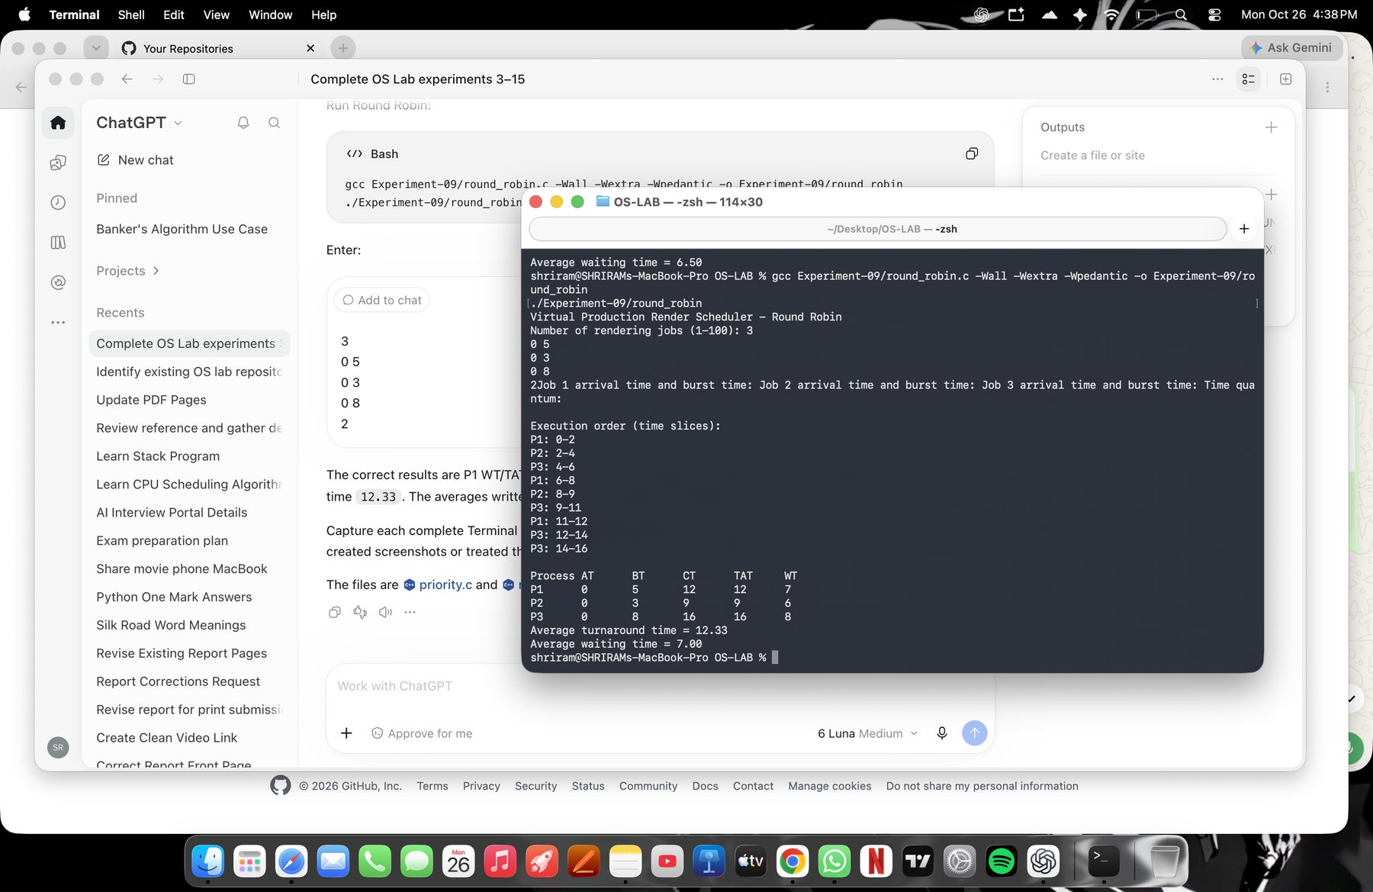
User-supplied Mac Terminal output for Round Robin Scheduling.
Result: Priority order is P2 → P4 → P1 → P3 for the captured example. Round Robin produces the captured time-slice schedule and averages.

Experiment No. 10 FIFO Page Replacement Algorithm
Aim: To implement First-In, First-Out page replacement.
Theory: FIFO replaces the page that has remained in memory the longest. A page hit leaves the frame set unchanged; a page fault loads the new page and may evict the oldest resident page.
Algorithm:
1. Read the page-reference string and frame count.
2. For each page, detect a hit or replace the oldest resident page.
3. Display the frame contents and status after each reference.
4. Count and report page faults and hits.
Program: FIFO page replacement for a genome-sequencing data buffer
#include <stdio.h>
#include <stdlib.h>
#define MAX_PAGES 1000
#define MAX_FRAMES 100
int main(void) {
int pages[MAX_PAGES], frames[MAX_FRAMES], n, count, faults = 0, next = 0;
puts("Genome Sequencing Data Buffer - FIFO Page Replacement");
printf("Number of page references (1-%d): ", MAX_PAGES);
if (scanf("%d", &n) != 1 || n < 1 || n > MAX_PAGES) { fputs("Invalid reference count.\n", stderr); return 1; }
printf("Number of frames (1-%d): ", MAX_FRAMES);
if (scanf("%d", &count) != 1 || count < 1 || count > MAX_FRAMES) { fputs("Invalid frame count.\n", stderr); return 1; }
printf("Enter %d page numbers: ", n);
for (int i = 0; i < n; ++i) if (scanf("%d", &pages[i]) != 1 || pages[i] < 0) { fputs("Page numbers must be non-negative integers.\n", stderr); return 1; }
for (int i = 0; i < count; ++i) frames[i] = -1;
puts("\nPage\tFrames\t\tStatus");
for (int i = 0; i < n; ++i) {
int hit = 0;
for (int j = 0; j < count; ++j) if (frames[j] == pages[i]) hit = 1;
if (!hit) { frames[next] = pages[i]; next = (next + 1) % count; ++faults; }
printf("%d\t", pages[i]);
for (int j = 0; j < count; ++j) {
if (frames[j] < 0) printf("- ");
else printf("%d ", frames[j]);
}
printf("\t%s\n", hit ? "HIT" : "FAULT");
}
printf("\nTotal page faults = %d\nTotal page hits = %d\n", faults, n - faults);
return 0;
}
MARK ALLOCATION | Allocated: ______ | Awarded: ______
Compile and run: clang Experiment-10/fifo.c -Wall -Wextra -Wpedantic -o Experiment-10/fifo && ./Experiment-10/fifo
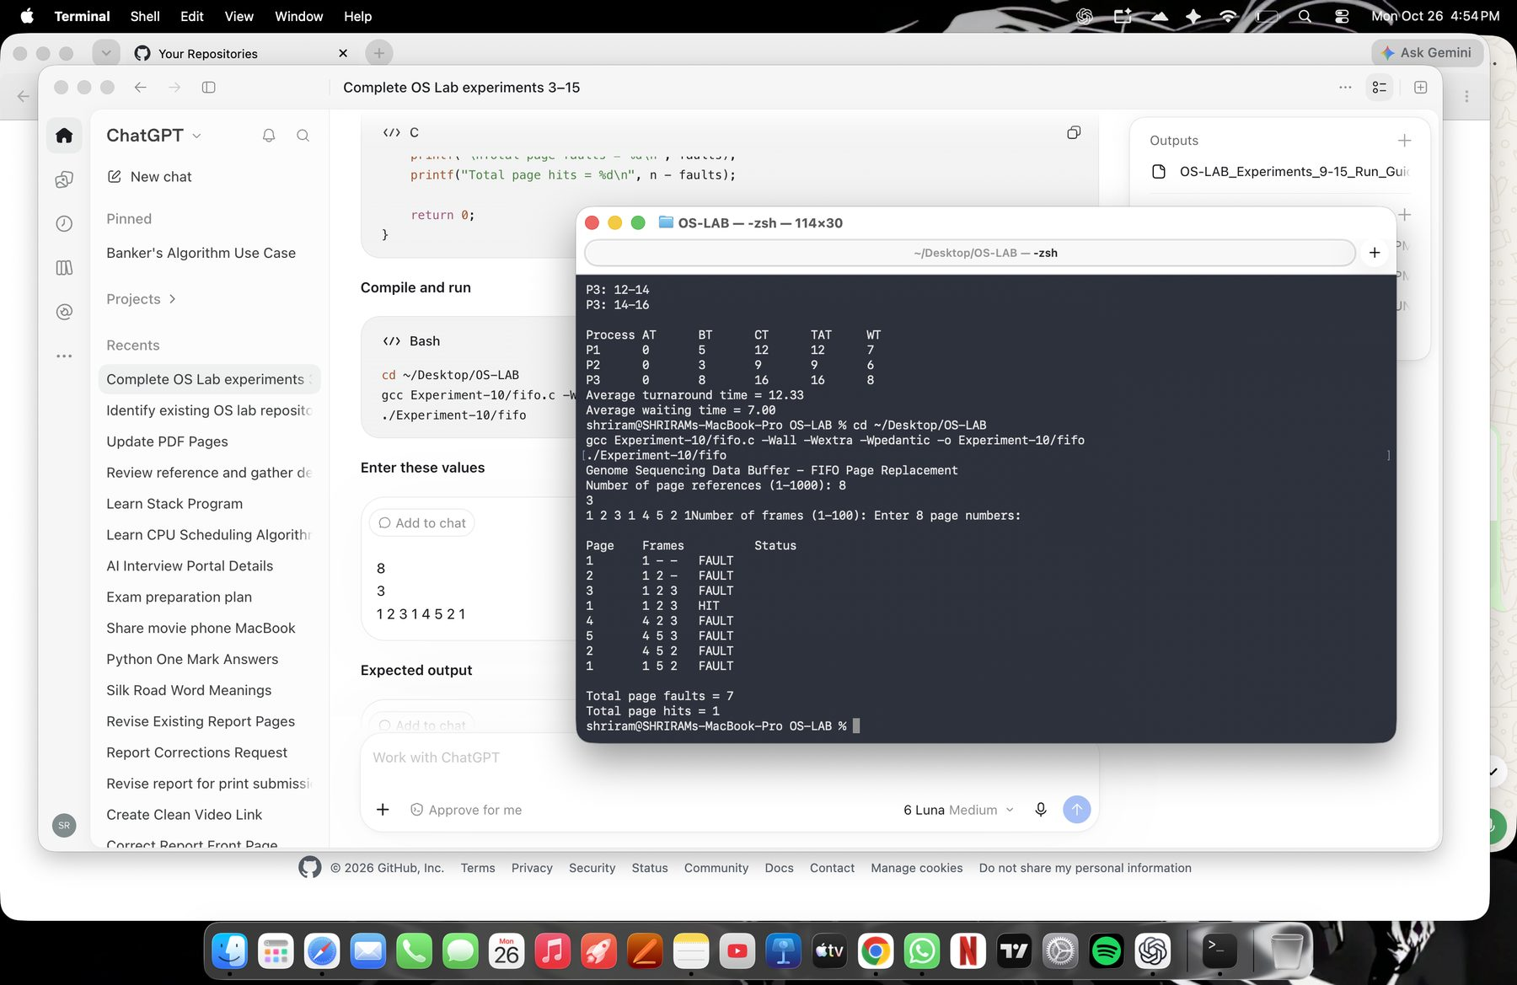
User-supplied Mac Terminal output for FIFO page replacement.
Result: For 3 frames and references 1 2 3 1 4 5 2 1, FIFO reports 7 page faults and 1 hit.

Experiment No. 11 LRU and LFU Page Replacement Algorithm
Aim: To compare Least Recently Used and Least Frequently Used page replacement.
Theory: LRU evicts the resident page used least recently. LFU evicts the resident page with the lowest reference frequency; equal-frequency ties are resolved by least-recent use.
Algorithm:
1. Read the frame count and page-reference string.
2. Update recency on every reference; update frequency for LFU.
3. On a fault with full frames, evict according to LRU or LFU policy.
4. Display each frame state and total faults and hits.
Program A: LRU cache for a satellite image-processing pipeline
#!/usr/bin/env python3
"""LRU page replacement; least-recently-used resident page is evicted."""
def main():
capacity = int(input("Number of frames: "))
refs = list(map(int, input("Page reference string (space-separated): ").split()))
if capacity <= 0 or not refs or any(x < 0 for x in refs):
raise SystemExit("Frames must be positive and references non-negative.")
frames, last_used, faults = [], {}, 0
print("Page\tFrames\t\tStatus")
for t, page in enumerate(refs):
if page in frames:
status = "HIT"
else:
status, faults = "FAULT", faults + 1
if len(frames) < capacity:
frames.append(page)
else:
victim = min(frames, key=lambda x: last_used[x])
frames[frames.index(victim)] = page
last_used[page] = t
print(f"{page}\t{' '.join(map(str, frames)):<16}\t{status}")
print(f"Total page faults = {faults}\nTotal page hits = {len(refs) - faults}")
if __name__ == "__main__":
main()
MARK ALLOCATION | Allocated: ______ | Awarded: ______
Compile and run: python3 Experiment-11/lru.py
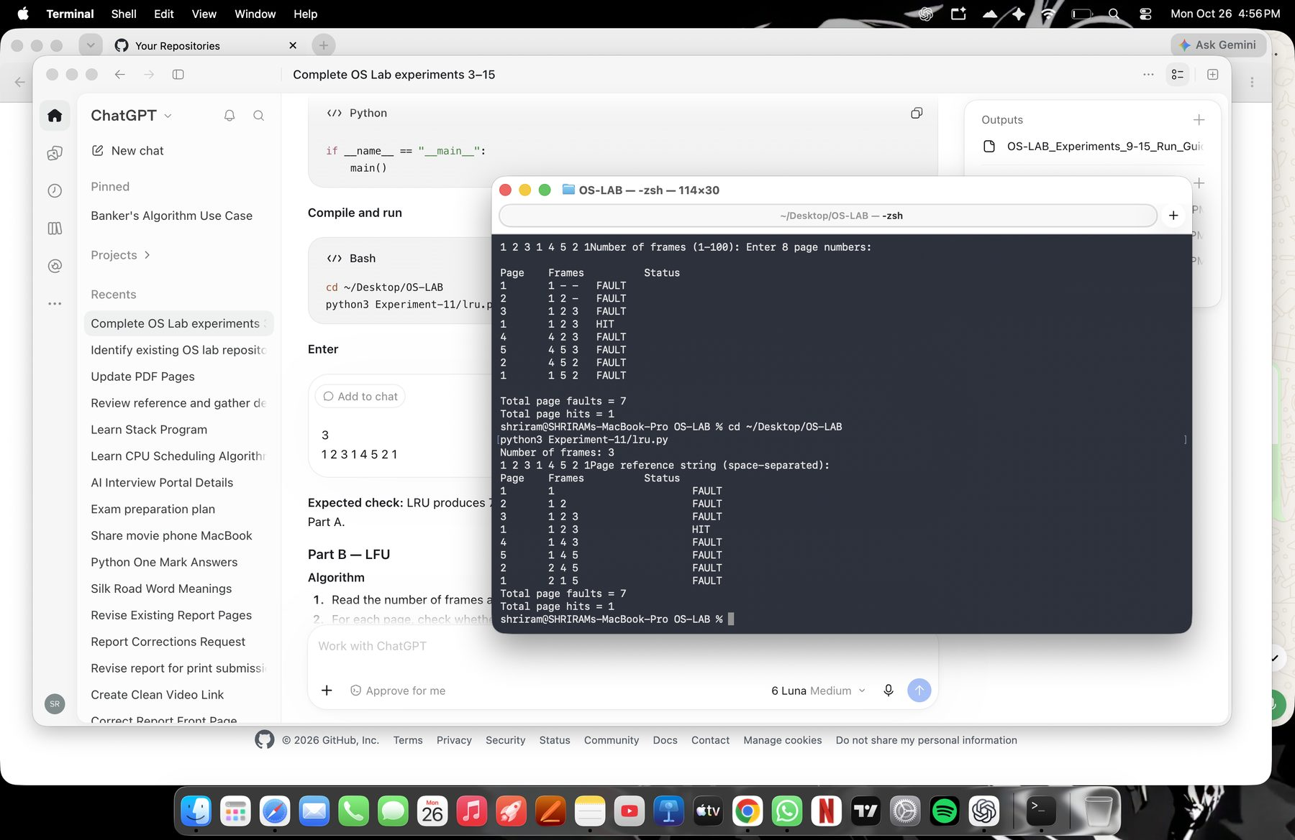
User-supplied Mac Terminal output for LRU.
Program B: LFU cache with least-recently-used tie breaking
#!/usr/bin/env python3
"""LFU page replacement; equal frequencies are broken by least recent use."""
def main():
capacity = int(input("Number of frames: "))
refs = list(map(int, input("Page reference string (space-separated): ").split()))
if capacity <= 0 or not refs or any(x < 0 for x in refs):
raise SystemExit("Frames must be positive and references non-negative.")
frames, frequency, last_used, faults = [], {}, {}, 0
print("Page\tFrames\t\tStatus")
for t, page in enumerate(refs):
if page in frames:
frequency[page] += 1
last_used[page] = t
status = "HIT"
else:
status, faults = "FAULT", faults + 1
if len(frames) == capacity:
victim = min(frames, key=lambda x: (frequency[x], last_used[x]))
frames[frames.index(victim)] = page
del frequency[victim]
del last_used[victim]
else:
frames.append(page)
frequency[page], last_used[page] = 1, t
print(f"{page}\t{' '.join(map(str, frames)):<16}\t{status}")
print("Tie rule: among equal-frequency resident pages, evict the least recently used.")
print(f"Total page faults = {faults}\nTotal page hits = {len(refs) - faults}")
if __name__ == "__main__":
main()
MARK ALLOCATION | Allocated: ______ | Awarded: ______
Compile and run: python3 Experiment-11/lfu.py
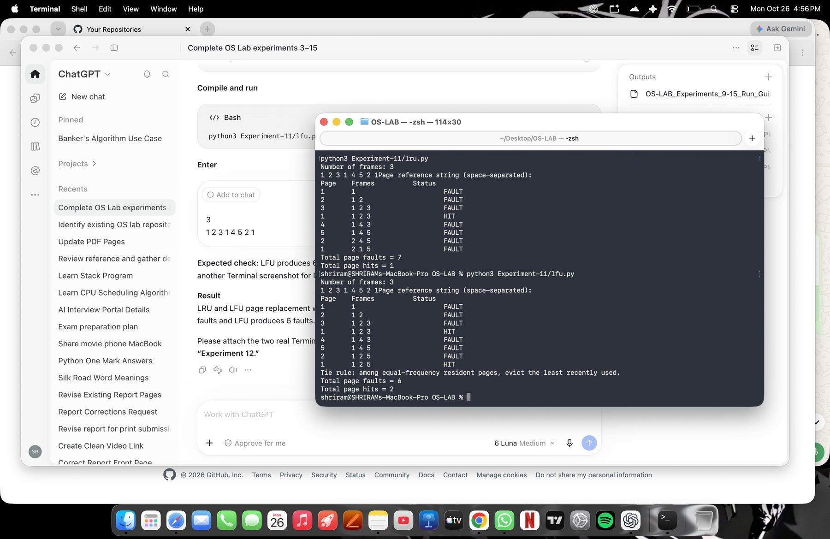
User-supplied Mac Terminal output for LFU.
Result: For the captured reference string, LRU reports 7 faults and 1 hit; LFU reports 6 faults and 2 hits.

Experiment No. 12 Best Fit and Worst Fit Memory Management Policies
Aim: To allocate processes using Best Fit and Worst Fit policies.
Theory: Best Fit selects the smallest available block large enough for a process. Worst Fit selects the largest suitable block. The programs treat leftover space as a variable-sized free region available to later processes.
Algorithm:
1. Read the memory block sizes and process sizes.
2. For each process, choose the smallest fitting block for Best Fit or largest fitting block for Worst Fit.
3. Reduce the selected block by the process size.
4. Report allocations, unallocated processes, and remaining space.
Program A: Best Fit hospital emergency application memory allocation
#!/usr/bin/env python3
"""Best Fit allocation. A block's remainder can be used by later processes."""
def allocate(blocks, processes):
remaining = blocks[:]
result = []
for process_id, size in enumerate(processes, 1):
candidates = [i for i, free in enumerate(remaining) if free >= size]
if not candidates:
result.append((process_id, size, None))
continue
# Lowest-index block breaks equal-size ties.
block = min(candidates, key=lambda i: (remaining[i], i))
remaining[block] -= size
result.append((process_id, size, block + 1))
return result, remaining
def read_sizes(prompt):
values = list(map(int, input(prompt).split()))
if not values or any(x <= 0 for x in values):
raise ValueError("Enter one or more positive sizes.")
return values
def main():
print("Hospital Emergency Application Memory Allocation - Best Fit")
try:
blocks = read_sizes("Memory block sizes (space-separated): ")
processes = read_sizes("Process sizes (space-separated): ")
except ValueError as error:
raise SystemExit(str(error))
result, remaining = allocate(blocks, processes)
print("\nProcess\tSize\tAllocated block")
for pid, size, block in result:
print(f"P{pid}\t{size}\t{block if block is not None else 'Not allocated'}")
print("Remaining block space: " + " ".join(f"B{i+1}={x}" for i, x in enumerate(remaining)))
print("Assumption: blocks are variable-sized; each leftover region remains available.")
if __name__ == "__main__":
main()
MARK ALLOCATION | Allocated: ______ | Awarded: ______
Compile and run: python3 Experiment-12/best_fit.py
Verified sample result (Mac screenshot pending):
P1 → B4
P2 → B2
P3 → B3
P4 → B5
Remaining space: B1=100 B2=83 B3=88 B4=88 B5=174
Actual Mac Terminal screenshot for Best Fit pending.
Program B: Worst Fit hospital emergency application memory allocation
#!/usr/bin/env python3
"""Worst Fit allocation. A block's remainder can be used by later processes."""
def allocate(blocks, processes):
remaining = blocks[:]
result = []
for process_id, size in enumerate(processes, 1):
candidates = [i for i, free in enumerate(remaining) if free >= size]
if not candidates:
result.append((process_id, size, None))
continue
# Lowest-index block breaks equal-size ties.
block = max(candidates, key=lambda i: (remaining[i], -i))
remaining[block] -= size
result.append((process_id, size, block + 1))
return result, remaining
def read_sizes(prompt):
values = list(map(int, input(prompt).split()))
if not values or any(x <= 0 for x in values):
raise ValueError("Enter one or more positive sizes.")
return values
def main():
print("Hospital Emergency Application Memory Allocation - Worst Fit")
try:
blocks = read_sizes("Memory block sizes (space-separated): ")
processes = read_sizes("Process sizes (space-separated): ")
except ValueError as error:
raise SystemExit(str(error))
result, remaining = allocate(blocks, processes)
print("\nProcess\tSize\tAllocated block")
for pid, size, block in result:
print(f"P{pid}\t{size}\t{block if block is not None else 'Not allocated'}")
print("Remaining block space: " + " ".join(f"B{i+1}={x}" for i, x in enumerate(remaining)))
print("Assumption: blocks are variable-sized; each leftover region remains available.")
if __name__ == "__main__":
main()
MARK ALLOCATION | Allocated: ______ | Awarded: ______
Compile and run: python3 Experiment-12/worst_fit.py
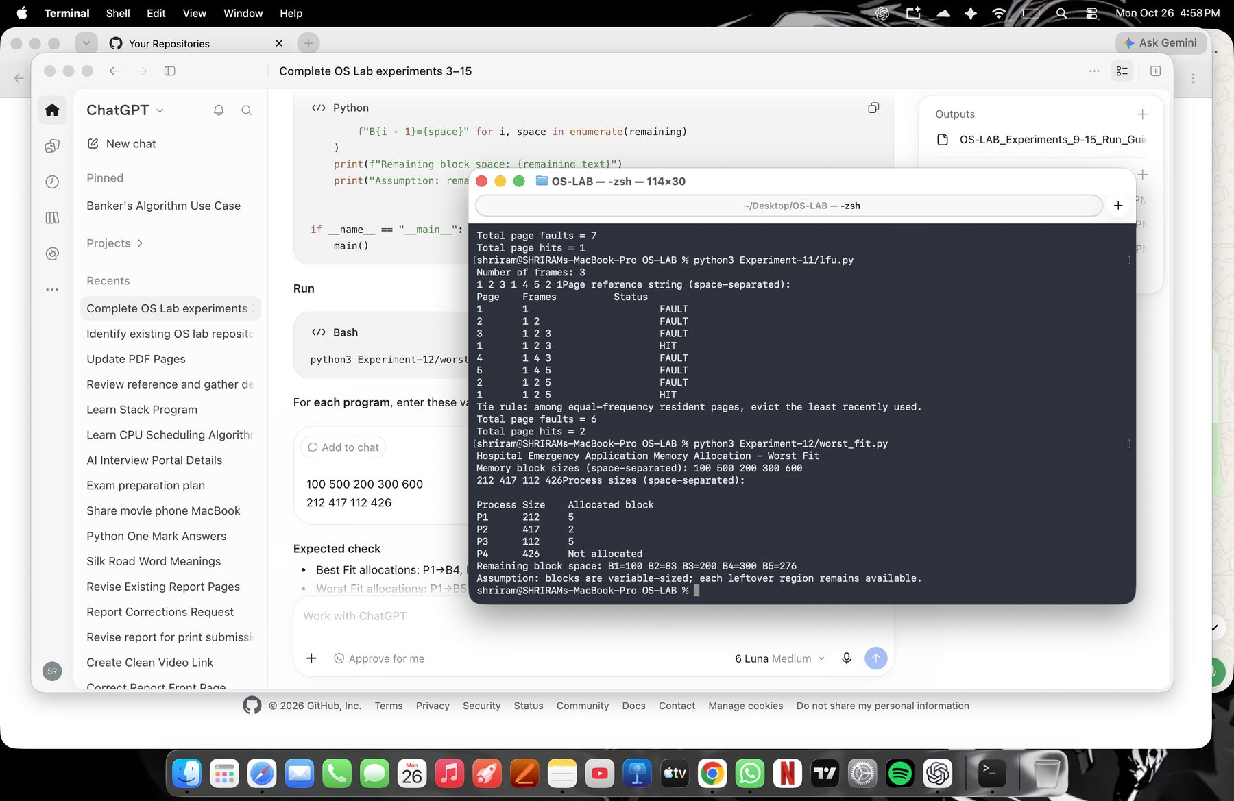
User-supplied Mac Terminal output for Worst Fit.
Result: Best Fit allocates all four sample processes. Worst Fit cannot allocate P4 with the supplied sample sizes.

Experiment No. 13 Disk Scheduling Algorithm
Aim: To compare FCFS, SSTF, SCAN, C-SCAN, LOOK, and C-LOOK disk scheduling using one program.
Theory: Disk scheduling determines the order in which queued cylinder requests are serviced. The program models disk requests for a railway ticket-reservation server; it is an educational simulation, not a booking platform.
Algorithm:
1. Read the algorithm choice, request queue, head position, and cylinder bounds.
2. Read direction for SCAN, C-SCAN, LOOK, and C-LOOK.
3. Generate the service order according to the selected policy.
4. Sum the head movement between visited cylinders and report the average per request.
Program: one menu-driven implementation for all six disk scheduling algorithms
#!/usr/bin/env python3
"""Run one of six disk scheduling algorithms for a railway server example."""
def movement(start, stops):
total = 0
position = start
for stop in stops:
total += abs(stop - position)
position = stop
return total
def schedule(algorithm, requests, head, low, high, direction):
if algorithm == "FCFS":
order = requests[:]
return order, movement(head, order)
if algorithm == "SSTF":
pending, order, position = requests[:], [], head
while pending:
request = min(pending, key=lambda value: (abs(value - position), value))
order.append(request)
pending.remove(request)
position = request
return order, movement(head, order)
at_head = [request for request in requests if request == head]
left = sorted((request for request in requests if request < head), reverse=True)
right = sorted(request for request in requests if request > head)
if algorithm == "SCAN":
if direction == "right":
order = at_head + right + left
route = at_head + right + ([high] if left else []) + left
else:
order = at_head + left + right
route = at_head + left + ([low] if right else []) + right
return order, movement(head, route)
if algorithm == "C-SCAN":
if direction == "right":
order = at_head + right + sorted(left)
route = at_head + right
if left:
route += [high, low] + sorted(left)
else:
order = at_head + left + sorted(right, reverse=True)
route = at_head + left
if right:
route += [low, high] + sorted(right, reverse=True)
return order, movement(head, route)
if algorithm == "LOOK":
order = at_head + (right + left if direction == "right" else left + right)
return order, movement(head, order)
if algorithm == "C-LOOK":
if direction == "right":
order = at_head + right + (sorted(left) if left else [])
else:
order = at_head + left + (sorted(right, reverse=True) if right else [])
return order, movement(head, order)
raise ValueError("Unknown algorithm")
def main():
choices = ("FCFS", "SSTF", "SCAN", "C-SCAN", "LOOK", "C-LOOK")
print("Railway Ticket Reservation Server - Disk Scheduling")
print("Algorithms: FCFS, SSTF, SCAN, C-SCAN, LOOK, C-LOOK")
algorithm = input("Choose algorithm: ").strip().upper()
if algorithm not in choices:
raise SystemExit("Choose one of the listed algorithms.")
try:
requests = list(map(int, input("Disk request queue (space-separated): ").split()))
head = int(input("Initial head position: "))
low = int(input("Lowest cylinder number (inclusive): "))
high = int(input("Highest cylinder number (inclusive): "))
direction = "right"
if algorithm in ("SCAN", "C-SCAN", "LOOK", "C-LOOK"):
direction = input("Initial direction (left/right): ").strip().lower()
except ValueError:
raise SystemExit("Enter integer cylinder numbers.")
if not requests or low >= high or not (low <= head <= high):
raise SystemExit("Enter a non-empty queue, valid bounds, and a head within the bounds.")
if any(request < low or request > high for request in requests):
raise SystemExit("Every request must be within the cylinder bounds.")
if direction not in ("left", "right"):
raise SystemExit("Direction must be left or right.")
order, total = schedule(algorithm, requests, head, low, high, direction)
print(f"\n{algorithm} disk scheduling")
print("Service order: " + " -> ".join(map(str, order)))
print(f"Total head movement = {total} cylinders")
print(f"Average head movement per request = {total / len(requests):.2f} cylinders")
if algorithm in ("SCAN", "C-SCAN"):
print("Direction: " + direction)
if algorithm == "C-SCAN":
print("Circular wrap movement is included in the total.")
if algorithm in ("SCAN", "C-SCAN"):
print("Boundary handling: disk limits are visited when the sweep requires them to reach pending requests.")
if __name__ == "__main__":
main()
MARK ALLOCATION | Allocated: ______ | Awarded: ______
Compile and run: python3 Experiment-13/disk_scheduling.py
Use the request queue 98 183 37 122 14 124 65 67, initial head 53, bounds 0 and 199. Select right as the initial direction for the directional algorithms.
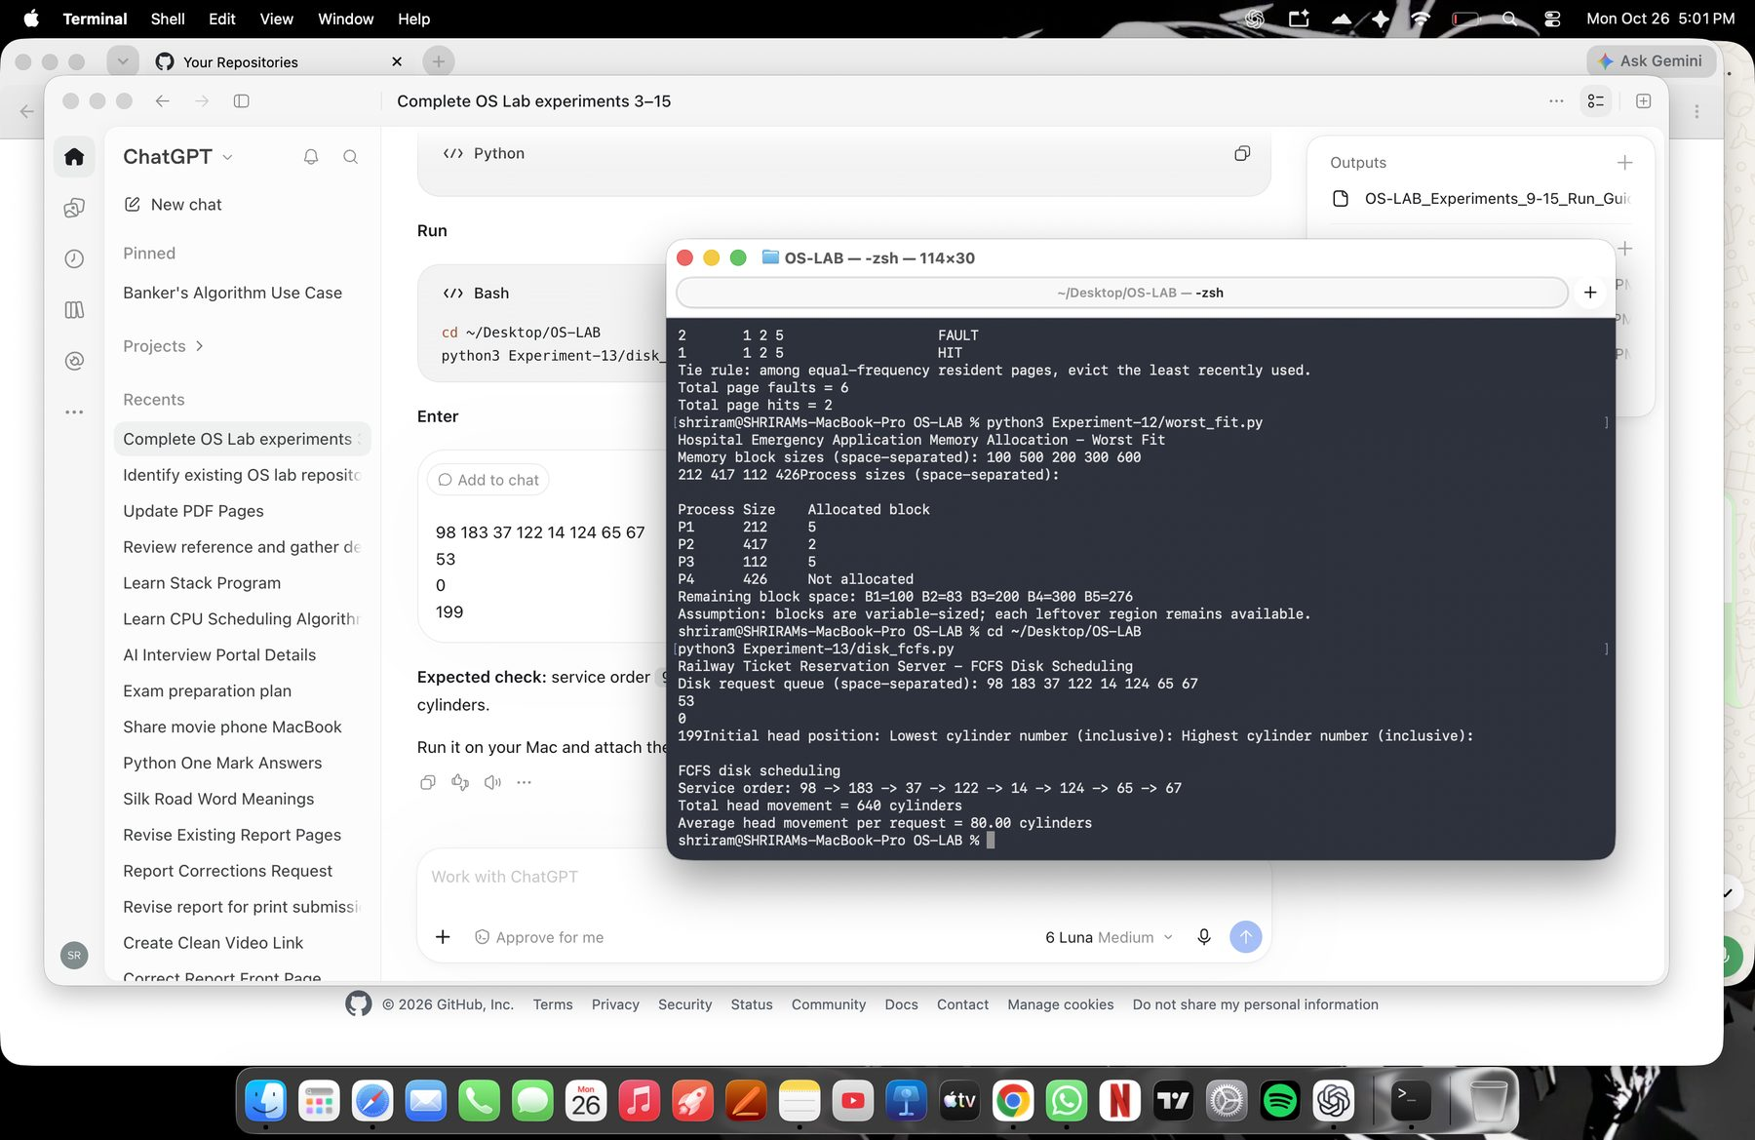
User-supplied terminal output for FCFS using the sample request queue.
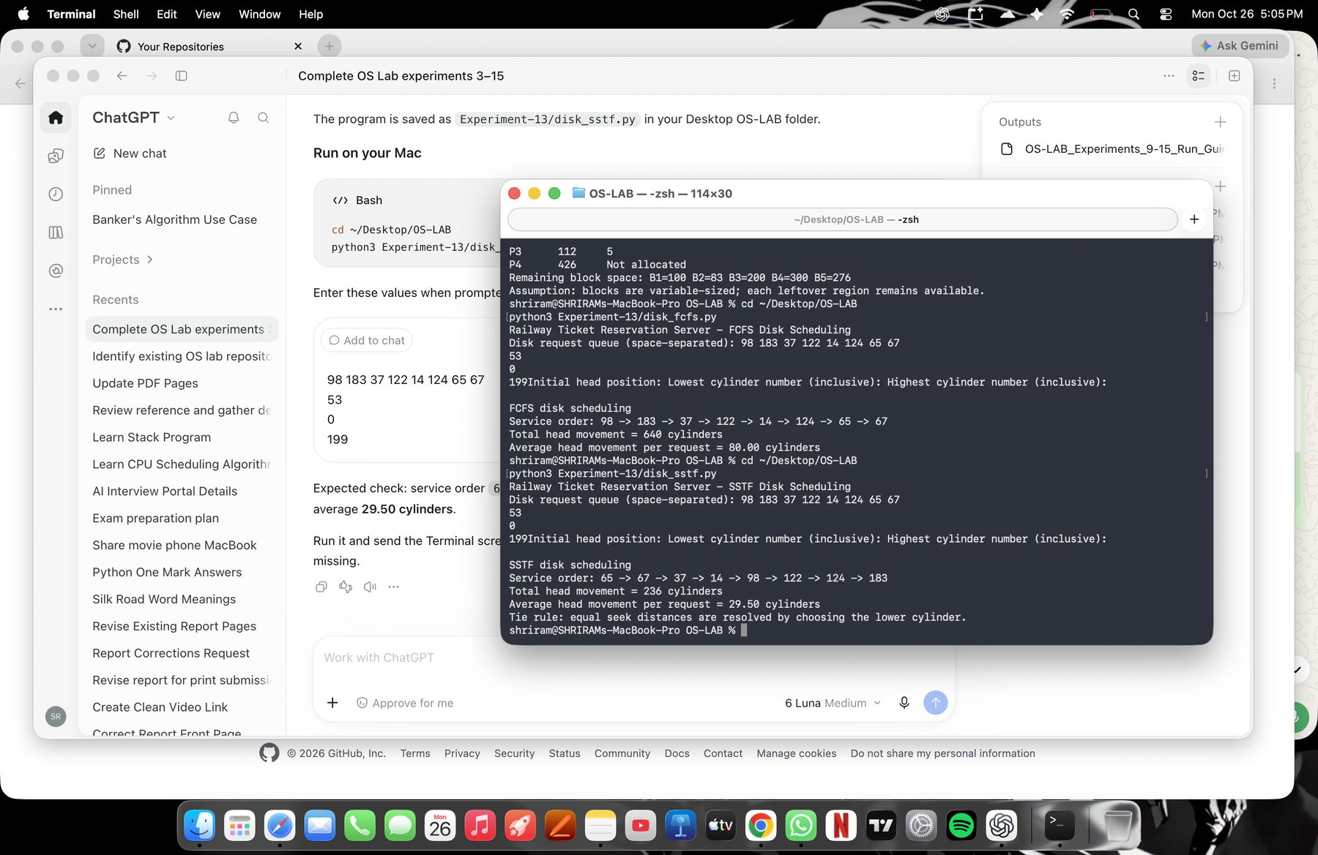
User-supplied terminal output for SSTF using the sample request queue.
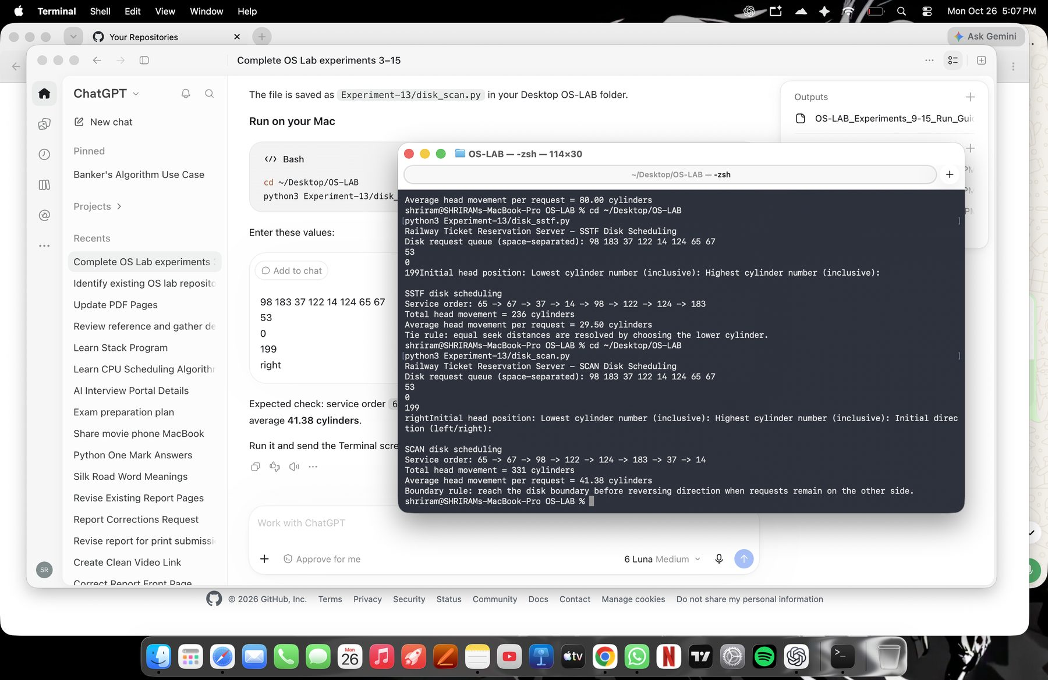
User-supplied terminal output for SCAN using the sample request queue.
Illustrative sample results (these are not Mac screenshots):
Illustrative sample output generated by running the program in the Codex workspace. This is not a screenshot from the student’s Mac.
C-SCAN: 382 cylinders; average 47.75
LOOK: 299 cylinders; average 37.38
C-LOOK: 322 cylinders; average 40.25
Actual Mac Terminal screenshots for C-SCAN, LOOK, and C-LOOK pending.
Result: The single program supports all six algorithms. The three supplied screenshots show FCFS, SSTF, and SCAN results.

Experiment No. 14 Sequential and Indexed File Allocation
Aim: To simulate sequential and indexed file allocation for college examination documents.
Theory: Sequential allocation stores a file in consecutive disk blocks. Indexed allocation stores a file’s data-block addresses in a separate index block. Both programs are in-memory educational simulations.
Algorithm:
1. Sequential: find a contiguous free run large enough for the file and assign those blocks.
2. Indexed: validate a free index block and a list of distinct free data blocks.
3. Display each file and its block mapping.
Program A: sequential allocation
#include <stdio.h>
#include <string.h>
#define TOTAL_BLOCKS 32
#define RESERVED_BLOCKS 8
#define MAX_FILES (TOTAL_BLOCKS - RESERVED_BLOCKS)
typedef struct { char name[20]; int start, size; } File;
int main(void) {
int used[TOTAL_BLOCKS] = {0}, files, size;
File table[MAX_FILES];
for (int b = 0; b < RESERVED_BLOCKS; ++b) used[b] = 1;
puts("College Examination Document Storage - Sequential File Allocation");
printf("Number of files (1-%d): ", MAX_FILES);
if (scanf("%d", &files) != 1 || files < 1 || files > MAX_FILES) { fputs("Invalid file count.\n", stderr); return 1; }
for (int f = 0; f < files; ++f) {
printf("File %d name and required block count: ", f + 1);
if (scanf("%19s %d", table[f].name, &size) != 2 || size <= 0 || size > TOTAL_BLOCKS - RESERVED_BLOCKS) {
fputs("Invalid name or block count.\n", stderr); return 1;
}
int start = -1;
for (int b = RESERVED_BLOCKS; b + size <= TOTAL_BLOCKS; ++b) {
int free_run = 1;
for (int k = b; k < b + size; ++k) if (used[k]) { free_run = 0; break; }
if (free_run) { start = b; break; }
}
if (start < 0) { printf("Insufficient contiguous space for %s.\n", table[f].name); return 1; }
table[f].start = start; table[f].size = size;
for (int k = start; k < start + size; ++k) used[k] = 1;
}
puts("\nFile\tSize\tStarting block\tAllocated blocks");
for (int f = 0; f < files; ++f) {
printf("%s\t%d\t%d\t\t", table[f].name, table[f].size, table[f].start);
for (int k = 0; k < table[f].size; ++k) printf("%d%s", table[f].start + k, k + 1 == table[f].size ? "" : " ");
putchar('\n');
}
puts("Simulation assumption: blocks 0-7 are reserved; each file receives one contiguous run.");
return 0;
}
MARK ALLOCATION | Allocated: ______ | Awarded: ______
Compile and run: clang Experiment-14/sequential_allocation.c -Wall -Wextra -o Experiment-14/sequential_allocation && ./Experiment-14/sequential_allocation
Illustrative output for inputs: 2 files; exam1 needs 3 blocks; exam2 needs 2 blocks.
Illustrative sample output generated by running the program in the Codex workspace. This is not a screenshot from the student’s Mac.
File Size Starting block Allocated blocks
exam1 3 8 8 9 10
exam2 2 11 11 12
Simulation assumption: blocks 0-7 are reserved; each file receives one contiguous run.
Actual Mac Terminal screenshot for sequential allocation pending.
Program B: indexed allocation
#include <iostream>
#include <string>
#include <vector>
int main() {
constexpr int disk_blocks = 12;
std::vector<bool> used(disk_blocks, false);
std::vector<std::string> names;
std::vector<int> indexes;
std::vector<std::vector<int>> data_blocks;
std::cout << "College Examination Document Storage - Indexed File Allocation\n";
int count;
std::cout << "Number of files (1-12): ";
if (!(std::cin >> count) || count < 1 || count > disk_blocks) {
std::cerr << "Invalid file count.\n"; return 1;
}
for (int f = 0; f < count; ++f) {
std::string name; int index, n;
std::cout << "File name, index block, and data-block count: ";
if (!(std::cin >> name >> index >> n) || index < 0 || index >= disk_blocks || n < 1 || n >= disk_blocks) {
std::cerr << "Invalid file details.\n"; return 1;
}
if (used[index]) { std::cerr << "Index block is already allocated.\n"; return 1; }
std::vector<int> blocks(n);
std::cout << "Enter " << n << " data block numbers: ";
for (int &b : blocks) {
if (!(std::cin >> b) || b < 0 || b >= disk_blocks || b == index || used[b]) {
std::cerr << "Data blocks must be valid, free, and different from the index block.\n"; return 1;
}
}
for (int i = 0; i < n; ++i)
for (int j = 0; j < i; ++j)
if (blocks[i] == blocks[j]) { std::cerr << "Duplicate data block in one file.\n"; return 1; }
used[index] = true;
for (int b : blocks) used[b] = true;
names.push_back(name); indexes.push_back(index); data_blocks.push_back(blocks);
}
puts("\nFile\tIndex block\tData blocks");
for (int f = 0; f < count; ++f) {
std::cout << names[f] << '\t' << indexes[f] << "\t\t";
for (std::size_t i = 0; i < data_blocks[f].size(); ++i)
std::cout << data_blocks[f][i] << (i + 1 == data_blocks[f].size() ? "" : " ");
std::cout << '\n';
}
std::cout << "Simulation assumption: each disk block holds one data block or one index block.\n";
return 0;
}
MARK ALLOCATION | Allocated: ______ | Awarded: ______
Compile and run: clang++ Experiment-14/indexed_allocation.cpp -Wall -Wextra -o Experiment-14/indexed_allocation && ./Experiment-14/indexed_allocation
Illustrative output for two files with distinct index and data blocks.
Illustrative sample output generated by running the program in the Codex workspace. This is not a screenshot from the student’s Mac.
File Index block Data blocks
answers 0 1 2 3
timetable 4 5 6
Simulation assumption: each disk block holds one data block or one index block.
Actual Mac Terminal screenshot for indexed allocation pending.
Result: The sample sequential and indexed allocations are valid under the programs’ stated block assumptions.

Experiment No. 15 File Organization Schemes for Single-Level and Two-Level Directory
Aim: To implement single-level and two-level directory organization for student project files.
Theory: A single-level directory stores files in one shared directory. A two-level directory gives each user a separate directory under a master directory. These programs model directory entries in memory and do not modify the host file system.
Algorithm:
1. Single-level: create a directory, add unique file names, list, search, and delete entries.
2. Two-level: create user directories and perform file operations within the selected user directory.
3. Reject duplicate file names within a directory while allowing the same name for different users.
Program A: single-level directory
#include <stdio.h>
#include <string.h>
#define MAX_FILES 100
int main(void) {
char directory[30], files[MAX_FILES][50], name[50];
int count = 0, choice;
printf("College Student Project Management - Single-Level Directory\nDirectory name: ");
if (scanf("%29s", directory) != 1) return 1;
do {
printf("\n1 Add file 2 List files 3 Search 4 Delete 5 Exit\nChoice: ");
if (scanf("%d", &choice) != 1) return 1;
if (choice == 1) {
if (count == MAX_FILES) { puts("Directory is full."); continue; }
printf("File name: "); if (scanf("%49s", name) != 1) return 1;
int duplicate = 0;
for (int i = 0; i < count; ++i) if (strcmp(files[i], name) == 0) duplicate = 1;
if (duplicate) puts("That file name already exists in this directory.");
else { strcpy(files[count++], name); puts("File added."); }
} else if (choice == 2) {
printf("Directory %s files:", directory);
if (!count) printf(" (empty)");
for (int i = 0; i < count; ++i) printf(" %s", files[i]);
putchar('\n');
} else if (choice == 3 || choice == 4) {
printf("File name: "); if (scanf("%49s", name) != 1) return 1;
int found = -1;
for (int i = 0; i < count; ++i) if (strcmp(files[i], name) == 0) { found = i; break; }
if (found < 0) puts("File not found.");
else if (choice == 3) printf("%s is in directory %s at position %d.\n", name, directory, found + 1);
else {
if (found != count - 1) strcpy(files[found], files[count - 1]);
--count; puts("File deleted.");
}
} else if (choice != 5) puts("Invalid choice.");
} while (choice != 5);
return 0;
}
MARK ALLOCATION | Allocated: ______ | Awarded: ______
Compile and run: clang Experiment-15/single_level_directory.c -Wall -Wextra -o Experiment-15/single_level_directory && ./Experiment-15/single_level_directory
Illustrative output for the sample directory operations.
Illustrative sample output generated by running the program in the Codex workspace. This is not a screenshot from the student’s Mac.
Directory projects files: report.pdf code.c
report.pdf is in directory projects at position 1
Actual Mac Terminal screenshot for the single-level directory program pending.
Program B: two-level directory
#include <stdio.h>
#include <string.h>
#define MAX_USERS 20
#define MAX_FILES 50
typedef struct { char name[30]; char files[MAX_FILES][50]; int count; } UserDirectory;
int main(void) {
UserDirectory users[MAX_USERS] = {0};
int user_count = 0, choice;
char user[30], file[50];
puts("College Student Project Management - Two-Level Directory");
do {
printf("\n1 Create user directory 2 Add file 3 List 4 Search 5 Delete file 6 Exit\nChoice: ");
if (scanf("%d", &choice) != 1) return 1;
if (choice == 1) {
if (user_count == MAX_USERS) { puts("Directory table is full."); continue; }
printf("User directory name: "); if (scanf("%29s", user) != 1) return 1;
int duplicate = 0;
for (int i = 0; i < user_count; ++i) if (strcmp(users[i].name, user) == 0) duplicate = 1;
if (duplicate) puts("User directory already exists.");
else { strcpy(users[user_count].name, user); users[user_count++].count = 0; puts("Directory created."); }
} else if (choice >= 2 && choice <= 5) {
printf("User directory: "); if (scanf("%29s", user) != 1) return 1;
int u = -1;
for (int i = 0; i < user_count; ++i) if (strcmp(users[i].name, user) == 0) { u = i; break; }
if (u < 0) { puts("Directory not found."); continue; }
if (choice == 3) {
printf("Files in %s:", user);
if (!users[u].count) printf(" (empty)");
for (int i = 0; i < users[u].count; ++i) printf(" %s", users[u].files[i]);
putchar('\n'); continue;
}
printf("File name: "); if (scanf("%49s", file) != 1) return 1;
int f = -1;
for (int i = 0; i < users[u].count; ++i) if (strcmp(users[u].files[i], file) == 0) { f = i; break; }
if (choice == 2) {
if (users[u].count == MAX_FILES) puts("User directory is full.");
else if (f >= 0) puts("That file already exists for this user.");
else { strcpy(users[u].files[users[u].count++], file); puts("File added."); }
} else if (f < 0) puts("File not found.");
else if (choice == 4) printf("%s/%s exists.\n", user, file);
else {
if (f != users[u].count - 1) strcpy(users[u].files[f], users[u].files[users[u].count - 1]);
--users[u].count; puts("File deleted.");
}
} else if (choice != 6) puts("Invalid choice.");
} while (choice != 6);
return 0;
}
MARK ALLOCATION | Allocated: ______ | Awarded: ______
Compile and run: clang Experiment-15/two_level_directory.c -Wall -Wextra -o Experiment-15/two_level_directory && ./Experiment-15/two_level_directory
Illustrative output showing the same file name in different user directories.
Illustrative sample output generated by running the program in the Codex workspace. This is not a screenshot from the student’s Mac.
Files in alice: project.c
Files in bob: project.c
Actual Mac Terminal screenshot for the two-level directory program pending.
Result: The programs demonstrate directory listing, lookup, and file operations in one-level and two-level in-memory directory models.

Output Evidence Status
Terminal screenshots supplied by the student are reproduced in the report. Generated sample-output text is explicitly marked and is not presented as a Mac screenshot.
Mac screenshots are still needed for the programs listed below. The Experiment 5 and 6 screenshots document the supplied versions; their code notes identify synchronization limits.
Experiment | Program | Evidence status
4 | Mutex / monitor-style ATM program | Mac screenshot pending
12 | Best Fit memory allocation | Mac screenshot pending
13 | C-SCAN disk scheduling | Mac screenshot pending
13 | LOOK disk scheduling | Mac screenshot pending
13 | C-LOOK disk scheduling | Mac screenshot pending
14 | Sequential file allocation | Mac screenshot pending
14 | Indexed file allocation | Mac screenshot pending
15 | Single-level directory | Mac screenshot pending
15 | Two-level directory | Mac screenshot pending

