Machine Maintenance Scheduler (Microservice):
Scenario: In a manufacturing plant, machines require periodic maintenance.

Input: Machine maintenance data
- 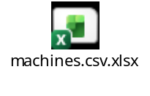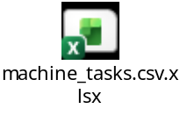

Objective:
Build an e2e maintenance scheduling module that manages maintenance tasks for machines that allow:
- Displays status for any selected machine
- schedule new maintenance tasks for machines
- Query upcoming due tasks
- Update maintenance records

Output:
A robust web application with the above requirements.

Focus Points
- Candidates are encouraged to think beyond the requirements and incorporate additional useful features where and how they see fit.
- Empasis will be placed on out-of-the-box thinking (over the run-of the mill solutions) while developing the application.
- Feel free to create additional (duplicate) data by replicating the current data or generating your own.
- Proper documentation required.
- Emphasize on microservices architecture (with inter-service communication, if required) and API implementation

