  Invention Disclosure Format (IDF)-B | Document No.
 | Issue No/Date
 | Amd. No/Date

1.Title of the invention:

ChronoSched: System and Method for Preemptive CPU Resource Allocation Using Neuro-Symbolic Temporal Dependency Prediction

2.Field / Area of invention:

- Primary Field: Operating Systems and Systems Programming.
- Sub-Fields: CPU Scheduling, Artificial Intelligence (Neuro-Symbolic Logic), Hardware Resource Management.
- Application Area: Desktop/Server OS kernel optimization, heterogeneous computing (big.LITTLE core assignment), cold-start latency reduction for multi-process chains.
- Target Platforms:
• Linux (CFS Scheduler)
• Windows Scheduler
• macOS XNU Scheduler
• ARM big.LITTLE Architecture
• Intel Hybrid CPUs
• Cloud and Virtualized Environments
• Edge Computing Platforms

3.Prior Patents and Publications from literature :
The following table summarizes representative global prior art in CPU scheduling, predictive operating systems, hardware-aware scheduling, dependency graph modeling, and neuro-symbolic reasoning. It highlights the technical limitations of existing approaches and the corresponding improvements introduced by ChronoSched.

Sl. No | Patent / Publication Reference | Current Technique | Technical Limitation | ChronoSched Improvement
1 | Linux Kernel Documentation – Completely Fair Scheduler (CFS) | Fair scheduling using virtual runtime | Cannot predict future process launches | Predicts future dependent processes using temporal dependency graphs
2 | Microsoft Windows Internals (Windows Scheduler) | Dynamic priority scheduling | No cross-session behavioral memory | Learns historical launch sequences across sessions
3 | US 2022/0261661 A1 (Intel) | Hardware-guided job scheduling | Reactive scheduling after workload execution | Assigns P-core/E-core proactively before initialization
4 | US 2022/0164668 A1 (IBM) | Neuro-symbolic safety reasoning | Not designed for CPU scheduling | Applies neuro-symbolic reasoning for scheduler safety decisions
5 | US9710309B2 (Qualcomm/ARM) — "Task scheduling in big and little cores" | Learns, over a task's own repeated executions, which core class it performs best on, applying placement to future runs of the same task. | Learns placement only for a task that has already run before; has no concept of a cross-process dependency graph predicting downstream processes. | Predicts core placement for a dependent process before its first launch in the chain, using cross-process historical relationships, not repeated self-history.
6 | US10,637,787 / US11,121,978 (Time Sensitive Networking scheduler with digital-twin) | Uses a digital twin to simulate a predicted network schedule and verifies it before committing to the physical TSN system. | Confined to TSN packet scheduling; verifies a pre-computed deterministic schedule, not a learned, cross-session probabilistic prediction. | Applies simulate-then-commit verification specifically to OS-level CPU decisions derived from a probabilistic temporal dependency graph and neuro-symbolic gates.

4. Technical Novelty and Inventive Step
Existing predictive schedulers rely solely on statistical prediction or runtime heuristics. Existing neuro-symbolic systems are designed for robotics and autonomous agents rather than operating-system scheduling. The inventive concept is not merely predicting future process launches. The inventive concept is an Adaptive Confidence-Gated Neuro-Symbolic Scheduling Pipeline (ACNSP) that combines (1) temporal dependency learning, (2) confidence estimation, (3) neuro-symbolic verification, (4) digital twin validation, (5) hardware-aware scheduler execution, and (6) adaptive rollback, within a single closed-loop scheduling architecture. The pipeline is formally defined as:
S={Telemetry, Graph, Prediction, Confidence, Verification, Simulation, Execution, Feedback}
The inventive step does not lie in any individual technique in isolation—temporal graph prediction, symbolic safety reasoning, twin-based simulation, and heterogeneous core scheduling each have isolated precedent in other domains. The inventive step lies in their specific integration into a single pipeline in which: (a) a cross-process prediction with an explicit confidence interval is (b) verified twice—first symbolically against hardware safety rules, then empirically via twin simulation—before (c) being committed as a preemptive OS-level scheduling primitive, with (d) the observed outcome feeding back to adjust the confidence for future evaluations. The scheduling decision optimizes a multi-dimensional state:
SchedulerDecision=Optimize(Prediction, Confidence, Hardware, Latency, Power, Safety)

5.Summary and background of the invention:
The novelty of the invention lies not merely in predicting future process launches, but in coupling prediction with confidence-gated neuro-symbolic verification before operating-system resource allocation.
Unlike conventional predictive schedulers that directly execute prediction outputs, the proposed architecture validates every scheduling decision against deterministic hardware safety rules before execution.
Unlike statistical schedulers that optimize only task ordering, ChronoSched predicts future execution states, verifies hardware feasibility, simulates scheduling, executes resource allocation, and continuously learns from execution outcomes. The present invention addresses the fundamental memory-blindness of modern

Operating System (OS) schedulers. Current schedulers treat every process launch as a novel event, forcing dependent processes (e.g., a language server launching after an IDE) to compete for CPU resources from a default state, resulting
in cold-start latency. The invention introduces a preemptive scheduling architecture that constructs a cross-session temporal dependency graph of process launches. Crucially, it utilizes a neuro-symbolic reasoning engine—in the present embodiment, implemented using a generalized annotated logic framework such as PyReason, though the invention is not limited to this specific implementation—to evaluate predictions against strict hardware safety rules. This allows the OS to proactively assign scheduling priority and heterogeneous core affinity (Performance vs. Efficiency cores) before a dependent process signals readiness, strictly bounded by a logical safety net.

6.Working principle of the invention:

The system operates via a continuous, closed-loop telemetry and execution cycle. A lightweight daemon intercepts process launch events and stores them to construct a temporally-weighted dependency graph. Upon a trigger event (e.g., Process A launches), the graph predicts an impending dependent process (Process B). This prediction, carrying a mathematical confidence interval, is passed to a neuro-symbolic engine. The engine evaluates the prediction against explicitly defined hardware state rules. If approved, the system executes OS primitives (nice, sched_setaffinity) to reserve optimal CPU resources for Process B. A rollback monitor tracks the execution; if Process B fails to launch within a calculated time window, the system reverts the OS state and degrades the confidence weight of that graph edge, ensuring adaptive, safe execution.

Each dependency edge maintains
• Historical Frequency
• Average Launch Delay
• Success Rate
• Failure Rate
• Confidence Score

- Confidence(t) = α(Frequency) + β(Recency) + $γ$(PredictionProbability) - $δ$(FailurePenalty) + η(HistoricalReward)
- Confidence(t+1) = Confidence(t) + (Learning Rate x Reward) – (Penalty x Failure)

Decision Rules
Rule 1
IF Memory >90%
Reject Prediction
Rule 2
IF CPU Usage >85%
Reduce Confidence
Rule 3
IF Thermal Throttling
Reject
Rule 4
IF Battery Saver
Assign E Core
Rule 5
IF Latency Critical
Assign P Core

7.Description of the invention in detail -Technical detail:

Stage 1: Telemetry Module: A userspace monitoring component (utilizing eBPF tracing hooks or psutil-based polling) observes process creation and inter-process-communication events via standard operating-system observability interfaces, mapping parent-child and IPC launch relationships with exact timestamps.
Stage 2: Graph Builder: Constructs a dynamic, open-world graph where nodes are distinct process types and edges represent temporal relationships weighted by historical frequency and time-lag.
Stage 3: Neuro-Symbolic Engine: The core reasoning layer utilizing generalized annotated logic. It unifies the probabilistic graph prediction with deterministic safety constraints (e.g., IF memory_pressure > 90% THEN veto action), producing an explainable inference trace.
Stage 4: Scheduler Action Module: Interfaces with the host operating system's native scheduling primitives via standard system calls or platform-equivalent APIs. On Linux, this is realized via nice/renice for

priority and sched_setaffinity() for core affinity against the CFS (Completely Fair Scheduler); on Windows, the equivalent is realized via SetPriorityClass()/SetThreadPriority() and SetProcessAffinityMask() against the Windows Scheduler; on macOS, via equivalent XNU scheduling APIs. Regardless of platform, the module proactively pins the impending process to a Performance (P) or Efficiency (E) core. The allocation is driven by an explicit Optimization Objective function to minimize: $\text{Cold Start Latency}+\text{CPU Migration Cost}+\text{Cache Miss Penalty}+\text{Power Consumption}$, subject to hardware constraints, confidence thresholds, and safety rules. The reasoning engine's inference latency is bounded and measured to remain substantially smaller than the cold-start latency it is designed to eliminate, ensuring the scheduling adjustment completes prior to the impending process's initialization.
Stage 5: Rollback & Negative Learning Monitor: Initiates a timeout window upon primitive execution. If the predicted process does not spawn, it reverts the hardware state and adjusts the specific node's confidence interval downward.
Stage 6: Digital Twin Verification Layer: Before modifying scheduler primitives, a digital twin evaluates the predicted scheduling decision. The twin generates a real-time scheduler snapshot and performs a virtual core assignment to explicitly simulate cache behavior, thermal generation (thermal throttling projections), and memory consumption (page fault probability). Only if this multi-dimensional simulated execution satisfies all timing and hardware constraints are the scheduler primitives committed to the operating system.
Graph Equation
Edge Weight=Frequency × Success Rate × Recency
Confidence=Edge Weight × Prediction Probability

8.Experimental validation results:

Simulation Environment: Ubuntu Linux environment running the ChronoSched background daemon monitoring a developer IDE workflow (VS Code → Pylance).
Experimental Validation Framework (Pending Prototyping): To quantify the technical improvements of the ACNSP architecture over the baseline kernel scheduler, the following metrics establish the targeted benchmark parameters to be empirically measured.

Metric | Before (Standard CFS) | After (ACNSP Active)
Cold Start Latency | To be measured | Target reduction (exceeding inference overhead)
CPU Utilization | To be measured | Target stabilization
Cache Misses | To be measured | Target reduction (via proactive P-Core affinity)
Inference Overhead | N/A | Target strictly bounded overhead
Energy Consumption | To be measured | Target net efficiency gain
Context Switch Rate | To be measured | Target reduction
Prediction Accuracy | N/A | Target > 90% (Post-Learning)
Scheduler Overhead | To be measured | Target net negative overall latency

- Architecture Diagram
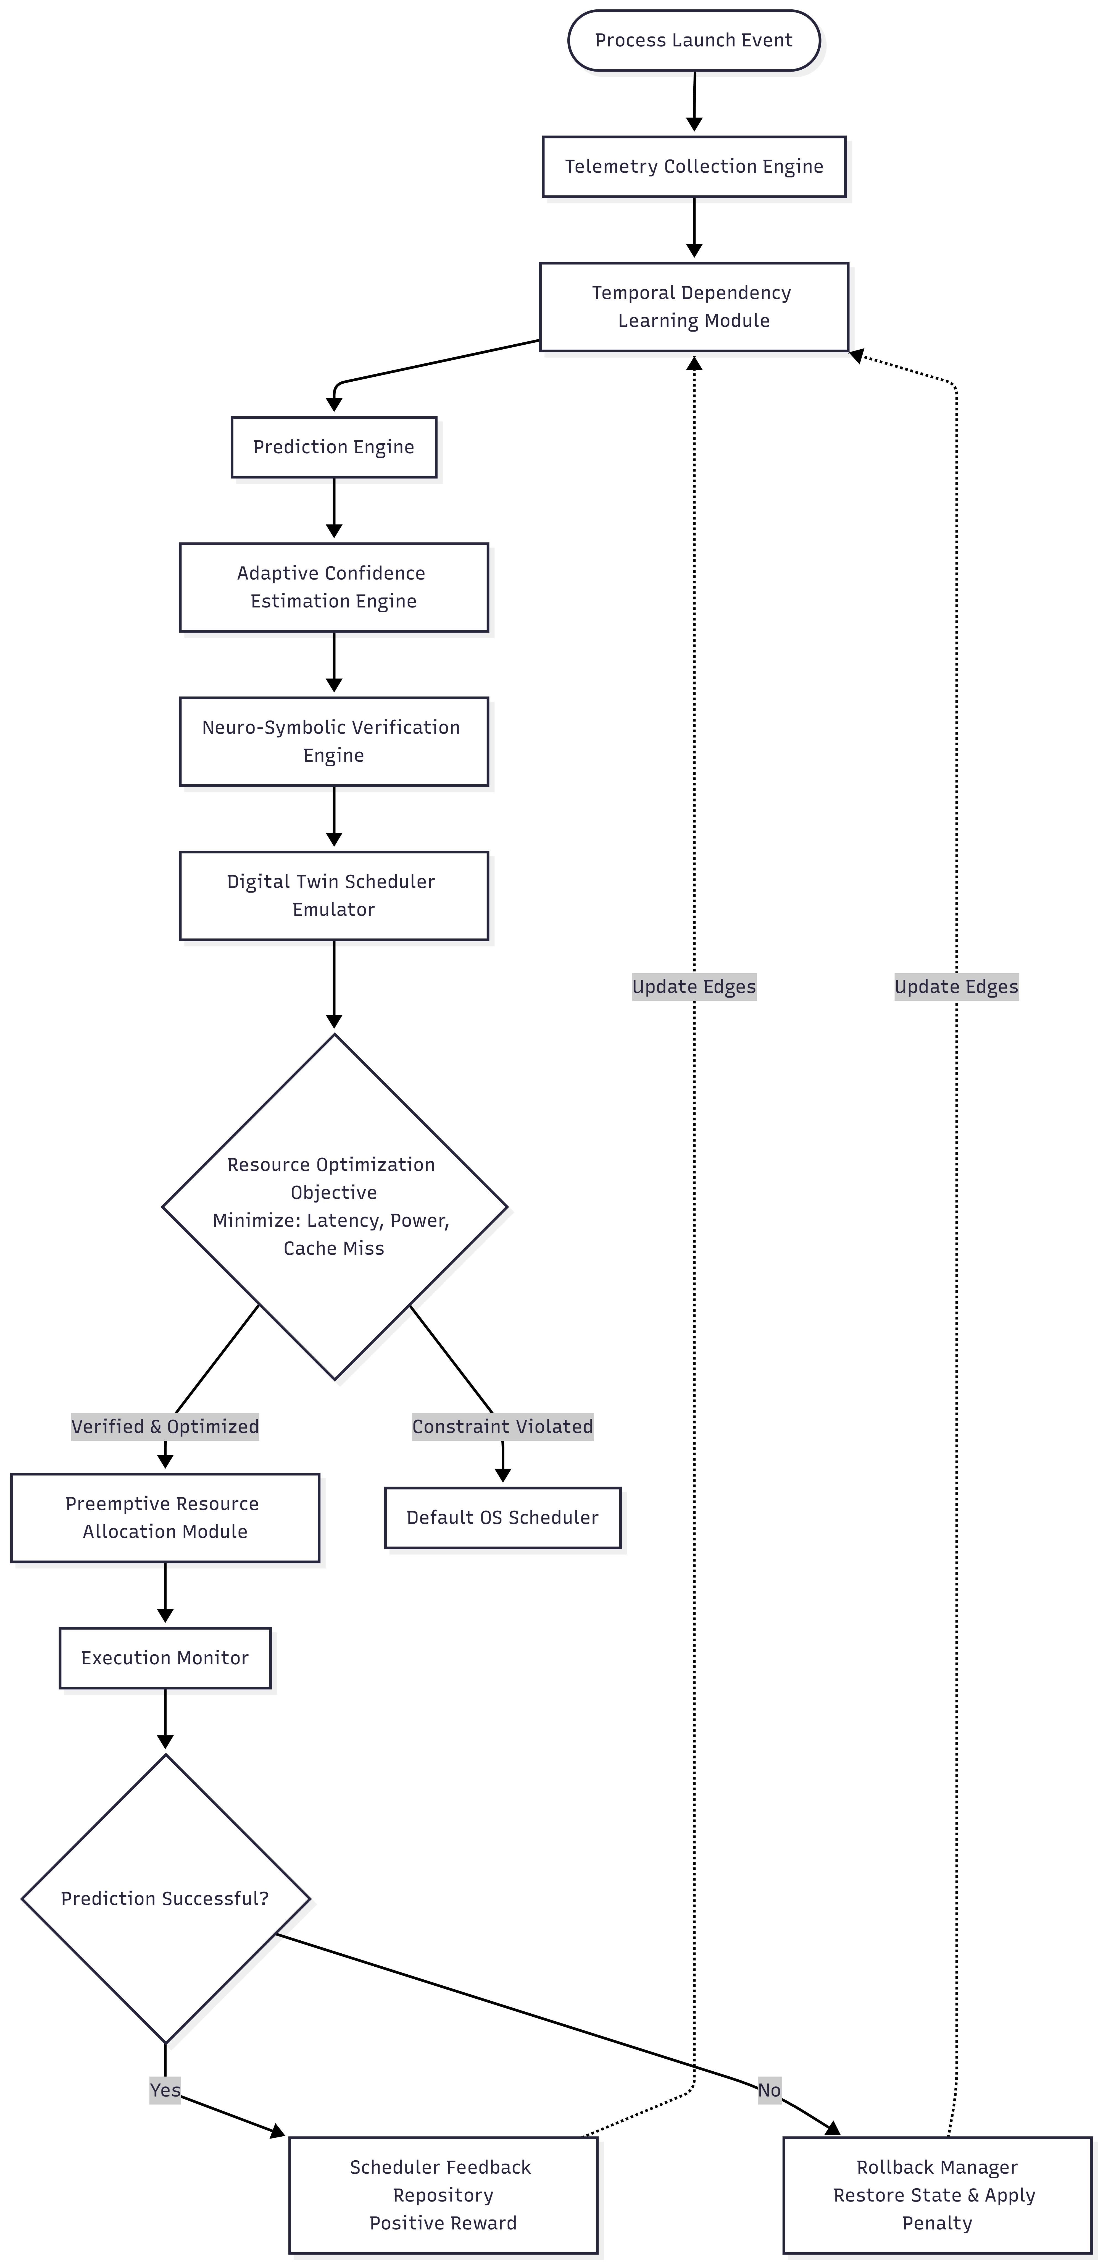
- Pseudo Diagram
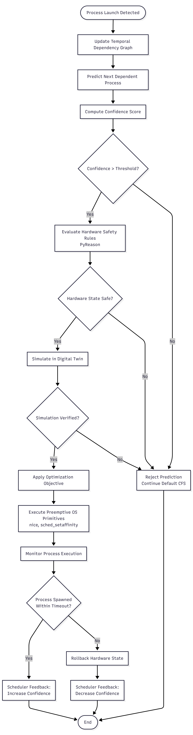

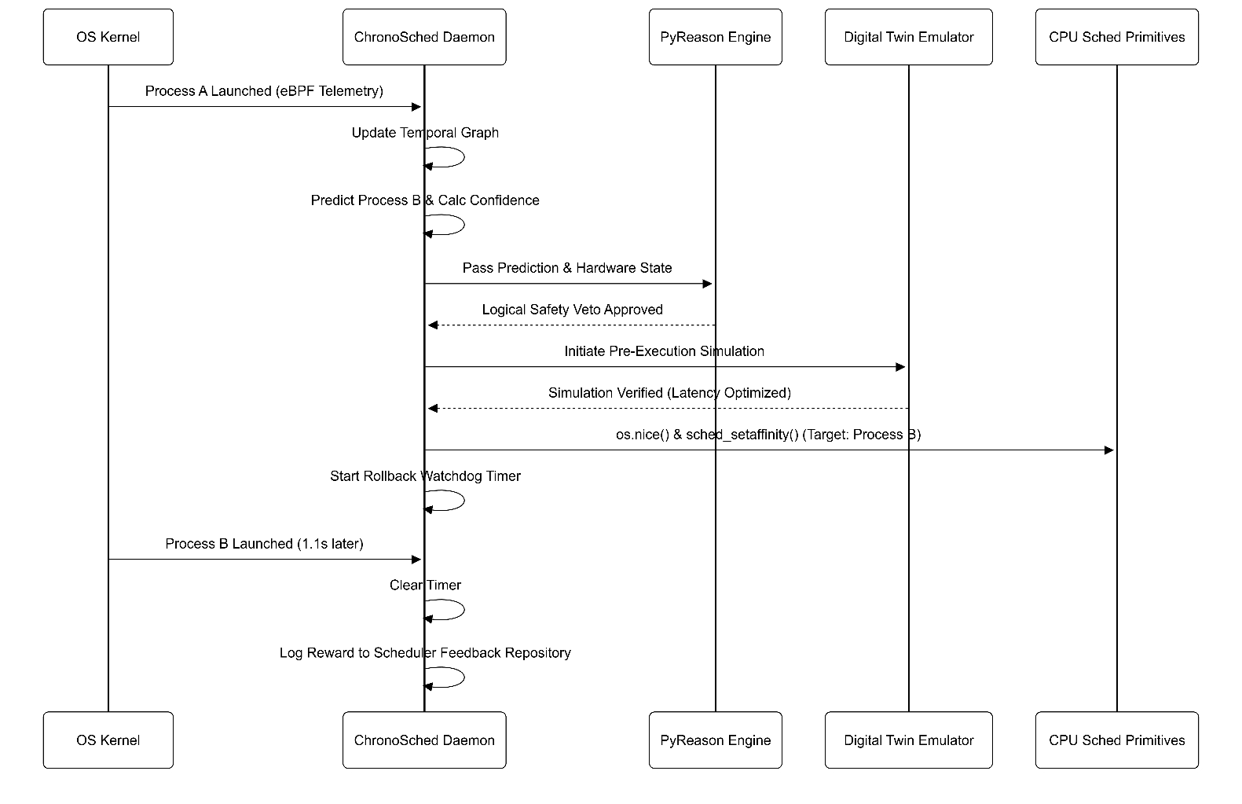
- Sequence Diagram
- Graph Model Diagram
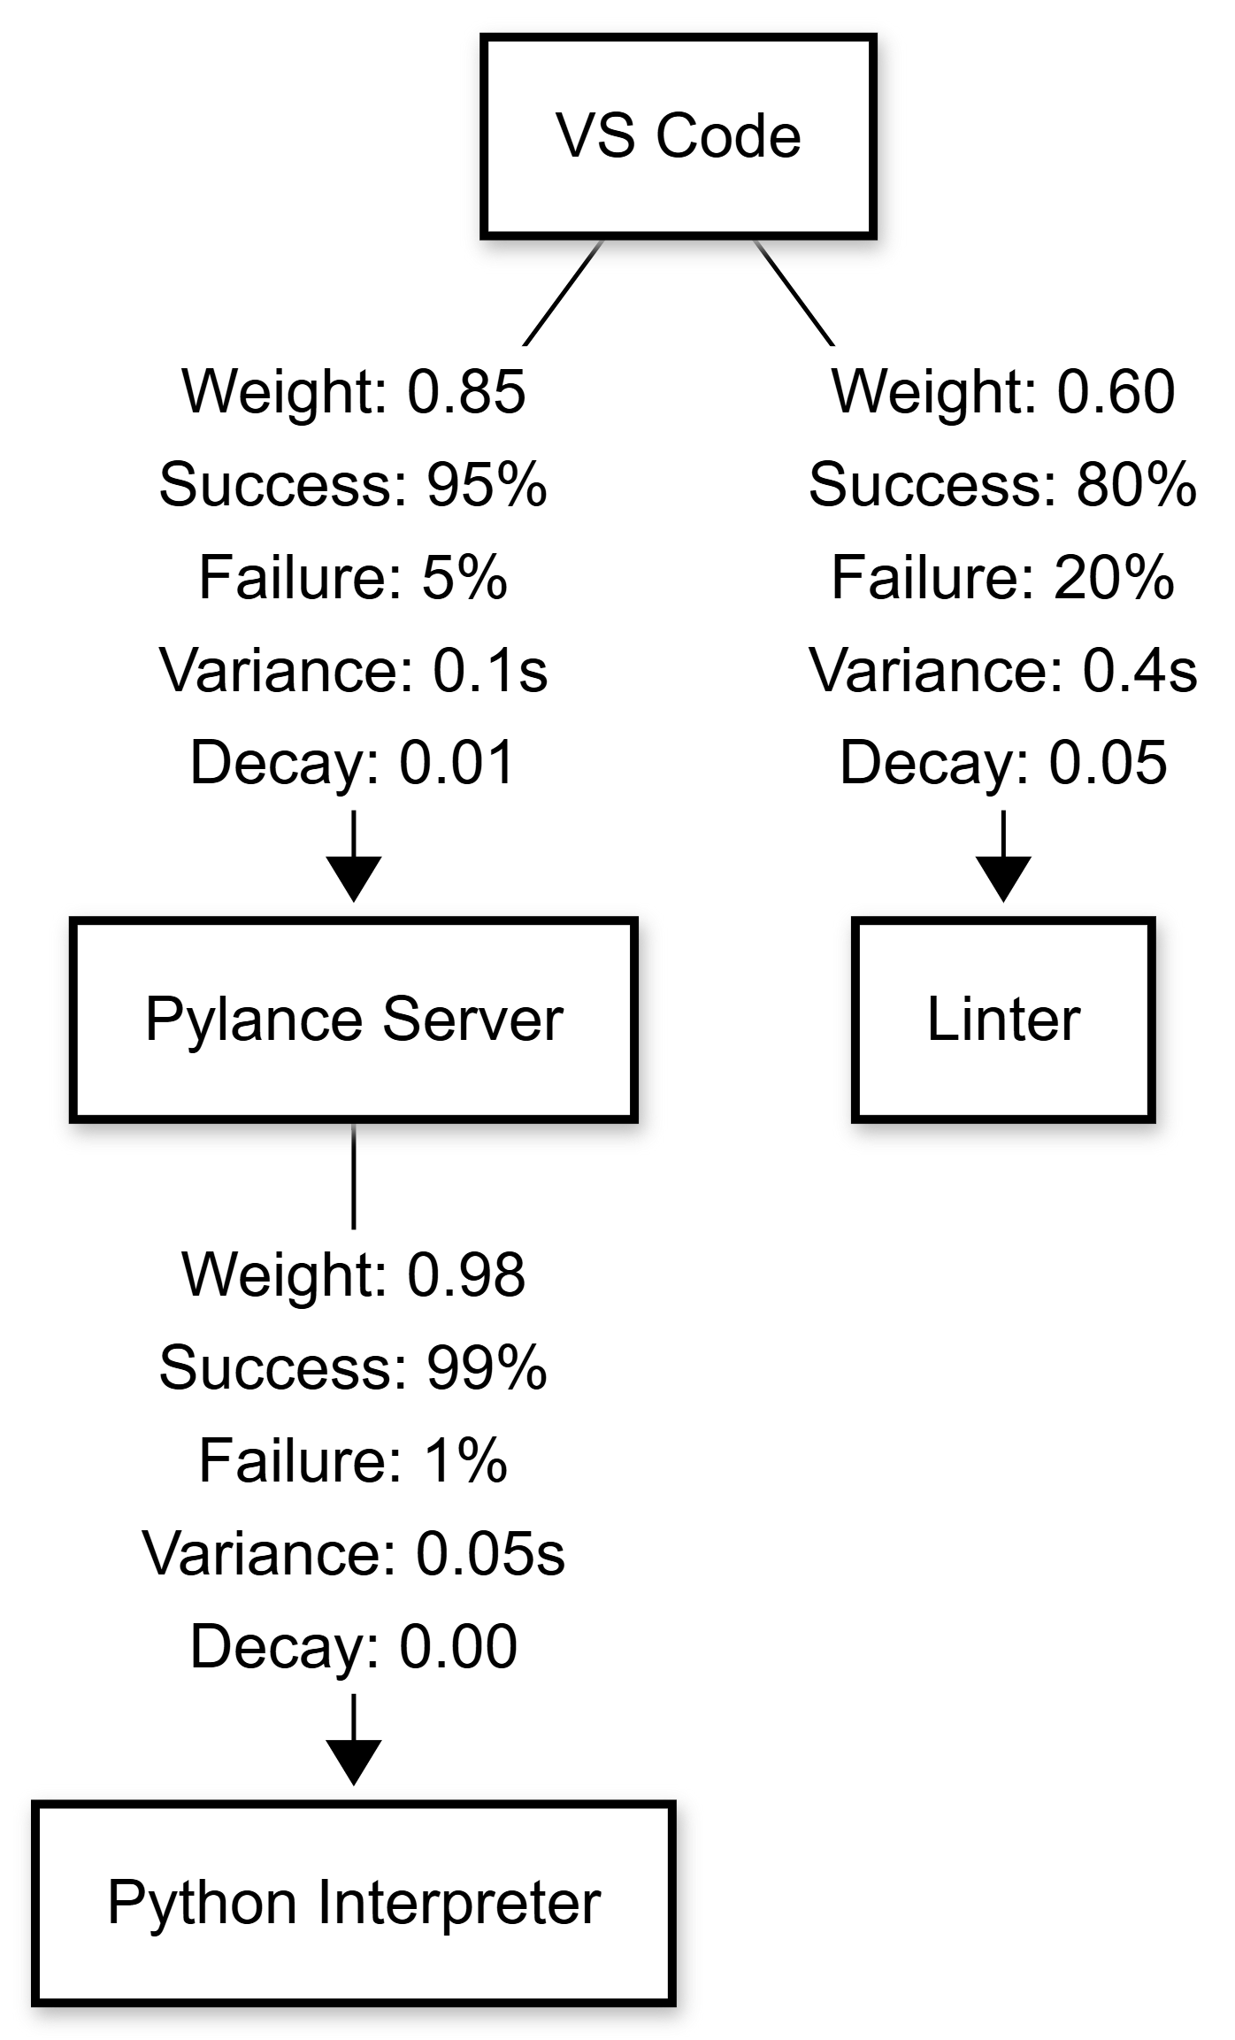

9. What aspect(s) of the invention need(s) protection?

Claim 1: A system for behavior-aware preemptive central processing unit resource allocation, comprising: a processor comprising a plurality of heterogeneous processing cores; a memory storing instructions; and a telemetry module, executing in user space via standard operating-system observability interfaces, configured to intercept process creation events and inter-process communication metrics without requiring modification of the operating-system kernel; wherein the processor is configured to: generate a cross-session temporal dependency graph based on the intercepted events; compute a probabilistic prediction of an impending process launch utilizing the dependency graph; evaluate the probabilistic prediction against a plurality of deterministic hardware safety constraints utilizing a neuro-symbolic reasoning engine; and upon determining that the prediction satisfies the hardware safety constraints, execute a preemptive operating system scheduling primitive to proactively assign the impending process to an optimal core among the plurality of heterogeneous processing cores prior to the initialization of the impending process.

Claim 2: The system of claim 1, wherein evaluating the probabilistic prediction comprises analyzing current physical hardware states, including memory utilization limits and page-fault metrics, to generate a logical veto; wherein the logical veto prevents the execution of the preemptive operating system scheduling primitive to prevent hardware thrashing and cache invalidation.

Claim 3: The system of claim 1, wherein the plurality of heterogeneous processing cores comprises at least one performance core and at least one efficiency core, and wherein the latency-criticality threshold is derived not from the impending process's own prior execution history in isolation, but from the temporal dependency graph's learned relationship between the triggering process and the impending process across multiple independent process types; and wherein the affinity assignment to the performance or efficiency core is transmitted to the operating system kernel prior to the first observed launch instance of the impending process within the current session.

Claim 4: The system of claim 1, further comprising a hardware state rollback monitor configured to initialize a timeout threshold upon execution of the preemptive operating system scheduling primitive; wherein, upon detecting a failure of the impending process to initialize within the timeout threshold, the

rollback monitor automatically reverts the processor core assignment to a default operating system state and degrades a confidence weight associated with the temporal dependency graph to adaptively calibrate subsequent predictions.

Claim 5: The system of claim 1, further comprising a confidence evaluation engine configured to calculate a confidence score associated with each predicted process launch based on a weighted combination of historical execution frequency, temporal recency, prediction probability, and execution success history; wherein the confidence score is utilized to determine whether the predicted scheduling action satisfies a predefined execution threshold prior to invoking the neuro-symbolic reasoning engine.

Claim 6: The system of claim 1, further comprising a digital twin verification module configured to simulate, within a virtual execution environment, the projected outcome of a scheduling action derived specifically from the temporal dependency graph's cross-session process-launch prediction and its associated confidence interval, prior to modification of operating system scheduling primitives; wherein the simulated verification jointly evaluates the confidence interval produced by the neuro-symbolic reasoning engine and the projected hardware state, and wherein the scheduling action is executed only upon successful completion of said joint simulated verification.

Claim 7: The system of claim 1, wherein the temporal dependency graph is continuously updated based on observed process execution behavior by modifying edge weights, execution frequencies, temporal delays, and dependency confidence values to improve subsequent process prediction accuracy across multiple execution sessions.

Claim 8: The system of claim 1, wherein successful prediction and execution of an impending process causes the associated temporal dependency confidence to be increased, and unsuccessful prediction or execution failure causes the corresponding confidence value to be decreased, thereby enabling adaptive reinforcement learning of process relationships without requiring retraining of a machine learning model.

Claim 9: The system of claim 1, wherein the neuro-symbolic reasoning engine generates an explainable inference trace identifying the hardware constraints, logical rules, and prediction confidence values that contributed to approval or rejection of the preemptive scheduling decision, thereby enabling transparent and auditable scheduler behavior.

Claim 10: The system of claim 1, wherein the preemptive operating system scheduling primitive is executed according to an objective function that jointly minimizes cold start latency, central processing unit migration cost, cache miss penalty, and power consumption, subject to deterministic hardware constraints and safety rules.

Claim 11: The system of claim 5, wherein the confidence score is dynamically updated for subsequent predictions via a closed-loop equation incorporating a historical reward for successful executions and a penalty for prediction failures, combined with a temporal decay factor, to continuously refine prediction accuracy.

Claim 12: The system of claim 1, wherein the temporal dependency graph automatically prunes obsolete dependency edges whose associated confidence values decay below a predefined threshold over a specified temporal window, thereby optimizing memory utilization.

Claim 13: The system of claim 1, wherein the probabilistic prediction undergoes a multi-level safety verification pipeline comprising an initial confidence threshold evaluation, a subsequent neuro-symbolic logical bounds check, and a final empirical digital twin simulation prior to any modification of operating system hardware states.

Claim 14: The system of claim 1, further comprising a scheduler feedback repository configured to persistently store execution traces, failure recovery states, and confidence updates, functioning as a continuous knowledge storage mechanism to bootstrap the prediction engine across system reboots.

10.Comparision Table

Feature | Linux CFS | Windows | Intel TD | ChronoSched
Prediction Before Launch | X | X | Partial | ✓
Cross Session Learning | X | X | X | ✓
Neuro Symbolic Verification | X | X | X | ✓
Confidence Gate | X | X | X | ✓
Digital Twin Simulation | X | X | X | ✓
Safe Rollback | X | Partial | X | ✓
Hardware Rules | X | X | Partial | ✓
Graph Learning | X | X | X | ✓
Cold Start Optimization | X | X | Partial | ✓
Heterogeneous CPU Aware | Partial | Partial | ✓ | ✓
Dynamic Thresholds | X | X | X | ✓
Optimization Objective | X | X | X | ✓
Execution Trace Logging | X | X | X | ✓
Failure Recovery | X | X | X | ✓
Explainability | X | X | X | ✓

Invention Disclosure Format (IDF)-B | Document No.
 | Issue No/Date
 | Amd. No/Date

9.What is Technology readiness level of your invention?

Research |  |  | Development |  |  | Deployment
TRL 1 | TRL 2 | TRL 3 | TRL 4 | TRL 5 | TRL 6 | TRL 7 | TRL 8 | TRL 9
Basic | Technology | Experimental | Technology | Technology | Technology | System | System | Actual system
Principles | concept | proof of | validated in | validated in a | demonstrated | prototype | complete | proven in an
observed | formulated | concept | a lab | relevant | in a relevant | demonstration | and | operational
 |  |  |  | environment | environment | in an | qualified | environment
 |  |  |  | (industrially | (industrially | operational |  | (competitive
 |  |  |  | relevant in | relevant in | environment |  | manufacturing
 |  |  |  | case of key | case of key |  |  | in case of key
 |  |  |  | enabling | enabling |  |  | enabling
 |  |  |  | technologies) | technologies) |  |  | technologies,
 |  |  |  |  |  |  |  | or in space )
✓ | ✓ | ✓

----------------------END OF THE DOCUMENT---------------------

