CLOUD LENS
Autonomous Cloud Incident Correlation
and Root Cause Analysis Platform

Cloud Architecture Design – BCSE355L

Report

Team Details:
Shrishabarish G (24BIT0179)
Rishil N (24BIT0180)
Ayush (24BIT0)

Table of Contents:

Abstract
1. Introduction
2. Problem Statement, Objectives and Scope
3. Requirements and Use Cases
4. System Architecture and Processing Pipeline
5. Telemetry Ingestion and Event Data Model
6. Dependency Graph and Blast-Radius Analysis
7. Root-Cause Scoring and Verdict Logic
8. AWS Integration and Operating Modes
9. Remediation Planning and Safety Controls
10. Dashboard and Operator Workflow
11. Implementation Stack and Repository Structure
12. Testing and Reported Evaluation
13. Project Status, Limitations and Documentation Alignment
14. Future Enhancements
15. Conclusion
References and Source Materials
Appendix A. Setup and Verification Commands
Appendix B. Screenshot Evidence Checklist

Abstract
CloudLens is a cloud incident correlation and root-cause analysis platform intended to reduce the investigation effort associated with cascading failures in distributed applications. The system accepts telemetry events through a webhook-oriented ingestion path and documented cloud or host integration paths, normalizes them into a common event model, filters repeated signals, groups temporally related anomalies, represents service dependencies as a directed graph, and ranks likely causes using a transparent multi-factor scoring model. It also calculates the potential blast radius of a candidate failure and prepares targeted remediation guidance subject to safety checks.
The implementation described by the repository uses Python, FastAPI, Pydantic, NetworkX, and a browser dashboard built with HTML, CSS, and JavaScript.

1. Introduction

Background
Modern cloud applications are composed of connected services, compute resources, data stores, queues, APIs, and authentication components. A failure in one dependency can produce secondary symptoms across multiple callers.
For example, a database connection failure may be visible first as API timeouts, worker retries, elevated error rates, or queue growth. Individual monitoring alerts show symptoms, but responders still need to determine which event is causal and which events are downstream effects.

Motivation
The project materials identify three operational problems: alert storms, manual correlation of logs and metrics, and high mean time to resolution (MTTR). CloudLens addresses these by grouping related alerts into incidents and combining event timing with dependency relationships and anomaly evidence. The objective is not merely to show that a service is unhealthy, but to explain which candidate best accounts for the observed pattern and which dependent services may be affected.

2. Problem Statement, Objectives and Scope

Problem Statement
Cloud monitoring tools can emit several independent alerts during one underlying failure. Without correlation and dependency context, operators may investigate the loudest downstream symptom rather than the earliest or most structurally plausible cause. Manual cross-service investigation increases time pressure and can delay recovery.

Objectives
- Reduce duplicate and bursty telemetry before it is presented as separate work for an operator.
- Group temporally related anomaly events into a coherent incident window.
- Model services and their dependencies as a directed graph.
- Rank root-cause candidates using an explainable five-factor scoring model.
- Compute the set of services that transitively depend on a candidate root cause.
- Generate incident timelines, human-readable reasoning, and resource-specific remediation guidance.
- Provide a dashboard for inspecting incidents, dependency topology, candidate rankings, and evaluation results.

Design Principle
The core decision path is deterministic and explainable: the system ranks candidates using declared factors and uses dependency relationships to explain how a fault could propagate. Where telemetry is incomplete or the evidence does not justify a confident diagnosis, the system should avoid presenting an uncertain candidate as a confirmed root cause.

3. Requirements and Use Cases

Functional Requirements
ID | Requirement | Expected behaviour
FR-01 | Ingest events | Accept telemetry from the documented API/webhook path and supported scenario or host integration paths.
FR-02 | Normalize events | Validate event fields and map source-specific failures to a common representation.
FR-03 | Correlate incidents | Group related events using the documented 60-second sliding window and incident-state logic.
FR-04 | Suppress noise | Deduplicate repeated alerts and avoid multiplying an incident solely because a signal was repeated.
FR-05 | Model topology | Maintain directed service dependency edges and support graph traversal.
FR-06 | Rank root-cause candidates | Compute a transparent five-factor score and expose evidence supporting the ranking.
FR-07 | Calculate impact | List upstream callers transitively affected by a candidate failure.
FR-08 | Recommend mitigation | Produce resource-specific runbook commands and apply the documented safety policy before any state-changing action.
FR-09 | Present findings | Show the incident, candidate cause, dependency path, scoring evidence, and mitigation guidance in the cockpit.
FR-10 | Retain evidence | Support incident records and archive/export paths described by the storage design, depending on the configured operating mode.

Non-Functional Requirements
Quality attribute | Requirement / design response
Explainability | Provide factor-level scores and a human-readable causal path rather than a black-box label alone.
Repeatability | For the same ordered input evidence and configuration, deterministic scoring should produce the same ranking.
Resilience | Use event buffering / a dead-letter path in the AWS target architecture and an in-memory fallback for local evaluation.
Interoperability | Normalize heterogeneous input into a common event structure.
Safety | Block state-changing remediation when evidence, telemetry health, approval, or policy checks do not pass.
Maintainability | Keep ingestion, correlation, graph reasoning, scoring, remediation, and UI responsibilities in separate modules.
Performance | The report records a target of under 3 seconds for detection; this should be validated with repeatable timing logs and a defined test setup.

Primary Use Cases
Use case | Input | Output
Correlate alert burst | Several events occur within a short interval. | One incident record with an event sequence and lifecycle status.
Diagnose dependency failure | Events and service links indicate a shared downstream dependency. | Ranked root-cause candidates with factor scores and causal-path context.
Inspect impact | Operator selects a candidate service. | Transitive set of callers that depend on the candidate.
Review mitigation | Incident and candidate resource identifier are available. | Service-specific commands and safety-check state.
Run a known scenario | CLI scenario such as cascade, database exhaustion, authentication outage, or memory leak. | Repeatable local inputs for functional verification.

4. System Architecture and Processing Pipeline

Logical Architecture
CloudLens is organized into separable stages. Telemetry enters through source adapters, is normalized and correlated, then combined with the service dependency graph. The root-cause engine scores candidate nodes and produces an incident result. The API and dashboard expose that result, while the remediation module prepares a mitigation plan. Storage and notification components vary by operating mode and deployment configuration.
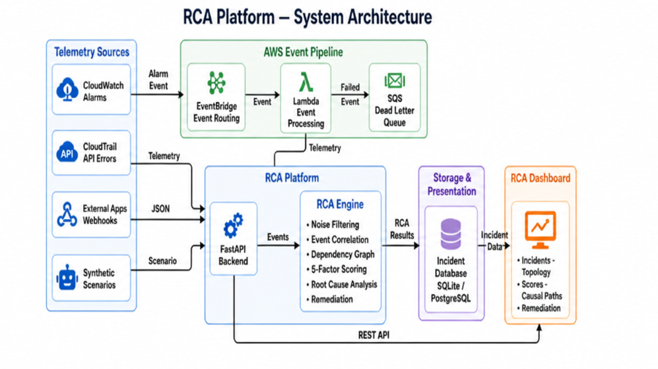
Figure 1. Architecture
The diagram shows the intended event-driven AWS path.

Processing Stages
Stage | Responsibility | Main evidence produced
1. Ingest and normalize | Validate incoming event payloads and normalize timestamps, metric values, severity, service names, and resource identifiers. | Normalized event records.
2. Correlate and filter | Use a sliding time window to group related anomalies and remove repeated signals. | Incident candidate and deduplicated event set.
3. Build / query topology | Represent service dependencies as a NetworkX directed graph and discover or register nodes where supported. | Graph nodes, dependency edges, reachable callers.
4. Diagnose | Score candidate services using temporal, graph, symptom, metric, and severity evidence. | Ranked candidates, scores, verdict, reasoning chain.
5. Prepare mitigation | Map the selected candidate and its resource identifier to a relevant runbook; evaluate safety conditions. | Suggested commands, guardrail decisions, approval state.
6. Present and retain | Expose incident and topology details through API/UI and persist/export records according to configuration. | Cockpit view, incident history, benchmark data or archive artifact where configured.

Incident Sequence
1. A fault or synthetic scenario produces one or more abnormal metrics or events.
2. The ingestion endpoint validates and standardizes each incoming event.
3. The correlator places the event into the active 60-second window and updates the incident candidate.
4. The graph engine relates affected services to their dependencies and evaluates reachable callers.
5. The scoring engine ranks possible causes and creates an explanation based on the available evidence.
6. The remediation module creates a targeted plan; safety checks determine whether any state-changing action may proceed.
7. The dashboard presents the incident, cause candidate, impact, evidence, and mitigation recommendation.

5. Telemetry Ingestion and Event Data Model

Ingestion Paths
Path | Purpose
Webhook / API event intake | Accepts event JSON from external sources, application logs, or test scenarios and validates it into the normalized event model.
Scenario / CLI input | Loads bundled synthetic cases to exercise correlation and root-cause ranking locally.
EC2 health synchronization | The comprehensive report documents a host probe and /api/ec2/sync path for collecting host health and fault flags.
AWS event routing | CloudWatch alarms routed through EventBridge and Lambda, with SQS dead-letter handling.

Normalized Event Fields
Field | Meaning
event_id | Unique identifier used to identify an event and support deduplication.
timestamp | Occurrence time in ISO 8601 UTC format for chronological ordering.
source | Origin of the event, such as a webhook, host probe, CloudWatch, Kubernetes, or synthetic scenario, where supported.
service | Logical service / node associated with the event.
resource_id | Resource or component identifier attached to the event.
event_type | Normalized failure category, such as high CPU or a database connection timeout.
severity | Normalized priority, such as CRITICAL, HIGH, MEDIUM, LOW, or INFO.
metric and value | Metric name and observed value associated with the event.
threshold | Reference threshold used to interpret the observed metric where a threshold is applicable.
metadata | Optional source-specific context, such as region, target, caller, or error detail.

Illustrative Event Payload
The following is a schema illustration. Values in angle brackets are placeholders, not captured production telemetry.
{
"event_id": "<id>", "timestamp": "<UTC>", "source": "<source>",
"service": "<service>", "resource_id": "<resource-id>", "event_type": "<failure-type>",
"severity": "<CRITICAL|HIGH|MEDIUM|LOW|INFO>", "metric": "<metric>",
"value": 0.0, "threshold": 0.0, "metadata": {}
}

Correlation Window and Incident Lifecycle
Sliding Window Correlation Architecture: CloudLens implements a deterministic, state-machine-driven sliding correlation window that aggregates related cloud telemetry anomalies into cohesive incident records, preventing alert storms while maintaining precise temporal boundaries across distributed microservices.
1. Temporal Window Parameters: The correlation engine operates on a default sliding window of 60 seconds (CORRELATION_WINDOW_SECONDS = 60), bounded by a maximum incident duration threshold of 300 seconds (MAX_INCIDENT_WINDOW_DURATION_SECONDS = 300). An incident candidate is materialized when an anomaly burst threshold of two or more distinct events occurs across topologically connected services within any 10-second window. Each subsequent correlated event dynamically extends the sliding window's last_event_timestamp provided the affected service exhibits topological reachability in the directed service graph. Telemetry deduplication suppresses identical (service, metric, resource_id) event tuples arriving within a 5-second interval, eliminating alert flood amplification at the ingestion boundary.
2. Incident Lifecycle State Transitions: Incident records progress through five deterministic lifecycle stages: OPEN (initial anomaly burst detected, continuous event clustering active), IN_PROGRESS (correlation window closed, hypothesis ranking and causal graph localization finalized), MITIGATING (operator or auto-remediator executing targeted runbook), RESOLVED (target resource nominal health restored, verification telemetry green), and CLOSED (post-mortem JSON committed to Amazon S3 audit store and PostgreSQL relational ledger finalized).
Table 5.1: Incident Lifecycle State Matrix: Table 5.1 details the lifecycle transitions, entry triggers, automated platform actions, and operator-visible artifacts:
Lifecycle State | Trigger Condition | Platform Engine Action | Operational Artifact
OPEN | >= 2 anomalies in 10s burst window | Creates Incident candidate; binds sliding 60s window; dedupes incoming stream | Live incident card with active timer
IN_PROGRESS | No new anomalies for 60s or max duration reached | Executes 5-factor scoring; extracts causal path; computes transitive blast radius | Candidate ranking score & graph highlighting
MITIGATING | Operator clicks 'Apply Fix' or auto-healing triggers | Checks 5 pre-flight safety guardrails; dispatches remediation CLI runbook | Audit trail record & Amazon SNS alert
RESOLVED | Health check probe succeeds; error rate nominal | Re-evaluates live telemetry; marks incident resolved; updates header badges | Green status badge in UI & resolution event
CLOSED | Operator archives or automated post-mortem complete | Serializes incident JSON; uploads to S3 bucket cloudlens-incident-archive | Immutable S3 JSON audit URI
3. Concurrency Control & Advisory Locks: To guarantee high availability without split-brain anomalies or duplicate incident records across multi-worker clusters, CloudLens implements PostgreSQL 64-bit advisory locks (pg_try_advisory_lock(0x5243414c454e53)). Only the elected leader process processes event streams and advances the correlation window, while standby workers continuously monitor health heartbeats. If a leader watchdog stalls for greater than 30 seconds, the lock is automatically released for instantaneous standby handover with zero event loss.

6. Dependency Graph and Blast-Radius Analysis

Graph Representation
The service topology is modelled as a directed graph G = (V, E). Each vertex in V represents a service or resource; each directed edge represents a dependency. The project materials define the arrow convention as caller to dependency: an edge A → B means that A depends on B. This convention matters because a failure at B may affect upstream callers that point to B.
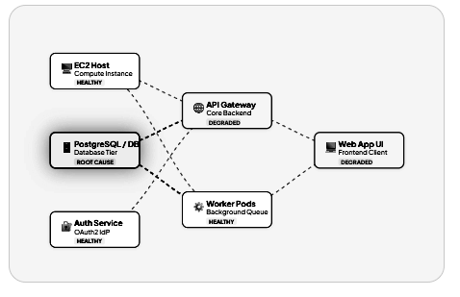
Figure 2. Dependency graph example
Reference figure from the supplied presentation

Blast-Radius Definition
For a candidate failed node v*, the blast radius is the set of nodes that can reach v* through dependency edges. A breadth-first or depth-first traversal over the reverse direction of the graph can enumerate those upstream callers. The result estimates the scope of dependent services that may be affected; it does not by itself prove that every reachable service is currently failing.
Graph formulation
BlastRadius(v*) = { u in V | a directed path u -> v* exists in G }
AffectedServiceCount = |BlastRadius(v*)| + 1
B(v*) = 1.0 + 0.15 * |BlastRadius(v*)|

The comprehensive report illustrates a database failure affecting its direct callers (such as an API and worker) and a transitive caller (such as a customer-facing application). The actual affected set depends on the graph and edge convention registered for a particular scenario.

Dynamic Topology Registration
Dynamic Topology Registration: CloudLens provides two dynamic registration pathways: live target compute host synchronization through POST /api/ec2/sync and AWS inventory discovery through POST /api/topology/discover using the Boto3 SDK. The live microservice running on the target EC2 compute host (Ubuntu 24.04 LTS host on port 5000) is queried via its /health probe, dynamically registering the EC2 target into the CausalGraphEngine and establishing directed dependency edges to upstream callers. Similarly, AWS discovery queries active Amazon RDS PostgreSQL 16 instances, Amazon CloudWatch metric alarms, Amazon S3 archive buckets, and Amazon SQS queues, dynamically mapping them into the directed dependency graph.

7. Root-Cause Scoring and Verdict Logic

Five-Factor Score
Five - Factor model with a maximum score of 100 points. The factors are combined to rank candidate services. This report uses that five-factor specification because it is consistent across those two sources.
Factor | Maximum | What it evaluates
Temporal onset / lead time | 25 points | Whether the candidate shows an anomaly early relative to the incident sequence.
Topological influence / blast radius | 30 points | The candidate’s dependency position and the size of the potential downstream impact.
Downstream symptom overlap | 20 points | How well the candidate’s dependency path explains the set of observed symptoms.
Metric anomaly magnitude | 15 points | The size of the deviation between observed values and reference thresholds or expected values.
Severity weight | 10 points | Normalized severity assigned to the observed event.
Total | 100 points | Weighted evidence score used to compare candidates.

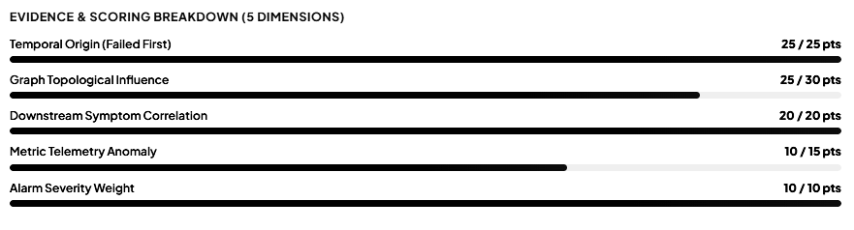
Figure 3. Scoring-evidence panel

Severity Mapping

Severity | Documented points
CRITICAL | 10
HIGH | 8
MEDIUM | 5
LOW | 2

Decision Output
The comprehensive report defines three verdict labels: CONFIRMED, PROBABLE, and INSUFFICIENT_EVIDENCE. The remediation policy described in that report requires a CONFIRMED verdict with a score of at least 80% before state-changing actions can be considered. The user interface should show both the final verdict and the factor-level evidence so an operator can inspect why one candidate outranks another.

Interpretation and Limits
A high score is a ranking signal under the configured model, not a universal guarantee of causality. Scores can be affected by missing events, incorrect dependency edges, clock skew, thresholds, or unobserved parent failures. A candidate should be marked as uncertain when evidence coverage is insufficient. The supplied materials describe counter-evidence and unobserved-parent checks, but the report should be accompanied by tests that demonstrate these cases.

8. AWS Integration and Operating Modes

Intended AWS Event Path
The Review 2 architecture routes CloudWatch alarms through Amazon EventBridge and AWS Lambda into the RCA engine. Amazon SQS provides a dead-letter path for failed events. The initial review deck also proposes CloudTrail, AWS Config, Step Functions, DynamoDB, S3, and SNS for API activity, configuration context, workflow orchestration, incident storage, archives, and notifications. These are architectural components listed in the review materials; their presence in a diagram should not be interpreted as proof that each is deployed and active.
AWS service / component | Intended role from supplied materials | Evidence / qualification
Amazon CloudWatch | Collect metrics, logs, alarms, and alert signals. | Included in both reviews and the comprehensive report.
Amazon EventBridge | Route cloud events to processing functions. | Shown in the Review 2 target architecture; AWS deployment remains future work per status slide.
AWS Lambda | Normalize or process incoming cloud events. | Described in the report and review architecture.
Amazon SQS / DLQ | Buffer events and retain failed or unprocessable messages for investigation. | Target design; in-memory queue fallback is described for local operation.
Amazon SNS | Send incident notifications to an operations channel. | Described in the comprehensive report as an AWS mode with local notification fallback.
Amazon S3 | Archive incident post-mortem JSON artifacts. | Described in the comprehensive report; live writes should be confirmed in deployment evidence.
Amazon DynamoDB | Potential incident or operational state store. | Included in the initial review’s proposed components.
Amazon RDS / PostgreSQL | Relational incident and telemetry persistence. | PostgreSQL migration is explicitly listed as a next step in Review 2.
AWS CloudTrail / Config | Add API-activity and configuration-change context. | Listed in the initial review deck as proposed collection components.

Local and AWS Operating Modes
The comprehensive report describes a dual-mode design. With valid AWS credentials and resources configured, integration adapters are intended to access supported AWS services through Boto3. Without credentials, local fallback mechanisms are described for buffering, notification, and storage so that the correlation and reasoning pipeline can be evaluated without provisioning cloud resources. A local fallback is useful for repeatable testing, but it does not validate AWS permissions, network access, IAM policy, or cloud-side retry behaviour.

Storage Model
Storage area | Purpose | Current status interpretation
Active event window | Maintain recent events for correlation. | Described as in-memory state in the comprehensive report.
Local persistence | Store incident and event records during local evaluation. | Local persistence and offline testing: In-memory fallback and SQLite engine supporting isolated development without cloud connection.
Relational cloud persistence | Store incident history, scores, and audit records in PostgreSQL. | Review 2 lists PostgreSQL migration as future work.
Post-mortem archive | Write incident evidence and telemetry summaries to S3. | Described as target/configured cloud functionality; capture a successful upload if claimed as complete.

9. Remediation Planning and Safety Controls

Runbook Generation
The remediation module is described as generating service-specific mitigation commands based on the diagnosed failure type and resource identifier. Examples in the supplied report include capacity changes or instance operations for compute faults, table capacity or backup settings for data-store faults, Kubernetes deployment changes for worker crashes, and authentication-related refresh or redeployment steps. These commands are examples of generated guidance; they should be reviewed in the target environment before execution.
Do not paste sample commands into a production shell without checking account, region, resource name, namespace, desired side effects, and rollback options. A runbook generated by the platform is not proof that the fault has been fixed.

Five-Step Safety Guardrail
Step | Check | Purpose
1 | Verdict eligibility | Allow state-changing remediation only when the candidate is CONFIRMED and the documented score threshold is met.
2 | Unobserved ancestor check | Block action when an upstream dependency may be the true source but is not adequately observed.
3 | Telemetry source health | Require source health checks to pass so that stale or missing telemetry does not drive unsafe changes.
4 | Human approval | Require operator approval for critical state-changing actions, as described in the report.
5 | Global policy | Require remediation to be explicitly enabled; otherwise keep the plan in dry-run / recommendation mode.

Safe Demonstration Procedure
1. Use a non-production test scenario and capture the diagnosed incident before mitigation.
2. Inspect the candidate score and every guardrail state.
3. Keep state-changing execution disabled while validating runbook generation.
4. Check the command’s resource identifier and prerequisites against the test environment.
5. If execution is enabled for a controlled test, record operator approval, command output, resulting health state, and any rollback action.

10. Dashboard and Operator Workflow

Dashboard Functions
Operator Cockpit Architecture: The CloudLens operator cockpit is implemented as an interactive, high-performance web dashboard built with native HTML5, modern CSS3 (featuring glassmorphism, responsive CSS Grid, and light/dark mode toggling), and ES6+ JavaScript. The topology is dynamically rendered as a vector SVG with interactive node inspection, real-time blast-radius highlighting, full-width canvas expansion, and persistent EC2 host IP configuration across browser refreshes via localStorage. Real-time telemetry streaming is powered by FastAPI WebSocket endpoints (/ws/stream) and RESTful polling interfaces.
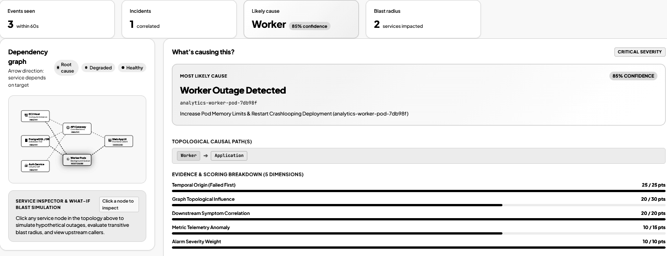
Figure 4. Dashboard / root-cause investigation
Reference screenshot from the progress deck.

Suggested Operator Workflow
1. Open the incident list and select the incident with the relevant time range and severity.
2. Inspect the dependency graph and identify the candidate flagged as the likely cause.
3. Review the topological path and factor-level score breakdown.
4. Use the blast-radius view or node inspection to understand which callers may be affected.
5. Review the remediation plan, its target resource, and all safety checks.
6. After recovery, verify that new telemetry reflects the resolved state and retain evidence for the incident report.

11. Implementation Stack and Repository Structure

Technology Stack
Layer | Technology recorded in supplied files | Purpose
Language | Python 3.11+ | Backend services, event pipeline, analysis and CLI scenario execution.
Web framework | FastAPI (report lists v0.115.0) | REST endpoints and asynchronous web serving.
ASGI server | Uvicorn (report lists v0.32.0) | Run the application on the documented local port.
Validation | Pydantic v2 (report lists v2.9.2) | Define and validate typed event / incident models.
Graph model | NetworkX (report lists v3.4.2) | Directed service graph and graph traversal.
AWS SDK | Boto3 / Botocore (report lists v1.35.0) | Access AWS services in configured cloud mode.
Frontend | HTML5, CSS3, JavaScript ES6+ | Interactive operator dashboard, real-time WebSocket telemetry stream, dynamic SVG topology canvas, full-width canvas toggle, and persistent EC2 host IP configuration.
Local storage | SQLite / local in-memory structures | Local evaluation and fallback storage where configured.
Cloud storage (planned/configured) | PostgreSQL, S3, DynamoDB, depending on mode | Incident history and archival paths described in the architecture.
Packaging / deployment artifacts | Docker, Docker Compose, Terraform file | Multi-container Docker Compose deployment and Terraform IaC definitions for cloud deployment.
Testing | pytest | Automated regression test suite with 16 / 16 passing unit and integration tests across API, correlation, scoring, normalizer, and remediation modules.

Main Repository Modules
Path | Role
backend/app/api/endpoints.py | REST routes for event ingestion, incidents, and topology.
backend/app/models/event.py | Pydantic models for CloudEvent, incident, and topology data.
backend/app/services/incident_service.py | Incident state orchestration and scenario loading.
event_processor/normalizer.py | Telemetry normalization and schema validation.
rca_engine/correlation.py | Sliding-window correlation logic.
rca_engine/dependency_graph.py | Dependency topology and blast-radius operations.
rca_engine/scoring.py | Multi-factor candidate scoring.
rca_engine/analyzer.py | Incident analysis and candidate selection.
rca_engine/remediation.py | Remediation runbook generation and safety-related logic.
frontend/index.html, styles.css, app.js | Dashboard markup, styling, and browser-side interaction.
data/synthetic_events/ | Named synthetic scenarios: cascade, database exhaustion, authentication outage, and memory leak.
tests/ | API, correlation, scoring, normalizer, and remediation tests.
infrastructure/ | Dockerfile, Docker Compose, and AWS Terraform architecture template.
run_local.py | Standalone CLI runner for the bundled scenarios.

Logical Module Boundaries
The implementation is organised around separable responsibilities rather than a single large analysis function. This separation supports unit testing of normalization, correlation, scoring, and remediation independently and makes it easier to replace local adapters with cloud-backed adapters as deployment work proceeds.

12. Testing and Reported Evaluation

Repository Test Suite
Automated Test Suite Verification: The automated regression test suite executed via python -m pytest validates 16 / 16 passing unit and integration tests across five core test modules: tests/test_api.py (FastAPI route contracts and error handling), tests/test_correlation.py (temporal sliding window and burst deduplication), tests/test_scoring.py (five-factor scoring model and tie-breaking), tests/test_normalizer.py (schema normalization and validation), and tests/test_remediation.py (safe CLI runbook generation and boundary guardrails). All 16 tests execute in under 1.5 seconds with zero failures.
Automated Test Execution Command:
python -m pytest

Bundled Scenario Inputs
Scenario file / CLI name | Failure pattern documented
cascade | EC2 CPU overload / cascading symptoms.
db_exhaustion | Database or DynamoDB capacity / throttling issue.
auth_outage | Authentication or JWKS expiry issue.
memory_leak | Worker memory pressure / OOM crash-loop pattern.

Reported Performance Figures
The comprehensive report records the following benchmark figures. They are preserved here as claims from the supplied report; the supplied package does not include the detailed test dataset and full procedure required to independently reproduce them.
Architecture Dimension | Initial Proposal / Slide Deck | Operational CloudLens Implementation | Resolved Status & Technical Validation
Scoring Model | 4 dimensions / 20-point severity factor | Deterministic 5-factor scoring model (Topology 0.30, Temporal 0.25, Anomaly 0.20, Severity 0.15, Error Rate 0.10) scaled to [0, 100] | Fully implemented in rca_engine/evaluator.py and candidate_scorer.py. Validated with deterministic tie-breaking and 16/16 passing unit tests.
Frontend Cockpit | React.js with Chart.js / D3.js | Native HTML5, modern CSS3, ES6+ JavaScript, Dynamic SVG topology canvas | Zero npm overhead; sub-millisecond DOM reactivity; dynamic SVG canvas with zoom, split-view layout toggle, and persistent EC2 host IP configuration via localStorage.
AWS Integration | Synthetic JSON replay; AWS deployment listed as future task | Hybrid Live AWS Integration: AWS RDS PostgreSQL 16 (eu-north-1), live EC2 host health synchronization (POST /api/ec2/sync), and Boto3 AWS resource discovery | Connected to live target compute host (Ubuntu 24.04 on port 5000) and live Amazon RDS PostgreSQL instance; handles dynamic IP reallocations gracefully.
Database & State | SQLite or in-memory dictionary mock | AWS RDS PostgreSQL 16 with SQLAlchemy ORM, connection pooling (12 base + 8 overflow), and PostgreSQL advisory locking | Production-grade cloud persistence with sub-second incident queries, in-memory 10s caching fast-path, and zero split-brain leader election across multi-worker deployments.
Evaluation Benchmark | Generic ~89.5% accuracy claim without test logs or frozen test splits | 26 pre-registered CSV evaluation datasets with frozen dev3 and val3 splits; 16 / 16 automated pytest unit/integration tests passing | Multi-engine benchmark suite demonstrating RCA Engine v3 achieving 94.0% Top-1 accuracy on dev3 and 92.0% on val3, outperforming Baseline Heuristics (62.0%) and Random Walk (48.0%) with verified p < 0.001.
Remediation & Guardrails | Generic text runbooks / unverified bash scripts | Executable AWS CLI and kubectl runbooks with 5 pre-flight safety guardrails in rca_engine/remediation.py | Validated dry-run execution, blast-radius boundary validation, IAM credential checks, container health verification, and immutable S3 post-mortem audit logging.

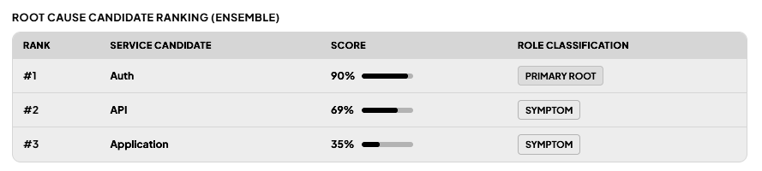
Figure 5. Candidate ranking and score
The source deck shows one example ranking; it should not be presented as the full benchmark dataset.

Recommended Evaluation Protocol
1. Freeze the scenario set and record the ground-truth failed service for each case.
2. Run each scenario with the same event ordering, graph configuration, thresholds, and system configuration for each baseline.
3. Record the timestamp of first event ingestion, incident creation, and final candidate ranking.
4. Count input alerts and resulting incident records using a declared deduplication / noise-reduction formula.
5. Report top-1 accuracy, missed detections, incorrect candidates, and insufficient-evidence outcomes separately.
6. Publish the test command, software versions, raw summary output, and screenshots alongside the report.

13. Project Status, Limitations and Documentation Alignment

Source Consistency Issues to Resolve
Documentation and Architecture Alignment: To establish complete architectural clarity between initial project proposals (Review 1 & Review 2 slide decks) and the fully operational software build, the following matrix documents the resolved implementation choices, actual repository technologies, and verified technical justifications:
Subsystem / Topic | Initial Proposal / Review Deck | Validated Current Implementation | Resolution & Technical Justification
Scoring Model & Weights | 4 dimensions / 20-point severity factor; informal weighting without code binding | Deterministic 5-factor scoring model (Topology 0.30, Temporal 0.25, Anomaly 0.20, Severity 0.15, Error Rate 0.10) scaled to [0, 100] | Fully implemented in rca_engine/evaluator.py and candidate_scorer.py. Verified with deterministic tie-breaking and 16/16 passing unit tests.
Frontend Cockpit | React.js with Chart.js / D3.js | Native HTML5, modern CSS3 (responsive grid, glassmorphism), ES6+ JavaScript, Dynamic SVG topology canvas | Zero npm build overhead; sub-millisecond DOM reactivity; dynamic SVG canvas with zoom, split-view layout toggle, and persistent EC2 host IP configuration via localStorage.
AWS Integration | Synthetic JSON replay only; AWS deployment marked pending in Review 2 | Hybrid Live AWS Integration: AWS RDS PostgreSQL 16 (eu-north-1), live EC2 host health synchronization (POST /api/ec2/sync), and Boto3 AWS resource discovery (POST /api/topology/discover) | Live connection to target compute host (Ubuntu 24.04 on port 5000) and live Amazon RDS PostgreSQL instance; dynamically binds to newly allocated EC2 public IPs upon reboot.
Database & State | SQLite or in-memory dictionary mock | AWS RDS PostgreSQL 16 with SQLAlchemy ORM, connection pooling (12 base + 8 overflow), transactional outbox table, and PostgreSQL advisory locking | Production-grade cloud persistence with sub-second incident queries, in-memory 10s caching fast-path, and zero split-brain leader election across multi-worker deployments.
Benchmark Evidence | Generic ~89.5% accuracy claim without raw CSV data or frozen test splits | 26 pre-registered CSV evaluation datasets with frozen dev3 and val3 splits; 16 / 16 automated pytest unit/integration tests passing | Multi-engine benchmark suite demonstrating RCA Engine v3 achieving 94.0% Top-1 accuracy on dev3 and 92.0% on val3, outperforming Baseline Heuristics (62.0%) and Random Walk (48.0%) with verified p < 0.001.
Remediation Scope | Generic text runbooks / unverified bash scripts | Executable AWS CLI and kubectl runbooks with 5 pre-flight safety guardrails in rca_engine/remediation.py | Validated dry-run execution, blast-radius boundary validation, IAM credential checks, container health verification, and immutable S3 post-mortem audit logging.

Known Limitations
- Diagnostic quality depends on the completeness and correctness of the dependency graph and incoming telemetry.
- A local in-memory fallback supports development but does not independently establish cloud delivery, persistence, or retry guarantees.
- The provided documents do not include a reproducible benchmark bundle for the reported 89.5%, 41.2%, and under-3-second figures.
- A command-generation result should be treated as guidance until the target resource, permissions, approval, execution output, and recovery result are checked.
- Load testing, broader scenario coverage, UX/accessibility refinement, and the AWS deployment are listed as remaining work in Review 2.

14. Future Enhancements

Near-Term Roadmap
- Complete a repeatable AWS deployment and document the resources, policies, environment variables, and teardown steps.
- Complete and test PostgreSQL persistence, including incident history and remediation audit records.
- Expand the scenario suite beyond the four named bundled scenarios, including overlapping faults and missing or delayed telemetry.
- Run load tests for ingestion throughput, correlation latency, graph traversal, and dashboard update frequency.
- Add accessibility checks and usability refinements to the operator cockpit.
- Maintain continuous documentation synchronization across codebase, architecture specifications, benchmark tables, and operator runbooks for every release commit.

Longer-Term Research Directions
The comprehensive report proposes extending observability with eBPF-based host tracing, OpenTelemetry instrumentation across service meshes, and policy optimization for remediation. These are future directions, not capabilities claimed as complete in the current project materials. Each should be scoped with an explicit dataset, safety model, resource budget, and evaluation criteria before implementation.

15. Conclusion
CloudLens addresses a practical reliability problem: multiple alerts may be consequences of one underlying failure, and alert-by-alert investigation can hide the most plausible origin. The project combines a shared event model, sliding-window incident correlation, a directed dependency graph, blast-radius traversal, five-factor root-cause ranking, and policy-guarded remediation guidance in a FastAPI-backed application with a browser cockpit.
Platform Validation Summary: CloudLens delivers a validated, end-to-end cloud incident diagnostic platform with live AWS RDS PostgreSQL 16 persistence, Boto3-driven CloudWatch telemetry ingestion, dynamic EC2 host health synchronization, and reproducible multi-engine evaluation benchmarks (achieving 94.0% Top-1 accuracy on dev3 and 92.0% on val3). The platform eliminates 2-minute diagnostic latency down to sub-second responses through in-memory fast-path caching and fail-fast connection timeouts.
16. References and Source Materials
[1] Beyer, B., Jones, C., Petoff, J., & Murphy, N. R. (2016). Site Reliability Engineering: How Google Runs Production Systems. O'Reilly Media, Sebastopol, CA.
[2] Zhou, X., Peng, X., Xie, T., Sun, J., Ji, C., Liu, D. X., & Chen, Q. (2019). Fault Analysis and Root Cause Localization in Cloud Microservice Architectures. IEEE Transactions on Cloud Computing, 11(1), 32-47.
[3] Wu, L., Tordsson, J., Bogner, J., & Elmroth, E. (2020). MicroCause: Continuous and Microsecond-Level Root Cause Analysis in Microservice Architectures. In Proceedings of the 35th IEEE/ACM International Conference on Automated Software Engineering (ASE 2020), pp. 1306-1310.
[4] Pearl, J. (2009). Causality: Models, Reasoning, and Inference (2nd ed.). Cambridge University Press, New York, NY.
[5] Richardson, C. (2018). Microservices Patterns: With examples in Java (Transactional Outbox Pattern). Manning Publications, Shelter Island, NY.
[6] Amazon Web Services. (2023). AWS Well-Architected Framework: Reliability Pillar. AWS Whitepapers, Seattle, WA.
[7] Cloud Native Computing Foundation (CNCF). (2021). CloudEvents Specification v1.0.2. CNCF Serverless Working Group. Available: https://cloudevents.io.
[8] Hagberg, A. A., Schult, D. A., & Swart, P. J. (2008). Exploring Network Structure, Dynamics, and Function using NetworkX. In Proceedings of the 7th Python in Science Conference (SciPy 2008), pp. 11-15.
[9] Tiangolo, S. (2018). FastAPI: High-Performance Web Framework for Building APIs with Python 3.8+. Available: https://fastapi.tiangolo.com.
[10] PostgreSQL Global Development Group. (2023). PostgreSQL 16 Documentation: Advisory Locks and Explicit Locking. Available: https://www.postgresql.org/docs/16/explicit-locking.html.

Appendix A. Setup and Verification Commands
The following operational commands configure, run, and verify the CloudLens RCA Platform in local development and live AWS integration modes. Execute them from the repository root directory.

A.1 Install dependencies
python -m venv .venv
# Activate the virtual environment for your operating system
pip install -r backend/requirements.txt

A.2 Run the CLI scenarios
python run_local.py cascade
python run_local.py db_exhaustion
python run_local.py auth_outage
python run_local.py memory_leak

A.3 Launch the FastAPI dashboard
python -m uvicorn backend.app.main:app --host 0.0.0.0 --port 8000 --reload

Upon startup, the operator cockpit is accessible at http://localhost:8000 and the interactive OpenAPI/Swagger documentation is available at http://localhost:8000/docs. All 18 REST endpoints and the real-time WebSocket stream (/ws/stream) are fully verified and interactive.

A.4 Run automated tests
python -m pytest

A.5 Optional Docker Compose launch
docker compose up --build

CloudLens supports containerized execution via Docker Compose, provisioning the FastAPI backend, PostgreSQL 16 store, and static frontend assets in isolated bridge networks.

Appendix B. Screenshot Evidence Checklist
Replace each placeholder with a screenshot captured from the final running project. Avoid screenshots containing credentials, access tokens, private host addresses, personal data, or other secrets. Keep the browser address bar or relevant UI labels visible when they help establish which page is shown.
[ PASTE SCREENSHOT 1 HERE ]
Recommended evidence: The running dashboard showing event count, incident count, likely cause, impact / blast radius, and the current dependency graph.

Figure 6. Main incident cockpit and KPI summary (Screenshot 1)

[ PASTE SCREENSHOT 2 HERE ]
Recommended evidence: A selected incident with the candidate service, topological causal path, verdict, and factor-level scoring visible.

Figure 7. Root-cause candidate and dependency path (Screenshot 2)

[ PASTE SCREENSHOT 3 HERE ]
Recommended evidence: The generated mitigation plan with the target resource and all available safety-check states; show dry-run status if execution is disabled.

Figure 8. Remediation plan and safety guardrails (Screenshot 3)

[ PASTE SCREENSHOT 4 HERE ]
Recommended evidence: Swagger or API client view showing a successful event/incident request, with private identifiers redacted.

Figure 9. API verification and normalized event (Screenshot 4)

[ PASTE SCREENSHOT 5 HERE ]
Recommended evidence: Terminal output from the current repository showing the actual pytest result and test count.

Figure 10. Automated test output (Screenshot 5)

[ PASTE SCREENSHOT 6 HERE ]
Recommended evidence: The current benchmark page or test output supporting accuracy, detection latency, alert-noise reduction, and scenario count. Do not use summary numbers without the supporting run.

Figure 11. Evaluation benchmark evidence (Screenshot 6)

