R1-HQ#show crypto map
Crypto Map HQ-TO-BRANCH-MAP 10 ipsec-isakmp
Peer = 198.51.100.2
Extended IP access list 101
access-list 101 permit ip 192.168.30.0 0.0.0.255 192.168.20.0 0.0.0.255
access-list 101 permit ip 192.168.40.0 0.0.0.255 192.168.20.0 0.0.0.255
access-list 101 permit ip 192.168.20.0 0.0.0.255 192.168.10.0 0.0.0.255
access-list 101 permit ip 192.168.20.0 0.0.0.255 192.168.30.0 0.0.0.255
access-list 101 permit ip 192.168.20.0 0.0.0.255 192.168.40.0 0.0.0.255
access-list 101 permit ip 192.168.10.0 0.0.0.255 192.168.20.0 0.0.0.255
Current peer: 198.51.100.2
Security association lifetime: 4608000 kilobytes/3600 seconds
PFS (Y/N): N
Transform sets={
TS-VPN,
}
Interfaces using crypto map HQ-TO-BRANCH-MAP:
GigabitEthernet0/1

Crypto Map HQ-TO-BRANCH-MAP 20 ipsec-isakmp
Peer = 192.0.2.2
Extended IP access list 102
access-list 102 permit ip 192.168.10.0 0.0.0.255 192.168.50.0 0.0.0.255

R1-HQ#
R1-HQ#show access-lists
Extended IP access list 110
10 deny ip 192.168.10.0 0.0.0.255 192.168.20.0 0.0.0.255
20 permit ip 192.168.10.0 0.0.0.255 any
30 deny ip 192.168.30.0 0.0.0.255 192.168.20.0 0.0.0.255 (11 match(es))
40 permit ip 192.168.30.0 0.0.0.255 any
50 deny ip 192.168.40.0 0.0.0.255 192.168.20.0 0.0.0.255 (124 match(es))
60 permit ip 192.168.40.0 0.0.0.255 any
70 deny ip 192.168.10.0 0.0.0.255 192.168.50.0 0.0.0.255
80 deny ip 192.168.30.0 0.0.0.255 192.168.50.0 0.0.0.255
90 deny ip 192.168.40.0 0.0.0.255 192.168.50.0 0.0.0.255
Extended IP access list 102
10 permit ip 192.168.10.0 0.0.0.255 192.168.50.0 0.0.0.255
20 permit ip 192.168.30.0 0.0.0.255 192.168.50.0 0.0.0.255
30 permit ip 192.168.40.0 0.0.0.255 192.168.50.0 0.0.0.255
Extended IP access list 101
10 permit ip 192.168.30.0 0.0.0.255 192.168.20.0 0.0.0.255 (1 match(es))
20 permit ip 192.168.40.0 0.0.0.255 192.168.20.0 0.0.0.255
30 permit ip 192.168.20.0 0.0.0.255 192.168.10.0 0.0.0.255
40 permit ip 192.168.20.0 0.0.0.255 192.168.30.0 0.0.0.255
50 permit ip 192.168.20.0 0.0.0.255 192.168.40.0 0.0.0.255
60 permit ip 192.168.10.0 0.0.0.255 192.168.20.0 0.0.0.255

R1-HQ#show ip route
Codes: L - local, C - connected, S - static, R - RIP, M - mobile, B - BGP
D - EIGRP, EX - EIGRP external, O - OSPF, IA - OSPF inter area
N1 - OSPF NSSA external type 1, N2 - OSPF NSSA external type 2
E1 - OSPF external type 1, E2 - OSPF external type 2, E - EGP
i - IS-IS, L1 - IS-IS level-1, L2 - IS-IS level-2, ia - IS-IS inter area
* - candidate default, U - per-user static route, o - ODR
P - periodic downloaded static route

Gateway of last resort is not set

S 192.0.2.0/24 [1/0] via 203.0.113.2
192.168.10.0/24 is variably subnetted, 2 subnets, 2 masks
C 192.168.10.0/24 is directly connected, GigabitEthernet0/0.10
L 192.168.10.1/32 is directly connected, GigabitEthernet0/0.10
S 192.168.20.0/24 [1/0] via 203.0.113.2
192.168.30.0/24 is variably subnetted, 2 subnets, 2 masks
C 192.168.30.0/24 is directly connected, GigabitEthernet0/0.20
L 192.168.30.1/32 is directly connected, GigabitEthernet0/0.20
192.168.40.0/24 is variably subnetted, 2 subnets, 2 masks
C 192.168.40.0/24 is directly connected, GigabitEthernet0/0.30
L 192.168.40.1/32 is directly connected, GigabitEthernet0/0.30
S 192.168.50.0/24 [1/0] via 203.0.113.2
--More—

F01:
- •
Phase 1 main mode key exchange failed, showing up as MM_KEY_EXCH or ACTIVE (deleted) status when running:

show crypto isakmp sa
• Root Cause: The Pre-Shared Key (PSK) configured on R1-HQ did not match the key configured on the peer branch router

Resolved : configure terminal
no crypto isakmp key INCORRECT_KEY address 198.51.100.2
crypto isakmp key vpnsecret123 address 198.51.100.2
end
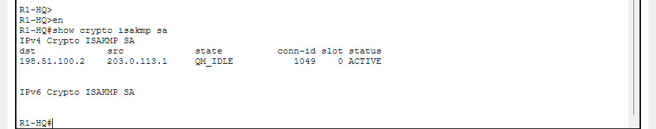

Experiment 2 (F02: IPsec Phase 2 Transform-Set Mismatch).
Step 1: Inject F02
Go to R1-HQ and change the transform-set parameters to 3DES/MD5 in configuration mode:
Step 2: Observe the Symptoms & Run Diagnostics
- Go to PC-HQ and try pinging PC-Branch (192.168.20.10). Notice that the pings time out.

2. Fault 02 (F02): IPsec Phase 2 Transform-Set Mismatch
- Symptom / Diagnostic Evidence:
  - Phase 1 successfully established (QM_IDLE), but Phase 2 security associations failed to negotiate or packet counters (#pkts encaps / #pkts decaps) remained at 0, verified via:
show crypto ipsec sa
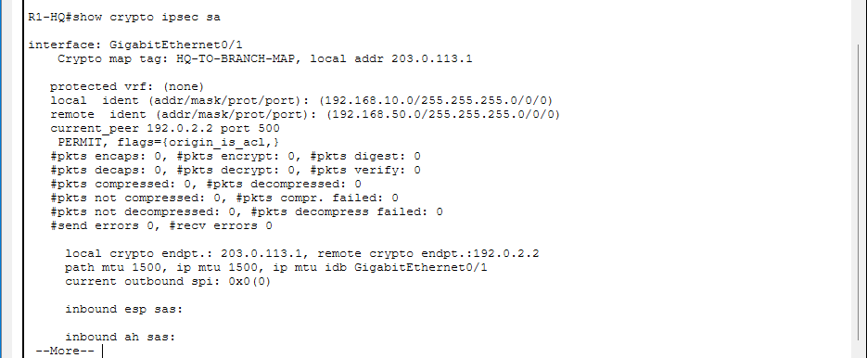
- Root Cause: Mismatched encryption/integrity algorithms between the HQ and branch transform-sets (e.g., testing with mismatched parameters like 3DES/MD5 vs AES/SHA).
- Resolution Commands Applied:
  - configure terminal
crypto ipsec transform-set TS-VPN esp-aes esp-sha-hmac
end
- Verification: Triggered traffic via ping from PC-HQ (192.168.30.10) to PC-Branch (192.168.20.10) to confirm 0% packet loss and active packet counter incrementing.
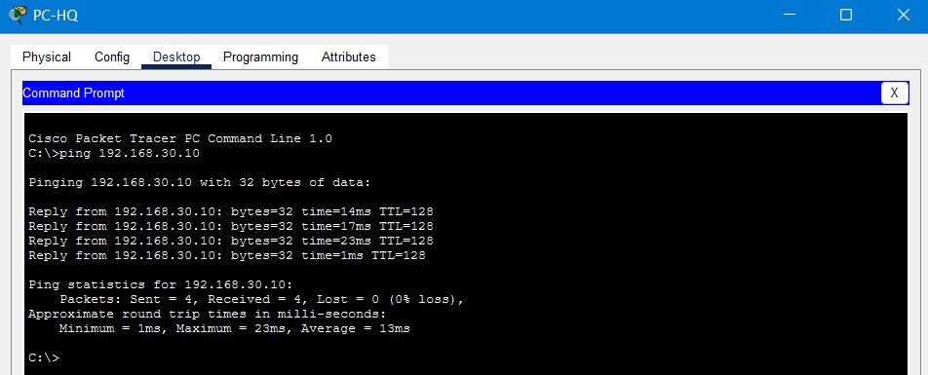
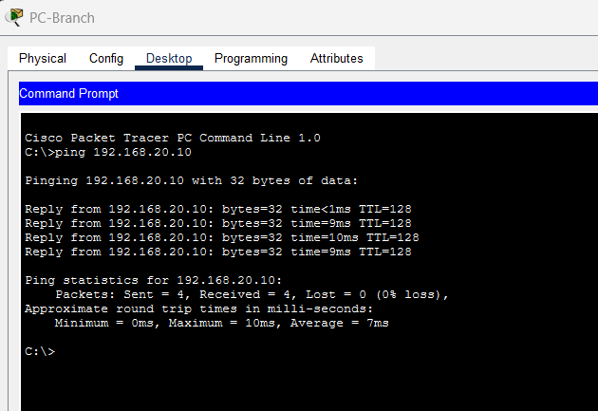

F03:
## 1. Fault Description (F03)
- The Problem: The source or destination subnet defined in the crypto ACL on R1-HQ is misconfigured to an incorrect network range.
- The Symptom: Phase 1 (show crypto isakmp sa) will look completely healthy (QM_IDLE), but pings will time out, and your IPsec security associations (show crypto ipsec sa) will show 0 packets processed or fail to trigger because the traffic fails the ACL match criteria.
- 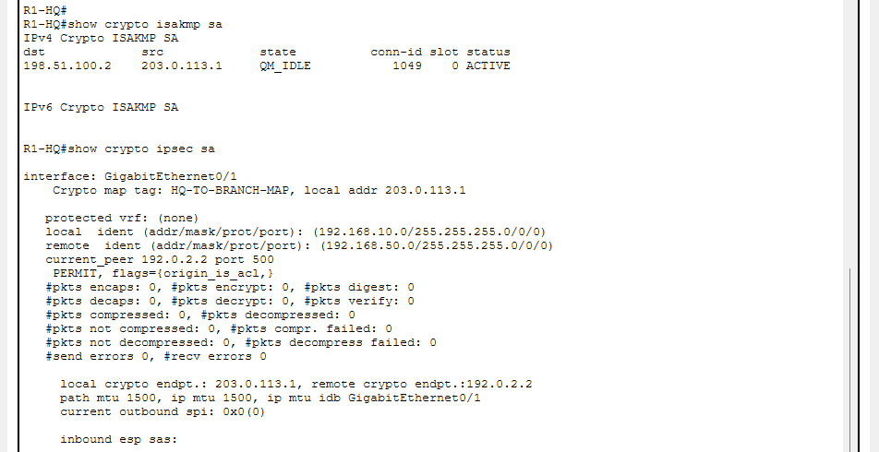

## 2. How to Inject F03
- Let's simulate the fault on R1-HQ by changing the permitted source subnet in the crypto access list to an incorrect network (192.168.99.0/24 instead of 192.168.30.0/24):
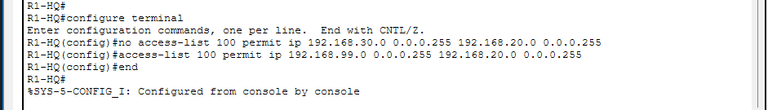

## 3. How to Diagnose F03
Once injected, run your diagnostic checks on R1-HQ:
- Test Connectivity:
  - Go to PC-HQ (192.168.30.10) and ping 192.168.20.10. Notice the request times out.
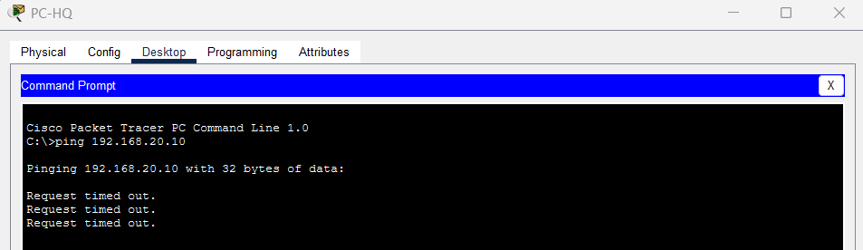
- Check Phase 1 (ISAKMP):
  - Run show crypto isakmp sa $→$ It will show QM_IDLE (Phase 1 is up and fine!).
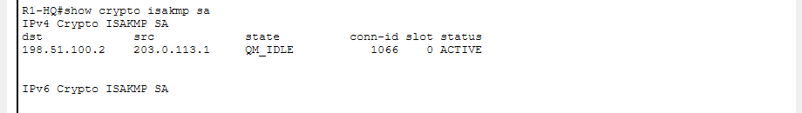
- Check IPsec SAs and Traffic Match:
  - Run show crypto ipsec sa $→$ Notice that packet counters remain at 0 because no traffic is matching the incorrect ACL rule.
- Inspect the Access List:
  - Run show access-lists to review the active rules bound to your crypto map and spot the subnet discrepancy.

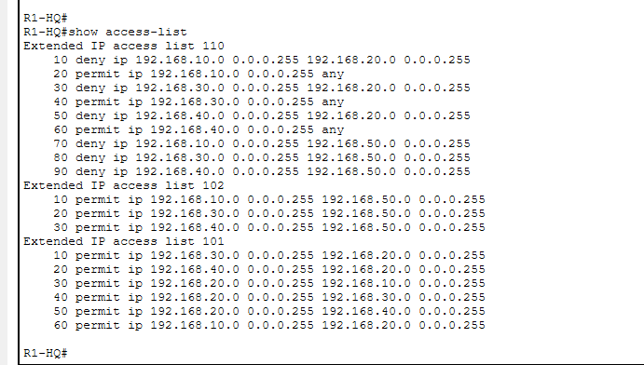

## 4. How to Fix F03 (Remediation)
To resolve the fault and restore normal operation, correct the ACL back to the proper subnet:
Plaintext
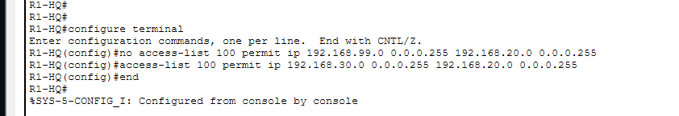

## Experiment 4 (F04): Crypto Map Peer IP Mismatch
In an enterprise VPN, the crypto map on the gateway must point to the exact public IP address of the peer gateway. If the peer IP address is misconfigured, the router won't know where to send the ISAKMP and IPsec traffic.
Step 1: Inject F04 on R1-HQ
Go to R1-HQ and change the peer IP address in the crypto map to an incorrect destination (198.51.100.99 instead of 198.51.100.2):
configure terminal
crypto map HQ-TO-BRANCH-MAP 10 ipsec-isakmp
set peer 198.51.100.99
end

Step 2: Test and Diagnose the Symptoms
- Go to PC-HQ (192.168.30.10) and try pinging 192.168.20.10. The pings will time out.
- Return to R1-HQ and check your ISAKMP associations:
  - Run show crypto isakmp sa $→$ Notice that Phase 1 fails to initialize or stays completely blank because the router is attempting to negotiate with a non-existent or incorrect peer IP address.
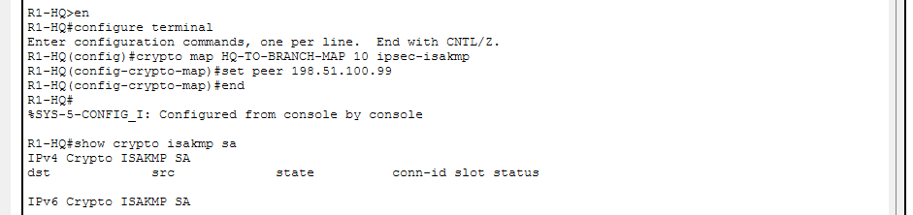
  - Run show crypto map $→$ Inspect the active crypto map configuration and spot the incorrect peer address
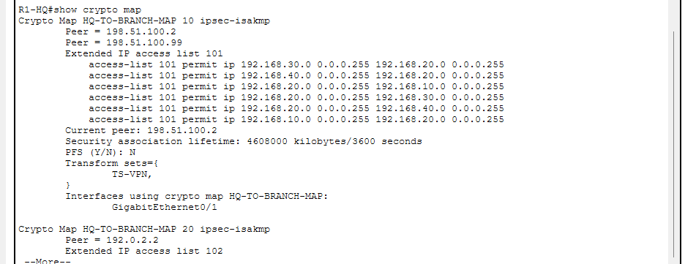

Step 3: Fix F04 & Verify
- Once you've observed the behavior and documented it for your lab report, correct the peer IP back to the proper branch address:
    - configure terminal
    - crypto map HQ-TO-BRANCH-MAP 10 ipsec-isakmp
    - set peer 198.51.100.2
    - end
- Then, clear/reset ISAKMP or send a fresh ping from PC-HQ to verify that the tunnel recovers successfully!

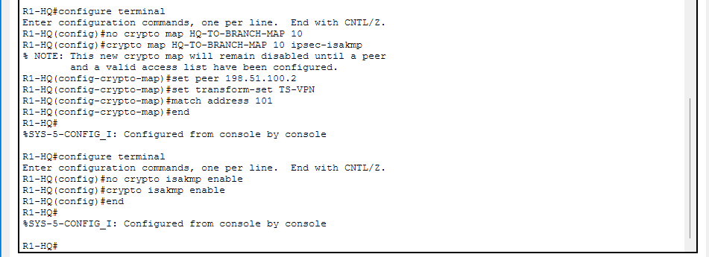
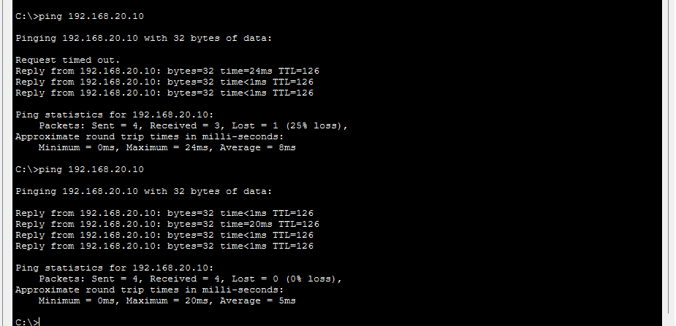

Experiment 5 (F05): Crypto Map Not Applied to Interface
## 1. Fault Description (F05)
- The Problem: The crypto map HQ-TO-BRANCH-MAP is completely unlinked from the outward-facing interface (GigabitEthernet0/1).
- The Symptom: Pings from PC-HQ to PC-Branch will fail and time out completely. Phase 1 (show crypto isakmp sa) will remain completely blank because the router's interface is not intercepting or processing traffic with the crypto engine.
## 2. How to Inject F05
Let's simulate this fault on R1-HQ by removing the crypto map binding from GigabitEthernet0/1:
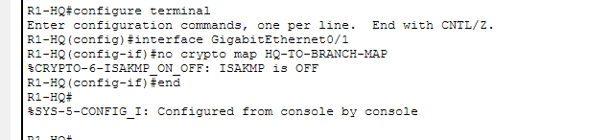
## 3. How to Diagnose F05
Once injected, run your diagnostic commands on R1-HQ:
- Test Connectivity:
  - Go to PC-HQ (192.168.30.10) and ping 192.168.20.10 $→$ Timed out.
- Check ISAKMP Associations:
  - Run show crypto isakmp sa $→$ Notice that Phase 1 fails to start up or remains completely empty.
- Check Crypto Map Binding:
  - Run show crypto map $→$ Scroll down to the bottom and look at the line Interfaces using crypto map HQ-TO-BRANCH-MAP:. You will notice it is completely blank or missing GigabitEthernet0/1!
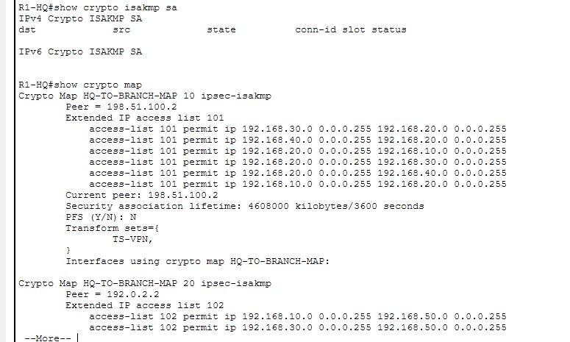

## 4. How to Fix F05 (Remediation)
To resolve the fault and rebind the crypto map to the interface:
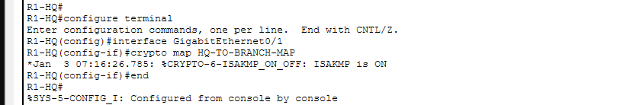
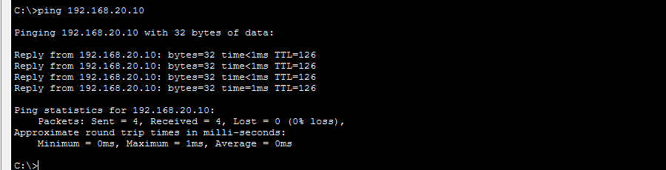

Experiment 6 (F06): Perfect Forward Secrecy (PFS) Mismatch
## 1. Fault Description (F06)
- The Problem: PFS is enabled on R1-HQ (requiring a specific Diffie-Hellman group like group2), but the peer branch router (R2-Branch) has PFS disabled or configured for a different DH group.
- The Symptom: Phase 1 (show crypto isakmp sa) will look completely healthy (QM_IDLE), but Phase 2 security associations will fail to establish, or traffic will fail to encrypt/decrypt because the peers disagree on whether (or which) DH group to use for generating fresh session keys.
## 2. How to Inject F06
Let's simulate this fault on R1-HQ by enabling PFS with a specific group on your crypto map, while the branch router does not match it:
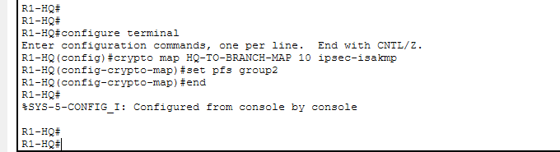
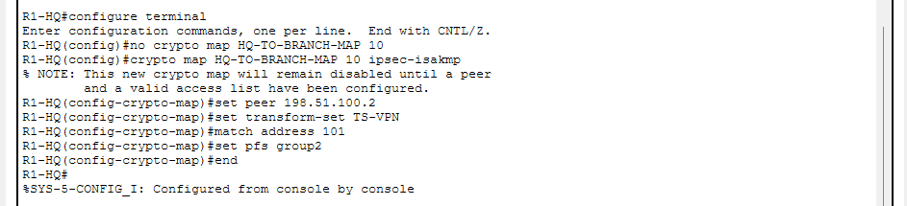
## 3. How to Diagnose F06
Once injected, run your diagnostics on R1-HQ:
- Test Connectivity:
  - Go to PC-HQ (192.168.30.10) and ping 192.168.20.10 $→$ Timed out.
- Check ISAKMP (Phase 1):
  - Run show crypto isakmp sa $→$ Shows QM_IDLE (Phase 1 is up!).
- Check IPsec SAs (Phase 2):
  - Run show crypto ipsec sa $→$ Look closely at the output; you will see that Phase 2 security associations are failing to negotiate or remain missing/inactive because of the PFS mismatch.
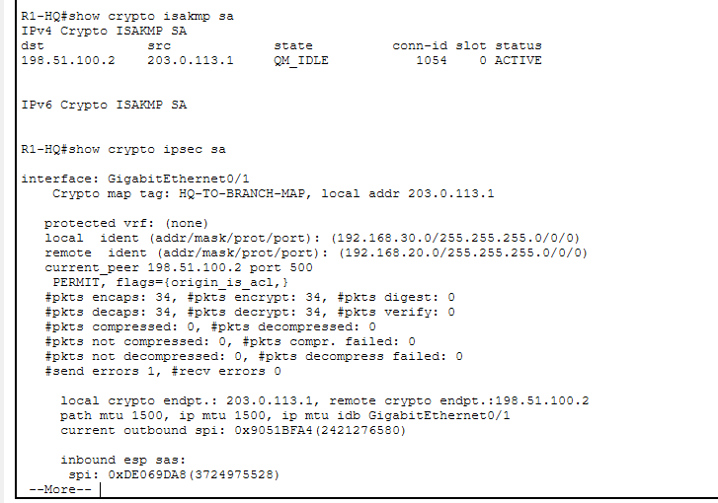
## 4. How to Fix F06 (Remediation)
To resolve the fault and align the PFS settings between both routers (or disable it if not required by your topology, e.g., setting no pfs):
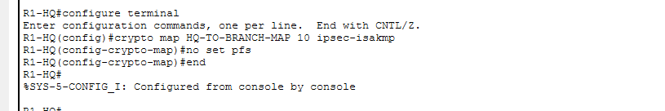
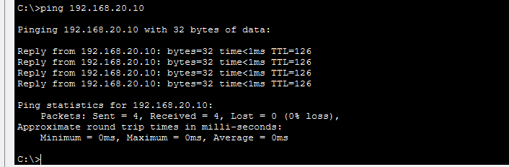

Experiment 7 (F07): Crypto Access List (Proxy ID) Mismatch
## 1. Fault Description (F07)
- The Problem: The crypto access list on R1-HQ (access-list 101) is misconfigured or mismatched relative to the branch router (e.g., the source and destination subnets are swapped or pointing to the wrong network range).
- The Symptom: Phase 1 (show crypto isakmp sa) will remain completely healthy (QM_IDLE), but Phase 2 will fail because the two routers cannot agree on what traffic is supposed to be encrypted.
## 2. How to Inject F07
Let's simulate this fault on R1-HQ by modifying access list 101 to point to an incorrect source subnet:

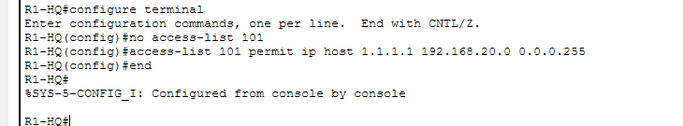

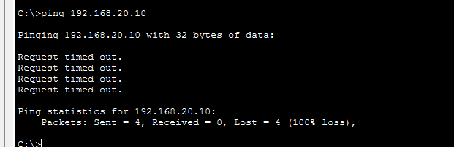
## 3. How to Diagnose F07
Once injected, run your diagnostics on R1-HQ:
- Test Connectivity:
  - Go to PC-HQ and ping 192.168.20.10 $→$ Timed out.
- Check ISAKMP (Phase 1):
  - Run show crypto isakmp sa $→$ Shows QM_IDLE (Phase 1 is fine).
- Check Crypto SAs / Debugs:
  - Run show crypto ipsec sa $→$ You will notice Phase 2 SAs fail to establish, or you'll see proxy ID mismatch errors in system messages.

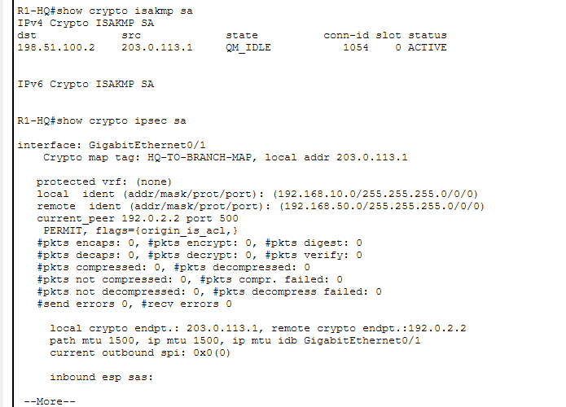

## 4. How to Fix F07 (Remediation)
To resolve the fault and restore the correct interesting traffic ACL matching the branch router:

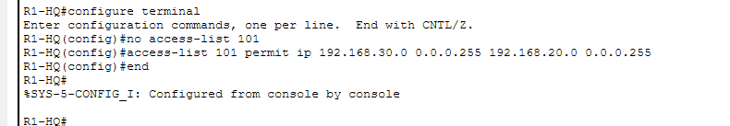

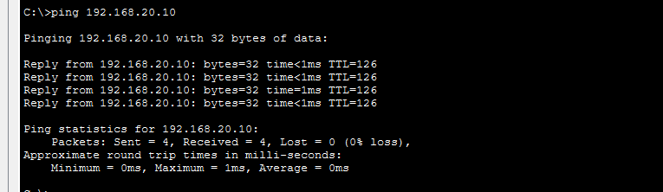

Experiment 8 (F08): Phase 2 Transform-Set Mismatch
## 1. Fault Description (F08)
- The Problem: The transform-set on R1-HQ is misconfigured or uses an algorithm that doesn't match the branch router (for example, R1 expects esp-aes while the branch expects esp-3des or esp-des).
- The Symptom: Phase 1 (show crypto isakmp sa) will remain healthy (QM_IDLE), but Phase 2 security associations will fail to establish because the peers cannot agree on how to encrypt and sign the actual data.
## 2. How to Inject F08
Let's simulate this fault on R1-HQ by changing the transform-set definition to an incompatible algorithm:
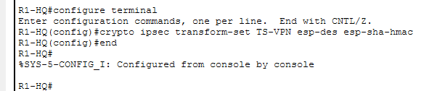
## 3. How to Diagnose F08
Once injected, run your diagnostics on R1-HQ:
- Test Connectivity:
  - Go to PC-HQ and ping 192.168.20.10 $→$ Timed out.
- Check Phase 1 (show crypto isakmp sa):
  - Shows QM_IDLE (Phase 1 is completely fine).
- Check Phase 2 (show crypto ipsec sa):
  - Active SAs will fail to negotiate or stay missing due to the transform-set disagreement.

