**Steganography** : It is the technique of hiding secret data within an ordinary, non-secret, file or message in order to avoid detection; the secret data is then extracted at its destination. The use of steganography can be combined with encryption as an extra step for hiding or protecting data. .It is a method of hiding secret data, by embedding it into an audio, video, image or text file. It is one of the methods employed to protect secret or sensitive data from malicious attacks.

There are various techniques to perform steganography. One of the method is using python script which is used in this experiment:

**The python script which we will be using for our experiment is:**

**# This script hide's text behind any media file like jpg file, mp3 file ecetera.**

**# This script accepts two parameter for hiding text and one parameter for finding text.**

**# Please install steganography python library by - pip install steganography**

**# This script is compatible with python 2.7**

**from _future_ import absolute_import,unicode_literals**

**import argparse**

**from steganography.steganography import Steganography**

**parser=argparse.ArgumentParser()**

**parser.add_argument("--carrier",help="Give path of carrier file which will contain our text.")**

**parser.add_argument("--stego_text",help="Enter text to hide.")**

**parser.add_argument("--stego_find",help="Give path of image which contains hidden text.")**

**args=parser.parse_args()**

**# Function for hide the message**

**def hideText(carrier_path,secret_text):**

**path=carrier_path**

**output_path="stego.png"**

**text=secret_text**

**Steganography.encode(path,output_path,text)**

**# Function for finding and detecting steganography**

**def findText(steg_img):**

**secret_text=Steganography.decode(steg_img)**

**print "Hidden text found :: "+secret_text**

**if args.carrier:**

**carrier_path=args.carrier**

**if args.stego_text:**

**secret_text=args.stego_text**

**hideText(carrier_path,secret_text)**

**if args.stego_find:**

**steg_img=args.stego_find**

**findText(steg_img)**

**Tools required to perform this experiment:**

* Linux OS
* Python3
* Pip Steganography package
* Stego.py script to run

**Installation and Steganography Process:**

**Step 1:** Firstly install python in the system. We can use the command the below commands to install python:

*sudo apt-get install python3*

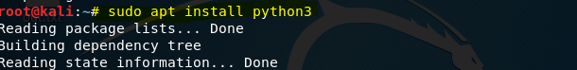

**Step 2:** Then, we need to install python pip in our system

***sudo apt-get install python-pip***

**pip is a standard package-management system used to install and manage software packages written in Python.**

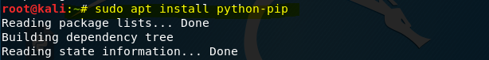



**Step 3:** After installing pip, we need to install pip Steganography package: We can do so by typing the following command:

*pip install steganography*

This package is basically used to perform steganography using python scripts.

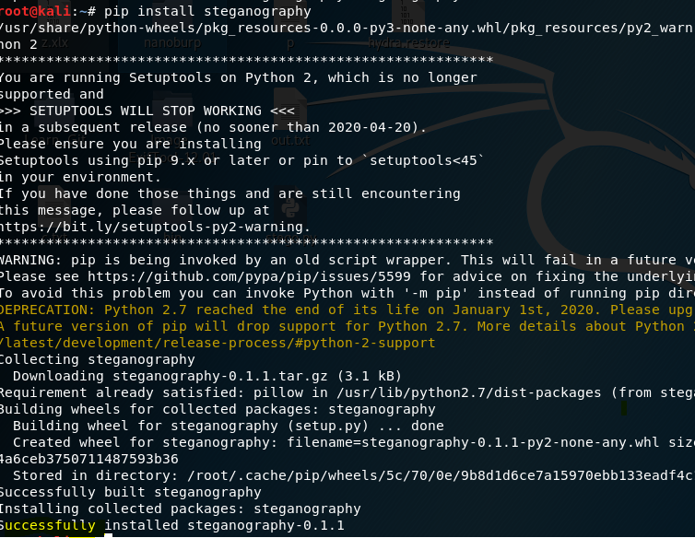

**Step 4:** After this, we will write a command to make our python file stego.py executable. Chmod is used to change the mode of the file.

*chmod -x stego.py*

***here x is for executable mode***

**

**s Step 5:** After that we can call for --help .

Type **“python stego.py --help**” to access the help menu.

*python stego.py --help*

This will display the various functions we can do with this file

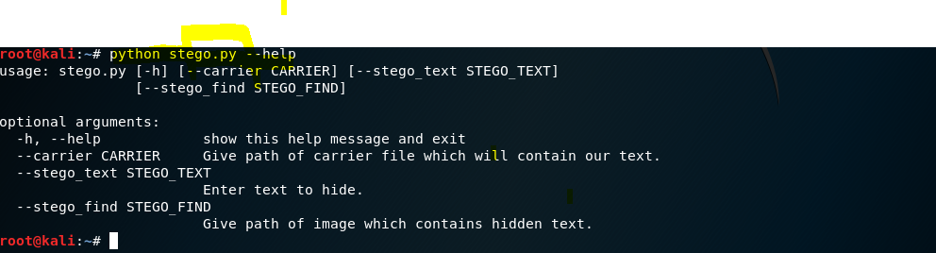

**Step 6:** Now we’ll hide our secret message into the **shrishty.jpg** by write the following command:

***python stego.py --carrier shrishty.jpg --stego_text GO_CORONA_GO***



Here **--stego_text is stego function use to take text as input and “GO_CORONA_GO” is our secret message.**

**This command will create a new stego.png and hides that hidden message into that shrishty.jpg.**



**Step 7:** Now we’ll find out secret message inside the newly created stego.png. And we’ll do so by using stego function called STEGO_FIND. For this we’ve to write the following command:

python stego.png –stego_find stego.png



As we can see, this find function has find out our hidden message –

**“GO_CORONA_GO”**