Steps for implementing project

1. Firstly we will create data_dump.py
2. Secondly run template.py
3. Then, run setup.py for creating python package, 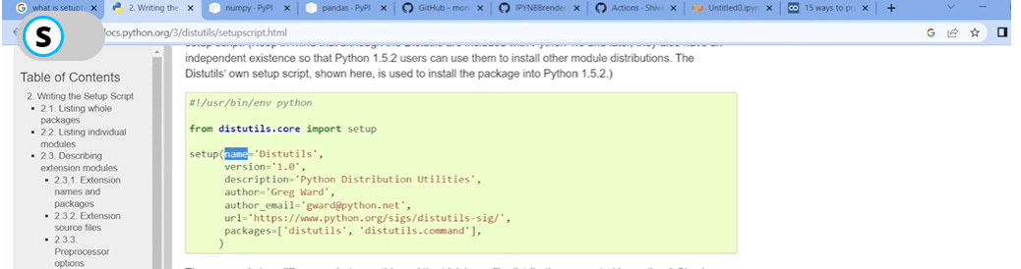
4. Notes:
   1. -e . means editable mode and . is current directory.
   2. After installing setup.py file there is no need of –e . file.
   3. Egg.info will store all data in meta data form.
5. Then, write logger file and exception file.