Customer Shopping Behaviour Analysis
Analysing 3,900 Purchases using Python, MYSQL & Power BI
Project Report
Tools: Python, Pandas, MYSQL, Power BI

About This Project
- For this project, I analysed customer shopping behaviour using real transactional data from 3,900 purchases across different product categories.
- The goal was to find useful patterns — things like how much people spend, what they buy, who subscribes, and how discounts affect behaviour.
- I used Python to clean and prepare the data, PostgreSQL to run business analysis queries, and Power BI to build an interactive dashboard.
- The insights from this project can help businesses make smarter decisions around marketing, product placement, and customer retention.

1. About the Dataset
- The dataset has 3,900 rows and 19 columns, covering a wide range of customer and purchase details.
- Here’s what kind of data is in it:
Category | Columns Included
Customer Info | Age, Gender, Location, Subscription Status
Purchase Details | Item Purchased, Category, Purchase Amount, Season, Size, Color
Shopping Behaviour | Discount Applied, Promo Code Used, Previous Purchases, Frequency, Review Rating, Shipping Type

- One issue I found: 37 values were missing in the Review Rating column — I fixed those during the cleaning step.

2. Tools I Used
Tool | What I Used It For
Python + Pandas | Cleaning and preparing the data
MYSQL | Running business analysis queries
Power BI | Building the interactive dashboard

3. How I Cleaned the Data (Python)
- Loaded the dataset with Pandas and used df.info() and .describe() to understand its structure.
- Filled in the 37 missing Review Rating values using the median rating for each product category — this way the imputed values made sense in context.
- Renamed all columns to snake_case for consistency (e.g., ‘Purchase Amount’ → ‘purchase_amount’).
- Created two new columns: age_group (to group customers by age range) and purchase_frequency_days (calculated from purchase data).
- Checked if discount_applied and promo_code_used were saying the same thing — they were, so I dropped promo_code_used to avoid redundancy.
- Finally, connected Python to PostgreSQL and loaded the cleaned data into the database for SQL analysis.

4. SQL Analysis (MYSQL)
- Once the data was in PostgreSQL, I wrote 10 queries to answer specific business questions:
# | What the Query Answers
1 | Revenue by Gender — how much do male vs. female customers spend in total?
2 | High-Spending Discount Users — which customers used discounts but still spent above average?
3 | Top 5 Products by Rating — which products have the highest average review scores?
4 | Shipping Type Comparison — do Express shipping customers spend more than Standard?
5 | Subscribers vs. Non-Subscribers — who spends more and generates more total revenue?
6 | Discount-Dependent Products — which 5 products have the most discounted purchases?
7 | Customer Segmentation — classified customers into New, Returning, and Loyal based on purchase history.
8 | Top 3 Products per Category — the most purchased items within each product category.
9 | Repeat Buyers & Subscriptions — are customers with 5+ purchases more likely to subscribe?
10 | Revenue by Age Group — which age group contributes the most to total revenue?

- These queries gave me a really clear picture of who the customers are, what they buy, and what drives their spending.

5. Power BI Dashboard
- I used the SQL query results to build an interactive Power BI dashboard showing all the key insights in one place.
- Key numbers: 3.9K total customers, average purchase amount of $59.76, and an average review rating of 3.75.
- The dashboard covers revenue and sales by category and age group, subscription status breakdown (27% Yes, 73% No), review ratings by category, and filters for gender, subscription, category, and shipping type.

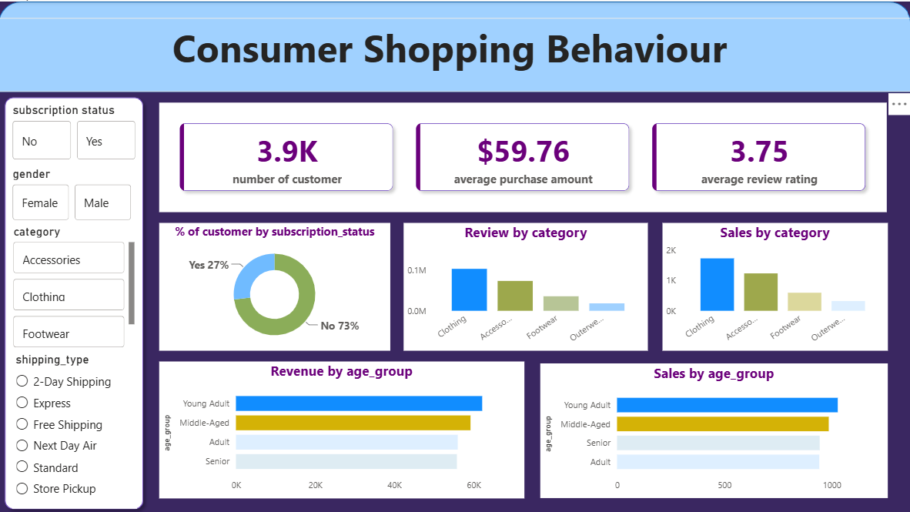

6. Conclusion
- This project took a raw shopping dataset and turned it into actionable business insights.
- Through Python cleaning, PostgreSQL analysis, and a Power BI dashboard, I was able to answer real business questions about customer spending, product performance, and subscriber behaviour.
- It was a great end-to-end data project that covered the whole pipeline from messy data to clear visuals.

7. References
- Pandas Documentation – https://pandas.pydata.org/docs/
- PostgreSQL Documentation – https://www.postgresql.org/docs/
- Dataset: Customer Shopping Behaviour — 3,900 transactions

