Data Analyst Job Market Analysis
Cleaning and Analyzing Glassdoor Job Postings with Python, MYSQL & Power BI
Project Report
Tools: Python, Pandas, NumPy, Power BI, MYSQL

About This Project
- For this project, I worked with a real dataset of Data Analyst job postings scraped from Glassdoor.
- The raw data was messy — salaries were written in different formats, some values were missing (marked as -1), and fields like company name and location had extra info mixed in.
- I used Python and Pandas to clean everything up and turn it into a proper, ready-to-use dataset.
- Along the way I also created a few new columns, like average salary, company age, and flags showing which skills (Python, SQL, Excel, etc.) each job posting asks for.
- Finally, I used the cleaned data to build a Power BI dashboard to explore salary trends and in-demand skills.

1. Tools I Used
Tool | What I Used It For
Python | Main language for the whole project
Pandas | Loading, cleaning, and reshaping the data
NumPy | Handling missing values (NaN)
Power BI | Building the interactive dashboard
MySQL | Storing cleaned data and running analysis queries
Jupyter Notebook | Connecting to MySQL and running everything together
CSV files | Input file: DataAnalyst.csv.zip → Output: cleaned_data2.csv

2. About the Dataset
- The data comes from DataAnalyst.csv.zip — a collection of Data Analyst job postings from Glassdoor.
- It includes things like job title, salary estimate, job description, company rating, company name, location, company size, founding year, industry, sector, and more.
- Here's what was wrong with it before cleaning:
- Salary Estimate was a messy text string like ‘$53K-$91K (Glassdoor est.)’ or ‘Employer Provided Salary: $74K-$83K’.
- Rating and Founded used -1 to represent missing values instead of actually being blank.
- Company Name had the company's rating stuck onto the end with a line break.
- Location combined the city and state into one field, like ‘New York, NY’.
- Job Description was just a big block of text — useful info about required skills was buried inside it.

3. How I Cleaned the Data
- Here's a step-by-step breakdown of what I did in Python using Pandas.

3.1 First Look at the Data
- Loaded the dataset with pd.read_csv() and used df.shape, df.head(), df.info(), df.isnull().sum(), and df.describe() to get a feel for it.
- Noticed that a lot of columns used -1 as a stand-in for missing values, so I replaced all of those with NaN across the whole dataset — this made columns like Rating and Founded behave properly.

3.2 Cleaning Up the Salary Column
- Wrote a function called clean_salary() to turn the messy Salary Estimate text into two clean numbers: salary_min and salary_max.
- It strips out text like ‘Employer Provided Salary:’, ‘(Glassdoor est.)’, and the ‘$’ sign.
- It checks for ‘Per Hour’ listings and converts those to yearly salaries (× 2080 hours).
- Replaces ‘K’ with ‘000’ and splits the range on the ‘-’ to get the low and high numbers.
- I added error handling so weird/unexpected formats don't crash the whole thing — they just return blank values instead.
- Then I created salary_avg as the midpoint between salary_min and salary_max.

3.3 Fixing Company Name & Location
- Split the Company Name on the line break to get rid of the rating that was stuck to it.
- Split Location into separate City and State columns (it was originally written as ‘City, State’).

3.4 Cleaning Text Columns & Adding Company Age
- Cleaned up columns like Sector, Industry, Size, and Revenue by removing extra spaces and making the capitalization consistent.
- Added a new company_age column by subtracting the founding year from the current year.

3.5 Removing Duplicates & Bad Rows
- Dropped exact duplicate rows.
- Removed any rows missing a Job Title or Company Name, since those are pretty essential.
- Reset the index afterward so everything stays in order.

3.6 Finding Skills Mentioned in Job Descriptions
- Checked each job description for 10 common skills: python, sql, excel, tableau, power bi, r, machine learning, statistics, pandas, and spark.
- For each skill, I added a new column with a 1 or 0 depending on whether that skill was mentioned.
- This makes it really easy to count how often each skill shows up across all the job postings.

3.7 Final Cleanup & Saving the File
- Made all column names lowercase with underscores instead of spaces (e.g., ‘Salary Estimate’ → ‘salary_estimate’).
- Dropped the leftover index column that came from the original CSV.
- Saved everything to a new file: cleaned_data2.csv.

4. What the Cleaned Dataset Looks Like
- Along with the original columns (now cleaned up), here are the new columns I added:
Column | What It Means
salary_min / salary_max | Lowest and highest salary in the range, in yearly dollars
salary_avg | Average of salary_min and salary_max
company_name | Just the company name, rating removed
city / state | Location split into two separate columns
founded_year / company_age | Year the company was founded, and how old it is now
python, sql, excel, tableau, power_bi, r, machine_learning, statistics, pandas, spark | 1 if that skill is mentioned in the job posting, 0 if not

5. SQL Analysis (MySQL)
- After cleaning the data in Python, I loaded it into a MySQL database (job_market_db, table: jobs) and connected to it from Jupyter Notebook.
- From there, I wrote 10 SQL queries to dig into the data and pull out useful insights — these results are what I used to build the Power BI dashboard.
# | What the Query Finds
1 | Top 10 companies hiring the most Data Analysts
2 | Average salary (min, max, and overall) for the top 10 job titles
3 | Top 10 locations with the most job postings and their average salary
4 | Most in-demand skills overall, ranked by how often each one appears
5 | Whether companies with better ratings tend to pay more (rating vs. average salary)
6 | How many jobs ask for Python only, SQL only, both, or neither
7 | How job postings split across salary ranges (under $50k, $50k-$70k, etc.)
8 | Which skills show up most often in jobs that pay above the average salary
9 | Skill demand broken down by job title — which titles ask for which skills the most
10 | Top 10 locations with the highest average salary (only locations with more than 5 jobs)

- These query results gave me a clear picture of which skills, companies, and locations matter most — and that's exactly what I turned into visuals for the Power BI dashboard below.

6. Power BI Dashboard
- Once the data was clean, I built a Power BI dashboard called ‘Job Market Analyser’ to explore it visually.
- Top numbers: average salary around 2.25K, average company rating of 3.73, and around 2,252 total jobs.
- It shows the top hiring companies, the most in-demand skills (SQL, Excel, Python, Tableau, and Statistics come out on top), top locations by job count and by pay, and how company ratings relate to salary.
- There are also filters for salary range, rating, and location so you can explore the data interactively.
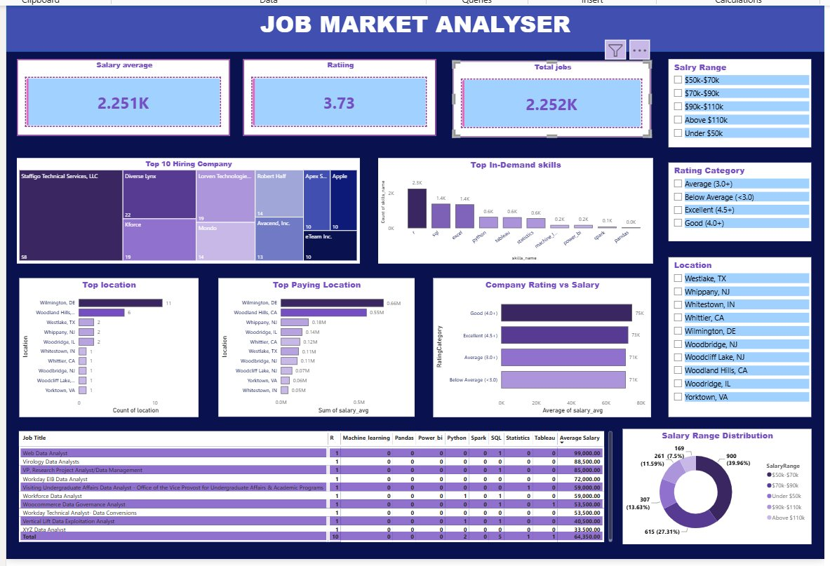

7. Conclusion
- Overall, this project took a messy, real-world dataset and turned it into something clean and usable.
- I fixed the missing values, sorted out the salary numbers, cleaned up text fields, and added useful new columns like company age and skill flags.
- The final cleaned dataset (cleaned_data2.csv) and the Power BI dashboard together give a good picture of salary trends and which skills are most in demand for Data Analyst roles.

8. References
- Pandas Documentation – https://pandas.pydata.org/docs/
- NumPy Documentation – https://numpy.org/doc/
- MySQL Documentation – https://dev.mysql.com/doc/
- Dataset Source: Glassdoor Data Analyst job postings dataset (DataAnalyst.csv)

