Research Design
In the previous section we identified some of the concerns related to fragmentation of the records and how important it is to have a holistic approach in the mental health support providing services. In this section we will identify the users of the system, what are their actual requirements from the system, what components should the system have and all the workflows through different diagrams.

Use Case Diagram
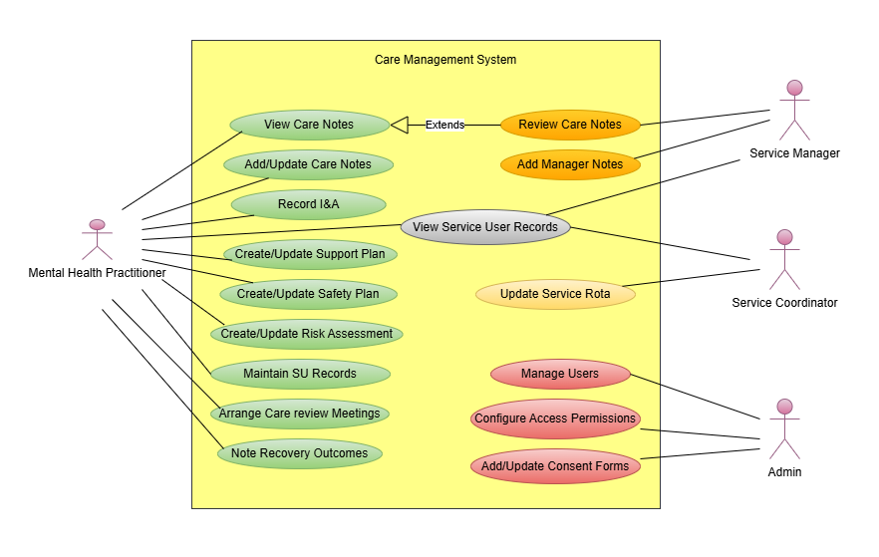
Use Case Diagram
In mental health care providing services, there are a lot of processes which need to be documented in the same platform for better accessibility, planning, reporting, and assessments. This documentation is mainly the responsibility of the support practitioners providing support to the clients or service users. This includes creating care notes after every support session, recording incidents and accidents during support sessions, creating and updating support plans, risk assessments, safety plans after every six months, arranging care review meetings with the care managers of the service users after every six months and writing the key outcomes derived from that meeting to take actions on, maintaining the service users records related to their mental health condition, past care history, contacts, mental health team, GP, etc. Apart from care notes and I&A reports, the rest of the operations are carried out by keyworkers who are basically assigned practitioners for every service user. A support plan is basically the plan decided by the service user, care manager, and service management to frame the goals to achieve during the support session. Risk Assessment has different sections like risk to others, risk to children, risk to self, risk to environment, etc., and ranges from high to low to mark accordingly. This decides what aspect needs more attention in terms of risk. Safety plans as the name suggests is a plan to handle the situation when the service user is in crisis, showing self-harming or suicidal tendencies which is pretty common in individuals with mental health disorders.
The secondary users of the system are Service Manager, Service Coordinator, and Administrator. So every organisation usually tends to have one service manager who basically monitors the service quality and plans necessary strategies along with its team of practitioners to improve it further. Additionally, managers can add any facts or strategies they want to highlight for a particular service user through the Manager Notes component. The service coordinator is mainly responsible for the service delivery by planning the rota for both the practitioners and service users. Whereas admin is responsible for creating and maintaining user accounts along with configuring access permissions to every user based on their job role. Another responsibility of the admin is to update the consent forms of all the service users yearly. Consent forms basically hold the permissions needed by the organisation to store the information of the service users. However, unlike other users admin is not allowed to view the records of service users to maintain their privacy. Each actor interacts with the system based on their specific responsibilities within the organisation. The use case diagram helps define the system’s functional requirements by identifying how each user interacts with the system and what actions they are allowed to perform. By modelling these interactions during the design phase, the system requirements can be clearly understood before implementation.

Activity Diagram
The activity diagram represents the workflow involved in creating and updating a risk assessment for a service user. It is important to note that all other similar components following the same process are not represented in this section.
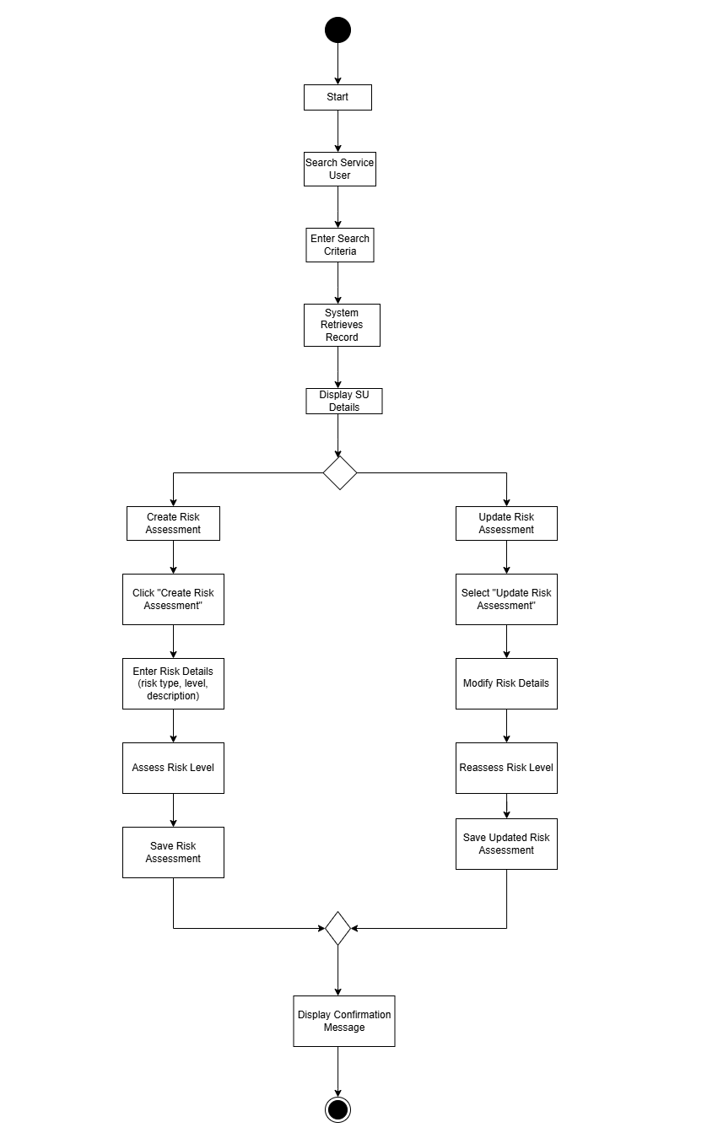
Activity Diagram
The purpose of this diagram is to illustrate the sequence of actions that occur when a practitioner evaluates and records the different risk sections of a service user within the system. The process starts when the practitioner using its credentials logins to the system and then searches the relevant service user using either their name or service user ID. The system then retrieves the record and the practitioner can either click on create risk assessment to create a new one or update the risk assessment to update the old one.

The practitioner is required to mention the risk types, risk levels, and description of each aspect like risk to others, risk to self, risk to health, risk to children, risk to environment, risks in house, etc. The practitioner checks the risk level either high, medium, or low based on the service user’s current or recent condition, behaviour, and other support information. Once the information is saved the system loads a confirmation message. This activity diagram helps to visualise the operational workflow of risk assessment management and ensures that the system supports a structured process for updating critical service user information.

Sequence Diagrams
In order to understand the workflow some sequences like creating a care note, creating a user, and creating a support plan are explained in this section sequentially.
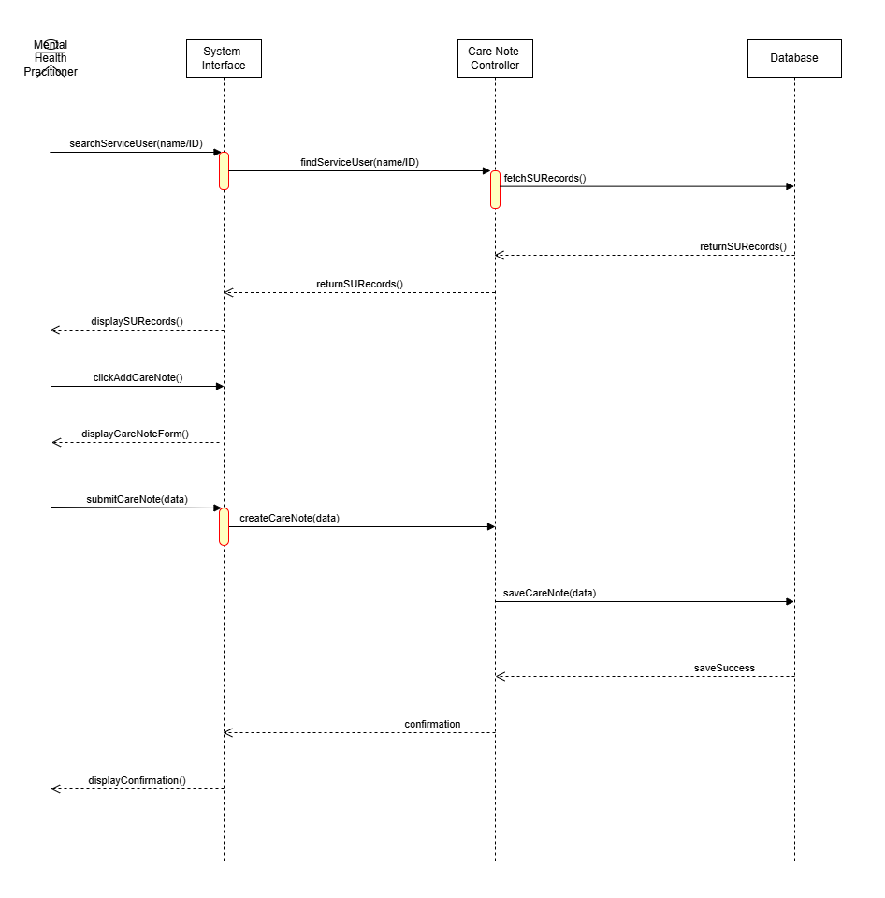
Care Note Sequence
The first sequence diagram is for creating a care note. This shows how different components of the system interact with each other. Care notes are basically the generic notes of the activities or conversations that happened during the support session. They are important as they are also used to create support plans, risk assessments, and safety plans for the service users. They also highlight any major event that happened during the support session. In case the practitioner wants the manager to review the care note to draw his/her attention then they choose the checkbox for review.
After logging into the system, the practitioner searches for the relevant service user using the search criteria and the system fetches the record. The practitioner then clicks add Care Note and the form is displayed. After entering the description, along with time and date, the user submits the care note. The system then saves the care note and displays the confirmation for the same.
The sequence diagram demonstrates how the user interface, system processing layer, and database interact sequentially during this process. This clarifies how the system components communicate to successfully record and store care note information.

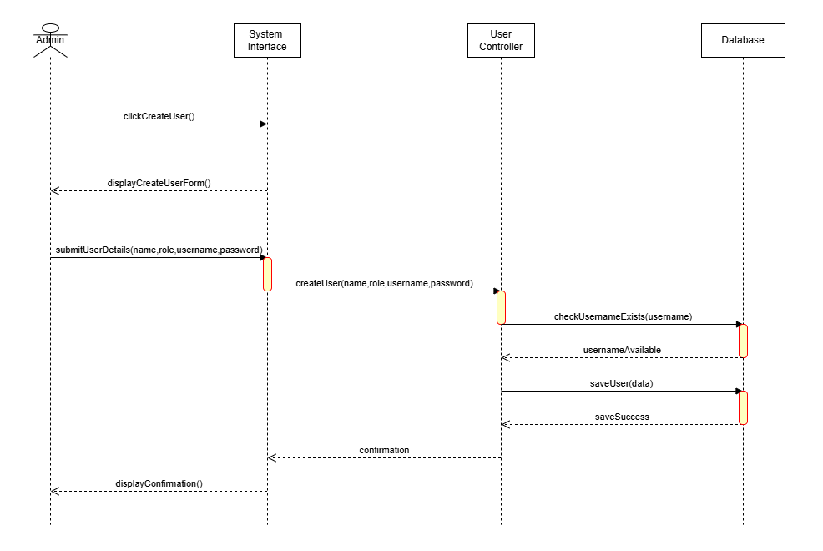
Create User Sequence
This sequence diagram shows the process through which an administrator creates a new system user account. The administrator logs into the system and selects the option to create a new user. The administrator enters user details including username, password, email address, and user type. The user type decides the level of access the individual will have within the system, such as practitioner, manager, or coordinator.
Once the information is entered, the system verifies that the username is unique and validates the data. The system stores the new user information in the database after validating successfully. The user can then log into the system using the assigned credentials.
This diagram shows how the administrator interacts with the system interface and how the system communicates with the database to create and store a new user.
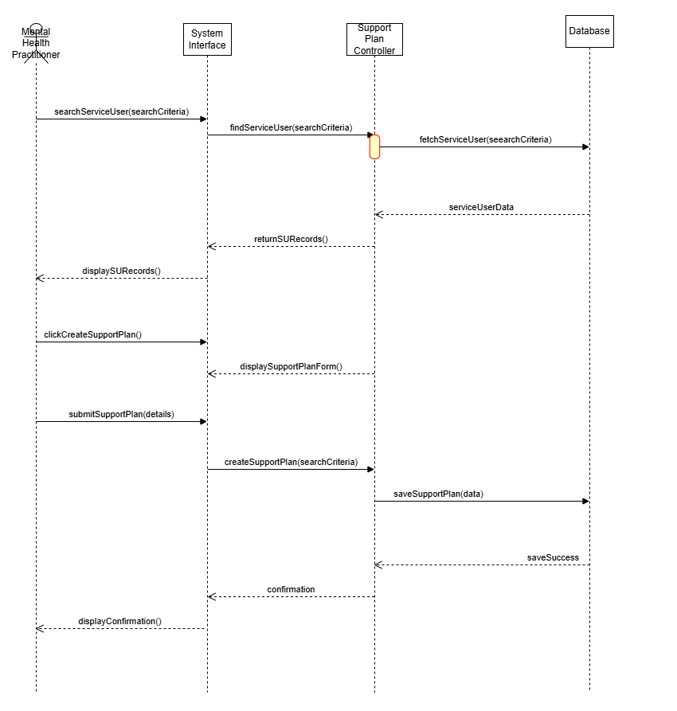
Support Plan Sequence
In this sequence diagram the mental health practitioner is creating a support plan of a service user. The practitioner firstly searches the service user using the search criteria and once the results appear the user clicks on create support plan option. The support plan form is displayed where the user submits all the details. The system then validates the data and creates the support plan. The plan has all the details regarding the challenges, strategies, interventions, and goals for the particular service user. Specifically related to daily routine, activities to do, medication guidance, emotional support strategies, etc. The support has a publish date and review date for the reference of the practitioners.

Class Diagram

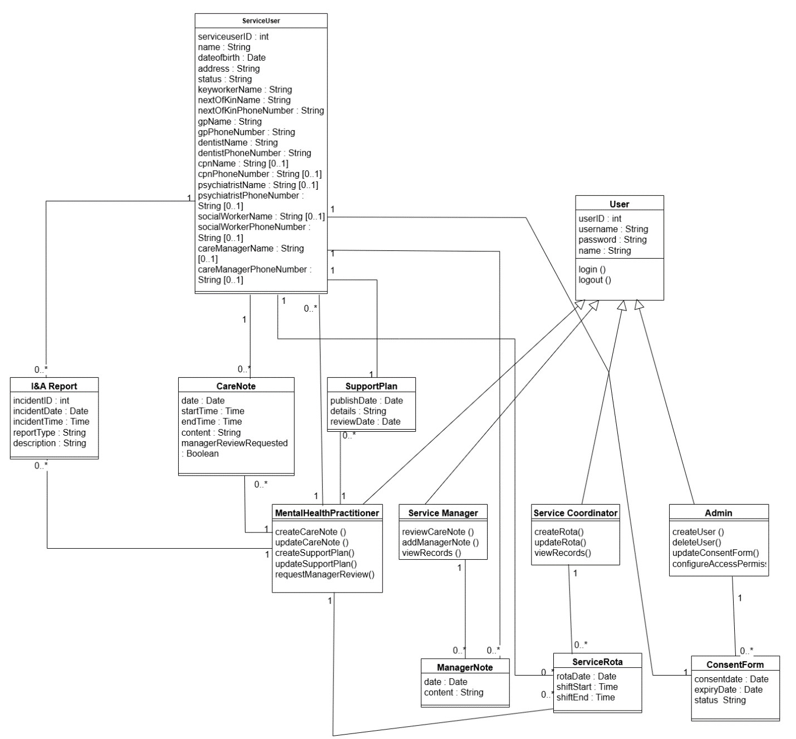
Class Diagram
The class diagram represents the object-oriented structure of the system by modelling system entities as classes. Each class contains attributes representing the data associated with it. The diagram also shows the relationships between different classes.
Classes within the system are User, ServiceUser, SupportPlan, CareNote, IncidentReport, ConsentForm, ManagerNote, and ServiceRota. Each class contains attributes that define the data stored within the system. For example, the ServiceUser class includes attributes such as service user name, contact details, status, keyworker, etc.
Relationships between classes represent how different components of the system interact. For instance, the relationship between a service user and care note is one to many which means a service user can have multiple care notes in their record. These relationships help illustrate how system objects interact within the application logic. This class diagram supports the system design by providing a structured representation of organised components and data before implementation.

ERD
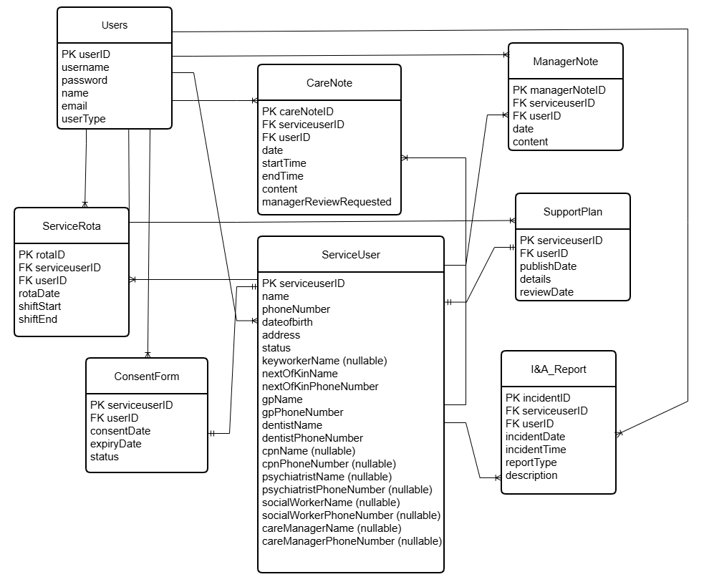
ER Diagram
The Entity Relationship Diagram represents the structure of the database. It depicts the main entities of the system and the relationships between them. All the key entities such as Users, Service Users, Support Plans, Care Notes, Incident and Accident Reports, Consent Forms, Manager Notes, and Service Rota store specific information related to service delivery and operations.
Primary keys are used to uniquely identify each record within a table, while foreign keys establish relationships between tables. For example, the service user identifier connects several tables such as support plans, care notes, and incident reports, ensuring that all records related to a specific service user remain linked. The ERD ensures that the database design supports data consistency and avoids duplication. By defining relationships between tables, the system can efficiently store and retrieve information across multiple operational processes.

Information System Architecture

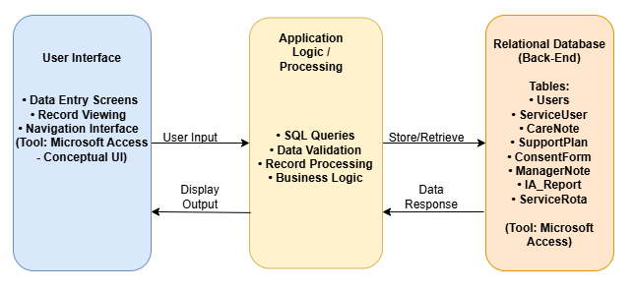
System Architecture
The information system architecture diagram represents the blueprint of the proposed care management system. The system follows a layered approach where the user interacts with the front end interface developed in MS Access which communicates with the back end database having all the tables. The data entered is processed by queries and stored in the database. This depicts how user actions are translated into the database.

