E-COMMERCE CUSTOMER ANALYTICS
Data Analytics Project Report
Python • SQL • Customer Analytics • Power BI-ready Reporting

1. Executive Summary
This project presents a complete customer analytics workflow for an e-commerce dataset. The analysis starts from the raw customer data, performs reproducible data cleaning and validation, and then develops descriptive insights around customer value, order activity, preferred categories, geography, loyalty, engagement, and the dataset-provided fraud indicator.
The central deliverable is a single Jupyter Notebook that contains the complete pipeline: raw data loading, cleaning, validation, exploratory analysis, KPI calculations, segmentation, visualizations, and business questions. The cleaned CSV produced by the notebook is suitable for downstream SQL analysis and Power BI reporting.

2. Project Objectives
- Clean and validate the raw customer dataset in a reproducible way.
- Understand customer and order-related patterns using descriptive analytics.
- Calculate meaningful business KPIs.
- Segment customers using a transparent customer-value methodology.
- Analyze preferred categories and country-level order activity.
- Study loyalty, engagement, and customer value relationships.
- Summarize the dataset-provided fraud indicator without making unsupported fraud inferences.
- Prepare a clean dataset and documentation suitable for SQL and Power BI.

3. Dataset Overview
Attribute | Details
Rows | 5,000 customer records
Columns | 13
Primary identifier | customer_id
Core customer metrics | age, avg_order_value, total_orders, loyalty_score
Engagement | email_open_rate
Dates | last_purchase, customer_since
Business dimensions | gender, country, preferred_category
Indicator fields | is_fraudulent, churn_risk

4. Data Cleaning & Preparation
The notebook performs the following cleaning pipeline:
- Standardizes column names into lowercase snake_case.
- Strips unnecessary whitespace from text fields.
- Converts numeric fields to numeric data types.
- Converts date fields to datetime.
- Removes exact duplicate rows.
- Validates logical ranges for age, order value, order count, email open rate, loyalty score, churn risk, and fraud indicator.
- Converts invalid values to missing values so they can be handled consistently.
- Fills missing numeric values using the median of the respective column.
- Fills missing categorical values using the mode.
- Runs final missing-value and duplicate checks.
- Exports the cleaned dataset as ecommerce_customer_cleaned.csv.

5. Analytical Methodology

5.1 KPI Analysis
The notebook calculates total customers, total orders, average order value, average loyalty score, and the percentage of records marked by the dataset's fraud indicator.

5.2 Customer Value
Customer value is derived as Average Order Value × Total Orders. Customers are divided into Low Value, Mid Value, and High Value groups using the 33rd and 67th percentiles. This is a transparent descriptive segmentation method, not a machine-learning model.

5.3 Category & Geography
Preferred categories are compared using customer counts, total orders, average order value, and average loyalty. Countries are compared using customer counts, total orders, and average order value.

5.4 Loyalty & Engagement
Correlation analysis and scatter visualization are used to examine relationships between loyalty score, email open rate, order activity, and derived customer value.

5.5 Fraud Indicator
The `is_fraudulent` column is treated as a dataset-provided indicator. The notebook summarizes observed records by this field and does not independently classify transactions or customers as fraudulent.

6. Visual Analysis
The following figures are generated from the same dataset and analytical definitions used in the notebook.

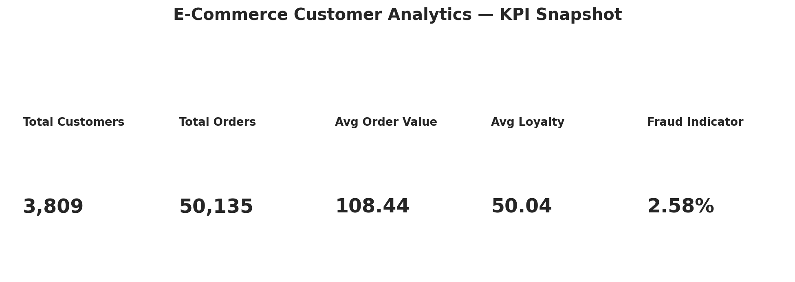
Figure 1. KPI snapshot

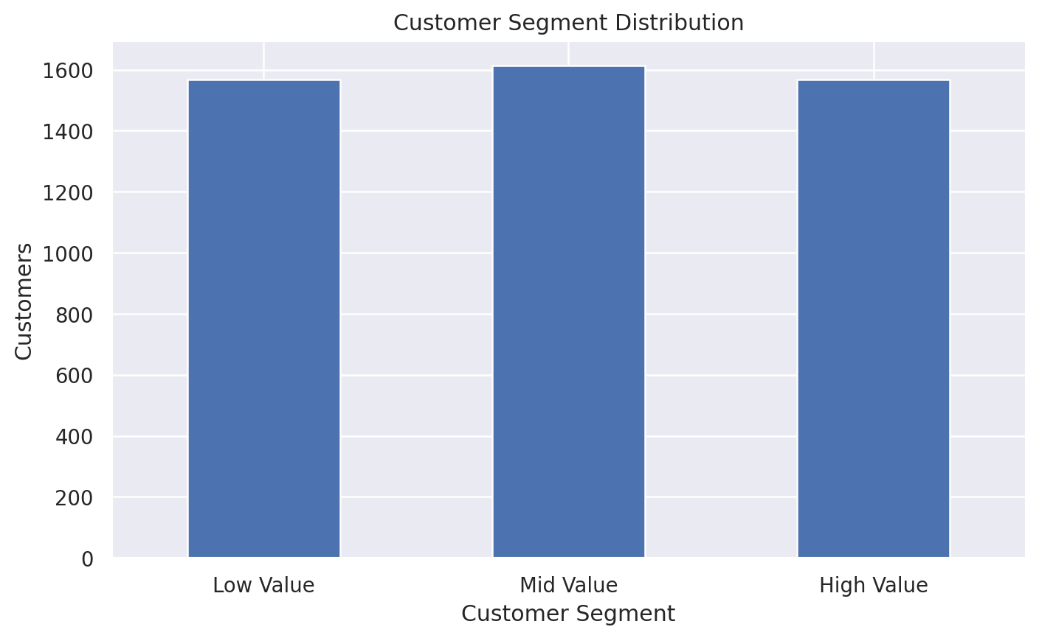
Figure 2. Customer segment distribution

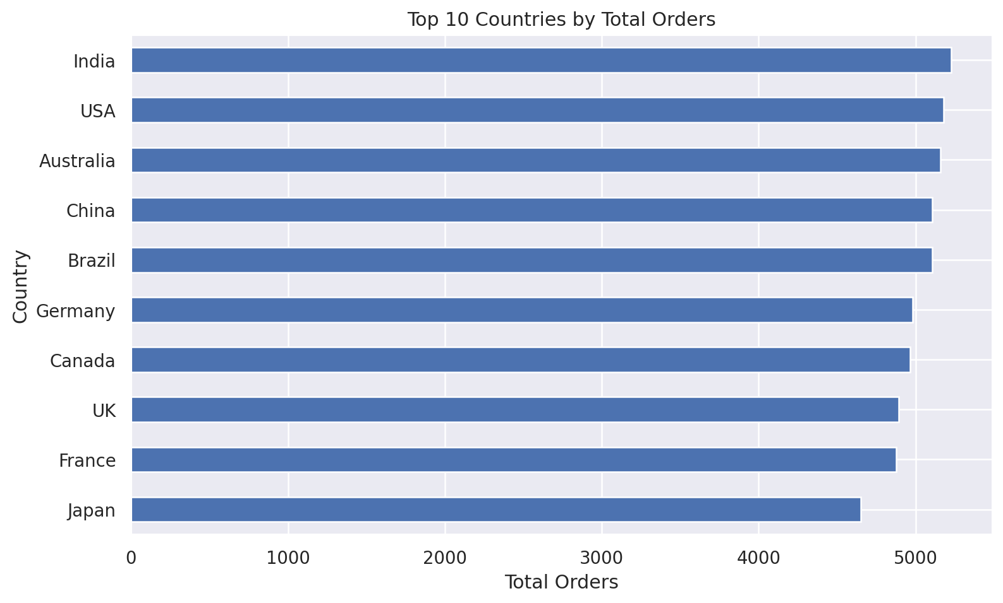
Figure 3. Top 10 countries by total orders

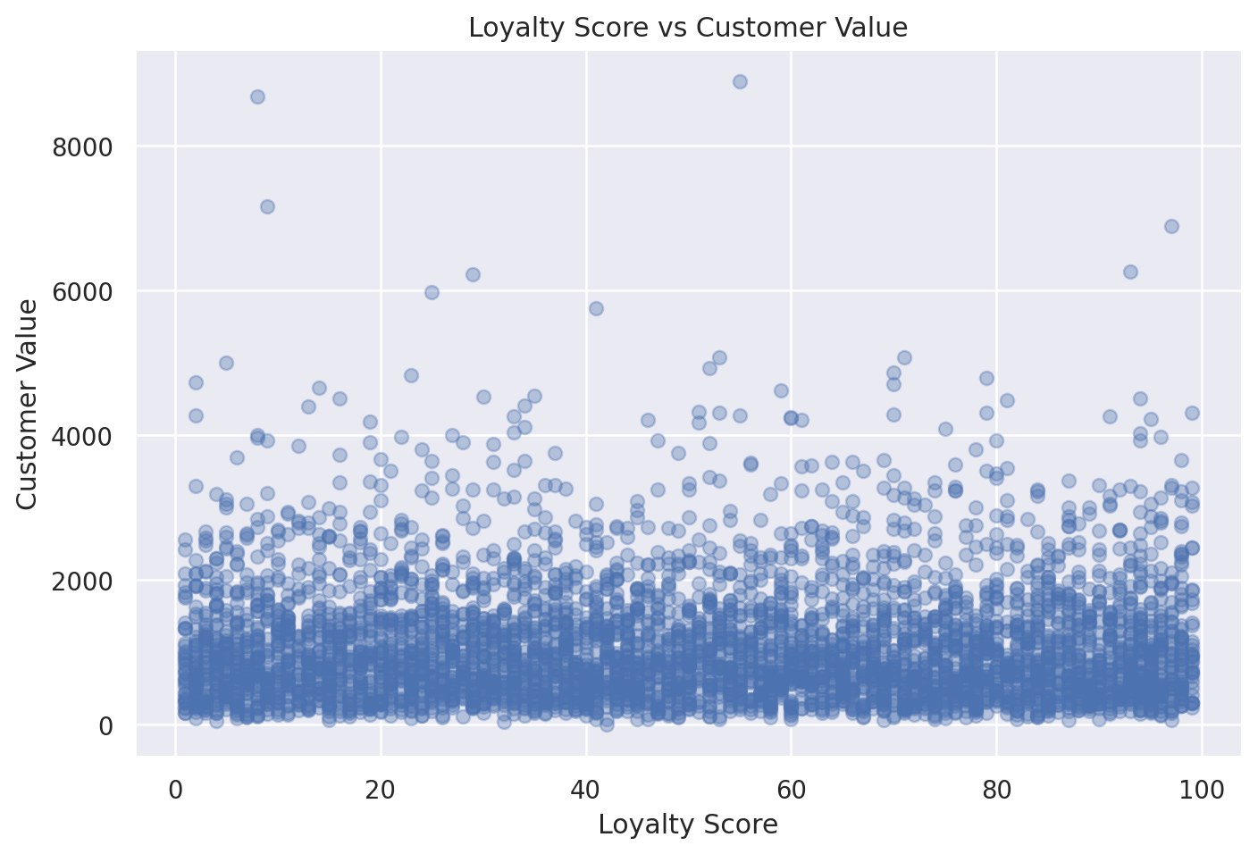
Figure 4. Loyalty score vs customer value

7. Key Analytical Outputs
Segment | Customers | Avg Customer Value | Avg Orders | Avg Order Value | Avg Loyalty
Low Value | 1,437 | 395.13 | 8.43 | 51.32 | 50.89
Mid Value | 1,474 | 894.88 | 9.97 | 96.89 | 50.00
High Value | 1,422 | 1,993.72 | 11.66 | 177.45 | 49.86

8. Business Questions Covered
- Which customer segments contain more customers and how do their average values differ?
- Which preferred categories contribute the most order volume?
- Which countries contribute the most order activity?
- How are loyalty and engagement metrics related to customer value?
- What proportion of records is marked by the dataset's fraud indicator?

9. How to Run the Project
1. Install Python 3.10+.
2. Open the project folder in VS Code, Jupyter Notebook, or JupyterLab.
3. Open Terminal in the project folder.
4. Run: pip install -r requirements.txt
5. Start Jupyter using: jupyter notebook (or jupyter lab).
6. Open ECommerce_Customer_Analytics.ipynb.
7. Run Kernel → Restart & Run All.
8. The notebook will generate ecommerce_customer_cleaned.csv and all analysis outputs.

10. Power BI Reporting
The cleaned CSV can be imported into Power BI for a presentation dashboard. Recommended visual sections include KPI cards, customer segments, category order volume, country-wise order activity, loyalty versus customer value, and the fraud-indicator overview. The notebook figures in this report can be used as visual references when recreating the dashboard.

11. Project Deliverables
File | Purpose
ECommerce_Customer_Analytics.ipynb | Complete reproducible analysis notebook
requirements.txt | Python package dependencies
README.md | Setup, execution, structure and usage guide
ECommerce_Project_Report.docx | Project documentation and analytical report
ecommerce_customer_cleaned.csv | Cleaned dataset for downstream analysis
synthetic_ecommerce_churn_dataset.csv | Original raw dataset

12. Conclusion
This project demonstrates an end-to-end customer analytics workflow: data preparation, validation, exploratory analysis, KPI creation, customer segmentation, visualization, and business-oriented interpretation. The workflow is intentionally transparent and reproducible so that the same raw dataset can be processed again and the outputs regenerated.

End of Project Report

