**Mobile Tower Maintenance System**

Created By **:**Shristi

Contents

Introduction 3

Architectural Overview 3

Activity Diagram 4

Flow Diagram 5

Use Case Diagram 9

Deployment 9

Introduction: This document provides the high level and detail overview of mobile tower maintenance system.

Architectural Overview: The application will be three tier architect.

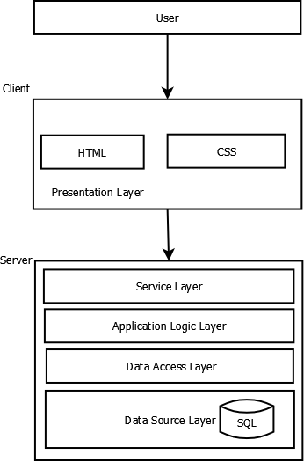

Activity Diagram:

The activity diagram will be as below

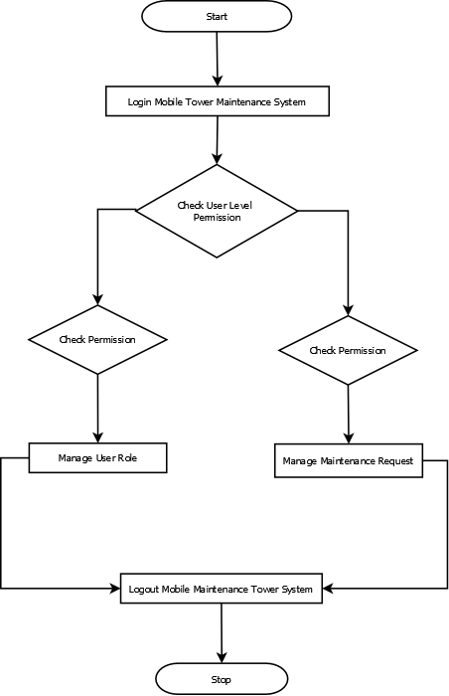

# Flow Diagram

Below are the flow diagram of the overall system and also provided the user based

1. System Flow

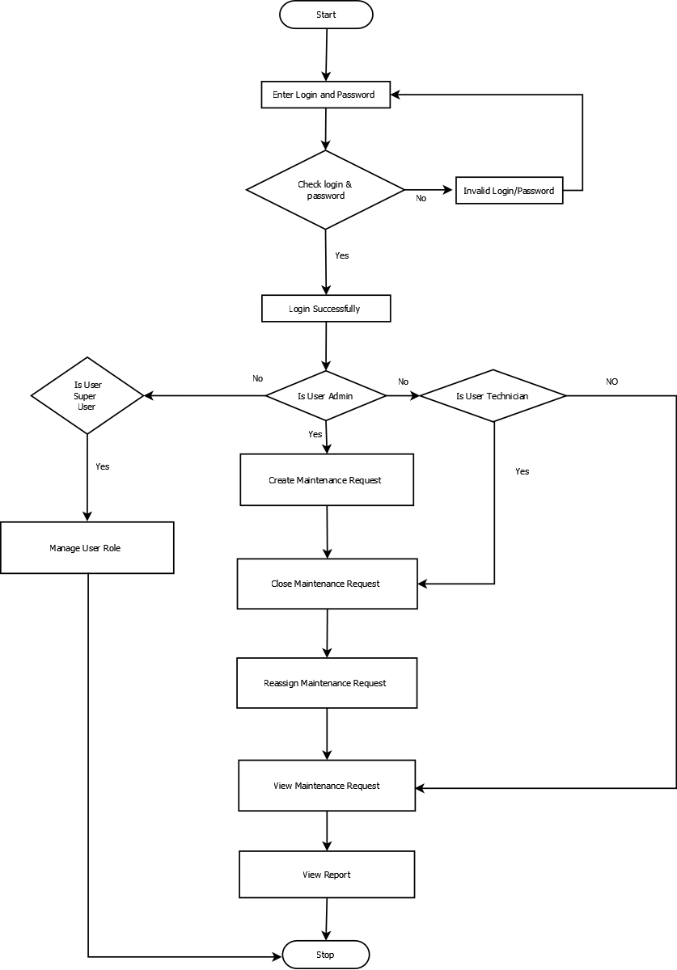

1. User is Super User

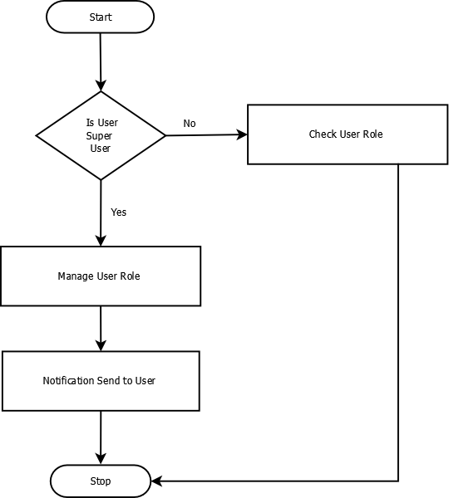

1. User is Technician

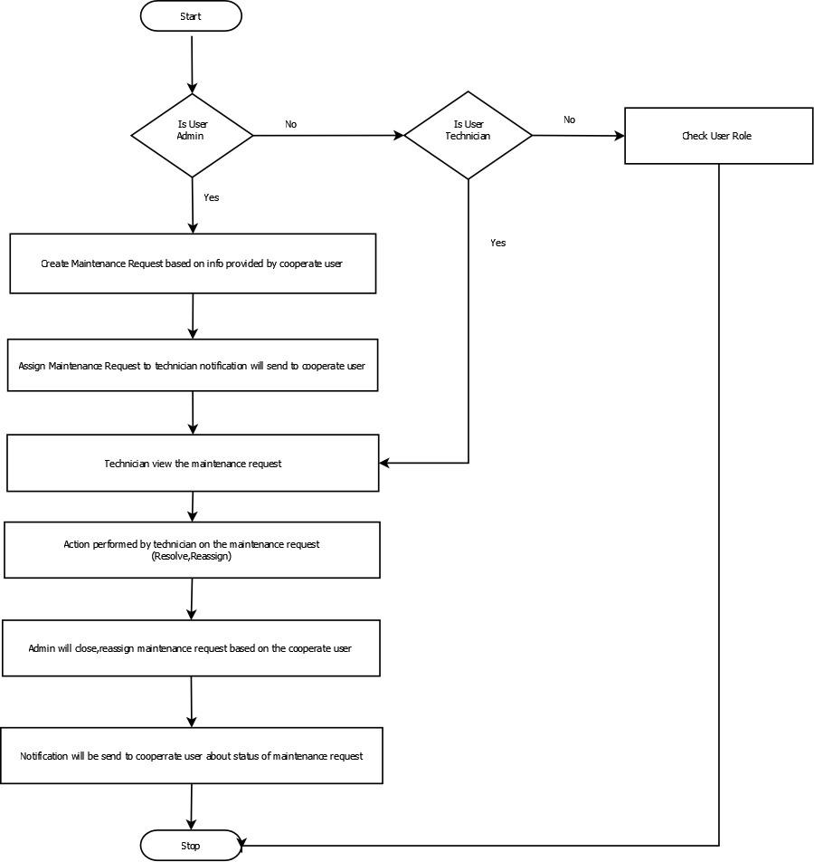

d) User is cooperate officer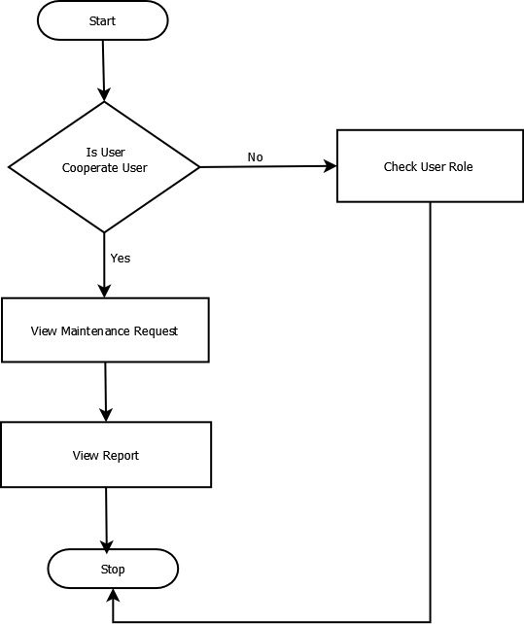

# Use Case Diagram

# 

# Deployment

Application will created in visual studio and publish the website

Deploy the published website on IIS

The application will be deployed on multiple IIS server and will be connected to Virtual IP with load balancer