Analysis

Chapter 2

2.1 Introduction to Analysis-

Analysis is evaluating data and requirements which later is transformed into the project, it basically helps in decision making and to solve the problem appeared during the project.

In analysis, a name of the application that describes it, to the final deployed product every details are analysed. The project ‘Book Quest’ is an ecommerce portal, so for such a portal, market needs and requirements must be analysed. It is important that the web based application is different and has better features than the other competing web applications. We also analyse which age group is mostly influenced and how the application contributes in making life of the people easier.

This project analysis methodology, feasibility of the project which contains technical, operation, legal, social findings, software requirements which contains functional and non-functional requirements, Moscow prioritisation, hardware and software specification also use case diagram and NLA along with class diagram are described further for better understanding of the analysis of the project.

2.2 Analysis Methodology-

For this project, SWOT analysis methodology is used. It Stands for Strength Weakness, Opportunities and Threats. It is referred to as strategic planning which helps in developing missions, policies, strategies and objectives of the project. In a project, it finds strategic fit between internal strength and external opportunities along with external threats and internal weakness. Using SWOT analysis competencies, capabilities are also identified. It is used to make a broader view of analysis strategy.

The potential strength, weakness, opportunities and threats of the project are listed below:

Strength

* Time Saving-

User are able to share and search books from home, this saves a lot of time of users as it reduces physical movement.

* Product and price comparison-

Users can decide which item to buy by comparing between products and price from different users, leading better bargaining and user satisfaction.

* No time constraint-

There is no time restrictions, users can view and share their items on the website at any time.

* Faster procedure-

Users are just a click away from making their transactions, there is no need to visit different places for the right price.

Weakness

* Security-

Users are found to be insecure about their information and transaction process, thus, for an ecommerce site, security has always been a great challenge.

* Uncertain delivery time-

The current application is made aiming at Kathmandu valley, so the deliveries outside the valley is totally up to the user who posted the item. Your product may be delivery may be delayed longer than you expected or the user might not get convinced to deliver.

* Impossibility of physical examination-

The user selects the product on the basis of the uploaded photos, there are no chances for viewing the product physically before buying it.

* Limited Product-

The product available at the website are uploaded by users, so there are also chances that you might not get the product that you are looking for.

Opportunities

* User increment-

Almost every people use internet these days. So providing good facility and proper advertisement will increase the number of users within a short period of time.

* Trend-

People start reading books from early age. The need and trend of reading books, novels, comics etc. never seems to go out of trend.

* Business expansion-

Once the current application becomes successful inside Kathmandu valley, it can then focus on the other cities of Nepal.

* New features-

Growing market and technology highlights the importance to add new features to website for user convenience.

Threats

* Competitors-

Within certain period of time, there are chances of similar website concept to enter the market.

* Changes in law –

The application is made regarding the current law, so, change in law might affect the validity of the application.

* New innovation-

In today’s competing market, adding new features has always been a burden for ecommerce site, as people tend to look for easier and convenient ways.

* Privacy concern-

User inputs their information such as email ID, phone numbers, so the users are mostly insecure about misuse of their data.

2.3 Feasibility Study-

Feasibility study is performed to check the viability of the project’s idea. This study justifies legal, financial, technical, social and time feasibility of the project. It helps us to determine whether the project is doable or not.

The feasibility study of the project ‘Book Quest’ is described below:

* Technical Feasibility-

‘Book Quest’ is a web application which is developed using PHP and bootstrap, it is a common website developing language used widely. The code for website is written using Brackets, Apache and XAMPP. It is developed on Laptop PC with windows 10, 8GB RAM, i5 processor and 1 TB HDD but the application can be run on devices such as PC, smart phone, tablet PC, etc. with no hardware/software specifications, as long as the device is connected with the internet. Since, the application runs on todays most used devices, as a result, the project is technically feasible.

* Financial Feasibility-

Also known as cost benefit analysis, it analyses the potential benefits of the system comparing with costs. For a project to be financially feasible, it must outweigh the costs. The project is developed using open source software on a Laptop which I already owned. The web application is a platform for selling and buying books, the website is handled by admin (myself), which saves cost for hiring and training staffs. So, the benefits from the system will be entirely accounted as profit. Thus, the project is financially feasible.

* Time Feasibility-

Developing a project successfully but exceeding the deadline is considered as failure. Time must be managed accordingly, so that it is completed within given time. The project is divided into different task and the task have their own individual deadlines. This makes development of the project easier. The below table describes the time assigned for each tasks.

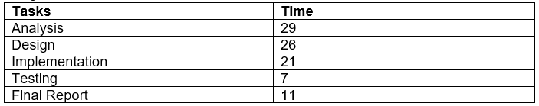

The project does not take excessive time, making the project feasible.

* Social Feasibility-

‘Book Quest’ provides with facility to sell and buy your old used books that are in good conditions from home. It solves the problem of people to search and visit the stores and bargain for the price that you want. It makes lives of people easier by few simple steps. The website is made only for e-commerce and welcomes users of all castes, genders, religions, etc. It will not encourage any kind of social discrimination or does not offend any cultures.

* Political Feasibility-

The application will be made regarding the law of Nepal. It will be made sure that the project doesn’t violate any law. During this study it was found that the project content and ideas doesn’t offend any laws of Nepal.

2.4 Software Requirement Specification

Software Requirement Specification (SRS) is an initial development phase where list of requirements are documented. SRS describe how the system is expected to function. It defines how the system is supposed to interact with users, hardwares and other programs categorizing it into functional and non-functional requirements.

The functional and non-functional requirements of the project are listed below:

2.4.1. Functional Requirements

The functional requirements describes the functionality of the system relating the behaviour of the system. They list out the features to be provided to users, they are considered as major requirements and are expected in the system.

|  |  |  |  |  |
| --- | --- | --- | --- | --- |
| ID | Requirement Specification | Description | Rational | Dependency |
| 01-FR | Registration | New users with their details are registered. | To validate new users. | N/A |
| 02-FR | User Login | Only registered user with validate username and password are allowed access. | To provide access to authorized users maintaining their confidentiality and integrity. | 01-FR |
| 03-FR | User Roles authorization | Admins and users must have different privileges. | For role based access to data. | 01-FR |
| 04-FR | Responsive website | The application must be able to function on any devices. | To operate on any devices. | N/A |
| 05-FR | Chat | Users must be able to communicate. | For buyers and sellers communication. | 01-FR, 02-FR |
| 06-FR | Search | Users must be able to search using keywords. | For users convenience. | 01-FR, 02-FR |
| 07-FR | Upload Photo button | Users must be able to upload photo to ensure the described condition. | To add photo. | 01-FR, 02-FR |
| 08-FR | Buy or sell options | Selling and buying must have different procedures. | To choose if the user wanted to sell or buy. | 01-FR, 02-FR |
| 09-FR | Products detailing | Users must be able to input details such as price, current condition, location, etc. | To enter details such as price, condition, etc. | 01-FR, 02-FR |
| 10-FR | Cookies | A text like welcome back appeared on the screen. | To identify users. | 01-FR,02-FR,  03-FR |
| 11-FR | Edit/delete/ update user information | User must be able to edit their details. | For accurate information. | 01-FR,02-FR,  03-FR |
| 12-FR | Session tracking | User must be able to log out of their account. | For security purpose. | 02-FR |
| 13-FR | Similar Searches | Related product are displayed. | To show what user might like. | 06-FR |
| 14-FR | Provide contact info | Contains information like service, purpose, etc. | For application description. | N/A |
| 15-FR | Display Dashboard | It must show details of user, buy & sell history etc. | For privatization. | 02-FR |
| 16-FR | Language Options | User must be able to select the language. | To choose preferred language. | n/a |
| 17-FR | Forum | Users must be able to ask questions. | To ask app related questions. | 02-FR |
| 18-FR | Display FAQs | Users does not need to wait for their answer. | For easy Q&A findings. | 02-FR |
| 19-FR | Topic filtering | Makes it easier to search for users. | For efficient search. | N/A |
| 20-FR | Availability Mark | Users can know its availability without conversing with the seller. | To display availability of the product. | 07-FR,08-FR, 09-FR |
| 21-FR | Product CMS | Users can add, delete update and view available products. | Users have the privilege to upload and buy available products at will. | 01-FR |

2.4.2. Non- Functional Requirements

A non-functional requirement specifies the quality of the system. It defines the aspects that is not related to the system’s execution but is related to the evolution of the system over time.

|  |  |  |  |  |
| --- | --- | --- | --- | --- |
| ID | Requirement Specification | Description | Rational | Dependency |
| 01-NR | Security | Only authorized users must be able to access the application. | To ensure safety of users’ data. | 01-FR |
| 02-NR | Scalability | The system must be able to deal with the increased number of users. | To cope up with the increased number of users. | 02-FR,08-FR, 09-FR |
| 03-NR | Availability | Maintenance must be done frequently. | For availability of the website 24/7. | 01-NR |
| 04-NR | Usability | The application must work on todays most used devices like smartphones, laptops, etc. | To ensure that application work on other devices. | 02-FR |
| 05-NR | Reliability | Data integrity and availability must be maintained. | To provide updated information at any time. | 01-NR,03-NR |
| 06-NR | Recoverability | Information or data entered in the application must be able to recover. | To recover information. | N/A |
| 07-NR | Sustainability | The classes and its codes must be reused. | To be able to reuse codes. | N/A |
| 08-NR | System support | The application must be able to function on any system. | To be able to operate. | N/A |
| 09-NR | Speed | The webpage should not take forever to load | To easily load pages. | n/a |
| 10-NR | Easy to navigate | Users can use it easily. | For easiness. | N/A |

Moscow prioritisation of the Requirements

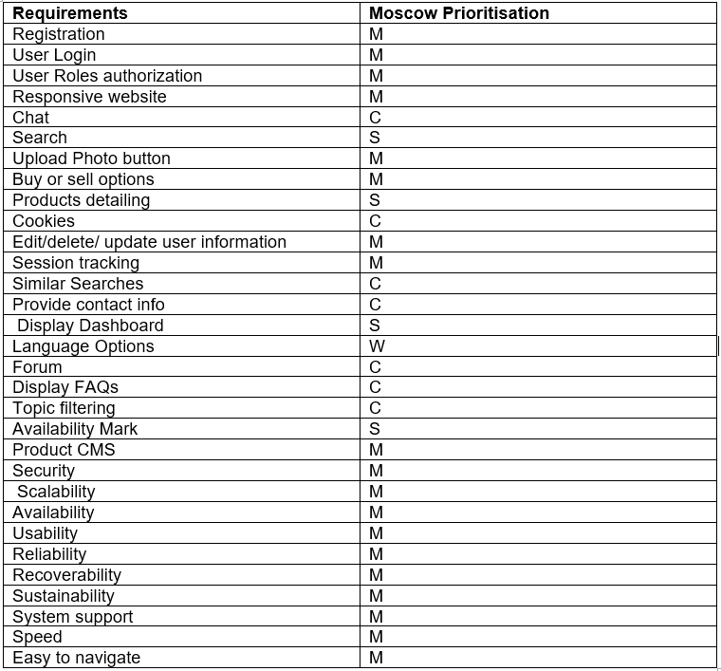

2.4.3. Moscow Prioritisation

Prioritizing is the process of identifying which tasks are more important at that particular time. Moscow prioritization is the prioritization method for requirements and objectives. This method helps to decide which task to complete first. For using Moscow prioritisation, firstly a list of requirements must be listed then crucial decision of prioritisation must be made.

According to Moscow prioritisation the requirements can be categorized into:

* Must have-

The essential requirements which absence can be considered as the failure of the project.

* Should have-

The requirements that does not fails the project, but holds significant value for the user.

* Could have-

These are the desirable requirements. The list can be sorted if there is shortage of time period. It doesn’t really affect the project.

* Won’t have-

These requirements doesn’t exist for this current project but are considered in future growth requirements.

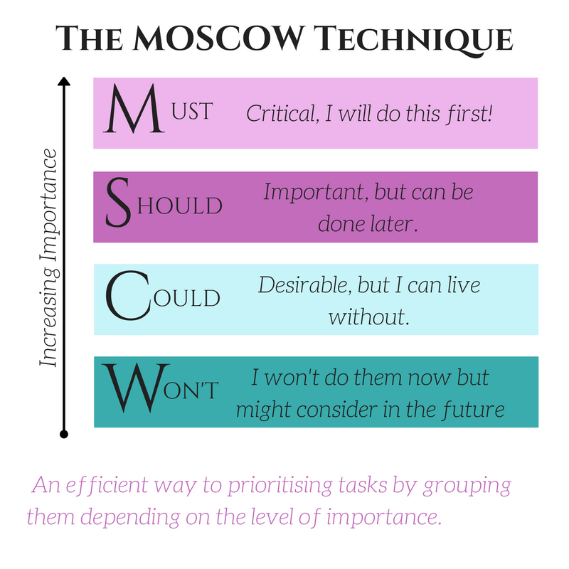

Figure : Moscow Technique

Importance

* Prioritizing the requirements appropriately ensures our project is delivered efficiently on time.
* Sorting requirements into four categories i.e. must have, should have, could have and won’t have allows you to understand the importance of requirements and invest time accordingly.
* The least important features that do not affect the project can easily be identified and cut off during shortage of time.

Firstly, requirements that are essential for the projects were listed. Then the requirements was further categorised into functional and non-functional requirements according to its functionality. Then those categorised requirements were prioritised observing its importance in the project.

2.4.4. Hardware/ Software Specification

The devices which are mostly used today doesn’t have same specification of hardwares and softwares. They work on different operating system, version and architecture. Thankfully, web application can be run on any devices with the help of browsers.

The specification of hardware and software used while developing the web-application are:

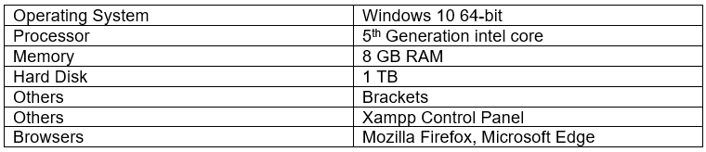

The web application is made responsive, so it works on devices like smart phones, Tablet PC, Desktop etc. having internet access and for browser Google chrome, Mozilla Firefox, Microsoft Edge, Safari is suggested. For desktop and laptop a minimum operating system of Windows 7 is suggested for users’ convenience.

2.5. Use Case Diagram

The use case diagram is used to show the relationship between the actors and the use cases. Use case also describe how an actor perform a set of tasks. It identifies and describes different types of actors and their interactions with the system. It consist three elements i.e. system, actors and usecases.

The use cases diagrams for the system ‘Book Quest’ are:

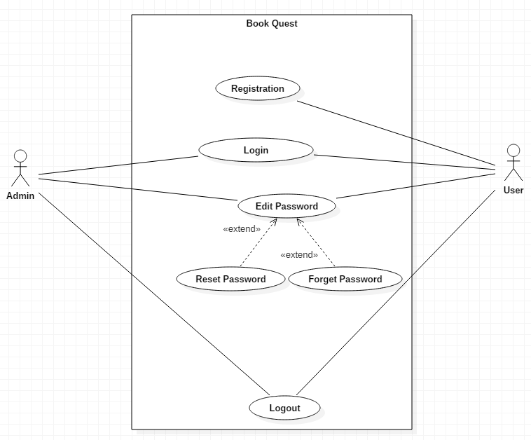

Figure : Usecase diagram 1

|  |  |  |  |  |
| --- | --- | --- | --- | --- |
| Actors | Use Case | Sub use case included | Sub use case  extended | Flow |
| User | Registration | - | - | 1. User register their account with unique id to the system.  2. Both admin and user are able to login to the system.  3. Both admin and user are able to edit their password and reset it in case they forget their password.  4. Both admin and user are able to log out of the system. |
| Admin, User | Login | - | - |
| Admin, User | Edit Password | - | -Forget Password  -Reset Password |
| Admin, User | Logout | - | - |

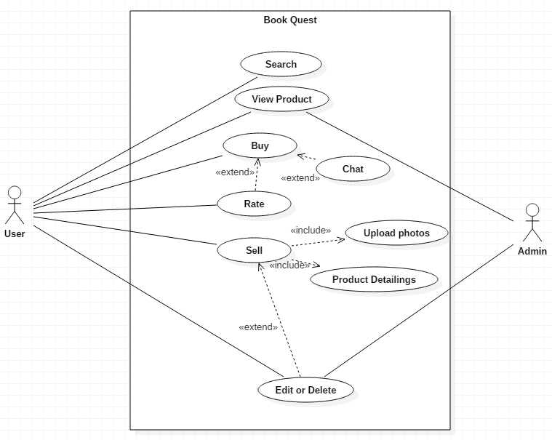

Figure : Usecase diagram 2

|  |  |  |  |  |
| --- | --- | --- | --- | --- |
| Actors | Use Case | Sub use case included | Sub use case  extended | Flow |
| User | Search | - | - | 1. User search for the products.  2. Both admin and user are able to view the products.  3. User can buy the product they wanted, they are able to chat for negotiation and further details.  4. To sell a product a user must first upload pictures and provide details of the product.  5. Both user and admin can delete or edit the sale post. |
| Admin, User | View Product | - | - |
| User | Buy | - | -Chat  -Rate |
| Admin, User | Sell | -Upload photos  -Product detailing | -Edit or Delete |

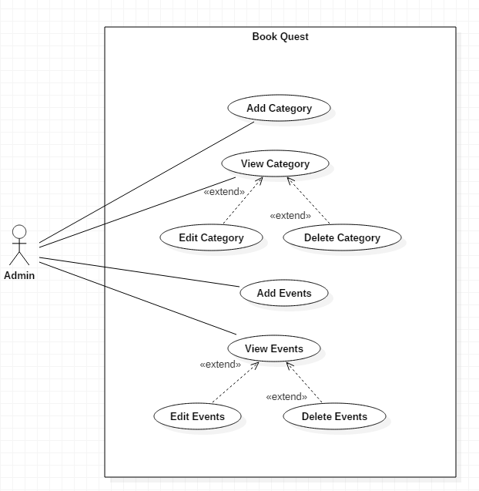

Figure : Usecase diagram 3

|  |  |  |  |  |
| --- | --- | --- | --- | --- |
| Actors | Use Case | Sub use case included | Sub use case  extended | Flow |
| Admin | Add Category | - | - | 1. Admin is able to add category.  2. Admin are able to view, add and delete category whereas users are able to view only.  3. Admin can add events.  4. Admin can view, edit or delete events whereas users can only view events. |
| Admin | View Category | - | -Edit Category  -Delete Category |
| Admin | Add Events | - | - |
| Admin | View Events | - | -Edit Events -Delete Events |

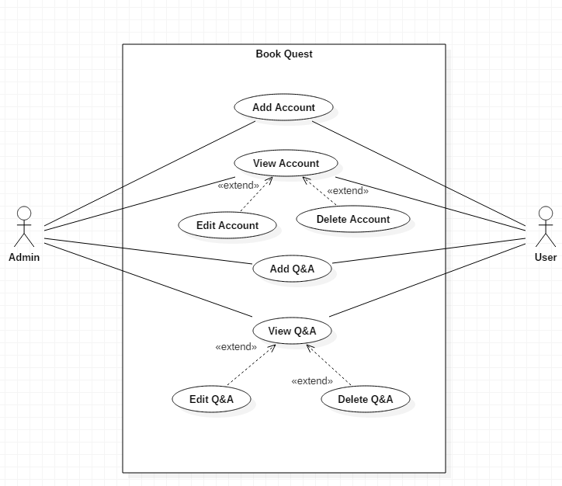

Figure : Usecase diagram 4

|  |  |  |  |  |
| --- | --- | --- | --- | --- |
| Actors | Use Case | Sub use case included | Sub use case  extended | Flow |
| Admin, User | Add Account | - | - | 1. Both Admin and User are able to add accounts.  2. User are able to view, edit or delete their account while admin can view, edit and delete both user and admin account.  3. Both Admin and User are able to ask questions and answer it.  4. User are able to view, edit or delete their questions or answers while admin can view, edit and delete both user and admin question and answers. |
| Admin, User | View Account | - | -Edit Account  -Delete Account |
| Admin, User | Add Q&A | - | - |
| Admin, User | View Q&A | - | -Edit Q&A -Delete Q&A |

2.6. Initial Class Diagram

Scenario

‘Book Quest’ is an online ecommerce platform, where you can sell and buy your old used books at a reasonable price. It is proposed to make life of people easier by eliminating the need to search for a physical store and bargain. There are two types of users who uses the system i.e. Admin and a user. Admin has the privileges to add, edit or delete users’ posts and accounts. Users register their account by providing basic information like their name, address, Email ID etc. and can login to the system using their unique username and password. Users are then able to view, buy or sell products. For selling a product, user must upload photos and provide product details such as product name, category name. The system must have purchase records.

Now for an Initial class diagram, we must perform NLA (Natural Language Analysis) on the above scenario. Performing NLA, a list of nouns are listed below:

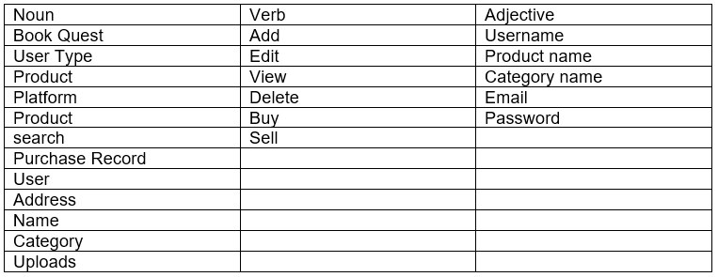

Removing duplicate and irrelevant words, we get:

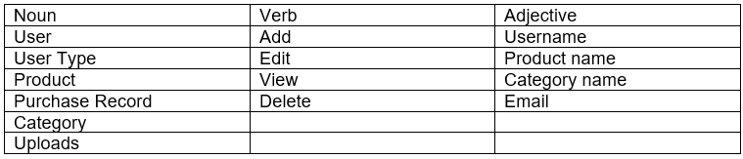

Now a class diagram is formed.

Class diagram is basically relationship between classes. The class diagram for this project is formed in starUML.

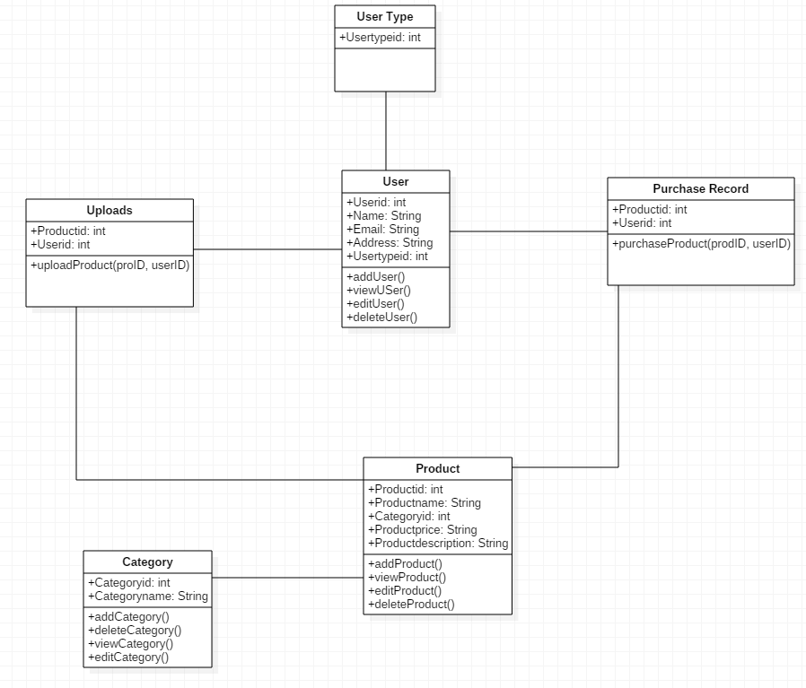

Figure : Initial Class Diagram