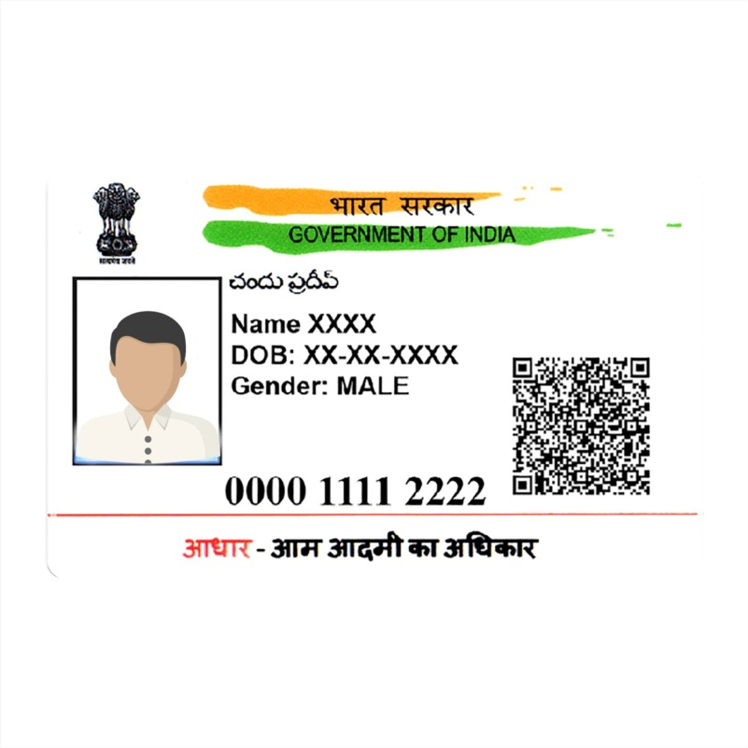

Shristi

DOB 13/09/2007

Rajeev kumar

**9876 3556 6556**





