CHANDIGARH UNIVERSITY
University Institute of Computing (UIC)

CASE STUDY ON
Bhukkad Bazz: A College Canteen Management and Food Ordering System Using Oracle SQL and PL/SQL

Submitted by
Shristi Kumari
UID
26MCD10074
Programme
Master of Computer Applications (MCA)

In Partial Fulfilment of the Requirements for the Award of the Degree of
MASTER OF COMPUTER APPLICATION

Under the Guidance of
Ms. Winky
University Institute of Computing (UIC)
SESSION 2026 – 2028

BHUKKAD BAZZ : A COLLEGE CANTEEN MANAGEMENT AND FOOD ORDERING SYSTEM
A Case Study Report submitted in partial fulfillment of the requirements for the degree of Master of Computer Applications (MCA)
Submitted By: Shristi Kumari | Roll No: 26MCD10074 | Semester / Year: Semester I / Year: 1st
Under the Guidance of: Ms. Winky
University Institute of Computing (UIC), Chandigarh University | Academic Year: 2026–2028

1. Executive Summary
This case study presents Bhukkad Bazz, an Oracle SQL and PL/SQL database application that automates order taking, billing, stock control and payment recording for a college canteen. In the manual process, orders and payments are kept in registers or handled verbally, so bills are calculated by hand, stock is not tracked and there is no reliable history of orders or payments. Bhukkad Bazz replaces this with an eight-table relational database built in Oracle FreeSQL: constraints protect data quality, the PLACE_ORDER procedure validates each order and deducts stock, functions calculate bills and discounts, triggers maintain food availability and an audit trail, and a payment procedure rejects duplicate payments. The main result is that one procedure call now validates an order, creates it and logs the stock change: in the recorded test run, order 3 (Rs. 30) was placed in 0.014 seconds and a duplicate payment attempt was rejected in 0.008 seconds. Because the project is an academic prototype without a live canteen pilot, these are verification results and no percentage improvement over manual operation is claimed.

2. Introduction & Problem Statement

2.1 Background of the Study
A college canteen serves students, faculty members and staff throughout the academic day, with demand concentrated in the short breaks between lectures. The people at the centre of this case are the canteen administrator and staff, who must take orders, track stock and record payments, and the students who place those orders. In most campuses these tasks are handled informally, with orders written in registers or taken verbally. Moving them onto a single database gives students and canteen staff one reliable source of truth and removes manual calculation errors. The project was developed as an MCA mini project using Oracle SQL and PL/SQL in the Oracle FreeSQL environment [5].

2.2 Problem Statement (The “Before” State)
The existing manual approach to canteen operations suffers from the following pain points:
- Calculation Errors: Bills and discounts are worked out by hand for every order, so wrong amounts are charged and disputes arise at the counter.
- No Live Stock Record: Stock is judged by eye or counted occasionally, so items may be sold when they are not available and re-ordering is late.
- No Order or Payment History: Registers are hard to search and easy to lose, so there is no basis for reviewing past orders or daily sales.
- Unclear Payment Status: Payments are noted informally, so duplicate or missing entries go unnoticed and nobody can say exactly who has paid.
- No Accountability for Changes: Order status changes are not recorded, so there is no way to trace what happened to an order.
Three approaches are commonly tried and each leaves part of the problem unsolved [1], [2]. Paper registers or token slips still depend on hand calculation and give no stock tracking or searchable history. Spreadsheets store totals but do not enforce the relationships between students, orders and stock, and stock updates stay manual. Commercial point-of-sale or online ordering software is feature-rich but costly, complex and hard to customize for a campus canteen. These are the standard approaches considered during the project analysis; no pilot was run in a live canteen, so no failed deployment of Bhukkad Bazz itself is described.

2.3 Objectives
- Designing a relational database for students, administrators, food items, orders, payments, inventory logs and audit records, protected by primary keys, foreign keys, unique and check constraints.
- Automating order placement and stock deduction through a PL/SQL stored procedure, and calculating bills and discounts through functions.
- Using triggers to maintain food availability and to audit order-status changes, and grouping related operations into PL/SQL packages.
- Demonstrating cursors, exception handling, savepoints, rollback and commit, and generating sales, inventory and payment reports.

2.4 Scope
The system covers the database layer of a canteen: student and food records, order creation, order details, inventory adjustment, simulated payment recording, audit logging and SQL-based reports. It is built in Oracle SQL and PL/SQL and developed and tested in Oracle FreeSQL. It does not include a graphical user interface, a real payment gateway, production-grade authentication or notifications; these are identified as future work.

3. System Analysis & Modeling

3.1 Feasibility Study
- Technical Feasibility: The implementation uses standard Oracle SQL and PL/SQL features [3], [4] that can be created and tested through the browser-based Oracle FreeSQL environment, so no local installation is needed.
- Economic Feasibility: The project is developed on a browser-based Oracle environment and ordinary computing equipment, so no paid point-of-sale hardware or payment gateway is required for the prototype.
- Operational Feasibility: The data structure follows familiar canteen activities (select food, place an order, check stock, record payment, review sales), so little training is needed for students and canteen staff.

3.2 Requirements Specification
- Functional Requirements: Store student, administrator and food records; place an order only for a valid student and an available food item with sufficient stock; deduct stock and log it; calculate the bill, discount and final amount; record one payment per order; audit order creation and status changes; and produce sales and inventory reports.
- Non-Functional Requirements: Data integrity through constraints and PL/SQL rules, reliability through transaction control and exception handling, maintainability through packages, and extensibility so that a front-end can be connected later.

3.3 Analytical System Diagrams
Figure 3.1 shows the eight entities with their primary and foreign keys and the relationships between them. Figure 3.2 shows the order-processing flow, in which an invalid student, quantity or stock level sends the request to a rollback instead of creating a partial order.
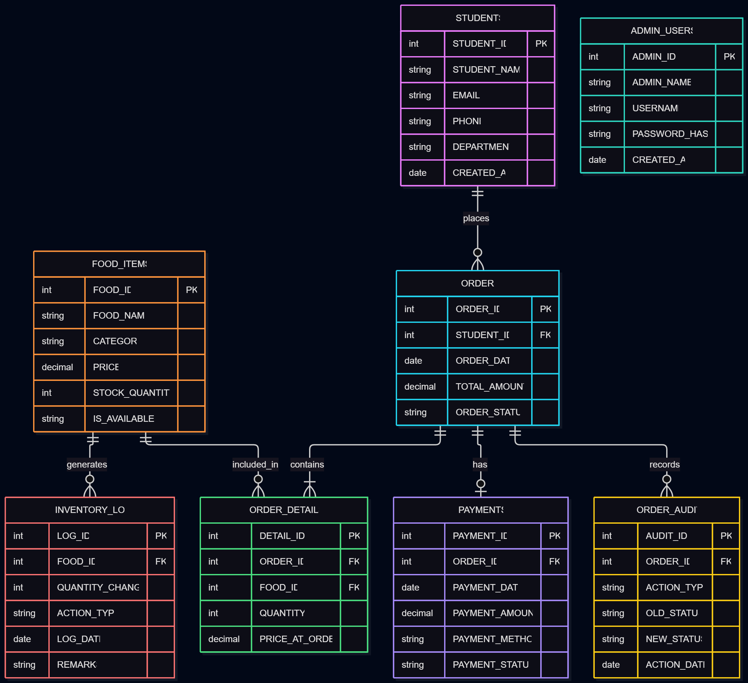  Figure 3.1: Entity-relationship diagram | 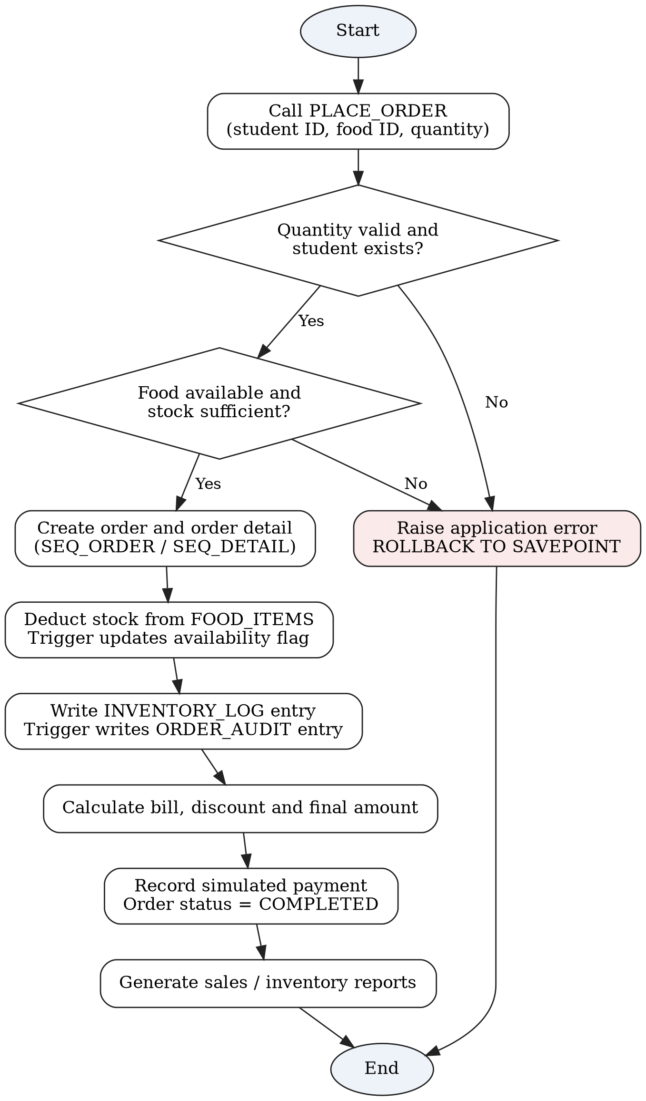  Figure 3.2: Order-processing flowchart

4. Proposed Technical Solution & Architecture

4.1 Technology Stack Selection
- Database Infrastructure: Oracle Database holding eight tables, eight sequences and one view, with constraints enforcing referential integrity and business rules [3].
- Development Environment: Oracle FreeSQL, a browser-based SQL worksheet used to develop and test every script [5].
- Logic Layer: PL/SQL procedures (PLACE_ORDER, PROCESS_PAYMENT), three billing functions (CALCULATE_ORDER_BILL, GET_DISCOUNT, GET_FINAL_BILL), two triggers (TRG_FOOD_AVAILABILITY, TRG_ORDER_AUDIT) and three packages [4].
- Reporting Layer: Cursor-based reports and the view VW_ORDER_SUMMARY, which combines order, student and payment data.

4.2 System Architecture Description
Bhukkad Bazz follows a database-centred architecture in which the business rules live inside the database. Users interact through an Oracle SQL worksheet, which calls the PL/SQL logic layer; that layer reads and writes the Oracle tables inside transactions and returns results and reports to the caller. Because every order passes through the same procedure, the same checks apply whoever enters it. A graphical front-end is outside the current scope but can be connected to the same database later.
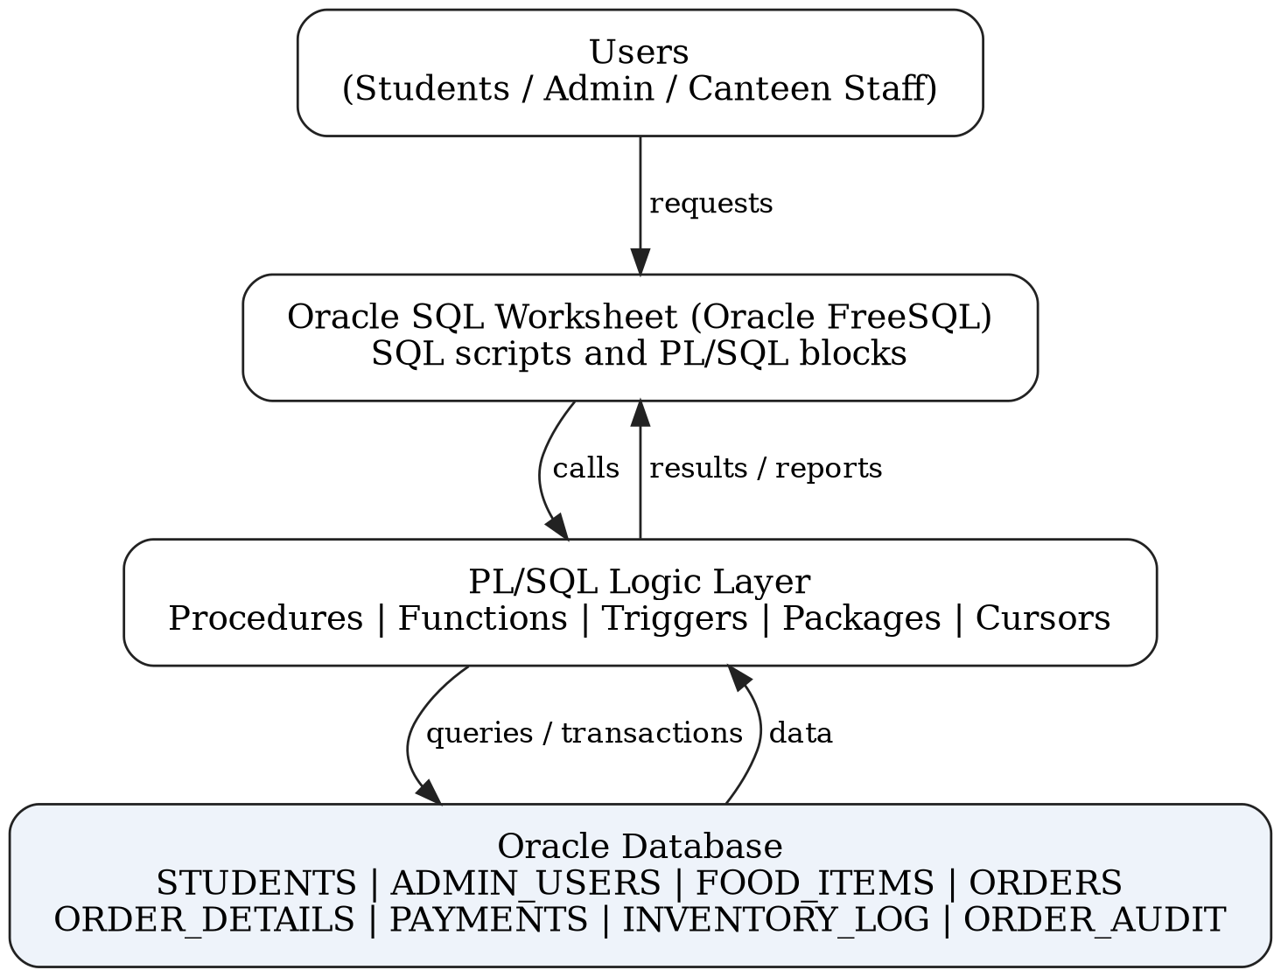
Figure 4.1: System architecture of Bhukkad Bazz

5. Implementation Details

5.1 Database Schema Design Overview
The relational design uses eight tables [1], [2]. Students (student_id, student_name, email, phone, department, created_at) and Admin_Users (admin_id, admin_name, username, password_hash, created_at) store account details. Food_Items (food_id, food_name, category, price, stock_quantity, is_available) stores the menu and stock. Orders (order_id, student_id, order_date, total_amount, order_status) holds the order header, while Order_Details (detail_id, order_id, food_id, quantity, price_at_order) holds its line items, so one order can contain several food items. Payments (payment_id, order_id, payment_date, payment_amount, payment_method, payment_status) records one payment per order through a unique constraint on order_id. Inventory_Log (log_id, food_id, quantity_change, action_type, log_date, remarks) and Order_Audit (audit_id, order_id, action_type, old_status, new_status, action_date) keep the history of stock and status changes. Identifiers are generated by eight sequences.

5.2 Core Module Code Snippet (Order Placement with Stock Deduction)
-- Simplified illustration of the PLACE_ORDER workflow
SAVEPOINT ORDER_START;
-- 1. Validate quantity and student; lock and check the food item
-- 2. Reject if the item is unavailable or stock is insufficient
-- 3. Insert into ORDERS and ORDER_DETAILS (IDs from SEQ_ORDER, SEQ_DETAIL)
-- 4. Deduct stock in FOOD_ITEMS and insert a row into INVENTORY_LOG
-- On any error: ROLLBACK TO ORDER_START; RAISE;
-- Example call used in testing
DECLARE
V_ORDER_ID NUMBER;
V_TOTAL NUMBER;
BEGIN
PLACE_ORDER(P_STUDENT_ID => 1, P_FOOD_ID => 1, P_QUANTITY => 2,
P_ORDER_ID => V_ORDER_ID, P_TOTAL => V_TOTAL);
COMMIT;
END;
/

5.3 Technical Challenges & Mitigation Strategies
- Challenge: An error half-way through an order could leave an order without its stock deduction or log entry.
- Mitigation: PLACE_ORDER sets a savepoint and rolls back to it on any error; the caller decides the final COMMIT or ROLLBACK.
- Challenge: A second payment for the same order could be recorded by mistake.
- Mitigation: A unique constraint on payments.order_id and a check inside PROCESS_PAYMENT reject duplicates with a clear error (ORA-20035).
- Challenge: Food availability could drift out of step with stock.
- Mitigation: TRG_FOOD_AVAILABILITY sets the flag to ‘N’ when stock reaches zero and back to ‘Y’ when stock is positive.

6. Testing & Results Analysis (The “After” State)

6.1 Testing Methodology
Testing verified that the tables, procedures, functions, triggers and views work together. Twelve test cases were designed to cover table creation, valid data, order placement, invalid students and quantities, insufficient stock, availability changes, audit records, billing, payments and reports. Each test was executed in the Oracle FreeSQL worksheet, and output was captured for the four cases shown in the matrix below. Key validation rules were that an order is created only for a valid student with sufficient stock and that an order cannot be paid twice.

6.2 Test Execution Matrix
Test ID | Component | Input Vector | Expected Result | Observed Result | Status
TC-01 | Schema | Create the eight tables | All table definitions created without errors | USER_TABLES lists all 8 tables | PASS
TC-03 | PLACE_ORDER | Valid student, available food, quantity 2 | Order created; stock reduced; inventory log written | Order ID 3 created (Rs. 30); log shows −2 units for food ID 1 | PASS
TC-08 | Audit trigger | Change an order status | Audit record of the transition | STATUS_UPDATED rows recorded, e.g. PLACED to COMPLETED | PASS
TC-11 | Payment module | Second payment for a paid order | Payment rejected | Rejected with ORA-20035: payment already exists | PASS

6.3 Measured Outcomes
The figures below are taken from the implementation and from the outputs captured in the Oracle FreeSQL worksheet (Figures 6.1 to 6.6).
Measure | Value | Source
Database tables created | 8 | Figure 6.1 (USER_TABLES query)
Sequences / procedures / functions | 8 / 2 / 3 | Implementation
Triggers / packages / views | 2 / 3 / 1 | Implementation
Order placement time (order 3) | 0.014 s | Figure 6.2 (elapsed time reported by the worksheet)
Order total generated (order 3) | Rs. 30 | Figure 6.2
Duplicate payment rejection time | 0.008 s | Figure 6.5 (error ORA-20035)
Stock-deduction log entries (food ID 1) | 3 entries, 5 units in total (−2, −1, −2) | Figure 6.3 (INVENTORY_LOG)
Audit records shown | 8 records (4 ORDER_CREATED, 4 STATUS_UPDATED) covering 5 orders | Figure 6.4 (ORDER_AUDIT)
Orders in the summary view | 5 orders from 2 students | Figure 6.6 (VW_ORDER_SUMMARY)
Payments recorded | 2 successful UPI payments, Rs. 45 in total (Rs. 30 + Rs. 15) | Figure 6.6
Orders with no payment recorded | 3 orders, Rs. 150 in total (Rs. 30 + Rs. 60 + Rs. 60) | Figure 6.6
Order statuses in the view | 2 PLACED, 2 PREPARING, 1 COMPLETED | Figure 6.6
Test cases designed / evidenced | 12 designed; 4 with captured output (TC-01, TC-03, TC-08, TC-11) | Section 6.2

6.4 Before and After Comparison
Area | Before (manual) | After (Bhukkad Bazz)
Order validation | None; depends on staff | PLACE_ORDER checks student, quantity, availability and stock before creating the order
Stock update | Manual count | Automatic deduction with an INVENTORY_LOG entry for each order
Billing | Hand-calculated | Functions apply three discount slabs: below Rs. 250 none, Rs. 250 to 499.99 5%, Rs. 500 and above 10%
Payment record | Notebook or memory | PAYMENTS table with one payment per order; a duplicate attempt was rejected in the test run
History and accountability | Not recorded | ORDER_AUDIT records creation and every status change
Reporting | Manual summing | SQL reports and VW_ORDER_SUMMARY combine order, student and payment data

6.5 Output Screens

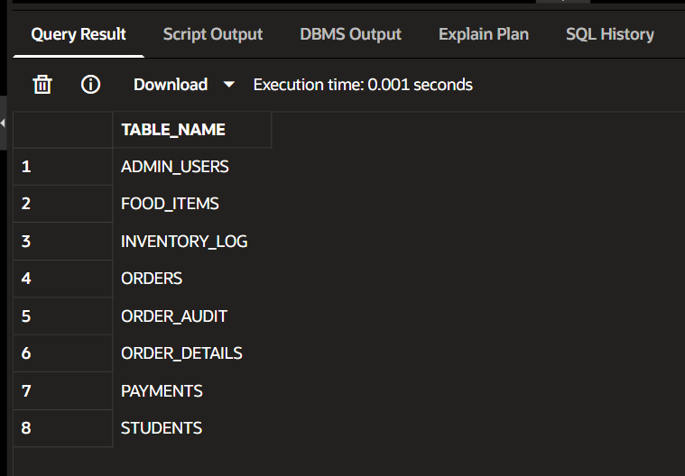  Figure 6.1: USER_TABLES query output | 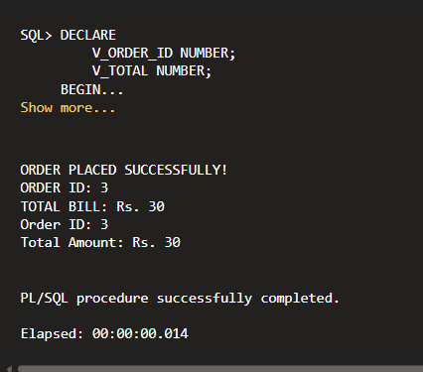  Figure 6.2: Valid PLACE_ORDER execution

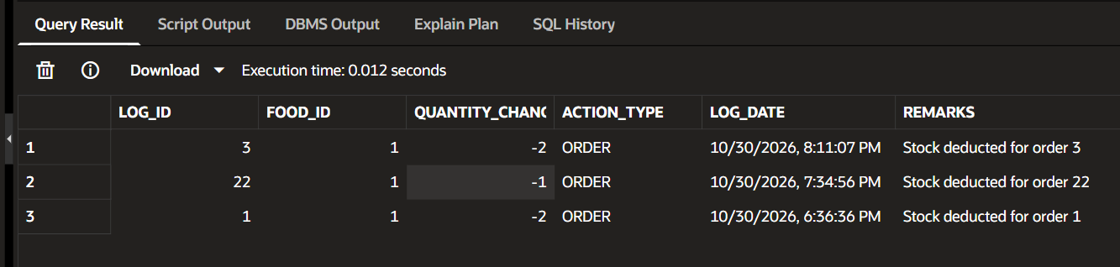
Figure 6.3: Stock deduction recorded in INVENTORY_LOG

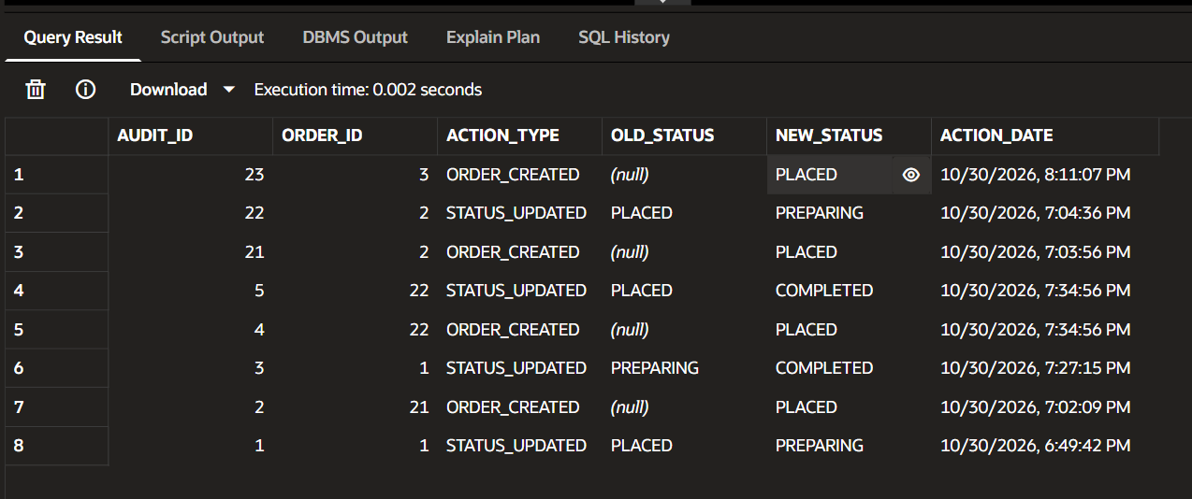
Figure 6.4: Audit records written by the trigger

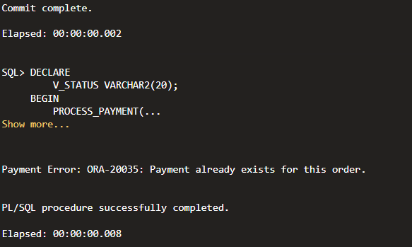
Figure 6.5: Duplicate payment rejected

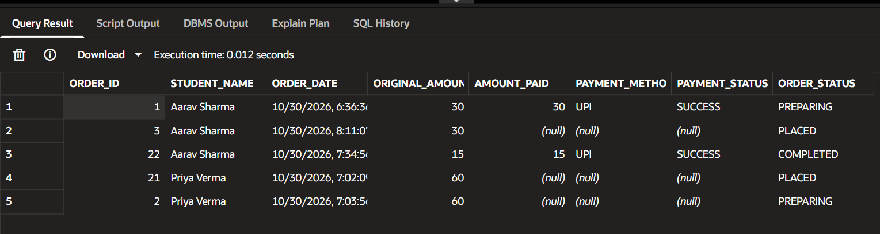
Figure 6.6: Order summary view (VW_ORDER_SUMMARY)

7. Conclusion & Recommendations

7.1 Conclusion
Bhukkad Bazz successfully translates a common campus problem, manual and error-prone canteen operations, into a structured, database-driven system. Placing the rules inside the database means every order passes the same checks, and a single procedure call now validates, creates, deducts stock and logs the change. The inventory and audit tables give a history of stock and status changes that the manual process never had, while savepoints, rollback and exception handling keep a failed order from leaving partial data behind. The project meets its objectives by demonstrating relational design, constraints, procedures, functions, triggers, packages, cursors and transaction control, and it provides a solid foundation for a full canteen application.

7.2 Limitations
The current prototype is a database application without a graphical interface. Payments are simulated and no bank, UPI or card gateway is integrated, the data is demonstration data, and authentication needs production-grade security before real use. Only four of the twelve designed test cases have captured output so far, and no before-and-after measurements from a live canteen are available.

7.3 Future Scope and Recommendations
The recommended next steps are:
- Run a short pilot in a real canteen and record baseline measures first (time per order, billing errors, stock mismatches) so that the improvement can be stated in numbers.
- Capture output for the remaining eight test cases and add them to the test matrix.
- Build a web or mobile front-end for students and canteen staff on top of the existing database, with role-based authentication and secure password hashing.
- Connect a real payment gateway only after security, compliance and institutional approval, and add order notifications, live order-status tracking and analytics such as peak-hour demand and inventory forecasting.

8. References
[1] R. Elmasri and S. B. Navathe, Fundamentals of Database Systems, 7th ed. Hoboken, NJ, USA: Pearson, 2016.
[2] A. Silberschatz, H. F. Korth, and S. Sudarshan, Database System Concepts, 7th ed. New York, NY, USA: McGraw-Hill, 2019.
[3] Oracle Corporation, "Oracle Database SQL Language Reference," Oracle Help Center. [Online]. Available: https://docs.oracle.com/en/database/
[4] Oracle Corporation, "Oracle Database PL/SQL Language Reference," Oracle Help Center. [Online]. Available: https://docs.oracle.com/en/database/
[5] Oracle, "Oracle FreeSQL." [Online]. Available: https://freesql.com/

