Bhukkad Bazz
College Canteen Management and Food Ordering System
A PROJECT REPORT
Submitted by
Shristi Kumari
(26MCD10074)
in partial fulfillment for the award of the degree of
Master of Computer Applications
IN
Data Science

2026-28
Chandigarh University
2026-28

BONAFIDE CERTIFICATE
Certified that this project report titled “Bhukkad Bazz” is the bonafide work of Shristi Kumari (UID: 26MCD10074) who carried out the project work under my/our supervision in partial fulfillment of the requirements for the award of the degree of Master of Computer Applications at Chandigarh University.
SIGNATURE | SIGNATURE
Name: Shristi Kumari | Name: Ms. Winky
UID: 26MCD10074 | Designation: ____________________
Class: MCD ______ | E-Code: ____________________
ACKNOWLEDGEMENT
The successful completion of this project would not have been possible without the guidance, support, and encouragement of several individuals and organizations. It is a matter of great pleasure and privilege for me to express my sincere gratitude to all those who contributed directly or indirectly towards the completion of this project titled “Bhukkad Bazz.”
First and foremost, I would like to express my heartfelt gratitude to Chandigarh University for providing me with the opportunity to undertake this project as a part of my academic curriculum. The university has provided an excellent learning environment, modern facilities, and valuable resources that helped me gain practical knowledge and technical skills throughout the course of this project.
I would like to convey my deepest appreciation to my project supervisor, Ms. Winky, for constant guidance, constructive suggestions, and continuous motivation during every stage of the project. Her insights, technical expertise, and willingness to share knowledge played a crucial role in the successful completion of this work.
I am also thankful to the Head of the Department, faculty members, and staff of the Department of Computer Applications for their support and cooperation throughout the project duration. Their academic guidance and timely feedback helped me understand the practical applications of Oracle SQL, PL/SQL, and database management systems.
Special thanks are extended to my friends and classmates who continuously encouraged me and shared valuable suggestions throughout the development process. Their discussions, feedback, and moral support helped me improve various aspects of the project and remain motivated during challenging phases of implementation.
TABLE OF CONTENTS
Chapter | Title | Section
Chapter 1 | Introduction | 1.0
 | Problem Statement & Client Identification | 1.1
 | Objectives of the Project | 1.2
 | Scope of the Project | 1.3
Chapter 2 | System Architecture & Design Flow | 2.0
 | System Architecture Overview | 2.1
 | Database Design & Entity Relationships | 2.2
 | Data Flow & System Flowcharts | 2.3
Chapter 3 | Implementation & Major Modules | 3.0
 | Backend Implementation (PL/SQL Procedures, Functions & Triggers) | 3.1
 | Database Implementation (Oracle SQL & FreeSQL) | 3.2
 | Reports, Cursors & Exception Handling | 3.3
Chapter 4 | Project Showcase (Visual Walkthrough) | 4.0
 | Order Placement & Billing Output | 4.1
 | Backend Validation & Exception Handling | 4.2
 | DBMS Records & Schema Verification | 4.3
Chapter 5 | Testing & Validation | 5.0
 | Functional & Integration Testing | 5.1
 | Test Cases & Results | 5.2
Chapter 6 | Future Scope & Conclusion | 6.0
 | Proposed Enhancements | 6.1
 | Final Conclusion & References | 6.2
LIST OF FIGURE / TABLES
Type | Number | Title
Figure | 2.1 | System Architecture Diagram
Figure | 2.2 | Database Entity Relationship (ER) Diagram
Figure | 2.3 | Data Flow Diagram Level 1
Figure | 2.4 | Overall System Flowchart
Figure | 4.1 | PLACE_ORDER Execution and Generated Order
Figure | 4.2 | Duplicate Payment Rejected
Figure | 4.3 | Table Creation Output (USER_TABLES)
Figure | 4.4 | Inventory Update (INVENTORY_LOG)
Figure | 4.5 | Trigger Audit Records (ORDER_AUDIT)
Figure | 4.6 | Order Summary View (VW_ORDER_SUMMARY)
Table | 2.1 | System Layers and Responsibilities
Table | 3.1 | PL/SQL Program Units
Table | 5.1 | Functional Test Cases

Chapter 1: Introduction

1.1 Problem Statement & Client Identification
Bhukkad Bazz addresses the everyday challenge of running a college canteen: taking food orders, keeping track of stock, calculating bills, and recording payments. In a manual process, orders and payments are written in registers or handled verbally, stock is judged by eye, and totals are worked out by hand. This leads to calculation mistakes, delays, no reliable view of how much stock remains, no clear record of who has paid, and no easy way to review past orders or daily sales.
The primary problem addressed is how to build a database application that centralizes canteen information, validates every order, updates stock automatically, calculates bills and discounts accurately, records payments without duplication, and keeps an audit trail of order changes. The primary clients are the students who order food and the canteen administrators and staff who prepare orders and manage stock. Management also benefits from accurate sales, payment, and inventory reports.

1.2 Objectives of the Project
The primary objective of Bhukkad Bazz is to provide a single, reliable data platform for canteen ordering, billing, and inventory, replacing manual and register-based processes with structured digital records.
Functional objectives
- Store student, administrator, and food-item records, including price, stock, and availability.
- Place an order only for a valid student and an available food item with sufficient stock.
- Deduct stock automatically and record each stock change in an inventory log.
- Calculate the bill, discount, and final payable amount.
- Record one simulated payment per order and audit every order status change.
- Generate sales, inventory, and payment reports.
Technical objectives
- Design a relational database of eight tables using primary keys, foreign keys, unique, check, not-null, and default constraints.
- Use PL/SQL procedures, functions, triggers, and packages to keep the business logic inside the database.
- Demonstrate explicit and implicit cursors, exception handling, savepoints, rollback, and commit.
- Develop and test every script in the Oracle FreeSQL environment.

1.3 Scope of the Project
The functional scope covers student and food-item records, order creation with stock and availability checks, order details, automatic inventory adjustment, simulated payment recording, audit logging of order changes, and SQL-based sales and inventory reports. The technical scope is an Oracle SQL and PL/SQL database developed and tested in Oracle FreeSQL. The project does not include a graphical front-end, a real payment gateway, or production-grade authentication; payment processing is a simulated academic feature, and these items are identified as future work.

Chapter 2: System Architecture & Design Flow

2.1 System Architecture Overview
Bhukkad Bazz follows a database-centred layered architecture that separates user interaction, business logic, and data storage. Users interact through an Oracle SQL worksheet (Oracle FreeSQL), which calls the PL/SQL logic layer: the procedures PLACE_ORDER and PROCESS_PAYMENT, the billing functions, the triggers, the packages, and the cursor-based reports. This layer reads and writes the eight Oracle tables inside transactions and returns results and reports to the caller. Because every order passes through the same procedure, the same checks apply whoever enters it.
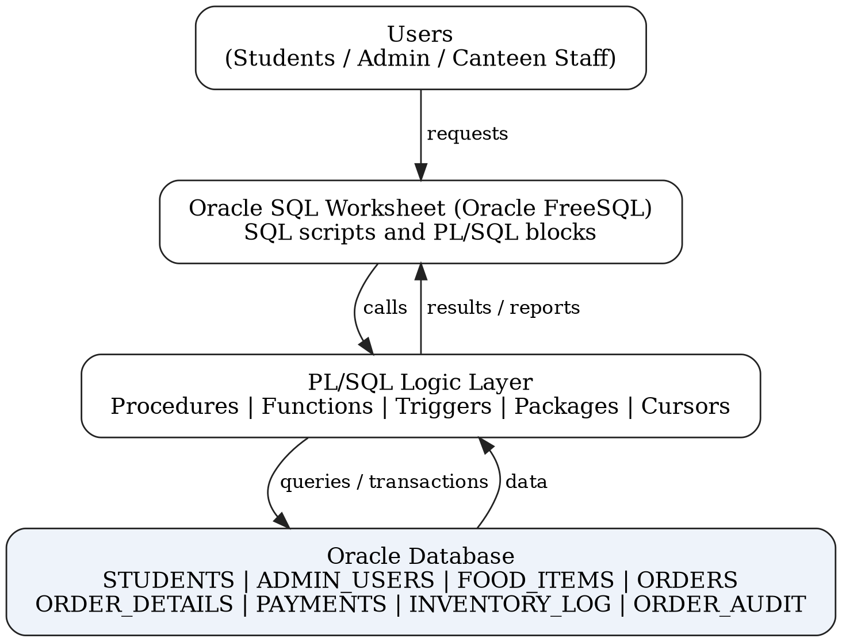
Figure 2.1 — System Architecture Diagram
Layer | Component | Objects | Responsibility
Interaction | Oracle FreeSQL worksheet | SQL scripts, PL/SQL blocks | Run commands and show results
Logic | Stored procedures and functions | PLACE_ORDER, PROCESS_PAYMENT, CALCULATE_ORDER_BILL, GET_DISCOUNT, GET_FINAL_BILL | Validation, stock update, billing, payment
Automation | Triggers | TRG_FOOD_AVAILABILITY, TRG_ORDER_AUDIT | Availability flag and audit records
Organization | Packages | PKG_ORDER_MANAGEMENT, PKG_BILLING, PKG_REPORTS | Group related operations
Reporting | Cursors and view | Cursor-based reports, VW_ORDER_SUMMARY | Sales and order summaries
Database | Oracle Database | 8 tables, 8 sequences | Persistent storage
Table 2.1 — System Layers and Responsibilities

2.2 Database Design & Entity Relationships
The relational design uses eight tables. The students and admin_users tables store account details. The food_items table stores the menu, price, stock, and availability. The orders table stores the order header, while the order_details table stores the food items and quantities of each order, so one order can contain several food items. The payments table records the payment for an order, the inventory_log table records every stock change, and the order_audit table records order creation and status changes. Foreign keys enforce referential integrity: an order cannot refer to a student that does not exist, an order line cannot refer to a missing order or food item, and a unique rule on payments.order_id allows at most one payment per order.
STUDENTS
Column | Type | Notes
student_id | INT | Primary key
student_name | VARCHAR | Student name
email | VARCHAR | Unique
phone | VARCHAR | Contact number
department | VARCHAR | Student department
created_at | DATE | Record creation date
ADMIN_USERS
Column | Type | Notes
admin_id | INT | Primary key
admin_name | VARCHAR | Administrator name
username | VARCHAR | Unique, used for login
password_hash | VARCHAR | Stored password hash
created_at | DATE | Record creation date
FOOD_ITEMS
Column | Type | Notes
food_id | INT | Primary key
food_name | VARCHAR | Menu item name
category | VARCHAR | Item category
price | DECIMAL | Selling price (not negative)
stock_quantity | INT | Units in stock (not negative)
is_available | VARCHAR | ‘Y’ / ‘N’ flag maintained by trigger
ORDERS
Column | Type | Notes
order_id | INT | Primary key
student_id | INT | Foreign key to students
order_date | DATE | Date and time of the order
total_amount | DECIMAL | Order total
order_status | VARCHAR | e.g. PLACED, PREPARING, COMPLETED
ORDER_DETAILS
Column | Type | Notes
detail_id | INT | Primary key
order_id | INT | Foreign key to orders
food_id | INT | Foreign key to food_items
quantity | INT | Ordered quantity (positive)
price_at_order | DECIMAL | Price when the order was placed
PAYMENTS
Column | Type | Notes
payment_id | INT | Primary key
order_id | INT | Foreign key to orders; unique
payment_date | DATE | Payment date
payment_amount | DECIMAL | Amount paid
payment_method | VARCHAR | e.g. UPI
payment_status | VARCHAR | e.g. SUCCESS
INVENTORY_LOG
Column | Type | Notes
log_id | INT | Primary key
food_id | INT | Foreign key to food_items
quantity_change | INT | Stock change (negative for a deduction)
action_type | VARCHAR | e.g. ORDER
log_date | DATE | Date and time of the change
remarks | VARCHAR | Description of the change
ORDER_AUDIT
Column | Type | Notes
audit_id | INT | Primary key
order_id | INT | Foreign key to orders
action_type | VARCHAR | ORDER_CREATED or STATUS_UPDATED
old_status | VARCHAR | Status before the change
new_status | VARCHAR | Status after the change
action_date | DATE | Date and time of the event

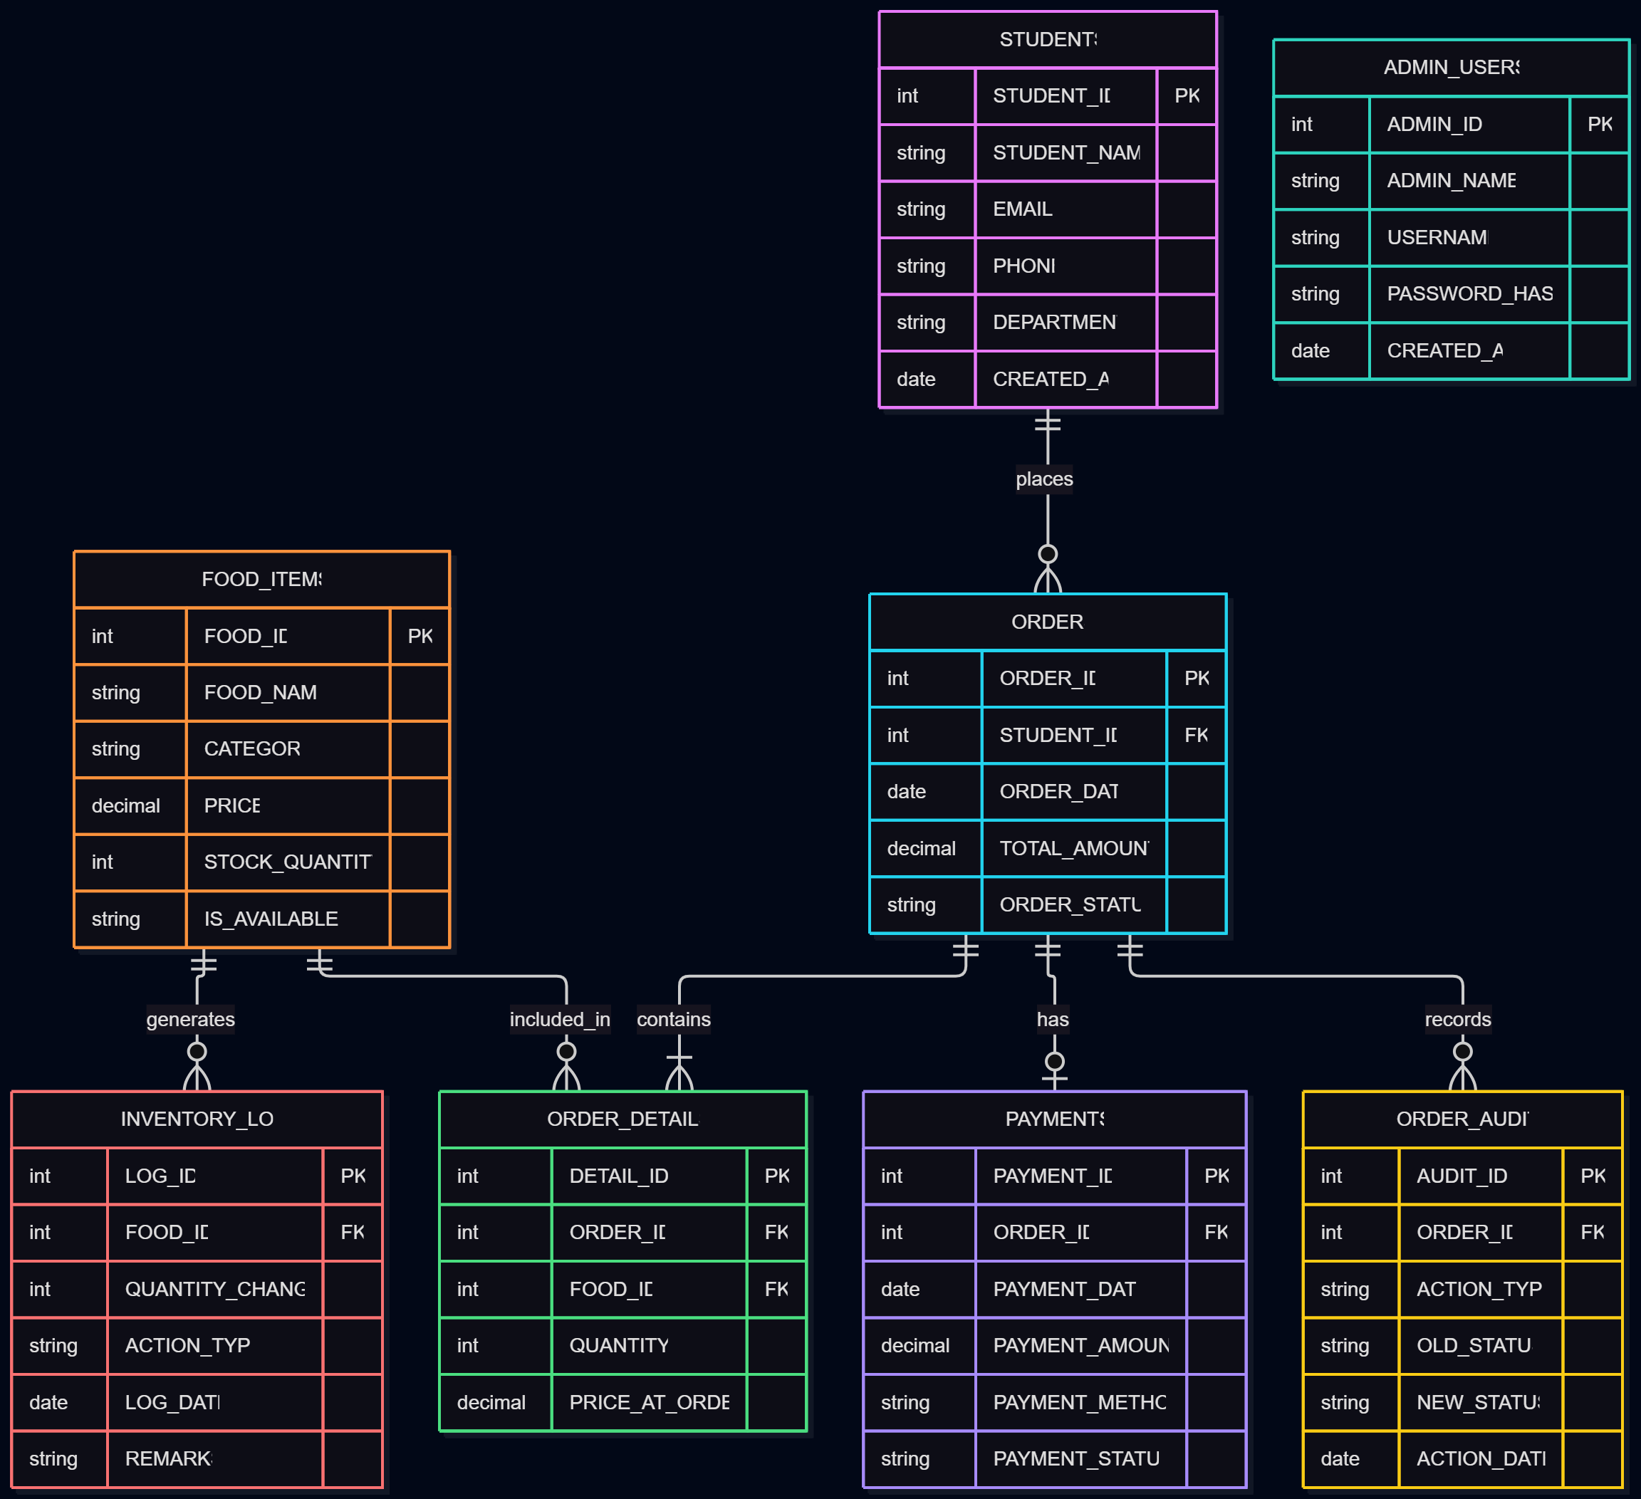
Figure 2.2 — Database Entity Relationship (ER) Diagram

2.3 Data Flow & System Flowcharts
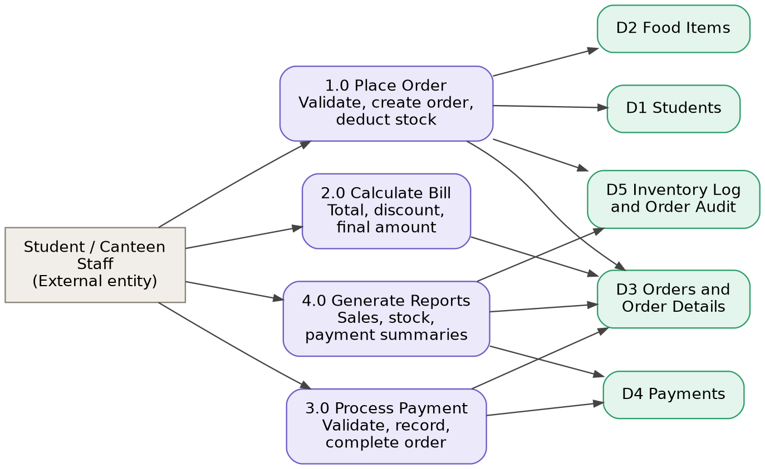  Figure 2.3 — Data Flow Diagram Level 1 | 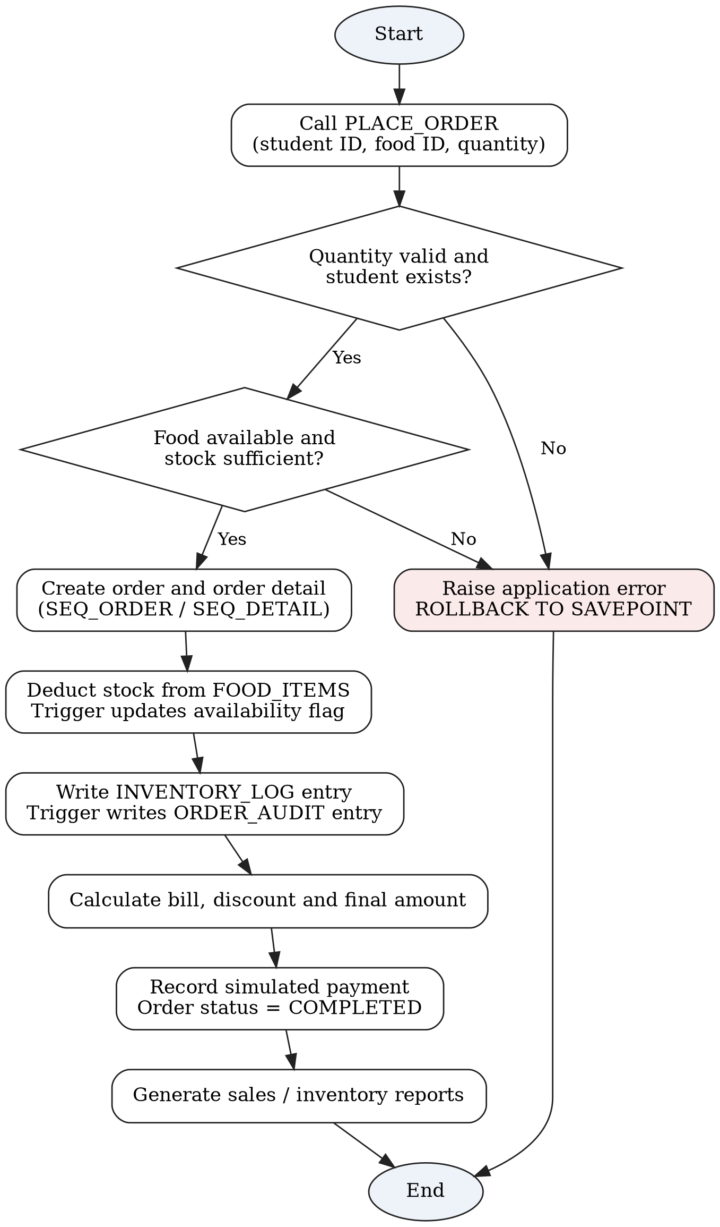  Figure 2.4 — Overall System Flowchart
At Level 0, the student or canteen staff member provides an order request (student, food item, quantity) and payment details, and receives an order confirmation, a bill, and reports in return. Level 1 breaks this into four processes: Place Order, Calculate Bill, Process Payment, and Generate Reports. Each order request is checked in order: valid quantity and student, food item available, and stock sufficient, then the order is inserted, with any failure rolled back to the savepoint. The outcome is returned to the caller as a message.
Chapter 3: Implementation & Major Modules

3.1 Backend Implementation (PL/SQL Procedures, Functions & Triggers)
The backend is organized into stored PL/SQL program units that keep all business rules inside the database [2]. Related operations are grouped into three packages.
Program unit | Type | Function
PLACE_ORDER | Procedure | Validates quantity, student, availability, and stock; creates the order and order detail; deducts stock; writes an inventory-log entry; returns the order ID and total
PROCESS_PAYMENT | Procedure | Validates order, amount, method, and status; rejects duplicate payments; inserts the payment; marks the order COMPLETED
CALCULATE_ORDER_BILL | Function | Sums quantity multiplied by the price at order time
GET_DISCOUNT | Function | Returns the discount for the order amount (0%, 5%, or 10%)
GET_FINAL_BILL | Function | Returns the amount after the discount
TRG_FOOD_AVAILABILITY | Trigger | Sets IS_AVAILABLE to ‘N’ when stock is zero and ‘Y’ when stock is positive
TRG_ORDER_AUDIT | Trigger | Inserts an audit record when an order is created or its status changes
PKG_ORDER_MANAGEMENT, PKG_BILLING, PKG_REPORTS | Packages | Group order placement and status updates, billing wrappers, and sales reports
Table 3.1 — PL/SQL Program Units
Order placement logic (PLACE_ORDER). The procedure accepts a student ID, food ID, and quantity, and returns the generated order ID and total through OUT parameters. It locks and checks the selected food item, verifies availability and stock, inserts the order and order detail using sequence values, deducts stock, and writes an inventory-log entry.
Transaction handling. PLACE_ORDER sets a savepoint and rolls back to it if any error occurs, so a failed order never leaves partial data behind. The order and payment procedures do not commit automatically; the calling block decides whether to COMMIT or ROLLBACK.
Billing slabs. The discount functions apply three slabs: an order below ₹250 receives no discount, an order from ₹250 to ₹499.99 receives 5%, and an order of ₹500 or more receives 10%.
Payment simulation. PROCESS_PAYMENT is an academic simulation. A successful payment marks the order COMPLETED, and a second attempt for the same order is rejected with an application error. It does not connect to any real bank or payment service.

3.2 Database Implementation (Oracle SQL & FreeSQL)
Bhukkad Bazz stores its data in an Oracle database developed and tested in Oracle FreeSQL [3], a browser-based SQL worksheet, so no local installation is required. The tables are created with NOT NULL, UNIQUE, CHECK, and DEFAULT constraints [1]. CHECK constraints validate non-negative prices and stock, positive quantities, and the allowed availability values, order statuses, payment methods, and payment statuses, while DEFAULT values set creation dates and initial statuses automatically.
Eight sequences generate identifiers: SEQ_STUDENT, SEQ_ADMIN, SEQ_FOOD, SEQ_ORDER, SEQ_DETAIL, SEQ_PAYMENT, SEQ_INVENTORY, and SEQ_AUDIT. The design follows the normal forms: columns hold atomic values and multiple food items of an order are stored as separate rows in ORDER_DETAILS (1NF); order-line attributes such as quantity and price at order time are stored with the order-detail record (2NF); and student details are stored once in STUDENTS instead of being repeated in every order (3NF).

3.3 Reports, Cursors & Exception Handling
Explicit cursors support controlled row-by-row processing in the daily sales and student order-history reports. The cursor lifecycle includes declaration, opening, fetching, checking the %NOTFOUND attribute, and closing. An implicit cursor demonstration uses SQL%ROWCOUNT, SQL%FOUND, SQL%NOTFOUND, and SQL%ISOPEN after a DML statement [2].
The project raises application errors for invalid quantities, missing students, unavailable food, insufficient stock, missing orders, invalid payment details, duplicate payment attempts, and incorrect payment amounts. The reports cover top-selling food items, highest-spending students, daily revenue, category-wise sales, low-stock alerts, payment-method analysis, and monthly revenue. The view VW_ORDER_SUMMARY combines order, student, and payment information for easier review.

Chapter 4: Project Showcase (Visual Walkthrough)
This chapter gives a visual demonstration of the completed Bhukkad Bazz database, showing how the procedures, triggers, and stored records work together. All outputs were captured from the Oracle FreeSQL worksheet.

4.1 Order Placement & Billing Output
A call to PLACE_ORDER for a valid student and an available food item reports a successful order. In the captured run, the order was generated with order ID 3 and a total bill of Rs. 30, and the whole block completed in 0.014 seconds.
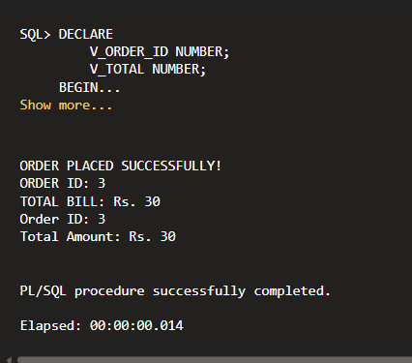
Figure 4.1: PLACE_ORDER Execution and Generated Order

4.2 Backend Validation & Exception Handling
The backend validates input before any data is saved: invalid quantities, unknown students, unavailable food, insufficient stock, and duplicate or incorrect payments are rejected with an application error and rolled back. Figure 4.2 shows an attempt to pay for an order that already has a payment; the procedure rejects it with error ORA-20035 (“Payment already exists for this order”) in 0.008 seconds.
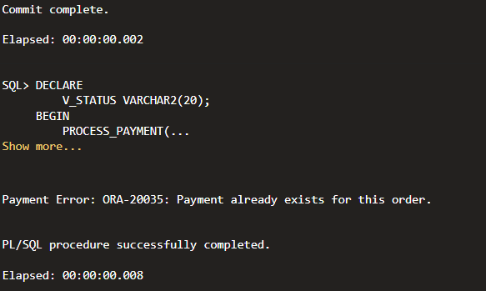
Figure 4.2: Duplicate Payment Rejected

4.3 DBMS Records & Schema Verification
To show that data is persisted, the actions performed by the procedures are verified directly in the database tables. Figure 4.3 confirms that all eight tables exist.
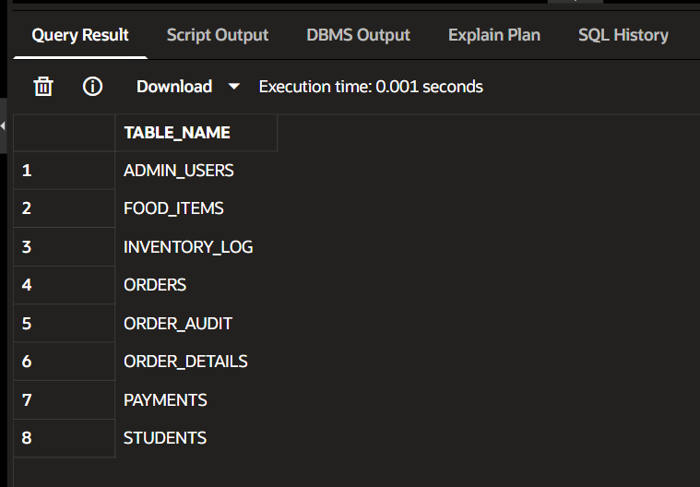
Figure 4.3: Table Creation Output (USER_TABLES)
Figure 4.4 shows the inventory log: three stock deductions for food ID 1 (−2, −1, and −2 units), five units in total, each linked to its order in the remarks, including order 3 placed in Figure 4.1.
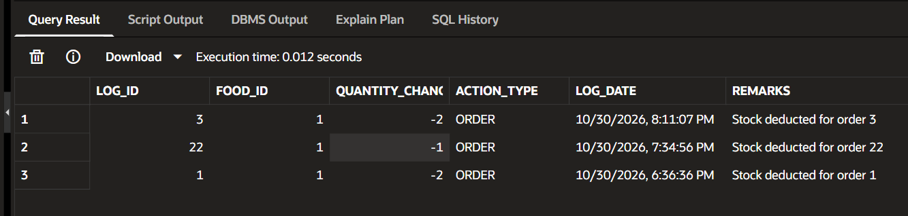
Figure 4.4: Inventory Update (INVENTORY_LOG)
Figure 4.5 shows the audit records written by the trigger: eight records, four ORDER_CREATED and four STATUS_UPDATED (for example PLACED to COMPLETED for order 22), covering five orders.
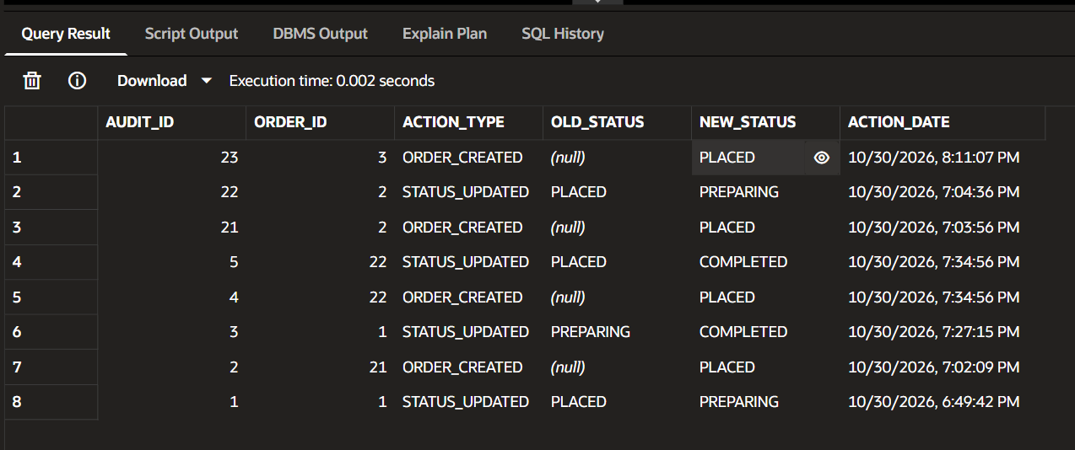
Figure 4.5: Trigger Audit Records (ORDER_AUDIT)
Figure 4.6 shows the order summary view: five orders from two students, of which two have a successful UPI payment (Rs. 30 and Rs. 15, Rs. 45 in total) and three have no payment recorded yet (Rs. 150 in total). The order statuses are two PLACED, two PREPARING, and one COMPLETED.
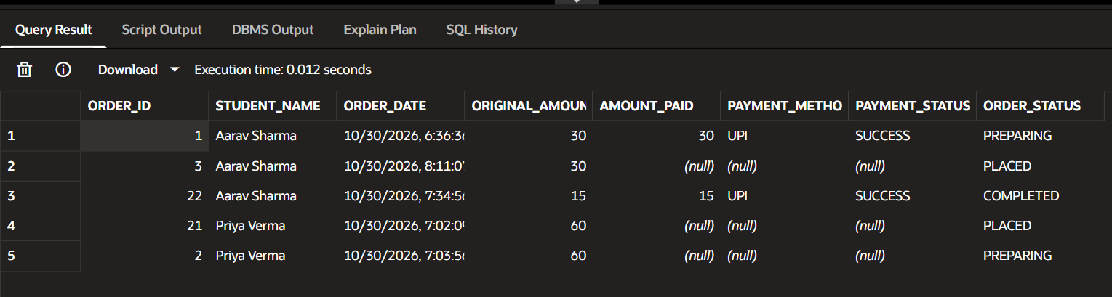
Figure 4.6: Order Summary View (VW_ORDER_SUMMARY)

Chapter 5: Testing & Validation

5.1 Functional & Integration Testing
Testing verifies that the tables, procedures, functions, triggers, and views work together. Functional testing checks that each feature (order placement, billing, payment, audit logging, reports) behaves as specified. Integration testing confirms that an order placed through the procedure reaches the ORDERS, ORDER_DETAILS, INVENTORY_LOG, and ORDER_AUDIT tables correctly and that the results are shown back through the summary view. All tests are executed in the Oracle FreeSQL workspace.

5.2 Test Cases & Results
The system was checked against the following functional test cases. Output was captured for TC-01, TC-03, TC-08, and TC-11 (see Chapter 4); the status of the remaining cases is to be recorded after each test is executed.
Test Case ID | Module | Description | Expected Result | Status
TC-01 | Schema | Create the eight database tables | All table definitions created without errors | Pass
TC-02 | Data Entry | Insert valid student, administrator, and food records | Records inserted and committed | [Pass / Fail]
TC-03 | Order Placement | Place an order for a valid student and an available food item | Order and order-detail rows created; stock reduced; inventory log written | Pass
TC-04 | Order Placement | Place an order with a non-existent student ID | Student-not-found error; no partial order remains | [Pass / Fail]
TC-05 | Order Placement | Place an order with zero or negative quantity | Quantity rejected | [Pass / Fail]
TC-06 | Order Placement | Place an order when stock is insufficient or food is unavailable | Order rejected; data consistency preserved | [Pass / Fail]
TC-07 | Triggers | Update food stock to zero and then to a positive quantity | Availability flag set accordingly | [Pass / Fail]
TC-08 | Audit | Change an order status | Audit trigger records the status transition | Pass
TC-09 | Billing | Calculate order total, discount, and final bill | Values follow the configured discount slabs | [Pass / Fail]
TC-10 | Payment | Process a valid simulated payment | Payment recorded; order marked completed | [Pass / Fail]
TC-11 | Payment | Process an invalid amount or a duplicate payment | Payment rejected; changes rolled back to the savepoint | Pass
TC-12 | Reports | Run sales and inventory reports | Reports return rows from the committed data | [Pass / Fail]
Table 5.1 — Functional Test Cases
A key validation rule is that an order is created only for a valid student, an available food item, and sufficient stock, and that an order can never hold two payments. The stock and availability rules are checked inside PLACE_ORDER and the availability trigger, and the one-payment rule is enforced by the database through a unique constraint and reported to the user as an application error.

Chapter 6: Future Scope & Conclusion

6.1 Proposed Enhancements
While Bhukkad Bazz successfully handles order placement, billing, and payment recording, the modular design allows easy extension. Proposed future work includes:
- Web or Mobile Interface: Build a responsive interface for students and canteen administrators on top of the existing database.
- Role-Based Authentication: Add user roles and secure password hashing before handling real accounts.
- Payment Gateway: Integrate a real payment gateway only after appropriate security, compliance, and institutional approval.
- Notifications & Order Tracking: Send order notifications and show live order-status tracking.
- Menu Scheduling & Configurable Discounts: Provide item availability by time slot and discount rules that can be configured.
- Advanced Analytics: Add peak-hour demand, food wastage, and inventory forecasting reports.
- Backup & Audit Retention: Add automated backup, recovery, and audit-retention policies.

6.2 Final Conclusion & References
Bhukkad Bazz successfully demonstrates the translation of a common campus problem, manual and error-prone canteen operations, into a structured, database-driven system. By combining Oracle SQL and PL/SQL with constraints, stored procedures, functions, triggers, packages, cursors, and transaction control, the project replaces register-based handling with a centralized, traceable, and reliable ordering workflow. The order-placement procedure validates a request, calculates an amount, updates stock, and maintains an audit record, while the billing and reporting components turn stored data into useful operational information. Bhukkad Bazz provides a solid foundation for a full canteen management application with a graphical interface.
References
- R. Elmasri and S. B. Navathe, Fundamentals of Database Systems, 7th ed. Hoboken, NJ, USA: Pearson, 2016.
- Oracle, Oracle Database PL/SQL Language Reference. https://docs.oracle.com/en/database/
- Oracle, Oracle FreeSQL. https://freesql.com/
- Oracle, Oracle Database SQL Language Reference. https://docs.oracle.com/en/database/
- A. Silberschatz, H. F. Korth, and S. Sudarshan, Database System Concepts, 7th ed. New York, NY, USA: McGraw-Hill, 2019.

