Technical Brief
Urban Heat and Green-Space Assessment
Kathmandu Valley, Nepal
Summer land-surface temperature, vegetation condition and heat exposure summarised by local administrative unit.
Author | Shristi Karki
Date | 17 September 2026
Tools | Google Earth Engine, ArcGIS Pro, Excel
Imagery | Landsat 8/9 Collection 2 Level 2 (surface reflectance + surface temperature)
Ancillary | ESA WorldCover v200 (10 m land cover); WorldPop 100 m population
Season | Pre-monsoon hot season, March–May
Summary unit | Administrative unit

1 Introduction
Kathmandu Valley has urbanised rapidly, converting agricultural land and open space within the valley floor to continuous built-up surface. Replacing vegetated and permeable ground with dry, dark, impervious material raises daytime surface temperature, because built materials store more incoming radiation and, lacking soil moisture and leaf area, shed almost none of it through evapotranspiration. The result is a surface urban heat island: a persistent, spatially structured temperature difference between the dense core and the valley’s greener margins.
This brief maps that pattern from satellite imagery and reduces it to numbers that can be acted on administratively. It answers three questions:
- Where in the valley is the land surface hottest during the pre-monsoon season, and by how much does each unit depart from the valley average?
- How does that pattern track tree and vegetation cover versus built-up surface?
- Which units combine high heat with high population, and therefore carry the greatest exposure?
The intended use is screening and prioritisation — identifying candidate units for tree planting, surface treatment or further study. It is not a substitute for air-temperature monitoring; see Section 6.

2 Study area
The analysis covers the three districts of Kathmandu Valley — Kathmandu, Lalitpur and Bhaktapur — a bowl-shaped basin at roughly 1,300 m elevation, ringed by hills that rise several hundred metres above the floor. The valley floor holds the dense historic cores of Kathmandu, Patan and Bhaktapur together with the newer built-up fringe; the rim retains forest and terraced agriculture.
That topography matters for interpretation. Elevation alone depresses surface temperature on the valley rim, so part of any core-to-rim difference is orographic rather than a consequence of land cover. Section 6 returns to this.
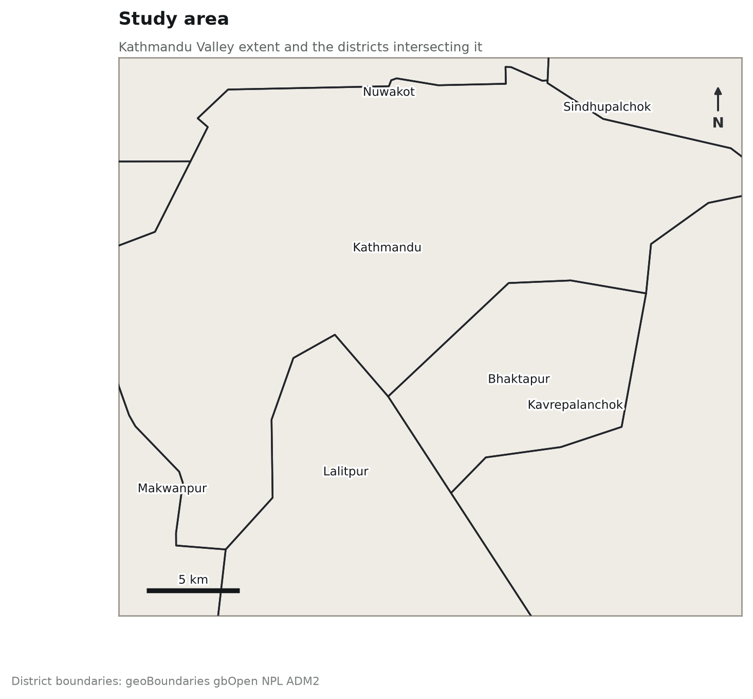
Figure 1. Study area: Kathmandu Valley districts and summary units.

3 Data and methods

3.1 Imagery and compositing
Land surface temperature and vegetation indices were derived from Landsat 8 and Landsat 9 Collection 2 Level 2 scenes. Collection 2 Level 2 supplies atmospherically corrected surface reflectance and a surface temperature product, so no separate top-of-atmosphere conversion or emissivity model was applied.
Scenes were restricted to March–May, the pre-monsoon hot season. This window is chosen deliberately: it captures the annual surface-temperature peak while avoiding the June–September monsoon, during which persistent cloud makes optical and thermal imagery over the valley largely unusable. Scenes with more than 40 per cent scene-wide cloud were discarded, and within the remaining scenes cloud, cloud shadow, cirrus and dilated-cloud pixels were masked individually using the QA_PIXEL band. Saturated pixels were removed using QA_RADSAT.
Because a single date can leave large masked gaps, scenes from several years were pooled and reduced to a per-pixel median. The median is robust to the residual cloud edges that survive masking. The composite therefore represents typical pre-monsoon surface conditions rather than any one overpass.

3.2 Surface temperature
The thermal band ST_B10 was rescaled to kelvin using the Collection 2 scale and offset (0.00341802 and 149.0) and converted to degrees Celsius. Two quantities are reported. Mean LST is the absolute surface temperature of a unit. The LST anomaly is each pixel’s departure from the valley-wide mean of the same composite; it is the more useful of the two for comparing units, because it removes the seasonal and inter-annual level and isolates spatial structure.

3.3 Vegetation and built-up indices
NDVI was computed as (NIR − Red) / (NIR + Red) from bands SR_B5 and SR_B4, and NDBI as (SWIR1 − NIR) / (SWIR1 + NIR) from SR_B6 and SR_B5. NDVI is reported as a unit mean and as the fraction of a unit at or above 0.3, a conventional threshold separating vegetated from sparsely vegetated surface.

3.4 Cover fractions
Tree, vegetation and built-up fractions were taken from ESA WorldCover v200 at 10 m rather than from a threshold on NDBI. This is a deliberate choice: a threshold on a 30 m spectral index is a weak impervious-surface estimate, particularly in a city whose building materials and bare agricultural soil are spectrally similar. WorldCover classes were aggregated to tree cover, total green cover (tree + grassland + cropland), built-up and permanent water, and averaged within each unit to give an areal fraction.

3.5 Zonal summary and exposure
All layers were summarised within each administrative unit using area-weighted zonal means at 30 m, with LST additionally summarised by standard deviation, 90th percentile and maximum to describe within-unit spread and hot spots. Population came from WorldPop 100 m and was summed per unit.
A heat exposure index was formed as unit population multiplied by the unit’s positive LST anomaly, and set to zero where a unit is cooler than the valley mean. It is an intentionally simple screening quantity that ranks units by the number of people living under elevated surface temperature; it is not a health-risk estimate and carries no vulnerability weighting.

3.6 Software
Compositing, index calculation and zonal statistics were run in Google Earth Engine. Exported rasters were symbolised and laid out as the map series in ArcGIS Pro. Tabular results were checked and charted in Excel; the figures reproduced here were generated from the same exported table.

4 Results

4.1 Temperature pattern
Across 8 summary units the pre-monsoon composite gives a mean land surface temperature of 28.1 °C, ranging from 26.5 °C in Makwanpur to 30.0 °C in Bhaktapur — a spread of 3.5 °C between the coolest and hottest unit.
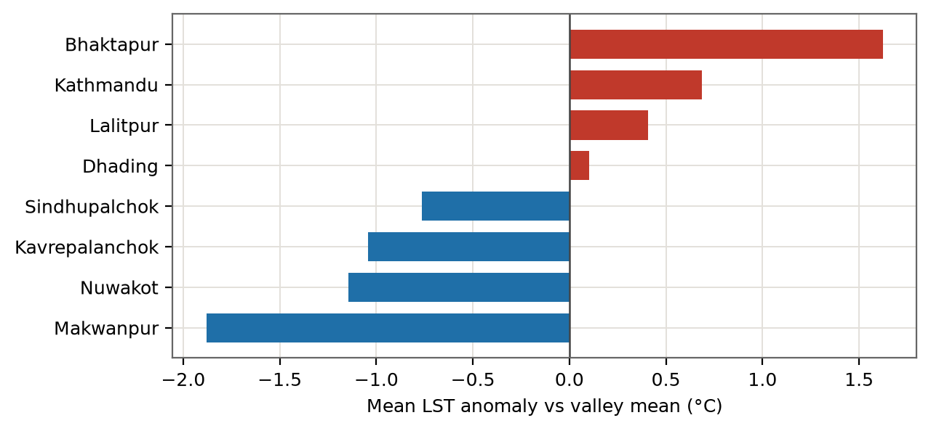
Figure 2. Mean land surface temperature anomaly by unit, relative to the valley mean. Warm bars are hotter than the valley average.

4.2 Relationship with green cover
Unit mean LST correlates with green cover at r = -0.78, and the LST anomaly with built-up cover at r = 0.79. Green cover across units averages 91.1 per cent, of which tree cover is 62.8 per cent.
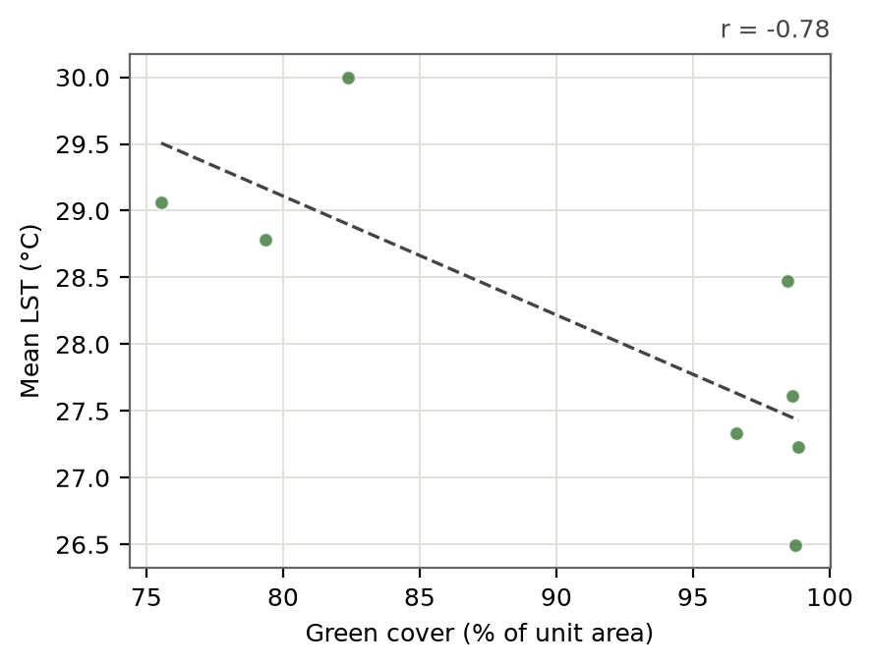
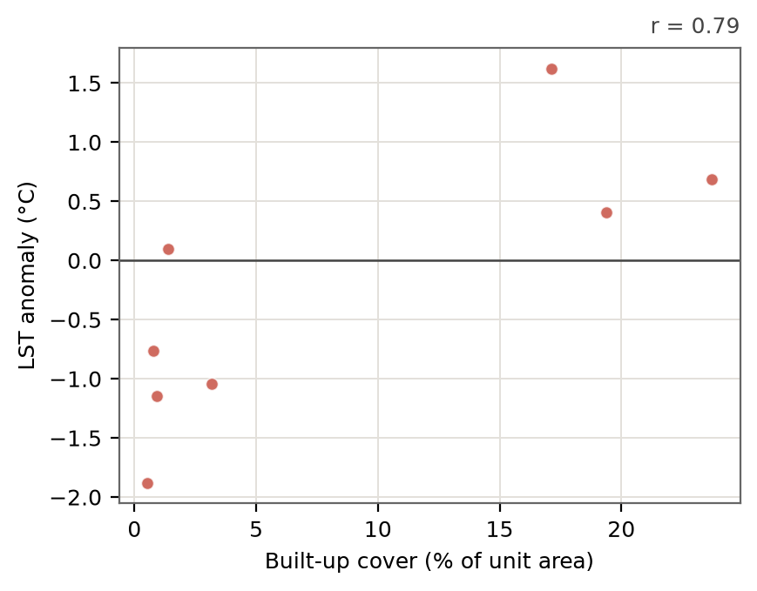
Figure 3. Unit mean LST against green cover (left) and LST anomaly against built-up cover (right).

4.3 Heat exposure
Ranking units by population under a positive heat anomaly puts Kathmandu at the top, followed by Bhaktapur, Lalitpur, Dhading. These are the units where elevated surface temperature and population density coincide.
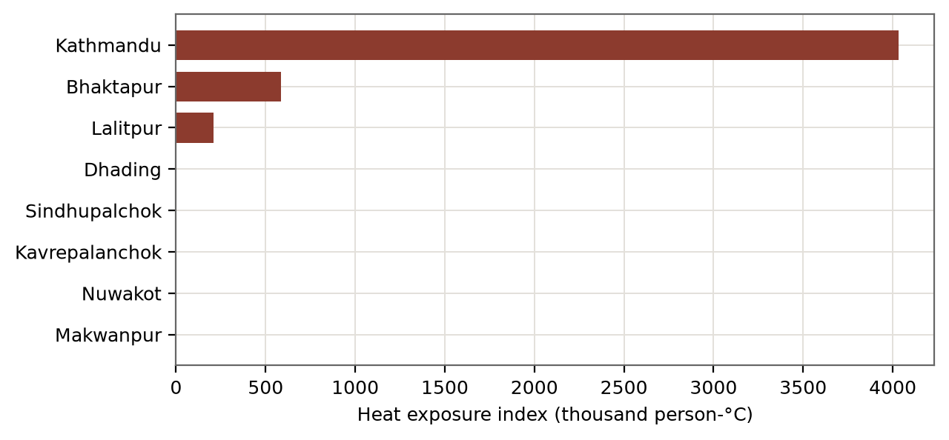
Figure 4. Heat exposure index, highest-ranked units.

4.4 Summary table
Unit | Area km² | Pop. | LST °C | ΔLST °C | NDVI | Tree % | Green % | Built %
Bhaktapur | 123.1 | 360,036 | 30.00 | 1.62 | 0.45 | 32.2 | 82.4 | 17.1
Kathmandu | 416.0 | 5,867,519 | 29.06 | 0.69 | 0.48 | 47.7 | 75.5 | 23.7
Lalitpur | 155.8 | 513,409 | 28.78 | 0.41 | 0.47 | 43.7 | 79.4 | 19.4
Dhading | 42.9 | 10,247 | 28.48 | 0.10 | 0.58 | 78.7 | 98.4 | 1.4
Sindhupalchok | 65.6 | 11,640 | 27.61 | -0.77 | 0.58 | 73.2 | 98.6 | 0.8
Kavrepalanchok | 181.4 | 30,414 | 27.33 | -1.04 | 0.59 | 68.3 | 96.6 | 3.2
Nuwakot | 154.4 | 23,786 | 27.23 | -1.14 | 0.60 | 80.2 | 98.9 | 0.9
Makwanpur | 75.9 | 8,913 | 26.50 | -1.88 | 0.60 | 78.6 | 98.7 | 0.5
Table 1. Per-unit summary, ordered by LST anomaly. Full table in data/ward_summary.csv.

4.5 Data quality notes
Population is summed from the WorldPop unconstrained grid and implies a peak density of about 14,105 people per km². That is roughly three times the district figure implied by the 2021 national census, so the population totals and the heat exposure index below should be read as an ordinal ranking only. Substitute census counts before quoting any absolute number.

5 Map series
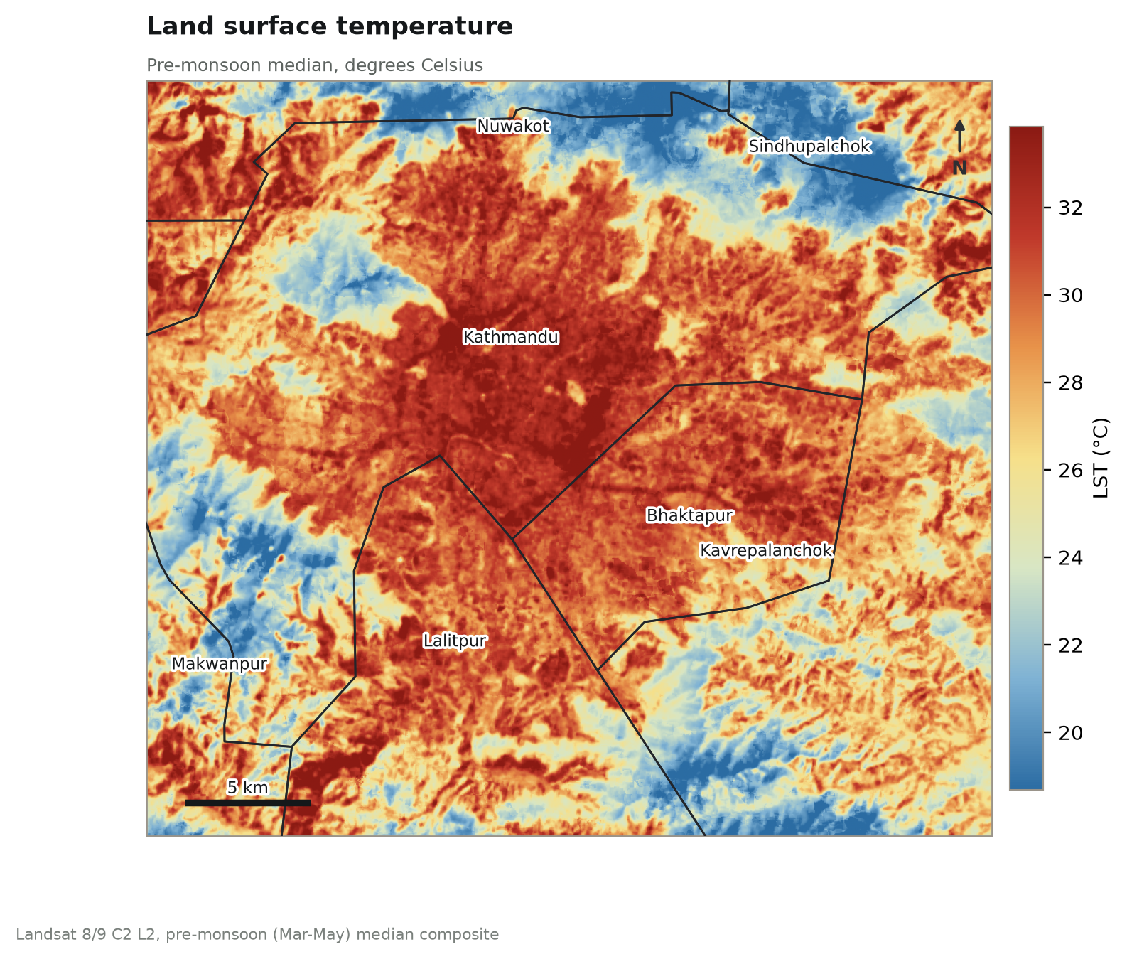
Map 1. Land surface temperature, pre-monsoon composite (°C).
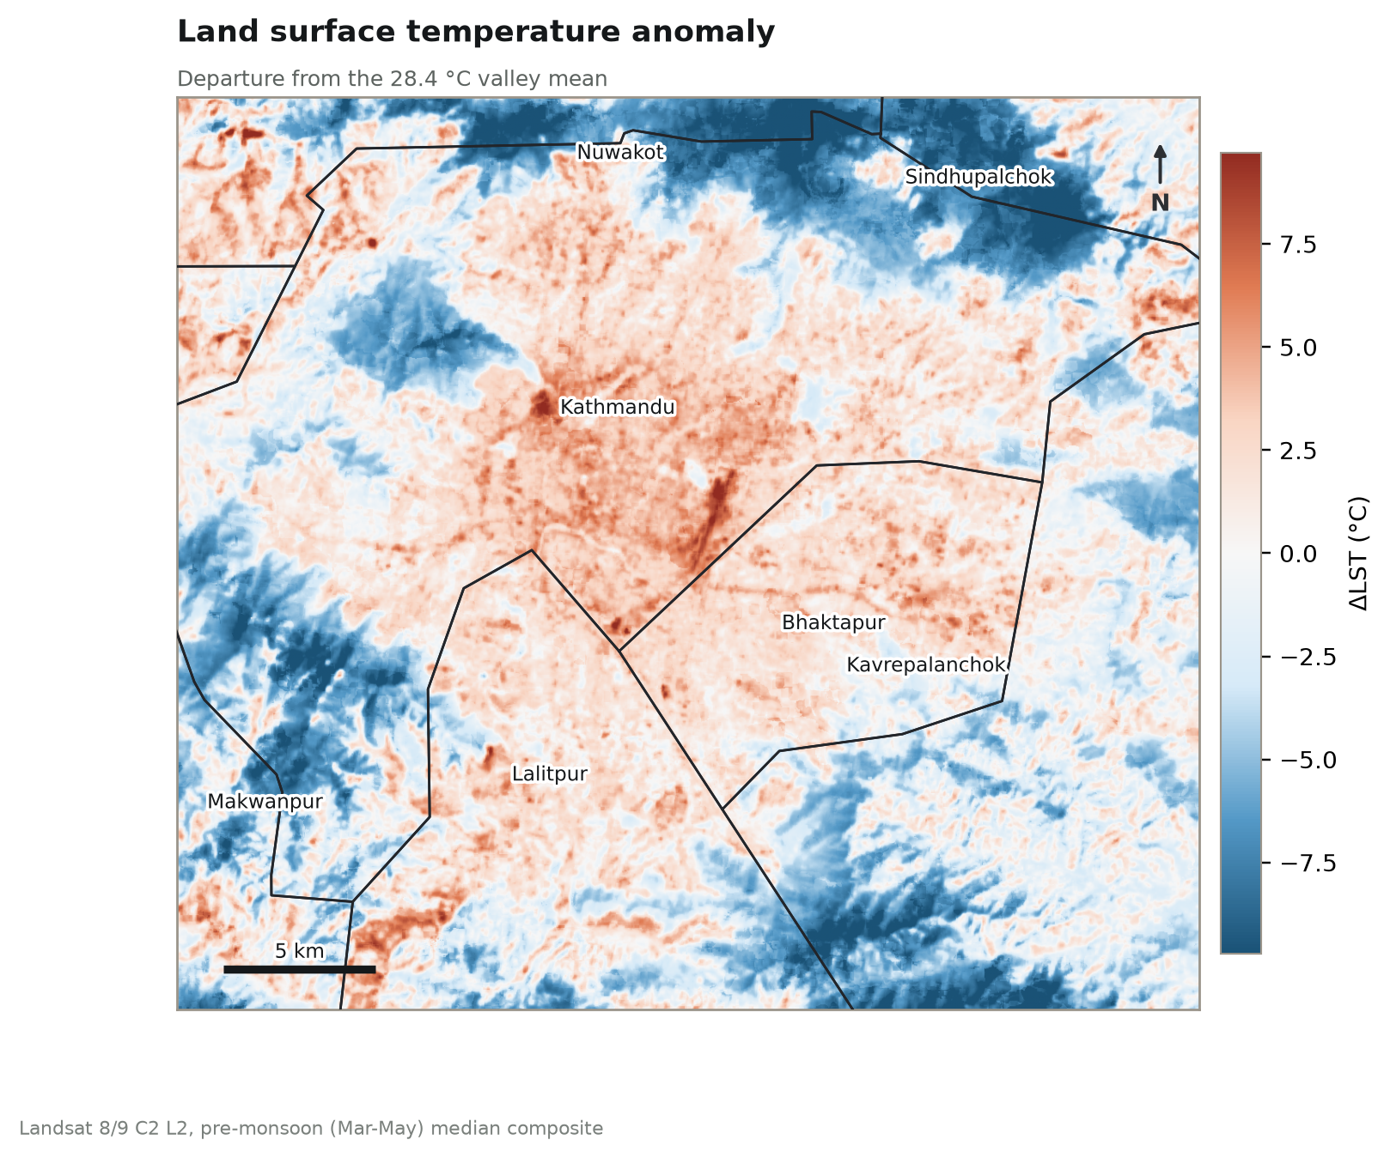
Map 2. Land surface temperature anomaly relative to the valley mean (°C).
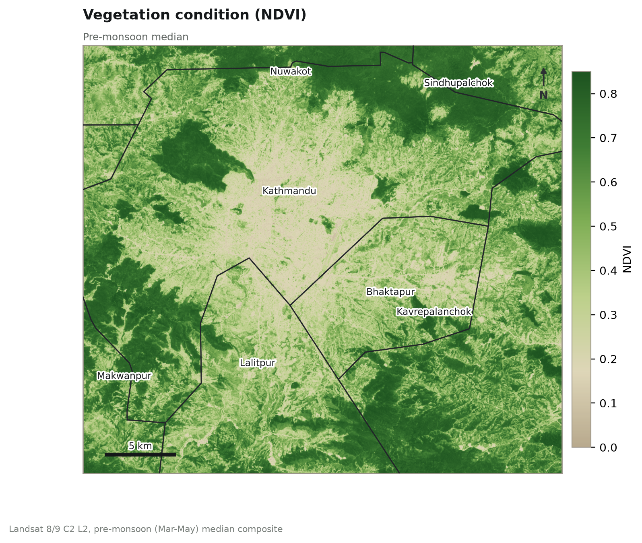
Map 3. NDVI, pre-monsoon composite.
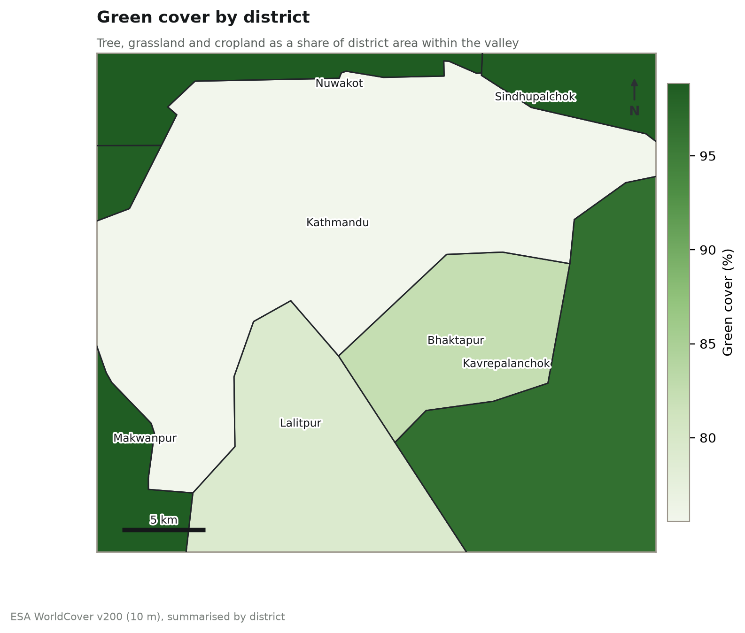
Map 4. Tree and vegetation cover from ESA WorldCover.
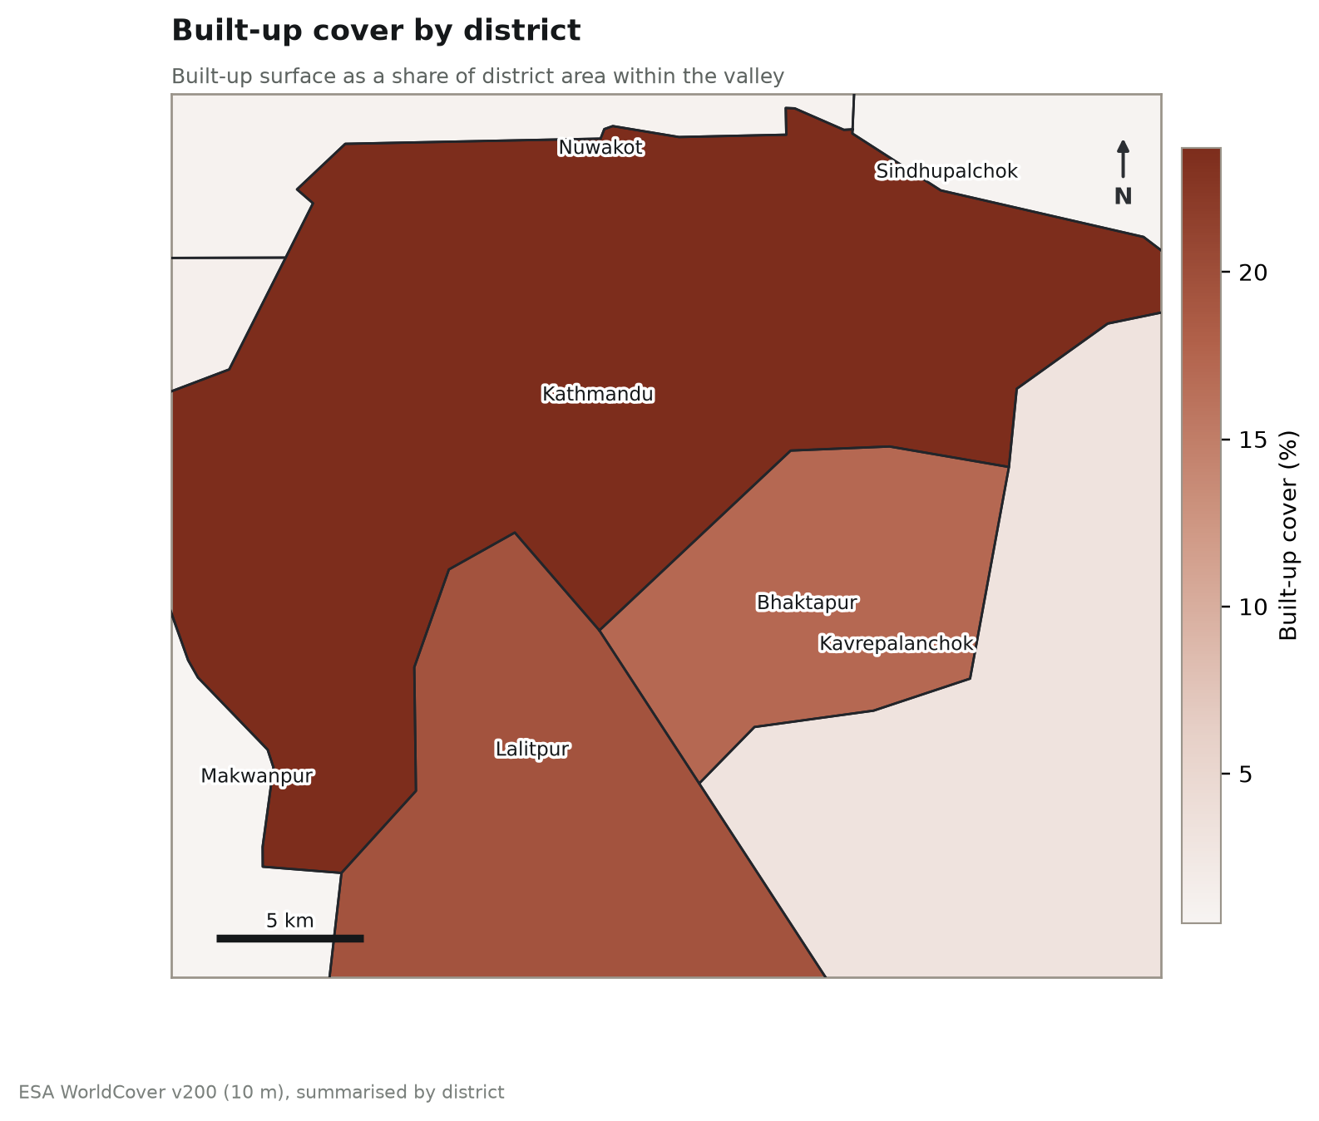
Map 5. Built-up surface from ESA WorldCover.
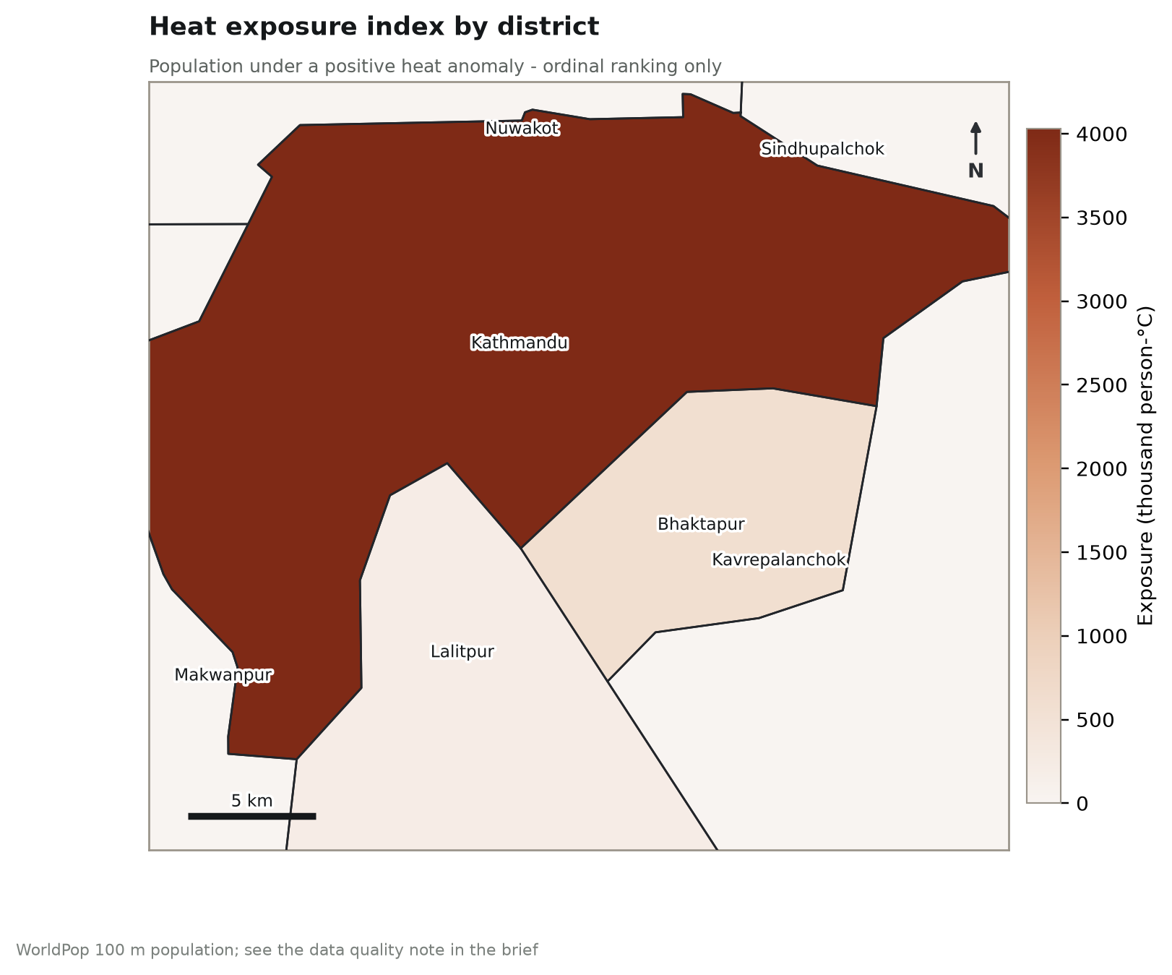
Map 6. Heat exposure index by administrative unit.

6 Limitations
- Land surface temperature is not air temperature. LST is the radiometric temperature of the ground and roof surfaces the satellite sees. It runs hotter than screen-level air temperature by a margin that itself varies with surface type, and it should not be read as what a person standing in the street would feel.
- The composite describes one season. March–May results say nothing about the monsoon or winter pattern, and nocturnal heat islands — often the more relevant ones for health — are not captured by a daytime overpass.
- Landsat overpasses the valley in mid-morning, before the afternoon surface maximum.
- Topography is confounded with land cover. The valley rim is both greener and higher, and elevation alone lowers surface temperature, so the core-to-rim contrast overstates the part attributable to land cover. Interpreting a unit against units at similar elevation is safer than against the valley as a whole.
- The 30 m thermal grid is coarser than the fabric of the historic cores, so narrow streets, courtyards and small gardens are mixed within single pixels.
- Cover fractions inherit the accuracy of ESA WorldCover, which was not validated locally for this work.
- The exposure index weights population by heat anomaly only. It carries no weighting for age, income, health status, indoor conditions or access to cooling, all of which shape who is actually harmed by heat.
- Results are a screening product. Unit rankings should be confirmed against local knowledge before being used to direct investment.

7 Data sources
USGS Landsat 8 and 9 Collection 2 Level 2 Science Products. U.S. Geological Survey. https://www.usgs.gov/landsat-missions
Zanaga, D. et al. (2022). ESA WorldCover 10 m 2021 v200. https://doi.org/10.5281/zenodo.7254221
WorldPop (2020). Global High Resolution Population Denominators. University of Southampton. https://www.worldpop.org
Gorelick, N. et al. (2017). Google Earth Engine: Planetary-scale geospatial analysis for everyone. Remote Sensing of Environment, 202, 18–27.

Appendix Reproducibility
The complete Earth Engine script is gee_kathmandu_uhi.js in this folder. It is parameterised at the top for years, season, cloud threshold, NDVI threshold and the ward boundary asset. Running it reproduces every number in this brief; running build_report.py regenerates this document from the exported table.

